Change Request
for the update of ISO 20022 financial repository items
- Origin of the request:
A.1 Submitter:
RBC I&TS Luxembourg
A.2 Contact person:
GLAY Thierry
+352 26 05 95 59
Thierry.glay@rbc.com
ANGELIDIS Philippe
+ 352 26 05 96 23
Philippe.angelidis@rbc.com
A.3 Sponsors:
Conference call and proposal to implement these codes with SWIFT (Standards) and ….
NMPG ALMUS within Luxembourg is supporting this change request

- Related messages:
SubscriptionOrderConfirmation setr.012.001.04
RedemptionOrderConfirmation setr.006.001.04

- Description of the change request:
ADDING codes
- Depreciation deposit (DDEP)
- High Water Mark (HWMK)
- Global Asset Value (GAVA) per share
- Equalisation Credit (EQCR) per share
- Contingent Liquidation (COLI) per share
• Net Asset Value (NAVL) per share ➔ exiting code

EQUALISATION CREDIT – DEFINITIONS
High Water Mark (HWM)
The highest peak in value that an investment fund has reached means the larger of:
the highest NAV at the end of any previous calculation period when a Performance Fee was payable ( after the deduction of any such Performance Fees); or
the initial NAV. For the purposes of the first date on which the Performance Fee is calculated with respect to the Shares, the High Watermark Amount shall be the initial Net Asset Value of such Shares.
The high watermark ensures that the asset manager does not get paid large sums for poor performance. So if the asset manager loses money over a period, he or she must get the fund above the high watermark before receiving a performance bonus. For example, say after reaching its peak a fund loses $100,000 in year one, and then makes $250,000 in year two. The asset manager therefore not only reached the high watermark but exceeded it by $150,000 ($250,000 - $100,000), which is the amount on which the asset manager gets paid the bonus.

Global Asset Value (GAV) per share
Gross Asset Value which corresponds to NAV before accruals for performance fee. (GAV-PF=NAV).

Equalisation Credit (EC) per share
Prepayment of the amount based on the positive difference between the GAV at subscription and the HWM, when shares are subscribed above their HWM. It serves as a credit against performance fee that might be payable by the fund but that should not, in equity, be charged against the shareholder making the subscription as to such shares, no favorable performance has occurred yet.
At the date of subscription, the equalization credit per share will be equal to the accrued applicable performance fee per share.
The value of the equalization credit paid initially at subscription can vary following the GAV price evolution. It could be reduced to 0, should the GAV drop below the HWM or recover its initial and maximum value, should the GAV match the initial subscription price.

Contingent Liquidation (CL) per share
Mandatory redemption of shares processed either at redemption or crystallization, whose proceeds are due to the asset manager as performance fee against “free ride” .Performance fee paid when shares have been subscribed below their applicable HWM and having gained performance when further redeemed.

Depreciation Deposit (DD)
If the fund's NAV is under the high watermark on subscription day, the investor will be required to pay a Depreciation Deposit equal to the incentive fee that would be payable to the asset manager if the NAV reaches again the HWM. Then the Depreciation Deposit becomes payable to the asset manager as a performance fee.

Net Asset Value (NAV) per share
NAV plus accruals of the performance fee.

EQUALISATION CREDIT – DEPRECIATION DEPOSIT

General Principle
Under the Equalization Credit / Depreciation Deposit Approach, each investor invests at the NAV, plus:
the Equalization Credit (EC) if the NAV of the Fund has increased from the last high watermark.
the Depreciation Deposit (DD) if the NAV of the Fund has decreased from the last high watermark.
If the NAV has risen during the period, then a new subscriber would invest the equivalent of the GAV, the difference between the NAV and the GAV being the Equalization Credit.

GAV
HWM
EC
DD
If the fund's NAV is at a discount to the high watermark when an investor makes a subscription, then the investor will be required to pay a Depreciation Deposit equal to the incentive fee that would have been paid if his shares had risen to the HWM. If the fund situation starts to improve and recover its losses, then the Depreciation Deposit becomes payable to the asset manager as a performance fee.
Upon the crystallization, the asset manager will receives a total performance fees calculated on the GAV increase between the subscription time and the crystallization time. So the performance fee will be calculated “subscription by subscription”.
The asset manager can also receive a performance fees for any GAV increase below the HWM. This performance fee is called the performance fee “against free ride”. Upon crystallization, this performance fee “against free ride”, if any, will be paid out of the DD prepaid at the subscription.
The total performance fees paid to the asset manager =
Performance fees (above the HWM) + performance fees “against free ride” (below the HWM)
EQUALISATION CREDIT – CONTINGENT LIQUIDATION

General Principle
Under the Equalization Credit / Contingent Liquidation Approach, each investor invests at the NAV, plus:
the Equalization Credit if the NAV of the Fund has increased from the last high watermark.
If the NAV of the Fund has decreased from the last high watermark, there is no pre-payment of the performance fee (that would be paid to the asset manager, should the GAV (=NAV) reach again the HWM level)
If the NAV has risen during the period, then a new subscriber would invest the equivalent of the GAV, the difference between the NAV and the GAV being the Equalization Credit.

GAV
HWM
EC
CL
If the fund's NAV is at a discount to the high watermark when an investor makes a subscription, then the investor will only pay the NAV.
Upon the crystallization, the asset manager will receives a total performance fees calculated on the GAV increase between the subscription time and the crystallization time. So the performance fee will be calculated “subscription by subscription”. It’s why the total performance fees have to be calculated in SARA and not by the accountant at the level of the global fund assets: we need to know the detail of each subscription.
The asset manager can also receive a performance fees for any GAV increase below the HWM. This performance fee is called the performance fee “against free ride”. Upon crystallization, this performance fee “against free ride”, if any, will be paid out of a « forced » redemption.
The total performance fees paid to the asset manager =
Performance fees (above the HWM) + performance fees “against free ride” (below the HWM)

Examples:

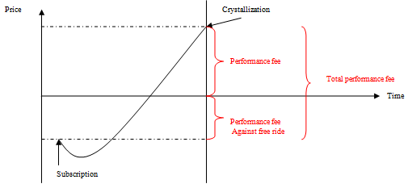
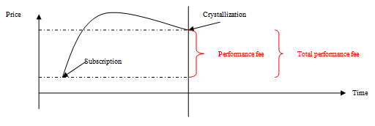
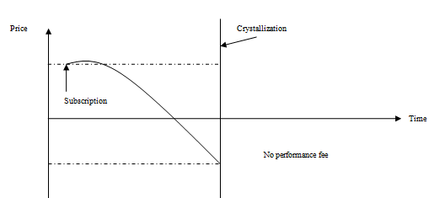

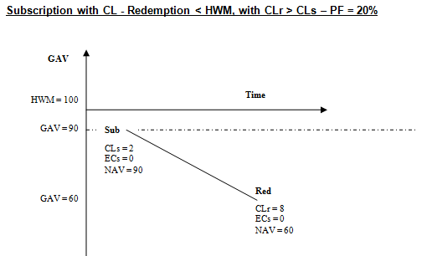
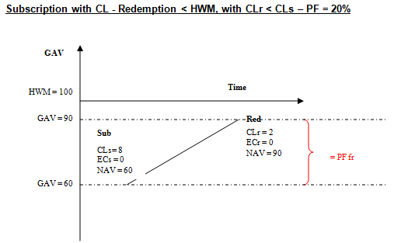

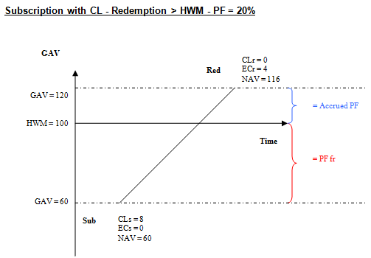
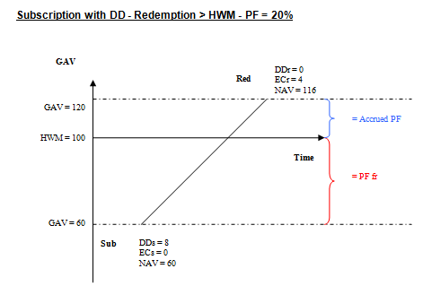
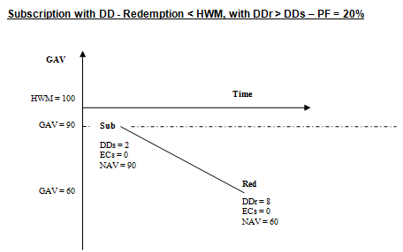
Purpose of the change:
More and more Hedge funds and Alternative Investment Funds are created, then an increase of business.
Investors request more and more transparency in the execution of transactions, it will help actors to be transparent.

- Urgency of the request: /

- Business examples:
Examples illustrating the change request.

- Proposed implementation:
  - Summary of Changes
New elements are shown in blue.
Setr.006.001.05:
RedemptionOrderConfirmationV05/MultipleExecutionDetails/IndividualExecutionDetails/Equalisation
Setr.012.001.05:
SubscriptionOrderConfirmationV05/MultipleExecutionDetails/IndividualExecutionDetails/Equalisation
- SEG/TSG recommendation:

Consider | X | Timing
 |  | - Next yearly cycle: 2023/2024  (the change will be considered for implementation in the yearly maintenance cycle which starts in 2023 and completes with the publication of new message versions in the spring of 2024) |  | X
- At the occasion of the next maintenance of the messages
(the change will be considered for implementation, but does not justify maintenance of the messages in its own right – will be pending until more critical change requests are received for the messages)
- Urgent unscheduled
(the change justifies an urgent implementation outside of the normal yearly cycle)
 |  | - Other timing:

Comments:

Reject
Reason for rejection:

