Change Request
for the update of ISO 20022 financial repository items

- Origin of the request:
A.1 Submitter:
Federal Reserve Bank of New York (on behalf of the US Federal Reserve Banks)
33 Liberty Street
New York, NY 10045
U.S.A.
A.2 Contact person:
Federal Reserve Bank of New York
Mr. Frank Van Driessche (frank.vandriessche@ny.frb.org)
A.3 Sponsors:
CPMI/PMPG Joint Task Force

- Related messages:
pacs.008.001.11 – FI To FI Customer Credit Transfer
pacs.004.001.12 – Payment Return
pacs.009.001.10 – Financial Institution Credit Transfer

- Description of the change request:
Make the Category Purpose element in the Payment Type Information component (appearing at multiple levels) repetitive, like the Service Level element in the same component to enable the inclusion of multiple payment category purposes that may trigger different processing conditions between the exchanging financial institutions.
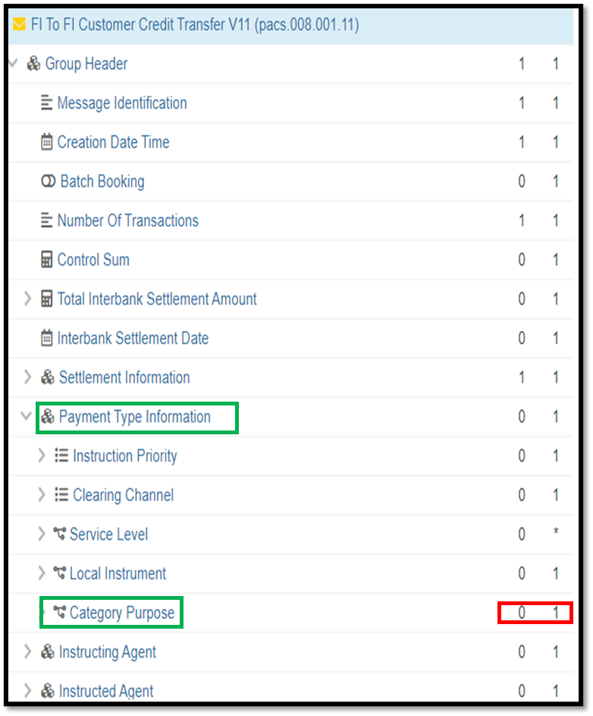

- Purpose of the change:
As part of the CPMI ISO 20022 harmonization efforts and the minimum required data model to enhance cross-border payments, requirement 3 focuses on indicating that a payment is a cross-border payment to enhance the efficiency in processing the cross-border payment. If the requirement is confirmed during the industry consultation (ended 31 May 2023), then to avoid conflicts with existing correspondents’ (bilateral) needs and use of the element, the cardinality of Category Purpose would need to be increased become repetitive for a payment instruction to be able to carry multiple category purposes.
Note: If the requirement is not confirmed in the final report, then the change requests will be withdrawn.

- Urgency of the request:
Request to include the change in the current maintenance cycle.

- Business examples:
See above.

- SEG/TSG recommendation:
This section is not to be taken care of by the submitter of the change request. It will be completed in due time by the SEG(s) in charge of the related ISO 20022 messages or the TSG for changes related to the BAH.

Consider |  |  | Timing
- Next yearly cycle: 2023/2024
(the change will be considered for implementation in the yearly maintenance cycle which starts in 2021 and completes with the publication of new message versions in the spring of 2024)
- At the occasion of the next maintenance of the messages
(the change will be considered for implementation, but does not justify maintenance of the messages in its own right – will be pending until more critical change requests are received for the messages)
- Urgent unscheduled
(the change justifies an urgent implementation outside of the normal yearly cycle)
 |  |  | - Other timing:
Comments: Withdrawn by submitter.

Reject
Reason for rejection:

