Change Request
for the update of ISO 20022 financial repository items

- Origin of the request:
A.1 Submitter:
Federal Reserve Bank of New York (on behalf of the US Federal Reserve Banks)
33 Liberty Street
New York, NY 10045
U.S.A.
A.2 Contact person:
Federal Reserve Bank of New York
Mr. Frank Van Driessche (frank.vandriessche@ny.frb.org)
A.3 Sponsors:
-
- Related messages:
pain.013 – Creditor Payment Activation Request (aka Request for Payment)
Other impacted messages: all messages with the StructuredRemittanceInformation17 component, e.g., pain.001, pacs.008, pacs.009.

- Description of the change requests:
- Add the following elements to the Referred Document Amount component to better cater for evolving (request for) payment use cases, e.g., mortgage, bank loan, and credit card payments.
Below a non-exhaustive list of some of the amounts needed:
- For Mortgage and other Bank Loan payments
  - Outstanding Principal Amount
  - Total Payment
  - Principal Payment
  - Interest Payment
  - Escrow Amount
  - Tax Amount
  - Insurance Amount
  - …
- For Credit Card payments
  - Outstanding Balance
  - Statement Balance
  - Minimum Amount Due
  - Past Due Amount
  - Available Credit
  - Previous Balance
  - Payments and Credits
  - New Charges
  - Fees
  - Interest Charges
  - …

To future-proof the remittance information component we suggest considering a structural change to the component enabling a repetitive component with each occurrence having an amount in combination with a qualifying Type indicator (and an externalized code list as shown in the graphic below).
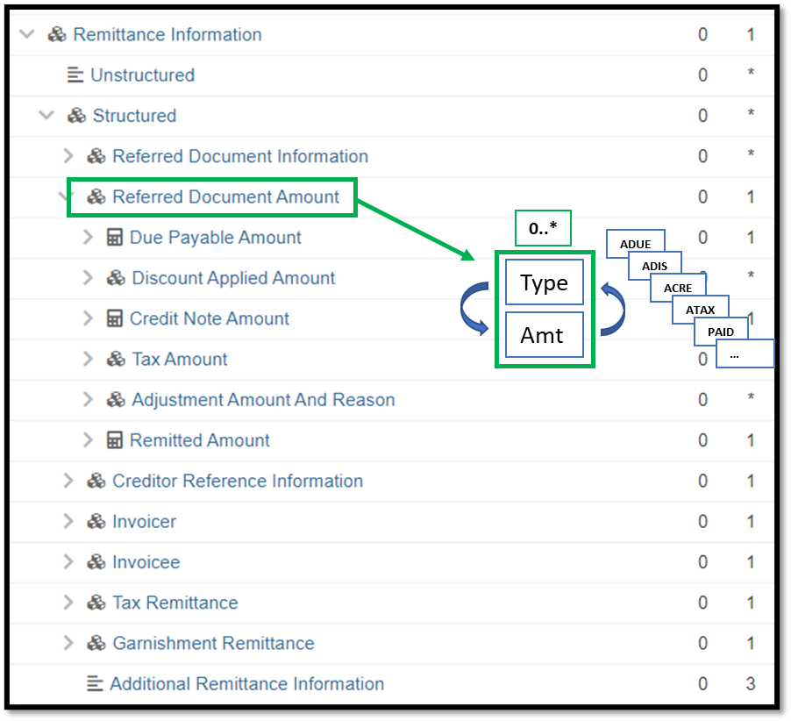

- Purpose of the change:
The change will enable a more flexible inclusion of the different amounts needed to communicate for use cases beyond the more traditional invoice bill payment use case.

- Urgency of the request:
Request to include the change in the current maintenance cycle.

- Business examples:
See above.

- SEG/TSG recommendation:
This section is not to be taken care of by the submitter of the change request. It will be completed in due time by the SEG(s) in charge of the related ISO 20022 messages or the TSG for changes related to the BAH.

Consider |  | X | Timing
 |  |  | - Next yearly cycle: 2023/2024  (the change will be considered for implementation in the yearly maintenance cycle which starts in 2021 and completes with the publication of new message versions in the spring of 2024) |  | X
- At the occasion of the next maintenance of the messages
(the change will be considered for implementation, but does not justify maintenance of the messages in its own right – will be pending until more critical change requests are received for the messages)
- Urgent unscheduled
(the change justifies an urgent implementation outside of the normal yearly cycle)
 |  |  | - Other timing:
Comments:

Reject
Reason for rejection:

