Change Request
for the update of ISO 20022 financial repository items

- Origin of the request:
A.1 Submitter:
Federal Reserve Bank of New York (on behalf of the US Federal Reserve Banks)
33 Liberty Street
New York, NY 10045
U.S.A.
A.2 Contact person:
Federal Reserve Bank of New York
Mr. Frank Van Driessche (frank.vandriessche@ny.frb.org)
A.3 Sponsors:
-
- Related messages:
pain.013 – Creditor Payment Activation Request (aka Request for Payment)
Further impact: all messages with StructuredRemittanceInformation17 component, e.g., pain.001, pacs.008, pacs.009, etc.

- Description of the change requests:
- Externalize the codes of the Type/Code element in Referred Document Information component (Referred Document Information/Type/CodeOrProprietary/Code).
- Externalize the codes of the Type/Code element in Creditor Reference Information component (CreditorReferenceInformation/Type/CodeOrProprietary/Code)
Graphic for information purposes.
- 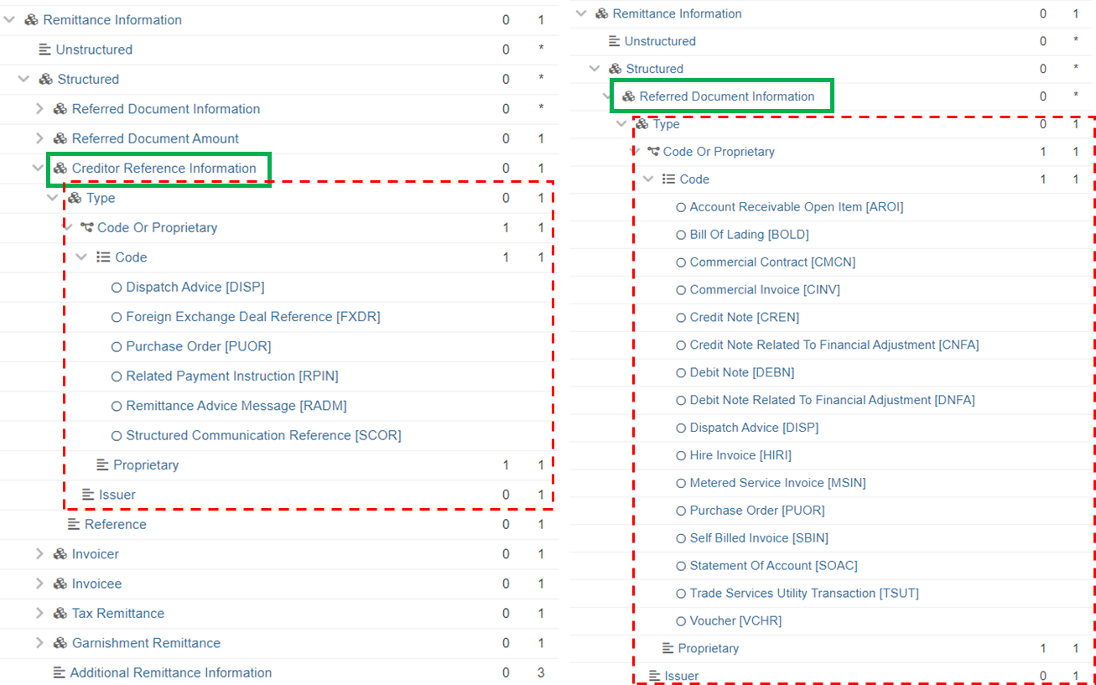

- Purpose of the change:
By now most of the codes across ISO 20022 (payment) message have been externalized for increased flexibility in updating/adding codes to lists without impact on the message xsds.
The code lists mentioned under Section C are still embedded in the schema, and externalizing will offer that same flexibility of adding codes and cater for additional (request for) payment use cases through quarterly updates of externalized lists versus yearly maintenance of the message component.
Examples of use cases to be catered for: remittance information related to mortgage, bank loan, credit card payments, etc. for which no (embedded) codes are available today.

- Urgency of the request:
Request to include the change in the current maintenance cycle.

- Business examples:
See above.

- SEG/TSG recommendation:
This section is not to be taken care of by the submitter of the change request. It will be completed in due time by the SEG(s) in charge of the related ISO 20022 messages or the TSG for changes related to the BAH.

Consider |  | X | Timing
 |  |  | - Next yearly cycle: 2023/2024  (the change will be considered for implementation in the yearly maintenance cycle which starts in 2021 and completes with the publication of new message versions in the spring of 2024) |  | X
- At the occasion of the next maintenance of the messages
(the change will be considered for implementation, but does not justify maintenance of the messages in its own right – will be pending until more critical change requests are received for the messages)
- Urgent unscheduled
(the change justifies an urgent implementation outside of the normal yearly cycle)
 |  |  | - Other timing:
Comments:

Reject
Reason for rejection:

