Change Request
for the update of ISO 20022 financial repository items

- Origin of the request:
A.1 Submitter:
Federal Reserve Bank of New York (on behalf of the US Federal Reserve Banks)
33 Liberty Street
New York, NY 10045
U.S.A.
A.2 Contact person:
Federal Reserve Bank of New York
Mr. Frank Van Driessche (frank.vandriessche@ny.frb.org)
A.3 Sponsors:

- Related messages:
pain.013.001.10 – Creditor Payment Activation Request (‘Request for Payment’)
pain.014.001.10 – Creditor Payment Activation Request Status Report (‘Request for Payment Response’)

- Description of the change request:
Ease the schema restrictions in the Payment Condition (pain.013) and Payment Condition Status (pain.014) components to make conditions within the component individually independent and optional vs. jointly required (i.e., make Amount Modification Allowed, Early Payment Allowed and Guaranteed Payment Requested optional 0..1 vs. 1..1 as shown in graphic).
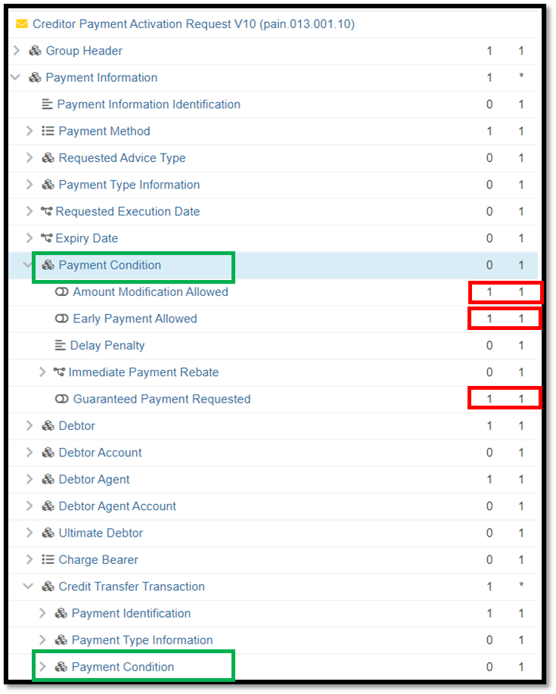

- Purpose of the change:
Offer flexibility with possible use of these conditions when specifically needed for a payment use case vs. forcing all indicators upon all users even if only one indicator is relevant for the payment use case. For example, if a biller is willing to allow payments of a different amount, then there is no reason to force that biller to indicate whether a bank guarantee is requested.

- Urgency of the request:
Request to include the change in the current maintenance cycle.

- Business examples:
See above.

- SEG/TSG recommendation:
This section is not to be taken care of by the submitter of the change request. It will be completed in due time by the SEG(s) in charge of the related ISO 20022 messages or the TSG for changes related to the BAH.

Consider |  | X | Timing
 |  |  | - Next yearly cycle: 2023/2024  (the change will be considered for implementation in the yearly maintenance cycle which starts in 2021 and completes with the publication of new message versions in the spring of 2024) |  | X
- At the occasion of the next maintenance of the messages
(the change will be considered for implementation, but does not justify maintenance of the messages in its own right – will be pending until more critical change requests are received for the messages)
- Urgent unscheduled
(the change justifies an urgent implementation outside of the normal yearly cycle)
 |  |  | - Other timing:
Comments:

Reject
Reason for rejection:

