Change Request
for the update of ISO 20022 financial repository items

- Origin of the request:
A.1 Submitter:
Federal Reserve Bank of New York (on behalf of the US Federal Reserve Banks)
33 Liberty Street
New York, NY 10045
U.S.A.
A.2 Contact person:
Federal Reserve Bank of New York
Mr. Frank Van Driessche (frank.vandriessche@ny.frb.org)
A.3 Sponsors:

- Related messages:
pain.013.001.10 – Creditor Payment Activation Request (‘Request for Payment’)

- Description of the change request:
Request to add a Sequence Type to the Payment Type Information component (at both levels in the pain.013 message where the component occurs) to indicate the frequency / recurrence of a request for payment (RFP) as shown in the below graphic.
Possible values to be aligned with SequenceType3Code values (recurring, first, final, one-off, re-presented).

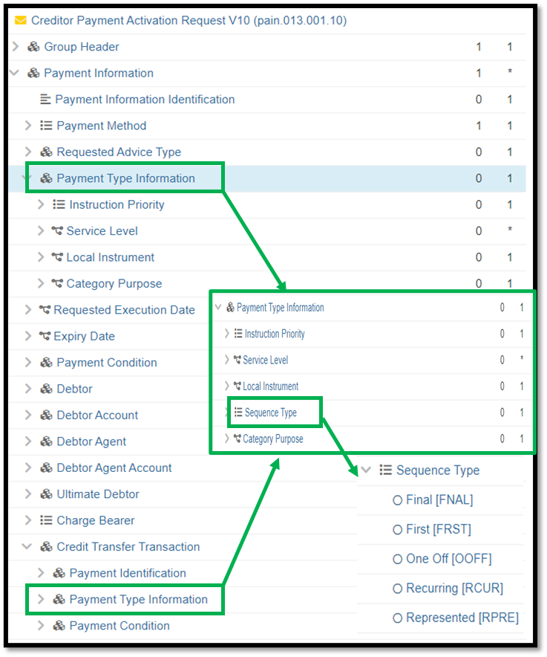

- Purpose of the change:
Very similar to direct debits, (agreement around) billing via RFP may be a one-off occasion or an invoice/service may be billed via a series of recurring RFPs. Having the frequency indicator will enable the receiving FIs to optimize/automate processing and response mechanisms.

- Urgency of the request:
Request to include the change in the current maintenance cycle.

- Business examples:
See above.

- SEG/TSG recommendation:
This section is not to be taken care of by the submitter of the change request. It will be completed in due time by the SEG(s) in charge of the related ISO 20022 messages or the TSG for changes related to the BAH.

Consider |  | X | Timing
 |  |  | - Next yearly cycle: 2023/2024  (the change will be considered for implementation in the yearly maintenance cycle which starts in 2021 and completes with the publication of new message versions in the spring of 2024) |  | X
- At the occasion of the next maintenance of the messages
(the change will be considered for implementation, but does not justify maintenance of the messages in its own right – will be pending until more critical change requests are received for the messages)
- Urgent unscheduled
(the change justifies an urgent implementation outside of the normal yearly cycle)
 |  |  | - Other timing:
Comments:

Reject
Reason for rejection:

