Change Request
for the update of ISO 20022 financial repository items

- Origin of the request:
A.1 Submitter:
Federal Reserve Bank of New York (on behalf of the US Federal Reserve Banks)
33 Liberty Street
New York, NY 10045
U.S.A.
A.2 Contact person:
Federal Reserve Bank of New York
Mr. Frank Van Driessche (frank.vandriessche@ny.frb.org)
A.3 Sponsors:

- Related messages:
pain.013.001.10 – Creditor Payment Activation Request (‘Request for Payment’)
Potential impact on all other messages where Party Identification / Contact Details component is used.

- Description of the change request:
Request to add a URL option to the Contact Details component (in this case to the Creditor element) to inform how to contact a creditor/biller customer department online, e.g., through chat function.
As shown in the graphic below this could be achieved by either explicitly adding a URL option to the currently present methods like email, mobile, fax, or by enhancing the Identification element under the Other channel method (currently restricted to Max128Text).
If added as a result also the Preferred Method would need to have the online option.

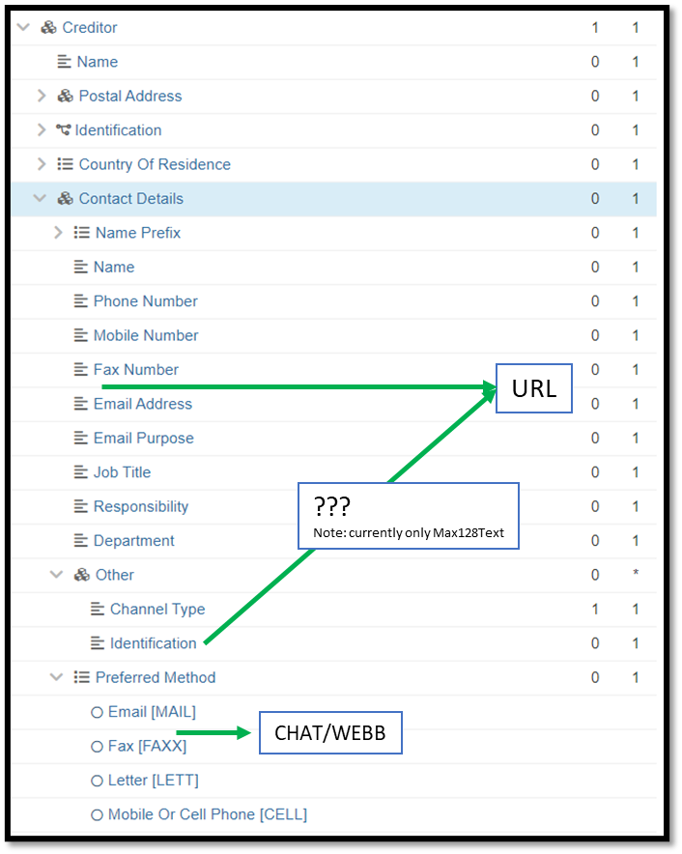

- Purpose of the change:
Enable customers to reach biller customer support through chat.

- Urgency of the request:
Request to include the change in the current maintenance cycle.

- Business examples:
See above.

- SEG/TSG recommendation:
This section is not to be taken care of by the submitter of the change request. It will be completed in due time by the SEG(s) in charge of the related ISO 20022 messages or the TSG for changes related to the BAH.

Consider |  | X | Timing
 |  |  | - Next yearly cycle: 2023/2024  (the change will be considered for implementation in the yearly maintenance cycle which starts in 2021 and completes with the publication of new message versions in the spring of 2024) |  | X
- At the occasion of the next maintenance of the messages
(the change will be considered for implementation, but does not justify maintenance of the messages in its own right – will be pending until more critical change requests are received for the messages)
- Urgent unscheduled
(the change justifies an urgent implementation outside of the normal yearly cycle)
 |  |  | - Other timing:
Comments:

Reject
Reason for rejection:

