Change Request
for the update of ISO 20022 financial repository items
Note: the purpose of this document is to give guidelines to parties who want to introduce a request to change an existing ISO 20022 message(s), or update other items of the ISO 20022 financial repository. Such change requests are subject to the approval of the ISO 20022 Standards Evaluation Group(s) in charge of the related message/item or to the approval of the Technical Support Group (TSG), if the requested change relates to the Business Application Header (BAH). Please consult the iso20022.org website for additional details on the maintenance process. Change requests are to be sent to iso20022ra@iso20022.org. All change requests conforming to this template received by June 1st will be considered for development in the following yearly ISO 20022 maintenance cycle which completes with publication of new message versions in April/May of the following year.
- Origin of the request:
A.1 Submitter: identity of the company, organization, group, initiative or community that submits the change request.

Bank of England,
Threadneedle St, London, EC2R 8AH
United Kingdom

A.2 Contact person: person(s) who can be contacted to get additional information on the request (name, e-mail, telephone)

Helen Bygrave helen.bygrave@bankofengland.co.uk

A.3 Sponsors: it is highly recommended that a submitter of a Change Request gain the agreement and support from as many additional organisations, groups, initiatives or communities of users as possible, thus demonstrating as wide as possible a consultation of the relevant stakeholders. All organisations, groups, initiatives or communities supporting the change request should be identified as sponsors along with a contact person, if possible. This community involvement is intended to help avoid delays and/or subsequent amendments to the change request.

- Related messages:
The list of ISO 20022 messages which would be impacted by the change, including the Message IDs as shown in the Catalogue of ISO 20022 messages. Only the latest version of a message definition can be maintained.
The submitter is invited to carefully examine whether the change may have an impact on other messages that come into play earlier or later in the transaction chain or on other messages that also use message components that this change request may impact.
camt.011.001.07 ModifyLimitV07
We do not believe that any other related camt messages should be impacted by this change.

- Description of the change request:
A specific change request form must be completed for each particular change requested (for example, adding, deleting, modifying, renaming, changing the cardinality, moving an element/component, or changing the type of an element, changing a code set).
If the change request consists, for example, of adding new functionality which requires several changes which would not make sense if not performed all together, then all these related changes should be described on the same form.
Change requests may not lead to creation of new messages. In such cases, a 'business justification' for development of new candidate ISO 20022 messages must be introduced by a submitting organization that is ready to develop the new messages.

Following the recommendation of the Pay SEG on September 12th 2022 the submitter would like to request the following change to the camt.011 Modify Limit message.
Optionally include at the same level as message component <New Limit Value Set>, the difference between the previous amount of money of the limit and the new amount of money of the limit. The new message component should be named <Increase Decrease Amount>.
In addition to the above, the Pay SEG requested a new optional message component <Old Limit Value> to carry the previous amount of money of the limit. <Old Limit Value> should also be at the same level as <New Limit Value Set>.
A rule should also be implemented to ensure that <Old Limit Value> and <Increase Decrease Amount> are mutually exclusive.

- Purpose of the change:
Background, business context, community of users interested by the change and expected benefits/savings.
This section must explain why the existing ISO 20022 messages need to be changed. The reason for the update may be a business reason (e.g., evolution of market practice, or creation of new financial instruments), a technical reason (e.g., automation of the business process, or switch from a batch to a real time process), a regulatory reason (introduction, generally mandatory, of new rule/law) or the extension of the user community (newly identified business requirements).

The Bank of England (BoE) provides a deferred net settlement (DNS) service which is moving to ISO 20022 from a proprietary MT format.
This DNS service simultaneously settles net obligations arising from customer transactions built up over time between participants. Transactions are recorded by a Scheme Operator on an ongoing basis and then at regular intervals netted off and sent to the BoE for simultaneous settlement.
Each Scheme participant has an account at the BoE used to settle these obligations. The Scheme participant can increase or decrease the limit on this account. To do this, the participant will send a camt.011 modify limit message to the BoE settlement service. The BoE will then forward this to the Scheme Operator to notify them of the amount of the new limit requested. The Scheme Operator will then accept or reject the limit modification using a camt.025 Receipt. If accepted the BoE will change the limit. If rejected, the limit remains the same as it was prior to the modify limit request.

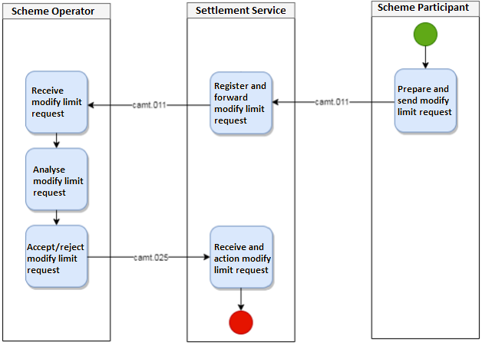

The camt.011 allows the BoE to send the amount of the new limit, but for the Scheme Operator to reconcile in all scenarios, they also need to know the difference between that new limit and the old limit. The Scheme Operator cannot in all scenarios reliably calculate this difference based on their record of the previous limit in their system and the new limit in the camt.011. It is critical for financial stability that the BoE and the Scheme Operator agree at all times on both what the change in limit is and what the new limit is.
ISO 20022 provides five camt messages to create, request, return, modify and delete the limit set on an account. These messages are the camt.101, camt.009, 010,011 and 012 respectively.
On reviewing the camt messages, the BoE has not identified a suitable message that could carry this change in limit and believes it is best placed in the camt.011 with the limit itself. Therefore, when a modify limit message is sent, it will include the new limit and optionally either the difference between that new limit and the old limit OR the old limit.

Additional Information
Why does the DNS Scheme Operator need the BoE to send the difference between the old limit and the new limit as well as the balance?
In the situation where the Scheme Operator sends the BoE a net settlement request at nearly the same time as the BoE sends the Operator a modify limit request, the DNS Scheme operator can't tell if the balance in the modify limit request is the balance before or after the settlement without the change also being provided. They need to know whether the balance was the result of an increase and by how much, or a decrease and by how much.

- Urgency of the request:
Next yearly cycle: 2023/2024.

- Business examples:
Examples illustrating the change request.
The ISO 20022 repository contains the message component Amount1Choice (used in tsrv.004.001.01 UndertakingAmendmentRequestV01) which provides all the elements required to convey an increase or decrease in limit.

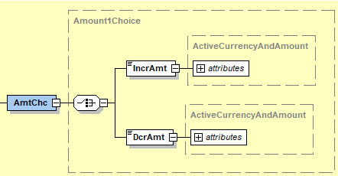

However, the IncrAmt and DcrAmt sub components of Amount1Choice only allow amount with currency. The PaySEG recommended that this be extended to include both amount with currency and amount without currency. Therefore, a new message component Amount4Choice (see diagram below – IncrDcrAmt) has been created to meet this requirement.
Old Limit Value (see diagram below – OdLmtVal) reuses the existing New Limit Value Set datatype, Limit8.

Diagram shows proposed structure for the new message component.
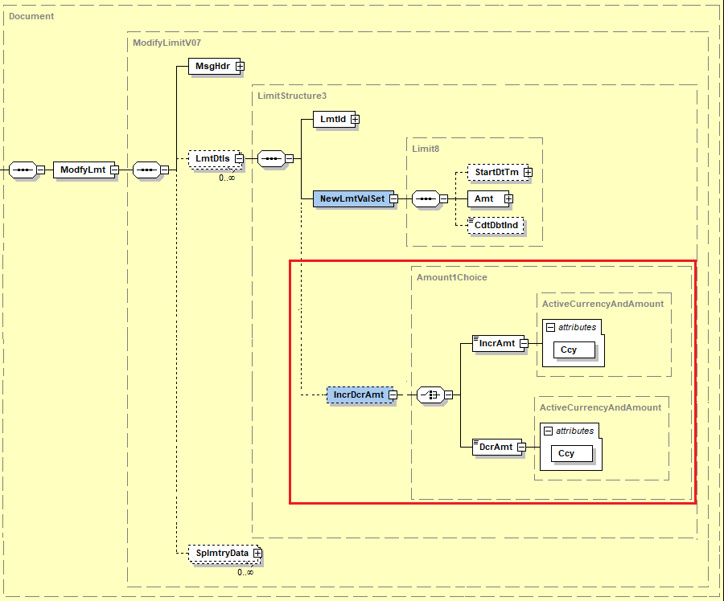
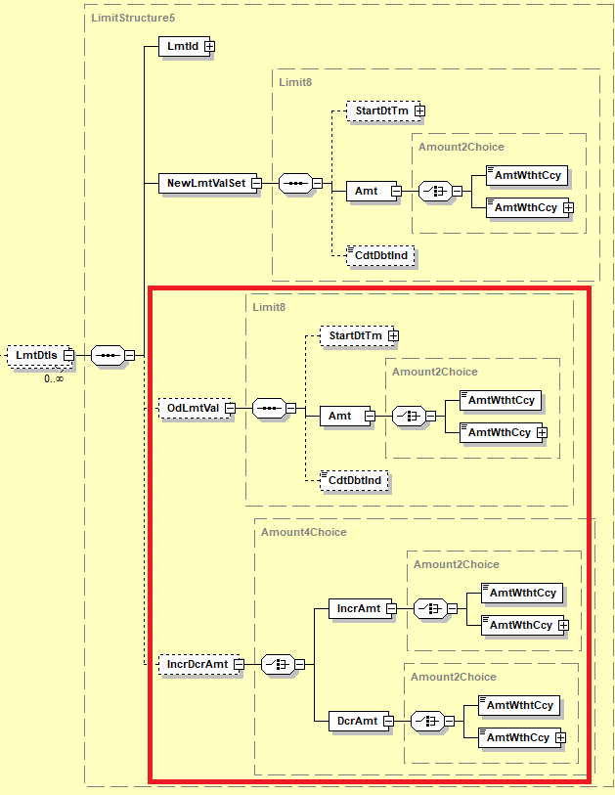
Diagram shows the proposed ModifyLimitV08 message structure within the Standards Editor
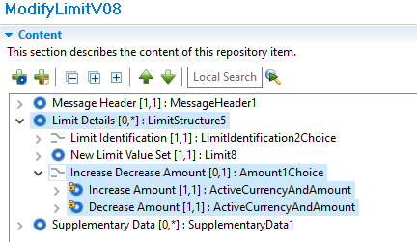

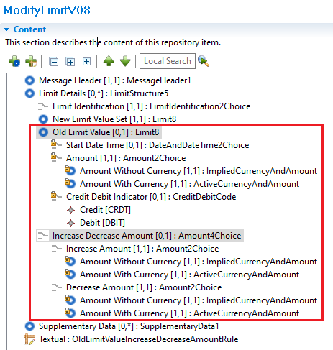

Diagram shows the mutually exclusive constraint applied to OldLimitValue and IncreaseDecreaseAmount
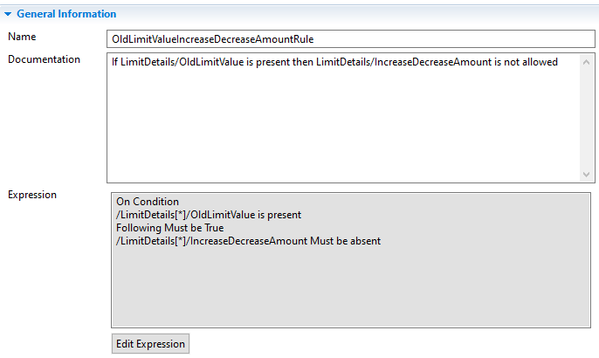
Example XML
Example 1 requesting the value of limit for account 72604168 to be set at 100 and indicating that the difference between the old limit and this new limit is an increase of 25

<Document>
<ModfyLmt>
<MsgHdr>
<MsgId>GBGS33HKRQSYYMCA</MsgId>
<CreDtTm>2021-11-05T15:08:59.026+00:00</CreDtTm>
</MsgHdr>
<LmtDtls>
<LmtId>
<Cur>
<Tp>
<Cd>MULT</Cd>
</Tp>
<AcctId>
<Othr>
<Id>72604168</Id>

</Othr>
</AcctId>
</Cur>
</LmtId>
<NewLmtValSet>
<Amt>
<AmtWthtCcy>100</AmtWthtCcy>
</Amt>
</NewLmtValSet>
<IncrDcrAmt>
<IncrAmt>
<AmtWthtCcy>25</AmtWthtCcy>
</IncrAmt>
</IncrDcrAmt>
</LmtDtls>
</ModfyLmt>
</Document>

Example 2 requesting the value of limit for account 72604168 to be set at 70 and indicating that the difference between the old limit and this new limit is a decrease of 30.

<Document>
<ModfyLmt>
<MsgHdr>
<MsgId>GBGS33HKRQSYYMCA</MsgId>
<CreDtTm>2021-11-05T15:08:59.026+00:00</CreDtTm>
</MsgHdr>
<LmtDtls>
<LmtId>
<Cur>
<Tp>
<Cd>MULT</Cd>
</Tp>
<AcctId>
<Othr>
<Id>72604168</Id>

</Othr>
</AcctId>
</Cur>
</LmtId>
<NewLmtValSet>
<Amt>
<AmtWthtCcy>70</AmtWthtCcy>
</Amt>
</NewLmtValSet>
<IncrDcrAmt>
<DcrAmt>
<AmtWthtCcy>30</AmtWthtCcy>
</DcrAmt>
</IncrDcrAmt>
</LmtDtls>
</ModfyLmt>
</Document>
Example 3 requesting the value of limit for account 72604168 to be set at 100 and indicating that the old limit of the account is 40.

<Document>
<ModfyLmt>
<MsgHdr>
<MsgId>GBGS33HKRQSYYMCA</MsgId>
<CreDtTm>2021-11-05T15:08:59.026+00:00</CreDtTm>
</MsgHdr>
<LmtDtls>
<LmtId>
<Cur>
<Tp>
<Cd>MULT</Cd>
</Tp>
<AcctId>
<Othr>
<Id>72604168</Id>
</Othr>
</AcctId>
</Cur>
</LmtId>
<NewLmtValSet>
<Amt>
<AmtWthtCcy>100</AmtWthtCcy>
</Amt>
</NewLmtValSet>
<OdLmtVal>
<Amt>
<AmtWthtCcy>40</AmtWthtCcy>
</Amt>
</OdLmtVal>
</LmtDtls>
</ModfyLmt>
</Document>
- SEG/TSG recommendation:
This section is not to be taken care of by the submitter of the change request. It will be completed in due time by the SEG(s) in charge of the related ISO 20022 messages or the TSG for changes related to the BAH.

Consider |  | X | Timing
 |  |  | - Next yearly cycle: 2023/2024  (the change will be considered for implementation in the yearly maintenance cycle which starts in 2022 and completes with the publication of new message versions in the spring of 2023) |  | X
- At the occasion of the next maintenance of the messages
(the change will be considered for implementation, but does not justify maintenance of the messages in its own right – will be pending until more critical change requests are received for the messages)
- Urgent unscheduled
(the change justifies an urgent implementation outside of the normal yearly cycle)
 |  |  | - Other timing:
Comments:
CR is for the request of a new field in Modify Limit message, camt.011 update:
- Request is to add the Old Amount, using Amount1Choice reused.
- Maybe needs more flexibility, with an option to increase/ decrease and an option to provide the old amount.
- Need to implement a choice of the Amount: With Currency and Implied Currency to align with the amount fields defined in all Cash Management messages
- Proposal to also add an exclusive choice between the Delta (Increase / Decrease) and the Old Amounts.
Submitting organization to provide a reviewed implementation proposal in the MCR.

Reject
Reason for rejection:

