Maintenance Change Request
for the update of ISO 20022 financial repository items

Name of the request:
ISO 20022 Payments Maintenance 2022/2023

Submitting organisation(s):
SWIFT, on behalf of SWIFT, Bank of England, CBI, Deutsche Bundesbank (on behalf of 4CB), EPC, FFI, FFI and Tieto, GUF, IFX/OAGi, ISTH, nexo, Payments UK, RU-CMPG, SABS, T2S and TWIST

Standards Department,
Avenue Adele, 1
1310 La Hulpe – Belgium

Related messages:

Under this maintenance, below existing ISO 20022 message definitions will be maintained (resulting from the impact analysis performed on each CR)

Given the huge impact of CR942 and CR1124 change requests, we have listed the impacted messages in 2 sections:
- Messages impacted by the CRs excluding CR942 and CR1124
- Messages impacted when CR942 and CR1124 are approved to be implemented for this maintenance cycle. SWIFT proposes to postpone those implementations at a later maintenance cycle (see rationale in CRs)

C.1 Impact on messages except CR942 and CR1124

Message sets impacted under responsibility of SWIFT:
Cash Management message set:

camt.005.001.09 | GetTransactionV09
camt.006.001.09 | ReturnTransactionV09
camt.007.001.08 | ModifyTransactionV08
camt.008.001.09 | CancelTransactionV09
camt.025.001.05 | ReceiptV05
camt.046.001.06 | GetReservationV06
camt.029.001.09 | ResolutionOfInvestigationV09
camt.029.001.11 | ResolutionOfInvestigationV11

Bank-to-Customer Cash Management message set:

camt.052.001.10 | BankToCustomerAccountReportV10
camt.053.001.10 | BankToCustomerStatementV10
camt.054.001.10 | BankToCustomerDebitCreditNotificationV10

Payments, Clearing and Settlement message set:

pacs.002.001.12 | FIToFIPaymentStatusReportV12
pacs.003.001.09 | FIToFICustomerDirectDebitV09
pacs.004.001.11 | PaymentReturnV11
pacs.007.001.11 | FIToFIPaymentReversalV11
pacs.008.001.10 | FIToFICustomerCreditTransferV10

Payments Initiation message set:

pain.002.001.12 | CustomerPaymentStatusReportV12

Message sets impacted not under responsibility of SWIFT:
Please note that not all message sets are under the responsibility of SWIFT, and the RA will contact the original submitting organisation of those messages set to confirm they intend to implement the changes in their respective message sets.
For those message sets, SWIFT cannot guarantee the submitting organisations will agree to implement the changes.

Creditor Payment Activation Request message set (under the responsibility of CBI):

pain.013.001.09 | CreditorPaymentActivationRequestV09
pain.014.001.09 | CreditorPaymentActivationRequestStatusReportV09

Note: SWIFT will implement the changes on behalf of CBI for this message set, if accepted.

C.1 Impact on messages including CR942 and CR1124

Should CR0942 and CR1124 be approved under this maintenance, below existing ISO 20022 message definitions will be maintained (resulting from the impact analysis performed on each CR).

Message sets impacted under responsibility of SWIFT:
Bank Account Management message set:

acmt.007.001.04 | AccountOpeningRequestV04
acmt.008.001.04 | AccountOpeningAmendmentRequestV04
acmt.009.001.03 | AccountOpeningAdditionalInformationRequestV03
acmt.010.001.03 | AccountRequestAcknowledgementV03
acmt.011.001.03 | AccountRequestRejectionV03
acmt.012.001.03 | AccountAdditionalInformationRequestV03
acmt.013.001.03 | AccountReportRequestV03
acmt.014.001.04 | AccountReportV04
acmt.015.001.03 | AccountExcludedMandateMaintenanceRequestV03
acmt.016.001.03 | AccountExcludedMandateMaintenanceAmendmentRequestV03
acmt.017.001.03 | AccountMandateMaintenanceRequestV03
acmt.018.001.03 | AccountMandateMaintenanceAmendmentRequestV03
acmt.019.001.03 | AccountClosingRequestV03
acmt.020.001.03 | AccountClosingAmendmentRequestV03
acmt.021.001.03 | AccountClosingAdditionalInformationRequestV03
Cash Management message Set:

camt.003.001.07 | GetAccountV07
camt.004.001.09 | ReturnAccountV09
camt.005.001.09 | GetTransactionV09
camt.006.001.09 | ReturnTransactionV09
camt.007.001.08 | ModifyTransactionV08
camt.007.002.03 | RequestToModifyPaymentV03
camt.008.001.09 | CancelTransactionV09
camt.009.001.07 | GetLimitV07
camt.010.001.08 | ReturnLimitV08
camt.011.001.07 | ModifyLimitV07
camt.012.001.07 | DeleteLimitV07
camt.024.001.07 | ModifyStandingOrderV07
camt.025.001.05 | ReceiptV05
camt.046.001.06 | GetReservationV06
camt.047.001.07 | ReturnReservationV07
camt.048.001.06 | ModifyReservationV06
camt.049.001.06 | DeleteReservationV06
camt.050.001.06 | LiquidityCreditTransferV06
camt.051.001.06 | LiquidityDebitTransferV06
camt.069.001.04 | GetStandingOrderV04
camt.070.001.05 | ReturnStandingOrderV05
camt.071.001.04 | DeleteStandingOrderV04
camt.101.001.01 | CreateLimitV01
camt.102.001.02 | CreateStandingOrderV02
camt.103.001.02 | CreateReservationV02
Exceptions and Investigations message Set:

camt.026.001.09 | UnableToApplyV09
camt.027.001.09 | ClaimNonReceiptV09
camt.028.001.11 | AdditionalPaymentInformationV11
camt.029.001.09 | ResolutionOfInvestigationV09
camt.029.001.11 | ResolutionOfInvestigationV11
camt.030.001.05 | NotificationOfCaseAssignmentV05
camt.031.001.06 | RejectInvestigationV06
camt.032.001.04 | CancelCaseAssignmentV04
camt.033.001.06 | RequestForDuplicateV06
camt.034.001.06 | DuplicateV06
camt.035.001.05 | ProprietaryFormatInvestigationV05
camt.036.001.05 | DebitAuthorisationResponseV05
camt.037.001.09 | DebitAuthorisationRequestV09
camt.038.001.04 | CaseStatusReportRequestV04
camt.039.001.05 | CaseStatusReportV05
camt.055.001.11 | CustomerPaymentCancellationRequestV11
camt.056.001.10 | FIToFIPaymentCancellationRequestV10
camt.087.001.08 | RequestToModifyPaymentV08
Notification to Receive message Set:

camt.057.001.07 | NotificationToReceiveV07
camt.058.001.08 | NotificationToReceiveCancellationAdviceV08
camt.059.001.07 | NotificationToReceiveStatusReportV07

Cash Management – Charges Management message Set:

camt.105.001.01 | ChargesPaymentNotificationV01
camt.106.001.01 | ChargesPaymentRequestV01
Cash Management – Cheques Management message Set:

camt.107.001.01 | ChequePresentmentNotificationV01
camt.108.001.01 | ChequeCancellationOrStopRequestV01
camt.109.001.01 | ChequeCancellationOrStopReportV01
Business Application Header message Set:

head.001.001.03 | BusinessApplicationHeaderV03
Payments, Clearing and Settlement message Set:

pacs.002.001.12 | FIToFIPaymentStatusReportV12
pacs.003.001.09 | FIToFICustomerDirectDebitV09
pacs.004.001.11 | PaymentReturnV11
pacs.007.001.11 | FIToFIPaymentReversalV11
pacs.008.001.10 | FIToFICustomerCreditTransferV10
pacs.009.001.10 | FinancialInstitutionCreditTransferV10
pacs.010.001.05 | FinancialInstitutionDirectDebitV05
pacs.028.001.05 | FIToFIPaymentStatusRequestV05
Payments Initiation message set:

pain.001.001.11 | CustomerCreditTransferInitiationV11
pain.002.001.12 | CustomerPaymentStatusReportV12
pain.007.001.11 | CustomerPaymentReversalV11
pain.008.001.10 | CustomerDirectDebitInitiationV10

Payments Mandates message Set:

pain.009.001.07 | MandateInitiationRequestV07
pain.010.001.07 | MandateAmendmentRequestV07
pain.011.001.07 | MandateCancellationRequestV07
pain.012.001.07 | MandateAcceptanceReportV07
pain.017.001.03 | MandateCopyRequestV03
pain.018.001.03 | MandateSuspensionRequestV03
Bank-to-Customer Cash Management message set:

camt.052.001.10 | BankToCustomerAccountReportV10
camt.053.001.10 | BankToCustomerStatementV10
camt.054.001.10 | BankToCustomerDebitCreditNotificationV10
camt.060.001.06 | AccountReportingRequestV06
Bank Services Billing message set:

camt.086.001.04 | BankServicesBillingStatementV04

Message sets impacted not under responsibility of SWIFT:
Please note that not all message sets are under the responsibility of SWIFT, and the RA will contact the original submitting organisation of those messages set to confirm they intend to implement the changes in their respective message sets.
For those message sets, SWIFT cannot guarantee the submitting organisations will agree to implement the changes.

Change or Verify Account Identification message set (under the responsibility of GUF):

acmt.022.001.03 | IdentificationModificationAdviceV03
acmt.023.001.03 | IdentificationVerificationRequestV03
acmt.024.001.03 | IdentificationVerificationReportV03

Note: SWIFT will implement the changes on behalf of GUF for this message set, if accepted.

Account Switching message set (under the responsibility of Payments UK):

acmt.027.001.04 | AccountSwitchInformationRequestV04
acmt.028.001.04 | AccountSwitchInformationResponseV04
acmt.029.001.04 | AccountSwitchCancelExistingPaymentV04
acmt.030.001.03 | AccountSwitchRequestRedirectionV03
acmt.031.001.04 | AccountSwitchRequestBalanceTransferV04
acmt.032.001.04 | AccountSwitchBalanceTransferAcknowledgementV04
acmt.034.001.04 | AccountSwitchRequestPaymentV04

Note: SWIFT will implement the changes on behalf of Payments UK for this message set, if accepted.

Target2-Securities message set (under the responsibility of T2S):

admi.005.001.01 | ReportQueryRequestV01
camt.066.001.01 | IntraBalanceMovementInstructionV01
camt.067.001.01 | IntraBalanceMovementStatusAdviceV01
camt.068.001.01 | IntraBalanceMovementConfirmationV01
camt.072.001.01 | IntraBalanceMovementModificationRequestV01
camt.073.001.01 | IntraBalanceMovementModificationRequestStatusAdviceV01
camt.074.001.01 | IntraBalanceMovementCancellationRequestV01
camt.075.001.01 | IntraBalanceMovementCancellationRequestStatusAdviceV01
camt.078.001.01 | IntraBalanceMovementQueryV01
camt.079.001.01 | IntraBalanceMovementQueryResponseV01
camt.080.001.01 | IntraBalanceMovementModificationQueryV01
camt.081.001.01 | IntraBalanceMovementModificationReportV01
camt.082.001.01 | IntraBalanceMovementCancellationQueryV01
camt.083.001.01 | IntraBalanceMovementCancellationReportV01
camt.084.001.01 | IntraBalanceMovementPostingReportV01
camt.085.001.01 | IntraBalanceMovementPendingReportV01
colr.001.001.01 | CollateralValueQueryV01
colr.002.001.01 | CollateralValueReportV01
Authorities Financial Investigations message set (under the responsibility of FFI):

auth.002.001.01 | InformationRequestResponseV01

Cross-Border Transactions Currency Control Reporting message set (under the responsibility of RU-CMPG):

auth.018.001.03 | ContractRegistrationRequestV03
auth.019.001.03 | ContractRegistrationConfirmationV03
auth.020.001.03 | ContractRegistrationClosureRequestV03
auth.021.001.03 | ContractRegistrationAmendmentRequestV03
auth.022.001.03 | ContractRegistrationStatementV03
auth.023.001.03 | ContractRegistrationStatementRequestV03
auth.024.001.03 | PaymentRegulatoryInformationNotificationV03
auth.025.001.03 | CurrencyControlSupportingDocumentDeliveryV03
auth.026.001.03 | CurrencyControlRequestOrLetterV03
auth.027.001.03 | CurrencyControlStatusAdviceV03

Multilateral Settlement message set (under the responsibility of Bank of England):

pacs.029.001.01 | MultilateralSettlementRequestV01

Creditor Payment Activation Request message set (under the responsibility of CBI):

pain.013.001.09 | CreditorPaymentActivationRequestV09
pain.014.001.09 | CreditorPaymentActivationRequestStatusReportV09

Note: SWIFT will implement the changes on behalf of CBI for this message set, if accepted.

Request To Pay -RTP- Service message set (under the responsibility of EPC):

reda.066.001.01 | RequestToPayCreditorEnrolmentRequestV01
reda.067.001.01 | RequestToPayCreditorEnrolmentAmendmentRequestV01
reda.068.001.01 | RequestToPayCreditorEnrolmentCancellationRequestV01
reda.069.001.01 | RequestToPayCreditorEnrolmentStatusReportV01
reda.070.001.01 | RequestToPayDebtorActivationRequestV01
reda.071.001.01 | RequestToPayDebtorActivationAmendmentRequestV01
reda.072.001.01 | RequestToPayDebtorActivationCancellationRequestV01
reda.073.001.01 | RequestToPayDebtorActivationStatusReportV01

Note: SWIFT will implement the changes on behalf of EPC for this message set, if accepted.

Stand-Alone Remittance Advice message set (under the responsibility of IFX/OAGi):

remt.001.001.05 | RemittanceAdviceV05
remt.002.001.02 | RemittanceLocationAdviceV02

Note: SWIFT will implement the changes on behalf of IFX/OAGi for this message set, if accepted.

SWIFT has already received following information for the maintenance of some of the message sets as following:
- Target2-Securities messages – as the messages have just been finalised recently and no major release is planned for T2S, the change requests will be held over and will only be implemented when new changes are required based on new T2S business requirements, as no change request addresses explicitly the Target2-Securities message sets.

On top of the above messages, we identified an impact as well on following message sets outside of the Payments SEG responsibility and domain, with a total of 39 additional messages impacted (details of the messages have not been provided here):
- Message sets under the responsibility of the Securities SEG as following:
  - Settlement And Reconciliation
- Message sets under the responsibility of the Trade Services SEG as following:
  - Demand Guarantees and Standby Letters of Credit
  - Factoring Services
  - Financial Invoice
  - Invoice Tax Report
- Message sets under the responsibility of the Cards SEG as following:
  - Acceptor to Acquirer Card Transaction

Commitments of the submitting organisation:

The submitting organisations confirm that they can and will:
- undertake the development of the new version of the candidate ISO 20022 message models that it will submit to the RA for compliance review and evaluation. New valid Message Definition models will be made available to the RA by December 1.
- provide a new version of part 1 of the related Message Definition Reports (MDR) by December 1, and new examples of valid message instances of each candidate message (only when valid samples were published for current version) by May 1 at the latest.
- address any queries related to the description of the new models and messages as published by the RA on the ISO 20022 website.

SWIFT intends to implement most of the above new versions on its SWIFTNet network once the related documentation has been published by the RA.

The submitting organisations confirm their knowledge and acceptance of the ISO 20022 Intellectual Property Rights policy for contributing organisations, as follows.
“Organisations that contribute information to be incorporated into the ISO 20022 Repository shall keep any Intellectual Property Rights (IPR) they have on this information. A contributing organisation warrants that it has sufficient rights on the contributed information to have it published in the ISO 20022 Repository through the ISO 20022 Registration Authority in accordance with the rules set in ISO 20022. To ascertain a widespread, public and uniform use of the ISO 20022 Repository information, the contributing organisation grants third parties a non-exclusive, royalty-free license to use the published information”.

Contact persons:
Dean Chard – SWIFT Standards, dean.chard@swift.com
Karin De Ridder – SWIFT Standards, karin.deridder@swift.com

Change request CR0942: Modify Building Name element length

Origin of the request:
A.1 Submitter:
- CFONB, Comité Français d’Organisation et de Normalisation Bancaires (French Committee for Banking Organisation and Normalisation),
- GUF, Groupement des Utilisateurs de SWIFT en France (French SWIFT Members and Users Group).

A.2 Contact person: person(s) who can be contacted to get additional information on the request (name, e-mail, telephone)
Laurent LAFEUILLADE laurent.lafeuillade@socgen.com +33 1 42 14 66 70
Sylvain DAUGE Sylvain.Dauge@socgen.com +33 1 58 98 94 16
Rocco ZIRPOLI Rocco.Zirpoli@caissedesdepots.fr +33 1 58 50 19 50
A.3 Sponsors:
French mail institution, “La Poste”, which has written the postal address standard NF Z 10-011, used in France and in French Territories, made available to all users around the world through the UPU.

Related messages:
All ISO20022 messages using the Postal Address <PstlAdr> element.

Description of the change request:
We are requesting the extension of the length of the BuildingName element to more than 35c.
We ask you for advice on alignment with the length of the Floor element, i.e. 70c.

Purpose of the change:
We request to bring closer the lengths of the elements BuildingName (at 35c) and Floor (at 70c). We are looking for consistency between these elements.
The objective of this Change Request is to allow the BuildingName element to be filled by a French postal address, without truncation and thus ensuring its conformity with the French postal standard, while avoiding an induced loss of data.
Failing that, additional information could be filled in the Floor element only, by keeping the BuildingName element unused, but this is not desirable, in order to keep and store this data in its appropriate information category.

Urgency of the request:
End November 2022 for a usage in 2023.

Business examples:
You will find, herebelow, the summary of Universal Post Union element description of French addresses and some examples of French addresses, for both physical persons and companies, impacted by this issue.
The Examples illustrate the difficulty to fill, with the Line 2 from the French Postal Standard, the ISO20022 BuildingName element, for both physical persons and companies:

“Line 2” from French Postal Standard (38c) | “Building Name” Tag (35c)
“Zone industrielle de la Ballastrierre” | “Zone industrielle de la Ballastrier”
“Résidence des Capucins Bâtiment Quater” | “Résidence des Capucins Bâtiment Qua”
“Chez Mme COPPÉ Porte A Bâtiment Cerise” | “Chez Mme COPPÉ Porte A Bâtiment Cer”

FR | France
Summary Corporate Address
Level | ISO20022 tag | Element description | DataType | Universal Post Union (UPU) element description of French addresses |  | DataType
2 | <Dbtr> | Debtor
3 | <Nm> | Name |  |  | corporate name
3 | <PstlAdr> | Postal Address
4 | <Dept> | Department | Max70Text | Line 2 | Unit, addressee | Max 38
4 | <SubDept> | Sub Department | Max70Text | Line 2 | Unit, addressee | Max 38
4 | <StrtNm> | Street Name | Max70Text | Line 4 | house number and street name (= max 38 characters for the line) | 32
4 | <BldgNb> | Building Number | Max16Text |  |  | 5+1
4 | <BldgNm> | Building Name | Max35Text | Line 3 | additional geographical information (this line contains also the "Room" information) | Max 38
4 | <Flr> | Floor | Max70Text | Line 3 |  | Max 38
4 | <PstBx> | Post Box | Max16Text | Line 5 | PO box number (this line contains also the "Town Location Name" information) | Max 38
4 | <Room> | Room | Max70Text | Line 3 | additional geographical information  ==> Refers also to ISO 20022 elements "Building Name" and "Floor"
4 | <PstCd> | Post Code | Max16Text | Line 6 | postcode and CEDEX delivery office (= max 38 characters for the line) | 5+1
4 | <TwnNm> | Town Name | Max35Text |  |  | 32
4 | <TwnLctnNm> | Town Location Name | Max35Text | Line 5 | locality (only if geographical locality differs from CEDEX delivery office)  ==> Refers also to ISO 20022 element "Post Box"
4 | <DstrctNm> | District Name | Max35Text |  | Not used in French addresses
4 | <CtrySubDvsn> | Country Sub Division | Max35Text |  | Not used in French addresses
4 | <Ctry> | Country | Code2Text | Line 7 | COUNTRY | Max 38
Summary Private individual
Level | ISO20022 tag | Element description | DataType | Universal Post Union (UPU) element description of French addresses |  | DataType
2 | <Dbtr> | Debtor
3 | <Nm> | Name |  |  | Name
3 | <PstlAdr> | Postal Address
4 | <Dept> | Department | Max70Text |  | Not used in French addresses of private individuals | Max 38
4 | <SubDept> | Sub Department | Max70Text |  | Not used in French addresses of private individuals | Max 38
4 | <StrtNm> | Street Name | Max70Text | Line 4 | house number and street name (= max 38 characters for the line) | 32
4 | <BldgNb> | Building Number | Max16Text |  |  | 5+1
4 | <BldgNm> | Building Name | Max35Text | Line 3 | additional geographical information | Max 38
4 | <Flr> | Floor | Max70Text | Line 2 | additional delivery point information (This line contains also the "Room" information) | Max 38
4 | <PstBx> | Post Box | Max16Text | Line 5 | If PO BOX available
4 | <Room> | Room | Max70Text | Line 2 | additional delivery point information  ==> Refers also to ISO 20022 element "Floor" | Max 38
4 | <PstCd> | Post Code | Max16Text | Line 6 | postcode and locality (= max 38 characters for the line) | 5+1
4 | <TwnNm> | Town Name | Max35Text |  | postcode and locality (= max 38 characters for the line) | 32
4 | <TwnLctnNm> | Town Location Name | Max35Text | Line 5 | lieu-dit or hamlet name | Max 38
4 | <DstrctNm> | District Name | Max35Text |  | Not used in French addresses
4 | <CtrySubDvsn> | Country Sub Division | Max35Text |  | Not used in French addresses
4 | <Ctry> | Country | Code2Text | Line 7 | PAYS | Max 38

ISO code | Country name
FR | France
Example #1: Company 1
Level | ISO20022 tag | Element description | Universal Post Union (UPU) example | French postal elements | Recommended  ISO20022 mapping exemple | Possible  ISO20022 mapping example
2 | <Dbtr> | Debtor
3 | <Nm> | Name | DURAND SA  Service achat  Zone industrielle de la Ballastrierre  22BIS RUE DES FLEURS  BP 40122  33506 LIBOURNE CEDEX  France | DURAND SA | DURAND SA | DURAND SA
3 | <PstlAdr> | Postal Address
4 | <Dept> | Department |  | Service achat |  | Service achat
4 | <SubDept> | Sub Department |  | Service achat
4 | <StrtNm> | Street Name |  | 22BIS RUE DES FLEURS | 22BIS RUE DES FLEURS | RUE DES FLEURS
4 | <BldgNb> | Building Number |  | 22BIS RUE DES FLEURS |  | 22BIS
4 | <BldgNm> | Building Name |  | Zone industrielle de la Ballastrierre | Zone industrielle de la Ballastrierre
4 | <Flr> | Floor |  | Zone industrielle de la Ballastrierre |  | Zone industrielle de la Ballastrierre
4 | <PstBx> | Post Box |  | BP 40122 | BP 40122 | BP 40122
4 | <Room> | Room
4 | <PstCd> | Post Code |  | 33506 LIBOURNE CEDEX | 33506 | 33506
4 | <TwnNm> | Town Name |  | 33506 LIBOURNE CEDEX | LIBOURNE CEDEX | LIBOURNE CEDEX
4 | <TwnLctnNm> | Town Location Name
4 | <DstrctNm> | District Name
4 | <CtrySubDvsn> | Country Sub Division
4 | <Ctry> | Country |  | France | France | France
Example #2: Company 2
Level | ISO20022 tag | Element description | Universal Post Union element (UPU) | French postal elements | Recommended  ISO20022 mapping exemple | Possible  ISO20022 mapping example
2 | <Dbtr> | Debtor
3 | <Nm> | Name | Société DUPONT  Mademoiselle Lucie MARTIN  Résidence des Capucins Batiment Quater  56 RUE EMILE ZOLA  BP 90432 MONTFERRIER SUR LEZ  34092 MONTPELLIER CEDEX 5  France | Société DUPONT | Société DUPONT | Société DUPONT
3 | <PstlAdr> | Postal Address
4 | <Dept> | Department |  | Mademoiselle Lucie MARTIN | Mademoiselle Lucie MARTIN | Mademoiselle Lucie MARTIN
4 | <SubDept> | Sub Department |  | Mademoiselle Lucie MARTIN
4 | <StrtNm> | Street Name |  | 56 RUE EMILE ZOLA | 56 RUE EMILE ZOLA | RUE EMILE ZOLA
4 | <BldgNb> | Building Number |  | 56 RUE EMILE ZOLA |  | 56
4 | <BldgNm> | Building Name |  | Résidence des Capucins Batiment Quater | Résidence des Capucins Batiment Quater
4 | <Flr> | Floor |  | Résidence des Capucins Batiment Quater |  | Résidence des Capucins Batiment Quater
4 | <PstBx> | Post Box |  | BP 90432 | BP 90432 | BP 90432
4 | <Room> | Room
4 | <PstCd> | Post Code |  | 34092 MONTPELLIER CEDEX 5 | 34092 | 34092
4 | <TwnNm> | Town Name |  | 34092 MONTPELLIER CEDEX 5 | MONTPELLIER CEDEX 5 | MONTPELLIER CEDEX 5
4 | <TwnLctnNm> | Town Location Name |  | MONTFERRIER SUR LEZ | MONTFERRIER SUR LEZ | MONTFERRIER SUR LEZ
4 | <DstrctNm> | District Name
4 | <CtrySubDvsn> | Country Sub Division
4 | <Ctry> | Country |  | France | France | France
Example #3: Private Individual in residence
Level | ISO20022 tag | Element description | Universal Post Union element (UPU) | French postal elements | Recommended  ISO20022 mapping exemple | Possible  ISO20022 mapping example
2 | <Dbtr> | Debtor
3 | <Nm> | Name | Monsieur Jean DELHOURME  Chez Mme COPPÉ  Porte A Bâtiment Cerise  25 RUE DE L EGLISE  CAUDOS  33380 MIOS  FRANCE | Monsieur Jean DELHOURME | Monsieur Jean DELHOURME | Monsieur Jean DELHOURME
3 | <PstlAdr> | Postal Address
4 | <Dept> | Department
4 | <SubDept> | Sub Department
4 | <StrtNm> | Street Name |  | 25 RUE DE L EGLISE | 25 RUE DE L EGLISE | RUE DE L EGLISE
4 | <BldgNb> | Building Number |  | 25 RUE DE L EGLISE |  | 25
4 | <BldgNm> | Building Name |  | Porte A Bâtiment Cerise
4 | <Flr> | Floor |  |  | Porte A Bâtiment Cerise | Chez Mme COPPÉ Porte A Bâtiment Cerise
4 | <PstBx> | Post Box
4 | <Room> | Room |  | Chez Mme COPPÉ | Chez Mme COPPÉ
4 | <PstCd> | Post Code |  | 33380 MIOS | 33380 | 33380
4 | <TwnNm> | Town Name |  | 33380 MIOS | MIOS | MIOS
4 | <TwnLctnNm> | Town Location Name |  | CAUDOS | CAUDOS | CAUDOS
4 | <DstrctNm> | District Name
4 | <CtrySubDvsn> | Country Sub Division
4 | <Ctry> | Country |  | France | France | France

SEG/TSG recommendation:

Consider |  | X | Timing
- Next yearly cycle: 2022/2023
(the change will be considered for implementation in the yearly maintenance cycle which starts in 2022 and completes with the publication of new message versions in the spring of 2023)
- At the occasion of the next maintenance of the messages
(the change will be considered for implementation, but does not justify maintenance of the messages in its own right – will be pending until more critical change requests are received for the messages)
- Urgent unscheduled
(the change justifies an urgent implementation outside of the normal yearly cycle)
- Other timing:
See comments below
Comments: During the maintenance 2021/2022 cycle, the PaySEG made following decision during the 21st June 2021 meeting: The CR will be implemented when there will be additional changes submitted for the PostalAddress message component. All changes should be collected and implemented at the same time. The SEG decided to not define an implementation timing at the time.
During the assessment of the PaySEG for the 2022/2023 maintenance cycle, the PaySEG suspended its decision of the implementation and will provide the final conclusion on whether the change will be implemented in this maintenance cycle or in a next maintenance cycle once the impact of the CR is fully identified in the MCR.

Reject
Reason for rejection:

Impact analysis and type of impact:
Following the detailed analysis of the impact of the changes to the existing messages, we identified further impacted messages, compared to the list already proposed by the change request submitter.

Bank Account Management message set:
- acmt.007.001.04 - AccountOpeningRequestV04
- acmt.008.001.04 - AccountOpeningAmendmentRequestV04
- acmt.009.001.03 - AccountOpeningAdditionalInformationRequestV03
- acmt.010.001.03 - AccountRequestAcknowledgementV03
- acmt.011.001.03 - AccountRequestRejectionV03
- acmt.012.001.03 - AccountAdditionalInformationRequestV03
- acmt.013.001.03 - AccountReportRequestV03
- acmt.014.001.04 - AccountReportV04
- acmt.015.001.03 - AccountExcludedMandateMaintenanceRequestV03
- acmt.016.001.03 - AccountExcludedMandateMaintenanceAmendmentRequestV03
- acmt.017.001.03 - AccountMandateMaintenanceRequestV03
- acmt.018.001.03 - AccountMandateMaintenanceAmendmentRequestV03
- acmt.019.001.03 - AccountClosingRequestV03
- acmt.020.001.03 - AccountClosingAmendmentRequestV03
- acmt.021.001.03 - AccountClosingAdditionalInformationRequestV03
Bank-to-Customer Cash Management message set:
- camt.052.001.10 - BankToCustomerAccountReportV10
- camt.053.001.10 - BankToCustomerStatementV10
- camt.054.001.10 - BankToCustomerDebitCreditNotificationV10
- camt.060.001.06 - AccountReportingRequestV06
Bank Services Billing message set:
- camt.086.001.04 - BankServicesBillingStatementV04
Cash Management message set:
- camt.003.001.07 - GetAccountV07
- camt.004.001.09 - ReturnAccountV09
- camt.005.001.09 - GetTransactionV09
- camt.006.001.09 - ReturnTransactionV09
- camt.007.001.08 - ModifyTransactionV08
- camt.008.001.09 - CancelTransactionV09
- camt.009.001.07 - GetLimitV07
- camt.010.001.08 - ReturnLimitV08
- camt.011.001.07 - ModifyLimitV07
- camt.012.001.07 - DeleteLimitV07
- camt.024.001.07 - ModifyStandingOrderV07
- camt.025.001.05 - ReceiptV05
- camt.046.001.06 - GetReservationV06
- camt.047.001.07 - ReturnReservationV07
- camt.048.001.06 - ModifyReservationV06
- camt.049.001.06 - DeleteReservationV06
- camt.050.001.06 - LiquidityCreditTransferV06
- camt.051.001.06 - LiquidityDebitTransferV06
- camt.069.001.04 - GetStandingOrderV04
- camt.070.001.05 - ReturnStandingOrderV05
- camt.071.001.04 - DeleteStandingOrderV04
- camt.101.001.01 - CreateLimitV01
- camt.102.001.02 - CreateStandingOrderV02
- camt.103.001.02 - CreateReservationV02
Cash Management – Charges message set:
- camt.105.001.01 - ChargesPaymentNotificationV01
- camt.106.001.01 - ChargesPaymentRequestV01
Cash Management – Cheque message set:
- camt.107.001.01 - ChequePresentmentNotificationV01
- camt.108.001.01 - ChequeCancellationOrStopRequestV01
- camt.109.001.01 - ChequeCancellationOrStopReportV01
Exceptions and Investigations message set:
- camt.026.001.09 - UnableToApplyV09
- camt.027.001.09 - ClaimNonReceiptV09
- camt.028.001.11 - AdditionalPaymentInformationV11
- camt.029.001.11 - ResolutionOfInvestigationV11
- camt.030.001.05 - NotificationOfCaseAssignmentV05
- camt.031.001.06 - RejectInvestigationV06
- camt.032.001.04 - CancelCaseAssignmentV04
- camt.033.001.06 - RequestForDuplicateV06
- camt.034.001.06 - DuplicateV06
- camt.035.001.05 - ProprietaryFormatInvestigationV05
- camt.036.001.05 - DebitAuthorisationResponseV05
- camt.037.001.09 - DebitAuthorisationRequestV09
- camt.038.001.04 - CaseStatusReportRequestV04
- camt.039.001.05 - CaseStatusReportV05
- camt.055.001.11 - CustomerPaymentCancellationRequestV11
- camt.056.001.10 - FIToFIPaymentCancellationRequestV10
- camt.087.001.08 - RequestToModifyPaymentV08
Notification to Receive message set:
- camt.057.001.07 - NotificationToReceiveV07
- camt.058.001.08 - NotificationToReceiveCancellationAdviceV08
- camt.059.001.07 - NotificationToReceiveStatusReportV07
Payments Clearing and Settlement message set:
- pacs.002.001.12 - FIToFIPaymentStatusReportV12
- pacs.003.001.09 - FIToFICustomerDirectDebitV09
- pacs.004.001.11 - PaymentReturnV11
- pacs.007.001.11 - FIToFIPaymentReversalV11
- pacs.008.001.10 - FIToFICustomerCreditTransferV10
- pacs.009.001.10 - FinancialInstitutionCreditTransferV10
- pacs.010.001.05 - FinancialInstitutionDirectDebitV05
- pacs.028.001.05 - FIToFIPaymentStatusRequestV05
Payments Initiation message set:
- pain.001.001.11 - CustomerCreditTransferInitiationV11
- pain.002.001.12 - CustomerPaymentStatusReportV12
- pain.007.001.11 - CustomerPaymentReversalV11
- pain.008.001.10 – CustomerDirectDebitInitiationV10
Payments Mandates message set
- pain.009.001.07 - MandateInitiationRequestV07
- pain.010.001.07 - MandateAmendmentRequestV07
- pain.011.001.07 - MandateCancellationRequestV07
- pain.012.001.07 - MandateAcceptanceReportV07
- pain.017.001.03 - MandateCopyRequestV03
- pain.018.001.03 - MandateSuspensionRequestV03

Message sets impacted not under responsibility of SWIFT:
- Business Application Header (under responsibility of TSG):
  - head.001.001.03 - BusinessApplicationHeaderV03
- Account Switching message set (under responsibility of Pay.UK):
  - acmt.027.001.04 - AccountSwitchInformationRequestV04
  - acmt.028.001.04 - AccountSwitchInformationResponseV04
  - acmt.029.001.04 - AccountSwitchCancelExistingPaymentV04
  - acmt.030.001.03 - AccountSwitchRequestRedirectionV03
  - acmt.031.001.04 - AccountSwitchRequestBalanceTransferV04
  - acmt.032.001.04 - AccountSwitchBalanceTransferAcknowledgementV04
  - acmt.034.001.04 - AccountSwitchRequestPaymentV04
- Change or Verify Account Identification message set (under the responsibility of the French GUF):
- acmt.022.001.03 – IdentificationModificationAdviceV03
- acmt.023.001.03 – IdentificationVerificationRequestV03
- acmt.024.001.03 – IdentificationVerificationReportV03
- Creditor Payment Activation Request message set (under the responsibility of CBI consortium):
- pain.013.001.09 - CreditorPaymentActivationRequestV09
- pain.014.001.09 - CreditorPaymentActivationRequestStatusReportV09
- Cross-Border Transactions Currency Control Reporting message set (under the responsibility of RU-CMPG):
- auth.018.001.03 - ContractRegistrationRequestV03
- auth.019.001.03 - ContractRegistrationConfirmationV03
- auth.020.001.03 - ContractRegistrationClosureRequestV03
- auth.021.001.03 - ContractRegistrationAmendmentRequestV03
- auth.022.001.03 - ContractRegistrationStatementV03
- auth.023.001.03 - ContractRegistrationStatementRequestV03
- auth.024.001.03 - PaymentRegulatoryInformationNotificationV03
- auth.025.001.03 - CurrencyControlSupportingDocumentDeliveryV03
- auth.026.001.03 - CurrencyControlRequestOrLetterV03
- auth.027.001.03 - CurrencyControlStatusAdviceV03
- Multilateral Settlement (under responsibility of Bank of England):
  - pacs.029.001.01 - MultilateralSettlementRequestV01
- Request To Pay -RTP- Service (under responsibility of the European Payments Council – EPC)
  - reda.066.001.01 - RequestToPayCreditorEnrolmentRequestV01
  - reda.067.001.01 - RequestToPayCreditorEnrolmentAmendmentRequestV01
  - reda.068.001.01 - RequestToPayCreditorEnrolmentCancellationRequestV01
  - reda.069.001.01 - RequestToPayCreditorEnrolmentStatusReportV01
  - reda.070.001.01 - RequestToPayDebtorActivationRequestV01
  - reda.071.001.01 - RequestToPayDebtorActivationAmendmentRequestV01
  - reda.072.001.01 - RequestToPayDebtorActivationCancellationRequestV01
  - reda.073.001.01 - RequestToPayDebtorActivationStatusReportV01
- Stand-Alone Remittance Advice message set (under responsibility of IFX):
- remt.001.001.05 - RemittanceAdviceV05
- remt.002.001.02 - RemittanceLocationAdviceV02
- Target2-Securities message sets (under responsibility of T2S):
- Administration:
- admi.005.001.01 - ReportQueryRequestV01
- Collateral Value:
- colr.001.001.01 - CollateralValueQueryV01
- colr.002.001.01 - CollateralValueReportV01
- Intrabalance Movements:
- camt.066.001.01 - IntraBalanceMovementInstructionV01
- camt.067.001.01 - IntraBalanceMovementStatusAdviceV01
- camt.068.001.01 - IntraBalanceMovementConfirmationV01
- camt.072.001.01 - IntraBalanceMovementModificationRequestV01
- camt.073.001.01 - IntraBalanceMovementModificationRequestStatusAdviceV01
- camt.074.001.01 - IntraBalanceMovementCancellationRequestV01
- camt.075.001.01 - IntraBalanceMovementCancellationRequestStatusAdviceV01
- camt.078.001.01 - IntraBalanceMovementQueryV01
- camt.079.001.01 - IntraBalanceMovementQueryResponseV01
- camt.080.001.01 - IntraBalanceMovementModificationQueryV01
- camt.081.001.01 - IntraBalanceMovementModificationReportV01
- camt.082.001.01 - IntraBalanceMovementCancellationQueryV01
- camt.083.001.01 - IntraBalanceMovementCancellationReportV01
- camt.084.001.01 - IntraBalanceMovementPostingReportV01
- camt.085.001.01 - IntraBalanceMovementPendingReportV01

Proposed implementation:
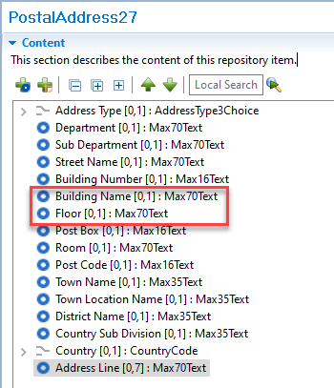

Proposed timing:

Timing | Given the high impact, SWIFT does not agree with the proposed timing and proposes to postpone the implementation to a future maintenance cycle.  With just under 150 Message Identifiers and numerous business domains impacted (including Securities, Trade and FX not even listed here), SWIFT recommends only implementing this change once most countries confirm the updated PostalAddress component meets their local requirements. If other requirements are found and delivered as separate versions, this may needlessly burden the parts of the industry that implement the latest versions regularly.  To ascertain whether the PostalAddress meets most local country requirements SWIFT would suggest creating a dedicated PaySEG working group of cross domain industry experts to focus on this.  This working group could also consider alternative implementations, such as a split between a restricted postal address for compliance reasons and the postal address for shipping purpose (which could be located in the contact details element).

Final decision of the SEG(s):

Approve | X
Payments SEG comments (September 12th): set up a WG for a broader review of Postal Address structure. This CR will be implemented at the next maintenance cycle to give enough time to the communities to submit their requirements and implement them in one major update of the messages.

Reject
Reason for rejection:

Change request CR1083: Modify Inter Bank to Interbank in cash management messages

Origin of the request:
A.1 Submitter: Payments Canada
A.2 Contact person:
Mr. Anshul Tripathi, +1(416) 676-6151, atripathi@payments.ca
Mr. Isak Penttila, +1(613)-315-4075, ipenttila@payments.ca

A.3 Sponsors: n.a.

Related messages:
camt.007, camt.008 and any other messages containing these elements.

Description of the change request:
The word “Interbank” in name of elements “Interbank Settlement Amount” and “Interbank Settlement Date” is spelled differently in camt.007 (“Inter Bank”) than in pacs.008 (“Interbank”). Refer the screenshots below from online editor:
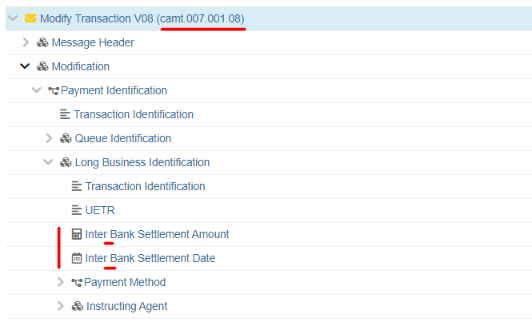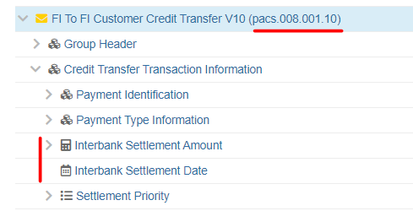

Purpose of the change:
To correct and align the naming of these 2 elements across rest of the camt message set. The recommendation here is to follow the pacs.008 naming in all other messages for the same elements.

Urgency of the request:
Not urgent but should be corrected perhaps in the next maintenance cycle.

Business examples:
Not sure business examples are necessary for this change request since it is a correction of an apparent mistake in the naming of same elements used across different ISO 20022 messages.

SEG/TSG recommendation:
Consider |  | X | Timing
 |  |  | - Next yearly cycle: 2022/2023  (the change will be considered for implementation in the yearly maintenance cycle which starts in 2022 and completes with the publication of new message versions in the spring of 2023) |  | x
- At the occasion of the next maintenance of the messages
(the change will be considered for implementation, but does not justify maintenance of the messages in its own right – will be pending until more critical change requests are received for the messages)
- Urgent unscheduled
(the change justifies an urgent implementation outside of the normal yearly cycle)
 |  |  | - Other timing:
Comments:

Reject
Reason for rejection:

Impact analysis and type of impact:
Following the detailed analysis of the impact of the changes to the existing messages, we identified further impacted messages.
The below list provides the full list of impacted messages per message set:

Cash Management message set:
- camt.005.001.09 GetTransactionV09
- camt.006.001.09 ReturnTransactionV09
- camt.007.001.08 ModifyTransactionV08
- camt.008.001.09 CancelTransactionV09
- camt.025.001.05 ReceiptV05

Proposed implementation:
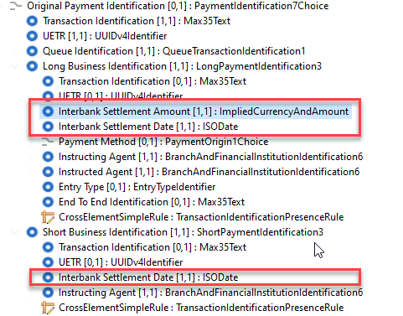

This update does not change the schema as Inter Bank and Interbank will be generated with the same XML tag, so there is only a change in the element name.

Proposed timing:
The submitting organisation confirms that it can implement the requested changes in the requested timing.

Timing | As requested

Final decision of the SEG(s):

Approve | X

Reject
Reason for rejection:

Change request CR1091: Add DateTime range to camt.046

Origin of the request:
A.1 Submitter:
Partior Pte. Ltd.
A.2 Contact person:
Person that can be contacted for additional information on the request
- Rakhi Shrivastava: Rakhi.shrivastava@partior.com
- Petrina Chong: Petrina.chong@partior.com
- Dmitry Avramenko: dmitry.avramenko@partior.com
A.3 Sponsors:
N/A

Related messages:
camt.046.001.06 GetReservationV06

Description of the change request:
This change request seeks to include the date-time range in the camt.046.001.06 GetReservationV06 to request the details of one or more reservations on the account.
This allows the users to select a particular time span specified between a start date time and an end date time in the camt.046.001.07 request message as one of the options in the search criteria to get the reservation details.

Purpose of the change:
Addition of date time range attributes is to allow for the ability to search the reservations in the specified time range.
This will prevent the time unbounded list of reservations to be returned with camt.047.001 which may result in huge data to handle.

Urgency of the request:
It is proposed to include this change request in the next regular maintenance cycle.

Business examples:
Requested date time fields are to be included in the message element ‘SearchCriteria’ which is used to defines the criteria to extract the reservation information.
For Example:
Field | Type
SearchCriteria <SchCrit>
DateTime <DtTm>
FromDateTime <FrDtTm> | DateTime
ToDateTime <ToDtTm> | DateTime

High Level design Flow

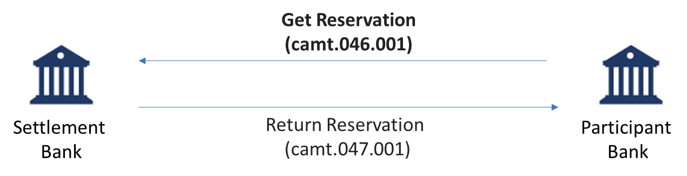

SEG/TSG recommendation:
This section is not to be taken care of by the submitter of the change request. It will be completed in due time by the SEG(s) in charge of the related ISO 20022 messages or the TSG for changes related to the BAH.

Consider |  | X | Timing
 |  |  | - Next yearly cycle: 2022/2023  (the change will be considered for implementation in the yearly maintenance cycle which starts in 2022 and completes with the publication of new message versions in the spring of 2023) |  | x
- At the occasion of the next maintenance of the messages
(the change will be considered for implementation, but does not justify maintenance of the messages in its own right – will be pending until more critical change requests are received for the messages)
- Urgent unscheduled
(the change justifies an urgent implementation outside of the normal yearly cycle)
 |  |  | - Other timing:
Comments:

Reject
Reason for rejection:

Impact analysis and type of impact:
Following the detailed analysis of the impact of the changes to the existing messages, we identified no further impacted messages.
The below list provides the full list of impacted messages per message set:
Cash Management message set:
- camt.046.001.06 GetReservationV06

Proposed implementation:
SWIFT proposes using DateTimeSearch2Choice.
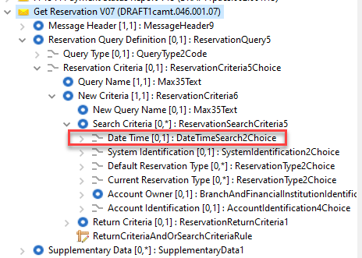

Proposed timing:
The submitting organisation confirms that it can implement the requested changes in the requested timing.

Timing | As requested

Final decision of the SEG(s):

Approve | X

Reject
Reason for rejection:

Change request CR1093: Add Debtor Agent Account and Creditor Agent Account to pain.013

Origin of the request:
A.1 Submitter:
Russian National Member and User Group (ROSSWIFT)
A.2 Contact person:
Timothy Romaslovsky, Consultant, ROSSWIFT, Timothy.Romaslovsky@swift-russia.ru, +7 910 458 8897
A.3 Sponsors:
Russian National Member and User Group (ROSSWIFT).

Related messages:
pain.013.001.09 - CreditorPaymentActivationRequestV09.

Description of the change request:
The values of Creditor Agent Account and Debtor Agent Account are required in pain.013. We propose to use the standard block CashAccount40 currently available in pacs messages. These elements are to be optional and non-repetitive. They are necessary for legislation reasons in accordance with the the Central Bank of the Russian Federation regulations:
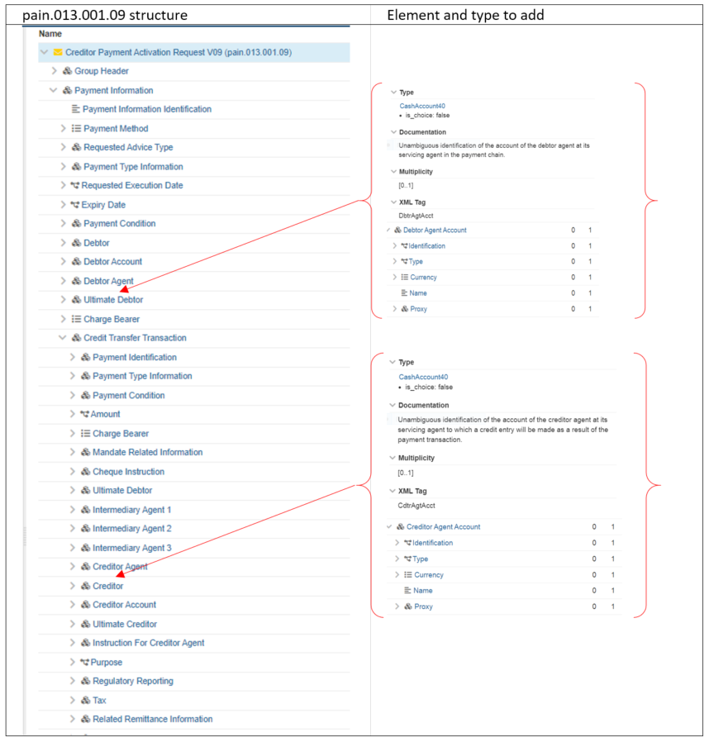
Creditor Agent Account [0..1]
Debtor Agent Account [0..1]

Purpose of the change:
The regulatory reason - in accordance with Russian regulation Creditor Payment Activation Requests must include the value of correspondent account number of Agent in Bank of Russia.

Urgency of the request:
Migration to ISO 20022 in Russia are planned now in the period 2022-2024.

Business examples:
The Debtor performs the Role of the Ultimate Debtor. The Creditor performs the Role of the Initiating Party and the Ultimate Creditor. Agents are not correspondents. Agents have opened accounts in Intermediary Agent. There is no Prior Acceptance. There is no request for notification of account transactions.
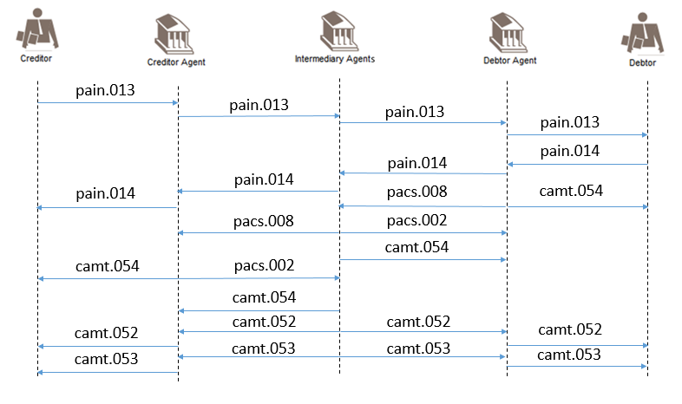
- SEG/TSG recommendation:
This section is not to be taken care of by the submitter of the change request. It will be completed in due time by the SEG(s) in charge of the related ISO 20022 messages or the TSG for changes related to the BAH.

Consider |  | X | Timing
 |  |  | - Next yearly cycle: 2022/2023  (the change will be considered for implementation in the yearly maintenance cycle which starts in 2022 and completes with the publication of new message versions in the spring of 2023) |  | x
- At the occasion of the next maintenance of the messages
(the change will be considered for implementation, but does not justify maintenance of the messages in its own right – will be pending until more critical change requests are received for the messages)
- Urgent unscheduled
(the change justifies an urgent implementation outside of the normal yearly cycle)
 |  |  | - Other timing:
Comments:

Reject
Reason for rejection:

Impact analysis and type of impact:
Following the detailed analysis of the impact of the changes to the existing messages, we identified no further impacted messages.
The below list provides the full list of impacted messages per message set:
Creditor Payment Activation Request message set:
- pain.013.001.09 - CreditorPaymentActivationRequestV09

Proposed implementation:
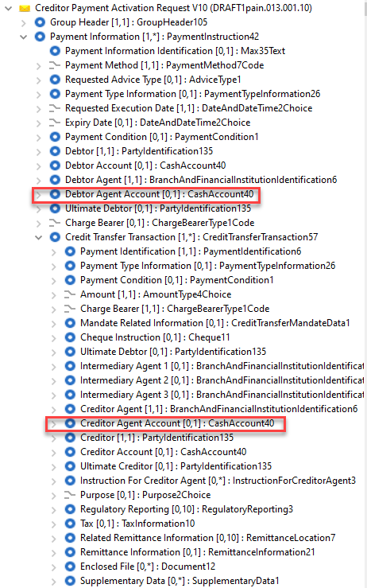
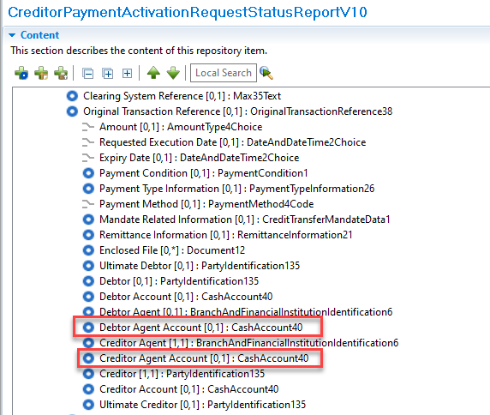

Proposed timing:
The submitting organisation confirms that it can implement the requested changes in the requested timing.

Timing | As requested

Final decision of the SEG(s):

Approve | X
Payments SEG comments: add these new elements to OriginalTransactionReference and also implement in pain.014 for alignment purpose. Update required to include pain.014 in the scope of the change.

Reject
Reason for rejection:

Change request CR1105: Modify Charges Information element

Origin of the request:
A.1 Submitter:
SIX Interbank Clearing Ltd
A.2 Contact person:
Roman Locher
roman.locher@six-group.com
T +41 58 399 4125
A.3 Sponsors:
SIX Interbank Clearing is involved in several committees focused on questions of standardization concerning the national and international payment traffic. In this role SIX Interbank Clearing acts as a representative of the Swiss financial industry. SIX Interbank Clearing also operates the Swiss RTGS systems SIC for Swiss Francs (monitored and steered by the Swiss National Bank) and euroSIC in Euro.
This Change Request is supported by the national committee “Taskforce ISO V2019 Interbank”, representing Swiss National Bank, UBS, Credit Suisse, PostFinance, Raiffeisen, Zürcher Kantonalbank, Entris Banking.

Related messages:
- pacs.004 (latest version: pacs.004.001.11)
- pacs.008 (latest version: pacs.008.001.10)
Note:
The change request explained below is primarily required for the Swiss Interbank community in the messages pacs.004/008. However, since the affected element is also used in other pacs messages, it should be checked whether a general adjustment of all messages of the category "Payments Clearing and Settlement" is necessary.

Description of the change request:
In this change request, the Swiss Interbank community requests an extension of the element "Charges Information" (<ChrgsInf>, Type Charges7):
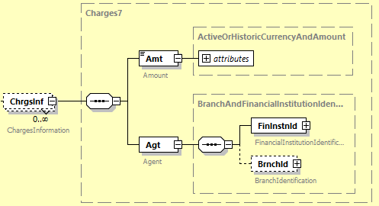
Currently, the <ChrgsInf> element only supports information about the charges amount and to which agent the charges are to be paid.
Within the Swiss Interbank Market Practice, for certain bilaterally agreed charges, further information on the specific nature of the charges must be added to this information. Since there is currently no suitable element for this purpose, a text sub-element within <Agt> element (that is not actually intended for this purpose) has to be used for these cases.
To fix this workaround, the Swiss community requests to add an additional optional sub-element "Type" within the <ChrgsInf> element. The Swiss community proposes to design the new element in same form as already known from "Cash Management" messages as ChargeType3Choice:
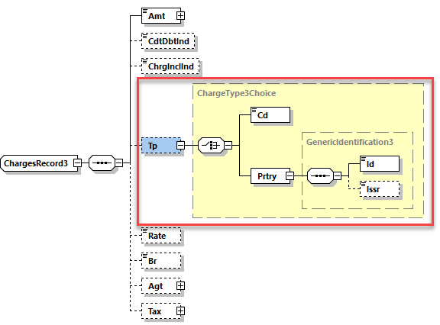

Purpose of the change:
As mentioned before, this extension is intended to fix a currently used workaround within Swiss Interbank Market Practice so that the <Agt> sub-element can be used in the exclusive sense of this element.
With a proper delivery of this additional information, the Swiss community believes that more transparency about the reasons for a charge deduction can be created, especially if these charges are part of a bilateral agreement. Furthermore, with this additional information in the payload of the interbank payment message, subsequent clarifications based on end-customer queries can be avoided.

Urgency of the request:
The change should be implemented in the regular yearly maintenance cycle with publication per next ISO 20022 version in spring 2023.

Business examples:
Extract from Swiss Interbank Market practice, document “Implementation Guidelines for ISO 20022 Interbank Messages, Customer Payments (pacs.008)”:
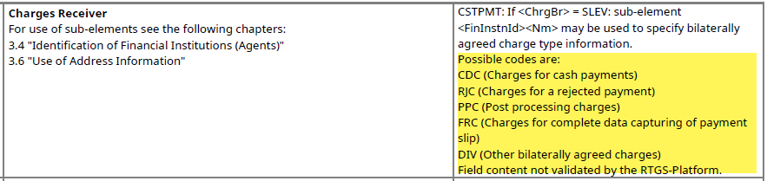

SEG/TSG recommendation:
This section is not to be taken care of by the submitter of the change request. It will be completed in due time by the SEG(s) in charge of the related ISO 20022 messages or the TSG for changes related to the BAH.

Consider |  | X | Timing
 |  |  | - Next yearly cycle: 2022/2023  (the change will be considered for implementation in the yearly maintenance cycle which starts in 2022 and completes with the publication of new message versions in the spring of 2023) |  | x
- At the occasion of the next maintenance of the messages
(the change will be considered for implementation, but does not justify maintenance of the messages in its own right – will be pending until more critical change requests are received for the messages)
- Urgent unscheduled
(the change justifies an urgent implementation outside of the normal yearly cycle)
 |  |  | - Other timing:
Comments:

Reject
Reason for rejection:

Impact analysis and type of impact:
Following the detailed analysis of the impact of the changes to the existing messages, we identified further impacted messages, as already suggested by the change request submitter
The below list provides the full list of impacted messages per message set:
Creditor Payment Activation Request message set:
- pain.014.001.09 - CreditorPaymentActivationRequestStatusReportV09
Exceptions and Investigations message set:
- camt.029.001.09 - ResolutionOfInvestigationV09
Payments Clearing and Settlement message set:
- pacs.002.001.12 - FIToFIPaymentStatusReportV11
- pacs.003.001.09 - FIToFICustomerDirectDebitV08
- pacs.004.001.11 - PaymentReturnV10
- pacs.007.001.11 - FIToFIPaymentReversalV10
- pacs.008.001.10 - FIToFICustomerCreditTransferV09
Payments Initiation message set:
- pain.002.001.12 - CustomerPaymentStatusReportV12

Proposed implementation:
As per change request, we support the proposed implementation, which will result in the following new structure:
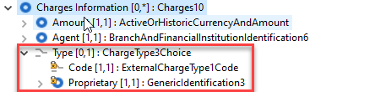
In performing the impact analysis, we identified a component in the camt.029.001.11 currently using Charges9 whilst all remaining messages use Charges7.
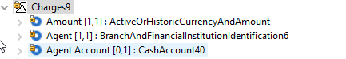
Questions to the SEG
- Should this element also be updated to include the charge type as requested for the other messages? Use the below alternate component only in the camt.029 if yes or
- Should we align the two charges components to have a unique global charges component (this might duplicate the charges account in some messages), which means adding both account and type elements in the Charges component:
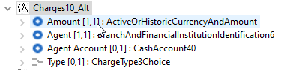

Proposed timing:
The submitting organisation confirms that it can implement the requested changes in the requested timing.

Timing | As requested

Final decision of the SEG(s):

Approve | X
Payments SEG comments:
- Use the follow for impacted messages + update the definition for the pain messages
- Use the following for the camt.029

Reject
Reason for rejection:

Change request CR1106: Add new Processing Date element to pacs.002

Origin of the request:
A.1 Submitter:
SIX Interbank Clearing Ltd
A.2 Contact person:
Roman Locher
roman.locher@six-group.com
T +41 58 399 4125
A.3 Sponsors:
SIX Interbank Clearing is involved in several committees focused on questions of standardization concerning the national and international payment traffic. In this role SIX Interbank Clearing acts as a representative of the Swiss financial industry. SIX Interbank Clearing also operates the Swiss RTGS systems SIC for Swiss Francs (monitored and steered by the Swiss National Bank) and euroSIC in Euro.
This Change Request is supported by the national committee “Taskforce ISO V2019 Interbank”, representing Swiss National Bank, UBS, Credit Suisse, PostFinance, Raiffeisen, Zürcher Kantonalbank, Entris Banking.

Related messages:
pacs.002 (latest version: pacs.002.001.12)

Description of the change request:
In this change request, the Swiss community requests the extension of the block "Transaction Information And Status" (<TxInfAndSts>, Type PaymentTransaction130) by an additional optional element "Processing Date".

In its current design, the pacs.002 block <TxInfAndSts> message supports only 2 elements for specifying a timestamp related to the underlying transaction/payment:
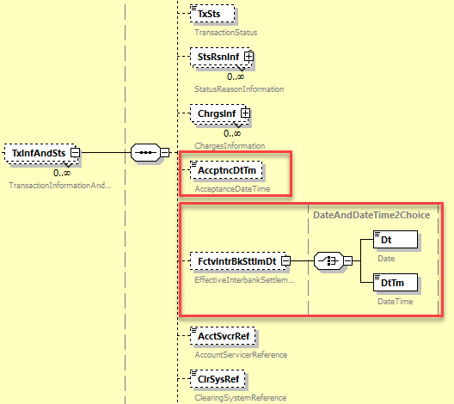
For the planned future Swiss instant payment service, the infrastructure will use the pacs.002 message to confirm final transaction status of an instant payment to the participants. This can be either the confirmation of the final settlement or the cancellation of an instant payment. For this purpose, a timestamp in the sense of a processing date time is required, which can be used in relation to the transaction status provided in the <TxSts> element. This need actually cannot be satisfied within pacs.002 <TxInfAndSts> block for the following reasons, neither in the element <AccptnDtTm>, nor <FctvIntrbkSttlmDt>:
- For SEPA Instant Credit Transfer Scheme compatibility, the <AccptncDtTm> element will contain the start of maximum execution time and therefore cannot be used to specify another processing timestamp.
- Only one of the two sub-elements <Dt> or <DtTm> can be used in the <FctvIntrBkSttlmDt> element due to the choice specification. For the Swiss instant payment service, the <Dt> element is needed for settled instant payments to confirm final interbank value date of the settlement.
SIX Interbank Clearing Ltd therefore requests addition of a new optional element called "Processing Date" in the <TxInfAndSts> block of the pacs.002 message.
In order to grant some flexibility in the use of the element, SIX Interbank Clearing Ltd proposes to
- keep the definition of this new element generic (incl. possible addition that the concrete use is to be determined by market practices / bilateral agreements) and
- design the element with type <DateAndDateTime2Choice>, i.e. consisting of a choice for sub-elements <Dt> or <DtTm>.

Purpose of the change:
The above mentioned additional element would provide more flexibility in the usage of the pacs.002 message. With the current message design, the Swiss community is forced to use proprietary text elements (as for ex. <AddtlInf> within <StsRsnInf>) to provide timestamp information.

Urgency of the request:
The change should be implemented in the regular yearly maintenance cycle with publication per next ISO 20022 version in spring 2023.

Business examples:
n/a

SEG/TSG recommendation:
This section is not to be taken care of by the submitter of the change request. It will be completed in due time by the SEG(s) in charge of the related ISO 20022 messages or the TSG for changes related to the BAH.

Consider |  | X | Timing
 |  |  | - Next yearly cycle: 2022/2023  (the change will be considered for implementation in the yearly maintenance cycle which starts in 2022 and completes with the publication of new message versions in the spring of 2023) |  | x
- At the occasion of the next maintenance of the messages
(the change will be considered for implementation, but does not justify maintenance of the messages in its own right – will be pending until more critical change requests are received for the messages)
- Urgent unscheduled
(the change justifies an urgent implementation outside of the normal yearly cycle)
 |  |  | - Other timing:
Comments:

Reject
Reason for rejection:

Impact analysis and type of impact:
Following the detailed analysis of the impact of the changes to the existing messages, we identified no further impacted messages.
The below list provides the full list of impacted messages per message set:
Payments Clearing and Settlement message set:
- pacs.002.001.12 - FIToFIPaymentStatusReportV12

Proposed implementation:
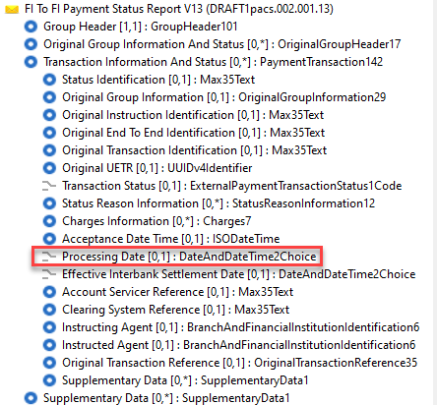

Proposed timing:
The submitting organisation confirms that it can implement the requested changes in the requested timing.

Timing | As requested

Final decision of the SEG(s):

Approve | X

Reject
Reason for rejection:

Change request CR1107: Add additional UETR elements to camt.005

Origin of the request:
A.1 Submitter:
SIX Interbank Clearing Ltd
A.2 Contact person:
Roman Locher
roman.locher@six-group.com
T +41 58 399 4125
A.3 Sponsors:
SIX Interbank Clearing is involved in several committees focused on questions of standardization concerning the national and international payment traffic. In this role SIX Interbank Clearing acts as a representative of the Swiss financial industry. SIX Interbank Clearing also operates the Swiss RTGS systems SIC for Swiss Francs (monitored and steered by the Swiss National Bank) and euroSIC in Euro.
This Change Request is supported by the national committee “Taskforce ISO V2019 Interbank”, representing Swiss National Bank, UBS, Credit Suisse, PostFinance, Raiffeisen, Zürcher Kantonalbank, Entris Banking.

Related messages:
camt.005 (latest version: camt.005.001.09)

Description of the change request:
This change request refers to the support of the search criterion UETR within the element "Payment Identification" (<PmtId>, Type PaymentIdentification6Choice) in the block "Payment Search" (<PmtSch>, Type PaymentSearch8) of the message "Get Transaction" (camt.005):
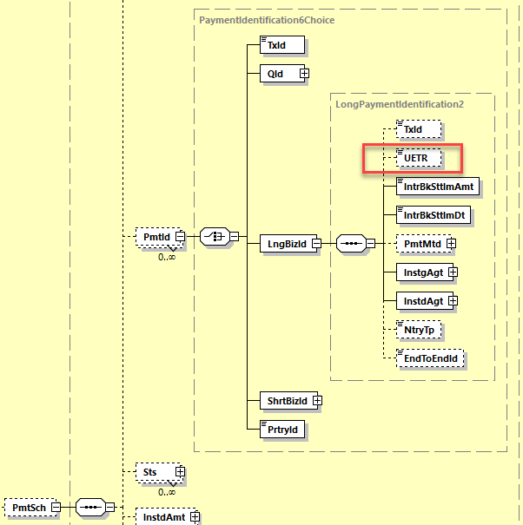
Since Swiss RTGS SIC and euroSIC have fully migrated to ISO 20022 the message camt.005 is well established to query individual transactions. As the use of UETR has been defined mandatory since November 2021 in payment messages of the Swiss Interbank Market Practice, there is also a need for the participants to query corresponding transaction by using the search criterion UETR.

In the current message design camt.005, the search criterion UETR is offered exclusively within the element "Long Business Identification" (<LngBizId>, Type LongPaymentIdentification2). If the search criterion UETR is to be supported, the participant would currently be forced to additionally provide the mandatory elements <IntrbkSttlmAmt>, <IntrbkSttlmDt>, <InstgAgt> and <InstdAgt>. This is in contrast, for example, to the support of <TxId> element, which is provided within the message camt.005 a) also on other messages levels and
b) can also be used as a sole search criterion:
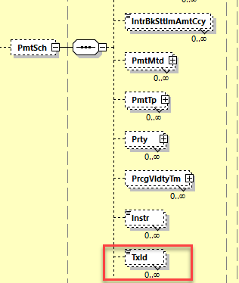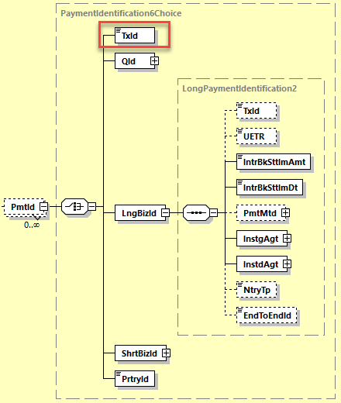
Similar to the <TxId> element, the Swiss community requests that the search criterion UETR is added to the message camt.005 additionally in the following places:
- new sub-element <UETR> under .../SchCrit/PmtSch (optional, unbounded) and
- new sub-element <UETR> under .../SchCrit/PmtSch/PmtId (choice).

Purpose of the change:
The use of the UETR as a unique identifier has established itself in interbank payment transactions in recent years. Due to the uniqueness of the UETR, it makes sense to support this identifier in query messages as the sole search criterion. However, this is not possible due to the current camt.005 design. According to demands of the Swiss community, more flexibility should be created here in order to use the advantages of this identifier efficiently and to avoid unnecessary additional message content.

Urgency of the request:
The change should be implemented in the regular yearly maintenance cycle with publication per next ISO 20022 version in spring 2023.

Business examples:
n/a

SEG/TSG recommendation:
This section is not to be taken care of by the submitter of the change request. It will be completed in due time by the SEG(s) in charge of the related ISO 20022 messages or the TSG for changes related to the BAH.

Consider |  | X | Timing
 |  |  | - Next yearly cycle: 2022/2023  (the change will be considered for implementation in the yearly maintenance cycle which starts in 2022 and completes with the publication of new message versions in the spring of 2023) |  | x
- At the occasion of the next maintenance of the messages
(the change will be considered for implementation, but does not justify maintenance of the messages in its own right – will be pending until more critical change requests are received for the messages)
- Urgent unscheduled
(the change justifies an urgent implementation outside of the normal yearly cycle)
 |  |  | - Other timing:
Comments:

Reject
Reason for rejection:

Impact analysis and type of impact:
Following the detailed analysis of the impact of the changes to the existing messages, we identified no further impacted messages.
The below list provides the full list of impacted messages per message set:
Cash Management message set:
- camt.005.001.09 - GetTransactionV09
- camt.006.001.09 - ReturnTransactionV09
- camt.007.001.08 - ModifyTransactionV08
- camt.008.001.09 - CancelTransactionV09
- camt.025.001.05 - ReceiptV05

Proposed implementation:
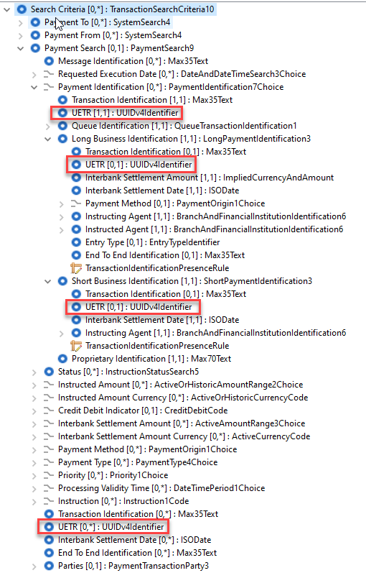

Proposed timing:
The submitting organisation confirms that it can implement the requested changes in the requested timing.

Timing | As requested

Final decision of the SEG(s):

Approve | X

Reject
Reason for rejection:

Change request CR1123: Add Forwarding Agent to pain.013 and pain.014 Group Header

Origin of the request:
A.1 Submitter:
Federal Reserve Bank of New York (on behalf of the US Federal Reserve Banks)
33 Liberty Street
New York, NY 10045
U.S.A.
A.2 Contact person:
Federal Reserve Bank of New York
Mr. Frank Van Driessche (frank.vandriessche@ny.frb.org)
A.3 Sponsors:
-

Related messages:
pain.013 – Creditor Payment Activation Request (aka Request for Payment)
pain.014 – Creditor Payment Activation Request Status Report (aka Request for Payment Response)

Description of the change request:
- Add a Forwarding Agent to the Group Header of both pain.013 and pain.014 messages to align with other payment initiation message like the customer credit transfer initiation (pain.001) and customer direct debit initiation (pain.008) messages where a Forwarding Agent is available.
The requested change is reflected in the below diagrams.

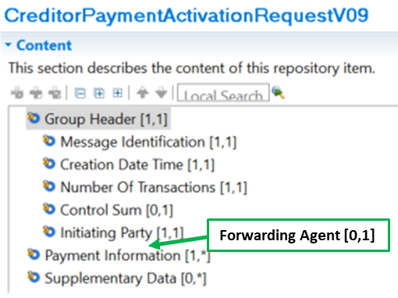

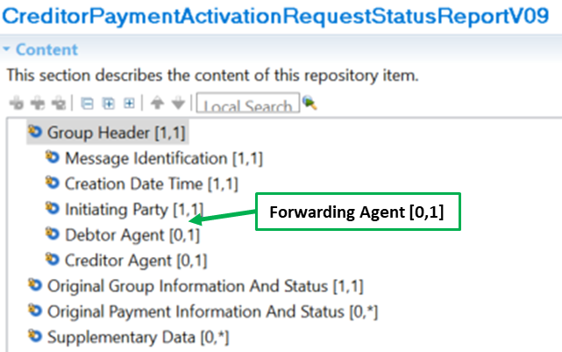

Purpose of the change:
The change will enable use of the request for payment messages in a relay scenario where the messages are exchanged by a financial institution other than the account servicing institution of the initiating party / creditor (i.e., Creditor Agent).

Urgency of the request:
Request to include the change in the current maintenance cycle.

Business examples:
See above.

SEG/TSG recommendation:
This section is not to be taken care of by the submitter of the change request. It will be completed in due time by the SEG(s) in charge of the related ISO 20022 messages or the TSG for changes related to the BAH.

Consider |  | X | Timing
 |  |  | - Next yearly cycle: 2022/2023  (the change will be considered for implementation in the yearly maintenance cycle which starts in 2021 and completes with the publication of new message versions in the spring of 2022) |  | x
- At the occasion of the next maintenance of the messages
(the change will be considered for implementation, but does not justify maintenance of the messages in its own right – will be pending until more critical change requests are received for the messages)
- Urgent unscheduled
(the change justifies an urgent implementation outside of the normal yearly cycle)
 |  |  | - Other timing:
Comments:

Reject
Reason for rejection:

Impact analysis and type of impact:
Following the detailed analysis of the impact of the changes to the existing messages, we identified no further impacted messages.
The below list provides the full list of impacted messages per message set:
Creditor Payment Activation Request message set:
- pain.013.001.09 - CreditorPaymentActivationRequestV09
- pain.014.001.09 - CreditorPaymentActivationRequestStatusReportV09

Proposed implementation:
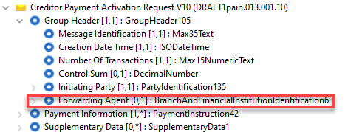
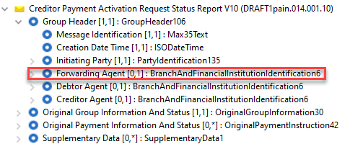

Proposed timing:
The submitting organisation confirms that it can implement the requested changes in the requested timing.

Timing | As requested

Final decision of the SEG(s):

Approve | X

Reject
Reason for rejection:

Change request CR1124: Modify Organisation Identification and Generic Organisation Identification length

Origin of the request:
A.1 Submitter:
360kompany AG
A.2 Contact person:
Dusan Stanojevic
dusan.stanojevic@kompany.com
+4368110466320
A.3 Sponsors:
360kompany AG as the registered partner of the SWIFT, is building an interface to the SWIFT network for entity verification, for which we had asked the sponsorship of this change request.

Related messages:
The ISO 20022 message which would be impacted by the change: pain.001.001.11CustomerCreditTransferInitiationV11
Component affected: OrganisationIdentification29 / GenericOrganisationIdentification1
Scheme name: COID

Description of the change request:
The current definition for the field RegistrationAuthorityIdentification in the Organisation & Party Identification Schema (https://www.iso20022.org/standardsrepository/type/OrganisationIdentification) has an 35 character limitation. However, most of the issuing bodies for company registration numbers have defined registration numbers with a longer length. Therefore, this change request addresses the need to extend the field length to max of 50 characters.

Purpose of the change:
Users of the schema which want to perform entity verification versus official register number will not be able to perform this action because of the current max 35 character limitation while official register number usually exceed this limitation.

Urgency of the request:
By default, valid change requests introduced by June 1 and subsequently approved by the SEG/TSG will be included in the following yearly maintenance cycle which completes with the publication of new message versions by April/May of the following year, unless decided otherwise by the SEG/TSG.
If there is a need to have the new version of the related messages published earlier, the reason for the urgency of the maintenance and the expected consequences of a delay should be described here. Acceptance of such an unscheduled maintenance for the BAH is subject to approval by TSG. Acceptance of an unscheduled maintenance for messages other than the BAH is subject to the approval of the SEG and availability of a submitting organization to develop the new version of the messages.
Note: the ISO 20022 maintenance results in the publication of a new version of an ISO 20022 message. The actual implementation of such new version on networks and in user installations is not within the purview of ISO.

Business examples:
India official register number: U63040DL2008PTC173850

German official numbers contain as part of registration number, also the federal court, therefore it is possible that for specific German cases the length of registration number might even exceed 50 characters.
Germany official register number: VR 120720Arnstadt Zweigstelle Ilmenau

SEG/TSG recommendation:
This section is not to be taken care of by the submitter of the change request. It will be completed in due time by the SEG(s) in charge of the related ISO 20022 messages or the TSG for changes related to the BAH.

Consider |  | X | Timing
- Next yearly cycle: 2022/2023
(the change will be considered for implementation in the yearly maintenance cycle which starts in 2022 and completes with the publication of new message versions in the spring of 2023)
 |  |  | - At the occasion of the next maintenance of the messages  (the change will be considered for implementation, but does not justify maintenance of the messages in its own right – will be pending until more critical change requests are received for the messages) |  | x
- Urgent unscheduled
(the change justifies an urgent implementation outside of the normal yearly cycle)
 |  |  | - Other timing:
Comments:

Reject
Reason for rejection:

Impact analysis and type of impact:
Following the detailed analysis of the impact of the changes to the existing messages, we identified further impacted messages, compared to the list already proposed by the change request submitter.

Bank Account Management message set:
- acmt.007.001.04 - AccountOpeningRequestV04
- acmt.008.001.04 - AccountOpeningAmendmentRequestV04
- acmt.009.001.03 - AccountOpeningAdditionalInformationRequestV03
- acmt.010.001.03 - AccountRequestAcknowledgementV03
- acmt.011.001.03 - AccountRequestRejectionV03
- acmt.012.001.03 - AccountAdditionalInformationRequestV03
- acmt.013.001.03 - AccountReportRequestV03
- acmt.014.001.04 - AccountReportV04
- acmt.015.001.03 - AccountExcludedMandateMaintenanceRequestV03
- acmt.016.001.03 - AccountExcludedMandateMaintenanceAmendmentRequestV03
- acmt.017.001.03 - AccountMandateMaintenanceRequestV03
- acmt.018.001.03 - AccountMandateMaintenanceAmendmentRequestV03
- acmt.019.001.03 - AccountClosingRequestV03
- acmt.020.001.03 - AccountClosingAmendmentRequestV03
- acmt.021.001.03 - AccountClosingAdditionalInformationRequestV03
Bank-to-Customer Cash Management message set:
- camt.052.001.10 - BankToCustomerAccountReportV10
- camt.053.001.10 - BankToCustomerStatementV10
- camt.054.001.10 - BankToCustomerDebitCreditNotificationV10
- camt.060.001.06 - AccountReportingRequestV06
Bank Services Billing message set:
- camt.086.001.04 - BankServicesBillingStatementV04
Cash Management message set:
- camt.003.001.07 - GetAccountV07
- camt.004.001.09 - ReturnAccountV09
- camt.005.001.09 - GetTransactionV09
- camt.006.001.09 - ReturnTransactionV09
- camt.007.001.08 - ModifyTransactionV08
- camt.008.001.09 - CancelTransactionV09
- camt.009.001.07 - GetLimitV07
- camt.010.001.08 - ReturnLimitV08
- camt.011.001.07 - ModifyLimitV07
- camt.012.001.07 - DeleteLimitV07
- camt.024.001.07 - ModifyStandingOrderV07
- camt.025.001.05 - ReceiptV05
- camt.046.001.06 - GetReservationV06
- camt.047.001.07 - ReturnReservationV07
- camt.048.001.06 - ModifyReservationV06
- camt.049.001.06 - DeleteReservationV06
- camt.050.001.06 - LiquidityCreditTransferV06
- camt.051.001.06 - LiquidityDebitTransferV06
- camt.069.001.04 - GetStandingOrderV04
- camt.070.001.05 - ReturnStandingOrderV05
- camt.071.001.04 - DeleteStandingOrderV04
- camt.101.001.01 - CreateLimitV01
- camt.102.001.02 - CreateStandingOrderV02
- camt.103.001.02 - CreateReservationV02
Cash Management – Charges message set:
- camt.105.001.01 - ChargesPaymentNotificationV01
- camt.106.001.01 - ChargesPaymentRequestV01
Cash Management – Cheque message set:
- camt.107.001.01 - ChequePresentmentNotificationV01
- camt.108.001.01 - ChequeCancellationOrStopRequestV01
- camt.109.001.01 - ChequeCancellationOrStopReportV01
Exceptions and Investigations message set:
- camt.026.001.09 - UnableToApplyV09
- camt.027.001.09 - ClaimNonReceiptV09
- camt.028.001.11 - AdditionalPaymentInformationV11
- camt.029.001.11 - ResolutionOfInvestigationV11
- camt.030.001.05 - NotificationOfCaseAssignmentV05
- camt.031.001.06 - RejectInvestigationV06
- camt.032.001.04 - CancelCaseAssignmentV04
- camt.033.001.06 - RequestForDuplicateV06
- camt.034.001.06 - DuplicateV06
- camt.035.001.05 - ProprietaryFormatInvestigationV05
- camt.036.001.05 - DebitAuthorisationResponseV05
- camt.037.001.09 - DebitAuthorisationRequestV09
- camt.038.001.04 - CaseStatusReportRequestV04
- camt.039.001.05 - CaseStatusReportV05
- camt.055.001.11 - CustomerPaymentCancellationRequestV11
- camt.056.001.10 - FIToFIPaymentCancellationRequestV10
- camt.087.001.08 - RequestToModifyPaymentV08
Notification to Receive message set:
- camt.057.001.07 - NotificationToReceiveV07
- camt.058.001.08 - NotificationToReceiveCancellationAdviceV08
- camt.059.001.07 - NotificationToReceiveStatusReportV07
Payments Clearing and Settlement message set:
- pacs.002.001.12 - FIToFIPaymentStatusReportV12
- pacs.003.001.09 - FIToFICustomerDirectDebitV09
- pacs.004.001.11 - PaymentReturnV11
- pacs.007.001.11 - FIToFIPaymentReversalV11
- pacs.008.001.10 - FIToFICustomerCreditTransferV10
- pacs.009.001.10 - FinancialInstitutionCreditTransferV10
- pacs.010.001.05 - FinancialInstitutionDirectDebitV05
- pacs.028.001.05 - FIToFIPaymentStatusRequestV05
Payments Initiation message set:
- pain.001.001.11 - CustomerCreditTransferInitiationV11
- pain.002.001.12 - CustomerPaymentStatusReportV12
- pain.007.001.11 - CustomerPaymentReversalV11
- pain.008.001.10 – CustomerDirectDebitInitiationV10
Payments Mandates message set
- pain.009.001.07 - MandateInitiationRequestV07
- pain.010.001.07 - MandateAmendmentRequestV07
- pain.011.001.07 - MandateCancellationRequestV07
- pain.012.001.07 - MandateAcceptanceReportV07
- pain.017.001.03 - MandateCopyRequestV03
- pain.018.001.03 - MandateSuspensionRequestV03
Message sets impacted not under responsibility of SWIFT:
- Business Application Header (under responsibility of TSG):
  - head.001.001.03 - BusinessApplicationHeaderV03
- Account Switching message set (under responsibility of Pay.UK):
  - acmt.027.001.04 - AccountSwitchInformationRequestV04
  - acmt.028.001.04 - AccountSwitchInformationResponseV04
  - acmt.029.001.04 - AccountSwitchCancelExistingPaymentV04
  - acmt.030.001.03 - AccountSwitchRequestRedirectionV03
  - acmt.031.001.04 - AccountSwitchRequestBalanceTransferV04
  - acmt.032.001.04 - AccountSwitchBalanceTransferAcknowledgementV04
  - acmt.034.001.04 - AccountSwitchRequestPaymentV04
- Authorities Financial Investigations message set (under responsibility of FFI):
  - auth.002.001.01 - InformationRequestResponseV01
- Change or Verify Account Identification message set (under the responsibility of the French GUF):
- acmt.022.001.03 – IdentificationModificationAdviceV03
- acmt.023.001.03 – IdentificationVerificationRequestV03
- acmt.024.001.03 – IdentificationVerificationReportV03
- Creditor Payment Activation Request message set (under the responsibility of CBI consortium):
- pain.013.001.09 - CreditorPaymentActivationRequestV09
- pain.014.001.09 - CreditorPaymentActivationRequestStatusReportV09
- Cross-Border Transactions Currency Control Reporting message set (under the responsibility of RU-CMPG):
- auth.018.001.03 - ContractRegistrationRequestV03
- auth.019.001.03 - ContractRegistrationConfirmationV03
- auth.020.001.03 - ContractRegistrationClosureRequestV03
- auth.021.001.03 - ContractRegistrationAmendmentRequestV03
- auth.022.001.03 - ContractRegistrationStatementV03
- auth.023.001.03 - ContractRegistrationStatementRequestV03
- auth.024.001.03 - PaymentRegulatoryInformationNotificationV03
- auth.025.001.03 - CurrencyControlSupportingDocumentDeliveryV03
- auth.026.001.03 - CurrencyControlRequestOrLetterV03
- auth.027.001.03 - CurrencyControlStatusAdviceV03
- Multilateral Settlement (under responsibility of Bank of England):
  - pacs.029.001.01 - MultilateralSettlementRequestV01
- Request To Pay -RTP- Service (under responsibility of the European Payments Council – EPC)
  - reda.066.001.01 - RequestToPayCreditorEnrolmentRequestV01
  - reda.067.001.01 - RequestToPayCreditorEnrolmentAmendmentRequestV01
  - reda.068.001.01 - RequestToPayCreditorEnrolmentCancellationRequestV01
  - reda.069.001.01 - RequestToPayCreditorEnrolmentStatusReportV01
  - reda.070.001.01 - RequestToPayDebtorActivationRequestV01
  - reda.071.001.01 - RequestToPayDebtorActivationAmendmentRequestV01
  - reda.072.001.01 - RequestToPayDebtorActivationCancellationRequestV01
  - reda.073.001.01 - RequestToPayDebtorActivationStatusReportV01
- Stand-Alone Remittance Advice message set (under responsibility of IFX):
- remt.001.001.05 - RemittanceAdviceV05
- remt.002.001.02 - RemittanceLocationAdviceV02
- Target2-Securities message sets (under responsibility of T2S):
- Administration:
- admi.005.001.01 - ReportQueryRequestV01
- Collateral Value:
- colr.001.001.01 - CollateralValueQueryV01
- colr.002.001.01 - CollateralValueReportV01
- Intrabalance Movements:
- camt.066.001.01 - IntraBalanceMovementInstructionV01
- camt.067.001.01 - IntraBalanceMovementStatusAdviceV01
- camt.068.001.01 - IntraBalanceMovementConfirmationV01
- camt.072.001.01 - IntraBalanceMovementModificationRequestV01
- camt.073.001.01 - IntraBalanceMovementModificationRequestStatusAdviceV01
- camt.074.001.01 - IntraBalanceMovementCancellationRequestV01
- camt.075.001.01 - IntraBalanceMovementCancellationRequestStatusAdviceV01
- camt.078.001.01 - IntraBalanceMovementQueryV01
- camt.079.001.01 - IntraBalanceMovementQueryResponseV01
- camt.080.001.01 - IntraBalanceMovementModificationQueryV01
- camt.081.001.01 - IntraBalanceMovementModificationReportV01
- camt.082.001.01 - IntraBalanceMovementCancellationQueryV01
- camt.083.001.01 - IntraBalanceMovementCancellationReportV01
- camt.084.001.01 - IntraBalanceMovementPostingReportV01
- camt.085.001.01 - IntraBalanceMovementPendingReportV01
On top of the above messages, we identified an impact as well impact on following message sets outside of the Payments domain, with a total of 39 additional messages impacted:
- Securities message sets as following:
  - Settlement And Reconciliation
- Trade Services message sets as following:
  - Demand Guarantees and Standby Letters of Credit
  - Factoring Services
  - Financial Invoice
  - Invoice Tax Report
- Cards message sets as following:
  - Acceptor to Acquirer Card Transaction

Proposed implementation:
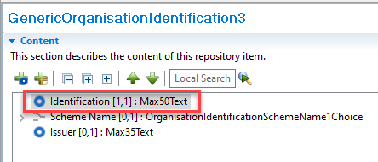

Questions to the SEG
- The examples provided by the submitter of the CR do not really justify the need to extend the length, as the use of the scheme and issuer has not been considered in the CR. Should we really extend the data type given the huge impact of existing messages, or should the CR submitter consider a dedicated market practice to use the current definition of the component to make use of the scheme and issue elements ?
- If this change is agreed, should the same update also be applied to the GenericPrivateIdentification1 component in the same maintenance cycle ?

Proposed timing:

Timing | Given the high impact, SWIFT does not agree with the proposed timing and proposes to postpone the implementation to a future maintenance cycle.  With just under 150 Message Identifiers and numerous business domains impacted SWIFT recommend only implementing this change in parallel with CR0942. If CR0942 and CR1124 are not delivered together this may needlessly burden the parts of the industry that implement the latest versions regularly  SWIFT recommends delivering CR1124 alongside CR0942. As SWIFT recommends further analysis of CR0942 as well as CR1124 before delivery, CR1124 would only be implemented at the point when this analysis was complete.

Final decision of the SEG(s):

Approve | X
Payments SEG comments: Not for an implementation in 2022/2023 - Joint implementation of CR0942 and CR1124 given the impact on the existing messages. This CR will be reviewed at the next maintenance cycle.

Reject
Reason for rejection:

Change request CR1125: Add Requested Execution Date to pain.013 Credit Transfer Transaction

Origin of the request:
A.1 Submitter: EPC – European Payments Council.
A.2 Contact person: Christophe Godefroi, Christophe.godefroi@epc-cep.eu, +32 2 739 16 93
A.3 Sponsors: The payment service providers (PSPs) community of SEPA (Single Euro Payments Area)

Related messages:
The message impacted by the present change request is the pain.013.001.09 CreditorPaymentActivationRequestV09.
Please refer also to “Remarks” under section C.

Description of the change request:
Introduce in the current pain.013.001.09 the possibility to request a payment payable in instalments, please refer to D. below.
To allow this, it is proposed to add an optional [0..1] element “RequestedExecutionDate” to the “CreditTransferTransaction” block. The type of this element would be “DateAndDateTime2Choice”.
As a consequence:
- the “RequestedExecutionDate” element at the upper level, under “PaymentInformation”, that currently is mandatory [1..1] should be made optional [0..1]
- and a new constraint should be added, “C24 RequestedExecutionDateRule” stating that “RequestedExecutionDate must be present either directly under PaymentInformation or under CreditTransferTransaction but cannot be present at both levels simultaneously”.
  - Side effect: The numbering of the constraints after “RequestedExecutionDateRule” (in alphabetical order) would need to be changed.
The proposed modifications are reflected below in green :

Or | MessageElement/BuildingBlock <XML Tag> | Mult. | Type | Constr. No.
 | PaymentInformation <PmtInf> | [1..*] |  | C5, C7,  C8, C9,  C10,  C13,  C14,  C23, C6,  C28
 | PaymentInformationIdentification <PmtInfId> | [0..1] | Text
 | PaymentMethod <PmtMtd> | [1..1] | CodeSet
 | RequestedAdviceType <ReqdAdvcTp> | [0..1]
 | PaymentTypeInformation <PmtTpInf> | [0..1] | ±
 | RequestedExecutionDate <ReqdExctnDt> | [0..1] | ± | C24
 | ExpiryDate <XpryDt> | [0..1] | ±
 | PaymentCondition <PmtCond> | [0..1]
 | Debtor <Dbtr> | [1..1] | ±
 | DebtorAccount <DbtrAcct> | [0..1] |  | C19,  C18
 | DebtorAgent <DbtrAgt> | [1..1] | ±
 | UltimateDebtor <UltmtDbtr> | [0..1] | ±
 | ChargeBearer <ChrgBr> | [0..1] | CodeSet
 | CreditTransferTransaction <CdtTrfTx> | [1..*] |  | C20,  C21,  C22,  C27,  C29
 | PaymentIdentification <PmtId> | [1..1] | ±
 | PaymentTypeInformation <PmtTpInf> | [0..1] | ±
 | PaymentCondition <PmtCond> | [0..1]
 | RequestedExecutionDate <ReqdExctnDt> | [0..1] | ± | C24
 | Amount <Amt> | [1..1] | ±
 | ChargeBearer <ChrgBr> | [1..1] | CodeSet
 | etc…
Remarks:
The proposed modification:
- does not affect pain.014.001.09 where “RequestedExecutionDate” already exists only under “TransactionInformationAndStatus / OriginalTransactionReference”;
- does not need to be transposed into pain.001.001.11 CustomerCreditTransferInitiationV11 for the purpose of this change (see under D. below). Indeed, the customer-to-bank initiation of instalment payments is not managed with pain.001.

Purpose of the change:
A change request was submitted in relation to the SEPA Request-to-Pay (SRTP) scheme to allow a payment request for instalment payments. This means that under one unique “PaymentInformation” block there is a need to have several “CreditTransferTransaction” blocks with different requested execution dates. This is currently not possible because “RequestedExecutionDate” exists only at “PaymentInformation” level. In order to allow for instalment payments, “RequestedExecutionDate” should hence be added under “CreditTransferTransaction”, where it currently does not exist.
The use of the “RequestedExecutionDate” would then be as follows:
- For a payment request with a one-time payment, the “PaymentInformation” block would continue to be used with “RequestedExecutionDate” directly in this block.
- For a payment request with instalment payments mandated by the Payee, the “PaymentInformation” block would be used without “RequestedExecutionDate” but with several occurrences of the “CreditTransferTransaction” block, each of them with a different “RequestedExecutionDate” according to the instalment periodicity.
- For a payment request whereby the Payer is given the choice to either pay via a one-time payment or via instalment payments, the Payee would use two occurrences of the “PaymentInformation” block with the same “PaymentInformationIdentification”:
  - One occurrence where “PaymentInformation” contains “RequestedExecutionDate” and one occurrence of “CreditTransferTransaction” with the full amount to be paid.
  - Another occurrence of “PaymentInformation” without “RequestedExecutionDate” but with several occurrences of the “CreditTransferTransaction” block, each of them with the requested split amount and the respective “RequestedExecutionDate” according to the instalment periodicity.
In the latter case, the SRTP scheme usage rule would then provide guidance on how to link both “PaymentInformation” occurrences, e.g. by using the same “PaymentInformationIdentification” for both, thus allowing to (automatically) detect that they refer to the same payment request and imply a choice between them.

Urgency of the request:
The change request should be approved for publication as soon as possible as the possibility of instalment payments in the SRTP scheme is requested by the stakeholders for version 3 of the Rulebook to be published in November 2022. Consequently, the possibility to introduce the ISO change request in a fast track procedure would be highly welcomed. Indeed, the EPC Implementation Guidelines on the use of the ISO 20022 messages for the purpose of the SRTP can only be completed once the definitive version of the ISO message is known. Waiting for the annual publication cycle in January/February 2023 would delay the publication and implementation of the EPC SRTP Implementation Guidelines version 3 and thus hamper the take-off of SRTP.

Business examples:
“Buy Now Pay Later” use cases (e.g. for purchasing furniture, household appliances etc.), combined with instalments to allow the splitting of a payment over a longer period of time.

SEG/TSG recommendation:
This section is not to be taken care of by the submitter of the change request. It will be completed in due time by the SEG(s) in charge of the related ISO 20022 messages or the TSG for changes related to the BAH.

Consider |  | X | Timing
 |  |  | - Next yearly cycle: 2022/2023  (the change will be considered for implementation in the yearly maintenance cycle which starts in 2022 and completes with the publication of new message versions in the spring of 2023) |  | x
- At the occasion of the next maintenance of the messages
(the change will be considered for implementation, but does not justify maintenance of the messages in its own right – will be pending until more critical change requests are received for the messages)
- Urgent unscheduled
(the change justifies an urgent implementation outside of the normal yearly cycle)
 |  |  | - Other timing:
Comments:

Reject
Reason for rejection:

Impact analysis and type of impact:
Following the detailed analysis of the impact of the changes to the existing messages, we identified no further impacted messages.
The below list provides the full list of impacted messages per message set:
Creditor Payment Activation Request message set:
- pain.013.001.09 - CreditorPaymentActivationRequestV09

Proposed implementation:
We support the proposed implementation as requested by the submitter of the change request, with the addition of a rule to enforce that only one of the elements may be present in the message.
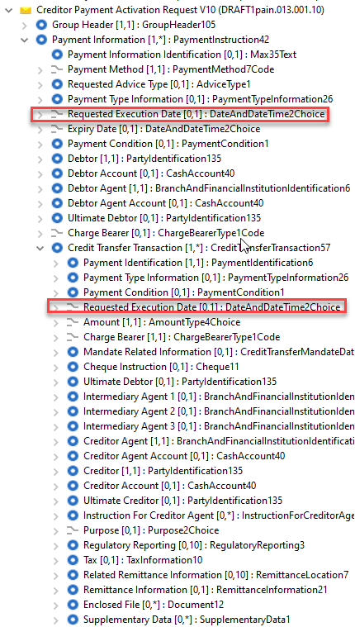

Proposed rule to be implemented in the PaymentInformation element:
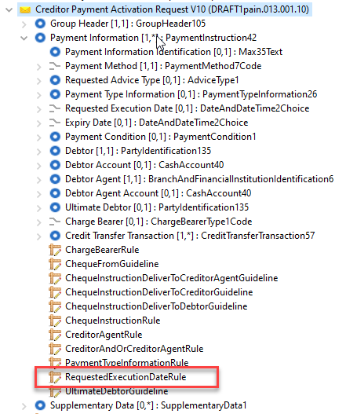
Description:
RequestExecutionDate must be absent or CreditTransferTransaction/RequestExecutionDate must be absent.
Both may be absent.
Formal definition
Following Must be True
/RequestedExecutionDate Must be absent
Or /CreditTransferTransaction[*]/RequestedExecutionDate Must be absent

Proposed timing:
The submitting organisation confirms that it can implement the requested changes in the requested timing.

Timing | Next yearly cycle: 2022/2023

Final decision of the SEG(s):

Approve | X

Reject
Reason for rejection:

Change request CR1126: Add Exchange Base element to camt.052, camt.053, camt.054

Origin of the request:
A.1 Submitter:
SIX Interbank Clearing Ltd.
A.2 Contact person:
Martin Walder
martin.walder@six-group.com
T +41 58 399 53 79
A.3 Sponsors: SIX Interbank Clearing is involved in several committees focused on questions of standardization concerning the national and international payment traffic. In this role SIX Interbank Clearing acts as a representative of the Swiss financial industry.
This change was discussed with the WG responsible for the bank-to-client interfaces.

Related messages:
camt.053
camt.052
camt.054
There might be other message, for which the change is useful as well.

Description of the change request:
Add an optional element “Exchange Base” in the Currency Exchange set of elements. 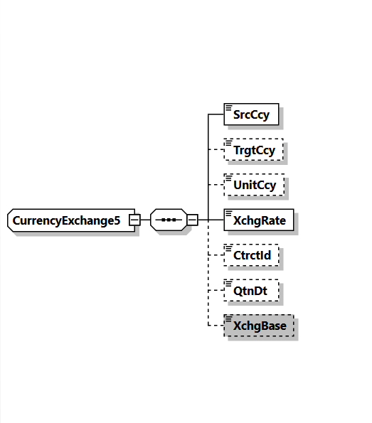

Purpose of the change:
Although the element ExchangeRate <XchgRate> is defined as factor used to convert an amount from one currency into another, many markets are still using in addition different bases.
For internationally operating corporate clients, it creates problems and can lead to errors if it is not possible to extract from the message whether or not a particular exchange base is being used.
The issue is mostly related to reporting, as the following example of an implementation guideline for camt.053 shows:
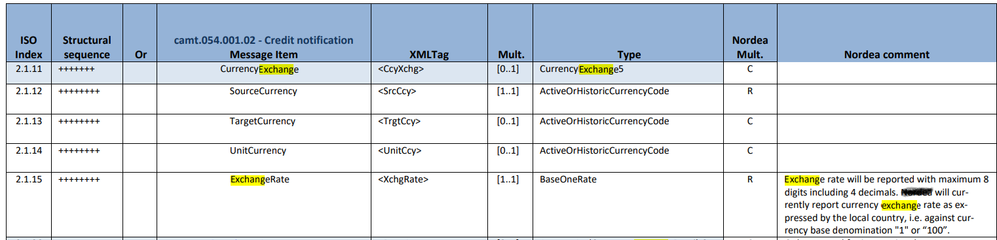

Urgency of the request:
There is no specific timeline for this change request. I can be assumed, that before 2025 our market is not changing the message version. Nevertheless, it may be helpful for other markets, if this option is available within the next cycle.

Business examples:
Example based on the exchange rate presentation of the Swiss National Bank:
Aktuelle Wechselkurse: Übersicht  Cours de change actuels: aperçu  Current exchange rates: overview  Tassi di cambio attuali: panoramica |  |  |  |  | 30.05.2022
EUR |  | 1 EUR in/en CHF
USD |  | 1 USD in/en CHF
JPY |  | 100 JPY in/en CHF
GBP |  | 1 GBP in/en CHF
 | EUR | USD | JPY | GBP
30.05.2022 | 1.0298 | 0.9569 | 0.7517 | 1.2084
27.05.2022 | 1.0287 | 0.9588 | 0.7547 | 1.2095
25.05.2022 | 1.0275 | 0.9628 | 0.7577 | 1.2058
24.05.2022 | 1.0310 | 0.9631 | 0.7559 | 1.2022
23.05.2022 | 1.0318 | 0.9692 | 0.7598 | 1.2182
20.05.2022 | 1.0290 | 0.9728 | 0.7596 | 1.2147
19.05.2022 | 1.0251 | 0.9764 | 0.7636 | 1.2101
18.05.2022 | 1.0479 | 0.9972 | 0.7717 | 1.2340
Many market practices for client-to-bank interaction are using the same currency exchange methods as their respective regulator, national bank or common usage.
Example:
30’000 JPY (booked)
225.51 CHF (
Exchange rate 0.007517
Unit Currency CHF
Exchange Base 1
225.51/0.007517=30000
30’000 JPY
225.51 CHF
Exchange rate 0.7517
Unit Currency CHF
Exchange Base 100 (1 CHF to 100 JPY)
225.51/0.7517*100=30000
Usage:
Currenttly:
ExchangeRate expresses the ratio between UnitCurrency and QuotedCurrency (ExchangeRate = UnitCurrency/QuotedCurrency).
Added:
ExchangeBase expresses the ratio between the base of the denomination of the UnitCurrency to the base of the denominated of the Quoted Currency.

SEG/TSG recommendation:
This section is not to be taken care of by the submitter of the change request. It will be completed in due time by the SEG(s) in charge of the related ISO 20022 messages or the TSG for changes related to the BAH.

Consider |  | X | Timing
- Next yearly cycle: 2022/2023
(the change will be considered for implementation in the yearly maintenance cycle which starts in 2022 and completes with the publication of new message versions in the spring of 2023)
- At the occasion of the next maintenance of the messages
(the change will be considered for implementation, but does not justify maintenance of the messages in its own right – will be pending until more critical change requests are received for the messages)
- Urgent unscheduled
(the change justifies an urgent implementation outside of the normal yearly cycle)
 |  |  | - Other timing:
Comments:

Reject
Reason for rejection:

Impact analysis and type of impact:
Following the detailed analysis of the impact of the changes to the existing messages, we identified no further impacted messages.
The below list provides the full list of impacted messages per message set:
Bank-to-Customer Cash Management message set:
- camt.052.001.10 - BankToCustomerAccountReportV10
- camt.053.001.10 - BankToCustomerStatementV10
- camt.054.001.10 - BankToCustomerDebitCreditNotificationV10

Proposed implementation:
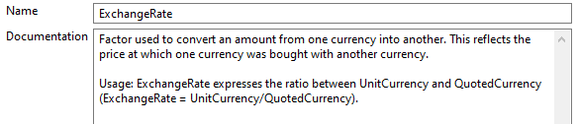

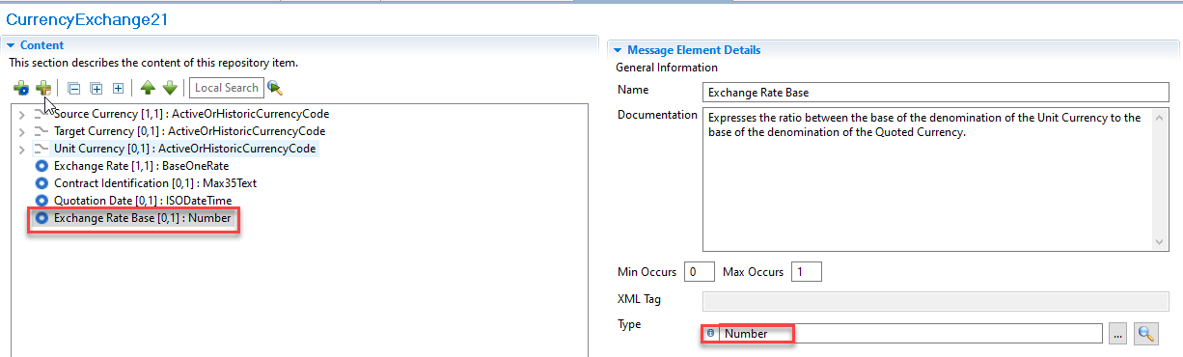

Question to the SEG
We received informal feedback from FX SEG members that we consulted that the existing Exchange Rate element has clear documentation around its usage. If this element is being used differently within communities would a better approach be to align these communitites with the standard usage as opposed to introducing a new element that may not be clearly understood by all?

Proposed timing:
The submitting organisation confirms that it can implement the requested changes in the requested timing.

Timing | As requested

Final decision of the SEG(s):

Approve | X
Payments SEG comments: Add a rule that the new element must be used with a bilaterally agreement.

Reject
Reason for rejection:

Change request CR1127: Add Running Total element to camt.052, camt.053, camt.054

Origin of the request:
A.1 Submitter:
SIX Interbank Clearing Ltd.
A.2 Contact person:
Martin Walder
martin.walder@six-group.com
T +41 58 399 53 79
A.3 Sponsors: SIX Interbank Clearing is involved in several committees focused on questions of standardization concerning the national and international payment traffic. In this role SIX Interbank Clearing acts as a representative of the Swiss financial industry.
This change was discussed with the WG responsible for the bank-to-client interfaces.

Related messages:
camt.053
camt.052
camt.054
There might be other message, for which the change is useful as well.

Description of the change request:
Add an optional element “Running Total” for an entry, which indicates the running total resulted by this specific entry.
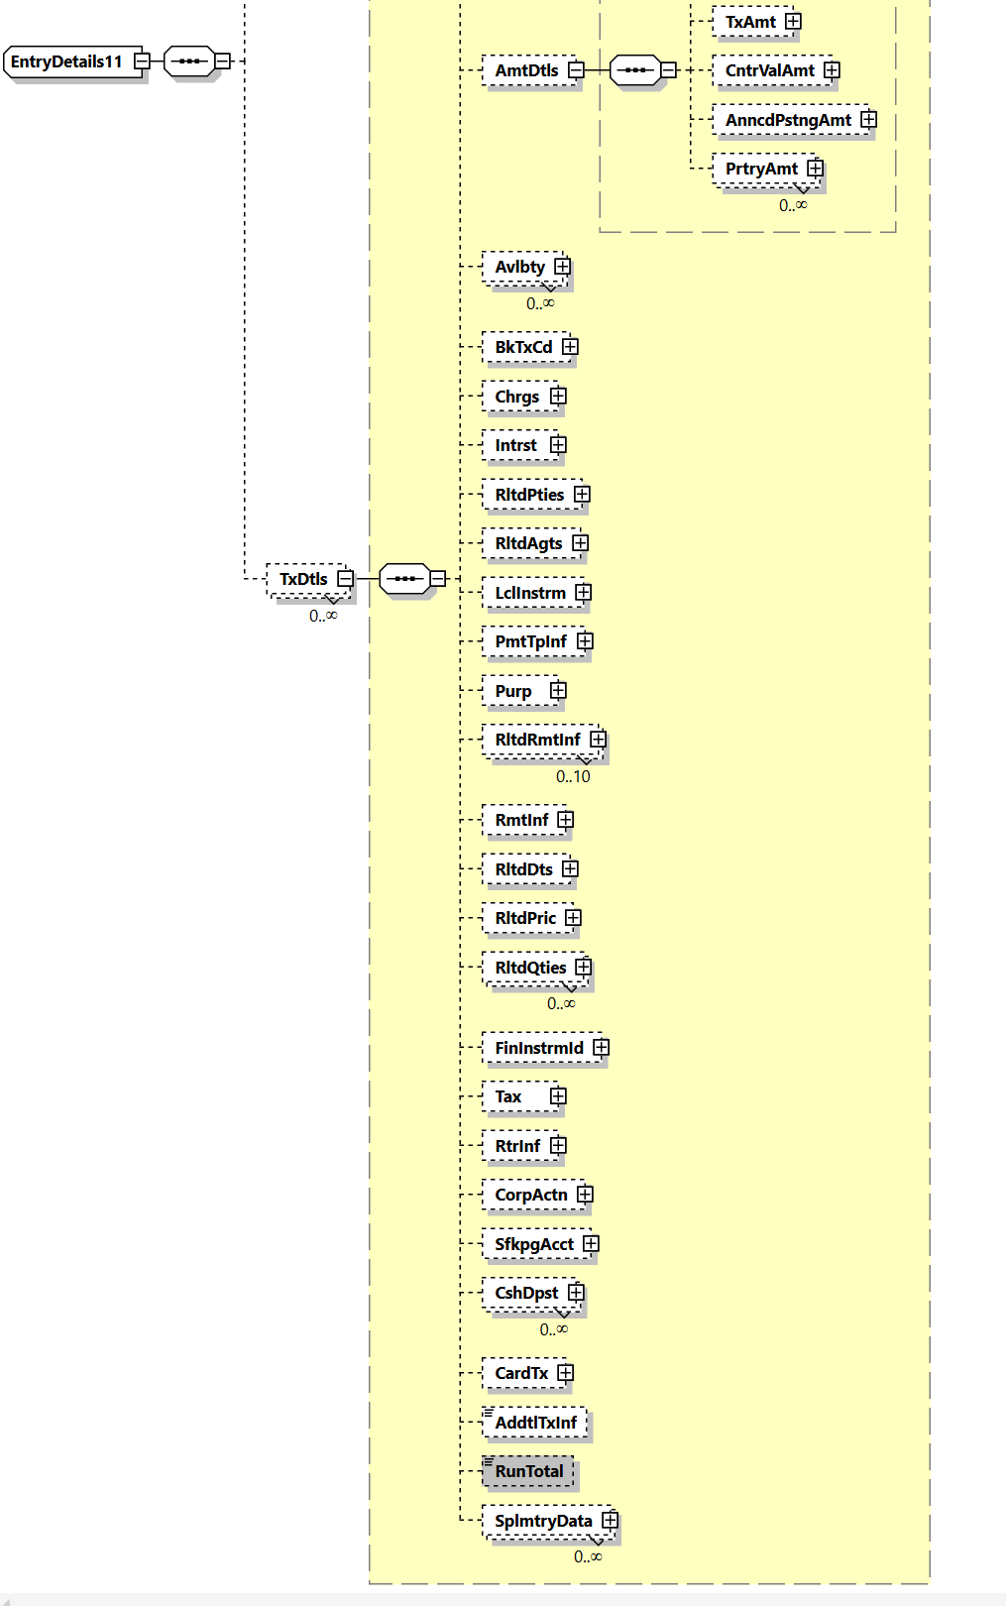
The component could be consisted of the same elements as CashBalance8, but might be limited to less elements as well.
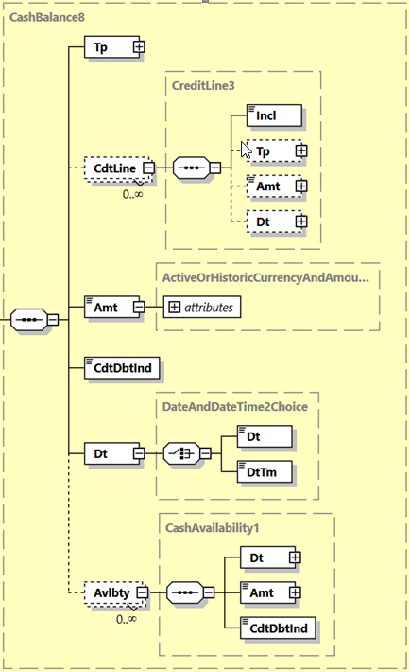

Purpose of the change:
With the increasing implementation of instant payment schemes and systems, the need for comprehensive information is growing. One example is the reporting of respective transactions which can be used as a base for various services by clients, e.g e-commerce provider.
One new feature is the RunningTotal indicating the immediate result of transaction on the bank account of the client.
This allow banks and provider to offer similar services with instant payments, as already know by card transaction (e.g. 100 USD debited, you available amount its USD 4383).
In addition, this information can be used to oversee the liquidity and for statistical purposes.

Urgency of the request:
There is no specific timeline for this change request. I can be assumed, that before 2025 our market is not changing the message version. Nevertheless, it may be helpful for other markets, if this option is available within the next cycle.

Business examples:
camt.054 offered as single debit or credit notification. In this case informing the client of a credit of an incoming payment of SEK 105’678.50 resulting in a running total of SEK 507’328.25
Element | <XMLTag> | Content
Group Header | <GrpHdr>
MessageIdentification | <MsgId> | AAAASESS-FP-00001
CreationDateTime | <CreDtTm> | 2015-10-18T13:20:00+01:00
Notification | <Ntfctn>
Identification | <Id> | AAAASESS-FP-CN-98765
CreationDateTime | <CreDtTm> | 2015-10-18T13:20:00+01:00
Account | <Acct>
Identification | <Id>
Other | <Othr>
Identification | <Id> | 50000000054910000003
Owner | <Ownr>
Name | <Nm> | FINPETROL
Servicer | <Svcr>
FinancialInstitutionIdentification | <FinInstnId>
Name | <Nm> | AAAA BANKEN
PostalAddress | <PstlAdr>
Country | <Ctry> | SE
Entry | <Ntry>
Amount | <Amt> | SEK 105678.50
CreditDebitIndicator | <CdtDbtInd> | CRDT
Status | <Sts> | BOOK
BookingDate | <BookgDt>
DateTime | <DtTm> | 2015-10-18T13:15:00+01:00
ValueDate | <ValDt>
Date | <Dt> | 2015-10-18
AccountServicerReference | <AcctSvcrRef> | AAAASESS-FP-CN-98765/01
BankTransactionCode | <BkTxCd>
Domain | <Domn>
Code | <Cd> | PAYM
Family | <Fmly>
Code | <Cd> | 0001
SubFamilyCode | <SbFmlyCd> | 0005
EntryDetails | <NtryDtls>
TransactionDetails | <TxDtls>
References | <Refs>
EndToEndIdentification | <EndToEndId> | MUELL/FINP/RA12345
……
RunningTotal | <RunTotal>
Type | <Tp>
Code | <Cd> | ITBD
Amount | <Amt> | SEK 507328.25
CreditDebitIndicator | <CdtDbtInd> | CRDT
Date | <Dt> | 2015-10-18T13:15:00+01:00

SEG/TSG recommendation:
This section is not to be taken care of by the submitter of the change request. It will be completed in due time by the SEG(s) in charge of the related ISO 20022 messages or the TSG for changes related to the BAH.

Consider |  | X | Timing
 |  |  | - Next yearly cycle: 2022/2023  (the change will be considered for implementation in the yearly maintenance cycle which starts in 2022 and completes with the publication of new message versions in the spring of 2023) |  | X
- At the occasion of the next maintenance of the messages
(the change will be considered for implementation, but does not justify maintenance of the messages in its own right – will be pending until more critical change requests are received for the messages)
- Urgent unscheduled
(the change justifies an urgent implementation outside of the normal yearly cycle)
 |  |  | - Other timing:
Comments:

Reject
Reason for rejection:

Impact analysis and type of impact:
Following the detailed analysis of the impact of the changes to the existing messages, we identified no further impacted messages.
The below list provides the full list of impacted messages per message set:
Bank-to-Customer Cash Management message set:
- camt.052.001.10 - BankToCustomerAccountReportV10
- camt.053.001.10 - BankToCustomerStatementV10
- camt.054.001.10 - BankToCustomerDebitCreditNotificationV10

Proposed implementation:
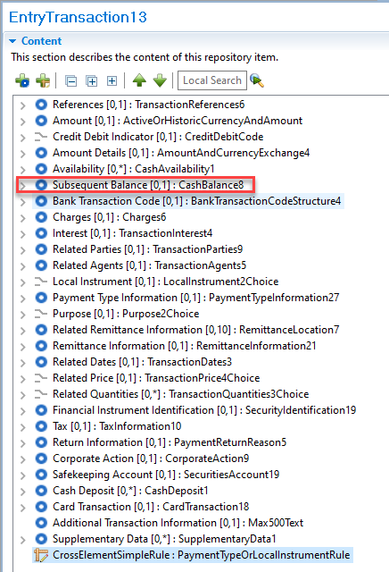

Questions to the SEG
Adding the new element to Transaction Details (within Entry Details) could see the element repeated multiple times, especially where an entry is a consolidated accounting entry with multiple underlying entries. Could this requirement be supported by the Balance element with a dedicated Type and Sub-Type within the Entry block?

Proposed timing:
The submitting organisation confirms that it can implement the requested changes in the requested timing.

Timing | As requested

Final decision of the SEG(s):

Approve

Reject | X
Reason for rejection:

Additional technical adjustments in the ISO 20022 rules identified during the maintenance (standing change request)

As part of the implementation, we have identified a number of technical errors in the description of the rules defined in the messages. Below is the exhaustive list of corrections as applied to the messages:

 | Issue in rule | Description of the change required
1. | The validation (expression) within the ChequeMaturityDateRule is incorrect and does not match the documentation.  The documentation states -  If ChequeMaturityDate is present, then ChequeType must be present and equal to DRFT or ELDR. | Validation (expression) needs to be updated from…  On Condition  /ChequeType is present  And /ChequeType is within DataType <<Code>> ChequeType3Code  Following Must be True  /ChequeMaturityDate Must be absent  To…  On Condition  /ChequeType is present  And /ChequeType is within DataType <<Code>> ChequeType3Code  Following Must be True  /ChequeMaturityDate Must be present
2. | The validation (expression) within the ChargesAccountAgentRule is incorrect and has been removed.  The current formal rule cannot be validated and formal definition will be deleted. | Validation (expression) will be removed as impossible to network validate.  On Condition  /ChargesAccountAgent is present  Following Must be True  /ChargesAccountAgent/FinancialInstitutionIdentification/Name Must be equal to value 'Branch of DebtorAgent'

List of rules impacted by Item 1:

Message | Rule Name | Location of the rule in the message
AccountSwitchInformationRequestV04 | ChequeMaturityDateRule | Cheque11
AccountSwitchInformationResponseV04 | ChequeMaturityDateRule | Cheque11
AccountSwitchCancelExistingPaymentV04 | ChequeMaturityDateRule | Cheque11
AccountSwitchRequestBalanceTransferV04 | ChequeMaturityDateRule | Cheque11
AccountSwitchBalanceTransferAcknowledgementV04 | ChequeMaturityDateRule | Cheque11
AccountSwitchRequestPaymentV04 | ChequeMaturityDateRule | Cheque11
CustomerCreditTransferInitiationV11 | ChequeMaturityDateRule | Cheque11
CreditorPaymentActivationRequestV09 | ChequeMaturityDateRule | Cheque11

List of rules impacted by Item 2:

Message | Rule Name | Location of the rule in the message
CustomerCreditTransferInitiationV11 | ChargesAccountAgentRule | PaymentInstruction40

The ISO 20022 RA has noted these issues and will update the impacted messages as and when new versions arise from approved change requests. The following message definitions do have new versions as part of the 2022/2023 maintenance period and therefore will be updated –
- pain.013.001.09 CreditorPaymentActivationRequestV09
Proposed implementation:
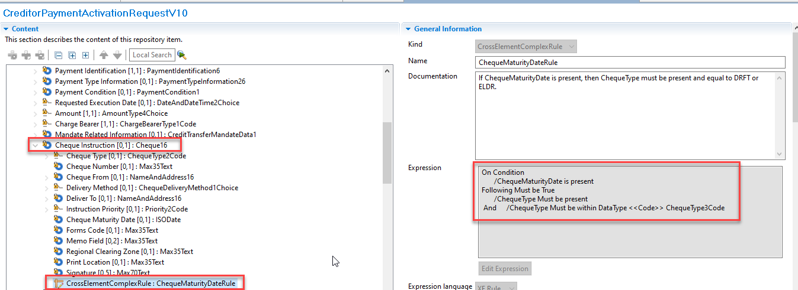

The Bank of Russia Regulation dated 29.06.2021 # 762-P “On Funds Transfer Rules”
Only if the PaySEG decides to align with the other messages

