Maintenance Change Request
for the update of ISO 20022 financial repository items

Name of the request:
“ISO 20022 FX Maintenance 2022/2023”

Submitting organisation(s):
CLS Bank International
Exchange Tower
Harbour Exchange Square
London E14 9GE

Related messages:

Under this maintenance, below existing ISO 20022 message definitions will be maintained (resulting from the impact analysis performed on each CR).

Post Trade Foreign Exchange message set:
- admi.017.001.01 - ProcessingRequestV01
- camt.088.001.01 - NetReportV01
- fxtr.008.001.06 - ForeignExchangeTradeStatusNotificationV06
- fxtr.014.001.04 - ForeignExchangeTradeInstructionV04
- fxtr.015.001.04 - ForeignExchangeTradeInstructionAmendmentV04
- fxtr.016.001.04 - ForeignExchangeTradeInstructionCancellationV04
- fxtr.017.001.04 - ForeignExchangeTradeStatusAndDetailsNotificationV04
- fxtr.030.001.04 - ForeignExchangeTradeBulkStatusNotificationV04
- reda.060.001.01 - NettingCutOffReferenceDataUpdateRequestV01
- reda.061.001.01 - NettingCutOffReferenceDataReportV01

Commitments of the submitting organisation:

The submitting organisations confirm that they can and will:
- undertake the development of the new version of the candidate ISO 20022 message models that it will submit to the RA for compliance review and evaluation. New valid Message Definition models will be made available to the RA by December 1.
- provide a new version of part 1 of the related Message Definition Reports (MDR) by December 1, and new examples of valid message instances of each candidate message (only when valid samples were published for current version) by May 1 at the latest.
- address any queries related to the description of the new models and messages as published by the RA on the ISO 20022 website.

CLS Bank International intends to implement above new versions on its network as part of the 2023 Standards release once the related documentation has been published by the RA.

The submitting organisations confirm their knowledge and acceptance of the ISO 20022 Intellectual Property Rights policy for contributing organisations, as follows.
“Organisations that contribute information to be incorporated into the ISO 20022 Repository shall keep any Intellectual Property Rights (IPR) they have on this information. A contributing organisation warrants that it has sufficient rights on the contributed information to have it published in the ISO 20022 Repository through the ISO 20022 Registration Authority in accordance with the rules set in ISO 20022. To ascertain a widespread, public and uniform use of the ISO 20022 Repository information, the contributing organisation grants third parties a non-exclusive, royalty-free license to use the published information”.

Contact persons:
Stuart Buckley – CLS Bank International, sbuckley@cls-services.com
Hilal Ahamed Thawkamangalam – CLS Bank International, hthawkamangalam@cls-services.com

Change request CR1116:
Update BIC Identifier data type to latest version

Origin of the request:
A.1 Submitter: CLS Bank International
A.2 Contact person: Stuart Buckley. sbuckley@cls-services.com
A.3 Sponsors: This change has been socialised with all CLS Member/Participant banks via an official Participant notice. We adopt a policy at CLS of aligning our messages to the latest standards where there is a valid business case to do so. No objections have been received.
The list of ISO 20022 messages which would be impacted by the change, including the Message IDs as shown in the Catalogue of ISO 20022 messages. Only the latest version of a message definition can be maintained.
Message | Message Name | AnyBIC Update?
fxtr.008.001.06.xsd | ForeignExchangeTradeStatusNotificationV06 | Yes
fxtr.014.001.04.xsd | ForeignExchangeTradeInstructionV04 | Yes
fxtr.015.001.04.xsd | ForeignExchangeTradeInstructionAmendmentV04 | Yes
fxtr.016.001.04.xsd | ForeignExchangeTradeInstructionCancellationV04 | Yes
fxtr.017.001.04.xsd | ForeignExchangeTradeStatusAndDetailsNotificationV04 | Yes
fxtr.030.001.04.xsd | ForeignExchangeTradeBulkStatusNotificationV04 | Yes
camt.088.001.01.xsd | NetReportV01 | Yes
reda.060.001.01.xsd | NettingCutOffReferenceDataUpdateRequestV01 | Yes
reda.061.001.01.xsd | NettingCutOffReferenceDataReportV01 | Yes

Description of the change request:
Updating the message schemas listed above for the suite of CLS related FX messages, with the “AnyBICDec2014Identifier” Instead of “AnyBICIdentifier.” as initially introduced in (CR0751) in 2018.

Purpose of the change:
CLS requires this change to meet the Participant requirements on BIC validation for the CLSNet service.
CLS also has a policy of aligning messages to the latest versions and standards. Updating the BIC type has been deferred for four years but is required going forward to meet our Members expectations regarding standards alignment across our message suite.

Urgency of the request:
Default timeline of June 1st for submission and availability of the new versions in SR2023.

Business examples:
Examples illustrating the change request.
Current:
<xs:simpleType name="AnyBICIdentifier">
<xs:restriction base="xs:string">
<xs:pattern value="[A-Z]{6,6}[A-Z2-9][A-NP-Z0-9]([A-Z0-9]{3,3}){0,1}"/>
</xs:restriction>
</xs:simpleType>
Proposed:
<xs:simpleType name="AnyBICDec2014Identifier">
<xs:restriction base="xs:string">
<xs:pattern value="[A-Z0-9]{4,4}[A-Z]{2,2}[A-Z0-9]{2,2}([A-Z0-9]{3,3}){0,1}"/>
</xs:restriction>
</xs:simpleType>

SEG/TSG recommendation:
This section is not to be taken care of by the submitter of the change request. It will be completed in due time by the SEG(s) in charge of the related ISO 20022 messages or the TSG for changes related to the BAH.

Consider |  | X | Timing
 |  |  | - Next yearly cycle: 2022/2023  (the change will be considered for implementation in the yearly maintenance cycle which starts in 2022 and completes with the publication of new message versions in the spring of 2023) |  | X
- At the occasion of the next maintenance of the messages
(the change will be considered for implementation, but does not justify maintenance of the messages in its own right – will be pending until more critical change requests are received for the messages)
- Urgent unscheduled
(the change justifies an urgent implementation outside of the normal yearly cycle)
 |  |  | - Other timing:
Comments:

Reject
Reason for rejection:

Impact analysis and type of impact:
Following the detailed analysis of the impact of the changes to the existing messages, we identified one additional impacted message (ProcessingRequestV01), compared to the list already proposed by the change request submitter.
The below list provides the full list of impacted messages per message set:
Post Trade Foreign Exchange message set:
- admi.017.001.01 - ProcessingRequestV01
- camt.088.001.01 - NetReportV01
- fxtr.008.001.06 - ForeignExchangeTradeStatusNotificationV06
- fxtr.014.001.04 - ForeignExchangeTradeInstructionV04
- fxtr.015.001.04 - ForeignExchangeTradeInstructionAmendmentV04
- fxtr.016.001.04 - ForeignExchangeTradeInstructionCancellationV04
- fxtr.017.001.04 - ForeignExchangeTradeStatusAndDetailsNotificationV04
- fxtr.030.001.04 - ForeignExchangeTradeBulkStatusNotificationV04
- reda.060.001.01 - NettingCutOffReferenceDataUpdateRequestV01
- reda.061.001.01 - NettingCutOffReferenceDataReportV01

Proposed implementation:
As per proposed implementation, the following changes update will result in the replacement of PartyIdentifiation73Choice with a new version with the updated BIC Identifier data type:
The updates will result in the following structure:
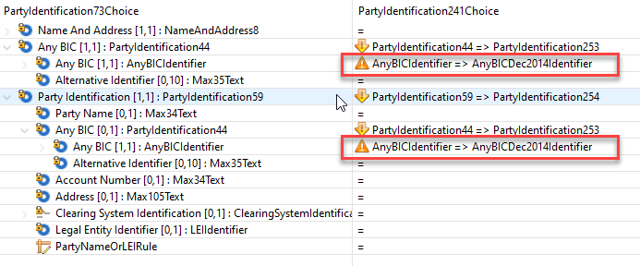
Remark:
As part of the update, the SupplementaryData has been added to the admi.017 message.

Proposed timing:
The submitting organisation confirms that it can implement the requested changes in the requested timing.

Timing | As requested

Final decision of the SEG(s):

Approve | X
Comments:

Reject
Reason for rejection:

Change request CR1117:
Addition of the Commissions and Fees element defined in the MT messages

Origin of the request:
A.1 Submitter: CLS Bank International
A.2 Contact person: Stuart Buckley. sbuckley@cls-services.com
A.3 Sponsors: This change has been socialised with all CLS Member/Participant banks via an official Participant notice. We adopt a policy at CLS of aligning our messages to the latest standards where there is a valid business case to do so. No objections have been received.
The list of ISO 20022 messages which would be impacted by the change, including the Message IDs as shown in the Catalogue of ISO 20022 messages. Only the latest version of a message definition can be maintained.

Message | Message Name
fxtr.014.001.04.xsd | ForeignExchangeTradeInstructionV04
fxtr.015.001.04.xsd | ForeignExchangeTradeInstructionAmendmentV04
fxtr.016.001.04.xsd | ForeignExchangeTradeInstructionCancellationV04
fxtr.017.001.04.xsd | ForeignExchangeTradeStatusAndDetailsNotificationV04

Description of the change request:
Updating the message schemas listed above from the suite of CLS related FX messages, with Commission and Fee’s fields to align with field 34C and Digital Token Identifier field to align with field 35C in the MT 300 and MT 304.

Purpose of the change:
CLS also has a policy of aligning messages to the latest versions and standards. Adding the Commission and Fee’s field to align to the MT 300 and MT 304 has been deferred for four years and there are therefore obvious synergies to add the Digital Token Identifier in tandem with these changes. This will meet our Members expectations regarding standards alignment across our message suite.

Urgency of the request:
Default timeline of June 1st for submission and availability of the new versions in SR2023.

Business examples:
Examples illustrating the change request.
These are new MX elements required in the fxtr messages to align with the below MT change requests from SR2018 and SR2022 respectively.

Field 34C
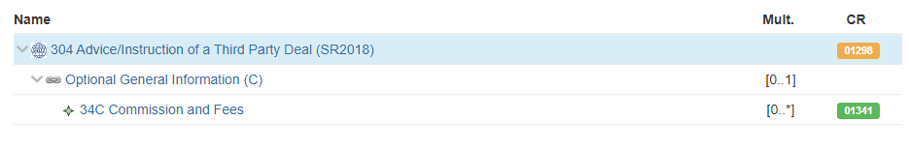

Field 35C
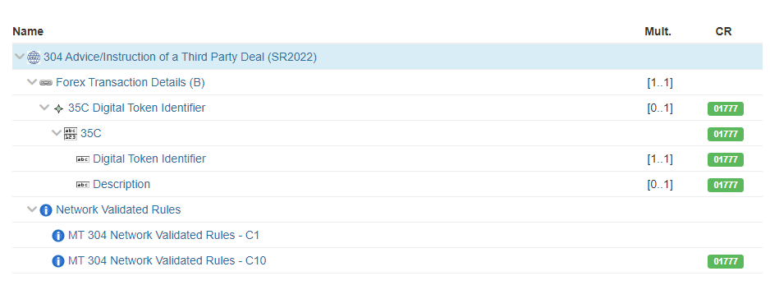

SEG/TSG recommendation:
This section is not to be taken care of by the submitter of the change request. It will be completed in due time by the SEG(s) in charge of the related ISO 20022 messages or the TSG for changes related to the BAH.

Consider |  | X | Timing
 |  |  | - Next yearly cycle: 2022/2023  (the change will be considered for implementation in the yearly maintenance cycle which starts in 2022 and completes with the publication of new message versions in the spring of 2023) |  | X
- At the occasion of the next maintenance of the messages
(the change will be considered for implementation, but does not justify maintenance of the messages in its own right – will be pending until more critical change requests are received for the messages)
- Urgent unscheduled
(the change justifies an urgent implementation outside of the normal yearly cycle)
 |  |  | - Other timing:
Comments:

Reject
Reason for rejection:

Impact analysis and type of impact:
Following the detailed analysis of the impact of the changes to the existing messages, we identified one additional impacted message (ForeignExchangeTradeStatusNotificationV06), compared to the list already proposed by the change request submitter.
The below list provides the full list of impacted messages per message set:
Post Trade Foreign Exchange message set:
- fxtr.008.001.06 - ForeignExchangeTradeStatusNotificationV06
- fxtr.014.001.04 - ForeignExchangeTradeInstructionV04
- fxtr.015.001.04 - ForeignExchangeTradeInstructionAmendmentV04
- fxtr.016.001.04 - ForeignExchangeTradeInstructionCancellationV04
- fxtr.017.001.04 - ForeignExchangeTradeStatusAndDetailsNotificationV04
- fxtr.030.001.04 - ForeignExchangeTradeBulkStatusNotificationV04

Proposed implementation:
The current Regulatory Reporting element will be extended to include the Commissions and Fees element for the implementation of the MT Field 34C
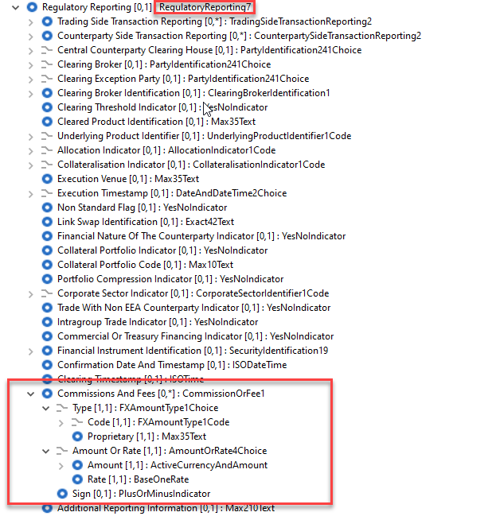
The current TradeAmounts element will be updated to include the structure Digital Token Identifier:
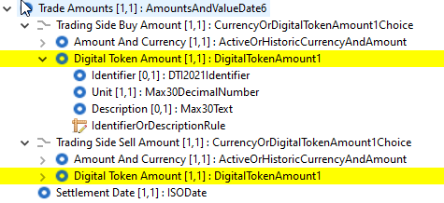

Proposed timing:
The submitting organisation confirms that it can implement the requested changes in the requested timing.

Timing | As requested

Final decision of the SEG(s):

Approve | X

Reject
Reason for rejection:

