Maintenance Change Request
for the update of ISO 20022 financial repository items
Note: the purpose of this document is to give guidelines to submitting organizations that will develop a new version of existing ISO 20022 messages based on change requests screened by the Standards Evaluation Group(s). Such development is subject to the approval of a Maintenance Change Request which must include a detailed description of the impact of each change on the related messages. The Maintenance Change Request must start with a general chapter covering topics related to the whole maintenance effort and a specific chapter for each change request, as described below. Please consult the iso20022.org website for additional details on the maintenance process. Valid Maintenance Change Requests for the following ISO 20022 yearly maintenance cycle must be sent to iso20022ra@iso20022.org by August 21st.
- Name of the request:
CAPE Messages Maintenance for year 2022-2023

Change request number 1118 Business Area Code 6
Change request number 1119 NonFinancialRequestType1Code 15
Change request number 1120 ActionType12Code 29
Change request number 1121 MessageFunctionCode 35
Change request number 1131 messageItemCode 48
Change request number 1132 OutputBarcode 54
Change request number 1133 SaleToPOIProtocolParameter 61
Change request number 1134 Salt in TMS messages 65
Change request number 1135 ServiceProviderParameters in AcceptorConfigurationUpdate 73
Change request number 1136 Signer Information 85
Change request number 1137 TransactionLog Request and Response 99

- Submitting organization(s):
nexo A.I.S.B.L. formerly (EPASOrg).

- Related messages:

- AcceptorAuthorisationRequest V11 caaa.001.001.11
- AcceptorAuthorisationResponse V11 caaa.002.001.11
- AcceptorCompletionAdvice V11 caaa.003.001.11
- AcceptorCompletionAdviceResponse V10 caaa.004.001.10
- AcceptorCancellationRequest V11 caaa.005.001.11
- AcceptorCancellationResponse V10 caaa.006.001.10
- AcceptorCancellationAdvice V11 caaa.007.001.11
- AcceptorCancellationAdviceResponse V10 caaa.008.001.10
- AcceptorReconciliationRequest V10 caaa.009.001.10
- AcceptorReconciliationResponse V09 caaa.010.001.09
- AcceptorBatchTransfer V11 caaa.011.001.11
- AcceptorBatchTransferResponse V10 caaa.012.001.10
- AcceptorDiagnosticRequest V10 caaa.013.001.10
- AcceptorDiagnosticResponse V09 caaa.014.001.09
- AcceptorCurrencyConversionRequest V09 caaa.016.001.09
- AcceptorCurrencyConversionResponse V09 caaa.017.001.09
- AcceptorCurrencyConversionAdvice V06 caaa.018.001.06
- AcceptorCurrencyConversionAdviceResponse V05 caaa.019.001.05
- TransactionAdvice V03 caaa.020.001.03
- TransactionAdviceResponse V03 caaa.021.001.03
- AcceptorNonFinancialRequest V02 caaa.022.001.02
- AcceptorNonFinancialResponse V02 caaa.023.001.02
- AcceptorTransactionLogReportRequest V02 caaa.024.001.02
- AcceptorTransactionLogReportResponse V02 caaa.025.001.02

- SaleToPOIServiceRequest V04 casp.001.001.04
- SaleToPOIServiceResponse V04 casp.002.001.04
- SaleToPOIReconciliationRequest V04 casp.003.001.04
- SaleToPOIReconciliationResponse V04 casp.004.001.04
- SaleToPOISessionManagementRequest V04 casp.005.001.04
- SaleToPOISessionManagementResponse V04 casp.006.001.04
- SaleToPOIAdministrativeRequest V04 casp.007.001.04
- SaleToPOIAdministrativeResponse V04 casp.008.001.04
- SaleToPOIReportRequest V04 casp.009.001.04
- SaleToPOIReportResponse V04 casp.010.001.04
- SaleToPOIAbort V04 casp.011.001.04
- SaleToPOIEventNotification V04 casp.012.001.04
- SaleToPOIMessageStatusRequest V04 casp.014.001.04
- SaleToPOIMessageStatusResponse V04 casp.015.001.04
- SaleToPOIDeviceRequest V04 casp.016.001.04
- SaleToPOIDeviceResponse V04 casp.017.001.04

- StatusReport V11 catm.001.001.11
- ManagementPlanReplacement V10 catm.002.001.10
- AcceptorConfigurationUpdate V11 catm.003.001.11
- MaintenanceDelegationRequest V08 catm.005.001.08
- MaintenanceDelegationResponse V06 catm.006.001.06
- CertificateManagementRequest V05 catm.007.001.05
- CertificateManagementResponse V05 catm.008.001.05

- Commitments of the submitting organization:

nexo confirms that it can and will:
- undertake the development of the new version of the candidate ISO 20022 message models
- that it will submit to the RA for compliance review and evaluation.
- submit new valid Message Definition models to the RA by December 1.
- provide a new version of part 1 of the Message Definition Report (MDR) by December 1, and, new examples of valid message instances of each candidate message by May 1 at the latest.
- address any queries related to the description of the new models and messages as published by the RA on the ISO 20022 website.

nexo intends to support any testing or the actual implementation of the new version of the messages once the related documentation has been published by the RA. The purpose is to ensure that the documentation of the new version of the messages is accurate and consistent and to verify that these approved messages can be implemented with no adverse effects on communication infrastructures and/or applications.
nexo confirms its knowledge and acceptance of the ISO 20022 Intellectual Property Rights policy for contributing organizations, as follows.
“Organizations that contribute information to be incorporated into the ISO 20022 Repository shall keep any Intellectual Property Rights (IPR) they have on this information. A contributing organization warrants that it has sufficient rights on the contributed information to have it published in the ISO 20022 Repository through the ISO 20022 Registration Authority in accordance with the rules set in ISO 20022. To ascertain a widespread, public and uniform use of the ISO 20022 Repository information, the contributing organization grants third parties a non-exclusive, royalty-free license to use the published information”.

In the analysis made on the following pages, nexo highlights ripple effect through bullets and component changed by a previous Change Request in green in every impact analysis. In each chapter devoted to the implementation study, nexo presents the resulting implementation of all Change Request with respect to the legend presented below.

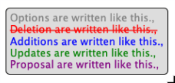

- Contact persons:

The submitting organization will identify the person(s) at the submitting organization that can be contacted to get additional information on this Maintenance Change Request.

- Philippe CECE (philippe.cece@ingenico.com), +33 6 84 42 93 14
- Evelyne de JONGHE (evelyne.de-jonghe@frenchsys.com), +33 6 49 31 04 75
- Laure BELTRI (laure.beltri@frenchsys.com), +33 6 72 57 79 75
- Philippe MERMOUD (philippe.mermoud@natixis.com), + 33 5 61 10 25 80
- Robert FARGIER (robert.fargier@istium.pro), +33 6 30 73 53 32
- Andrew HAMILTON (andrew.hamilton@ncr.com), +44 138 259 21 84
- Carlo PALITTI (carlo.palitti@kal.com), +39 388 8875690

Change request number 1118 Business Area Code

Copy of the approved change request:

- Origin of the request:
A.1 Submitter: nexo A.I.S.B.L
A.2 Contact person: Philippe CECE (Philippe.cece@ingenico.com) / Evelyne de JONGHE (evelyne.de-jonghe@frenchsys.com)
A.3 Sponsors: nexo A.I.S.B.L.

- Related messages:

- AcceptorAuthorisationRequest V11 caaa.001.001.11,
- AcceptorCompletionAdvice V11 caaa.003.001.11,
- AcceptorCancellationRequest V11 caaa.005.001.11,
- AcceptorCancellationAdvice V11 caaa.007.001.11,
- AcceptorBatchTransfer V11 caaa.011.001.11,
- TransactionAdvice V03 caaa.020.001.03,
- AcceptorNonFinancialRequest V02 caaa.022.001.02,
- AcceptorTransactionLogReportRequest V02 caaa.024.001.02,
- AcceptorTransactionLogReportResponse V02 caaa.025.001.02,

- SaleToPOIServiceRequest V04 casp.001.001.04,
- SaleToPOIServiceResponse V04 casp.002.001.04,
- SaleToPOIReconciliationRequest V04 casp.003.001.04,
- SaleToPOIReconciliationResponse V04 casp.004.001.04,
- SaleToPOISessionManagementRequest V04 casp.005.001.04,
- SaleToPOISessionManagementResponse V04 casp.006.001.04,
- SaleToPOIAdministrativeRequest V04 casp.007.001.04,
- SaleToPOIAdministrativeResponse V04 casp.008.001.04,
- SaleToPOIReportRequest V04 casp.009.001.04,
- SaleToPOIReportResponse V04 casp.010.001.04,
- SaleToPOIAbort V04 casp.011.001.04,
- SaleToPOIEventNotification V04 casp.012.001.04,
- SaleToPOIMessageStatusRequest V04 casp.014.001.04,
- SaleToPOIMessageStatusResponse V04 casp.015.001.04,
- SaleToPOIDeviceRequest V04 casp.016.001.04,
- SaleToPOIDeviceResponse V04 casp.017.001.04,

- StatusReport V11 catm.001.001.11,
- AcceptorConfigurationUpdate V10 catm.002.001.10,
- MaintenanceDelegationRequest V08 catm.005.001.08,

- Description of the change request:

In the BusinessArea1Code we are currently using a code value to identify transit open payment solution, but without clearly stating that it is linked to Transport solution. Consequently, we would like to adapt this code value to add the domain information.
Additionally, we would like to add a new code value for Open Solution that could be made on Energy domain, like Electric Vehicle.

- Purpose of the change:

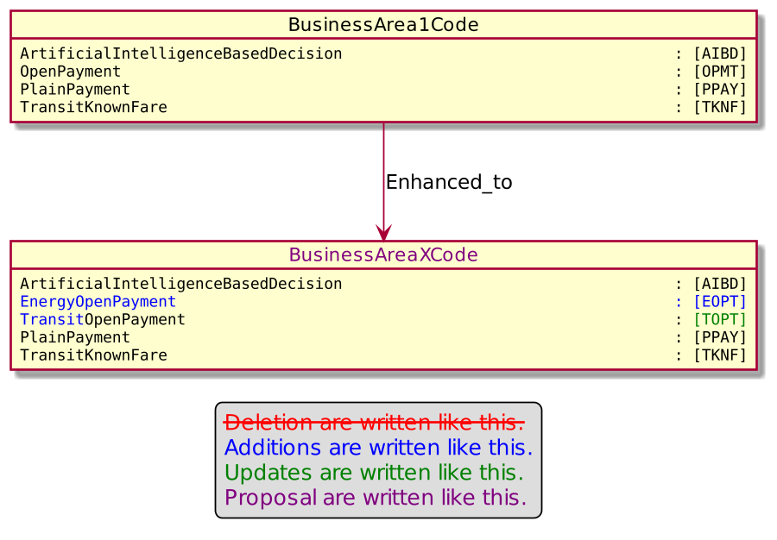
- Urgency of the request:

Urgent

- Business examples:
Examples illustrating the change request.
- SEG/TSG recommendation:
This section is not to be taken care of by the submitter of the change request. It will be completed in due time by the SEG(s) in charge of the related ISO 20022 messages or the TSG for changes related to the BAH.

Consider |  | X | Timing
 |  |  | - Next yearly cycle: 2022/2023  (the change will be considered for implementation in the yearly maintenance cycle which starts in 2022 and completes with the publication of new message versions in the spring of 2023) |  | X
- At the occasion of the next maintenance of the messages
(the change will be considered for implementation, but does not justify maintenance of the messages in its own right – will be pending until more critical change requests are received for the messages)
- Urgent unscheduled
(the change justifies an urgent implementation outside of the normal yearly cycle)
 |  |  | - Other timing:
Comments:

Reject
Reason for rejection:

- Impact analysis and type of impact:

The update of BusinessArea1Code will be done accordingly to the Change Request.

The ripple effect analysis has been done on this element.

On BusinessArea1Code

- BusinessArea1Code
  - PaymentContext28
    - CardPaymentContext29
      - AcceptorAuthorisationRequest11
        - AcceptorAuthorisationRequest V11 caaa.001.001.011
      - AcceptorCancellationAdvice11
        - AcceptorCanncellationAdvice V11 caaa.007.001.11
      - AcceptorCancellationRequest11
        - AcceptorCancellationRequest V11 caaa.005.001.11
      - AcceptorCompletionAdvice11
        - AcceptorCompletionAdvice V11 caaa.003.001.11
        - TransactionAdvice V03 caaa.020.001.03
      - ReconciliationRequest5
        - SaleToPOIReconciliationRequest V04 casp.003.001.04
      - ReconciliationResponse6
        - SaleToPOIReconciliationResponse V04 casp.004.001.04
      - ReportRequest5
        - SaleToPOIReportRequest V4 casp.009.001.04
        - AcceptorTransactionLogReportRequest V2 caaa.024.001.02
      - ReportResponse5
        - AcceptorTransactionLogReportResponse V2 caaa.025.001.02
        - SaleToPOIReportResponse V4 casp.010.001.04
      - CardPaymentDataSetTransaction39
        - CardPaymentDataSetTransaction10Choice
          - CardPaymentDataSet29 (Cf below)
      - CardPaymentDataSetTransaction40
        - CardPaymentDataSetTransaction10Choice
      - CardPaymentDataSetTransaction41
        - CardPaymentDataSetTransaction10Choice
      - CommonData11
        - CardPaymentDataSet29
      - SystemAbort5
        - SaleToPOIAbort V04 casp.011.001.04
      - SystemEventNotification5
        - SaleToPOIEventNotification V04 casp.012.001.04
      - NonFinancialRequestComponent2
        - AcceptorNonFinancialRequest V02 caaa.022.001.02
      - ServiceRequest5
        - SaleToPOIServiceRequest V04 casp.001.001.04
      - ServiceResponse6
        - SaleToPOIServiceResponse V04 casp.002.001.04
      - SessionManagementRequest5
        - SaleToPOISessionManagementRequest V04 casp.005.001.04
      - SessionManagementResponse5
        - SaleToPOISessionManagementResponse V04 casp.006.001.04
      - DeviceRequest5
        - SaleToPOIDeviceRequest V04 casp.016.001.04
        - TMSAction10
          - See below
      - DeviceResponse5
        - SaleToPOIDeviceResponse V04 casp.017.001.04
        - TMSEvent9
          - See below
      - MessageStatusRequest5
        - SaleToPOIMessageStatusRequest V04 casp.014.001.04
      - MessageStatusResponse6
        - SaleToPOIMessageStatusResponse V04 casp.015.001.04
      - AdministrativeRequest5
        - SaleToPOIAdministrativeRequest V04 casp.007.001.04
      - AdministrativeResponse5
        - SaleToPOIAdministrativeResponse V04 casp.008.001.04

On CardPaymentDataSet29

- CardPaymentDataSet29
  - CardPaymentBatchTransfer10
    - AcceptorBatchTransfer caaa.011.001.11

On TMSAction10

- TMSAction10
  - MaintenanceDelegateAction7
    - MaintenanceDelegation13
      - MaintenanceDelegationRequest8
        - MaintenanceDelegationRequest V08 catm.005.001.08
  - ManagementPlanContent10
    - TerminalManagementDataSet31
      - ManagementPlan10
        - ManagementPlanReplacement V10 catm.002.001.10

On TMSEvent9

- TMSEvent9
  - StatusReportContent11
    - StatusReportDataSetRequest3
      - StatusReport11
        - StatusReport V11 catm.001.001.11
    - DiagnosisResponse4
      - Session%ManagementResponse5

The severity of the impact of the proposed change for the message users should be indicated in the table below (either “no impact”, “conditional’ or “mandatory”).
Type of impact
 | No impact | The change(s) will not impact the schema (the version number will not change) and will not impact the business applications of any users, e.g. the clarification of a definition
X | Conditional | The change(s) will impact the schema (at least the version number) and the business applications of certain users but not all, e.g. the addition of an optional component
 | Mandatory | The change(s) will impact the schema and the business applications of all users, e.g. addition of a mandatory component.

- Proposed implementation:

The implementation will be done accordingly to the Change Request.
Then On BusinessArea1Code .

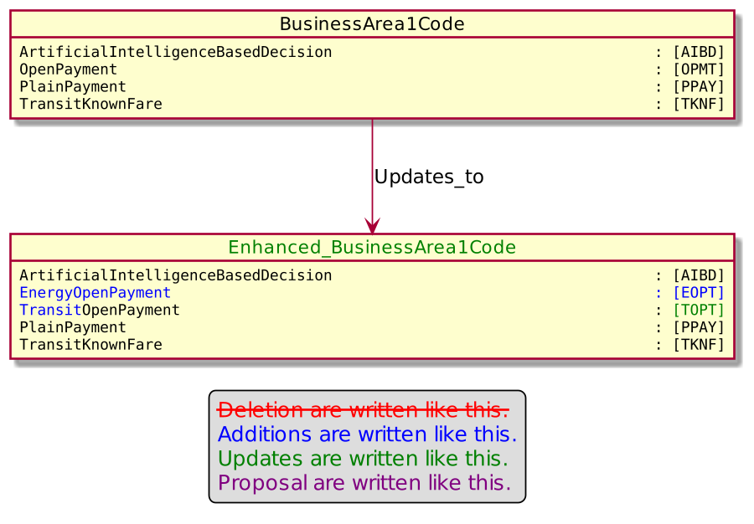

- Proposed timing:

The submitting organization confirms that it can implement the requested changes in the requested timing, or, if not, proposes another timing.
Timing | - As requested
 | - Other:

- Final decision of the SEG(s):
This section is not to be taken care of by the submitting organization. It will be completed in due time by the SEG(s) in charge of the related ISO 20022 messages.
Approve | X
Comments:

Reject
Reason for rejection:

Change request number 1119 NonFinancialRequestType1Code

Copy of the approved change request:
This is a copy of sections A to G of the change request approved by the SEG for further consideration as communicated to the submitting organization by the RA.

- Origin of the request:
A.1 Submitter: nexo A.I.S.B.L
A.2 Contact person: Philippe CECE (Philippe.cece@ingenico.com) / Evelyne de JONGHE (evelyne.de-jonghe@frenchsys.com)
A.3 Sponsors: nexo A.I.S.B.L.

- Related messages:

- AcceptorAuthorisationRequest V11 caaa.001.001.11,
- AcceptorAuthorisationResponse V11 caaa.002.001.11,
- AcceptorCompletionAdvice V11 caaa.003.001.11,
- AcceptorBatchTransfer V11 caaa.011.001.11,
- AcceptorCurrencyConversionRequest V09 caaa.016.001.09,
- AcceptorCurrencyConversionResponse V09 caaa.017.001.09,
- AcceptorCurrencyConversionAdvice V06 caaa.018.001.06,
- AcceptorCurrencyConversionAdviceResponse V03 caaa.020.001.03,
- AcceptorNonFinancialRequest V02 caaa.022.001.02,
- AcceptorNonFinancialResponse V02 caaa.023.001.02,
- AcceptorTransactionLogReportResponse V02 caaa.025.001.02,

- SaleToPOIServiceRequest V04 casp.001.001.04,
- SaleToPOIServiceResponse V04 casp.002.001.04,
- SaleToPOIReportResponse V04 casp.010.001.04,
- SaleToPOIMessageStatusResponse V04 casp.015.001.04,

- AcceptorConfigurationUpdate V11 catm.003.001.11,
- MaintenanceDelegationResponse V08 catm.005.001.08

- Description of the change request:

The aim of this Change Request is first to allow the exchange of Instalment Plans outside of a transaction. Then this behaviour will allow shorter transaction processing time and an improved integration in the sale step.
Additionally since the NonFinancialRequest message is exchanged outside of a transaction and to a service provider, it might also be an opportunity to exchange information through an AdditionalRequest which could be defined by another standards.
Then this new usage means that the NonFinancialResponse is able to convey multiple Instalment Plans and also a AdditionalResponse defined by another standards.

Secondly, since an Instalment is a loan, in some context a dedicated legal notice may be provided. Then we must update the RecurringTransaction4 message component to be sure to convey the relevant notice with the relevant Instalment Plan.

- Purpose of the change:

The NonFinancialRequestType1Code is updated with the 2 new options.
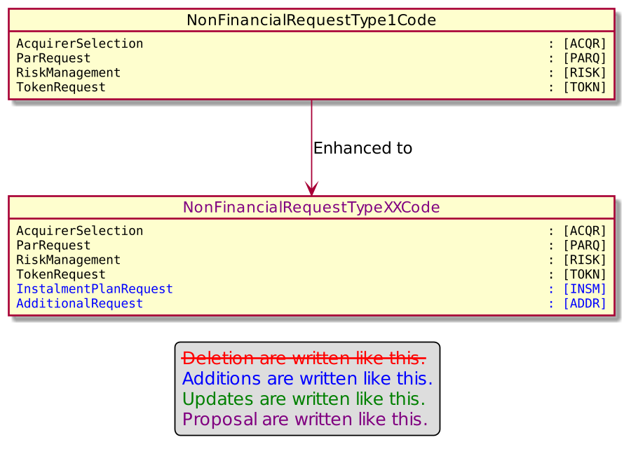
The core of the request is updated to support the exchange of an additional element defined by another standards.

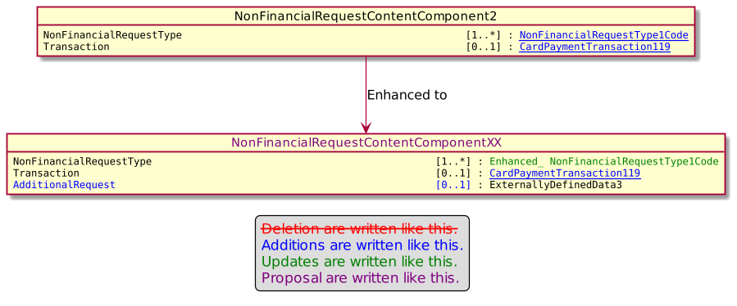

The content of the NonFinancialResponse message is updated to support a list of instalments that the POI may have to offer to the cardholder.

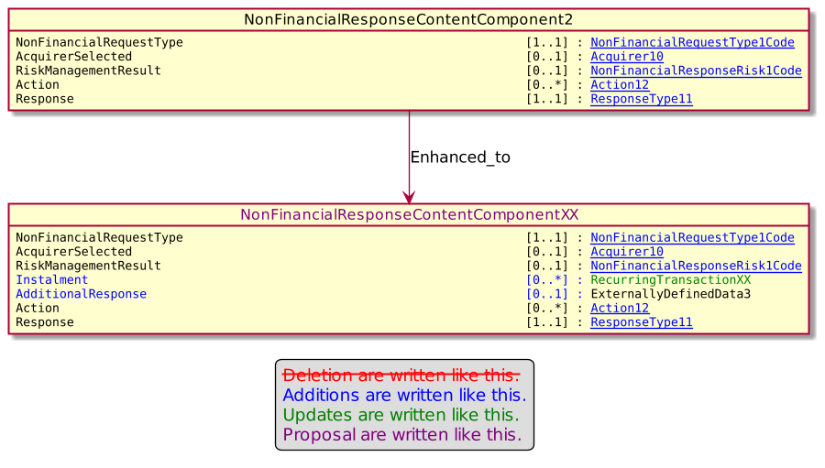

Finally, information related to a recurring transaction, like instalment, are updated to convey an optional notice.

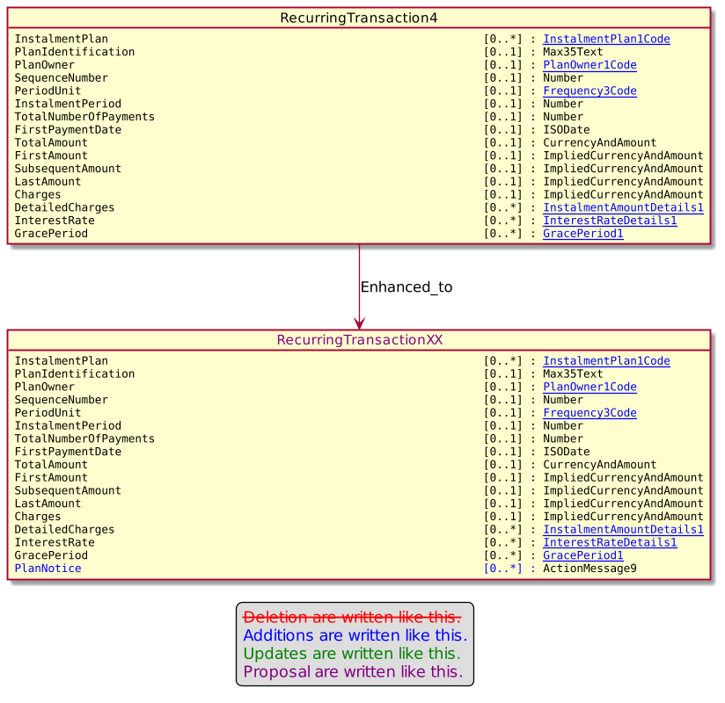

- Urgency of the request:

Urgent.

- Business examples:
Examples illustrating the change request.
- SEG/TSG recommendation:
This section is not to be taken care of by the submitter of the change request. It will be completed in due time by the SEG(s) in charge of the related ISO 20022 messages or the TSG for changes related to the BAH.

Consider |  |  | Timing
 |  |  | - Next yearly cycle: 2022/2023  (the change will be considered for implementation in the yearly maintenance cycle which starts in 2022 and completes with the publication of new message versions in the spring of 2023) |  | X
- At the occasion of the next maintenance of the messages
(the change will be considered for implementation, but does not justify maintenance of the messages in its own right – will be pending until more critical change requests are received for the messages)
- Urgent unscheduled
(the change justifies an urgent implementation outside of the normal yearly cycle)
 |  |  | - Other timing:
Comments:
AdditionalResponse should be [0..*]

Reject
Reason for rejection:

- Impact analysis and type of impact:

The modifications will be done accordingly to the Change Request with the correction identified by the CardSEG applied for AdditionalResponse and AdditionalRequest.

The ripple effect analysis has been done on these elements and provides the following result.

On NonFinancialRequestType1Code
- NonFinancialRequestType1Code
  - NonFinancialRequestContentComponent2
    - Cf below
  - NonFinancialResponseContentComponent2
    - Cf below
  - ServiceProviderParameters2
    - AcceptorConfigurationContent11
      - AcceptorConfigurationDataSet3
        - AcceptorConfiguration11
          - AcceptorConfigurationUpdate V11 catm.003.001.11
        - MaintenanceDelegation13

On NonFinancialRequestContentComponent2
- NonFinancialRequestContentComponent2
  - NonFinancialRequestComponent2

On NonFinancialResponseContentComponent2
- NonFinancialResponseContentComponent2
  - NonFinancialResponseComponent2
    - AcceptorNonFinancialResponse V02 caaa.023.001.02

On RecurringTransaction4
- RecurringTransaction4
  - CardPaymentTransactionDetails51
    - CardPaymentTransaction118
      - AcceptorCompletionAdvice11
      - CardPaymentDataSetTransaction41
    - CardPaymentTransaction119
      - AcceptorAuthorisationRequest11
      - CardPaymentDataSetTransaction40
      - NonFinancialRequestContentComponent2
    - CardPaymentTransaction120
      - AcceptorCurrencyConversionRequest9
        - AcceptorCurrencyConversionRequest V09 caaa.016.001.09
      - PaymentRequest4
        - ServiceRequest5
        - TransactionToPerform4Choice
          - Cf below
      - RetailerReversalResult4
        - ReversalResponse6
          - Cf below
      - RetailerPaymentResult4
        - PaymentResponse4
          - Cf below
        - PerformedTransaction4
          - Cf below
      - StoredValueData5
        - StoredValueRequest5
          - Cf below
        - StoredValueResponse5
          - ServiceResponse6
          - MessageStatusResponseData6
      - ReversalRequest4
        - ServiceRequest5
        - TransactionToPerform4Choice
      - LoyaltyTransaction4
        - LoyaltyRequest4
          - ServiceRequest5
          - TransactionToPerform4Choice
    - CardPaymentTransaction121
      - AcceptorAuthorisationResponse11
        - AcceptorAuthorisationResponse V11 caaa.002.001.11
      - AcceptorCurrencyConversionAdvice6
        - AcceptorCurrencyConversionAdvice V06 caaa.018.001.06
      - AcceptorCurrencyConversionResponse9
        - AcceptorCurrencyConversionResponse V09 caaa.017.001.09
      - CardPaymentDataSetTransaction38
        - CardPaymentDataSetTransaction10Choice

On TransactionToPerform4Choice
- TransactionToPerform4Choice
  - BatchRequest4
    - ServiceRequest5

On ReversalResponse
- ReversalResponse6
  - ServiceResponse6
  - MessageStatusResponseData6
    - MessageStatusResponse6

On PaymentResponse4
- PaymentResponse4
  - ServiceResponse6
  - MessageStatusResponseData6
  - PointOfInteractionTransactionReport4
    - ReportTransactionResponse4
      - ReportResponse5

On PerformedTransaction4
- PerformedTransaction4
  - BatchResponse4
    - ServiceResponse6

On StoredValueRequest5
- StoredValueRequest5
  - BalanceInquiryRequest5
    - ServiceRequest5
  - ServiceRequest5

The severity of the impact of the proposed change for the message users should be indicated in the table below (either “no impact”, “conditional’ or “mandatory”).
Type of impact
 | No impact | The change(s) will not impact the schema (the version number will not change) and will not impact the business applications of any users, e.g. the clarification of a definition
X | Conditional | The change(s) will impact the schema (at least the version number) and the business applications of certain users but not all, e.g. the addition of an optional component
 | Mandatory | The change(s) will impact the schema and the business applications of all users, e.g. addition of a mandatory component.

- Proposed implementation:

On NonFinancialRequestType1Code.
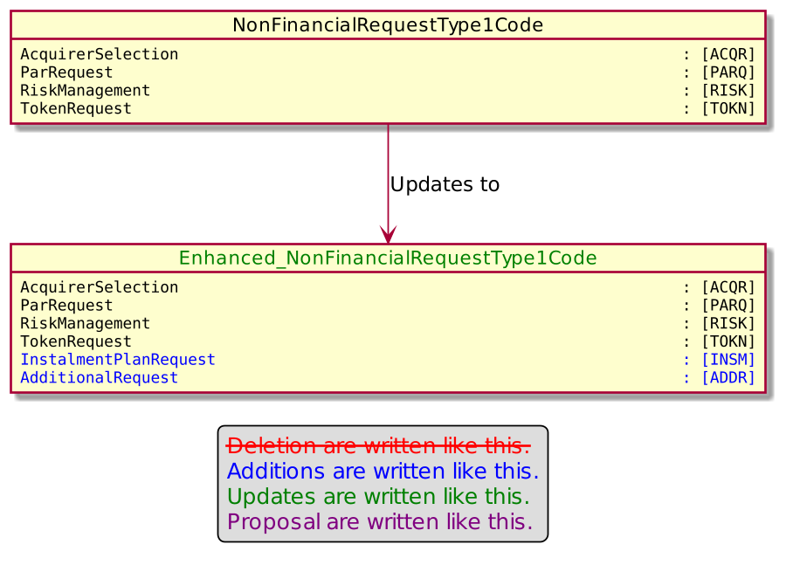

On NonFinancialRequestContentComponent2.

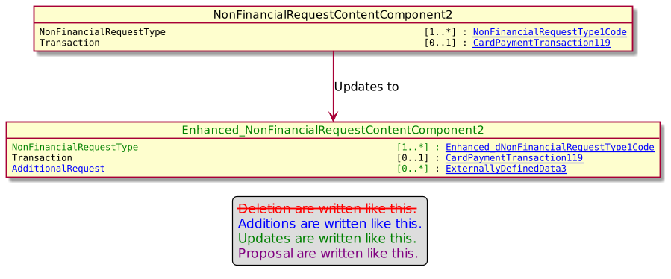

On NonFinancialResponseContentComponent2.

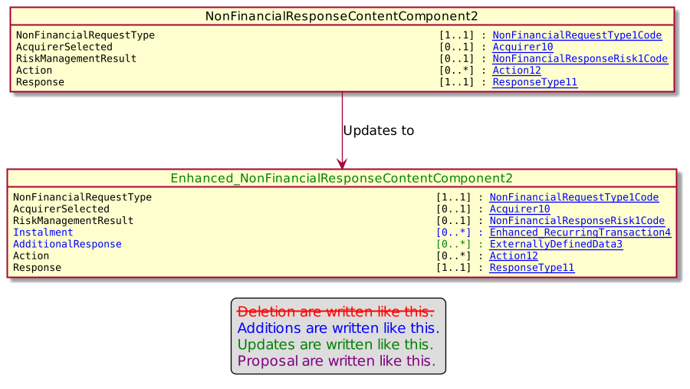

On RecurringTransaction4

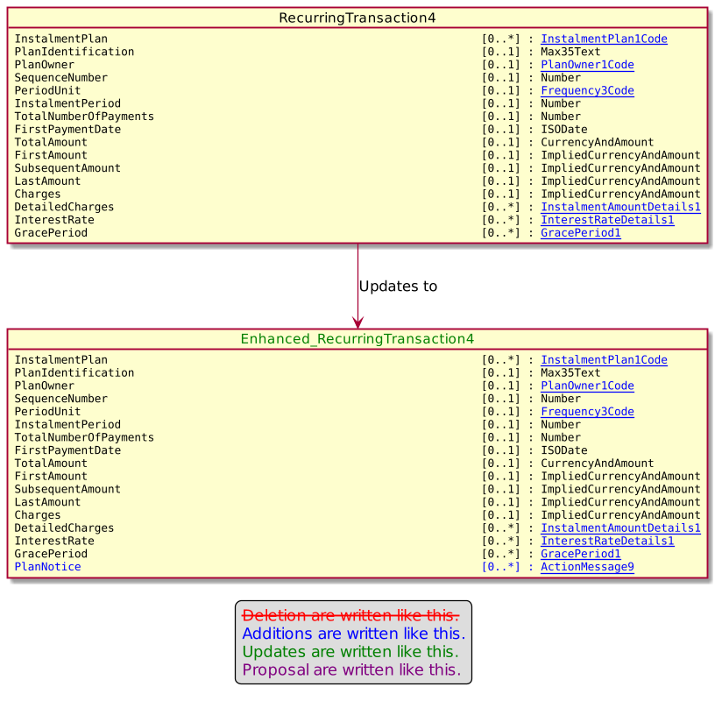

- Proposed timing:
The submitting organization confirms that it can implement the requested changes in the requested timing, or, if not, proposes another timing.

Timing | - As requested
 | - Other:

- Final decision of the SEG(s):
This section is not to be taken care of by the submitting organization. It will be completed in due time by the SEG(s) in charge of the related ISO 20022 messages.
Approve | X
Comments:

Reject
Reason for rejection:

Change request number 1120 ActionType12Code

Copy of the approved change request:
This is a copy of sections A to G of the change request approved by the SEG for further consideration as communicated to the submitting organization by the RA.

- Origin of the request:
A.1 Submitter: nexo A.I.S.B.L
A.2 Contact person: Philippe CECE (Philippe.cece@ingenico.com) / Evelyne de JONGHE (evelyne.de-jonghe@frenchsys.com)
A.3 Sponsors: nexo A.I.S.B.L.

- Related messages:

- AcceptorAuthorisationResponse V11 caaa.002.001.11,
- AcceptorCancellationResponse V10 caaa.006.001.10,
- AcceptorBatchTransfer V11 caaa.011.001.11,
- AcceptorNonFinancialResponse V02 caaa.023.001.02,
- AcceptorTransactionLogReportResponse V02 caaa.025.001.02,

- SaleToPOIServieResponse V04 casp.002.001.04,
- SaleToPOIReportResponse V04 casp.010.001.04,
- SaleToPOIMessageStatusResponse V04 casp.015.001.04

- Description of the change request:

Since new ISO8583 codes could be received by an Acquirer, we need to update the protocol in order to reflect the relevant action that the accepting device should trig.

These 2 new codes imply the creation of 2 new codes in the ActionType12Code codeset.
- Purpose of the change:

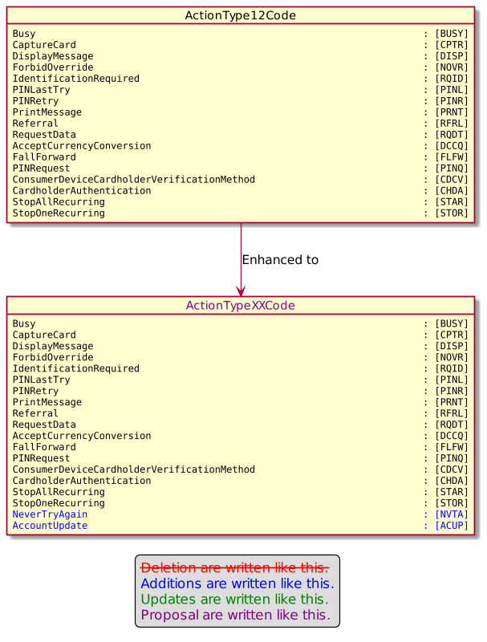

- Urgency of the request:

Urgent

- Business examples:
Examples illustrating the change request.

- SEG/TSG recommendation:
This section is not to be taken care of by the submitter of the change request. It will be completed in due time by the SEG(s) in charge of the related ISO 20022 messages or the TSG for changes related to the BAH.

Consider |  |  | Timing
 |  |  | - Next yearly cycle: 2022/2023  (the change will be considered for implementation in the yearly maintenance cycle which starts in 2022 and completes with the publication of new message versions in the spring of 2023) |  | X
- At the occasion of the next maintenance of the messages
(the change will be considered for implementation, but does not justify maintenance of the messages in its own right – will be pending until more critical change requests are received for the messages)
- Urgent unscheduled
(the change justifies an urgent implementation outside of the normal yearly cycle)
 |  |  | - Other timing:
Comments:

Reject
Reason for rejection:

- Impact analysis and type of impact:

The update will be done as explained in the Change Request.

The ripple effect analysis provides the following results.

On ActionType12Code
- ActionType12Code
  - Action12
    - CardPaymentTransaction114
      - AcceptorAuthorisationResponse11
      - RetailerPaymentResult4
      - CardPaymentDataSetTransaction38
    - CardPaymentTransaction113
      - AcceptorCancellationResponse10
        - AcceptorCancellationResponse V10 caaa.006.001.10
    - NonFinancialResponseContentComponent2

The severity of the impact of the proposed change for the message users should be indicated in the table below (either “no impact”, “conditional’ or “mandatory”).
Type of impact
 | No impact | The change(s) will not impact the schema (the version number will not change) and will not impact the business applications of any users, e.g. the clarification of a definition
 | Conditional | The change(s) will impact the schema (at least the version number) and the business applications of certain users but not all, e.g. the addition of an optional component
X | Mandatory | The change(s) will impact the schema and the business applications of all users, e.g. addition of a mandatory component.

- Proposed implementation:

On ActionType12Code.

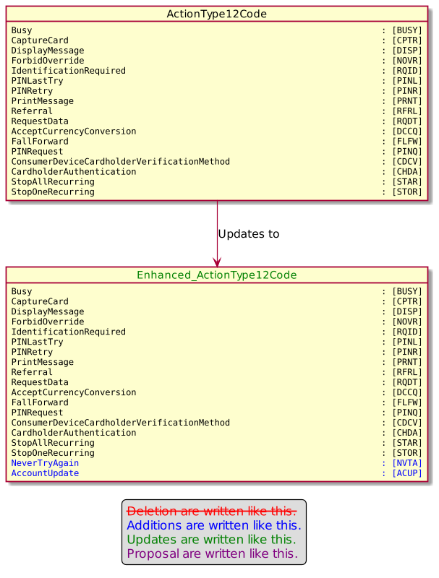

- Proposed timing:
The submitting organization confirms that it can implement the requested changes in the requested timing, or, if not, proposes another timing.

Timing | - As requested
 | - Other:

- Final decision of the SEG(s):
This section is not to be taken care of by the submitting organization. It will be completed in due time by the SEG(s) in charge of the related ISO 20022 messages.
Approve | X
Comments:

Reject
Reason for rejection:

Change request number 1121 MessageFunctionCode

Copy of the approved change request:

- Origin of the request:
A.1 Submitter: nexo A.I.S.B.L
A.2 Contact person: Philippe CECE (Philippe.cece@ingenico.com) / Evelyne de JONGHE (evelyne.de-jonghe@frenchsys.com)

A.3 Sponsors: nexo A.I.S.B.L.

- Related messages:

- AcceptorAuthorisationRequest V11 caaa.001.001.11,
- AcceptorAuthorisationResponse V11 caaa.002.001.11,
- AcceptorCompletionAdvice V11 caaa.003.001.11,
- AcceptorCompletionAdviceResponse V10 caaa.004.001.10,
- AcceptorCancellationRequest V11 caaa.005.001.11,
- AcceptorCancellationResponse V10 caaa.006.001.10,
- AcceptorCancellationAdvice V11 caaa.007.001.11,
- AcceptorCancellationAdviceResponse V10 caaa.008.001.10,
- AcceptorReconciliationRequest V10 caaa.009.001.10,
- AcceptorReconciliationResponse V09 caaa.010.001.09,
- AcceptorDiagnosticRequest V10 caaa.013.001.10,
- AcceptorDiagnosticResponse V09 caaa.014.001.09,
- AcceptorCurrencyConversionRequest V09 caaa.016.001.09,
- AcceptorCurrencyConversionResponse V09 caaa.017.001.09,
- AcceptorCurrencyConversionAdvice V06 caaa.018.001.06,
- AcceptorCurrencyConversionAdviceResponse V05 caaa.019.001.05,
- TransactionAdvice V03 caaa.020.001.03,
- TransactionAdviceResponse V03 caaa.021.001.03,
- AcceptorNonFinancialRequest V02 caaa.022.001.02,
- AcceptorNonFinancialResponse V02 caaa.023.001.02,
- AcceptorTransactionLogReportRequest V02 caaa.024.001.02,
- AcceptorTransactionLogReportResponse V02 caaa.025.001.02

- Description of the change request:

The AcceptorCurrencyConversionRequest message could be used outside of a transaction in order to receive all conversion details in the AcceptorCurrencyConversionResponse. This behaviour allows a shorter transaction processing time. In that case, it is essential for the receiver to know if the request is made in or outside a transaction, and to not mandate a transaction in the request. Additionally, if the message response provides currency conversion details, like rate, it is important also to provide the eligible card range for this service and, if necessary, a start date for the conversion. Obviously, result of conversion and converted amount must not be mandated any more in the message response.

The aim of this Change Request is to provide all the previously identified modifications.

- Purpose of the change:

The messageFunction42Code which is used in any header of Acquirer message will be updated to identify request or response related to currency conversion rate.
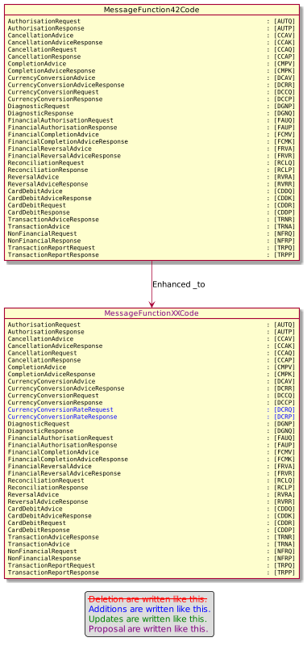

Then the AcceptorCurrencyConversionRequest must be updated to not mandate a transaction in the message.

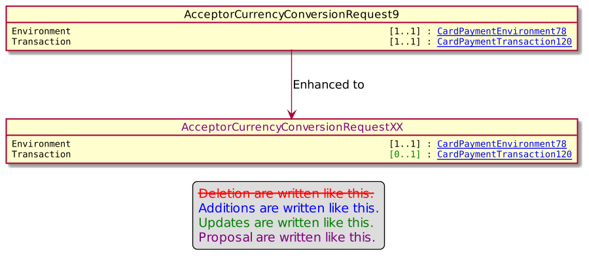

The identification of the eligible card range for the service will be provided as a suit of a BinRange identified by a lower range and a upper range.

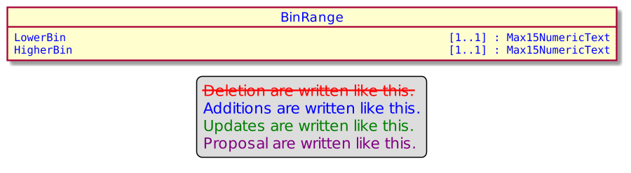

Finally the CurrencyConversion23 message component which hold the result of the currency conversion will be updated to not mandate currency conversion result or final amount, but also to provide the start date of the service and the eligible card range.
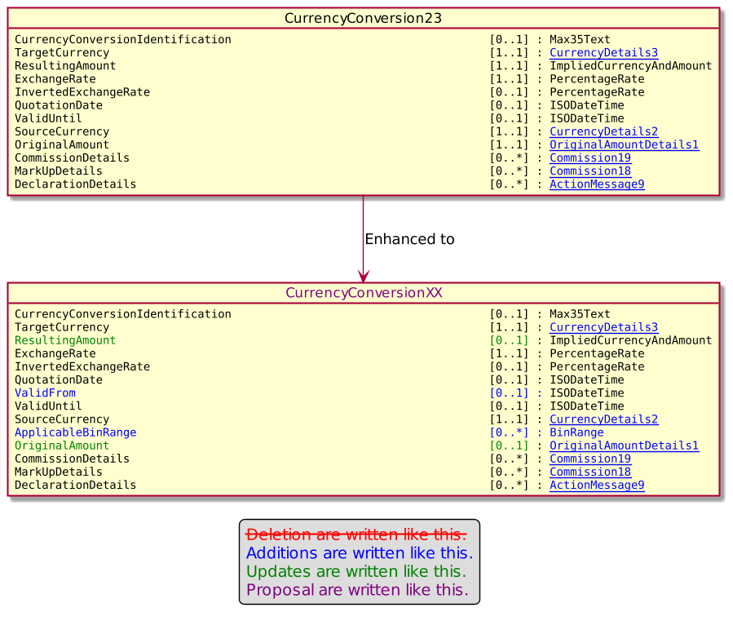

This modification will be propagated to the currency conversion response as illustrated by these diagrams.

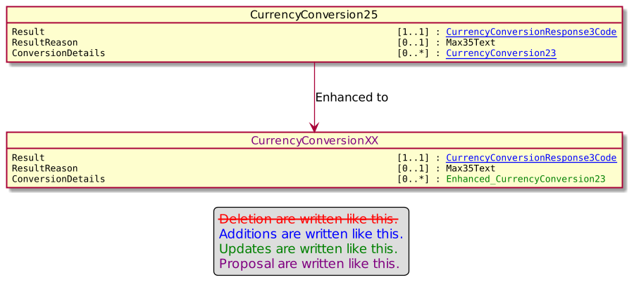

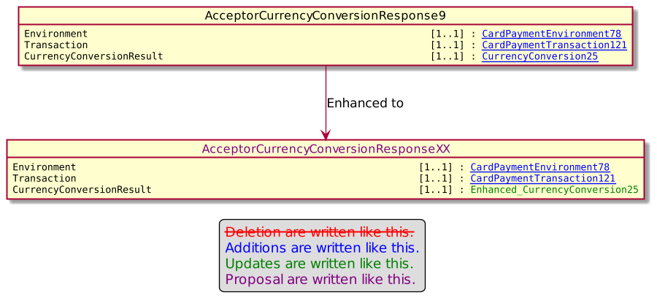
- Urgency of the request:

Urgent

- Business examples:
Examples illustrating the change request.
- SEG/TSG recommendation:
This section is not to be taken care of by the submitter of the change request. It will be completed in due time by the SEG(s) in charge of the related ISO 20022 messages or the TSG for changes related to the BAH.

Consider |  |  | Timing
 |  |  | - Next yearly cycle: 2022/2023  (the change will be considered for implementation in the yearly maintenance cycle which starts in 2022 and completes with the publication of new message versions in the spring of 2023) |  | X
- At the occasion of the next maintenance of the messages
(the change will be considered for implementation, but does not justify maintenance of the messages in its own right – will be pending until more critical change requests are received for the messages)
- Urgent unscheduled
(the change justifies an urgent implementation outside of the normal yearly cycle)
 |  |  | - Other timing:
Comments:
The data component Transaction must be optional in the response

Reject
Reason for rejection:

- Impact analysis and type of impact:
The modification will be done as depicted by the Change Request and taking into account the error identified by the CardSEG.

The ripple effect analysis provides the following result.

On MessageFunction42Code
- MessageFunction42Code
  - Header59
    - AcceptorAuthorisationRequest V11 caaa.001.001.11
    - AcceptorAuthorisationResponse V11 caaa.002.001.11
    - AcceptorCompletionAdvice V11 caaa.003.001.11
    - AcceptorCompletionAdviceResponse V10 caaa.004.001.10
    - AcceptorCancellationRequest V11 caaa.005.001.11
    - AcceptorCancellationResponse V10 caaa.006.001.10
    - AcceptorCancellationAdvice V11 caaa.007.001.11
    - AcceptorCancellationAdviceResponse V10 caaa.008.001.10
    - AcceptorReconciliationRequest V10 caaa.009.001.10
    - AcceptorReconciliationResponse V09 caaa.010.001.09
    - AcceptorDiagnosticRequest V10 caaa.013.001.10
    - AcceptorDiagnosticResponse V09 caaa.014.001.09
    - AcceptorCurrencyConversionRequest V09 caaa.016.001.09
    - AcceptorCurrencyConversionResponse V09 caaa.017.001.09
    - AcceptorCurrencyConversionAdvice V06 caaa.018.001.06
    - AcceptorCurrencyConversionAdviceResponse V05 caaa.019.001.05
    - TransactionAdvice V03 caaa.020.001.03
    - TransactionAdviceResponse V03 caaa.021.001.03
    - AcceptorNonFinancialRequest V02 caaa.022.001.02
    - AcceptorNonFinancialResponse V02 caaa.023.001.02
    - AcceptorTransactionLogReportRequest V02 caaa.024.001.02
    - AcceptorTransactionLogReportResponse V02 caaa.025.001.02

On AcceptorCurrencyConversionRequest9
This analysis was made for a previous ChangeRequest.

On BinRange
Since we will create this component the ripple effect analysis is empty.

On CurrencyConversion23
- CurrencyConversion23
  - CurrencyConversion24
    - AcceptorCurrencyConversionAdvice6
    - CardPaymentTransactionDetails51
  - CurrencyConversion25
    - Cf below
  - CardPaymentTransaction114

On CurrencyConversion25
- CurrencyConversion25
  - Cf below
  - CardPaymentTransaction123
    - CardPaymentTransaction120

On AcceptorCurrencyConversionResponse9
- AcceptorCurrencyConversionResponse9
  - AcceptorCurrencyConversionResponse V09 caaa.017.001.09

The severity of the impact of the proposed change for the message users should be indicated in the table below (either “no impact”, “conditional’ or “mandatory”).
Type of impact
 | No impact | The change(s) will not impact the schema (the version number will not change) and will not impact the business applications of any users, e.g. the clarification of a definition
X | Conditional | The change(s) will impact the schema (at least the version number) and the business applications of certain users but not all, e.g. the addition of an optional component
 | Mandatory | The change(s) will impact the schema and the business applications of all users, e.g. addition of a mandatory component.

- Proposed implementation:

On MessageFunction42Code :

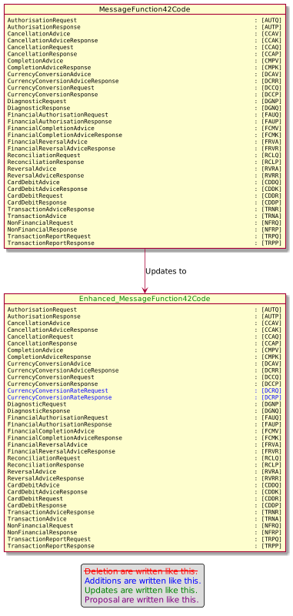

On AcceptorCurrencyConversionRequest9

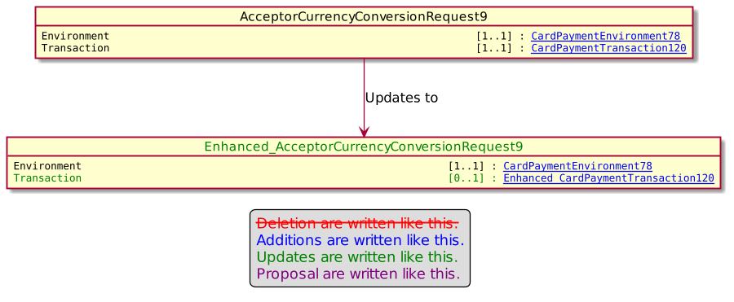

Then we will create BinRange1.

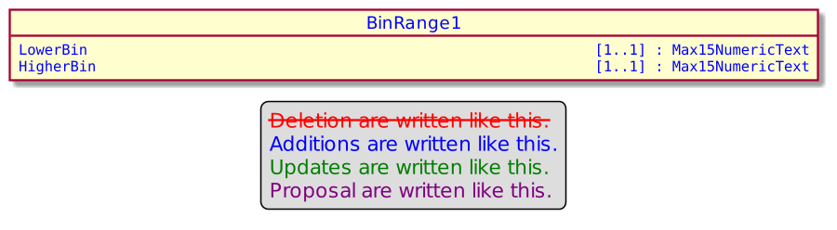

To update CurrencyConversion23.

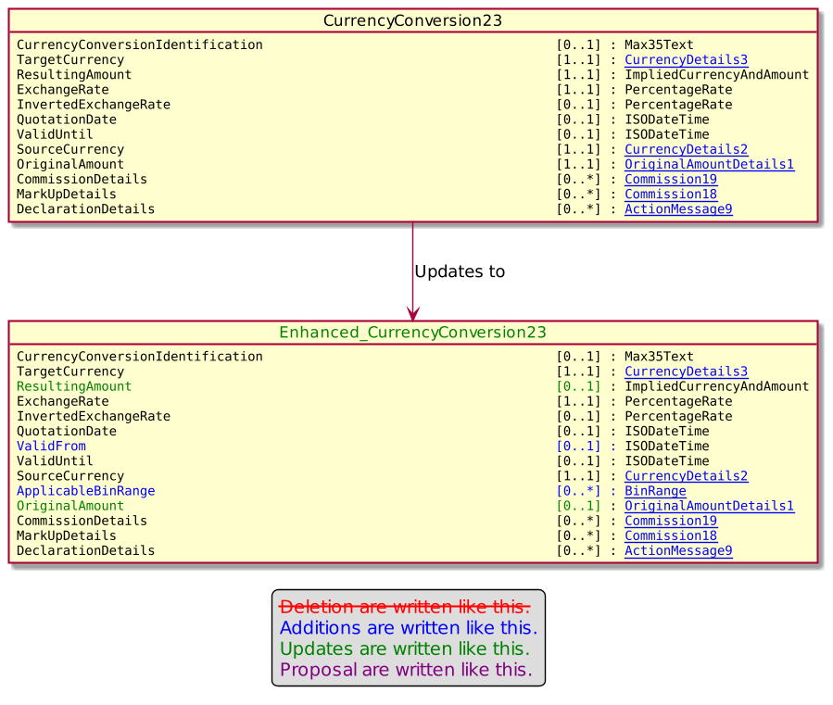

On CurrencyConversion25

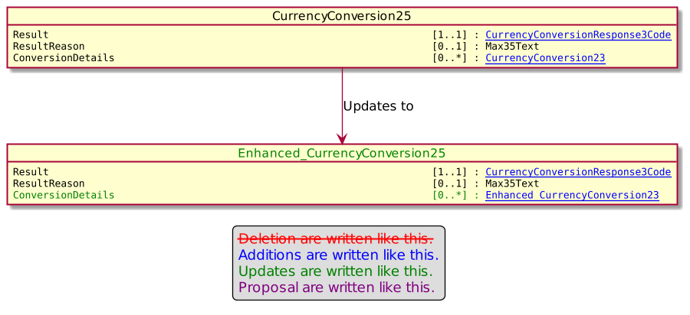

On AcceptorCurencyConversionResponse9

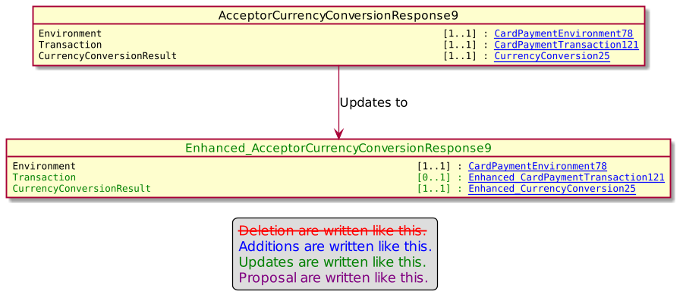
- Proposed timing:
The submitting organization confirms that it can implement the requested changes in the requested timing, or, if not, proposes another timing.

Timing | - As requested
 | - Other:

- Final decision of the SEG(s):
This section is not to be taken care of by the submitting organization. It will be completed in due time by the SEG(s) in charge of the related ISO 20022 messages.
Approve | X
Comments:

Reject
Reason for rejection:

Change request number 1131 messageItemCode

Copy of the approved change request:

- Origin of the request:
A.1 Submitter: nexo A.I.S.B.L
A.2 Contact person: Philippe CECE (Philippe.cece@ingenico.com) / Laure BELTRI (laure.beltri@frenchsys.com)
A.3 Sponsors: nexo A.I.S.B.L.

- Related messages:

- ManagementPlanReplacement V10 (catm.002.001.10)
- AcceptorConfigurationUpdate V11 (catm.003.001.11)
- MaintenanceDelegationRequest V08 (catm.005.001.08)

- Description of the change request:

In the current model of the protocols, MessageItem determines the condition of presence for some message elements in messages, and probably its value.
The MessageItem.ItemIdentification identifies the message element concerned by the configuration, and MessageItem.Condition defines the behavior of the configuration on the message element.
The Condition values currently supported are reminded in the following table.

Value | Usage
AllowedValues | Recipient supports only a set of values defined in the value list.
IfAvailable | Message element is sent if the message sender knows it.
Mandatory | Message element must be present in the message.
NotSupported | Message element is not supported by the recipient.
ConfiguredValue | Message element is mandatory and takes the specific value defined in the element Value of MessageItem.

Considering the previous table, we realized that there is no way to express that we expect at least values in a list but others could be also provided. The aim of this Change Request is to create this value.

- Purpose of the change:

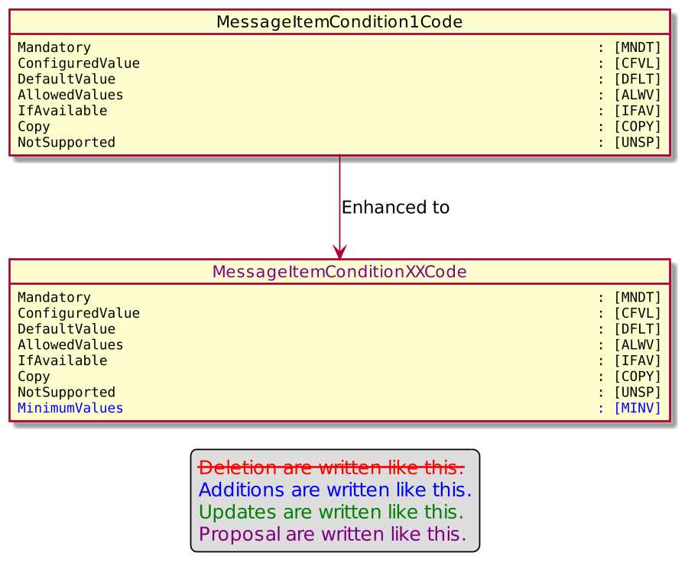

- Urgency of the request:

Urgent

- Business examples:
Examples illustrating the change request.
- SEG/TSG recommendation:
This section is not to be taken care of by the submitter of the change request. It will be completed in due time by the SEG(s) in charge of the related ISO 20022 messages or the TSG for changes related to the BAH.

Consider |  |  | Timing
 |  |  | - Next yearly cycle: 2022/2023  (the change will be considered for implementation in the yearly maintenance cycle which starts in 2022 and completes with the publication of new message versions in the spring of 2023) |  | X
- At the occasion of the next maintenance of the messages
(the change will be considered for implementation, but does not justify maintenance of the messages in its own right – will be pending until more critical change requests are received for the messages)
- Urgent unscheduled
(the change justifies an urgent implementation outside of the normal yearly cycle)
 |  |  | - Other timing:
Comments:

Reject
Reason for rejection:

- Impact analysis and type of impact:

The modification will be as highlighted in the Change Request.

The ripple effect analysis was done and provides the following result.

On MessageItemCondition1Code
- MessageItemCondition1Code
  - MessageItemCondition1
    - TMSAction10
    - TMSProtocolParameters6
      - AcceptorConfigurationContent11
    - AcquirerProtocolParameters15
      - AcceptorConfigurationContent11

The severity of the impact of the proposed change for the message users should be indicated in the table below (either “no impact”, “conditional’ or “mandatory”).
Type of impact
 | No impact | The change(s) will not impact the schema (the version number will not change) and will not impact the business applications of any users, e.g. the clarification of a definition
X | Conditional | The change(s) will impact the schema (at least the version number) and the business applications of certain users but not all, e.g. the addition of an optional component
 | Mandatory | The change(s) will impact the schema and the business applications of all users, e.g. addition of a mandatory component.

- Proposed implementation:

On MessageItemCondition1Code/
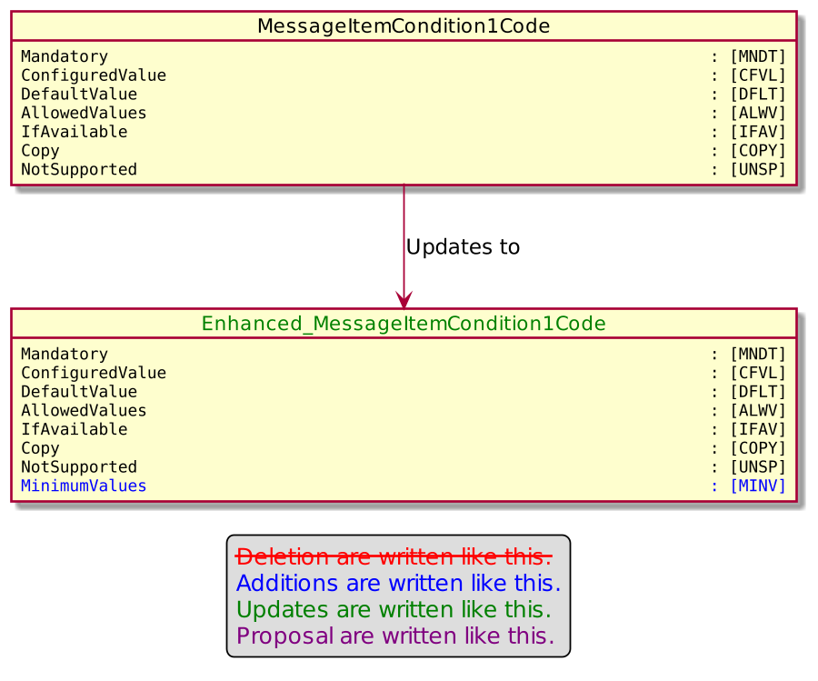

- Proposed timing:
The submitting organization confirms that it can implement the requested changes in the requested timing, or, if not, proposes another timing.

Timing | - As requested
 | - Other:

- Final decision of the SEG(s):
This section is not to be taken care of by the submitting organization. It will be completed in due time by the SEG(s) in charge of the related ISO 20022 messages.
Approve | X
Comments:

Reject
Reason for rejection:

Change request number 1132 OutputBarcode

Copy of the approved change request:

- Origin of the request:
A.1 Submitter: nexo A.I.S.B.L.
A.2 Contact person: Philippe CECE (Philippe.cece@ingenico.com) / Laure BELTRI (laure.beltri@frenchsys.com) / Evelyne de JONGHE (evelyne.de-jonghe@frenchsys.com) / Philippe MERMOUD (philippe.mermoud@bpce.fr) / Robert FARGIER (robert.fargier@istium.pro)
A.3 Sponsors: nexo A.I.S.B.L.

- Related messages:

- AcceptorAuthorisationRequest V11 caaa.001.001.11,
- AcceptorAuthorisationResponse V11 caaa.002.001.11,
- AcceptorCompletionAdvice V11 caaa.003.001.11,
- AcceptorCancellationResponse V10 caaa.006.001.10,
- AcceptorBatchTransfer V11 caaa.011.001.11,
- AcceptorCurrencyConversionRequest V09 caaa.016.001.09,
- AcceptorCurrencyConversionResponse V09 caaa.017.001.09,
- AcceptorCurrencyConversionAdvice V06 caaa.018.001.06,
- TransactionAdvice V03 caaa.020.001.03,
- AcceptorNonFinancialRequest V02 caaa.022.001.02,
- AcceptorNonFinancialResponse V02 caaa.023.001.02,
- AcceptorTransactionLogReportResponse V02 caaa.025.001.02,

- SaleToPOIServiceRequest V04 casp.001.001.04,
- SaleToPOIserviceResponse V04 casp.002.001.04,
- SaleToPOISessionManagementRequest V04 casp.005.001.04,
- SaleToPOISessionManagementResponse V04 casp.006.001.04,
- SaleToPOIReportResponse V04 casp.010.001.04,
- SaleToPOIAbort V04 casp.011.001.04,
- SaleToPOIEventNotification V04 casp.012.001.04,
- SaleToPOIMessageStatusResponse V04 casp.015.001.04,
- SaleToPOIDeviceRequest V04 casp.016.001.04,

- ManagementPlanReplacement V10 catm.002.001.10,
- MaintenanceDelegationRequest V08 catm.005.001.08

- Description of the change request:

We would like to correct an error in the barcode management. The current OutputBarcode1 message component mandates the message element QRCodeEncoding, which is only relevant for barcode of type COQR.

- Purpose of the change:

The aim of the modification is to set QRCodeEncoding as an optional message element.
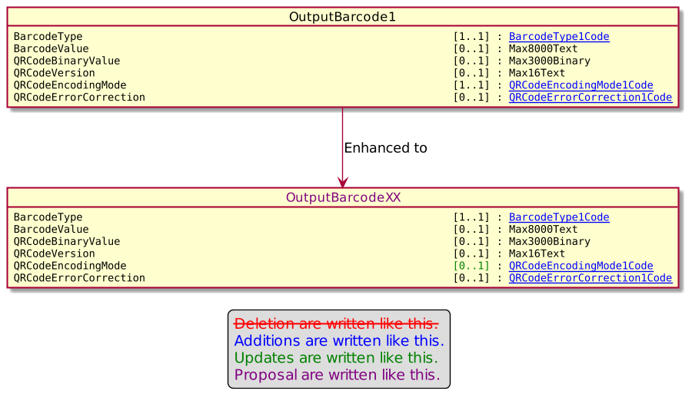

- Urgency of the request:

Urgent.

- Business examples:
Examples illustrating the change request.

- SEG/TSG recommendation:
This section is not to be taken care of by the submitter of the change request. It will be completed in due time by the SEG(s) in charge of the related ISO 20022 messages or the TSG for changes related to the BAH.

Consider |  |  | Timing
 |  |  | - Next yearly cycle: 2022/2023  (the change will be considered for implementation in the yearly maintenance cycle which starts in 2022 and completes with the publication of new message versions in the spring of 2023) |  | X
- At the occasion of the next maintenance of the messages
(the change will be considered for implementation, but does not justify maintenance of the messages in its own right – will be pending until more critical change requests are received for the messages)
- Urgent unscheduled
(the change justifies an urgent implementation outside of the normal yearly cycle)
 |  |  | - Other timing:
Comments:

Reject
Reason for rejection:

- Impact analysis and type of impact:

The modification will be done as depicted in the Change Request

The ripple Effect analysis provides the following results.

On OutputBarcode1
- OutputBarcode1
  - ActionMessage9
    - AbortData4
      - SystemAbort5
    - InputData4
      - DeviceInputRequest4
        - DeviceRequest5
    - LoginRequest4
      - SessionManagementRequest5
    - LoginResponse4
      - SessionManagementResponse5
    - CurrencyConversion23
    - DeviceDisplayRequest4
      - DeviceRequest5
    - PaymentReceipt4
      - PaymentResponse4
      - BalanceInquiryResponse4
        - ServiceResponse6
      - StoredValueResponse5
      - ReversalResponse6
    - EventNotificationData4
      - SystemEventNotification5
    - DeviceInitialisationCardReaderRequest4
      - DeviceRequest5
    - DeviceInputNotification4
      - DeviceRequest5
    - DeviceInputRequest4
    - DevicePoweroffCardReaderRequest4
      - DeviceRequest5
    - DevicePrintRequest4
      - DeviceRequest5
    - EnableServiceRequest4
      - ServiceRequest5
    - Action12

The severity of the impact of the proposed change for the message users should be indicated in the table below (either “no impact”, “conditional’ or “mandatory”).
Type of impact
 | No impact | The change(s) will not impact the schema (the version number will not change) and will not impact the business applications of any users, e.g. the clarification of a definition
X | Conditional | The change(s) will impact the schema (at least the version number) and the business applications of certain users but not all, e.g. the addition of an optional component
 | Mandatory | The change(s) will impact the schema and the business applications of all users, e.g. addition of a mandatory component.

- Proposed implementation:

On OutpoutBarcode1.
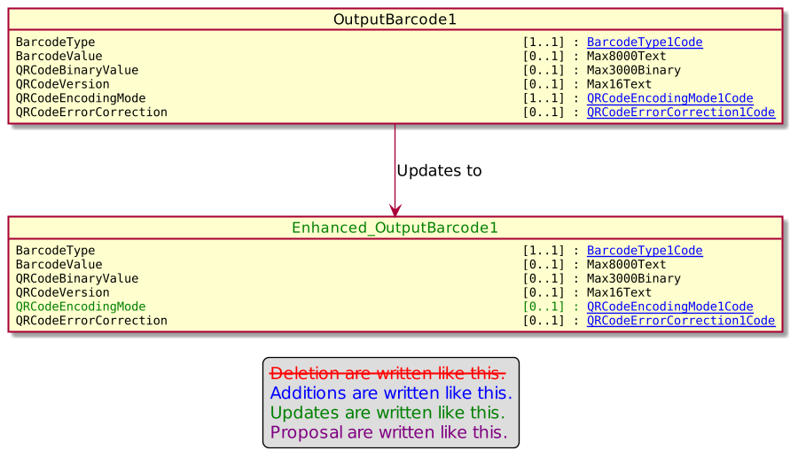

- Proposed timing:
The submitting organization confirms that it can implement the requested changes in the requested timing, or, if not, proposes another timing.

Timing | - As requested
 | - Other:

- Final decision of the SEG(s):
This section is not to be taken care of by the submitting organization. It will be completed in due time by the SEG(s) in charge of the related ISO 20022 messages.
Approve | X
Comments:

Reject
Reason for rejection:

Change request number 1133 SaleToPOIProtocolParameter

Copy of the approved change request:

- Origin of the request:
A.1 Submitter: nexo A.I.S.B.L.
A.2 Contact person: Philippe CECE (Philippe.cece@ingenico.com) / Laure BELTRI (laure.beltri@frenchsys.com) / Philippe MERMOUD (philippe.mermoud@bpce.fr) / Robert FARGIER (robert.fargier@istium.pro)
A.3 Sponsors: nexo A.I.S.B.L.

- Related messages:

- AcceptorConfigurationUpdate V11 catm.003.001.11
- MaintenanceDelegationRequest V08 catm.005.001.08

- Description of the change request:

We would like to improve how the retailer protocol could be configured by the TMS protocol. For instance, it might be interesting to set if a POI is able or not to send a device request to the sale terminal. Other configuration like service restriction might be also expected, like the CardReaderAPDU access. Additionally, we would like also make this configuration available with only readable access to the Sale solution through an updated message.

- Purpose of the change:

This modification should allow estate manager to have generic set of spare parts and to be able through configuration from the TMS protocol to be able to size a POI to its environment. By doing this through the TMS protocol may save time and money in the estate management. And a retailer will be also able to verify that the accepting solution will fit his needs.

- Urgency of the request:

Not Urgent.

- Business examples:
Examples illustrating the change request.

- SEG/TSG recommendation:
This section is not to be taken care of by the submitter of the change request. It will be completed in due time by the SEG(s) in charge of the related ISO 20022 messages or the TSG for changes related to the BAH.

Consider |  |  | Timing
 |  |  | - Next yearly cycle: 2022/2023  (the change will be considered for implementation in the yearly maintenance cycle which starts in 2022 and completes with the publication of new message versions in the spring of 2023) |  | X
- At the occasion of the next maintenance of the messages
(the change will be considered for implementation, but does not justify maintenance of the messages in its own right – will be pending until more critical change requests are received for the messages)
- Urgent unscheduled
(the change justifies an urgent implementation outside of the normal yearly cycle)
 |  |  | - Other timing:
Comments:

Reject
Reason for rejection:

- Impact analysis and type of impact:

After study, we would like to be able to identify messages that the POI could received and messages that it could sent. Then a spare POI, with extra features, is able to replace any POI by restricting it to necessary elements. Additionally, the availability to set which services are served by the POI will ease maintenance solution where different use cases are present (e.g face to face payment and unattended solutions). Finally, the availability to set which device request a POI may received and which it could sent will help to secure access to external peripherals.

This modification will only aim the message component SaleToPOIProtocolParameter2.

The ripple effect analysis only identifies 1 message component AcceptorConfigurationContent11 which is already modified by a previous Change Request.

The severity of the impact of the proposed change for the message users should be indicated in the table below (either “no impact”, “conditional’ or “mandatory”).
Type of impact
 | No impact | The change(s) will not impact the schema (the version number will not change) and will not impact the business applications of any users, e.g. the clarification of a definition
X | Conditional | The change(s) will impact the schema (at least the version number) and the business applications of certain users but not all, e.g. the addition of an optional component
 | Mandatory | The change(s) will impact the schema and the business applications of all users, e.g. addition of a mandatory component.

- Proposed implementation:

On SaleToPOIProtocolParameter2.

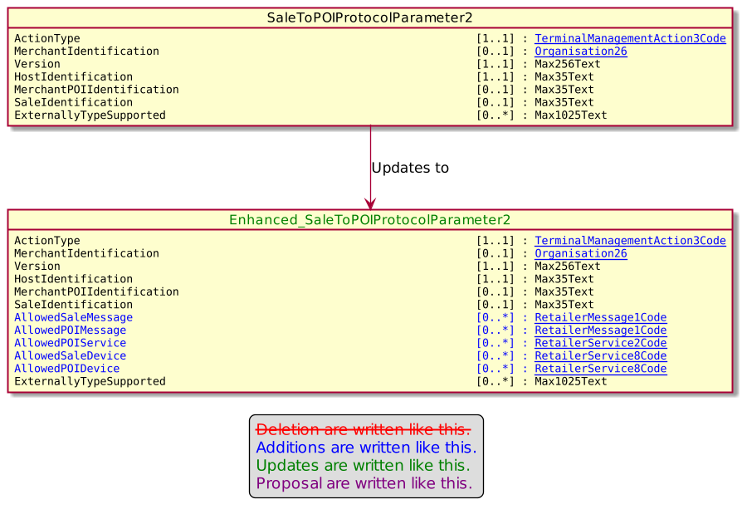

- Proposed timing:
The submitting organization confirms that it can implement the requested changes in the requested timing, or, if not, proposes another timing.

Timing | - As requested
 | - Other:

- Final decision of the SEG(s):
This section is not to be taken care of by the submitting organization. It will be completed in due time by the SEG(s) in charge of the related ISO 20022 messages.
Approve | X
Comments:

Reject
Reason for rejection:

Change request number 1134 Salt in TMS messages

Copy of the approved change request:

- Origin of the request:
A.1 Submitter: nexo A.I.S.B.L
A.2 Contact person: Philippe CECE (Philippe.cece@ingenico.com) / Laure BELTRI (laure.beltri@frenchsys.com)
A.3 Sponsors: nexo A.I.S.B.L.

- Related messages:

- CertificateManagementRequest V05
- CertificateManagementResponse V05
- MaintenanceDelegationRequest V08
- MaintenanceDelegationResponse V06

- Description of the change request:

After a study, we realize that, in some circumstances like using some cryptographic algorithms without respect to best practices, some TMS message bodies are not protected against a replay attack.
The aim of this Change request is to avoid this by adding elements like date and challenge that will avoid considering messages sent by a replay attack.

We take also this opportunity to clearly identify in the CertificateManagementRequest message, the KeyFunction since this information should be present in a certificate returned by the CertificateManagementResponse.
- Purpose of the change:

The following diagrams identify the message components that will be updated and the added message elements coupled with their type.

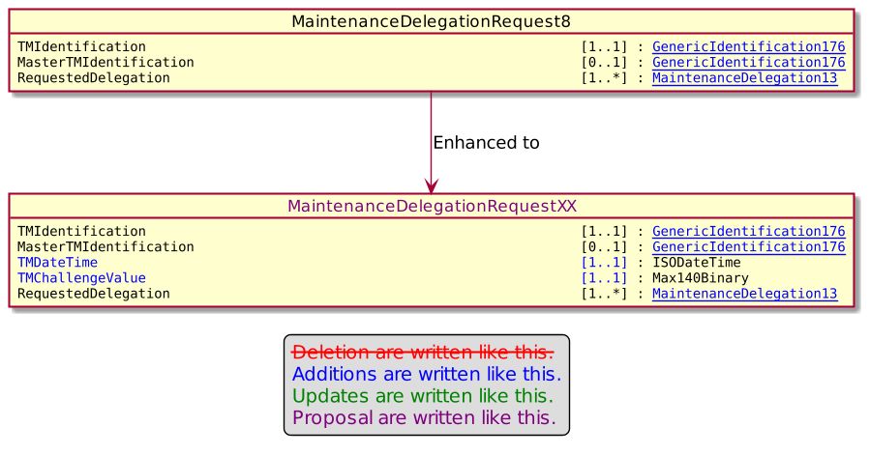

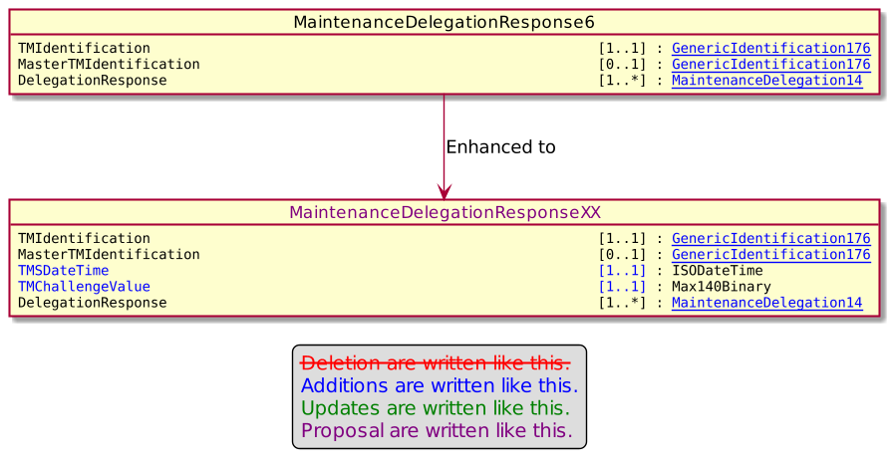

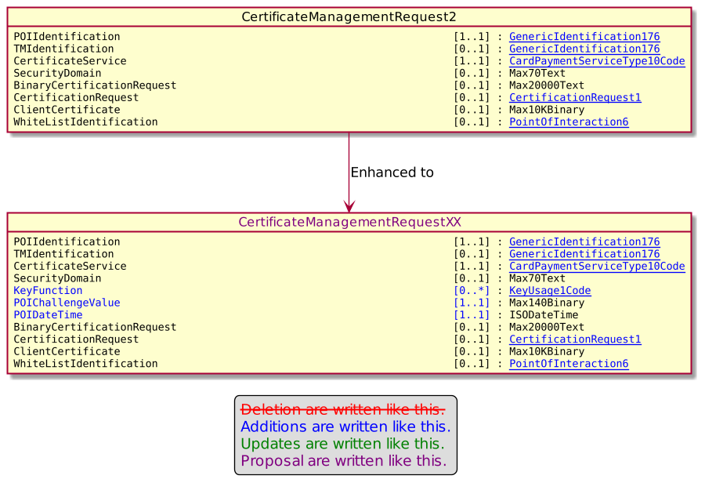

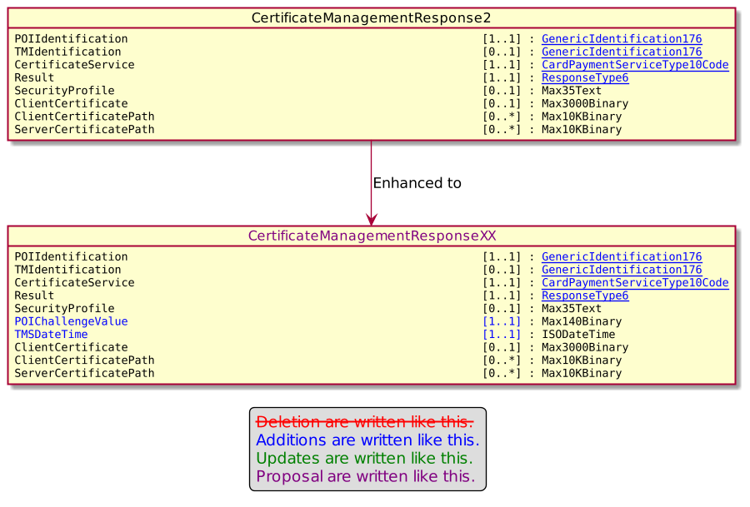

- Urgency of the request:

Urgent.

- Business examples:

- SEG/TSG recommendation:
This section is not to be taken care of by the submitter of the change request. It will be completed in due time by the SEG(s) in charge of the related ISO 20022 messages or the TSG for changes related to the BAH.

Consider |  |  | Timing
 |  |  | - Next yearly cycle: 2022/2023  (the change will be considered for implementation in the yearly maintenance cycle which starts in 2022 and completes with the publication of new message versions in the spring of 2023) |  | X
- At the occasion of the next maintenance of the messages
(the change will be considered for implementation, but does not justify maintenance of the messages in its own right – will be pending until more critical change requests are received for the messages)
- Urgent unscheduled
(the change justifies an urgent implementation outside of the normal yearly cycle)
 |  |  | - Other timing:
Comments:

Reject
Reason for rejection:

- Impact analysis and type of impact:

The modifications will be done as depicted in the Change Request.
The ripple effect analysis highlight that just MaintenanceDelegationRequets , MaintenanceDelegationResponse, CertificateManagementRequest and CertficateManagementResponse messages will be updated.

These modifications have huge impact in the schema but not so much on the field, since, as far as we know, these messages haven’t yet been deployed or used.

The severity of the impact of the proposed change for the message users should be indicated in the table below (either “no impact”, “conditional’ or “mandatory”).
Type of impact
 | No impact | The change(s) will not impact the schema (the version number will not change) and will not impact the business applications of any users, e.g. the clarification of a definition
 | Conditional | The change(s) will impact the schema (at least the version number) and the business applications of certain users but not all, e.g. the addition of an optional component
X | Mandatory | The change(s) will impact the schema and the business applications of all users, e.g. addition of a mandatory component.

- Proposed implementation:

On MaintenanceDelegationRequest8.
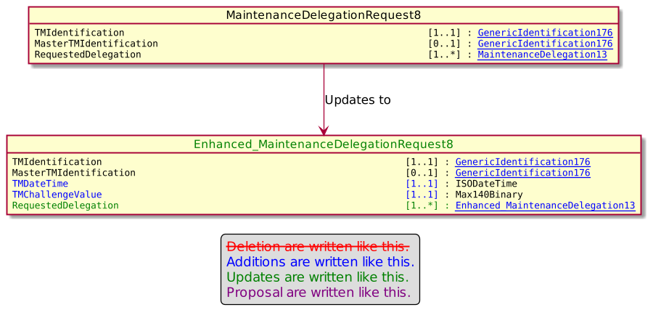

On MaintenanceDelegationResponse6.
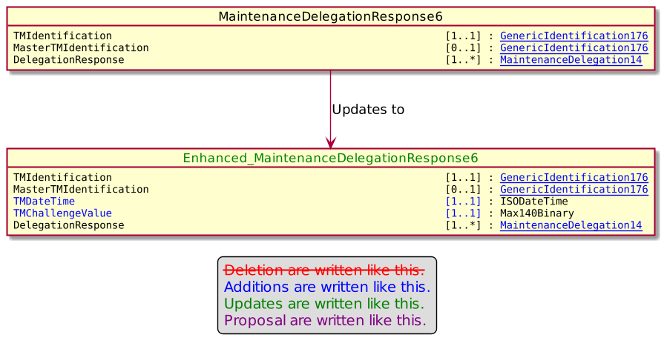

On CertificateManagementRequest2.
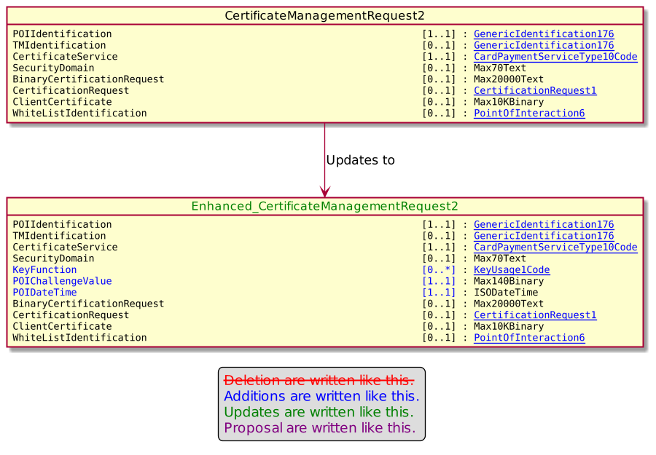
On CertificateManagementResponse2.
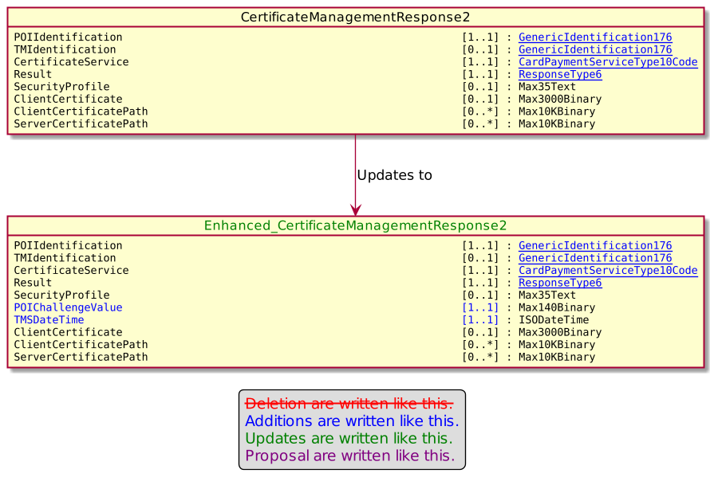

- Proposed timing:
The submitting organization confirms that it can implement the requested changes in the requested timing, or, if not, proposes another timing.

Timing | - As requested
 | - Other:

- Final decision of the SEG(s):
This section is not to be taken care of by the submitting organization. It will be completed in due time by the SEG(s) in charge of the related ISO 20022 messages.
Approve | X
Comments:

Reject
Reason for rejection:

Change request number 1135 ServiceProviderParameters in AcceptorConfigurationUpdate

Copy of the approved change request:
- Origin of the request:
A.1 Submitter: nexo A.I.S.B.L
A.2 Contact person: Philippe CECE (Philippe.cece@ingenico.com) / Laure BELTRI (laure.beltri@frenchsys.com) / Evelyne de JONGHE (evelyne.de-jonghe@frenchsys.com)

A.3 Sponsors: nexo A.I.S.B.L.

- Related messages:

- AcceptorAuthorisationRequest V11 caaa.001.001.11,
- AcceptorAuthorisationResponse V11 caaa.002.001.11,
- AcceptorCompletionAdvice V11 caaa.003.001.11,
- AcceptorCompletionAdviceResponse V10 caaa.004.001.10,
- AceptorCancellationRequest V11 caaa.005.001.11,
- AcceptorCancellationResponse V10 caaa.006.001.10,
- AcceptorCancellationAdvice V11 caaa.007.001.11,
- AcceptorCancellationAdviceResponse V10 caaa.008.001.10,
- AcceptorReconciliationRequest V10 caaa.009.001.10,
- AcceptorReconciliationResponse V09 caaa.010.001.09",
- AcceptorBatchTransfer V11 caaa.011.001.11,
- AcceptorBatchTransferResponse V10 caaa.012.001.10,
- AcceptorDiagnosticRequest V10 caaa.013.001.10,
- AcceptorDiagnosticResponse V09 caaa.014.001.09,
- AcceptorCurrencyConversionRequest V09 caaa.016.001.09,
- AcceptorCurrencyConversionResponse V09 caaa.017.001.09,
- AcceptorCurrencyConversionAdvice V06 caaa.018.001.06,
- AcceptorCurrencyConversionAdviceResponse V05 caaa.019.001.05,
- TransactionAdvice V03 caaa.020.001.03,
- TransactionAdviceResponse V03 caaa.021.001.03,
- AcceptorNonFinancialRequest V02 caaa.022.001.02,
- AcceptorNonFinancialResponse V02 caaa.023.001.02,
- AcceptorTransactionLogReportRequest V02 caaa.024.001.02,
- AcceptorTransactionLogReportResponse V02 caaa.025.001.02,

- SaleToPOIServiceRequest V04 casp.001.001.04,
- SaleToPOIserviceResponse V04 casp.002.001.04,
- SaleToPOIReconciliationRequest V04 casp.003.001.04,
- SaleToPOIReconciliationResponse V04 casp.004.001.04,
- SaleToPOISessionManagementRequest V04 casp.005.001.04,
- SaleToPOISessionManagementResponse V04 casp.006.001.04,
- SaleToPOIAdministrativeRequest V04 casp.007.001.04,
- SaleToPOIAdministrativeResponse V04 casp.008.001.04,
- SaleToPOIReportRequest V04 casp.009.001.04,
- SaleToPOIReportResponse V04 casp.010.001.04,
- SaleToPOIAbort V04 casp.011.001.04,
- SaleToPOIEventNotification V04 casp.012.001.04,
- SaleToPOIMessageStatusRequest V04 casp.014.001.04,
- SaleToPOIMessageStatusResponse V04 casp.015.001.04,
- SaleToPOIDeviceRequest V04 casp.016.001.04,
- SaleToPOIDevieResponse V04 casp.017.001.04,

- StatusReport V11 catm.001.001.11,
- ManagementPlanReplacement V10 catm.002.001.10,
- AcceptorConfigurationUpdate V11 catm.003.001.11,
- MaintenanceDelegationRequest V08 catm.005.001.08,
- MaintenanceDelegationResponse V06 catm.006.001.06,
- CertificateManagementRequest V05 catm.007.001.05,
- CertificateManagementResponse V06 catm.008.001.05

- Description of the change request:

We realized that the AcceptorConfigurationUpdate message is not able to convey ServiceProviderParameters on its own but only like a subset of AcquirerParameters, or of Parameters. The same applies for SaleToPOIProtocolParameters. Consequently, the aim of this Change Request is to correct this.

Additionally, we realized that the AcceptorNonFinancialRequest message sent to a ServiceProvider identifies an Acquirer in the Environment message element rather than a ServiceProvider. Consequently, we will update the CardPaymentEnvironment78 in order to add a ServiceProvider message element defined with Acquirer10 type.

- Purpose of the change:

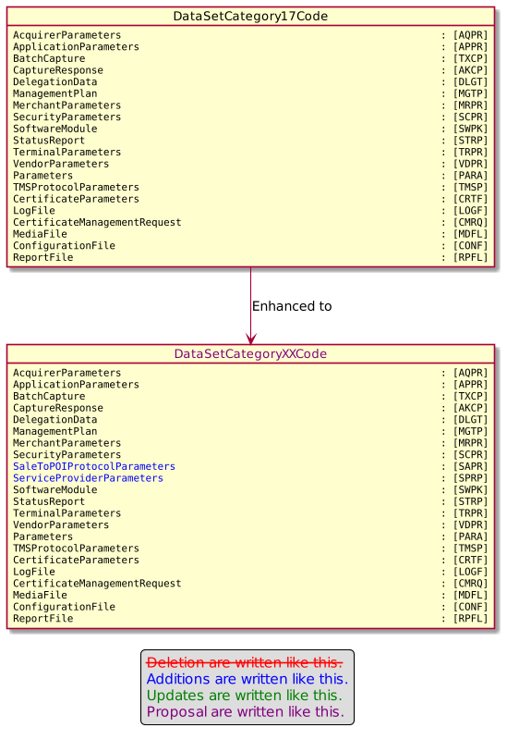

The CardPaymentEnvironment78 will be updated according to the following diagram.

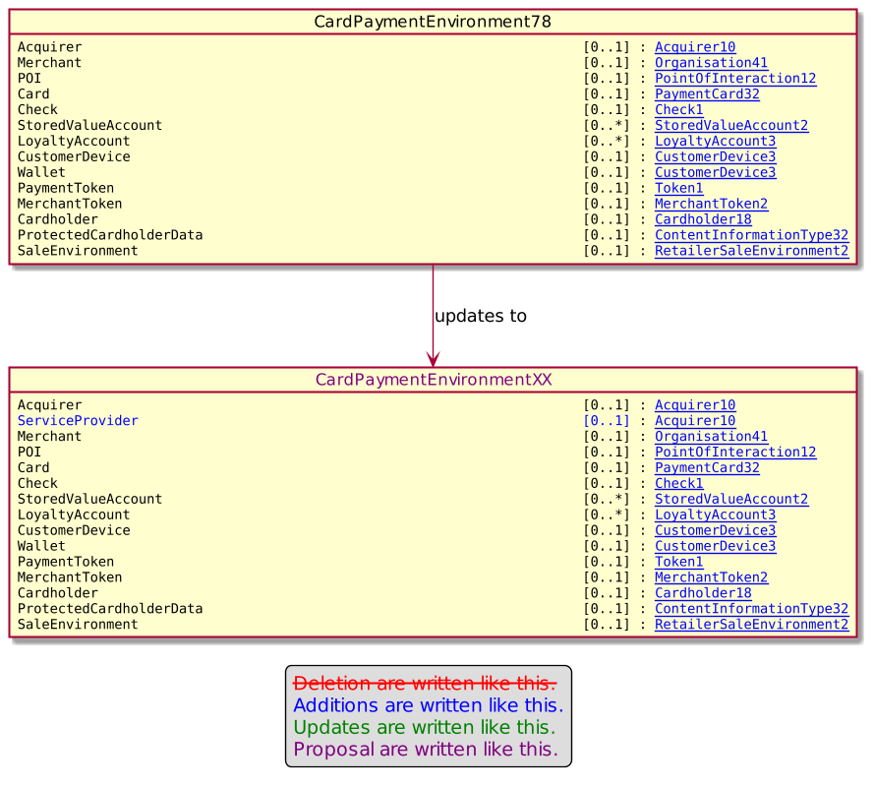

- Urgency of the request:

Urgent.

- Business examples:

- SEG/TSG recommendation:
This section is not to be taken care of by the submitter of the change request. It will be completed in due time by the SEG(s) in charge of the related ISO 20022 messages or the TSG for changes related to the BAH.

Consider |  |  | Timing
 |  |  | - Next yearly cycle: 2022/2023  (the change will be considered for implementation in the yearly maintenance cycle which starts in 2022 and completes with the publication of new message versions in the spring of 2023) |  | X
- At the occasion of the next maintenance of the messages
(the change will be considered for implementation, but does not justify maintenance of the messages in its own right – will be pending until more critical change requests are received for the messages)
- Urgent unscheduled
(the change justifies an urgent implementation outside of the normal yearly cycle)
 |  |  | - Other timing:
Comments:

Reject
Reason for rejection:

- Impact analysis and type of impact:

The modifications will be done as highlighted in the Change Request.

The ripple effect analysis provide the following results.

On DataSetCategory17Code

- DataSetCategory17Code
  - DataSetIdentification9
    - AcceptorConfigurationDataSet3
    - DataSetRequest3
      - StatusReportContent11
    - StatusReportDataSetRequest3
    - TerminalManagementDataSet31
    - TMSAction10
    - TMSActionIdentification8
      - TMSEvent9
    - MaintenanceDelegateAction7
  - TMSAction10

On CardPaymentEnvironment78

- CardPaymentEnvrionement78
  - AcceptorAuthorisationRequest11
  - AcceptorAuthorisationResponse11
  - AcceptorCancellationAdvice11
  - AcceptorCancellationAdviceResponse10
    - AcceptorCancellationAdviceResponse V10 caaa.008.001.10
    - AcceptorCurrencyConversionAdviceResponse V05 caaa.019.001.05
  - AcceptorCancellationRequest11
  - AcceptorCancellationResponse10
  - AcceptorCompletionAdvice11
  - AcceptorCompletionAdviceResponse10
    - AcceptorCompletionAdviceResponse V10 caaa.004.001.10
    - TransactionAdviceResponse V03 caaa.021.001.03
  - AcceptorCurrencyConversionAdvice6
  - AcceptorCurrencyConversionRequest9
  - AcceptorCurrencyConversionResponse9
  - AcceptorDiagnosticRequest10
    - AcceptorDiagnosticRequest V10 caaa.013.001.10
  - AcceptorDiagnosticResponse8
    - AcceptorDiagnosticResponse V09 caaa.014.001.09
  - AcceptorReconciliationRequest10
    - AcceptorReconciliationResponse V10 caaa.009.001.10
  - ReconciliationRequest5
  - ReconciliationResponse6
  - ReportRequest5
  - ReportResponse5
  - CardPaymentDataSet30
    - CardPaymentDataSet31
      - CardPaymentBatchTransferResponse9
        - BatchTransferResponse V10 caaa.012.001.10
  - CardPaymentDataSetTransaction38
  - CardPaymentDataSetTransaction39
  - CardPaymentDataSetTransaction40
  - CardPaymentDataSetTransaction41
  - CommonData11
  - SystemAbort5
  - SystemEventNotification5
  - NonFinancialRequestComponent2
  - NonFinancialResponseComponent2
  - ServiceRequest5
  - ServiceResponse6
  - SessionManagementRequest5
  - SessionManagementResponse5
  - DeviceRequest5
  - DeviceResponse5
  - MessageStatusRequest5
  - MessageStatusResponse6
  - AcceptorReconciliationResponse8
    - AcceptorReconciliationResponse V09 caaa.010.001.09
  - AdministrativeRequest5
  - AdministrativeResponse5
  - TokenRequestComponent2
    - CardPaymentDataSetTransaction10Choice

The severity of the impact of the proposed change for the message users should be indicated in the table below (either “no impact”, “conditional’ or “mandatory”).
Type of impact
 | No impact | The change(s) will not impact the schema (the version number will not change) and will not impact the business applications of any users, e.g. the clarification of a definition
X | Conditional | The change(s) will impact the schema (at least the version number) and the business applications of certain users but not all, e.g. the addition of an optional component
 | Mandatory | The change(s) will impact the schema and the business applications of all users, e.g. addition of a mandatory component.

- Proposed implementation:

On DataSetCategory17Code.

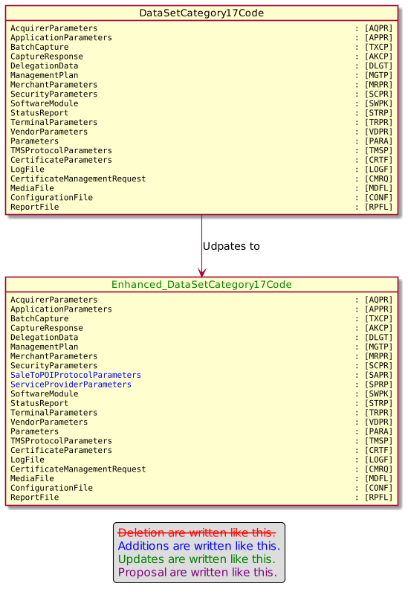

On CardPaymentEnvironment78.
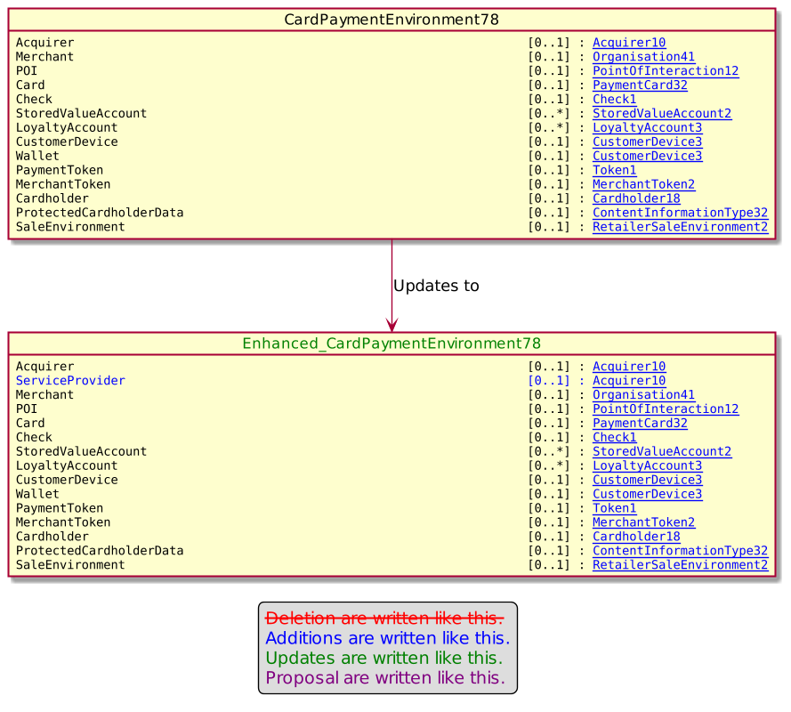

- Proposed timing:
The submitting organization confirms that it can implement the requested changes in the requested timing, or, if not, proposes another timing.

Timing | - As requested
 | - Other:

- Final decision of the SEG(s):
This section is not to be taken care of by the submitting organization. It will be completed in due time by the SEG(s) in charge of the related ISO 20022 messages.
Approve | X
Comments:

Reject
Reason for rejection:

Change request number 1136 Signer Information

Copy of the approved change request:

- Origin of the request:
A.1 Submitter: nexo A.I.S.B.L
A.2 Contact person: Philippe CECE (Philippe.cece@ingenico.com) / Laure BELTRI (laure.beltri@frenchsys.com) / Evelyne de JONGHE (evelyne.de-jonghe@frenchsys.com) / Philippe MERMOUD (philippe.mermoud@bpce.fr) / Robert FARGIER (robert.fargier@istium.pro)
A.3 Sponsors: nexo A.I.S.B.L.

- Related messages:

- AcceptorAuthorisationRequest V11 caaa.001.001.11,
- AcceptorAuthorisationResponse V11 caaa.002.001.11,
- AcceptorCompletionAdvice V11 caaa.003.001.11,
- AcceptorCompletionAdviceResponse V10 caaa.004.001.10,
- AceptorCancellationRequest V11 caaa.005.001.11,
- AcceptorCancellationResponse V10 caaa.006.001.10,
- AcceptorCancellationAdvice V11 caaa.007.001.11,
- AcceptorCancellationAdviceResponse V10 caaa.008.001.10,
- AcceptorReconciliationRequest V10 caaa.009.001.10,
- AcceptorReconciliationResponse V09 caaa.010.001.09",
- AcceptorBatchTransfer V11 caaa.011.001.11,
- AcceptorBatchTransferResponse V10 caaa.012.001.10,
- AcceptorDiagnosticRequest V10 caaa.013.001.10,
- AcceptorDiagnosticResponse V09 caaa.014.001.09,
- AcceptorCurrencyConversionRequest V09 caaa.016.001.09,
- AcceptorCurrencyConversionResponse V09 caaa.017.001.09,
- AcceptorCurrencyConversionAdvice V06 caaa.018.001.06,
- AcceptorCurrencyConversionAdviceResponse V05 caaa.019.001.05,
- TransactionAdvice V03 caaa.020.001.03,
- TransactionAdviceResponse V03 caaa.021.001.03,
- AcceptorNonFinancialRequest V02 caaa.022.001.02,
- AcceptorNonFinancialResponse V02 caaa.023.001.02,
- AcceptorTransactionLogReportRequest V02 caaa.024.001.02,
- AcceptorTransactionLogReportResponse V02 caaa.025.001.02,

- SaleToPOIServiceRequest V04 casp.001.001.04,
- SaleToPOIserviceResponse V04 casp.002.001.04,
- SaleToPOIReconciliationRequest V04 casp.003.001.04,
- SaleToPOIReconciliationResponse V04 casp.004.001.04,
- SaleToPOISessionManagementRequest V04 casp.005.001.04,
- SaleToPOISessionManagementResponse V04 casp.006.001.04,
- SaleToPOIAdministrativeRequest V04 casp.007.001.04,
- SaleToPOIAdministrativeResponse V04 casp.008.001.04,
- SaleToPOIReportRequest V04 casp.009.001.04,
- SaleToPOIReportResponse V04 casp.010.001.04,
- SaleToPOIAbort V04 casp.011.001.04,
- SaleToPOIEventNotification V04 casp.012.001.04,
- SaleToPOIMessageStatusRequest V04 casp.014.001.04,
- SaleToPOIMessageStatusResponse V04 casp.015.001.04,
- SaleToPOIDeviceRequest V04 casp.016.001.04,
- SaleToPOIDevieResponse V04 casp.017.001.04,

- StatusReport V11 catm.001.001.11,
- ManagementPlanReplacement V10 catm.002.001.10,
- AcceptorConfigurationUpdate V11 catm.003.001.11,
- MaintenanceDelegationRequest V08 catm.005.001.08,
- MaintenanceDelegationResponse V06 catm.006.001.06,
- CertificateManagementRequest V05 catm.007.001.05,
- CertificateManagementResponse V06 catm.008.001.05

- Description of the change request:

According to the RFC 5652, when managing an X509 certificate, we are able to identify this certificate either by the information coming from the issuer of this certificate (issuer information and issuer serial number of this certificate) or from the keys certified (subjectKeyIdentifier).
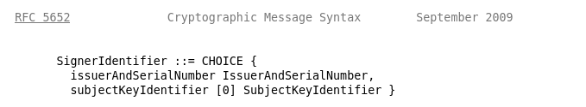
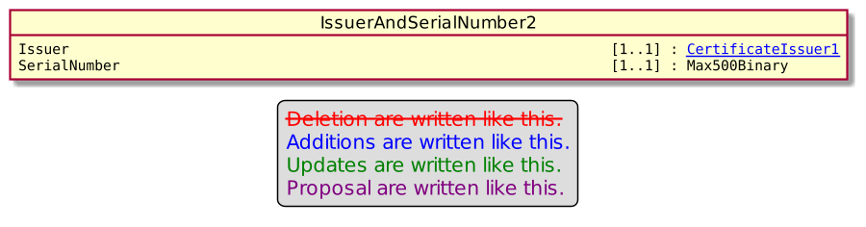
Unfortunately, the previous and current releases of the protocols don’t comply with these options and provide a KeyIdentifier of type KEKIdentifier7 which is slightly different than a SubjectKeyIdentifier.

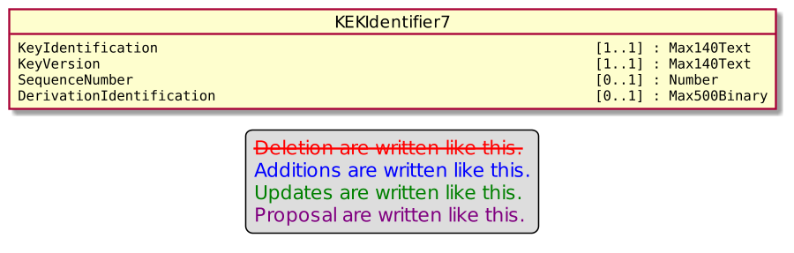

This slight modification was misleading, and some members twist the issuer serial number to set the subject key identifier.

Since this behaviour clearly impact interoperability, we create this change request to be in line with ASN.1 notation and fully support both way of identification and then get rid of any interoperability problem.

In order to manage interoperability, we will use the field Version, of the parent element SignerIdentification of type Signer6. Version is currently set to 1.
- We would use Version = 1 to identify the current behavior.
- We would use Version = 2 to identify that IssuerAndSerialNumber/SerialNumber is really the SerialNumber and not the SubjectKeyIdentifier.
- We would use Version = 3 (as in ASN.1) to identify that the Signer is identified by its SubjectKeyIdentifier

For Version set to 3, with previous release of protocols, the KEKIdentifier7 requires also a subfield named Version to identify the Key. Since this sub field Version is meaningless, as a workaround for current and previous release of protocols using KEKIdentifier7, we will set the sub field Version to 0.

- Purpose of the change:

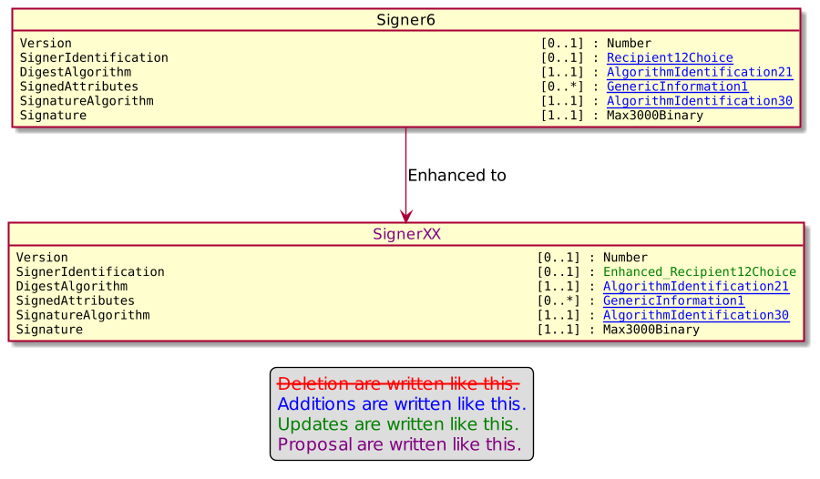

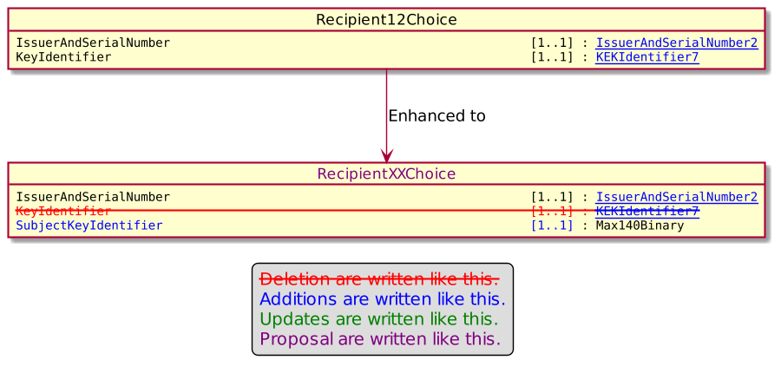

- Urgency of the request:

Urgent.

- Business examples:
Examples illustrating the change request.
- SEG/TSG recommendation:
This section is not to be taken care of by the submitter of the change request. It will be completed in due time by the SEG(s) in charge of the related ISO 20022 messages or the TSG for changes related to the BAH.

Consider |  |  | Timing
 |  |  | - Next yearly cycle: 2022/2023  (the change will be considered for implementation in the yearly maintenance cycle which starts in 2022 and completes with the publication of new message versions in the spring of 2023) |  | X
- At the occasion of the next maintenance of the messages
(the change will be considered for implementation, but does not justify maintenance of the messages in its own right – will be pending until more critical change requests are received for the messages)
- Urgent unscheduled
(the change justifies an urgent implementation outside of the normal yearly cycle)
 |  |  | - Other timing:
Comments:

Reject
Reason for rejection:

- Impact analysis and type of impact:

The modifications will done as defined in the Change Request, since it will also correct through the ripple effect the error on KeyTransport8.

The ripple effect analysis provides the following result.

On Recipient12Choice
- Recipient12Choice
  - KeyTransport8
    - Recipient11Choice
      - EnvelopedData9
        - ContentInformationType30
          - Cf below
        - ContentInformationType32
          - Cf below
      - AuthenticatedData8
        - ContentInformationType29
          - SaleToPOIReportRequest V04 casp.009.001.04
          - SaleToPOIServiceRequest V04 casp.001.001.04
          - SaleToPOIServiceResponse V04 casp.002.001.04
          - SaleToPOIReconciliationRequest V04 casp.003.001.04
          - SaleToPOIReconciliationResponse V04 casp.004.001.04
          - SaleToPOISessionManagementRequest V04 casp.005.001.04
          - SaleToPOISessionManagementResponse V04 casp.006.001.04
          - SaleToPOIAdministrativeRequest V04 casp.007.001.04
          - SaleToPOIAdministrativeResponse V04 casp.008.001.04
          - SaleToPOIReportResponse V04 casp.010.001.04
          - SaleToPOIAbort V04 casp.011.001.04
          - SaleToPOIEventNotification V04 casp.012.001.04
          - SaleToPOIMessageStatusRequest V04 casp.014.001.04
          - SaleToPOIMessageStatusResponse V04 casp.015.001.04
          - SaleToPOIDeviceRequest V04 casp.016.001.04
          - SaleToPOIDeviceResponse V04 casp.017.001.04
          - StatusReport V11 catm.001.001.11
          - ManagementPlanReplacement V10 catm.002.001.10
          - AcceptorConfigurationUpdate V11 catm.003.001.11
          - MaintenanceDelegationRequest V08 catm.005.001.08
          - MaintenanceDelegationResponse V06 catm.006.001.06
          - CertificateManagementRequest V05 catm.007.001.05
          - CertificateManagementResponse V05 catm.008.001.05
          - ActionMessage9
        - ContentInformationType30
        - ContentInformationType31
          - AcceptorCurrencyConversionResponse V09 caaa.017.001.09
          - AcceptorAuthorisationRequest V11 caaa.001.001.11
          - AcceptorAuthorisationResponse V11 caaa.002.001.11
          - AcceptorCompletionAdvice V11 caaa.003.001.11
          - AcceptorCompletionAdviceResponse V10 caaa.004.001.10
          - AcceptorCancellationRequest V11 caaa.005.001.11
          - AcceptorCancellationResponse V10 caaa.006.001.10
          - AcceptorCancellationAdvice V11 caaa.007.001.11
          - AcceptorCancellationAdviceResponse V10 caaa.008.001.10
          - AcceptorReconciliationRequest V10 caaa.009.001.10
          - AcceptorReconciliationResponse V09 caaa.010.001.09
          - AcceptorBatchTransfer V11 caaa.011.001.11
          - AcceptorBatchTransferResponse V10 caaa.012.001.10
          - AcceptorDiagnosticRequest V10 caaa.013.001.10
          - AcceptorDiagnosticResponse V09 caaa.014.001.09
          - AcceptorCurrencyConversionRequest V09 caaa.016.001.09
          - AcceptorCurrencyConversionAdvice V06 caaa.018.001.06
          - AcceptorCurrencyConversionAdviceResponse V05 caaa.019.001.05
          - TransactionAdvice V03 caaa.020.001.03
          - TransactionAdviceResponse V03 caaa.021.001.03
          - AcceptorNonFinancialRequest V02 caaa.022.001.02
          - AcceptorNonFinancialResponse V02 caaa.023.001.02
          - AcceptorTransactionLogReportRequest V02 caaa.024.001.02
          - AcceptorTransactionLogReportResponse V02 caaa.025.001.02
  - Signer6
    - Cf below

On ContentInformationType30
- ContentInformationType30
  - InputResultData4
    - InputResult4
      - DeviceInputResponse4
        - DeviceResponse5
  - DataSetRequest3
  - CryptographicKey16
    - DataSetRequest3
    - SecurityParameters14
      - AcceptorConfigurationContent11
    - PointOfInteractionComponentCharacteristics8
      - PointOfInteractionComponent12
        - LoginRequest4
        - LoginResponse4
        - EventContext4
          - Cf below
        - StatusReportContent11
        - PointOfInteraction12
          - CardPaymentEnvironment78
  - ExternallyDefinedData3
    - CardholderAuthentication15
      - Cardholder18
        - CardPaymentEnvironment78
    - PackageType3
      - TerminalPackageType3
        - AcceptorConfigurationContent11
      - PointOfInteractionComponent12
    - CardPaymentTransactionDetails51
  - TMSAction10
  - MaintenanceDelegation14
    - MaintenanceDelegationResponse6

On EventContext4
- EventContext4
  - RetailerEvent4
    - EventNotificationData4

On ContentInformationType32
- ContentInformationType32
  - PaymentCard32
    - CardPaymentEnvironment78
  - CardholderAuthentication15
  - CardPaymentTransaction114
  - MobileData4
    - Cardholder18
  - RetailerPaymentResult4
  - CardPaymentEnvironment78
  - ApplicationParameters11
    - AcceptorConfigurationContent11
  - OnLinePIN9
    - CardholderAuthentication15
    - DeviceSecureInputRequest4
      - DeviceRequest5
    - DeviceSecureInputResponse4
      - DeviceResponse5

On Signer6
- Signer6
  - SignedData7
    - ContentInformationType29
    - ContentInformationType30

This impact will only impact those who will sign messages.

The severity of the impact of the proposed change for the message users should be indicated in the table below (either “no impact”, “conditional’ or “mandatory”).
Type of impact
 | No impact | The change(s) will not impact the schema (the version number will not change) and will not impact the business applications of any users, e.g. the clarification of a definition
X | Conditional | The change(s) will impact the schema (at least the version number) and the business applications of certain users but not all, e.g. the addition of an optional component
 | Mandatory | The change(s) will impact the schema and the business applications of all users, e.g. addition of a mandatory component.

- Proposed implementation:

On Recipient12Choice.
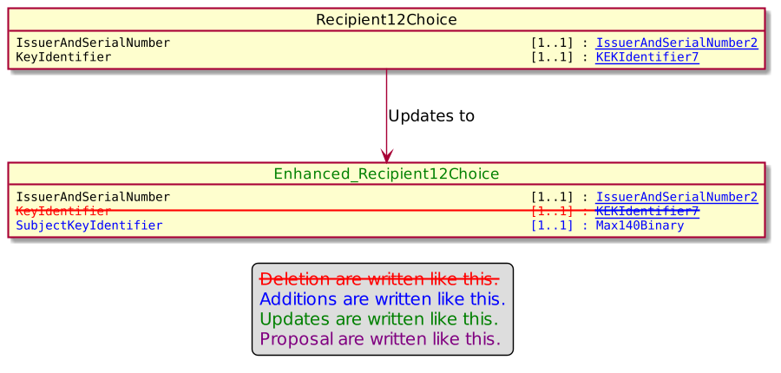

On Signer6

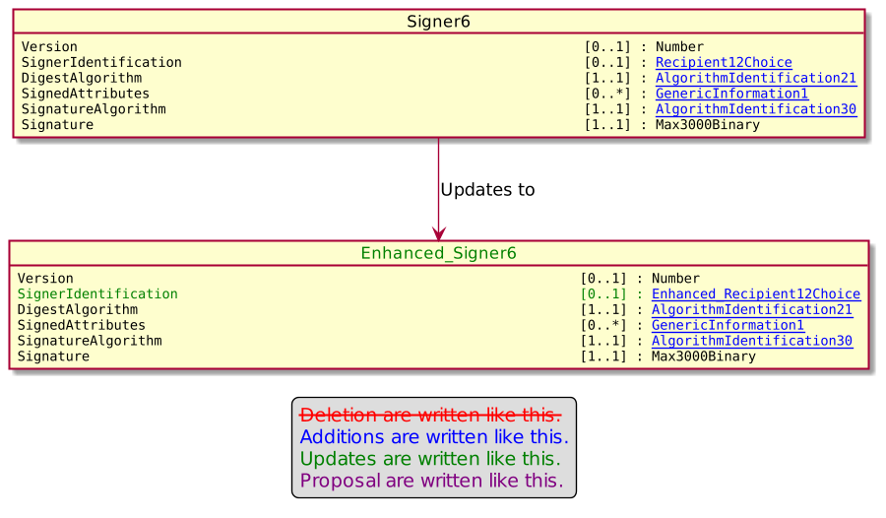

- Proposed timing:
The submitting organization confirms that it can implement the requested changes in the requested timing, or, if not, proposes another timing.

Timing | - As requested
 | - Other:

- Final decision of the SEG(s):
This section is not to be taken care of by the submitting organization. It will be completed in due time by the SEG(s) in charge of the related ISO 20022 messages.
Approve | X
Comments:

Reject
Reason for rejection:

Change request number 1137 TransactionLog Request and Response

Copy of the approved change request:

- Origin of the request:
A.1 Submitter: nexo A.I.S.B.L.
A.2 Contact person: Philippe CECE (Philippe.cece@ingenico.com) / Evelyne de JONGHE (evelyne.de-jonghe@frenchsys.com) / Philippe MERMOUD (philippe.mermoud@bpce.fr) / Robert FARGIER (robert.fargier@istium.pro) /Thomas IRMLER (Thomas.Irmler@fiserv.com)
A.3 Sponsors: nexo A.I.S.B.L.

- Related messages:

- AcceptorBatchTransfer V11 caaa.011.001.11
- AcceptorBatchTransferResponse V10 caaa.012.001.10
- AcceptorTransactionLogReportRequest V02 caaa.024.001.02
- AcceptorTransactionLogReportResponse V02 caaa.025.001.02

- SaleToPOIReportRequest V04 casp.009.001.04
- SaleToPOIReportResponse V04 casp.010.001.04

- Description of the change request:

We would like to rework the structure of the reporting messages from the acquirer and retailer protocols since we discovered that we can’t report transactions made with different cards or on different stores for the same merchant. We would like also to add in this change request the batch transfer messages since we will probably try to harmonize as far as possible these messages.

- Purpose of the change:
The modifications must manage all kind of solution architectures. Then the reporting messages could be sent to a server, an accepting or acquiring one, managing multiple POI for multiple merchants. Data access control will have to be managed at the application level and not at the protocol level. Nevertheless, confidentiality, integrity and authenticity must be managed at the protocol level.
- Urgency of the request:
Not Urgent.
- Business examples:
Examples illustrating the change request.

- SEG/TSG recommendation:
This section is not to be taken care of by the submitter of the change request. It will be completed in due time by the SEG(s) in charge of the related ISO 20022 messages or the TSG for changes related to the BAH.

Consider |  |  | Timing
 |  |  | - Next yearly cycle: 2022/2023  (the change will be considered for implementation in the yearly maintenance cycle which starts in 2022 and completes with the publication of new message versions in the spring of 2023) |  | X
- At the occasion of the next maintenance of the messages
(the change will be considered for implementation, but does not justify maintenance of the messages in its own right – will be pending until more critical change requests are received for the messages)
- Urgent unscheduled
(the change justifies an urgent implementation outside of the normal yearly cycle)
 |  |  | - Other timing:
Comments:
The complete model how to request specific data will be presented in the MCR.

Reject
Reason for rejection:

- Impact analysis and type of impact:

After analysis, we consider that the easiest way to provide reports to the requester is to back the solution on existing components. It should also simplify the development of solutions. Then, since the aim of this service is to provide the result of payment transactions, we decided to set our solution on top of the ServiceResponse6 component which is used in the Sale To POI protocol to provide result of transactions.

Consequently, the message element TransactionReport in the message component ReportTransactionResponse4 will be defined as ServiceResponse6.

The ripple effect analysis provide the following result.

On ReportTransactionResponse4
- ReportTransactionResponse4
  - ReportResponse5

The severity of the impact of the proposed change for the message users should be indicated in the table below (either “no impact”, “conditional’ or “mandatory”).
Type of impact
 | No impact | The change(s) will not impact the schema (the version number will not change) and will not impact the business applications of any users, e.g. the clarification of a definition
 | Conditional | The change(s) will impact the schema (at least the version number) and the business applications of certain users but not all, e.g. the addition of an optional component
X | Mandatory | The change(s) will impact the schema and the business applications of all users, e.g. addition of a mandatory component.

- Proposed implementation:

On ReportTransactionResponse4.
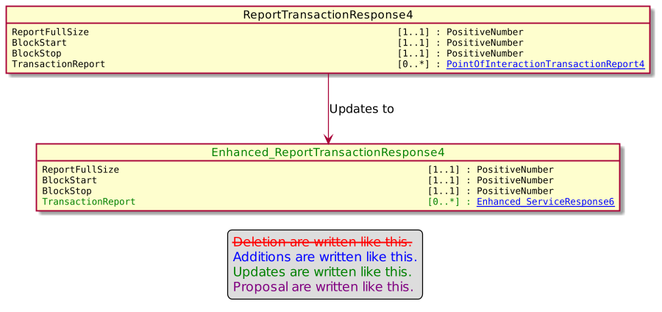

On ServiceResponse6.
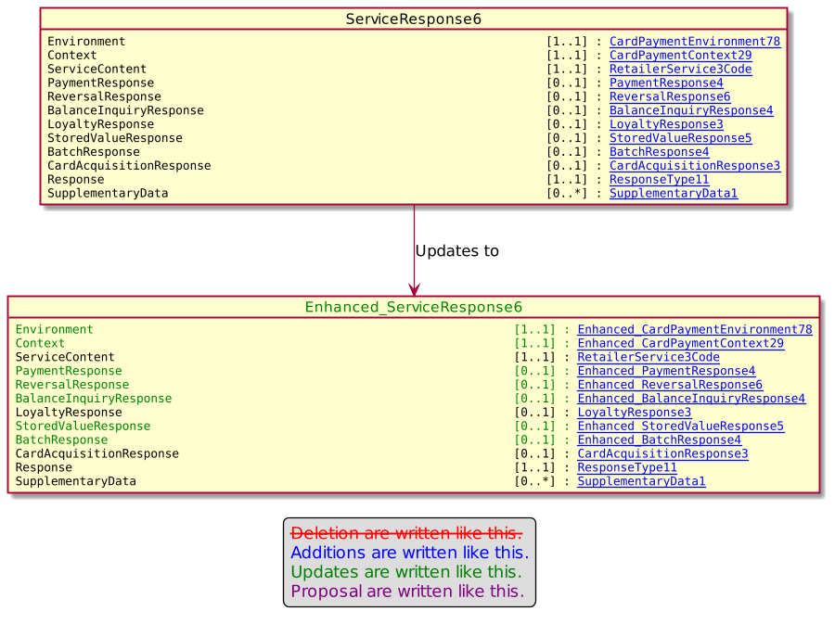

- Proposed timing:
The submitting organization confirms that it can implement the requested changes in the requested timing, or, if not, proposes another timing.

Timing | - As requested
 | - Other:

- Final decision of the SEG(s):
This section is not to be taken care of by the submitting organization. It will be completed in due time by the SEG(s) in charge of the related ISO 20022 messages.
Approve | X
Comments:

Reject
Reason for rejection:

