Maintenance Change Request
for the update of ISO 20022 financial repository items

Name of the request:
“ISO 20022 Collateral Management Maintenance 2021/2022”

Submitting organisation(s):
SWIFT.

Related messages:

Under this maintenance, below existing ISO 20022 message definitions will be maintained (resulting from the impact analysis performed on each CR).

Collateral Management message set:

- colr.005.001.05 - CollateralManagementCancellationRequestV05

The following messages are only impacted by the exposure type change:
- colr.003.001.04 – MarginCallRequestV04
- colr.004.001.04 – MarginCallResponseV04
- colr.006.001.04 - CollateralManagementCancellationStatusV04
- colr.007.001.05 - CollateralProposalV05
- colr.008.001.05 - CollateralProposalReponseV05
- colr.009.001.04 - MarginCallDisputeNotificationV04
- colr.010.001.04 - CollateralSubstitutionRequestV04
- colr.011.001.04 - CollateralSubstitutionResponseV04
- colr.012.001.04 - CollateralSubstitutionConfirmationV04
- colr.013.001.04 - InterestPaymentRequestV04
- colr.014.001.04 - InterestPaymentResponseV04
- colr.015.001.04 - InterestPaymentResponseV04
- colr.016.001.04 - CollateralAndExposureReportV04
Message sets impacted are under responsibility of SWIFT:
Please note that the Collateral Management message set is under the responsibility of SWIFT.

Commitments of the submitting organisation:

The submitting organisations confirm that they can and will:
- Undertake the development of the new version of the candidate ISO 20022 message models that it will submit to the RA for compliance review and evaluation. New valid Message Definition models will be made available to the RA by December 1.
- provide a new version of part 1 of the related Message Definition Reports (MDR) by December 1, and new examples of valid message instances of each candidate message (only when valid samples were published for current version) by May 1 at the latest.
- Address any queries related to the description of the new models and messages as published by the RA on the ISO 20022 website.

SWIFT intends to implement most of the above new versions on its SWIFTNet network once the related documentation has been published by the RA.

The submitting organisations confirm their knowledge and acceptance of the ISO 20022 Intellectual Property Rights policy for contributing organisations, as follows.
“Organisations that contribute information to be incorporated into the ISO 20022 Repository shall keep any Intellectual Property Rights (IPR) they have on this information. A contributing organisation warrants that it has sufficient rights on the contributed information to have it published in the ISO 20022 Repository through the ISO 20022 Registration Authority in accordance with the rules set in ISO 20022. To ascertain a widespread, public and uniform use of the ISO 20022 Repository information, the contributing organisation grants third parties a non-exclusive, royalty-free license to use the published information”.

Contact persons:
Karine Taquet – SWIFT Standards, karine.taquet@swift.com
Karin De Ridder – SWIFT Standards, karin.deridder@swift.com

Collateral Management SEG ET members for SR 2022:

Collateral Management SEG ET | Representing | Present
Jan Grauls | Euroclear | X
Ben Doughton | LCH | X
Filipe Branco - Clearstream | Clearstream | X
Simon Noakes | BNYM
Amitava Bandyopadhyay | BNYM | X
Prem Kumar Cileveri | BNYM | X
Stéphanie Clark Fisher | BNP Paribas | X
Charlotte Deleu | BNP Paribas | X
Manuel Huete | Banco de Espana | X
Gary McNamara | ECB | X
Marek Kozok | ECB
Javier Martinez | ECB
Karine Taquet | SWIFT | X
Mieko Morioka | SWIFT | X
Daniel Fabian | JP Morgan
Luise Gutowska | Eurex Clearing
Rechel Pollack | JP Morgan
JW Forsythe@statestreet.com' | Statestreet
Crispin Searle@deutsche-boerse.com' | Deutsche Boerse
Alexander Westphal | ICMA
Adrian.Dale | ISLA

Change request CR01037:
Alignement among the collateral management messages

Origin of the request:
A.1 Submitter: S.W.I.F.T. SC
A.2 Contact person: Karine Taquet; karine.taquet@swift.com; +32 (0) 2 655 3784
A.3 Sponsors: The Eurosystem’s Advisory Group on Market Infrastructures for Securities and Collateral (AMI-SeCo) agreed to introduce a single, harmonised triparty model for Europe that would be based on the global ISO20022 messaging standard.
There is broad endorsement of the Standards by all TPAs, central banks and other market participants.

Related messages:
The list of ISO 20022 messages which would be impacted by the change, including the Message IDs as shown in the Catalogue of ISO 20022 messages. Only the latest version of a message definition can be maintained.
The submitter is invited to carefully examine whether the change may have an impact on other messages that come into play earlier or later in the transaction chain or on other messages that also use message components that this change request may impact.
Related messages:
- colr.005 (CollateralManagementCancellationRequest)

Description of the change request:
- Align the exposure type among all the messages mentioned above.
Exposure type code CBCO (Central Bank Credit Operations) and UDMS (Uncleared Derivative Margin Segregation) will have to be added to ExposureType5Code list and exposure type code EQUI (EQUITY) will have to be added to ExposureType7Code list.
Further alignment might be required as the 2 lists of codes are linked to 2 different parent code lists. ExposureType5Code is linked to ExposureTypeCode and ExposureType7Code is linked to ExposureTypeV2Code. Merging the 2 parent code lists should be envisaged even though this will impact many more messages from different business areas.
Note that in ExposureTypeCode list there is a typo TreasuryCorssProduct that is corrected* in ExposureTypeV2Code though.

- Include the proprietary option for the exposure type in colr.005 Collateral Management Cancellation Request.

Purpose of the change:

The Eurosystem’s Advisory Group on Market Infrastructures for Securities and Collateral (AMI-SeCo) agreed to introduce a single, harmonised triparty model for Europe that would be based on the global ISO20022 messaging standard. In the light of the harmonisation needs identified by the AMI-SeCo in December 2017, a harmonised triparty model (the Single Triparty Model for Europe) was developed in June 2018 covering all relevant business processes and workflows. Key data elements were then mapped to ISO20022-compliant messages.

The Standards cover the communication of the triparty agents (TPAs) with relevant stakeholders based solely on the latest ISO20022-compliant messaging. The Triparty Collateral Management Standards defined requirements cover all existing triparty business processes and workflows and introduce enhanced features that will facilitate improved reporting capabilities to support the needs of treasurers and to meet regulatory requirements.

The Triparty Collateral Management Standards cover triparty processes offered to commercial and central banks. There is a single set of processes applicable for central banks and commercial banks. A few processes are more relevant in the context of the collateralisation of central bank operations (e.g.unilateral increase), while a number of other processes are more relevant for commercial banks (e.g.future-dated processing or customised baskets).

Implementation of theTriparty Collateral Management Standards will be mandatory for all TPAs (regardless of whether they are regulated as an (international) central securities depository ((I)CSD) or as a bank). (I)CSDs and custodian banks acting as TPAs are key stakeholders and are obliged to comply. It will also be mandatory for Eurosystem central banks and central counterparties (CCPs) as key users to implement the Triparty Collateral Management Standards. For collateral givers and collateral takers (unless they are Eurosystem central banks or CCPs), the use of existing messaging standards other than those based on ISO20022 remains possible.
The Triparty Collateral Management Standards should be implemented by November 2023 by all TPAs, CCPs and Eurosystem central banks (for triparty activities between key stakeholders in AMI-SeCo markets covered by the Standards). Timely implementation of the Triparty Collateral Management Standards by other actors (e.g.custodians not acting as TPAs but as collateral takers/givers) is also greatly encouraged in order to foster broader harmonisation across the industry.
In the frame of Triparty Collateral Management there is a need to align the exposure type code lists among all the colr messages used in the frame of the triparty collateral management.
Moreover if a proprietary exposure type code is used in the colr.019 (Triparty Collateral Transaction Instruction) at the moment it is not possible to reflect this information in the colr.005 (Collateral Management Cancellation Request) as this datatype is not an option. There must be an alignment on the data type too.

Urgency of the request:
To be included as part of the annual maintenance cycle.

Business examples:

- Addition of proprietary data type for the exposure type
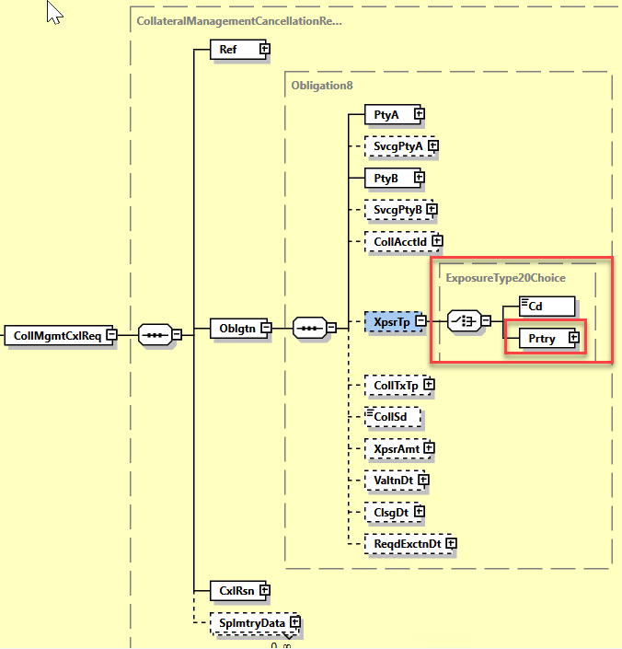

- Addition of the codes highlighted in red.
Need to discuss/choose duplicated in orange.

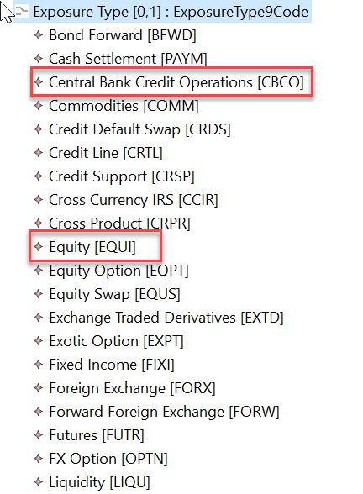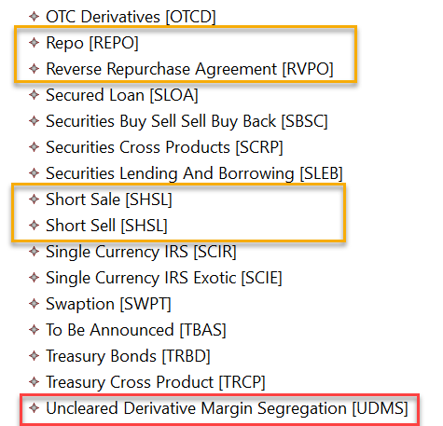

SEG/TSG recommendation:

Consider |  | X | Timing
 |  |  | - Next yearly cycle: 2021/2022  (the change will be considered for implementation in the yearly maintenance cycle which starts in 2021 and completes with the publication of new message versions in the spring of 2022) |  | X
- At the occasion of the next maintenance of the messages
(the change will be considered for implementation, but does not justify maintenance of the messages in its own right – will be pending until more critical change requests are received for the messages)
- Urgent unscheduled
(the change justifies an urgent implementation outside of the normal yearly cycle)
 |  |  | - Other timing:

Comments:
ISO RA agrees that the ExposureType business parent code lists must be merged and aligned. Note that doing so there will be an issue with codes SHORT SELL and SHORT SALE (reversed engineered from MT527) that have the same code SHSL. The SEG ET will need to identify whether 2 separate codes should coexist business wise. If yes, then one of the code must be changed. If no, which one do we remove?
Additional codes will be added only to the colr.005 for SR 2022. Proprietary data type might be added too based on the SEG ET decision.
Other colr messages should not be impacted by the alignment of the business code lists. The link to the latest business parent code list will be done when the messages are impacted by change requests in future maintenances.

Proposed timing:
The submitting organisation confirms that it can implement the requested changes in the requested timing.

Timing | As requested SR 2022

Final decision of the SEG(s):

Accepted | X

Comments:
The SEG ET approved the following changes in order to meet the alignment requirements between the TPCM messages and the existing collateral messages and more specifically the colr.005:
- Addition of the following exposure types codes: UDMS and CBCO.
NOTE: EQUI is already present in the message so no need to add it.
- Addition of a proprietary data type for the exposure type
- They also approved of the merging of the existing 2 collateral type parent lists and approved that between the following duplicates:
  - Short Sale and Short Sell: Short Sell would be kept and definition will be changed accordingly.
  - Repo and Repurchase Agreement: Repurchase Agreement will be kept.

The SEG ET raised the point that in the frame of the alignment exercise between the TPCM messages and the existing colr.005 message, there is a need to add the Settlement Process indicator (Specifies the settlement process in which the collateral will be settled) in or to cover the TPCM cancellation business case. The SEG ET agreed to add this element as optional non repetitive.

The SEG also discussed the alignment of the exposure amount. In the colr.005 there is debit/credit indicator which is not present in the other collateral management messages and which is redundant with the Collateral Side message element. The SEG ET therefore approved to remove the debit/credit indicator from the Exposure Amount.

Proposed implementation:

- Addition of proprietary data type for the exposure type

- Addition of the codes highlighted in green.
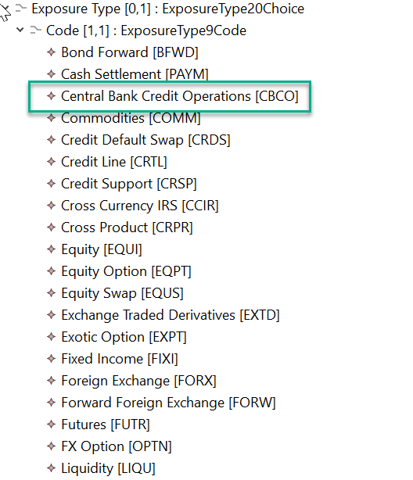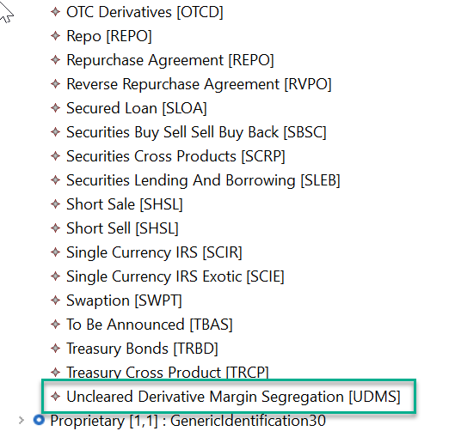

- After merging of Exposure Type parent code lists, removal of codes in red.
NOTE that this will not change anything in the colr.005 as it contains already the correct codes.

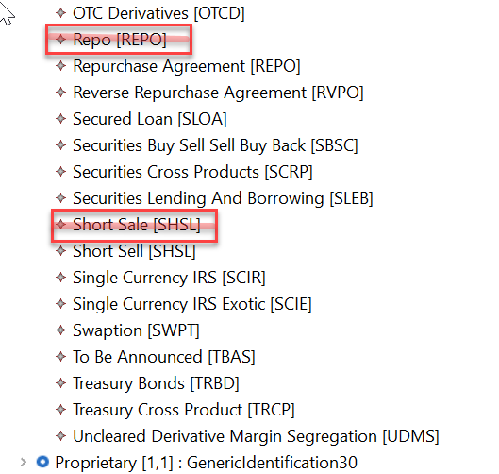

- Addition of the Settlement Process indicator under Obligation as an optional non repetitive message element.
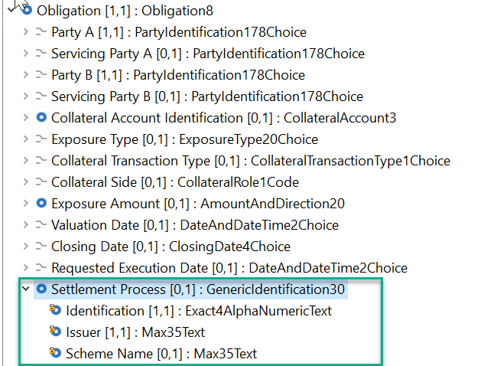

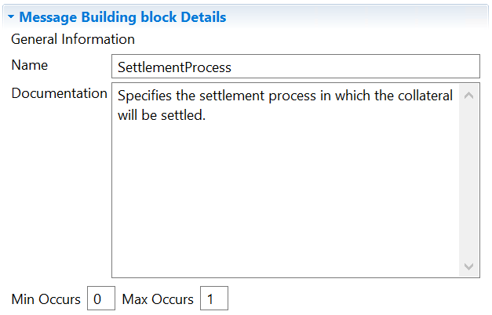

- Removal of the debit/credit indicator for the exposure amount.

