Maintenance Change Request
for the update of ISO 20022 financial repository items

Name of the request:
“ISO 20022 Payments Maintenance 2021/2022”

Submitting organization(s):
SWIFT, on behalf of SWIFT, IFX, TWIST and OAGi (ISTH)
Standards Department,
Avenue Adele, 1
1310 La Hulpe - Belgium

Related messages:
Under this project, below existing ISO 20022 message definitions will be maintained (resulting from the impact analysis performed on each CR).

- Bank to Customer Cash Management message set:
- camt.052.001.09 | BankToCustomerAccountReportV09
- camt.053.001.09 | BankToCustomerStatementV09
- camt.054.001.09 | BankToCustomerDebitCreditNotificationV09
- Notification to Receive
- camt.058.001.07 | NotificationToReceiveCancellationAdviceV07
- Exceptions and Investigations
- camt.055.001.10 | CustomerPaymentCancellationRequestV10

Commitments of the submitting organization:
The submitting organization must confirm that it can and will:
- undertake the development of the new version of the candidate ISO 20022 message models that it will submit to the RA for compliance review and evaluation. For the ISO 20022 yearly maintenance cycle, new valid Message Definition models must be available to the RA by December 1.
- provide a new version of part 1 of the Message Definition Report (MDR) by December 1, and, optionally, new examples of valid and invalid message instances of each candidate message by May 1 at the latest.
- address any queries related to the description of the new models and messages as published by the RA on the ISO 20022 website.

The submitting organisations confirm their knowledge and acceptance of the ISO 20022 Intellectual Property Rights policy for contributing organisations, as follows.
“Organizations that contribute information to be incorporated into the ISO 20022 Repository shall keep any Intellectual Property Rights (IPR) they have on this information. A contributing organization warrants that it has sufficient rights on the contributed information to have it published in the ISO 20022 Repository through the ISO 20022 Registration Authority in accordance with the rules set in ISO 20022. To ascertain a widespread, public and uniform use of the ISO 20022 Repository information, the contributing organization grants third parties a non-exclusive, royalty-free license to use the published information”.

Contact persons:
Tinne Verschueren – SWIFT Standards, tinne.verschueren@swift.com
Didier Hermans – SWIFT Standards, didier.hermans@swift.com
Vincent Kuntz – SWIFT Standards, vincent.kuntz@swift.com

Change request number CR0942
This chapter must be completed for every change request that the submitting organization has been requested to implement.

Origin of the request:
A.1 Submitter:
- CFONB, Comité Français d’Organisation et de Normalisation Bancaires (French Committee for Banking Organisation and Normalisation),
- GUF, Groupement des Utilisateurs de SWIFT en France (French SWIFT Members and Users Group).

A.2 Contact person: person(s) who can be contacted to get additional information on the request (name, e-mail, telephone)
Laurent LAFEUILLADE laurent.lafeuillade@socgen.com +33 1 42 14 66 70
Sylvain DAUGE Sylvain.Dauge@socgen.com +33 1 58 98 94 16
Rocco ZIRPOLI Rocco.Zirpoli@caissedesdepots.fr +33 1 58 50 19 50
A.3 Sponsors:
French mail institution, “La Poste”, which has written the postal address standard NF Z 10-011, used in France and in French Territories, made available to all users around the world through the UPU.

Related messages:
All ISO20022 messages using the Postal Address <PstlAdr> element.

Description of the change request:
We are requesting the extension of the length of the BuildingName element to more than 35c.
We ask you for advice on alignment with the length of the Floor element, i.e. 70c.

Purpose of the change:
We request to bring closer the lengths of the elements BuildingName (at 35c) and Floor (at 70c). We are looking for consistency between these elements.
The objective of this Change Request is to allow the BuildingName element to be filled by a French postal address, without truncation and thus ensuring its conformity with the French postal standard, while avoiding an induced loss of data.
Failing that, additional information could be filled in the Floor element only, by keeping the BuildingName element unused, but this is not desirable, in order to keep and store this data in its appropriate information category.

Urgency of the request:
End November 2022 for a usage in 2023.

Business examples:
You will find, herebelow, the summary of Universal Post Union element description of French addresses and some examples of French addresses, for both physical persons and companies, impacted by this issue.
The Examples illustrate the difficulty to fill, with the Line 2 from the French Postal Standard, the ISO20022 BuildingName element, for both physical persons and companies:

“Line 2” from French Postal Standard (38c) | “Building Name” Tag (35c)
“Zone industrielle de la Ballastrierre” | “Zone industrielle de la Ballastrier”
“Résidence des Capucins Bâtiment Quater” | “Résidence des Capucins Bâtiment Qua”
“Chez Mme COPPÉ Porte A Bâtiment Cerise” | “Chez Mme COPPÉ Porte A Bâtiment Cer”

FR | France
Summary Corporate Address
Level | ISO20022 tag | Element description | DataType | Universal Post Union (UPU) element description of French addresses |  | DataType
2 | <Dbtr> | Debtor
3 | <Nm> | Name |  |  | corporate name
3 | <PstlAdr> | Postal Address
4 | <Dept> | Department | Max70Text | Line 2 | Unit, addressee | Max 38
4 | <SubDept> | Sub Department | Max70Text | Line 2 | Unit, addressee | Max 38
4 | <StrtNm> | Street Name | Max70Text | Line 4 | house number and street name (= max 38 characters for the line) | 32
4 | <BldgNb> | Building Number | Max16Text |  |  | 5+1
4 | <BldgNm> | Building Name | Max35Text | Line 3 | additional geographical information (this line contains also the "Room" information) | Max 38
4 | <Flr> | Floor | Max70Text | Line 3 |  | Max 38
4 | <PstBx> | Post Box | Max16Text | Line 5 | PO box number (this line contains also the "Town Location Name" information) | Max 38
4 | <Room> | Room | Max70Text | Line 3 | additional geographical information  ==> Refers also to ISO 20022 elements "Building Name" and "Floor"
4 | <PstCd> | Post Code | Max16Text | Line 6 | postcode and CEDEX delivery office (= max 38 characters for the line) | 5+1
4 | <TwnNm> | Town Name | Max35Text |  |  | 32
4 | <TwnLctnNm> | Town Location Name | Max35Text | Line 5 | locality (only if geographical locality differs from CEDEX delivery office)  ==> Refers also to ISO 20022 element "Post Box"
4 | <DstrctNm> | District Name | Max35Text |  | Not used in French addresses
4 | <CtrySubDvsn> | Country Sub Division | Max35Text |  | Not used in French addresses
4 | <Ctry> | Country | Code2Text | Line 7 | COUNTRY | Max 38

Summary Private individual
Level | ISO20022 tag | Element description | DataType | Universal Post Union (UPU) element description of French addresses |  | DataType
2 | <Dbtr> | Debtor
3 | <Nm> | Name |  |  | Name
3 | <PstlAdr> | Postal Address
4 | <Dept> | Department | Max70Text |  | Not used in French addresses of private individuals | Max 38
4 | <SubDept> | Sub Department | Max70Text |  | Not used in French addresses of private individuals | Max 38
4 | <StrtNm> | Street Name | Max70Text | Line 4 | house number and street name (= max 38 characters for the line) | 32
4 | <BldgNb> | Building Number | Max16Text |  |  | 5+1
4 | <BldgNm> | Building Name | Max35Text | Line 3 | additional geographical information | Max 38
4 | <Flr> | Floor | Max70Text | Line 2 | additional delivery point information (This line contains also the "Room" information) | Max 38
4 | <PstBx> | Post Box | Max16Text | Line 5 | If PO BOX available
4 | <Room> | Room | Max70Text | Line 2 | additional delivery point information  ==> Refers also to ISO 20022 element "Floor" | Max 38
4 | <PstCd> | Post Code | Max16Text | Line 6 | postcode and locality (= max 38 characters for the line) | 5+1
4 | <TwnNm> | Town Name | Max35Text |  | postcode and locality (= max 38 characters for the line) | 32
4 | <TwnLctnNm> | Town Location Name | Max35Text | Line 5 | lieu-dit or hamlet name | Max 38
4 | <DstrctNm> | District Name | Max35Text |  | Not used in French addresses
4 | <CtrySubDvsn> | Country Sub Division | Max35Text |  | Not used in French addresses
4 | <Ctry> | Country | Code2Text | Line 7 | PAYS | Max 38

ISO code | Country name
FR | France
Example #1: Company 1
Level | ISO20022 tag | Element description | Universal Post Union (UPU) example | French postal elements | Recommended  ISO20022 mapping exemple | Possible  ISO20022 mapping example
2 | <Dbtr> | Debtor
3 | <Nm> | Name | DURAND SA  Service achat  Zone industrielle de la Ballastrierre  22BIS RUE DES FLEURS  BP 40122  33506 LIBOURNE CEDEX  France | DURAND SA | DURAND SA | DURAND SA
3 | <PstlAdr> | Postal Address
4 | <Dept> | Department |  | Service achat |  | Service achat
4 | <SubDept> | Sub Department |  | Service achat
4 | <StrtNm> | Street Name |  | 22BIS RUE DES FLEURS | 22BIS RUE DES FLEURS | RUE DES FLEURS
4 | <BldgNb> | Building Number |  | 22BIS RUE DES FLEURS |  | 22BIS
4 | <BldgNm> | Building Name |  | Zone industrielle de la Ballastrierre | Zone industrielle de la Ballastrierre
4 | <Flr> | Floor |  | Zone industrielle de la Ballastrierre |  | Zone industrielle de la Ballastrierre
4 | <PstBx> | Post Box |  | BP 40122 | BP 40122 | BP 40122
4 | <Room> | Room
4 | <PstCd> | Post Code |  | 33506 LIBOURNE CEDEX | 33506 | 33506
4 | <TwnNm> | Town Name |  | 33506 LIBOURNE CEDEX | LIBOURNE CEDEX | LIBOURNE CEDEX
4 | <TwnLctnNm> | Town Location Name
4 | <DstrctNm> | District Name
4 | <CtrySubDvsn> | Country Sub Division
4 | <Ctry> | Country |  | France | France | France
Example #2: Company 2
Level | ISO20022 tag | Element description | Universal Post Union element (UPU) | French postal elements | Recommended  ISO20022 mapping exemple | Possible  ISO20022 mapping example
2 | <Dbtr> | Debtor
3 | <Nm> | Name | Société DUPONT  Mademoiselle Lucie MARTIN  Résidence des Capucins Batiment Quater  56 RUE EMILE ZOLA  BP 90432 MONTFERRIER SUR LEZ  34092 MONTPELLIER CEDEX 5  France | Société DUPONT | Société DUPONT | Société DUPONT
3 | <PstlAdr> | Postal Address
4 | <Dept> | Department |  | Mademoiselle Lucie MARTIN | Mademoiselle Lucie MARTIN | Mademoiselle Lucie MARTIN
4 | <SubDept> | Sub Department |  | Mademoiselle Lucie MARTIN
4 | <StrtNm> | Street Name |  | 56 RUE EMILE ZOLA | 56 RUE EMILE ZOLA | RUE EMILE ZOLA
4 | <BldgNb> | Building Number |  | 56 RUE EMILE ZOLA |  | 56
4 | <BldgNm> | Building Name |  | Résidence des Capucins Batiment Quater | Résidence des Capucins Batiment Quater
4 | <Flr> | Floor |  | Résidence des Capucins Batiment Quater |  | Résidence des Capucins Batiment Quater
4 | <PstBx> | Post Box |  | BP 90432 | BP 90432 | BP 90432
4 | <Room> | Room
4 | <PstCd> | Post Code |  | 34092 MONTPELLIER CEDEX 5 | 34092 | 34092
4 | <TwnNm> | Town Name |  | 34092 MONTPELLIER CEDEX 5 | MONTPELLIER CEDEX 5 | MONTPELLIER CEDEX 5
4 | <TwnLctnNm> | Town Location Name |  | MONTFERRIER SUR LEZ | MONTFERRIER SUR LEZ | MONTFERRIER SUR LEZ
4 | <DstrctNm> | District Name
4 | <CtrySubDvsn> | Country Sub Division
4 | <Ctry> | Country |  | France | France | France
Example #3: Private Individual in residence
Level | ISO20022 tag | Element description | Universal Post Union element (UPU) | French postal elements | Recommended  ISO20022 mapping exemple | Possible  ISO20022 mapping example
2 | <Dbtr> | Debtor
3 | <Nm> | Name | Monsieur Jean DELHOURME  Chez Mme COPPÉ  Porte A Bâtiment Cerise  25 RUE DE L EGLISE  CAUDOS  33380 MIOS  FRANCE | Monsieur Jean DELHOURME | Monsieur Jean DELHOURME | Monsieur Jean DELHOURME
3 | <PstlAdr> | Postal Address
4 | <Dept> | Department
4 | <SubDept> | Sub Department
4 | <StrtNm> | Street Name |  | 25 RUE DE L EGLISE | 25 RUE DE L EGLISE | RUE DE L EGLISE
4 | <BldgNb> | Building Number |  | 25 RUE DE L EGLISE |  | 25
4 | <BldgNm> | Building Name |  | Porte A Bâtiment Cerise
4 | <Flr> | Floor |  |  | Porte A Bâtiment Cerise | Chez Mme COPPÉ Porte A Bâtiment Cerise
4 | <PstBx> | Post Box
4 | <Room> | Room |  | Chez Mme COPPÉ | Chez Mme COPPÉ
4 | <PstCd> | Post Code |  | 33380 MIOS | 33380 | 33380
4 | <TwnNm> | Town Name |  | 33380 MIOS | MIOS | MIOS
4 | <TwnLctnNm> | Town Location Name |  | CAUDOS | CAUDOS | CAUDOS
4 | <DstrctNm> | District Name
4 | <CtrySubDvsn> | Country Sub Division
4 | <Ctry> | - Country |  | France | France | France

SEG/TSG recommendation:

Consider |  | X | Timing
- Next yearly cycle: 2021/2022
(the change will be considered for implementation in the yearly maintenance cycle which starts in 2021 and completes with the publication of new message versions in the spring of 2022)
- At the occasion of the next maintenance of the messages
(the change will be considered for implementation, but does not justify maintenance of the messages in its own right – will be pending until more critical change requests are received for the messages)
- Urgent unscheduled
(the change justifies an urgent implementation outside of the normal yearly cycle)
 |  |  | - Other timing:
Comments: Decision made at the Payments SEG meeting on 21st June 2021. The CR will be implemented when there will be additional changes submitted for the PostalAddress message component. All changes should be collected and implemented at the same time. The SEG decided to not define an implementation timing for now.

SWIFT comment:
Change impacts other business domains as the current PostalAddress component is also used in other business areas (messages impacted in area semt, admi, auth, colr, reda, etc.). Therefore CR must be shared with other SEGs.

Reject
Reason for rejection:

Impact analysis and type of impact:
The severity of the impact of the proposed change for the message users:
Type of impact
 | Conditional | The change(s) will impact the schema (at least the version number) and the business applications of certain users but not all, e.g. the addition of an optional component

Proposed implementation:
New version of PostalAddress component needed to change Building Name to Max70Text (but combine with other changes, if needed by the time of implementation).
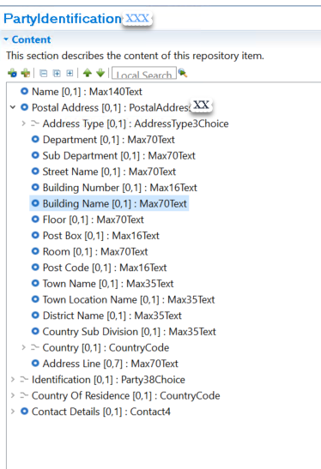

Proposed timing:
The submitting organization confirms that it can implement the requested change, but will wait for implementation until

Timing | - As requested
 | - Other: To be defined once the outcome of PMPG is known on further global needs to change Postal Address in the context of Payments ISO 20022 migration.

Final decision of the SEG(s):

Approve | X
Comments: Consider for implementation in 2022/2023. There might be additional change requests submitted in the meantime that will added to the new PostalAddress message element.

Reject
Reason for rejection:

Change request number CR0956
This chapter must be completed for every change request that the submitting organization has been requested to implement.

Origin of the request:
A.1 Submitter: ISO 20022 Payment SEG
A.2 Contact person: Neil Buchan, neil.buchan@swift.com +442077622135
A.3 Sponsors:

Related messages:
camt.055.001.09 CustomerPaymentCancellationRequestV09
pain.013.001.08 CreditorPaymentActivationRequestV08

Description of the change request:
Change the scope of the camt.055.001.09 (CustomerPaymentCancellationRequest)
The CustomerPaymentCancellationRequest message is sent by a case creator/case assigner to a case assignee. This message is used to request the cancellation of an original payment instruction. The CustomerPaymentCancellationRequest message is issued by the initiating party to request the cancellation of an initiation payment message previously sent (such as CustomerCreditTransferInitiation, CreditorPaymentActivationRequest or CustomerDirectDebitInitiation).

Purpose of the change:
Extend the scope of camt.055.001.09 (CustomerPaymentCancellationRequest) to include the request to cancel pain.013.001.08 (CreditorPaymentActivationRequest)
This will allow an initiator of a previously sent CreditorPaymentActivationRequest to request it to be cancelled.

Urgency of the request:
Next maintenance cycle.
.

Business examples:

Example - Cancelation Request of CustomerCreditTransferInitiation (pain.001)
Example - Cancelation Request of CustomerDirectDebitInitiation (pain.008)
Example - Cancelation Request of CreditorPaymentActivationRequest (pain.013)

SEG/TSG recommendation:

Consider |  | X | Timing
 |  |  | - Next yearly cycle: 2021/2022  (the change will be considered for implementation in the yearly maintenance cycle which starts in 2021 and completes with the publication of new message versions in the spring of 2022) |  | X
- At the occasion of the next maintenance of the messages
(the change will be considered for implementation, but does not justify maintenance of the messages in its own right – will be pending until more critical change requests are received for the messages)
- Urgent unscheduled
(the change justifies an urgent implementation outside of the normal yearly cycle)
 |  |  | - Other timing:
Comments: Decision made at the Payments SEG meeting on 21st June 2021.

Reject
Reason for rejection:

Impact analysis and type of impact:
Only camt.055.001.XX is impacted. As the change has no impact on the schema, it can be considered to update via a dictionary patch, which requires only a regeneration of the documentation in ISO 20022.
Question from SWIFT: Which previous version must be updated? Latest version is camt.055.001.10, change request was received for camt.055.001.09.
Type of impact
 | No impact | The change(s) will not impact the schema (the version number will not change) and will not impact the business applications of any users, e.g. the clarification of a definition

Proposed implementation:
Detailed description of the required modification to implement the requested change.
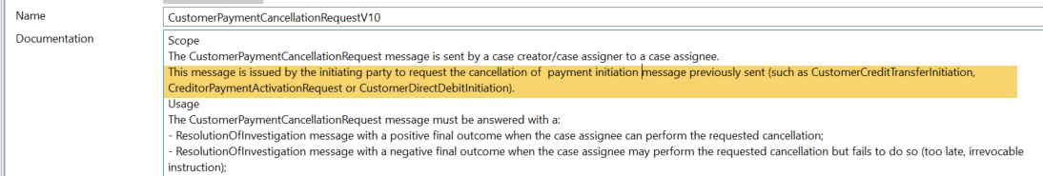

Proposed timing:
The submitting organization confirms that it can implement the requested changes in the requested timing.

Timing | - As requested

Final decision of the SEG(s):

Approve | X
Comments: Implementation in 2021/2022.

Reject
Reason for rejection:

Change request number CR0985
This chapter must be completed for every change request that the submitting organization has been requested to implement.

Origin of the request:
A.1 Submitter:
Russian National Member and User Group (ROSSWIFT)

A.2 Contact person:
Timothy Romaslovsky, Consultant, ROSSWIFT, Timothy.Romaslovsky@swift-russia.ru, +7 910 458 8897

A.3 Sponsors:
The Central Bank of the Russian Federation, Russian Corporate-to-Bank Market Practice Group (Russian CMPG) of Russian National Member and User Group (ROSSWIFT).

Related messages:
camt.052.001.09 - BankToCustomerAccountReport.
camt.053.001.09 - BankToCustomerStatement.
camt.054.001.09 - BankToCustomerDebitCreditNotification.

Description of the change request:
Add optional component <PaymentTypeInformation>, multiplicity [0..1], Type “PaymentTypeInformation28”, below element «References» to the messages:
Bank To Customer Account Report (camt.052.001.09) – /Document/BkToCstmrAcctRpt/Rpt/Ntry/NtryDtls/TxDtls
Bank To Customer Statement (camt.053.001.09) – /Document/BkToCstmrStmt/Stmt/Ntry/NtryDtls/TxDtls
Bank To Customer Debit Credit Notification (camt.054.001.09) – /Document/BkToCstmrDbtCdtNtfctn/Ntfctn/Ntry/NtryDtls/TxDtls
with the same structure as component <PaymentTypeInformation> in Financial Institution Credit Transfer (pacs.009.001.10),
to the parent component ReportEntry11 / EntryDetails10 / EntryTransaction11.
The optional and non-repetitive component PaymentTypeInformation28 will contain following sub-elements:

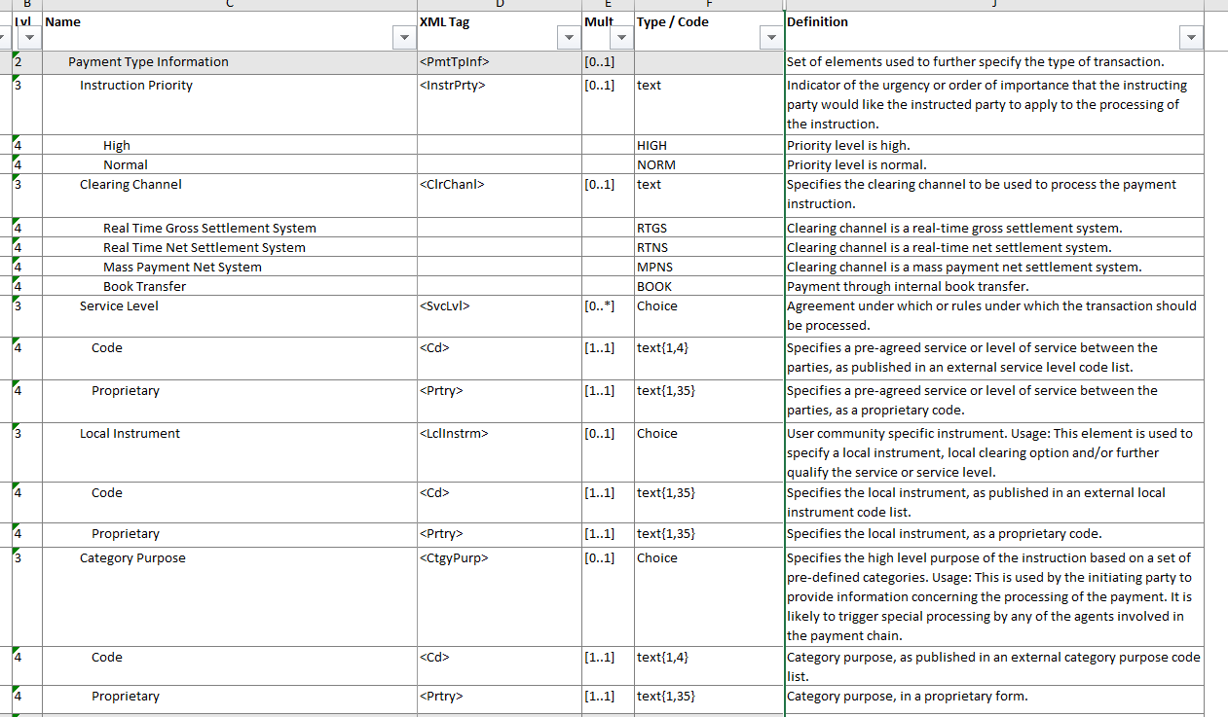

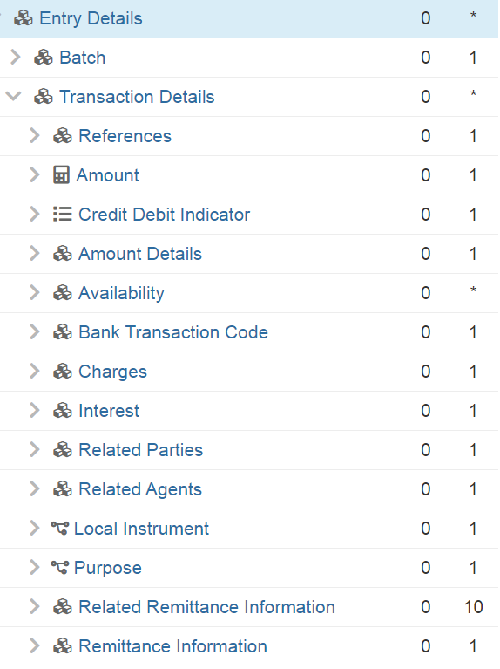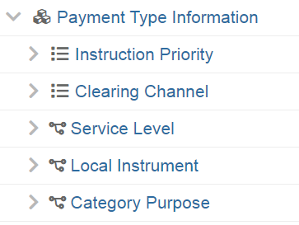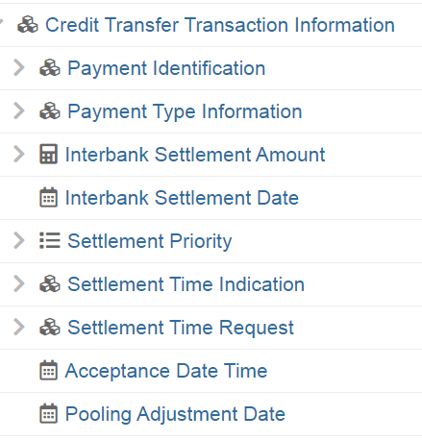

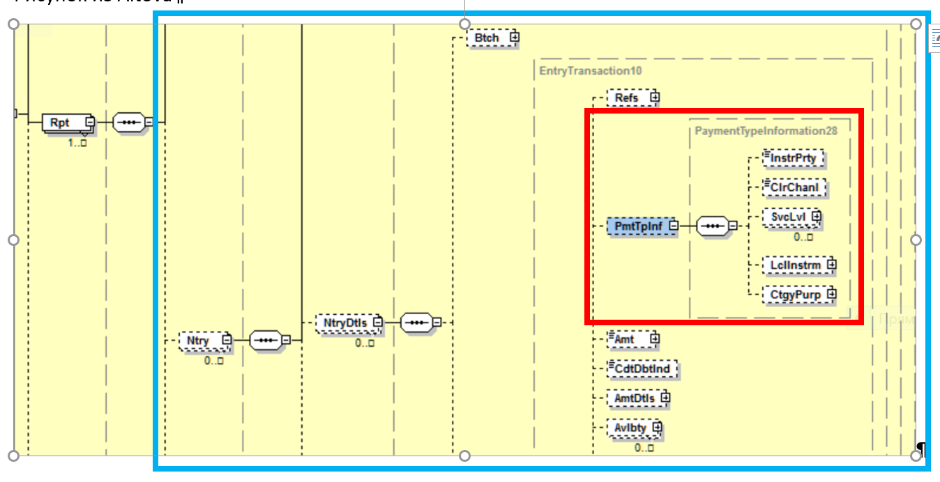

Purpose of the change:
1. The regulatory reason - in accordance with Russian regulations Customer Statements must include not only the information for entry recording but the whole information of the initiating payment order (including CategoryPurpose, as well InstructionPriority);
2. The technical reason - impossibility to transfer pain or pacs messages already contained necessary information to customer for proper reconciliation and the complexity and inefficiency of BTC-codes adoption and mapping for all possible combinations of payment attributes;
3. The technical reason - the need of software development and maintenance for mapping and codes processing become unnecessary and the level of straight-through processing increase substantially.

Urgency of the request:
Migration to ISO 20022 in Russia are planning now on 2022-2023.

Business examples:
Same component Payment Type Information present in Customer Credit Transfer Initiation (pain.001.001.11) must be shown without any changes in cash management reports sent to the Account Owner/Debtor: Bank To Customer Debit Credit Notification V09 (camt.054.001.09), Bank To Customer Account Report V09 (camt.052.001.09) and Bank To Customer Statement V09 (camt.053.001.09)
Same component Payment Type Information present in Financial Institution Credit Transfer V09 (pacs.009.001.10) must be shown without any changes in cash management reports sent to the Account Owner: Bank To Customer Debit Credit Notification V09 (camt.054.001.09), Bank To Customer Account Report V09 (camt.052.001.09) and Bank To Customer Statement V09 (camt.053.001.09))
Same component Payment Type Information present in FI To FI Customer Credit Transfer V10 (pacs.008.001.10) must be shown without any changes in cash management reports sent to the Account Owner/Creditor: Bank To Customer Debit Credit Notification V09 (camt.054.001.09), Bank To Customer Account Report V09 (camt.052.001.09) and Bank To Customer Statement V09 (camt.053.001.09))

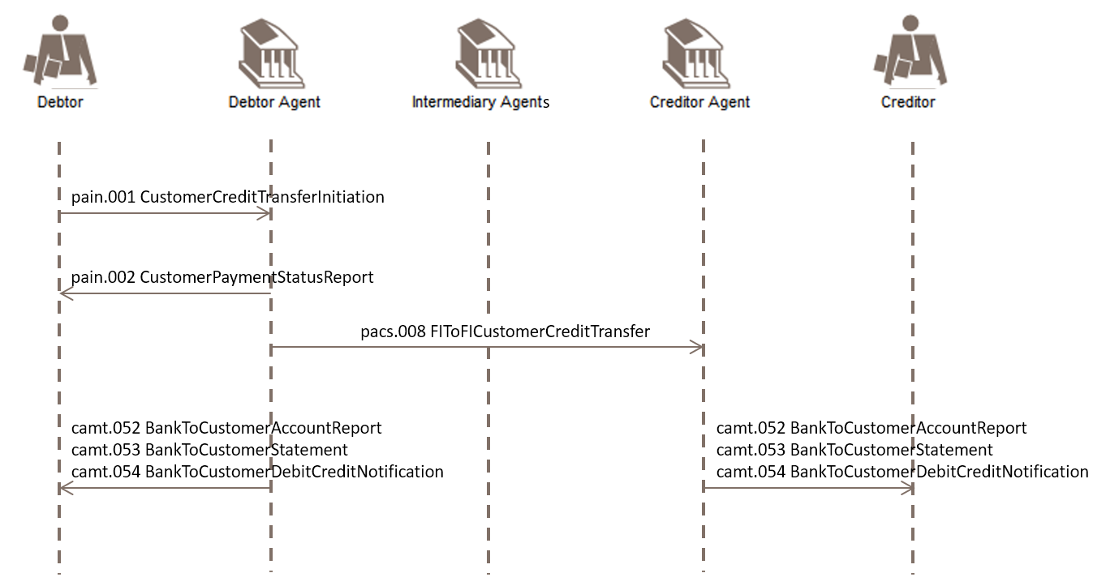

SEG/TSG recommendation:

Consider |  | X | Timing
 |  |  | - Next yearly cycle: 2021/2022  (the change will be considered for implementation in the yearly maintenance cycle which starts in 2021 and completes with the publication of new message versions in the spring of 2022) |  | X
- At the occasion of the next maintenance of the messages
(the change will be considered for implementation, but does not justify maintenance of the messages in its own right – will be pending until more critical change requests are received for the messages)
- Urgent unscheduled
(the change justifies an urgent implementation outside of the normal yearly cycle)
 |  |  | - Other timing:
Comments: Decision made at the Payments SEG meeting on 21st June 2021.

Reject
Reason for rejection:

Impact analysis and type of impact:
The severity of the impact of the proposed change for the message users should be indicated in the table below (either “no impact”, “conditional’ or “mandatory”).
Type of impact
 | Conditional | The change(s) will impact the schema (at least the version number) and the business applications of certain users but not all, e.g. the addition of an optional component

Proposed implementation:
Detailed description of the required modification to implement the requested change.
SWIFT proposes to reuse the PaymentTypeInformation27 message component from pacs.002 (not the PaymentTypeInformation28 from pacs.009 as proposed in the CR) as this can also cover direct debits.
SWIFT also proposes to keep LocalInstrument element that exists already on TransactionDetails level to not impact possible current use, but to add a rule that LocalInstrument and PaymentTypeInformation are mutually exclusive, so the LocalInstrument inside PaymentTypeInformation must be used when there is other PaymentTypeInformation.
The following picture shows the details for camt.054 (will be similar for camt.052, camt.053):
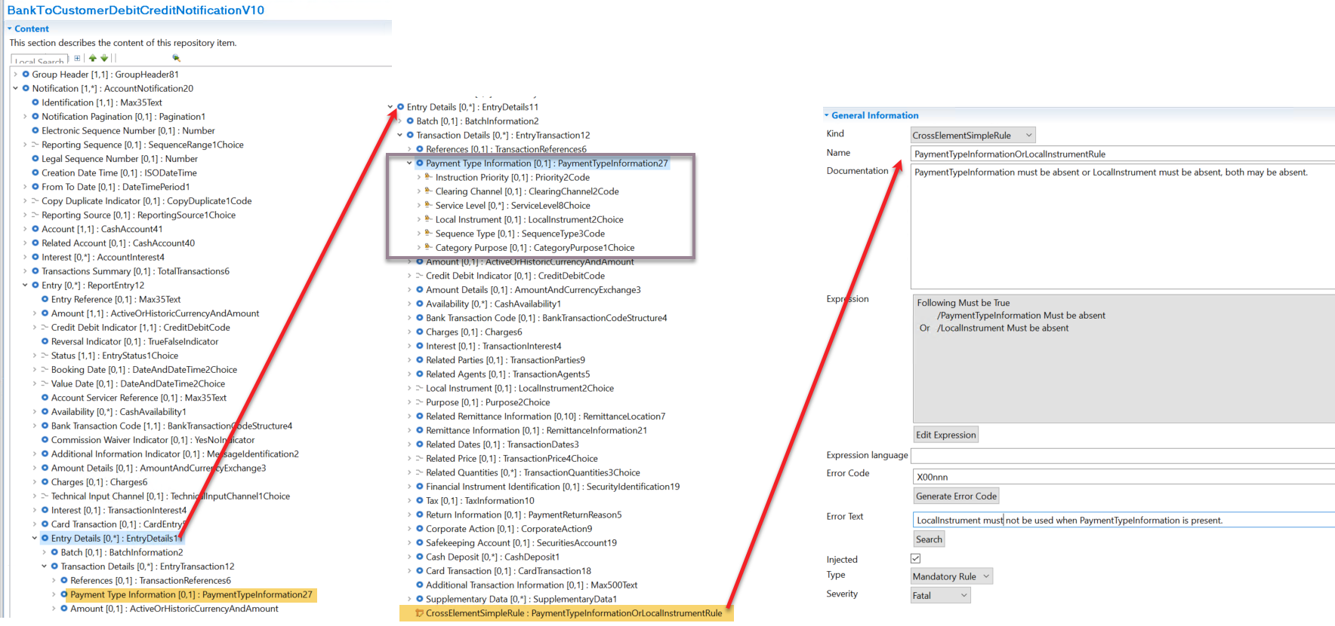

Question to the PAYSEG: is there a need for documentation/market practice on how to link Bank Transaction Codes and PaymentTypeInformation component? To be done outside the standard.

Proposed timing:
The submitting organization confirms that it can implement the requested changes in the requested timing.

Timing | - As requested

Final decision of the SEG(s):

Approve | X
Comments: Implementation in 2021/2022.

Reject
Reason for rejection:

Change request number CR1027
This chapter must be completed for every change request that the submitting organization has been requested to implement.

Origin of the request:
A.1 Submitter: SWIFT
A.2 Contact person: Evelyne.piron@swift.com
A.3 Sponsors: Cross Border Payment And Reporting Working Group

Related messages:
Camt.058 – NotificationToReceiveCancellationAdvice

Description of the change request:
The current change request is the addition of a component “CancellationReason Information” with two sub elements “Reason” (Code or Prop) and Additional Information.

Purpose of the change:
The NotificationToReceiveCancellationAdvice is used to advise the account servicing institution about the cancellation of one or more notifications in a previous NotificationToReceive message.
The current version of the camt.058 does not contain the element “Cancellation Reason Code” which is present in any other message type used to cancel a previously sent message.

Urgency of the request:
The camt.058 will be part of the CBPR plus Portfolio of messages that will be available as of November 2023. We therefore need the message to be updated for the next maintenance release

Business examples:
N/A

SEG/TSG recommendation:

Consider |  | X | Timing
 |  |  | - Next yearly cycle: 2021/2022  (the change will be considered for implementation in the yearly maintenance cycle which starts in 2021 and completes with the publication of new message versions in the spring of 2022) |  | X
- At the occasion of the next maintenance of the messages
(the change will be considered for implementation, but does not justify maintenance of the messages in its own right – will be pending until more critical change requests are received for the messages)
- Urgent unscheduled
(the change justifies an urgent implementation outside of the normal yearly cycle)
 |  |  | - Other timing:
Comments: Decision made at the Payments SEG meeting on 21st June 2021.

Reject
Reason for rejection:

Impact analysis and type of impact:
The change will require a new version of the NotificationToReceiveCancellationAdvice message (camt.058)
Type of impact
 | Conditional | The change(s) will impact the schema (at least the version number) and the business applications of certain users but not all, e.g. the addition of an optional component

Proposed implementation:
Detailed description of the required modification to implement the requested change.
SWIFT considers the reason for cancelling a NotificationToReceive similar, but not always equal, to the Payment Cancellation Reason. Therefore a new component (NotificationCancellationReason) is proposed, which will require a new (external?) code set. PAYSEG is asked to discuss the codes needed in the code list.
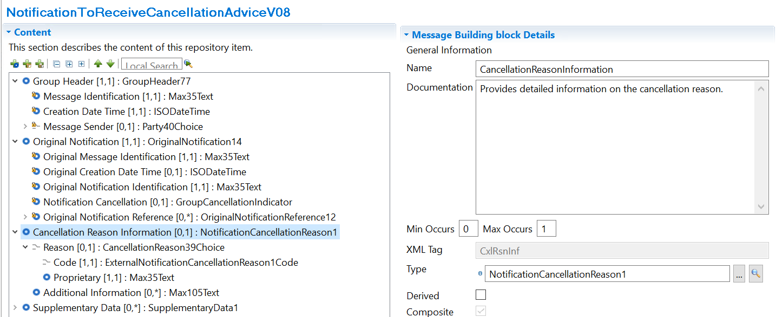

Proposed timing:
The submitting organization confirms that it can implement the requested changes in the requested timing, or, if not, proposes another timing.

Timing | - As requested

Final decision of the SEG(s):

Approve | X
Comments: Implementation in 2021/2022.

Reject
Reason for rejection:

Additional technical adjustments in the ISO 20022 rules identified during the maintenance (standing change request)
As part of the implementation, we have identified a number of technical errors in the description of the rules defined in the messages. Below is the exhaustive list of corrections as applied to the messages:

 | Issue in rule | Description of the change required
1. | Technical representation needs correction to ensure correct validation can be done. | Correction of pseudo code.

List of rules impacted by Item 1 which have been updated:
Note: SWIFT will further analyse and update this list with the implementation of the messages.

Message | Rule Name | Place in message
camt.029.001.XX | MessageOrInitiationTransactionResolvedCaseRule | Message Level
camt.055.001.XX | PaymentInformationOrTransactionCaseRule | Message Level
pacs.002.001.10 | GroupStatusAcceptedRule | Message Level
acmt.028.001.XX  acmt.029.001.XX  pain.001.001.XX | ChequeDeliveryAndNoCreditorAgentRule  ChequeDeliveryAndCreditorAgentRule  ChargesAccountAgentRule | PaymentInstructionXX
camt.029.001.XX | IdentificationRule | CorrectiveGroupInformation1
camt.029.001.XX | RequestedDateRule | CorrectiveGroupInformation1
pacs.008.001.08 | TransactionIdentificationPresenceRule | PaymentIdentification7
camt.055.001.XX | MessageOrTransactionCaseRule | Message Level
pacs.004.001.XX  pacs.007.001.XX | NoCoverSettlementMethodRule | Message Level
camt.029.001.XX | CancellationStatusReasonInformationRule | UnderlyingTransactionXX

