Maintenance Change Request
for fast track maintenance of existing message definitions
Note: the purpose of this document is to give guidelines to submitting organizations that intend to use the Fast Track maintenance process to develop a new version of existing ISO 20022 messages. Such development is subject to the approval, by the related Standards Evaluation Group (SEG), of a Maintenance Change Request which must include a detailed description of the impact of each change on the related messages. The Maintenance Change Request must start with a general chapter covering topics related to the whole maintenance effort and a specific chapter for each change request, as described below. Please consult the iso20022.org website for additional details on the Fast Track maintenance process. Maintenance Change Requests must be sent to iso20022ra@iso20022.org.

- Submitting organization(s):
SMPG / SWIFT
- Related messages:
seev.047.001.01 - ShareholdersIdentificationDisclosureResponseV01

- Purpose of the change:
In Belgium and in some Nordic markets, shareholders / account holders to be disclosed can be also multiple legal persons or a combination of multiple legal and natural persons.
In the current seev.047.001.01 version, it is only possible to mention as account holder either a single legal person or a single or multiple natural person. Providing multiple legal persons or a combination of both legal and natural persons is not allowed.
This change request is meant to adjust the multiplicity of these elements in the seev.047 message so as to allow the provision of multiple legal persons or a combination of both legal and natural persons.
Belgium has currently about 3 such disclosure cases involving several legal persons or a combination of both legal and natural persons per week.
- Urgency of the request:
Due to the frequency of these cases, this change should be implemented preferably with SR2021.
- Commitments of the submitting organization:
The submitting organization must confirm that it can and will:
- undertake the development of the new version of the candidate ISO 20022 message model that it will submit to the RA for compliance review. The submitting organisation is invited to mention here the expected date of submission to the RA for compliance review.
- address any queries related to the description of the message versions as published by the RA on the ISO 20022 website.
The submitting organization must confirm its knowledge and acceptance of the ISO 20022 Intellectual Property Rights policy for contributing organizations, as follows.
“Organizations that contribute information to be incorporated into the ISO 20022 Repository shall keep any Intellectual Property Rights (IPR) they have on this information. A contributing organization warrants that it has sufficient rights on the contributed information to have it published in the ISO 20022 Repository through the ISO 20022 Registration Authority in accordance with the rules set in ISO 20022. To ascertain a widespread, public and uniform use of the ISO 20022 Repository information, the contributing organization grants third parties a non-exclusive, royalty-free license to use the published information”.

- Contact persons:
Christine Strandberg: christine.strandberg@seb.se - +46 (8) 763 60 74
Mariangela Fumagalli: mariangela.fumagalli@bnpparibas.com - +442075954988
Jacques Littré: jacques.littre@swift.com - +3226554335

Change number #
- Related messages:
Seev.047.001.01
The change does not have an impact on other messages that come into play earlier or later in the transaction chain. The message component impacted is not shared with other messages.

- Description of the change and type of impact:
- Change the data type of the “AccountHolder” element in the “Disclosure” sequence to replace the “Choice” component by a “Sequence” component so as to allow LegalPerson and NaturalPerson identifications to be provided simultaneously
- Change the multiplicity of the “LegalPerson” element to [0..n] so that no or several legal persons identifications can be provided.
- Change the multiplicity of the Natural Person element to [0...n] so that no or several natural person’s identifications can be provided.
- Add a rule to mandate the presence of at least the “Legal Person” element or the “NaturalPerson” element.

- Proposed implementation:
Current implementation of disclosure in the seev.047.001.01 illustrated below:
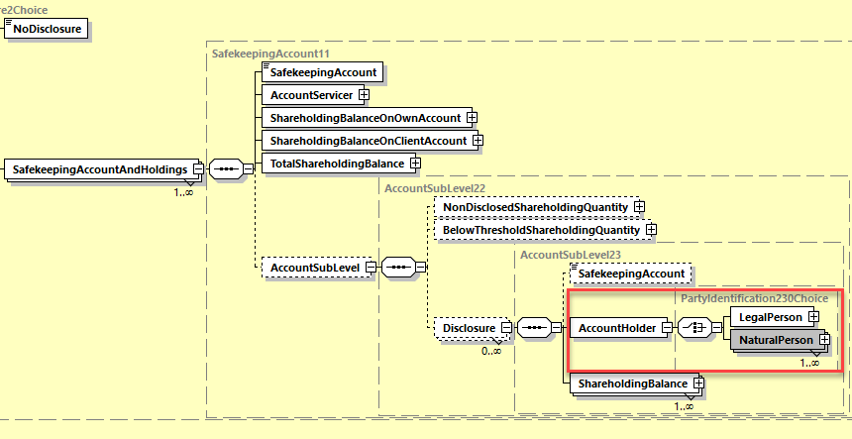
After the changes described in section B above, the implementation will be as illustrated below:

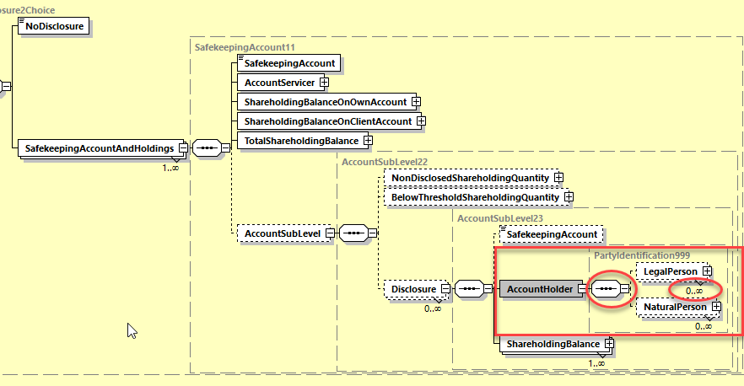

- Decision of the SEG(s):
This section is not to be taken care of by the submitting organization. It will be completed in due time by the SEG(s) in charge of the related ISO 20022 message definitions.

Change
 | approved | X
 | rejected
Comments:

Timing
 | - Fast track maintenance  (the change justifies an urgent implementation using the fast track maintenance process) |  | X
- At the occasion of the next maintenance of the messages
(the change will be considered for implementation, but does not justify an urgent implementation – will be pending until the next [yearly] maintenance of the messages)

