Maintenance Change Request
for fast track maintenance of existing message definitions

EU Strong Customer Authentication Exemptions

- Submitting organization(s):
ISO TC68/SC9/TG1

- Related messages:
The present Maintenance Change Requests will not lead to creation of new messages or variants of existing messages.

The list of ISO 20022 messages impacted by the proposed change request are:
  - Amendment (cain.020.001.01)
  - AuthorisationInitiation (cain.001.001.02)
  - AuthorisationResponse (cain.002.001.02)
  - CardManagementInitiation (cain.023.001.01)
  - CardManagementResponse (cain.024.001.01)
  - ChargeBackInitiation (cain.027.001.01)
  - ChargeBackResponse (cain.028.001.01)
  - FeeCollectionInitiation (cafc.001.001.01)
  - FeeCollectionReponse (cafc.002.001.01)
  - FinancialInitiation (cain.003.001.02)
  - FinancialResponse (cain.004.001.02)
  - FraudDispositionInitiation (cafr.003.001.01)
  - FraudDispositionResponse (cafr.004.001.01)
  - FraudReportingInitiation (cafr.001.001.01)
  - FraudReportingResponse (cafr.002.001.01)
  - InquiryInitiation (cain.016.001.01)
  - InquiryResponse (cain.017.001.01)
  - RetrievalFulfillmentInitiation (cain.014.001.01)
  - RetrievalFulfillmentResponse (cain.015.001.01)
  - RetrievalInitiation (cain.021.001.01)
  - RetrievalResponse (cain.022.001.01)
  - ReversalInitiation (cain.005.001.02)
  - ReversalResponse (cain.006.001.02)
  - VerificationInitiation (cain.018.001.01)
  - VerificationResponse (cain.019.001.01)

The proposed change request addresses the creation of an ISO 20022 SupplementaryData component related to several exemptions to specific regulatory information made mandatory by the implementation of the PSD2 EU regulation.

More specifically, it addresses the requirement of the European Banking Authority (EBA) related to the Regulatory Technical Standard (RTS) on Strong Customer Authentication (SCA) imposed by the EU regulation.

Given the specific requirements related to a community of users in Europe and specific to that region (all actors in the EU in the card payment value chain affected by the PSD2 regulation), the SupplementaryData approach of ISO 20022 has been adopted with a subsequent inclusion in the body of each of the aforementioned messages.

The addition of the proposed ISO 20022 SupplementaryData component does not lead to the creation of new messages.

- Purpose of the change:
The EBA has issued in the framework of a Commission Delegated Regulation a series of RTS on strong customer authentication and secure communication to achieve the objective of the PSD2 of enhancing consumer protection, promoting innovation and improving the security of payment services across the European Union.

The implementation of those RTS induce some impacts on card-related payment exchanges, especially as regards authorisation, financial and other related messages.

- The definition of a dedicated ISO 20022 SupplementaryData would address a series of exemptions to the SCA requirements. Those exemptions are: Payment Account Information
- Contactless Payment at Point of Sale
- Unattended Terminal for Transport Fares and Parking Fees
- Trusted Beneficiaries
- Recurring Transactions
- Credit Transfer between Accounts held by the same Natural or Legal Person
- Low-value Transactions
- Secure Corporate Payment Processes and Protocols
- Transaction Risk Analysis

Some other data related to the implementation of the regulation would also include:
- Transaction subject to SCA
- Delegated Authority
- Strong Customer Authentication Waiver
- Reason(s) for not honouring exemption(s)
- Reason authentication not performed

According to the European Banking Authority (EBA), Merchant Initiated Transaction (MIT) are out of scope of the exemptions foreseen by the EU regulation on Strong Customer Authentication.
MIT is globally applicable and available to ATICA messages whether to be subject to SCA or not.
The Message Usage Guide (MUG) for ATICA will clearly indicate that the presence of the code Merchant [MERC] in TransactionInitiator excludes de facto the presence of the SCA SupplementaryData component in or in association with the related message.

- Urgency of the request:
RTS is mandated to be implemented by end of December 2020 at the latest (with no further postponement of deadline).
TG1 recommends this SupplementaryData to be considered as an urgent unscheduled request to meet the EU Regulatory requirements deadline by year-end.

- Commitments of the submitting organization:
The submitting organisation confirms that it can and will:
- undertake the development of the new version of the candidate ISO 20022 message model that it will submit to the RA for compliance review. The date of submission to the RA for compliance review is expected ideally by September 2020.
- address any queries related to the description of the message versions as published by the RA on the ISO 20022 website.
The submitting organisation also confirms its knowledge and acceptance of the ISO 20022 Intellectual Property Rights policy for contributing organisations, as follows.
“Organizations that contribute information to be incorporated into the ISO 20022 Repository shall keep any Intellectual Property Rights (IPR) they have on this information. A contributing organization warrants that it has sufficient rights on the contributed information to have it published in the ISO 20022 Repository through the ISO 20022 Registration Authority in accordance with the rules set in ISO 20022. To ascertain a widespread, public and uniform use of the ISO 20022 Repository information, the contributing organization grants third parties a non-exclusive, royalty-free license to use the published information”.

- Contact persons:
Douglas Frantz (dfrantz@visa.com; +1 650 432 4591;
Nathalie Anon (nathalie.anon@frenchsys.com; +33 6 66 86 18 46);
William Vanobberghen (william-vanobberghen@cartes-bancaires.com; +33 6 72 95 19 03)

Change number #1
- Related messages:
The present proposed change is related to exemptions to the Regulatory Technical Standards (RTS) for Strong Customer Authentication (SCA) and common and secure open standards of communication of the European Commission Delegated Regulation (2018/389).
Its implementation will not lead to creation of new messages or variants of existing messages.
The new SupplementaryData message extension may be used in the corresponding ISO 20022 messages listed below if and when appropriate:
  - Amendment (cain.020.001.01)
  - AuthorisationInitiation (cain.001.001.02)
  - AuthorisationResponse (cain.002.001.02)
  - CardManagementInitiation (cain.023.001.01)
  - CardManagementResponse (cain.024.001.01)
  - ChargeBackInitiation (cain.027.001.01)
  - ChargeBackResponse (cain.028.001.01)
  - FeeCollectionInitiation (cafc.001.001.01)
  - FeeCollectionReponse (cafc.002.001.01)
  - FinancialInitiation (cain.003.001.02)
  - FinancialResponse (cain.004.001.02)
  - FraudDispositionInitiation (cafr.003.001.01)
  - FraudDispositionResponse (cafr.004.001.01)
  - FraudReportingInitiation (cafr.001.001.01)
  - FraudReportingResponse (cafr.002.001.01)
  - InquiryInitiation (cain.016.001.01)
  - InquiryResponse (cain.017.001.01)
  - RetrievalFulfillmentInitiation (cain.014.001.01)
  - RetrievalFulfillmentResponse (cain.015.001.01)
  - RetrievalInitiation (cain.021.001.01)
  - RetrievalResponse (cain.022.001.01)
  - ReversalInitiation (cain.005.001.02)
  - ReversalResponse (cain.006.001.02)
  - VerificationInitiation (cain.018.001.01)
  - VerificationResponse (cain.019.001.01)

- Description of the change and type of impact:
The use of the SupplementaryData mechanism of ISO 20022 enables a given community (European Economic Area, or EEA, in the present example as well as any other jurisdictions to which SCA may apply) to address some specific data requirements pertaining to that community without affecting other ones. It also allows for EU regulatory changes to be applied in an expedited manner.
To ensure a proper alignment between ISO 8583 and ISO 20022, the same common set of data elements will be used, and its maintenance ensured over time to avoid any discrepancies between the two specifications.

- Proposed implementation:
The existing Supplementary Data component defined in existing ATICA messages will contain the new supplementary data message. The component appears below for reference.
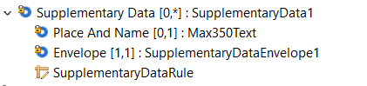
Within the existing Supplementary Data component, the following fields will contain information as shown below.
- Place And Name : Since this data is not directly related to another component in the message, no location is shown. Instead, a name of the new data to be included is given: EUSCAData.
- Envelope: will contain the new message that is defined below (which will be registered as a SupplementaryData extension)

Message Definition
EUSCADataSD1 extends ATICA messages that may involve or be related to customer-initiated transactions.
Its structure is shown below.

MessageElement/BuildingBlock | Mult. | Type | Definition
Message root <Document> <EUSCADataSD1> | [1..1] |  | EU PSD2 Strong Consumer Authentication data extension

SCA |  |  | EU PSD2 Strong Consumer Authentication data
SubjectToSCA | [0..1] | Boolean | Boolean flag indicating whether the transaction is subject to Strong Customer Authentication requirements (True) or not (False)
Exemption | [0..*] |  | SCA exemption detail
Type | [1..1] | Exemption2Code | Type of the exemption (see Exemption2Code CodeSet below)
Value | [1..1] | AttestationValue1Code | Status of the exemption (see AttestationExemptionValue1Code CodeSet below
ReasonNotHonored | [0..1] | Max4Text | Reason why the exemption claimed was not honored
DelegatedAuthorityAuthority | [0..1] | AttestationValue1Code | Authentication performed by a delegated authority (for example by a wallet solution)
Waiver | [0..1] | AttestationValue1Code | Waiver claimed for a SCA
ReasonAuthenticationNotPerformed | [0..1] | Max4Text | Reason why authentication was not performed
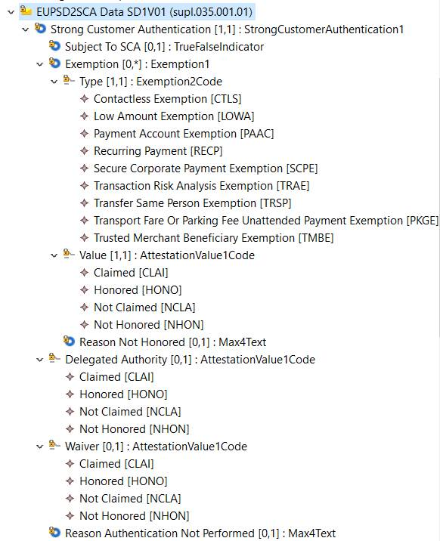

Exemption2Code CodeSet

Name | Code | Description
PaymentAccount | PAAC | Payment account information exemption
ContactlessTransaction | CTLS | Contactless payment at point of sale exemption
TransportOrParking | PKGE | Unattended terminal for transport fares and parking fees exemption
TrustedBeneficiary | TMBE | Trusted beneficiary exemption
Recurring | RECP | Recurring transaction exemption
TransferSamePerson | TRSP | Credit transfer between accounts held by the same natural or legal person exemption
LowValue | LOWA | Low-value transaction exemption
SecureCorporate | SCPE | Secure corporate payment process and protocol exemption
TRA | TRAA | Transaction risk analysis exemption
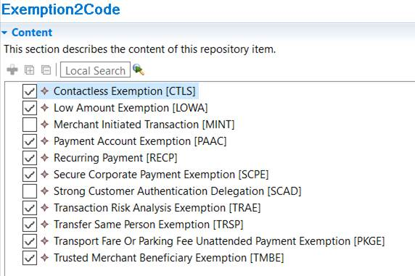
AttestationValue1Code CodeSet

Name | Code | Description
Claimed | CLAI | Attestation claimed
NotClaimed | NCLA | Attestation not claimed
Honored | HONO | Attestation validated
NotHonored | NHON | Attestation failed validation

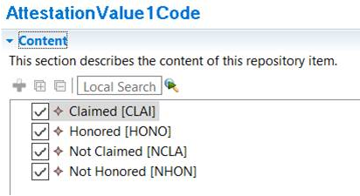

Decision of the SEG(s):
This section is not to be taken care of by the submitting organization. It will be completed in due time by the SEG(s) in charge of the related ISO 20022 message definitions.

Change
 | approved | X
 | rejected
Comments:
The Cards SEG members agreed that the Exemption2Code CodeSet should be enhanced by the code for Merchant Initiated Transactions (MINT).

Timing
 | - Fast track maintenance  (the change justifies an urgent implementation using the fast track maintenance process) |  | X
- At the occasion of the next maintenance of the messages
(the change will be considered for implementation, but does not justify an urgent implementation – will be pending until the next [yearly] maintenance of the messages)

ISO-TC68-SC9-TG1_N0339_Informational_article_for_recommendation_of_EU_PSD2_SCA_specific_data_20200306_-_environment_failure

