Maintenance Change Request
for the update of ISO 20022 financial repository items

Name of the request:
“ISO 20022 Collateral Management Maintenance 2020/2021”

Submitting organisation(s):
LCH Ltd and Banco de España and SWIFT.

Related messages:

Under this maintenance, below existing ISO 20022 message definitions will be maintained (resulting from the impact analysis performed on each CR).

Collateral Management message set:
- colr.016.001.03 – CollateralAnd ExposureReportV03
- colr.005.001.04 - CollateralManagementCancellationRequestV04

Message sets impacted are under responsibility of SWIFT:
Please note that the Collateral Management message set is under the responsibility of SWIFT.

Commitments of the submitting organisation:

The submitting organisations confirm that they can and will:
- Undertake the development of the new version of the candidate ISO 20022 message models that it will submit to the RA for compliance review and evaluation. New valid Message Definition models will be made available to the RA by December 1.
- provide a new version of part 1 of the related Message Definition Reports (MDR) by December 1, and new examples of valid message instances of each candidate message (only when valid samples were published for current version) by May 1 at the latest.
- Address any queries related to the description of the new models and messages as published by the RA on the ISO 20022 website.

SWIFT intends to implement most of the above new versions on its SWIFTNet network once the related documentation has been published by the RA.

The submitting organisations confirm their knowledge and acceptance of the ISO 20022 Intellectual Property Rights policy for contributing organisations, as follows.
“Organisations that contribute information to be incorporated into the ISO 20022 Repository shall keep any Intellectual Property Rights (IPR) they have on this information. A contributing organisation warrants that it has sufficient rights on the contributed information to have it published in the ISO 20022 Repository through the ISO 20022 Registration Authority in accordance with the rules set in ISO 20022. To ascertain a widespread, public and uniform use of the ISO 20022 Repository information, the contributing organisation grants third parties a non-exclusive, royalty-free license to use the published information”.

Contact persons:
Karine Taquet – SWIFT Standards, karine.taquet@swift.com
Karin De Ridder – SWIFT Standards, karin.deridder@swift.com

Change request CR0852:
Add settlement statuses

Origin of the request:
A.1 Submitter: LCH Ltd
A.2 Contact person: Ben Doughton; ben.doughton@lch.com; +44 (0) 20 7392 8278
A.3 Sponsors: LCH Ltd, LCH SA, SWIFT.

Related messages:
The list of ISO 20022 messages which would be impacted by the change, including the Message IDs as shown in the Catalogue of ISO 20022 messages. Only the latest version of a message definition can be maintained.
The submitter is invited to carefully examine whether the change may have an impact on other messages that come into play earlier or later in the transaction chain or on other messages that also use message components that this change request may impact.
Related messages:
- colr.016 (Collateral and Exposure Report)

Description of the change request:
Additional settlement states are requested in reference to the Settlement Status element (/Document/CollAndXpsrRpt/CollRpt/CollValtn/SttlmSts), as follows:
- Settlement Unmatched (NMAT)
- Settlement Matched (MACH)

Purpose of the change:
When reporting collateral in transit to Party A or to Party B it is necessary to provide additional detail on instructions that have been created but are not yet settled. For example on the Matched or Unmatched status of an instruction.

Urgency of the request:
To be included as part of the annual maintenance cycle.

Business examples:
In the below example collateral is in transit in between Party A and Party B as highlighted in yellow.

<Document xmlns="urn:iso:std:iso:20022:tech:xsd:colr.016.001.04">
<CollAndXpsrRpt>
<RptParams>
<RptId>REP00031</RptId>
<RptDtAndTm>
<DtTm>2020-05-09T02:00:00Z</DtTm>
</RptDtAndTm>
<Frqcy>INDA</Frqcy>
<RptCcy>EUR</RptCcy>
<ClctnDt>2020-05-11T00:00:00Z</ClctnDt>
</RptParams>
<Oblgtn>
<PtyA>
<AnyBIC>LCHLGB2LCOL</AnyBIC>
</PtyA>
<PtyB>
<AnyBIC>IDCLUS33COL</AnyBIC>
</PtyB>
<XpsrTp>CCPC</XpsrTp>
<ValtnDt>
<Dt>2020-05-08</Dt>
</ValtnDt>
</Oblgtn>
<Agrmt>
<AgrmtDtls>LCH Ltd Rulebook</AgrmtDtls>
<AgrmtDt>2017-08-18</AgrmtDt>
<BaseCcy>EUR</BaseCcy>
</Agrmt>
<CollRpt>
<AcctId>
<Id>AAA/H</Id>
<Tp>
<Tp>HOUS</Tp>
</Tp>
<Nm>BANK AAA HOUSE ACCOUNT</Nm>
</AcctId>
<RptSummry>
<XpsdAmtPtyA Ccy="EUR">2600000000.00</XpsdAmtPtyA>
<XpsrTp>OTCD</XpsrTp>
<TtlValOfColl Ccy="EUR">1095351010.42</TtlValOfColl>
<NetXcssDfcit Ccy="EUR">1504648989.58</NetXcssDfcit>
<NetXcssDfcitInd>SHOR</NetXcssDfcitInd>
<ValtnDtTm>2020-05-08T23:59:00Z</ValtnDtTm>
<ReqdSttlmDt>2020-05-08</ReqdSttlmDt>
<SummryDtls>
<PreHrcutCollVal Ccy="EUR">1153478099.26</PreHrcutCollVal>
<TtlPdgIncmgColl Ccy="EUR">1504648989.58</TtlPdgIncmgColl>
<TtlPdgOutgngColl Ccy="EUR">0.00</TtlPdgOutgngColl>
<TtlFees Ccy="EUR">0.00</TtlFees>
</SummryDtls>
</RptSummry>
<CollValtn>
<CollTp>CASH</CollTp>
<SttlmSts>STLD</SttlmSts>
<NbOfDaysAcrd>0</NbOfDaysAcrd>
<ValtnAmts>
<CollAmt Ccy="GBP">0.00</CollAmt>
<RptdCcyAndAmt Ccy="EUR">1085351353.90</RptdCcyAndAmt>
<MktValAmt Ccy="EUR">1142475109.37</MktValAmt>
<FeesAndComssns Ccy="GBP">6287.74</FeesAndComssns>
</ValtnAmts>
<DayCntBsis>A001</DayCntBsis>
<XchgRate>0.8734</XchgRate>
<CshColl>
<DpstAmt Ccy="GBP">997837444.74</DpstAmt>
<BlckdAmt Ccy="GBP">0.00</BlckdAmt>
<CollVal Ccy="GBP">947945572.50</CollVal>
<Hrcut>5.00</Hrcut>
</CshColl>
</CollValtn>
<CollValtn>
<CollId>SDREF001</CollId>
<CollTp>SECU</CollTp>
<SttlmSts>MACH</SttlmSts>
<NbOfDaysAcrd>0</NbOfDaysAcrd>
<ValtnAmts>
<CollAmt Ccy="GBP">0.00</CollAmt>
<RptdCcyAndAmt Ccy="EUR">1504648989.58</RptdCcyAndAmt>
<MktValAmt Ccy="EUR">1690616842.23</MktValAmt>
<FeesAndComssns Ccy="GBP">3420.42</FeesAndComssns>
</ValtnAmts>
<DayCntBsis>A005</DayCntBsis>
<XchgRate>0.8734</XchgRate>
<AdjstdRate>100.00</AdjstdRate>
<SctiesColl>
<SctyId>
<ISIN>GB0004893086</ISIN>
</SctyId>
<MtrtyDt>
<Dt>2032-06-07</Dt>
</MtrtyDt>
<CollOwnrsh>
<Prtry>true</Prtry>
</CollOwnrsh>
<LtdCvrgInd>true</LtdCvrgInd>
<Qty>
<FaceAmt>1000000000.00</FaceAmt>
</Qty>
<BlckdQty>
<FaceAmt>0.00</FaceAmt>
</BlckdQty>
<Pric>
<Tp>
<ValTp>PARV</ValTp>
</Tp>
<Val>
<Amt Ccy="GBP">147.658475</Amt>
</Val>
</Pric>
<MktVal Ccy="GBP">1476584750.00</MktVal>
<Hrcut>11.00</Hrcut>
<CollVal Ccy="GBP">1314160427.50</CollVal>
<SfkpgAcct>
<Id>5165-C</Id>
</SfkpgAcct>
<SfkpgPlc>
<TpAndId>
<SfkpgPlcTp>NCSD</SfkpgPlcTp>
<Id>CRSTGB22</Id>
</TpAndId>
</SfkpgPlc>
</SctiesColl>
</CollValtn>
<CollValtn>
<CollTp>SECU</CollTp>
<SttlmSts>STLD</SttlmSts>
<NbOfDaysAcrd>0</NbOfDaysAcrd>
<ValtnAmts>
<CollAmt Ccy="JPY">0</CollAmt>
<RptdCcyAndAmt Ccy="EUR">8115099.97</RptdCcyAndAmt>
<MktValAmt Ccy="EUR">9118089.86</MktValAmt>
<FeesAndComssns Ccy="JPY">2442</FeesAndComssns>
</ValtnAmts>
<DayCntBsis>A004</DayCntBsis>
<XchgRate>115.63</XchgRate>
<AdjstdRate>100.00</AdjstdRate>
<SctiesColl>
<SctyId>
<ISIN>JP1024101L33</ISIN>
</SctyId>
<MtrtyDt>
<Dt>2022-03-01</Dt>
</MtrtyDt>
<CollOwnrsh>
<Prtry>true</Prtry>
</CollOwnrsh>
<LtdCvrgInd>false</LtdCvrgInd>
<Qty>
<FaceAmt>1000000000.00</FaceAmt>
</Qty>
<BlckdQty>
<FaceAmt>0.00</FaceAmt>
</BlckdQty>
<Pric>
<Tp>
<ValTp>PARV</ValTp>
</Tp>
<Val>
<Amt Ccy="JPY">100.519444</Amt>
</Val>
</Pric>
<MktVal Ccy="JPY">1005194440</MktVal>
<Hrcut>6.65</Hrcut>
<CollVal Ccy="JPY">938349010</CollVal>
<SfkpgAcct>
<Id>12345</Id>
</SfkpgAcct>
<SfkpgPlc>
<TpAndId>
<SfkpgPlcTp>ICSD</SfkpgPlcTp>
<Id>MGTCBEBE</Id>
</TpAndId>
</SfkpgPlc>
</SctiesColl>
</CollValtn>
<CollValtn>
<CollTp>OTHR</CollTp>
<SttlmSts>STLD</SttlmSts>
<NbOfDaysAcrd>0</NbOfDaysAcrd>
<ValtnAmts>
<CollAmt Ccy="GBP">0.00</CollAmt>
<RptdCcyAndAmt Ccy="EUR">1884900.03</RptdCcyAndAmt>
<MktValAmt Ccy="EUR">1884900.03</MktValAmt>
<FeesAndComssns Ccy="GBP">0.00</FeesAndComssns>
</ValtnAmts>
<DayCntBsis>A001</DayCntBsis>
<XchgRate>1.0841</XchgRate>
<OthrColl>
<OthrTpOfColl>
<Desc>CashFail</Desc>
</OthrTpOfColl>
<Issr>
<AnyBIC>MGTCBEBE</AnyBIC>
</Issr>
<MktVal Ccy="USD">2043420.12</MktVal>
<CollVal Ccy="USD">2043420.12</CollVal>
</OthrColl>
</CollValtn>
</CollRpt>
</CollAndXpsrRpt>
</Document>

SEG/TSG recommendation:

Consider |  | X | Timing
 |  |  | - Next yearly cycle: 2020/2021  (the change will be considered for implementation in the yearly maintenance cycle which starts in 2020 and completes with the publication of new message versions in the spring of 2021) |  | X
- At the occasion of the next maintenance of the messages
(the change will be considered for implementation, but does not justify maintenance of the messages in its own right – will be pending until more critical change requests are received for the messages)
- Urgent unscheduled
(the change justifies an urgent implementation outside of the normal yearly cycle)
 |  |  | - Other timing:

Comments:

Reject
Reason for rejection:

Impact analysis and type of impact:
The impact of the change requested will be as described in the approved change request.

Proposed implementation:
The SEG ET supports the proposed implementation as described by the submitter.
The updates will result in the following structure:
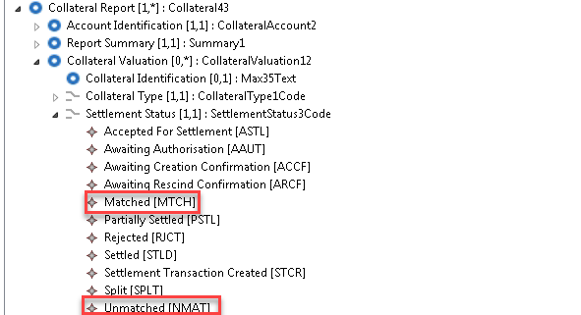

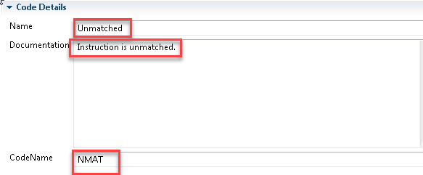

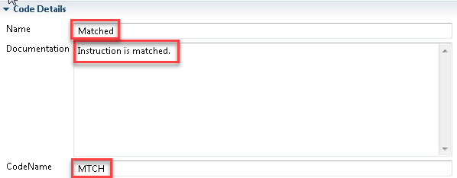

Proposed timing:
The submitting organisation confirms that it can implement the requested changes in the requested timing.

Timing | As requested SR 2021

Final decision of the SEG(s):

Approve | X
Comments: definitions of the matched and unmatched status were changed.
For matched status definition is changed from Settlement is matched to Instruction is matched.
For unmatched status definition is changed from Settlement is unmatched to Instruction is unmatched.

Reject
Reason for rejection:

Change request CR0853:
Addition of Applied Excess Indicator

Origin of the request:
A.1 Submitter:
- LCH Ltd
A.2 Contact person:
- Ben Doughton; ben.doughton@lch.com; +44 (0) 20 7392 8278
A.3 Sponsors:
- LCH Ltd, LCH SA, SWIFT.

Related messages:
The list of ISO 20022 messages which would be impacted by the change, including the Message IDs as shown in the Catalogue of ISO 20022 messages. Only the latest version of a message definition can be maintained.
The submitter is invited to carefully examine whether the change may have an impact on other messages that come into play earlier or later in the transaction chain or on other messages that also use message components that this change request may impact.
Related messages:
- colr.016 (Collateral and Exposure Report)

Description of the change request:
Request to add a new element “Applied Excess Indicator” as an optional element in the “Collateral Valuation” (/Document/CollAndXpsrRpt/CollRpt/CollValtn) block to indicate if the collateral being reported within the block is “Applied” or “Excess”.
“Applied” collateral is that which is currently utilised by the collateral receiver to discharge liabilities owed to it by the collateral provider.
“Excess” collateral is that which is held by the collateral receiver either in anticipation of future liabilities or towards previously liabilities which are no longer owed to it.

Purpose of the change:
Treatment of “Applied” collateral is often different to that of “Excess” collateral. For example: fees and commissions maybe applied differently to applied collateral than excess; or excess collateral could be subject to automated return from the collateral receiver to the collateral provider.

Urgency of the request:
To be included as part of the annual maintenance cycle.

Business examples:
The following example shows cash, securities and other collateral being used to cover an exposure as “Applied” collateral with an amount of “Excess” cash collateral also held in preparation for future liabilities.

<Document xmlns="urn:iso:std:iso:20022:tech:xsd:colr.016.001.04">
<CollAndXpsrRpt>
<RptParams>
<RptId>REP00031</RptId>
<RptDtAndTm>
<DtTm>2020-05-09T02:00:00Z</DtTm>
</RptDtAndTm>
<Frqcy>INDA</Frqcy>
<RptCcy>EUR</RptCcy>
<ClctnDt>2020-05-11T00:00:00Z</ClctnDt>
</RptParams>
<Oblgtn>
<PtyA>
<AnyBIC>LCHLGB2LCOL</AnyBIC>
</PtyA>
<PtyB>
<AnyBIC>IDCLUS33COL</AnyBIC>
</PtyB>
<XpsrTp>CCPC</XpsrTp>
<ValtnDt>
<Dt>2020-05-08</Dt>
</ValtnDt>
</Oblgtn>
<Agrmt>
<AgrmtDtls>LCH Ltd Rulebook</AgrmtDtls>
<AgrmtDt>2017-08-18</AgrmtDt>
<BaseCcy>EUR</BaseCcy>
</Agrmt>
<CollRpt>
<AcctId>
<Id>AAA/H</Id>
<Tp>
<Tp>HOUS</Tp>
</Tp>
<Nm>BANK AAA HOUSE ACCOUNT</Nm>
</AcctId>
<RptSummry>
<XpsdAmtPtyA Ccy="EUR">2600000000.00</XpsdAmtPtyA>
<XpsrTp>OTCD</XpsrTp>
<TtlValOfColl Ccy="EUR">2659599756.70</TtlValOfColl>
<NetXcssDfcit Ccy="EUR">59599756.70</NetXcssDfcit>
<NetXcssDfcitInd>LONG</NetXcssDfcitInd>
<ValtnDtTm>2020-05-08T23:59:00Z</ValtnDtTm>
<ReqdSttlmDt>2020-05-08</ReqdSttlmDt>
<SummryDtls>
<PreHrcutCollVal Ccy="EUR">2906831165.93</PreHrcutCollVal>
<TtlPdgIncmgColl Ccy="EUR">0.00</TtlPdgIncmgColl>
<TtlPdgOutgngColl Ccy="EUR">59599756.70</TtlPdgOutgngColl>
<TtlFees Ccy="EUR">0.00</TtlFees>
</SummryDtls>
</RptSummry>
<CollValtn>
<CollTp>CASH</CollTp>
<ApldXcss>EXCESS</ApldXcss>
<SttlmSts>STLD</SttlmSts>
<NbOfDaysAcrd>0</NbOfDaysAcrd>
<ValtnAmts>
<CollAmt Ccy="GBP">0.00</CollAmt>
<RptdCcyAndAmt Ccy="EUR">59599756.70</RptdCcyAndAmt>
<MktValAmt Ccy="EUR">62736586.00</MktValAmt>
<FeesAndComssns Ccy="GBP">395.33</FeesAndComssns>
</ValtnAmts>
<DayCntBsis>A001</DayCntBsis>
<XchgRate>0.8734</XchgRate>
<CshColl>
<DpstAmt Ccy="GBP">54794134.21</DpstAmt>
<BlckdAmt Ccy="GBP">0.00</BlckdAmt>
<CollVal Ccy="GBP">52054427.50</CollVal>
<Hrcut>5.00</Hrcut>
</CshColl>
</CollValtn>
<CollValtn>
<CollTp>CASH</CollTp>
<ApldXcss>APPLIED</ApldXcss>
<SttlmSts>STLD</SttlmSts>
<NbOfDaysAcrd>0</NbOfDaysAcrd>
<ValtnAmts>
<CollAmt Ccy="GBP">0.00</CollAmt>
<RptdCcyAndAmt Ccy="EUR">1085351353.90</RptdCcyAndAmt>
<MktValAmt Ccy="EUR">1142475109.37</MktValAmt>
<FeesAndComssns Ccy="GBP">6287.74</FeesAndComssns>
</ValtnAmts>
<DayCntBsis>A001</DayCntBsis>
<XchgRate>0.8734</XchgRate>
<CshColl>
<DpstAmt Ccy="GBP">997837444.74</DpstAmt>
<BlckdAmt Ccy="GBP">0.00</BlckdAmt>
<CollVal Ccy="GBP">947945572.50</CollVal>
<Hrcut>5.00</Hrcut>
</CshColl>
</CollValtn>
<CollValtn>
<CollId>SDREF001</CollId>
<CollTp>SECU</CollTp>
<ApldXcss>APPLIED</ApldXcss>
<SttlmSts>STLD</SttlmSts>
<NbOfDaysAcrd>0</NbOfDaysAcrd>
<ValtnAmts>
<CollAmt Ccy="GBP">0.00</CollAmt>
<RptdCcyAndAmt Ccy="EUR">1504648989.58</RptdCcyAndAmt>
<MktValAmt Ccy="EUR">1690616842.23</MktValAmt>
<FeesAndComssns Ccy="GBP">3420.42</FeesAndComssns>
</ValtnAmts>
<DayCntBsis>A005</DayCntBsis>
<XchgRate>0.8734</XchgRate>
<AdjstdRate>100.00</AdjstdRate>
<SctiesColl>
<SctyId>
<ISIN>GB0004893086</ISIN>
</SctyId>
<MtrtyDt>
<Dt>2032-06-07</Dt>
</MtrtyDt>
<CollOwnrsh>
<Prtry>true</Prtry>
</CollOwnrsh>
<LtdCvrgInd>true</LtdCvrgInd>
<Qty>
<FaceAmt>1000000000.00</FaceAmt>
</Qty>
<BlckdQty>
<FaceAmt>0.00</FaceAmt>
</BlckdQty>
<Pric>
<Tp>
<ValTp>PARV</ValTp>
</Tp>
<Val>
<Amt Ccy="GBP">147.658475</Amt>
</Val>
</Pric>
<MktVal Ccy="GBP">1476584750.00</MktVal>
<Hrcut>11.00</Hrcut>
<CollVal Ccy="GBP">1314160427.50</CollVal>
<SfkpgAcct>
<Id>5165-C</Id>
</SfkpgAcct>
<SfkpgPlc>
<TpAndId>
<SfkpgPlcTp>NCSD</SfkpgPlcTp>
<Id>CRSTGB22</Id>
</TpAndId>
</SfkpgPlc>
</SctiesColl>
</CollValtn>
<CollValtn>
<CollTp>SECU</CollTp>
<ApldXcss>APPLIED</ApldXcss>
<SttlmSts>STLD</SttlmSts>
<NbOfDaysAcrd>0</NbOfDaysAcrd>
<ValtnAmts>
<CollAmt Ccy="JPY">0</CollAmt>
<RptdCcyAndAmt Ccy="EUR">8115099.97</RptdCcyAndAmt>
<MktValAmt Ccy="EUR">9118089.86</MktValAmt>
<FeesAndComssns Ccy="JPY">2442</FeesAndComssns>
</ValtnAmts>
<DayCntBsis>A004</DayCntBsis>
<XchgRate>115.63</XchgRate>
<AdjstdRate>100.00</AdjstdRate>
<SctiesColl>
<SctyId>
<ISIN>JP1024101L33</ISIN>
</SctyId>
<MtrtyDt>
<Dt>2022-03-01</Dt>
</MtrtyDt>
<CollOwnrsh>
<Prtry>true</Prtry>
</CollOwnrsh>
<LtdCvrgInd>false</LtdCvrgInd>
<Qty>
<FaceAmt>1000000000.00</FaceAmt>
</Qty>
<BlckdQty>
<FaceAmt>0.00</FaceAmt>
</BlckdQty>
<Pric>
<Tp>
<ValTp>PARV</ValTp>
</Tp>
<Val>
<Amt Ccy="JPY">100.519444</Amt>
</Val>
</Pric>
<MktVal Ccy="JPY">1005194440</MktVal>
<Hrcut>6.65</Hrcut>
<CollVal Ccy="JPY">938349010</CollVal>
<SfkpgAcct>
<Id>12345</Id>
</SfkpgAcct>
<SfkpgPlc>
<TpAndId>
<SfkpgPlcTp>ICSD</SfkpgPlcTp>
<Id>MGTCBEBE</Id>
</TpAndId>
</SfkpgPlc>
</SctiesColl>
</CollValtn>
<CollValtn>
<CollTp>OTHR</CollTp>
<ApldXcss>APPLIED</ApldXcss>
<SttlmSts>STLD</SttlmSts>
<NbOfDaysAcrd>0</NbOfDaysAcrd>
<ValtnAmts>
<CollAmt Ccy="GBP">0.00</CollAmt>
<RptdCcyAndAmt Ccy="EUR">1884900.03</RptdCcyAndAmt>
<MktValAmt Ccy="EUR">1884900.03</MktValAmt>
<FeesAndComssns Ccy="GBP">0.00</FeesAndComssns>
</ValtnAmts>
<DayCntBsis>A001</DayCntBsis>
<XchgRate>1.0841</XchgRate>
<OthrColl>
<OthrTpOfColl>
<Desc>CashFail</Desc>
</OthrTpOfColl>
<Issr>
<AnyBIC>MGTCBEBE</AnyBIC>
</Issr>
<MktVal Ccy="USD">2043420.12</MktVal>
<CollVal Ccy="USD">2043420.12</CollVal>
</OthrColl>
</CollValtn>
</CollRpt>
</CollAndXpsrRpt>
</Document>

SEG/TSG recommendation:
This section is not to be taken care of by the submitter of the change request. It will be completed in due time by the SEG(s) in charge of the related ISO 20022 messages or the TSG for changes related to the BAH.

Consider |  | X | Timing
 |  |  | - Next yearly cycle: 2020/2021  (the change will be considered for implementation in the yearly maintenance cycle which starts in 2018 and completes with the publication of new message versions in the spring of 2019) |  | X
- At the occasion of the next maintenance of the messages
(the change will be considered for implementation, but does not justify maintenance of the messages in its own right – will be pending until more critical change requests are received for the messages)
- Urgent unscheduled
(the change justifies an urgent implementation outside of the normal yearly cycle)
 |  |  | - Other timing:

Comments:

Reject
Reason for rejection:

Impact analysis and type of impact:
The impact of the change requested will be as described in the approved change request.

implementation:
The SEG ET supports the proposed implementation as described by the submitter.
The updates will result in the following structure:

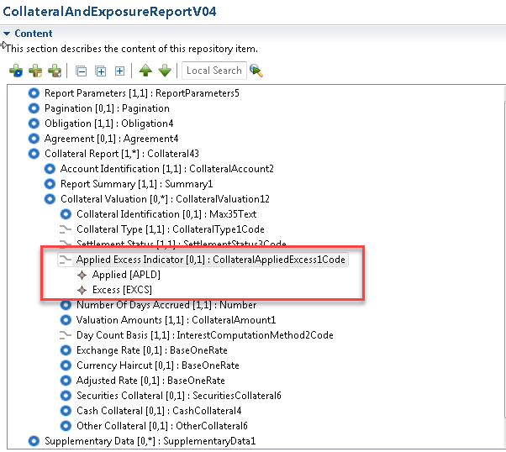

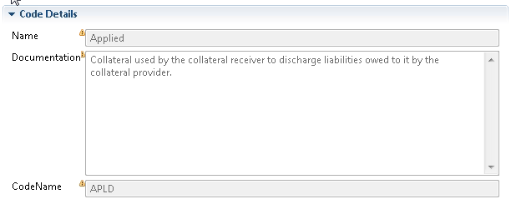

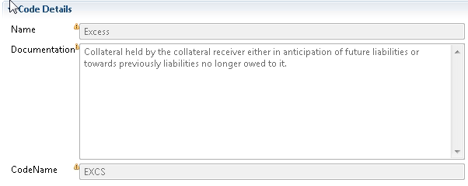

Proposed timing:
The submitting organisation confirms that it can implement the requested changes in the requested timing.

Timing | As requested SR 2021

Final decision of the SEG(s):

Approve | X
Comments:

Reject
Reason for rejection:

Change request CR0854:
Update ModifyReservation message.

Origin of the request:
A.1 Submitter:
- LCH Ltd
A.2 Contact person:
- Ben Doughton; ben.doughton@lch.com; +44 (0) 20 7392 8278
A.3 Sponsors:
- LCH Ltd, LCH SA, SWIFT.

Related messages:
The list of ISO 20022 messages which would be impacted by the change, including the Message IDs as shown in the Catalogue of ISO 20022 messages. Only the latest version of a message definition can be maintained.
The submitter is invited to carefully examine whether the change may have an impact on other messages that come into play earlier or later in the transaction chain or on other messages that also use message components that this change request may impact.
Related message:
colr.016 (Collateral and Exposure Report)

Description of the change request:
Add a new choice element under the existing “Collateral Valuation” block to indicate the direction of the collateral being reported as either “Collateral Due To Party A” or “Collateral Due To Party B”.

Purpose of the change:
When reporting collateral states other than settled, it is not easy to identify the direction that the collateral is traveling, either from Party A to Party B or from Party B to Party A.

Urgency of the request:
To be included as part of the annual maintenance cycle.

Business examples:
In the below example collateral is in transit in both directions between Party A and Party B as highlighted in green. While Party A also holds settled collateral to cover its exposure to Party B as highlighted in yellow.

<Document xmlns="urn:iso:std:iso:20022:tech:xsd:colr.016.001.04">
<CollAndXpsrRpt>
<RptParams>
<RptId>REP00031</RptId>
<RptDtAndTm>
<DtTm>2020-05-09T02:00:00Z</DtTm>
</RptDtAndTm>
<Frqcy>INDA</Frqcy>
<RptCcy>EUR</RptCcy>
<ClctnDt>2020-05-11T00:00:00Z</ClctnDt>
</RptParams>
<Oblgtn>
<PtyA>
<AnyBIC>LCHLGB2LCOL</AnyBIC>
</PtyA>
<PtyB>
<AnyBIC>IDCLUS33COL</AnyBIC>
</PtyB>
<XpsrTp>CCPC</XpsrTp>
<ValtnDt>
<Dt>2020-05-08</Dt>
</ValtnDt>
</Oblgtn>
<Agrmt>
<AgrmtDtls>LCH Ltd Rulebook</AgrmtDtls>
<AgrmtDt>2017-08-18</AgrmtDt>
<BaseCcy>EUR</BaseCcy>
</Agrmt>
<CollRpt>
<AcctId>
<Id>AAA/H</Id>
<Tp>
<Tp>HOUS</Tp>
</Tp>
<Nm>BANK AAA HOUSE ACCOUNT</Nm>
</AcctId>
<RptSummry>
<XpsdAmtPtyA Ccy="EUR">2600000000.00</XpsdAmtPtyA>
<XpsrTp>OTCD</XpsrTp>
<TtlValOfColl Ccy="EUR">2659599756.70</TtlValOfColl>
<NetXcssDfcit Ccy="EUR">59599756.70</NetXcssDfcit>
<NetXcssDfcitInd>LONG</NetXcssDfcitInd>
<ValtnDtTm>2020-05-08T23:59:00Z</ValtnDtTm>
<ReqdSttlmDt>2020-05-08</ReqdSttlmDt>
<SummryDtls>
<PreHrcutCollVal Ccy="EUR">2906831165.93</PreHrcutCollVal>
<TtlPdgIncmgColl Ccy="EUR">0.00</TtlPdgIncmgColl>
<TtlPdgOutgngColl Ccy="EUR">59599756.70</TtlPdgOutgngColl>
<TtlFees Ccy="EUR">0.00</TtlFees>
</SummryDtls>
</RptSummry>
<CollValtn>
<CollDueToB>
<CollId>MARGINPAYREF</CollId>
<CollTp>CASH</CollTp>
<SttlmSts>STCR</SttlmSts>
<NbOfDaysAcrd>0</NbOfDaysAcrd>
<ValtnAmts>
<CollAmt Ccy="GBP">54794134.21</CollAmt>
<RptdCcyAndAmt Ccy="EUR">59599756.70</RptdCcyAndAmt>
<MktValAmt Ccy="EUR">62736586.00</MktValAmt>
</ValtnAmts>
<DayCntBsis>A001</DayCntBsis>
<XchgRate>0.8734</XchgRate>
<CshColl>
<DpstAmt Ccy="GBP">54794134.21</DpstAmt>
<BlckdAmt Ccy="GBP">0.00</BlckdAmt>
<CollVal Ccy="GBP">52054427.50</CollVal>
<Hrcut>5.00</Hrcut>
</CshColl>
</CollDueToB>
</CollValtn>
<CollValtn>
<CollDueToA>
<CollId>VARIATIONMARGINCALLREF</CollId>
<CollTp>CASH</CollTp>
<SttlmSts>STCR</SttlmSts>
<NbOfDaysAcrd>0</NbOfDaysAcrd>
<ValtnAmts>
<CollAmt Ccy="USD">55.00</CollAmt>
<RptdCcyAndAmt Ccy="EUR">0.00</RptdCcyAndAmt>
<MktValAmt Ccy="EUR">0.00</MktValAmt>
</ValtnAmts>
<DayCntBsis>A001</DayCntBsis>
</CollDueToA>
</CollValtn>
<CollValtn>
<CollDueToA>
<CollTp>CASH</CollTp>
<SttlmSts>STLD</SttlmSts>
<NbOfDaysAcrd>0</NbOfDaysAcrd>
<ValtnAmts>
<CollAmt Ccy="GBP">0.00</CollAmt>
<RptdCcyAndAmt Ccy="EUR">1085351353.90</RptdCcyAndAmt>
<MktValAmt Ccy="EUR">1142475109.37</MktValAmt>
<FeesAndComssns Ccy="GBP">6287.74</FeesAndComssns>
</ValtnAmts>
<DayCntBsis>A001</DayCntBsis>
<XchgRate>0.8734</XchgRate>
<CshColl>
<DpstAmt Ccy="GBP">997837444.74</DpstAmt>
<BlckdAmt Ccy="GBP">0.00</BlckdAmt>
<CollVal Ccy="GBP">947945572.50</CollVal>
<Hrcut>5.00</Hrcut>
</CshColl>
</CollDueToA>
</CollValtn>
<CollValtn>
<CollDueToA>
<CollId>SDREF001</CollId>
<CollTp>SECU</CollTp>
<SttlmSts>STLD</SttlmSts>
<NbOfDaysAcrd>0</NbOfDaysAcrd>
<ValtnAmts>
<CollAmt Ccy="GBP">0.00</CollAmt>
<RptdCcyAndAmt Ccy="EUR">1504648989.58</RptdCcyAndAmt>
<MktValAmt Ccy="EUR">1690616842.23</MktValAmt>
<FeesAndComssns Ccy="GBP">3420.42</FeesAndComssns>
</ValtnAmts>
<DayCntBsis>A005</DayCntBsis>
<XchgRate>0.8734</XchgRate>
<AdjstdRate>100.00</AdjstdRate>
<SctiesColl>
<SctyId>
<ISIN>GB0004893086</ISIN>
</SctyId>
<MtrtyDt>
<Dt>2032-06-07</Dt>
</MtrtyDt>
<CollOwnrsh>
<Prtry>true</Prtry>
</CollOwnrsh>
<LtdCvrgInd>true</LtdCvrgInd>
<Qty>
<FaceAmt>1000000000.00</FaceAmt>
</Qty>
<BlckdQty>
<FaceAmt>0.00</FaceAmt>
</BlckdQty>
<Pric>
<Tp>
<ValTp>PARV</ValTp>
</Tp>
<Val>
<Amt Ccy="GBP">147.658475</Amt>
</Val>
</Pric>
<MktVal Ccy="GBP">1476584750.00</MktVal>
<Hrcut>11.00</Hrcut>
<CollVal Ccy="GBP">1314160427.50</CollVal>
<SfkpgAcct>
<Id>5165-C</Id>
</SfkpgAcct>
<SfkpgPlc>
<TpAndId>
<SfkpgPlcTp>NCSD</SfkpgPlcTp>
<Id>CRSTGB22</Id>
</TpAndId>
</SfkpgPlc>
</SctiesColl>
</CollDueToA>
</CollValtn>
<CollValtn>
<CollDueToA>
<CollTp>SECU</CollTp>
<SttlmSts>STLD</SttlmSts>
<NbOfDaysAcrd>0</NbOfDaysAcrd>
<ValtnAmts>
<CollAmt Ccy="JPY">0</CollAmt>
<RptdCcyAndAmt Ccy="EUR">8115099.97</RptdCcyAndAmt>
<MktValAmt Ccy="EUR">9118089.86</MktValAmt>
<FeesAndComssns Ccy="JPY">2442</FeesAndComssns>
</ValtnAmts>
<DayCntBsis>A004</DayCntBsis>
<XchgRate>115.63</XchgRate>
<AdjstdRate>100.00</AdjstdRate>
<SctiesColl>
<SctyId>
<ISIN>JP1024101L33</ISIN>
</SctyId>
<MtrtyDt>
<Dt>2022-03-01</Dt>
</MtrtyDt>
<CollOwnrsh>
<Prtry>true</Prtry>
</CollOwnrsh>
<LtdCvrgInd>false</LtdCvrgInd>
<Qty>
<FaceAmt>1000000000.00</FaceAmt>
</Qty>
<BlckdQty>
<FaceAmt>0.00</FaceAmt>
</BlckdQty>
<Pric>
<Tp>
<ValTp>PARV</ValTp>
</Tp>
<Val>
<Amt Ccy="JPY">100.519444</Amt>
</Val>
</Pric>
<MktVal Ccy="JPY">1005194440</MktVal>
<Hrcut>6.65</Hrcut>
<CollVal Ccy="JPY">938349010</CollVal>
<SfkpgAcct>
<Id>12345</Id>
</SfkpgAcct>
<SfkpgPlc>
<TpAndId>
<SfkpgPlcTp>ICSD</SfkpgPlcTp>
<Id>MGTCBEBE</Id>
</TpAndId>
</SfkpgPlc>
</SctiesColl>
</CollDueToA>
</CollValtn>
<CollValtn>
<CollDueToA>
<CollTp>OTHR</CollTp>
<SttlmSts>STLD</SttlmSts>
<NbOfDaysAcrd>0</NbOfDaysAcrd>
<ValtnAmts>
<CollAmt Ccy="GBP">0.00</CollAmt>
<RptdCcyAndAmt Ccy="EUR">1884900.03</RptdCcyAndAmt>
<MktValAmt Ccy="EUR">1884900.03</MktValAmt>
<FeesAndComssns Ccy="GBP">0.00</FeesAndComssns>
</ValtnAmts>
<DayCntBsis>A001</DayCntBsis>
<XchgRate>1.0841</XchgRate>
<OthrColl>
<OthrTpOfColl>
<Desc>CashFail</Desc>
</OthrTpOfColl>
<Issr>
<AnyBIC>MGTCBEBE</AnyBIC>
</Issr>
<MktVal Ccy="USD">2043420.12</MktVal>
<CollVal Ccy="USD">2043420.12</CollVal>
</OthrColl>
</CollDueToA>
</CollValtn>
</CollRpt>
</CollAndXpsrRpt>
</Document>

SEG/TSG recommendation:

Consider |  | X | Timing
 |  |  | - Next yearly cycle: 2020/2021  (the change will be considered for implementation in the yearly maintenance cycle which starts in 2018 and completes with the publication of new message versions in the spring of 2019) |  | X
- At the occasion of the next maintenance of the messages
(the change will be considered for implementation, but does not justify maintenance of the messages in its own right – will be pending until more critical change requests are received for the messages)
- Urgent unscheduled
(the change justifies an urgent implementation outside of the normal yearly cycle)
 |  |  | - Other timing:

Comments:

Reject
Reason for rejection:

Impact analysis and type of impact:
The impact of the change requested will differ from the approved change request to avoid and additional level of nesting.

Proposed implementation:
The SEG ET supports the proposed implementation as described by the submitter.
The updates will result in the following structure:

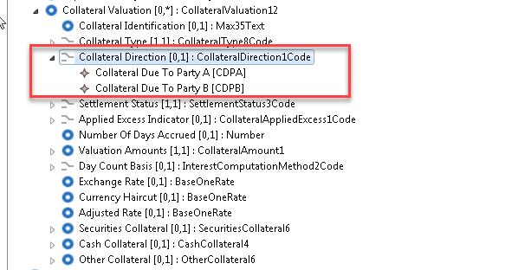



Party A Collateral Side: Indicates whether the collateral is due to or is received by party A.
Party B Collateral Side: Indicates whether the collateral is due to or is received by party B.

Proposed timing:
The submitting organisation confirms that it can implement the requested changes in the requested timing.

Timing | As requested SR 2021

Final decision of the SEG(s):

Approve | X
Comments:

Reject
Reason for rejection:

Change request CR0855:
Change Collateral Valuation from mandatory to optional

Origin of the request:
A.1 Submitter: LCH Ltd
A.2 Contact person: Ben Doughton; ben.doughton@lch.com; +44 (0) 20 7392 8278
A.3 Sponsors: LCH Ltd, LCH SA, SWIFT

Related messages:
The list of ISO 20022 messages which would be impacted by the change, including the Message IDs as shown in the Catalogue of ISO 20022 messages. Only the latest version of a message definition can be maintained.
The submitter is invited to carefully examine whether the change may have an impact on other messages that come into play earlier or later in the transaction chain or on other messages that also use message components that this change request may impact.
- colr.016 (Collateral and Exposure Report)

Description of the change request:
Request to make the following mandatory elements optional when using the Collateral Valuation (/Document/CollAndXpsrRpt/CollRpt/CollValtn) block as they do not apply to cash collateral:
- Number of Days Accrued (/Document/CollAndXpsrRpt/CollRpt/CollValtn/NbOfDaysAcrd)
- Day Count Basis (/Document/CollAndXpsrRpt/CollRpt/CollValtn/DayCntBsis

Purpose of the change:
The Collateral Valuation block Provides additional information about the collateral valuation that has been posted, including cash collateral. Yet it is currently mandatory to include the “Number of Days Accrued” and “Day Count Basis” for all usages of this block.

Urgency of the request:
To be included as part of the annual maintenance cycle.

Business examples:
Examples illustrating the change request.

<Document xmlns="urn:iso:std:iso:20022:tech:xsd:colr.016.001.04">
<CollAndXpsrRpt>
<RptParams>
<RptId>REP00031</RptId>
<RptDtAndTm>
<DtTm>2020-05-09T02:00:00Z</DtTm>
</RptDtAndTm>
<Frqcy>INDA</Frqcy>
<RptCcy>EUR</RptCcy>
<ClctnDt>2020-05-11T00:00:00Z</ClctnDt>
</RptParams>
<Oblgtn>
<PtyA>
<AnyBIC>LCHLGB2LCOL</AnyBIC>
</PtyA>
<PtyB>
<AnyBIC>IDCLUS33COL</AnyBIC>
</PtyB>
<XpsrTp>CCPC</XpsrTp>
<ValtnDt>
<Dt>2020-05-08</Dt>
</ValtnDt>
</Oblgtn>
<Agrmt>
<AgrmtDtls>LCH Ltd Rulebook</AgrmtDtls>
<AgrmtDt>2017-08-18</AgrmtDt>
<BaseCcy>EUR</BaseCcy>
</Agrmt>
<CollRpt>
<AcctId>
<Id>AAA/H</Id>
<Tp>
<Tp>HOUS</Tp>
</Tp>
<Nm>BANK AAA HOUSE ACCOUNT</Nm>
</AcctId>
<RptSummry>
<XpsdAmtPtyA Ccy="EUR">2700000000.00</XpsdAmtPtyA>
<XpsrTp>OTCD</XpsrTp>
<TtlValOfColl Ccy="EUR">2659599756.70</TtlValOfColl>
<NetXcssDfcit Ccy="EUR">40400243.30</NetXcssDfcit>
<NetXcssDfcitInd>SHOR</NetXcssDfcitInd>
<ValtnDtTm>2020-05-08T23:59:00Z</ValtnDtTm>
<ReqdSttlmDt>2020-05-08</ReqdSttlmDt>
<SummryDtls>
<PreHrcutCollVal Ccy="EUR">2906831165.93</PreHrcutCollVal>
<TtlPdgIncmgColl Ccy="EUR">40400243.30</TtlPdgIncmgColl>
<TtlPdgOutgngColl Ccy="EUR">0.00</TtlPdgOutgngColl>
<TtlFees Ccy="EUR">0.00</TtlFees>
</SummryDtls>
</RptSummry>
<CollValtn>
<CollId>MARGINCALLREF</CollId>
<CollTp>CASH</CollTp>
<SttlmSts>STCR</SttlmSts>

<ValtnAmts>
<CollAmt Ccy="EUR">40400243.30</CollAmt>
<RptdCcyAndAmt Ccy="EUR">40400243.30</RptdCcyAndAmt>
<MktValAmt Ccy="EUR">40400243.30</MktValAmt>
</ValtnAmts>

<XchgRate>1.00</XchgRate>
<CshColl>
<DpstAmt Ccy="EUR">40400243.30</DpstAmt>
<BlckdAmt Ccy="EUR">0.00</BlckdAmt>
<CollVal Ccy="EUR">40400243.30</CollVal>
<Hrcut>0.00</Hrcut>
</CshColl>
</CollValtn>
<CollValtn>
<CollTp>CASH</CollTp>
<SttlmSts>STLD</SttlmSts>
<NbOfDaysAcrd>0</NbOfDaysAcrd>
<ValtnAmts>
<CollAmt Ccy="GBP">0.00</CollAmt>
<RptdCcyAndAmt Ccy="EUR">1144950767.12</RptdCcyAndAmt>
<MktValAmt Ccy="EUR">1205211333.81</MktValAmt>
<FeesAndComssns Ccy="GBP">6633.02</FeesAndComssns>
</ValtnAmts>
<DayCntBsis>A001</DayCntBsis>
<XchgRate>0.8734</XchgRate>
<CshColl>
<DpstAmt Ccy="GBP">1052631578.95</DpstAmt>
<BlckdAmt Ccy="GBP">0.00</BlckdAmt>
<CollVal Ccy="GBP">1000000000.00</CollVal>
<Hrcut>5.00</Hrcut>
</CshColl>
</CollValtn>
<CollValtn>
<CollId>SDREF001</CollId>
<CollTp>SECU</CollTp>
<SttlmSts>STLD</SttlmSts>
<NbOfDaysAcrd>0</NbOfDaysAcrd>
<ValtnAmts>
<CollAmt Ccy="GBP">0.00</CollAmt>
<RptdCcyAndAmt Ccy="EUR">1504648989.58</RptdCcyAndAmt>
<MktValAmt Ccy="EUR">1690616842.23</MktValAmt>
<FeesAndComssns Ccy="GBP">3420.42</FeesAndComssns>
</ValtnAmts>
<DayCntBsis>A005</DayCntBsis>
<XchgRate>0.8734</XchgRate>
<AdjstdRate>100.00</AdjstdRate>
<SctiesColl>
<SctyId>
<ISIN>GB0004893086</ISIN>
</SctyId>
<MtrtyDt>
<Dt>2032-06-07</Dt>
</MtrtyDt>
<CollOwnrsh>
<Prtry>true</Prtry>
</CollOwnrsh>
<LtdCvrgInd>true</LtdCvrgInd>
<Qty>
<FaceAmt>1000000000.00</FaceAmt>
</Qty>
<BlckdQty>
<FaceAmt>0.00</FaceAmt>
</BlckdQty>
<Pric>
<Tp>
<ValTp>PARV</ValTp>
</Tp>
<Val>
<Amt Ccy="GBP">147.658475</Amt>
</Val>
</Pric>
<MktVal Ccy="GBP">1476584750.00</MktVal>
<Hrcut>11.00</Hrcut>
<CollVal Ccy="GBP">1314160427.50</CollVal>
<SfkpgAcct>
<Id>5165-C</Id>
</SfkpgAcct>
<SfkpgPlc>
<TpAndId>
<SfkpgPlcTp>NCSD</SfkpgPlcTp>
<Id>CRSTGB22</Id>
</TpAndId>
</SfkpgPlc>
</SctiesColl>
</CollValtn>
<CollValtn>
<CollTp>SECU</CollTp>
<SttlmSts>STLD</SttlmSts>
<NbOfDaysAcrd>0</NbOfDaysAcrd>
<ValtnAmts>
<CollAmt Ccy="JPY">0</CollAmt>
<RptdCcyAndAmt Ccy="EUR">8115099.97</RptdCcyAndAmt>
<MktValAmt Ccy="EUR">9118089.86</MktValAmt>
<FeesAndComssns Ccy="JPY">2442</FeesAndComssns>
</ValtnAmts>
<DayCntBsis>A004</DayCntBsis>
<XchgRate>115.63</XchgRate>
<AdjstdRate>100.00</AdjstdRate>
<SctiesColl>
<SctyId>
<ISIN>JP1024101L33</ISIN>
</SctyId>
<MtrtyDt>
<Dt>2022-03-01</Dt>
</MtrtyDt>
<CollOwnrsh>
<Prtry>true</Prtry>
</CollOwnrsh>
<LtdCvrgInd>false</LtdCvrgInd>
<Qty>
<FaceAmt>1000000000.00</FaceAmt>
</Qty>
<BlckdQty>
<FaceAmt>0.00</FaceAmt>
</BlckdQty>
<Pric>
<Tp>
<ValTp>PARV</ValTp>
</Tp>
<Val>
<Amt Ccy="JPY">100.519444</Amt>
</Val>
</Pric>
<MktVal Ccy="JPY">1005194440</MktVal>
<Hrcut>6.65</Hrcut>
<CollVal Ccy="JPY">938349010</CollVal>
<SfkpgAcct>
<Id>12345</Id>
</SfkpgAcct>
<SfkpgPlc>
<TpAndId>
<SfkpgPlcTp>ICSD</SfkpgPlcTp>
<Id>MGTCBEBE</Id>
</TpAndId>
</SfkpgPlc>
</SctiesColl>
</CollValtn>
<CollValtn>
<CollTp>OTHR</CollTp>
<SttlmSts>STLD</SttlmSts>
<NbOfDaysAcrd>0</NbOfDaysAcrd>
<ValtnAmts>
<CollAmt Ccy="GBP">0.00</CollAmt>
<RptdCcyAndAmt Ccy="EUR">1884900.03</RptdCcyAndAmt>
<MktValAmt Ccy="EUR">1884900.03</MktValAmt>
<FeesAndComssns Ccy="GBP">0.00</FeesAndComssns>
</ValtnAmts>
<DayCntBsis>A001</DayCntBsis>
<XchgRate>1.0841</XchgRate>
<OthrColl>
<OthrTpOfColl>
<Desc>CashFail</Desc>
</OthrTpOfColl>
<Issr>
<AnyBIC>MGTCBEBE</AnyBIC>
</Issr>
<MktVal Ccy="USD">2043420.12</MktVal>
<CollVal Ccy="USD">2043420.12</CollVal>
</OthrColl>
</CollValtn>
</CollRpt>
</CollAndXpsrRpt>
</Document>

SEG/TSG recommendation:

Consider |  | X | Timing
 |  |  | - Next yearly cycle: 2020/2021  (the change will be considered for implementation in the yearly maintenance cycle which starts in 2018 and completes with the publication of new message versions in the spring of 2019) |  | X
- At the occasion of the next maintenance of the messages
(the change will be considered for implementation, but does not justify maintenance of the messages in its own right – will be pending until more critical change requests are received for the messages)
- Urgent unscheduled
(the change justifies an urgent implementation outside of the normal yearly cycle)
 |  |  | - Other timing:

Comments:

Reject
Reason for rejection:

Impact analysis and type of impact:
The impact of the change requested will be as described in the approved change request.

Proposed implementation:
The SEG ET supports the proposed implementation as described by the submitter.
The updates will result in the following structure:

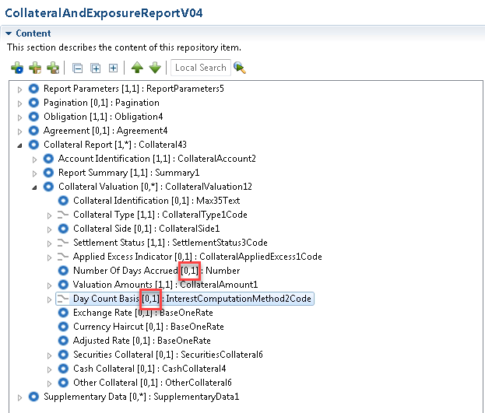

Proposed timing:
The submitting organisation confirms that it can implement the requested changes in the requested timing.

Timing | As requested SR 2021

Final decision of the SEG(s):

Approve | X
Comments:

Reject
Reason for rejection:

Change request CR0856:
Addition of CCP Member Type

Origin of the request:
A.1 Submitter: LCH Ltd
A.2 Contact person: Ben Doughton; ben.doughton@lch.com; +44 (0) 20 7392 8278
A.3 Sponsors: LCH Ltd, LCH SA, SWIFT

Related messages:
The list of ISO 20022 messages which would be impacted by the change, including the Message IDs as shown in the Catalogue of ISO 20022 messages. Only the latest version of a message definition can be maintained.
The submitter is invited to carefully examine whether the change may have an impact on other messages that come into play earlier or later in the transaction chain or on other messages that also use message components that this change request may impact.
- colr.016 (Collateral and Exposure Report)

Description of the change request:
Request to add a new element “Member Type” as an optional element in both the “Party A” and “Party B” elements within the “Obligation” (/Document/CollAndXpsrRpt/Oblgtn) block to indicate the type of CCP Membership where the opposing Party is a CCP.
Member Types should include, but not be limited to the following:
- Futures Commission Merchant (FCM)
- General Clearing Member (GCM)
- Direct Clearing Member (DCM)
- Sponsored Clearing Member (SCM)
- Agent Clearing Member (ACM)
- Clearing House (CCP)

Purpose of the change:
Treatment collateral at a CCP may be applied differently based on the type of membership the collateral provider holds with the CCP.

Urgency of the request:
To be included as part of the annual maintenance cycle.

Business examples:
Examples illustrating the change request.

<Document xmlns="urn:iso:std:iso:20022:tech:xsd:colr.016.001.04">
<CollAndXpsrRpt>
<RptParams>
<RptId>REP00031</RptId>
<RptDtAndTm>
<DtTm>2020-05-09T02:00:00Z</DtTm>
</RptDtAndTm>
<Frqcy>INDA</Frqcy>
<RptCcy>EUR</RptCcy>
<ClctnDt>2020-05-11T00:00:00Z</ClctnDt>
</RptParams>
<Oblgtn>
<PtyA>
<AnyBIC>LCHLGB2LCOL</AnyBIC>
</PtyA>
<PtyB>
<AnyBIC>MEMBER00BIC</AnyBIC>
<MbrTp>GCM</MbrTp>
</PtyB>
<XpsrTp>CCPC</XpsrTp>
<ValtnDt>
<Dt>2020-05-08</Dt>
</ValtnDt>
</Oblgtn>
<Agrmt>
<AgrmtDtls>LCH Ltd Rulebook</AgrmtDtls>
<AgrmtDt>2017-08-18</AgrmtDt>
<BaseCcy>EUR</BaseCcy>
</Agrmt>
<CollRpt>
<AcctId>
<Id>AAA/H</Id>
<Tp>
<Tp>HOUS</Tp>
</Tp>
<Nm>BANK AAA HOUSE ACCOUNT</Nm>
</AcctId>
<RptSummry>
<XpsdAmtPtyA Ccy="EUR">2700000000.00</XpsdAmtPtyA>
<XpsrTp>OTCD</XpsrTp>
<TtlValOfColl Ccy="EUR">2659599756.70</TtlValOfColl>
<NetXcssDfcit Ccy="EUR">40400243.30</NetXcssDfcit>
<NetXcssDfcitInd>SHOR</NetXcssDfcitInd>
<ValtnDtTm>2020-05-08T23:59:00Z</ValtnDtTm>
<ReqdSttlmDt>2020-05-08</ReqdSttlmDt>
<SummryDtls>
<PreHrcutCollVal Ccy="EUR">2906831165.93</PreHrcutCollVal>
<TtlPdgIncmgColl Ccy="EUR">40400243.30</TtlPdgIncmgColl>
<TtlPdgOutgngColl Ccy="EUR">0.00</TtlPdgOutgngColl>
<TtlFees Ccy="EUR">0.00</TtlFees>
</SummryDtls>
</RptSummry>
<CollValtn>
<CollId>MARGINCALLREF</CollId>
<CollTp>CASH</CollTp>
<SttlmSts>STCR</SttlmSts>
<NbOfDaysAcrd>0</NbOfDaysAcrd>
<ValtnAmts>
<CollAmt Ccy="EUR">40400243.30</CollAmt>
<RptdCcyAndAmt Ccy="EUR">40400243.30</RptdCcyAndAmt>
<MktValAmt Ccy="EUR">40400243.30</MktValAmt>
</ValtnAmts>
<DayCntBsis>A001</DayCntBsis>
<XchgRate>1.00</XchgRate>
<CshColl>
<DpstAmt Ccy="EUR">40400243.30</DpstAmt>
<BlckdAmt Ccy="EUR">0.00</BlckdAmt>
<CollVal Ccy="EUR">40400243.30</CollVal>
<Hrcut>0.00</Hrcut>
</CshColl>
</CollValtn>
<CollValtn>
<CollTp>CASH</CollTp>
<SttlmSts>STLD</SttlmSts>
<NbOfDaysAcrd>0</NbOfDaysAcrd>
<ValtnAmts>
<CollAmt Ccy="GBP">0.00</CollAmt>
<RptdCcyAndAmt Ccy="EUR">1144950767.12</RptdCcyAndAmt>
<MktValAmt Ccy="EUR">1205211333.81</MktValAmt>
<FeesAndComssns Ccy="GBP">6633.02</FeesAndComssns>
</ValtnAmts>
<DayCntBsis>A001</DayCntBsis>
<XchgRate>0.8734</XchgRate>
<CshColl>
<DpstAmt Ccy="GBP">1052631578.95</DpstAmt>
<BlckdAmt Ccy="GBP">0.00</BlckdAmt>
<CollVal Ccy="GBP">1000000000.00</CollVal>
<Hrcut>5.00</Hrcut>
</CshColl>
</CollValtn>
<CollValtn>
<CollId>SDREF001</CollId>
<CollTp>SECU</CollTp>
<SttlmSts>STLD</SttlmSts>
<NbOfDaysAcrd>0</NbOfDaysAcrd>
<ValtnAmts>
<CollAmt Ccy="GBP">0.00</CollAmt>
<RptdCcyAndAmt Ccy="EUR">1504648989.58</RptdCcyAndAmt>
<MktValAmt Ccy="EUR">1690616842.23</MktValAmt>
<FeesAndComssns Ccy="GBP">3420.42</FeesAndComssns>
</ValtnAmts>
<DayCntBsis>A005</DayCntBsis>
<XchgRate>0.8734</XchgRate>
<AdjstdRate>100.00</AdjstdRate>
<SctiesColl>
<SctyId>
<ISIN>GB0004893086</ISIN>
</SctyId>
<MtrtyDt>
<Dt>2032-06-07</Dt>
</MtrtyDt>
<CollOwnrsh>
<Prtry>true</Prtry>
</CollOwnrsh>
<LtdCvrgInd>true</LtdCvrgInd>
<Qty>
<FaceAmt>1000000000.00</FaceAmt>
</Qty>
<BlckdQty>
<FaceAmt>0.00</FaceAmt>
</BlckdQty>
<Pric>
<Tp>
<ValTp>PARV</ValTp>
</Tp>
<Val>
<Amt Ccy="GBP">147.658475</Amt>
</Val>
</Pric>
<MktVal Ccy="GBP">1476584750.00</MktVal>
<Hrcut>11.00</Hrcut>
<CollVal Ccy="GBP">1314160427.50</CollVal>
<SfkpgAcct>
<Id>5165-C</Id>
</SfkpgAcct>
<SfkpgPlc>
<TpAndId>
<SfkpgPlcTp>NCSD</SfkpgPlcTp>
<Id>CRSTGB22</Id>
</TpAndId>
</SfkpgPlc>
</SctiesColl>
</CollValtn>
<CollValtn>
<CollTp>SECU</CollTp>
<SttlmSts>STLD</SttlmSts>
<NbOfDaysAcrd>0</NbOfDaysAcrd>
<ValtnAmts>
<CollAmt Ccy="JPY">0</CollAmt>
<RptdCcyAndAmt Ccy="EUR">8115099.97</RptdCcyAndAmt>
<MktValAmt Ccy="EUR">9118089.86</MktValAmt>
<FeesAndComssns Ccy="JPY">2442</FeesAndComssns>
</ValtnAmts>
<DayCntBsis>A004</DayCntBsis>
<XchgRate>115.63</XchgRate>
<AdjstdRate>100.00</AdjstdRate>
<SctiesColl>
<SctyId>
<ISIN>JP1024101L33</ISIN>
</SctyId>
<MtrtyDt>
<Dt>2022-03-01</Dt>
</MtrtyDt>
<CollOwnrsh>
<Prtry>true</Prtry>
</CollOwnrsh>
<LtdCvrgInd>false</LtdCvrgInd>
<Qty>
<FaceAmt>1000000000.00</FaceAmt>
</Qty>
<BlckdQty>
<FaceAmt>0.00</FaceAmt>
</BlckdQty>
<Pric>
<Tp>
<ValTp>PARV</ValTp>
</Tp>
<Val>
<Amt Ccy="JPY">100.519444</Amt>
</Val>
</Pric>
<MktVal Ccy="JPY">1005194440</MktVal>
<Hrcut>6.65</Hrcut>
<CollVal Ccy="JPY">938349010</CollVal>
<SfkpgAcct>
<Id>12345</Id>
</SfkpgAcct>
<SfkpgPlc>
<TpAndId>
<SfkpgPlcTp>ICSD</SfkpgPlcTp>
<Id>MGTCBEBE</Id>
</TpAndId>
</SfkpgPlc>
</SctiesColl>
</CollValtn>
<CollValtn>
<CollTp>OTHR</CollTp>
<SttlmSts>STLD</SttlmSts>
<NbOfDaysAcrd>0</NbOfDaysAcrd>
<ValtnAmts>
<CollAmt Ccy="GBP">0.00</CollAmt>
<RptdCcyAndAmt Ccy="EUR">1884900.03</RptdCcyAndAmt>
<MktValAmt Ccy="EUR">1884900.03</MktValAmt>
<FeesAndComssns Ccy="GBP">0.00</FeesAndComssns>
</ValtnAmts>
<DayCntBsis>A001</DayCntBsis>
<XchgRate>1.0841</XchgRate>
<OthrColl>
<OthrTpOfColl>
<Desc>CashFail</Desc>
</OthrTpOfColl>
<Issr>
<AnyBIC>MGTCBEBE</AnyBIC>
</Issr>
<MktVal Ccy="USD">2043420.12</MktVal>
<CollVal Ccy="USD">2043420.12</CollVal>
</OthrColl>
</CollValtn>
</CollRpt>
</CollAndXpsrRpt>
</Document>

SEG/TSG recommendation:

Consider |  | X | Timing
 |  |  | - Next yearly cycle: 2020/2021  (the change will be considered for implementation in the yearly maintenance cycle which starts in 2018 and completes with the publication of new message versions in the spring of 2019) |  | X
- At the occasion of the next maintenance of the messages
(the change will be considered for implementation, but does not justify maintenance of the messages in its own right – will be pending until more critical change requests are received for the messages)
- Urgent unscheduled
(the change justifies an urgent implementation outside of the normal yearly cycle)
 |  |  | - Other timing:
Comments:

Reject
Reason for rejection:

Impact analysis and type of impact:
The impact of the change requested will be as described in the approved change request.

Proposed implementation:
The SEG ET supports the proposed implementation as described by the submitter.
The updates will result in the following structure:

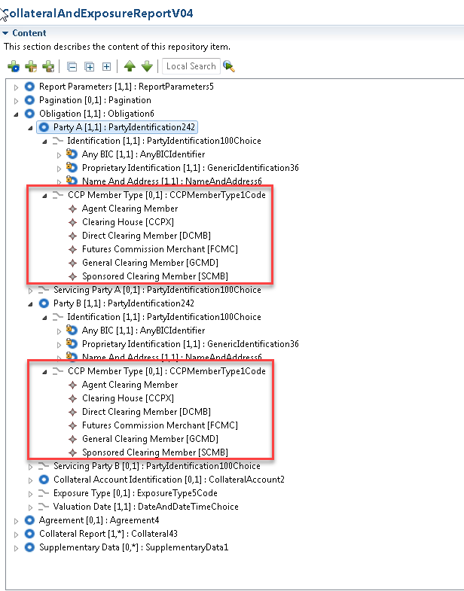

CCP Member Type: Specifies the type of membership the collateral provider holds with the CCP.

Proposed timing:
The submitting organisation confirms that it can implement the requested changes in the requested timing.

Timing | As requested SR 2021

Final decision of the SEG(s):

Approve | X
Comments:

Reject
Reason for rejection:

Change request CR0857:
Addition of Return Excess Cash Indicator

Origin of the request:
A.1 Submitter: LCH Ltd
A.2 Contact person: Ben Doughton; ben.doughton@lch.com; +44 (0) 20 7392 8278
A.3 Sponsors: LCH Ltd, LCH SA, SWIFT

Related messages:
The list of ISO 20022 messages which would be impacted by the change, including the Message IDs as shown in the Catalogue of ISO 20022 messages. Only the latest version of a message definition can be maintained.
The submitter is invited to carefully examine whether the change may have an impact on other messages that come into play earlier or later in the transaction chain or on other messages that also use message components that this change request may impact.
- colr.016 (Collateral and Exposure Report)

Description of the change request:
Request to add a new element “Return Excess Cash” as an optional repetitive block, with mandatory “Type” and “Collateral Currency” elements, in the “Summary Details” (/Document/CollAndXpsrRpt/CollRpt/RptSummry/SummryDtls) block to indicated if excess cash collateral in the currency will be automatically returned as per the collateral provider’s Excess Cash Margin Instruction (Colr.017).
The “Type” will be either “Yes” meaning excess cash in the currency will be returned, “Suspended” meaning has the automatic return has been temporarily suspended (for example due to a currency holiday); or “No” meaning the automatic return of excess has not been requested for the currency.

Purpose of the change:
Excess collateral could be subject to automated return from the collateral receiver to the collateral provider on a per currency and per collateral account basis.

Urgency of the request:
To be included as part of the annual maintenance cycle.

Business examples:
Examples illustrating the change request.

<Document xmlns="urn:iso:std:iso:20022:tech:xsd:colr.016.001.04">
<CollAndXpsrRpt>
<RptParams>
<RptId>REP00031</RptId>
<RptDtAndTm>
<DtTm>2020-05-09T02:00:00Z</DtTm>
</RptDtAndTm>
<Frqcy>INDA</Frqcy>
<RptCcy>EUR</RptCcy>
<ClctnDt>2020-05-11T00:00:00Z</ClctnDt>
</RptParams>
<Oblgtn>
<PtyA>
<AnyBIC>LCHLGB2LCOL</AnyBIC>
</PtyA>
<PtyB>
<AnyBIC>IDCLUS33COL</AnyBIC>
</PtyB>
<XpsrTp>CCPC</XpsrTp>
<ValtnDt>
<Dt>2020-05-08</Dt>
</ValtnDt>
</Oblgtn>
<Agrmt>
<AgrmtDtls>LCH Ltd Rulebook</AgrmtDtls>
<AgrmtDt>2017-08-18</AgrmtDt>
<BaseCcy>EUR</BaseCcy>
</Agrmt>
<CollRpt>
<AcctId>
<Id>AAA/H</Id>
<Tp>
<Tp>HOUS</Tp>
</Tp>
<Nm>BANK AAA HOUSE ACCOUNT</Nm>
</AcctId>
<RptSummry>
<XpsdAmtPtyA Ccy="EUR">2600000000.00</XpsdAmtPtyA>
<XpsrTp>OTCD</XpsrTp>
<TtlValOfColl Ccy="EUR">2659599756.70</TtlValOfColl>
<NetXcssDfcit Ccy="EUR">59599756.70</NetXcssDfcit>
<NetXcssDfcitInd>LONG</NetXcssDfcitInd>
<ValtnDtTm>2020-05-08T23:59:00Z</ValtnDtTm>
<ReqdSttlmDt>2020-05-08</ReqdSttlmDt>
<SummryDtls>
<PreHrcutCollVal Ccy="EUR">2906831165.93</PreHrcutCollVal>
<TtlPdgIncmgColl Ccy="EUR">0.00</TtlPdgIncmgColl>
<TtlPdgOutgngColl Ccy="EUR">59599756.70</TtlPdgOutgngColl>
<TtlFees Ccy="EUR">0.00</TtlFees>
<RtrXcssCsh>
<Tp>Suspended</Tp>
<CollCcy>EUR</CollCcy>
</RtrXcssCsh>
<RtrXcssCsh>
<Tp>Yes</Tp>
<CollCcy>GBP</CollCcy>
</RtrXcssCsh>
<RtrXcssCsh>
<Tp>No</Tp>
<CollCcy>USD</CollCcy>
</RtrXcssCsh>
</SummryDtls>
</RptSummry>
<CollValtn>
<CollId>MARGINPAYREF</CollId>
<CollTp>CASH</CollTp>
<SttlmSts>STCR</SttlmSts>
<NbOfDaysAcrd>0</NbOfDaysAcrd>
<ValtnAmts>
<CollAmt Ccy="GBP">54794134.21</CollAmt>
<RptdCcyAndAmt Ccy="EUR">59599756.70</RptdCcyAndAmt>
<MktValAmt Ccy="EUR">62736586.00</MktValAmt>
</ValtnAmts>
<DayCntBsis>A001</DayCntBsis>
<XchgRate>0.8734</XchgRate>
<CshColl>
<DpstAmt Ccy="GBP">54794134.21</DpstAmt>
<BlckdAmt Ccy="GBP">0.00</BlckdAmt>
<CollVal Ccy="GBP">52054427.50</CollVal>
<Hrcut>5.00</Hrcut>
</CshColl>
</CollValtn>
<CollValtn>
<CollId>VARIATIONMARGINCALLREF</CollId>
<CollTp>CASH</CollTp>
<SttlmSts>STCR</SttlmSts>
<NbOfDaysAcrd>0</NbOfDaysAcrd>
<ValtnAmts>
<CollAmt Ccy="USD">55.00</CollAmt>
<RptdCcyAndAmt Ccy="EUR">0.00</RptdCcyAndAmt>
<MktValAmt Ccy="EUR">0.00</MktValAmt>
</ValtnAmts>
<DayCntBsis>A001</DayCntBsis>
</CollValtn>
<CollValtn>
<CollTp>CASH</CollTp>
<SttlmSts>STLD</SttlmSts>
<NbOfDaysAcrd>0</NbOfDaysAcrd>
<ValtnAmts>
<CollAmt Ccy="GBP">0.00</CollAmt>
<RptdCcyAndAmt Ccy="EUR">1085351353.90</RptdCcyAndAmt>
<MktValAmt Ccy="EUR">1142475109.37</MktValAmt>
<FeesAndComssns Ccy="GBP">6287.74</FeesAndComssns>
</ValtnAmts>
<DayCntBsis>A001</DayCntBsis>
<XchgRate>0.8734</XchgRate>
<CshColl>
<DpstAmt Ccy="GBP">997837444.74</DpstAmt>
<BlckdAmt Ccy="GBP">0.00</BlckdAmt>
<CollVal Ccy="GBP">947945572.50</CollVal>
<Hrcut>5.00</Hrcut>
</CshColl>
</CollValtn>
<CollValtn>
<CollId>SDREF001</CollId>
<CollTp>SECU</CollTp>
<SttlmSts>STLD</SttlmSts>
<NbOfDaysAcrd>0</NbOfDaysAcrd>
<ValtnAmts>
<CollAmt Ccy="GBP">0.00</CollAmt>
<RptdCcyAndAmt Ccy="EUR">1504648989.58</RptdCcyAndAmt>
<MktValAmt Ccy="EUR">1690616842.23</MktValAmt>
<FeesAndComssns Ccy="GBP">3420.42</FeesAndComssns>
</ValtnAmts>
<DayCntBsis>A005</DayCntBsis>
<XchgRate>0.8734</XchgRate>
<AdjstdRate>100.00</AdjstdRate>
<SctiesColl>
<SctyId>
<ISIN>GB0004893086</ISIN>
</SctyId>
<MtrtyDt>
<Dt>2032-06-07</Dt>
</MtrtyDt>
<CollOwnrsh>
<Prtry>true</Prtry>
</CollOwnrsh>
<LtdCvrgInd>true</LtdCvrgInd>
<Qty>
<FaceAmt>1000000000.00</FaceAmt>
</Qty>
<BlckdQty>
<FaceAmt>0.00</FaceAmt>
</BlckdQty>
<Pric>
<Tp>
<ValTp>PARV</ValTp>
</Tp>
<Val>
<Amt Ccy="GBP">147.658475</Amt>
</Val>
</Pric>
<MktVal Ccy="GBP">1476584750.00</MktVal>
<Hrcut>11.00</Hrcut>
<CollVal Ccy="GBP">1314160427.50</CollVal>
<SfkpgAcct>
<Id>5165-C</Id>
</SfkpgAcct>
<SfkpgPlc>
<TpAndId>
<SfkpgPlcTp>NCSD</SfkpgPlcTp>
<Id>CRSTGB22</Id>
</TpAndId>
</SfkpgPlc>
</SctiesColl>
</CollValtn>
<CollValtn>
<CollTp>SECU</CollTp>
<SttlmSts>STLD</SttlmSts>
<NbOfDaysAcrd>0</NbOfDaysAcrd>
<ValtnAmts>
<CollAmt Ccy="JPY">0</CollAmt>
<RptdCcyAndAmt Ccy="EUR">8115099.97</RptdCcyAndAmt>
<MktValAmt Ccy="EUR">9118089.86</MktValAmt>
<FeesAndComssns Ccy="JPY">2442</FeesAndComssns>
</ValtnAmts>
<DayCntBsis>A004</DayCntBsis>
<XchgRate>115.63</XchgRate>
<AdjstdRate>100.00</AdjstdRate>
<SctiesColl>
<SctyId>
<ISIN>JP1024101L33</ISIN>
</SctyId>
<MtrtyDt>
<Dt>2022-03-01</Dt>
</MtrtyDt>
<CollOwnrsh>
<Prtry>true</Prtry>
</CollOwnrsh>
<LtdCvrgInd>false</LtdCvrgInd>
<Qty>
<FaceAmt>1000000000.00</FaceAmt>
</Qty>
<BlckdQty>
<FaceAmt>0.00</FaceAmt>
</BlckdQty>
<Pric>
<Tp>
<ValTp>PARV</ValTp>
</Tp>
<Val>
<Amt Ccy="JPY">100.519444</Amt>
</Val>
</Pric>
<MktVal Ccy="JPY">1005194440</MktVal>
<Hrcut>6.65</Hrcut>
<CollVal Ccy="JPY">938349010</CollVal>
<SfkpgAcct>
<Id>12345</Id>
</SfkpgAcct>
<SfkpgPlc>
<TpAndId>
<SfkpgPlcTp>ICSD</SfkpgPlcTp>
<Id>MGTCBEBE</Id>
</TpAndId>
</SfkpgPlc>
</SctiesColl>
</CollValtn>
<CollValtn>
<CollTp>OTHR</CollTp>
<SttlmSts>STLD</SttlmSts>
<NbOfDaysAcrd>0</NbOfDaysAcrd>
<ValtnAmts>
<CollAmt Ccy="GBP">0.00</CollAmt>
<RptdCcyAndAmt Ccy="EUR">1884900.03</RptdCcyAndAmt>
<MktValAmt Ccy="EUR">1884900.03</MktValAmt>
<FeesAndComssns Ccy="GBP">0.00</FeesAndComssns>
</ValtnAmts>
<DayCntBsis>A001</DayCntBsis>
<XchgRate>1.0841</XchgRate>
<OthrColl>
<OthrTpOfColl>
<Desc>CashFail</Desc>
</OthrTpOfColl>
<Issr>
<AnyBIC>MGTCBEBE</AnyBIC>
</Issr>
<MktVal Ccy="USD">2043420.12</MktVal>
<CollVal Ccy="USD">2043420.12</CollVal>
</OthrColl>
</CollValtn>
</CollRpt>
</CollAndXpsrRpt>
</Document>

SEG/TSG recommendation:
This section is not to be taken care of by the submitter of the change request. It will be completed in due time by the SEG(s) in charge of the related ISO 20022 messages or the TSG for changes related to the BAH.

Consider |  | X | Timing
 |  |  | - Next yearly cycle: 2020/2021  (the change will be considered for implementation in the yearly maintenance cycle which starts in 2018 and completes with the publication of new message versions in the spring of 2019) |  | X
- At the occasion of the next maintenance of the messages
(the change will be considered for implementation, but does not justify maintenance of the messages in its own right – will be pending until more critical change requests are received for the messages)
- Urgent unscheduled
(the change justifies an urgent implementation outside of the normal yearly cycle)
 |  |  | - Other timing:

Comments:

Reject
Reason for rejection:

Impact analysis and type of impact:
The impact of the change requested will be as described in the approved change request except for the naming of the codes.

Proposed implementation:
The SEG ET supports the proposed implementation as described by the submitter.
The updates will result in the following structure:

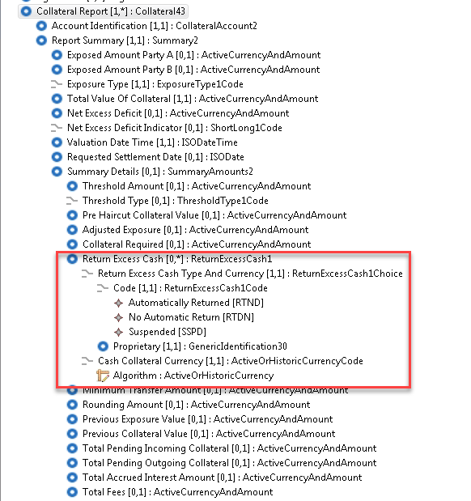

Proposed timing:
The submitting organisation confirms that it can implement the requested changes in the requested timing.

Timing | As requested SR 2021

Final decision of the SEG(s):

Approve | X
Comments:

Reject
Reason for rejection:

Change request CR00901:
New Exposure Type codes

Origin of the request:
A.1 Submitter: Banco de España on behalf of 4CB for ECMS
A.2 Contact person: Manuel Huete; manuel.huete@bde.es; +34 91 585 5237
A.3 Sponsors:

Related messages:
The list of ISO 20022 messages which would be impacted by the change, including the Message IDs as shown in the Catalogue of ISO 20022 messages. Only the latest version of a message definition can be maintained.
The submitter is invited to carefully examine whether the change may have an impact on other messages that come into play earlier or later in the transaction chain or on other messages that also use message components that this change request may impact.
- colr.016 (Collateral and Exposure Report)

Description of the change request:
Additional types are requested in reference to the Exposure Type element (/Document/CollAndXpsrRpt/CollRpt/RptSummry/XpsrTp), as follows:

- “EOMO” for "Credit: Total Open Market Credit Operations"
- “EOMI” for "Credit: Total Open Market Credit Operations Interest"
- “EOIM” for “Credit: Total Initial margin on outstanding liquidity providing OMO”
- “ECFR” for "Credit: Total Credit Freezing"
- “EMLO” for "Credit: Total Marginal Lending"
- “EMLI” for "Credit: Total Marginal Lending Interest"
- “ECRT” for "Credit: Total Credit"
- “ESCL” for “Suggested Credit Line”

Additional types are requested in reference to the Collateral Type element (/Document/CollAndXpsrRpt/CollRpt/CollValtn/CollTp), as follows:

- “CCCL” for "Collateral: Total Credit Claims"
- “CFTD” for "Collateral: Total Fixed-Term Deposit used as Collateral"
- “CFTI” for "Collateral: Total Interest for Fixed-Term Deposit used as Collateral"
- “CTRC” for "Collateral: Total Triparty Collateral"
- “CXCC” for "Collateral: Total Externally Managed Collateral for Credit Claims"
- “CEMC” for "Collateral: Total Externally Managed Collateral apart from Credit Claims"
- “COMO” for "Collateral: Total Collateral affected to OMO"
- “CTCO” for “Collateral: Total Collateral Operations”
- “CCVR” for "Total Collateral Value after Relative Credit Limit"

Purpose of the change:
When reporting collateral and exposure to Eurosystem counterparties it is necessary to provide proper and detailed identification using the Eurosystem operation types for credit and collateral.

Urgency of the request:
To be included as part of the annual maintenance cycle.

Business examples:
In the below example the usage of these required types is collateral is highlighted in yellow.
<CollAndXpsrRpt>
<RptParams>
<RptId>RPTIDXXXX001</RptId>
<RptDtAndTm>
<DtTm>2020-01-28T00:00:00</DtTm>
</RptDtAndTm>
<Frqcy>ONDE</Frqcy>
<RptCcy>EUR</RptCcy>
</RptParams>
<Oblgtn>
<PtyA>
<AnyBIC>NCBAAAAAXXX</AnyBIC>
</PtyA>
<PtyB>
<AnyBIC>CPTYBBBBXXX</AnyBIC>
</PtyB>
<ValtnDt>
<Dt>2020-01-28</Dt>
</ValtnDt>
</Oblgtn>
<CollRpt>
<AcctId>
<Id>POOL000000000081</Id>
<Nm>Pool XXXX</Nm>
</AcctId>
<RptSummry>
<XpsdAmtPtyA Ccy="EUR">2700000000.00</XpsdAmtPtyA>
<XpsrTp>ECRT</XpsrTp>
<TtlValOfColl Ccy="EUR">2700000001.00</TtlValOfColl>
<NetXcssDfcitInd>LONG</NetXcssDfcitInd>
<ValtnDtTm>2020-01-28T23:59:00Z</ValtnDtTm>
</RptSummry>
<CollValtn>
<CollId>CASHREF</CollId>
<CollTp>CASH</CollTp>
<SttlmSts>STLD</SttlmSts>
<NbOfDaysAcrd>0</NbOfDaysAcrd>
<ValtnAmts>
<CollAmt Ccy="EUR">2700000000.00</CollAmt>
<RptdCcyAndAmt Ccy="EUR">2700000000.00</RptdCcyAndAmt>
<MktValAmt Ccy="EUR">2700000000.00</MktValAmt>
</ValtnAmts>
<DayCntBsis>A004</DayCntBsis>

</CollValtn>
<CollValtn>
<CollId>CreditClaims</CollId>
<CollTp>CCCL</CollTp>
<SttlmSts>STLD</SttlmSts>
<NbOfDaysAcrd>0</NbOfDaysAcrd>
<ValtnAmts>
<CollAmt Ccy="EUR">1.00</CollAmt>
<RptdCcyAndAmt Ccy="EUR">1.00</RptdCcyAndAmt>
<MktValAmt Ccy="EUR">1.00</MktValAmt>
</ValtnAmts>
<DayCntBsis>A004</DayCntBsis>

</CollValtn>
</CollRpt>
<CollRpt>
<AcctId>
<Id>POOL000000000081</Id>
<Nm>Pool XXXX</Nm>
</AcctId>
<RptSummry>
<XpsdAmtPtyA Ccy="EUR">2699999999.00</XpsdAmtPtyA>
<XpsrTp>EOMO</XpsrTp>
<TtlValOfColl Ccy="EUR">2700000001.00</TtlValOfColl>
<ValtnDtTm>2020-01-28T23:59:00Z</ValtnDtTm>
</RptSummry>
</CollRpt>
<CollRpt>
<AcctId>
<Id>POOL000000000081</Id>
<Nm>Pool XXXX</Nm>
</AcctId>
<RptSummry>
<XpsrTp>EOMI</XpsrTp>
<TtlValOfColl Ccy="EUR">1.00</TtlValOfColl>
<ValtnDtTm>2020-01-28T00:00:00</ValtnDtTm>
</RptSummry>
</CollRpt>

</CollAndXpsrRpt>

SEG/TSG recommendation:

Consider |  | X | Timing
 |  |  | - Next yearly cycle: 2020/2021  (the change will be considered for implementation in the yearly maintenance cycle which starts in 2020 and completes with the publication of new message versions in the spring of 2021) |  | X
- At the occasion of the next maintenance of the messages
(the change will be considered for implementation, but does not justify maintenance of the messages in its own right – will be pending until more critical change requests are received for the messages)
- Urgent unscheduled
(the change justifies an urgent implementation outside of the normal yearly cycle)
 |  |  | - Other timing:
Comments:

Reject
Reason for rejection:

Impact analysis and type of impact:
The impact of the change requested will be as described in the approved change request. The codes might be too local market practice oriented and in this case the propriatry will have to be used.

Proposed implementation:
The SEG ET supports the proposed implementation as described by the submitter.
The updates will result in the following structure:

Collateral Type

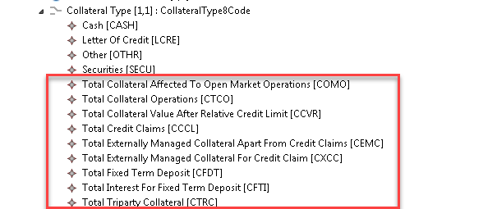

Exposure Type
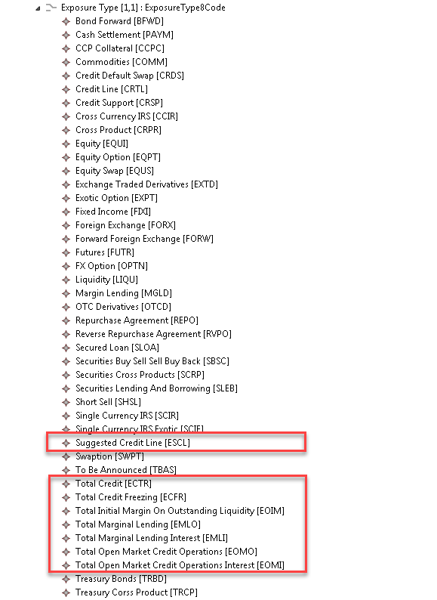

Proposed timing:
The submitting organisation confirms that it can implement the requested changes in the requested timing.

Timing | As requested SR 2021

Final decision of the SEG(s):

Approve | X
Comments:

Reject
Reason for rejection:

Change request CR00916:
Addition of references and elements at the olibgation level Deletion of transaction identification

Origin of the request:

A.1 Submitter: Banco de España on behalf of 4CB for ECMS; SWIFT.
A.2 Contact person: Manuel Huete, manuel.huete@bde.es, +34 91 585 5237
Karine Taquet, karine.taquet@swift.com, +32 2 655 37 84
A.3 Sponsors:
The Eurosystem’s Advisory Group on Market Infrastructures for Securities and Collateral (AMI-SeCo) agreed to introduce a single, harmonised triparty model for Europe that would be based on the global ISO20022 messaging standard.
There is broad endorsement of the Standards by all TPAs, central banks and other market participants.

Related messages:
- colr.005 (Collateral Management Cancellation Request)

Description of the change request:
In the context of the reverse engineering of the ISO 15022 Triparty Collateral Management messages, the existing MT 527 instruction message cancellation function will be done through the existing ISO 20022 existing message colr.005. Therefore, the colr.019 Triparty Collateral Transaction Instruction will be cancelled with the colr.005. Despite the fact that this message is generic some changes are required in order to meet the requirements of Triparty Collateral Management business.

- At the Reference level the following identification must be added:
  - ClientCollateralInstructionIdentification
  - TripartyAgentServiceProviderCollateralInstructionIdentification
  - ClientCollateralTransactionIdentification
  - TripartyAgentServiceProviderCollateralTransactionIdentification
  - Common Identification

- At the Obligation level
  - The Valuation Date should be changed from mandatory to optional
  - Addition of Closing Date and Execution Date as optional elements
  - Addition of the Collateral Instruction Type as optional
  - Additional of the role of the sender - Collateral Side (giver or taker) as optional
  - Addition of the Exposure Amount as optional

- Transaction Identification is identifying the cancellation request and should therefore be part of the Business Application Header. Transaction Identification should be removed from the colr.005

Purpose of the change:

The Eurosystem’s Advisory Group on Market Infrastructures for Securities and Collateral (AMI-SeCo) agreed to introduce a single, harmonised triparty model for Europe that would be based on the global ISO20022 messaging standard. In the light of the harmonisation needs identified by the AMI-SeCo in December 2017, a harmonised triparty model (the Single Triparty Model for Europe) was developed in June 2018 covering all relevant business processes and workflows. Key data elements were then mapped to ISO20022-compliant messages.

The Standards cover the communication of the triparty agents (TPAs) with relevant stakeholders based solely on the latest ISO20022-compliant messaging. The Triparty Collateral Management Standards defined requirements cover all existing triparty business processes and workflows and introduce enhanced features that will facilitate improved reporting capabilities to support the needs of treasurers and to meet regulatory requirements.

The Triparty Collateral Management Standards cover triparty processes offered to commercial and central banks. There is a single set of processes applicable for central banks and commercial banks. A few processes are more relevant in the context of the collateralisation of central bank operations (e.g.unilateral increase), while a number of other processes are more relevant for commercial banks (e.g.future-dated processing or customised baskets).

Implementation of theTriparty Collateral Management Standards will be mandatory for all TPAs (regardless of whether they are regulated as an (international) central securities depository ((I)CSD) or as a bank). (I)CSDs and custodian banks acting as TPAs are key stakeholders and are obliged to comply. It will also be mandatory for Eurosystem central banks and central counterparties (CCPs) as key users to implement the Triparty Collateral Management Standards. For collateral givers and collateral takers (unless they are Eurosystem central banks or CCPs), the use of existing messaging standards other than those based on ISO20022 remains possible.
The Triparty Collateral Management Standards should be implemented by November 2022 by all TPAs, CCPs and Eurosystem central banks (for triparty activities between key stakeholders in AMI-SeCo markets covered by the Standards). Timely implementation of the Triparty Collateral Management Standards by other actors (e.g.custodians not acting as TPAs but as collateral takers/givers) is also greatly encouraged in order to foster broader harmonisation across the industry.

Urgency of the request:
To be included as part of the annual maintenance cycle.

Business examples:
Examples illustrating the change request.

Addition of references
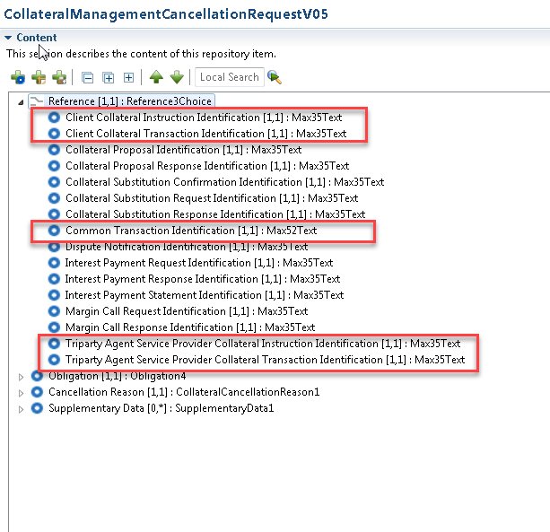

Addition of optional message elements in the Obligation message component

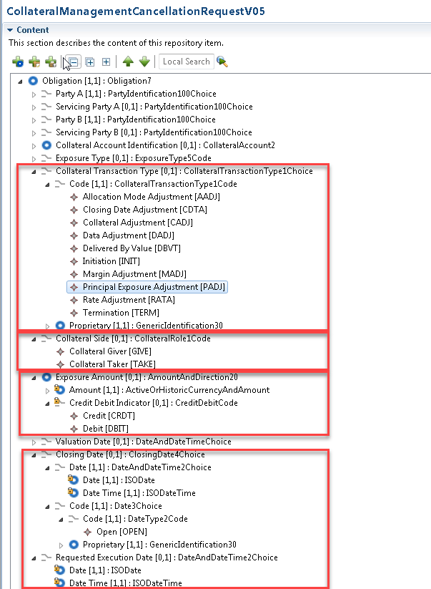

Valuation date changed to optional
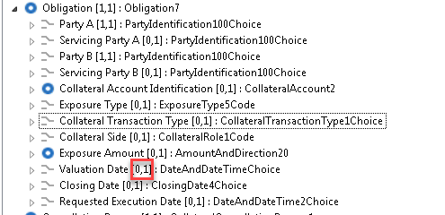

Removal of the transaction identification

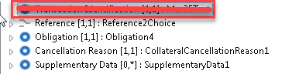

SEG/TSG recommendation:

Consider |  | X | Timing
 |  |  | - Next yearly cycle: 2020/2021  (the change will be considered for implementation in the yearly maintenance cycle which starts in 2020 and completes with the publication of new message versions in the spring of 2021) |  | X
- At the occasion of the next maintenance of the messages
(the change will be considered for implementation, but does not justify maintenance of the messages in its own right – will be pending until more critical change requests are received for the messages)
- Urgent unscheduled
(the change justifies an urgent implementation outside of the normal yearly cycle)
 |  |  | - Other timing:
Comments:

Reject
Reason for rejection:

Impact analysis and type of impact:
The impact of the change requested will be as described in the approved change request.

Proposed implementation:
The SEG ET supports the proposed implementation, as requested in this change request.

Addition of references
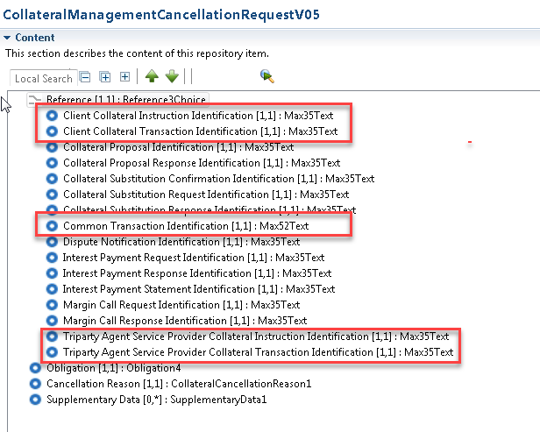

Valuation date changed to optional

Addition of elements in Obligation message component
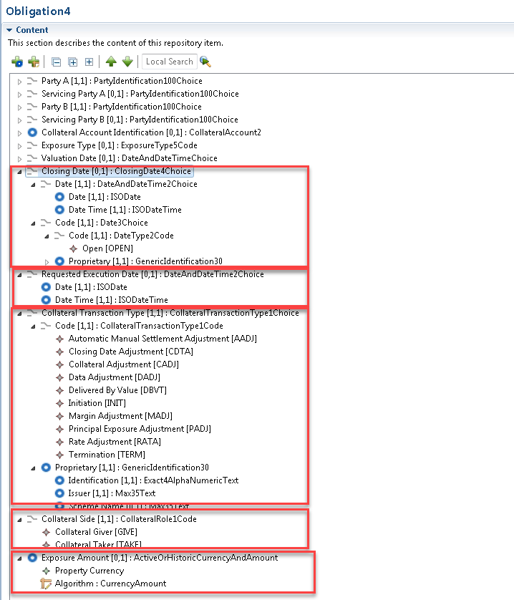

Removal of transaction identification

Proposed timing:
The submitting organisation confirms that it can implement the requested changes in the requested timing.

Timing | As requested SR 2021

Final decision of the SEG(s):

Approve | X
Comments:
The Single Collateral Management Rulebook for Europe (SCoRE) document must be updated to reflect the removal of the transaction identification message at the top of the message as this information (message identification) is included in the BAH head.001.

Reject
Reason for rejection:

