Maintenance Change Request
for the update of ISO 20022 financial repository items

Name of the request:
“ISO 20022 Payments Maintenance 2020/2021”

Submitting organisation(s):
SWIFT, on behalf of SWIFT, the GUF, TWIST and OAGi (ISTH), Pay.UK and the CBI consortium
Standards Department,
Avenue Adele, 1
1310 La Hulpe - Belgium

Related messages:

Under this maintenance, below existing ISO 20022 message definitions will be maintained (resulting from the impact analysis performed on each CR).

Bank Account Management message set:
- acmt.007.001.03 - AccountOpeningRequestV03
- acmt.008.001.03 - AccountOpeningAmendmentRequestV03

- acmt.014.001.03 - AccountReportV03

Bank-to-Customer Cash Management message set:
- camt.052.001.08 - BankToCustomerAccountReportV08
- camt.053.001.08 - BankToCustomerStatementV08
- camt.054.001.08 - BankToCustomerDebitCreditNotificationV08
- camt.060.001.05 - AccountReportingRequestV05
Bank Services Billing message set:
- camt.086.001.03 - BankServicesBillingStatementV03
Cash Management message set:

- camt.004.001.08 - ReturnAccountV08
- camt.005.001.08 - GetTransactionV08
- camt.006.001.08 - ReturnTransactionV08
- camt.008.001.08 - CancelTransactionV08

- camt.014.001.04 - ReturnMemberV04
- camt.017.001.04 - ReturnCurrencyExchangeRateV04
- camt.024.001.06 - ModifyStandingOrderV06
- camt.046.001.05 - GetReservationV05
- camt.047.001.06 - ReturnReservationV06
- camt.048.001.05 - ModifyReservationV05
- camt.049.001.05 - DeleteReservationV05
- camt.050.001.05 - LiquidityCreditTransferV05
- camt.051.001.05 - LiquidityDebitTransferV05
- camt.069.001.03 - GetStandingOrderV03
- camt.070.001.04 - ReturnStandingOrderV04
- camt.071.001.03 - DeleteStandingOrderV03

- camt.102.001.01 - CreateStandingOrderV01
- camt.103.001.01 - CreateReservationV01
Creditor Payment Activation Request message set:
- pain.013.001.08 - CreditorPaymentActivationRequestV08
- pain.014.001.08 - CreditorPaymentActivationRequestStatusReportV08
Exceptions and Investigations message set:
- camt.026.001.08 - UnableToApplyV08
- camt.027.001.08 - ClaimNonReceiptV08
- camt.028.001.10 - AdditionalPaymentInformationV10
- camt.029.001.10 - ResolutionOfInvestigationV10
- camt.037.001.08 - DebitAuthorisationRequestV08
- camt.055.001.09 - CustomerPaymentCancellationRequestV09
- camt.056.001.09 - FIToFIPaymentCancellationRequestV09
- camt.087.001.07 - RequestToModifyPaymentV07
Notification to Receive message set:
- camt.057.001.06 - NotificationToReceiveV06
- camt.058.001.06 - NotificationToReceiveCancellationAdviceV06
- camt.059.001.06 - NotificationToReceiveStatusReportV06
Payments Clearing and Settlement message set:
- pacs.002.001.11 - FIToFIPaymentStatusReportV11
- pacs.003.001.08 - FIToFICustomerDirectDebitV08
- pacs.004.001.10 - PaymentReturnV10
- pacs.007.001.10 - FIToFIPaymentReversalV10
- pacs.008.001.09 - FIToFICustomerCreditTransferV09
- pacs.009.001.09 - FinancialInstitutionCreditTransferV09
- pacs.010.001.04 - FinancialInstitutionDirectDebitV04
- pacs.028.001.04 - FIToFIPaymentStatusRequestV04
Payments Initiation message set:
- pain.001.001.10 - CustomerCreditTransferInitiationV10
- pain.002.001.11 - CustomerPaymentStatusReportV11
- pain.007.001.10 - CustomerPaymentReversalV10
- pain.008.001.09 - CustomerDirectDebitInitiationV09
Payments Mandates message set
- pain.009.001.06 - MandateInitiationRequestV06
- pain.010.001.06 - MandateAmendmentRequestV06
- pain.011.001.06 - MandateCancellationRequestV06
- pain.012.001.06 - MandateAcceptanceReportV06
- pain.017.001.02 - MandateCopyRequestV02
- pain.018.001.02 - MandateSuspensionRequestV02

Message sets impacted not under responsibility of SWIFT:
Please note that not all message sets are under the responsibility of SWIFT, and the RA contact the original submitting organisation of those messages set to confirm they intend to implement the changes in their respective message sets.
For those message sets, SWIFT cannot guarantee the submitting organisations will agree to implement the changes.
- Account Switching message set (under responsibility of Pay.UK):
- acmt.027.001.03 - AccountSwitchInformationRequestV03
- acmt.028.001.03 - AccountSwitchInformationResponseV03
- acmt.029.001.03 - AccountSwitchCancelExistingPaymentV03
- acmt.031.001.03 - AccountSwitchRequestBalanceTransferV03
- acmt.032.001.03 - AccountSwitchBalanceTransferAcknowledgementV03
- acmt.034.001.03 - AccountSwitchRequestPaymentV03
Note: SWIFT will implement the changes on behalf of the Pay.UK for this message set, if accepted.
- Change or Verify Account Identification message set (under the responsibility of the French GUF):
- acmt.022.001.02 – IdentificationModificationAdviceV02
- acmt.023.001.02 – IdentificationVerificationRequestV02
- acmt.024.001.02 – IdentificationVerificationReportV02
Note: SWIFT will implement the changes on behalf of the French GUF for this message set, if accepted.
- Creditor Payment Activation Request message set (under the responsibility of CBI consortium):
- pain.013.001.08 - CreditorPaymentActivationRequestV08
- pain.014.001.08 - CreditorPaymentActivationRequestStatusReportV08
Note: SWIFT will implement the changes on behalf of the CBI consortium for this message set, if accepted.
- Cross-Border Transactions Currency Control Reporting message set (under the responsibility of RU-CMPG):
- auth.018.001.02 - ContractRegistrationRequestV02
- auth.019.001.02 - ContractRegistrationConfirmationV02
- auth.021.001.02 - ContractRegistrationAmendmentRequestV02
- auth.022.001.02 - ContractRegistrationStatementV02
- auth.024.001.02 - PaymentRegulatoryInformationNotificationV02
- Stand-Alone Remittance Advice message set (under responsibility of IFX):
- remt.001.001.04 - RemittanceAdviceV04
Note: SWIFT will implement the changes on behalf of IFX for this message set, if accepted.
- Target2-Securities message sets (under responsibility of T2S):
- Administration:
- admi.005.001.01 - ReportQueryRequestV01
- Collateral Value:
- colr.001.001.01 - CollateralValueQueryV01
- colr.002.001.01 - CollateralValueReportV01
- Intrabalance Movements:
- camt.066.001.01 - IntraBalanceMovementInstructionV01
- camt.067.001.01 - IntraBalanceMovementStatusAdviceV01
- camt.068.001.01 - IntraBalanceMovementConfirmationV01
- camt.072.001.01 - IntraBalanceMovementModificationRequestV01
- camt.073.001.01 - IntraBalanceMovementModificationRequestStatusAdviceV01
- camt.074.001.01 - IntraBalanceMovementCancellationRequestV01
- camt.075.001.01 - IntraBalanceMovementCancellationRequestStatusAdviceV01
- camt.078.001.01 - IntraBalanceMovementQueryV01
- camt.079.001.01 - IntraBalanceMovementQueryResponseV01
- camt.080.001.01 - IntraBalanceMovementModificationQueryV01
- camt.081.001.01 - IntraBalanceMovementModificationReportV01
- camt.082.001.01 - IntraBalanceMovementCancellationQueryV01
- camt.083.001.01 - IntraBalanceMovementCancellationReportV01
- camt.084.001.01 - IntraBalanceMovementPostingReportV01
- camt.085.001.01 - IntraBalanceMovementPendingReportV01

SWIFT has already received following information for the maintenance of some of the message sets as following:

- Cross-Border Transactions Currency Control Reporting: the Russian Corporate Market Practice Group is currently working on a Fast Track MCR to include additional changes – we suggest that they include those changes with the updates requested for the Fast Track
- Target2-Securities messages – as the messages have just been finalised recently and no major release is planned for T2S, the change requests will be held over and will only be implemented when new changes are required based on new T2S business requirements, as no change request addresses explicitly the Target2-Securities message sets.

Commitments of the submitting organisation:

The submitting organisations confirm that they can and will:
- undertake the development of the new version of the candidate ISO 20022 message models that it will submit to the RA for compliance review and evaluation. New valid Message Definition models will be made available to the RA by December 1.
- provide a new version of part 1 of the related Message Definition Reports (MDR) by December 1, and new examples of valid message instances of each candidate message (only when valid samples were published for current version) by May 1 at the latest.
- address any queries related to the description of the new models and messages as published by the RA on the ISO 20022 website.

SWIFT intends to implement most of the above new versions on its SWIFTNet network once the related documentation has been published by the RA.

The submitting organisations confirm their knowledge and acceptance of the ISO 20022 Intellectual Property Rights policy for contributing organisations, as follows.
“Organisations that contribute information to be incorporated into the ISO 20022 Repository shall keep any Intellectual Property Rights (IPR) they have on this information. A contributing organisation warrants that it has sufficient rights on the contributed information to have it published in the ISO 20022 Repository through the ISO 20022 Registration Authority in accordance with the rules set in ISO 20022. To ascertain a widespread, public and uniform use of the ISO 20022 Repository information, the contributing organisation grants third parties a non-exclusive, royalty-free license to use the published information”.

Contact persons:
Vincent Kuntz – SWIFT Standards, vincent.kuntz@swift.com
Karin De Ridder – SWIFT Standards, karin.deridder@swift.com

Change request CR00822:
Modify cardinality of the Cash Account / Identification element

Origin of the request:
A.1 Submitter:
- CGI-MP Workgroup 1 (payments & status reports)
Please note that we consider this request not as a normal change request, because the addition of segment Proxy under the Account component was implemented in the ISO schema with a functional inconsistency. The use case for the corporate initiator of a payment to provide a proxy account ID instead of a traditional account number does not work with pain.001 V09. This topic is being discussed with SWIFT Standards team.
A.2 Contact person:
- WG1 convenor: kerstin.schoenwitz@db.com
Alternatively from WG1 during Kerstin’s vacation: Mike.Pawlisz@jpmchase.com
Please note that this change request was discussed with peter.hoogervorst@ca-cib.com.
A.3 Sponsors:
- CGI-MP community (several working groups, as we discussed in this XML corporate-to-bank industry group the move to ISO maintenance version 2019 for the usage guidelines of several message types (pain.001/002/008, camt.053/052/054 etc.)
Contacts: petra.kessner@baml.com, francois.lemaire@utsit.com

Related messages:
The list of ISO 20022 messages which would be impacted by the change, including the Message IDs as shown in the Catalogue of ISO 20022 messages. Only the latest version of a message definition can be maintained.
The submitter is invited to carefully examine whether the change may have an impact on other messages that come into play earlier or later in the transaction chain or on other messages that also use message components that this change request may impact.
Related messages:
- pain.001, pain.002, pain.008, pain.013, pain.014
- camt.053, camt.052, camt.054
- camt.086, camt.055, camt.029
- pacs.008, pacs.002, pacs.009 etc.

Description of the change request:
A change is required in the Account segments (e.g. DebtorAccount, CreditorAccount), i.e. Type CashAccount38.
The segment Identification (here e.g. under Creditor Account in the pain.001) needs to be corrected from status “mandatory” (1_1) into “optional” (0_1), in order to support the corporate use case for an account substitution scenario (using Proxy data).
The Proxy Identification is used in corporate related messages to provide a substitute account identifier, e.g. a mobile no. or email address, as a replacement for the traditional account number under Identification. Thus, Identification needs to be optional.
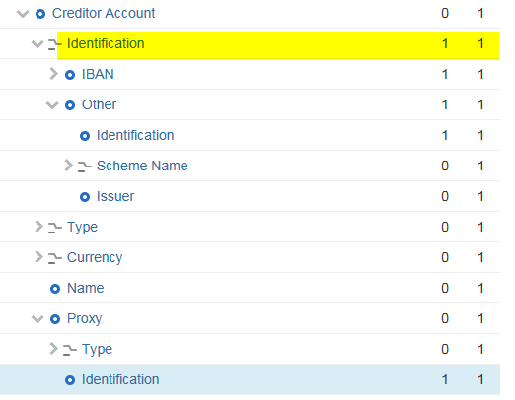

Purpose of the change:
Background, business context, community of users interested by the change and expected benefits/savings.
This section must explain why the existing ISO 20022 messages need to be changed. The reason for the update may be a business reason (e.g., evolution of market practice, or creation of new financial instruments), a technical reason (e.g., automation of the business process, or switch from a batch to a real time process), a regulatory reason (introduction, generally mandatory, of new rule/law) or the extension of the user community (newly identified business requirements).
This change is required to overcome a schema inconsistency and logical gap re. the introduction of the Proxy segment. The corporate use case as mentioned above was unfortunately ignored when designing ISO maintenance version 2019.
If a proxy account identifier shall be used by a party instead of the normal account identifier, then logically that normal account identifier cannot be mandatory.

Urgency of the request:
In the corporate to bank harmonization initiative CGI-MP the focus has been so far on ISO maintenance version 2009 for payment initiation, status, direct debit, and account statements. Now the plan is to shift to ISO 2019 maintenance version, driven by dedicated data tags for proxy identifiers, SWIFT gpi, requested execution date and time, and the ISO 20022 adoption in the interbank space with the opportunity to align messages and versions along the whole processing chain. However, with the perceived “bug” in the Account element for Proxy usage, the community would still need to apply format workarounds. Ultimately, the motivation in the community to move to latest ISO version would decrease.
Thus, this issue becomes a major roadblock for the upcoming alignment and end-to-end ISO 20022 workflows from corporate to clearing/interbank side.
Re. option of a workaround: The alternative to provide dummy data into tag IBAN or Other.Identification under Identification to fulfil mandatory status is not acceptable for corporates, as they do not have such logic in their systems to provide additional dummy data in a proxy scenario. Furthermore, banks run validations on the account data in the instruction. Therefore, a workaround to deal with the current schema in ISO 2019 maintenance version does not look feasible.
We have approached SWIFT Standards team in parallel to consider this issue as an urgent schema inconsistency (errata) to be resolved asap.

Business examples:
Examples illustrating the change request.
Below are some examples of markets where the service using proxy identifiers as replacement for beneficiary account numbers exists today.
- Singapore Paynow
- India UPI
- Thailand Prompt Pay
- Sweden Bankgiro
- Sweden SWISH payment (with mobile phone numbers)
- Denmark Clearing Creditor ID
- Hungary Instant Payment

SEG/TSG recommendation:

Consider |  | X | Timing
 |  |  | - Next yearly cycle: 2020/2021  (the change will be considered for implementation in the yearly maintenance cycle which starts in 2020 and completes with the publication of new message versions in the spring of 2021) |  | X
- At the occasion of the next maintenance of the messages
(the change will be considered for implementation, but does not justify maintenance of the messages in its own right – will be pending until more critical change requests are received for the messages)
- Urgent unscheduled
(the change justifies an urgent implementation outside of the normal yearly cycle)
 |  |  | - Other timing:
Comments:
This change request was initially submitted later after the deadline for the 2019/2020 maintenance cycle, but was considered by the Payments SEG.

Reject
Reason for rejection:

Impact analysis and type of impact:
Following the detailed analysis of the impact of the changes to the existing messages, we identified further impacted messages, compared to the list already proposed by the change request submitter.
The below list provides the full list of impacted messages per message set:
Account Switching message set:
- acmt.027.001.03 - AccountSwitchInformationRequestV03
- acmt.028.001.03 - AccountSwitchInformationResponseV03
- acmt.029.001.03 - AccountSwitchCancelExistingPaymentV03
- acmt.031.001.03 - AccountSwitchRequestBalanceTransferV03
- acmt.032.001.03 - AccountSwitchBalanceTransferAcknowledgementV03
- acmt.034.001.03 - AccountSwitchRequestPaymentV03
Bank Account Management message set:
- acmt.007.001.03 - AccountOpeningRequestV03
- acmt.008.001.03 - AccountOpeningAmendmentRequestV03

- acmt.014.001.03 - AccountReportV03

Bank-to-Customer Cash Management message set:
- camt.052.001.08 - BankToCustomerAccountReportV08
- camt.053.001.08 - BankToCustomerStatementV08
- camt.054.001.08 - BankToCustomerDebitCreditNotificationV08
- camt.060.001.05 - AccountReportingRequestV05
Bank Services Billing message set:
- camt.086.001.03 - BankServicesBillingStatementV03
Cash Management message set:

- camt.004.001.08 - ReturnAccountV08
- camt.005.001.08 - GetTransactionV08
- camt.006.001.08 - ReturnTransactionV08
- camt.008.001.08 - CancelTransactionV08

- camt.014.001.04 - ReturnMemberV04
- camt.024.001.06 - ModifyStandingOrderV06

- camt.050.001.05 - LiquidityCreditTransferV05
- camt.051.001.05 - LiquidityDebitTransferV05
- camt.069.001.03 - GetStandingOrderV03
- camt.070.001.04 - ReturnStandingOrderV04
- camt.071.001.03 - DeleteStandingOrderV03

- camt.102.001.01 - CreateStandingOrderV01

Change or Verify Account Identification message set:
- acmt.022.001.02 – IdentificationModificationAdviceV02
- acmt.023.001.02 – IdentificationVerificationRequestV02
- acmt.024.001.02 – IdentificationVerificationReportV02
Creditor Payment Activation Request message set:
- pain.013.001.08 - CreditorPaymentActivationRequestV08
- pain.014.001.08 - CreditorPaymentActivationRequestStatusReportV08
Cross-Border Transactions Currency Control Reporting message set:
- auth.018.001.02 - ContractRegistrationRequestV02
- auth.019.001.02 - ContractRegistrationConfirmationV02
- auth.021.001.02 - ContractRegistrationAmendmentRequestV02
- auth.022.001.02 - ContractRegistrationStatementV02
- auth.024.001.02 - PaymentRegulatoryInformationNotificationV02
Exceptions and Investigations message set:
- camt.026.001.08 - UnableToApplyV08
- camt.027.001.08 - ClaimNonReceiptV08
- camt.028.001.10 - AdditionalPaymentInformationV10
- camt.029.001.10 - ResolutionOfInvestigationV10
- camt.037.001.08 - DebitAuthorisationRequestV08
- camt.055.001.09 - CustomerPaymentCancellationRequestV09
- camt.056.001.09 - FIToFIPaymentCancellationRequestV09
- camt.087.001.07 - RequestToModifyPaymentV07
Notification to Receive message set:
- camt.057.001.06 - NotificationToReceiveV06
- camt.058.001.06 - NotificationToReceiveCancellationAdviceV06
- camt.059.001.06 - NotificationToReceiveStatusReportV06
Payments Clearing and Settlement message set:
- pacs.002.001.11 - FIToFIPaymentStatusReportV11
- pacs.003.001.08 - FIToFICustomerDirectDebitV08
- pacs.004.001.10 - PaymentReturnV10
- pacs.007.001.10 - FIToFIPaymentReversalV10
- pacs.008.001.09 - FIToFICustomerCreditTransferV09
- pacs.009.001.09 - FinancialInstitutionCreditTransferV09
- pacs.010.001.04 - FinancialInstitutionDirectDebitV04
- pacs.028.001.04 - FIToFIPaymentStatusRequestV04
Payments Initiation message set:
- pain.001.001.10 - CustomerCreditTransferInitiationV10
- pain.002.001.11 - CustomerPaymentStatusReportV11
- pain.007.001.10 - CustomerPaymentReversalV10
- pain.008.001.09 - CustomerDirectDebitInitiationV09
Payments Mandates message set
- pain.009.001.06 - MandateInitiationRequestV06
- pain.010.001.06 - MandateAmendmentRequestV06
- pain.011.001.06 - MandateCancellationRequestV06
- pain.012.001.06 - MandateAcceptanceReportV06
- pain.017.001.02 - MandateCopyRequestV02
- pain.018.001.02 - MandateSuspensionRequestV02
Stand-Alone Remittance Advice message set:
- remt.001.001.04 - RemittanceAdviceV04
Target2-Securities message sets:
- Administration:
- admi.005.001.01 - ReportQueryRequestV01
- Collateral Value:
- colr.001.001.01 - CollateralValueQueryV01
- colr.002.001.01 - CollateralValueReportV01
- Intrabalance Movements:
- camt.066.001.01 - IntraBalanceMovementInstructionV01
- camt.067.001.01 - IntraBalanceMovementStatusAdviceV01
- camt.068.001.01 - IntraBalanceMovementConfirmationV01
- camt.072.001.01 - IntraBalanceMovementModificationRequestV01
- camt.073.001.01 - IntraBalanceMovementModificationRequestStatusAdviceV01
- camt.074.001.01 - IntraBalanceMovementCancellationRequestV01
- camt.075.001.01 - IntraBalanceMovementCancellationRequestStatusAdviceV01
- camt.078.001.01 - IntraBalanceMovementQueryV01
- camt.079.001.01 - IntraBalanceMovementQueryResponseV01
- camt.080.001.01 - IntraBalanceMovementModificationQueryV01
- camt.081.001.01 - IntraBalanceMovementModificationReportV01
- camt.082.001.01 - IntraBalanceMovementCancellationQueryV01
- camt.083.001.01 - IntraBalanceMovementCancellationReportV01
- camt.084.001.01 - IntraBalanceMovementPostingReportV01
- camt.085.001.01 - IntraBalanceMovementPendingReportV01

Proposed implementation:
We support the proposed implementation, but following further exchanges with the CGI-MP WG1, we agreed to extend the length of the Identification/Other/Identification to Max256Text to support the identification of an account through an e-mail address or a phone number (those are new business cases to allow for the identification of an account through those types of identification – which are different from a proxy identification).
The updates will result in the following structure:
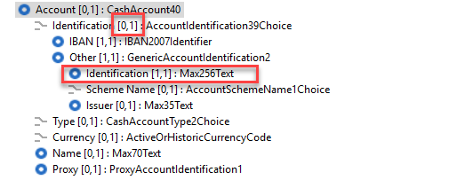

Proposed timing:
The submitting organisation confirms that it can implement the requested changes in the requested timing.

Timing | As requested

Final decision of the SEG(s):

Approve | X
Comments:
Following the initial assessment of the updated implementation proposal, the Payments SEG rejected the increase of the length of the Other/Id from Max34Text to Max256Text. Therefore, following exchanges with the submitter of the change request (CGI-MP WG1), we have submitted a new implementation proposal, which has been approved by the SEG as following:
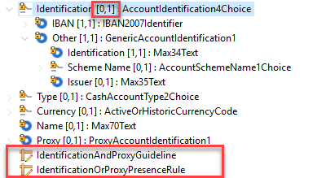
New updated proposal:
- Make Identification optional (as initially requested by CGI-MP), without changing the underlying data type
- Add a new rule IdentificationOrProxyPresenceRule, to mandate the presence of Identification or Proxy (both may be present)
- Add a new guideline IdentificationAndProxyGuideline, to indicate that if the account identification is defined through a non conventional identification such as an email address or a mobile number, then the proxy element should be used for the identification of the account.
The Payments SEG endorsed this proposal during the November 2020 monthly call.

Reject
Reason for rejection:

Change request CR00832:
Update CAI/VAI messages with approved Payments SEG changes

Origin of the request:
A.1 Submitter: Mastercard.
A.2 Contact person:
Heike Strasser (Director, Product Architecture) – heike.strasser@mastercard.com
tel +44(0)203 818 4364 | mobile +44(0)781 4681510
A.3 Sponsors:

Related messages:
- Identification Modification – acmt.022
- Identification Verification Request – acmt.023
- Identification Verification Report – acmt.024

Description of the change request:
For the Modification Advice and Verification Identification it is beneficial that the newly adapted element for proxy / alias information introduced in the 2019 Version to be used for account information.
Existing – AccountIdentification4Choice
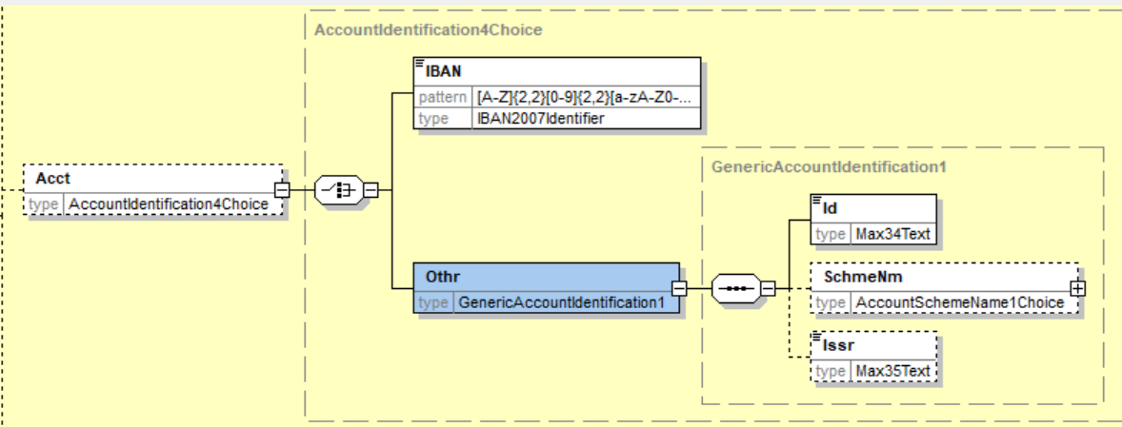
New (replaced) – CashAccount38
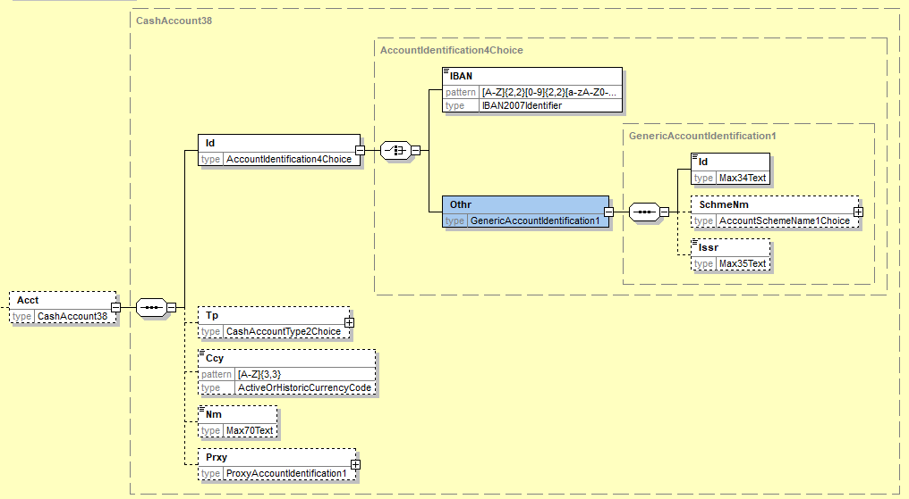
acmt.022
Existing
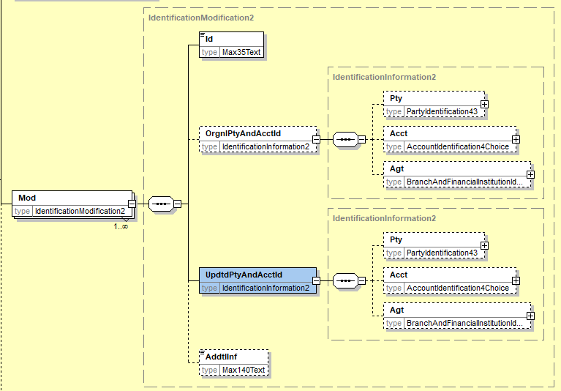
New
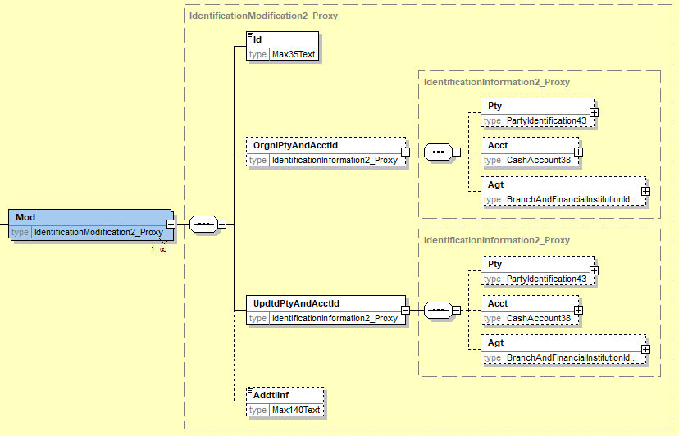

acmt.023
Existing
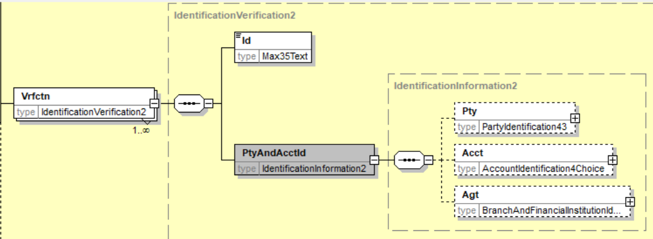

New
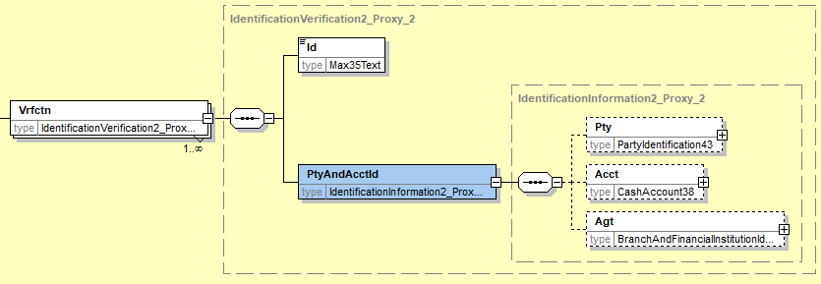
acmt.024
Existing

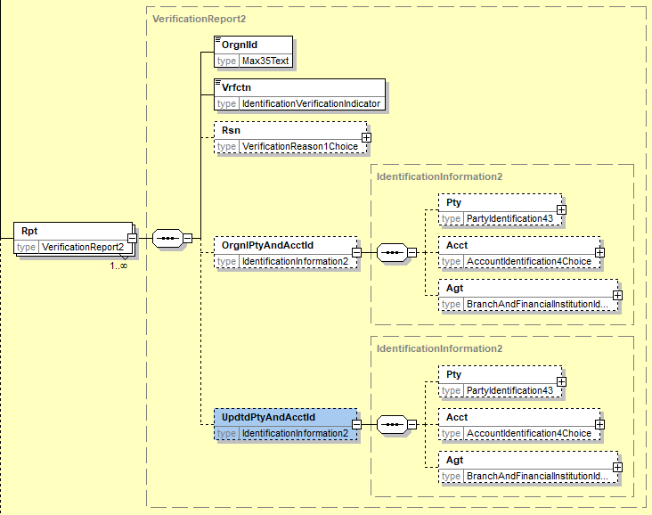
New
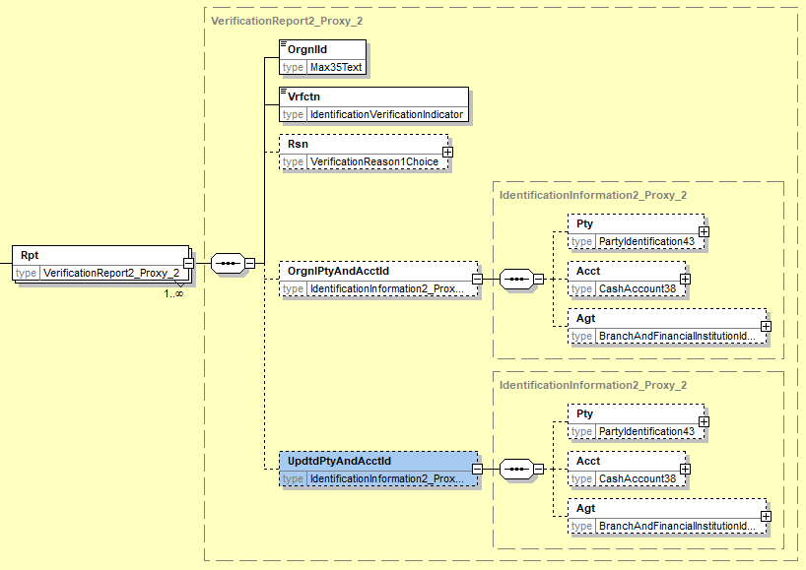

Purpose of the change:
The adaptation for the CashAccount38 in the 2019 versions for payments is being established in different regions. Closely linked to payment are automatically functions to inform the sender about changes in the account details (mainly account holder). With the new introduction of the proxy/alias information some of these updates are now linked to these new additional data fields. With the existing set of acmt.022/023 and 024 there are no relevant fields available.

Urgency of the request:
Request to be implemented in the next ISO release

Business examples:
Credit Transfer – pacs.008 – was executed with information of account details with proxy information. The creditor agent accepted the payment with information to the debtor agent that the proxy information was updated.

pacs.008 with proxy:
<ct:MsgId>M2020030200110011BTRF00000000011</ct:MsgId>
<ct:CreDtTm>2020-03-02T10:05:00</ct:CreDtTm>
:
:
<ct:DbtrAcct>
<ct:Id>
<ct:Othr>
<ct:Id>01196000999999999999</ct:Id>
</ct:Othr>
</ct:Id>
<ct:Prxy>
<ct:Tp>
<ct:Cd>EMAL</ct:Cd>
</ct:Tp>
<ct:Id>maxmuster@info.com</ct:Id>
</ct:Prxy>
</ct:DbtrAcct>

Modification Information acmt.022 with proxy:
<OrgnlTxRef>
<MsgId>M2020030200110011BTRF00000000011</MsgId>
<MsgNmId>pacs.008.001.08</MsgNmId>
<CreDtTm>2020-03-02T10:05:00</CreDtTm>

<Mod>
<Id>2020030300550055BACVR0000001</Id>
<OrgnlPtyAndAcctId>
<Pty>
<Nm>Max Muster</Nm>
<PstlAdr>
</Pty>
<Acct>
<Id>
<Othr>
<Id>01196000999999999999</Id>
</Othr>
</Id>
<Prxy>
<Tp>
<Cd>EMAL</Cd>
</Tp>
<Id>maxmuster@info.com</Id>
</Prxy>
</Acct>
</OrgnlPtyAndAcctId>
<UpdtdPtyAndAcctId>
<Pty>
<Nm>Max Muster-Smith</Nm>
</Pty>
<Acct>
<Id>
<Othr>
<Id>01196000999999999999</Id>
</Othr>
</Id>
<Prxy>
<Tp>
<Cd>EMAL</Cd>
</Tp>
<Id>max@muster-smith.com</Id>
</Prxy>
</Acct>
</UpdtdPtyAndAcctId>

SEG/TSG recommendation:
This section is not to be taken care of by the submitter of the change request. It will be completed in due time by the SEG(s) in charge of the related ISO 20022 messages or the TSG for changes related to the BAH.

Consider |  | X | Timing
 |  |  | - Next yearly cycle: 2020/2021  (the change will be considered for implementation in the yearly maintenance cycle which starts in 2018 and completes with the publication of new message versions in the spring of 2019) |  | X
- At the occasion of the next maintenance of the messages
(the change will be considered for implementation, but does not justify maintenance of the messages in its own right – will be pending until more critical change requests are received for the messages)
- Urgent unscheduled
(the change justifies an urgent implementation outside of the normal yearly cycle)
 |  |  | - Other timing:
Comments:

Reject
Reason for rejection:

Impact analysis and type of impact:
Following the detailed analysis of the impact of the changes to the existing messages, we have not identified further impacted messages, compared to the list already requested by the change request submitter.

The below list provides the full list of impacted messages per message set:
Change or Verify Account Identification message set:
- acmt.022.001.02 – IdentificationModificationAdviceV02
- acmt.023.001.02 – IdentificationVerificationRequestV02
- acmt.024.001.02 – IdentificationVerificationReportV02

Proposed implementation:
We support the request to finalise the messages, however, we propose to align the messages with the implementation of the new component as defined above in CR 822 – Proposed implementation:

Proposed timing:
The submitting organisation confirms that it can implement the requested changes in the requested timing.

Timing | As requested

Final decision of the SEG(s):

Approve | X
Comments:
Sylvain Dauge will consult the GUF to have their feedback and will get back to the SEG.
6 October 2020: Positive feedback from the GUF – no objections against the approval of the CR.

Reject
Reason for rejection:

Change request CR00833:
Update ModifyReservation message.

Origin of the request:
A.1 Submitter:
- CMA Small Systems AB
A.2 Contact person:
- E-mail: denis.smirnov@cma.ru
- Phone: +46 8 566 30 800
A.3 Sponsors: N/A

Related messages:

- camt.046 Get Reservation

Description of the change request:
Request change element type in camt.046 /Document/GetRsvatn/RsvatnQryDef/RsvatnCrit/NewCrit/SchCrit/CurRsvatnTp from ReservationType1Code to ReservationType1Choice to comply with related element in camt.047 “Return reservation” message and possibility to use Proprietary codes when requesting reserve.

Current type:
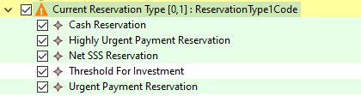

Requested type (like in camt.047):
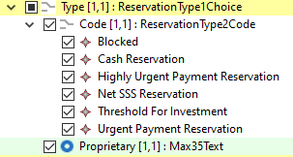

Proposed definition:
“Nature of the reservation.”

Purpose of the change:
Introduction of possibility to use Proprietary codes of Reservation type.

Urgency of the request:
Request can be supported in a new maintenance release.

Business examples:
As per current business schema.

SEG/TSG recommendation:

Consider |  | X | Timing
 |  |  | - Next yearly cycle: 2020/2021  (the change will be considered for implementation in the yearly maintenance cycle which starts in 2018 and completes with the publication of new message versions in the spring of 2019) |  | X
- At the occasion of the next maintenance of the messages
(the change will be considered for implementation, but does not justify maintenance of the messages in its own right – will be pending until more critical change requests are received for the messages)
- Urgent unscheduled
(the change justifies an urgent implementation outside of the normal yearly cycle)
 |  |  | - Other timing:
Comments:

Reject
Reason for rejection:
  - Impact analysis and type of impact:
Following the detailed analysis of the impact of the changes to the existing messages, we have not identified further impacted messages, compared to the list already proposed by the change request submitter.

Impact analysis and type of impact:
The below list provides the full list of impacted messages per message set:
Cash Management message set:
- camt.046.001.05 – GetReservationV05

Proposed implementation:
We support the proposed changes, as this change is an alignment with the other reservation messages, in which this change had already been applied:
The resulting structure is as follows:
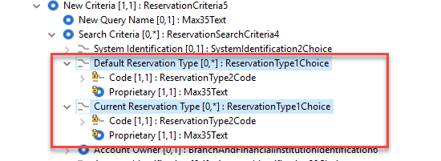
We will reuse the same definition as in the existing Reservation messages, where this component is already present.

Proposed timing:
The submitting organisation confirms that it can implement the requested changes in the requested timing.

Timing | As requested

Final decision of the SEG(s):

Approve | X
Comments: Decision made at September 28th meeting.

Reject
Reason for rejection:

Change request CR00834:
Add original status request reference in pacs.002

Origin of the request:
A.1 Submitter:
- CMA Small Systems AB
A.2 Contact person:
- E-mail: denis.smirnov@cma.ru
- Phone: +46 8 566 30 800
A.3 Sponsors:
- Central Bank of the Republic of Azerbaijan (Instant Payments System project team).

Related messages:
- pacs.002.001.11 FIToFIPaymentStatusReportV11

Description of the change request:
Request to add the following new optional element to pacs.002:
- /Document/GrpHdr/OrgnlBizQry

Datatype: OriginalBusinessQuery1 defined as following:
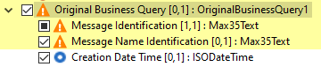

Proposed definition:
“Unique identification, as assigned by the original requestor, to unambiguously identify the business query message.”

Purpose of the change:
When payment status is requested by sending pacs.028 query message pacs.002 message generated in response does not contain within business contents any reference to the original request. Currently linkage is possible only by filling AppHdr/Rltd section, which is not enough i.e. for guaranteed mapping from MX to related MT message type.

The new optional element will be filled by receiving party in order to provide reference to the original request on which the response in generated.

Urgency of the request:
Request can be supported in a new maintenance release.

Business examples:
The following payment flow illustrates the messaging between two direct participants.

## | Description | Message type
1 | Participant 1 sends payment status request | Pacs.028
2 | Participant 2 processes message and checks
3 | Participant 2 sends payment status message to query sender | Pacs.002

Request to get payment status

<Document xmlns="urn:iso:std:iso:20022:tech:xsd:pacs.028.001.03">
<FIToFIPmtStsReq>
<GrpHdr>
<!--Query message unique reference -->
<MsgId>Q180217100120000001235</MsgId>
<!-- Message creation local date time -->
<CreDtTm>2018-01-14T14:08:48.232</CreDtTm>
</GrpHdr>
<OrgnlGrpInf>
<!--Original payment message unique reference -->
<OrgnlMsgId>M180217100120000001230</OrgnlMsgId>
<!--Original payment message type -->
<OrgnlMsgNmId>pacs.008.001.08</OrgnlMsgNmId>
<!--Original payment message creation date time -->
<OrgnlCreDtTm>2018-01-14T10:40:40.232</OrgnlCreDtTm>
</OrgnlGrpInf>
<TxInf>
<!--Transaction identifier as in original payment message -->
<OrgnlTxId>180217100120000001230</OrgnlTxId>
<InstgAgt>
<FinInstnId>
<!--Original payment sender participant. -->
<BICFI>TESTSW2X</BICFI>
</FinInstnId>
</InstgAgt>
<OrgnlTxRef>
<!-- Original payment settlement date -->
<IntrBkSttlmDt>2018-01-14</IntrBkSttlmDt>
</OrgnlTxRef>
</TxInf>
</FIToFIPmtStsReq>
</Document>

Payment status reply on request to get payment status

<Document xmlns="urn:iso:std:iso:20022:tech:xsd:pacs.002.001.10">
<FIToFIPmtStsRpt>
<GrpHdr>
<!--Unique message identifier-->
<MsgId>ME180217000010000001230</MsgId>
<!--Message creation local date time -->
<CreDtTm>2018-01-14T14:08:50.452</CreDtTm>
<OrgnlBizQry>
<!--Original request message identifier-->
<MsgId>Q180217100120000001235</MsgId>
<!--Type of original request message -->
<OrgnlMsgNmId>pacs.028.001.03</OrgnlMsgNmId>
<!--Original request creation local date time -->
<CreDtTm>2018-01-14T14:08:49.232</CreDtTm>
</OrgnlBizQry>
</GrpHdr>
<OrgnlGrpInfAndSts>
<!--As taken from pacs.008 FIToFICstmrCdtTrf/GrpHdr/MsgId -->
<OrgnlMsgId>M180217100120000001230</OrgnlMsgId>
<!--Type of original message to refer -->
<OrgnlMsgNmId>pacs.008.001.08</OrgnlMsgNmId>
<!--As taken from pacs.008 FIToFICstmrCdtTrf/GrpHdr/CreDtTm -->
<OrgnlCreDtTm>2018-01-14T10:40:40.232</OrgnlCreDtTm>
<!--Transaction processing result. -->
<GrpSts>ACSP</GrpSts>
</OrgnlGrpInfAndSts>
<TxInfAndSts>
<!--As taken from pacs.008 FIToFICstmrCdtTrf/CdtTrfTxInf/PmtId/EndToEndId -->
<OrgnlEndToEndId>NO34347438583</OrgnlEndToEndId>
<!--As taken from pacs.008 FIToFICstmrCdtTrf/CdtTrfTxInf/PmtId/TxId -->
<OrgnlTxId>180217100120000001230</OrgnlTxId>
<!--Transaction processing result. -->
<TxSts>ACSP</TxSts>
<!--Instructed agent. Participant who’s receiving payment status message. -->
<InstdAgt>
<FinInstnId>
<BICFI>TESTSW2X </BICFI>
</FinInstnId>
</InstdAgt>
<OrgnlTxRef>
<!-- Original payment amount and currency -->
<IntrBkSttlmAmt Ccy="SEK">71.12</IntrBkSttlmAmt>
<!--Settlement date of original payment -->
<IntrBkSttlmDt>2018-01-14</IntrBkSttlmDt>
</OrgnlTxRef>
</TxInfAndSts>
</FIToFIPmtStsRpt>
</Document>

On acceptance of pacs.002 message having new GrpHdr/OrgnlBizQry element participant will know that it this message was generated based on request sent previously and link this response with original request. Otherwise, it is not possible to distinguish by Document element contents if pacs.002 was generated independently or based on request sent earlier.

SEG/TSG recommendation:

Consider |  | X | Timing
 |  |  | - Next yearly cycle: 2020/2021  (the change will be considered for implementation in the yearly maintenance cycle which starts in 2018 and completes with the publication of new message versions in the spring of 2019) |  | X
- At the occasion of the next maintenance of the messages
(the change will be considered for implementation, but does not justify maintenance of the messages in its own right – will be pending until more critical change requests are received for the messages)
- Urgent unscheduled
(the change justifies an urgent implementation outside of the normal yearly cycle)
 |  |  | - Other timing:
Comments:

Reject
Reason for rejection:

Impact analysis and type of impact:
Following the detailed analysis of the impact of the changes to the existing messages, we have not identified further impacted messages, compared to the list already proposed by the change request submitter.
The below list provides the full list of impacted messages per message set:
Payments Clearing and Settlement message set:
- pacs.002.001.11 – FIToFIPaymentStatusReportV11

Proposed implementation:
We support the proposed changes, through the reuse of the existing OriginalBusinessQuery element present in other message headers which will result in the following update:
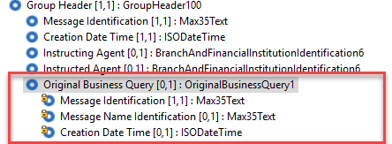

Proposed timing:
The submitting organisation confirms that it can implement the requested changes in the requested timing.

Timing | As requested

Final decision of the SEG(s):

Approve | X
Comments: Decision made at September 28th meeting.

Reject
Reason for rejection:

Change request CR00848:
Update description of previous Instructing agents

Origin of the request:
A.1 Submitter: SWIFT
A.2 Contact person: Neil Buchan, neil.buchan@swift.com +442077622135
A.3 Sponsors: None

Related messages:
- pacs.004.001.10 PaymentReturnV10
- pacs.008.001.09 FIToFICustomerCreditTransferV09
- pacs.009.001.09 FinancialInstitutionCreditTransferV09

Description of the change request:
Update the description of Previous Instructed Agent 2 and Previous Instructed Agent 3. And include an additional textual Usage guidance description to the Previous Instructing Agent 1, Previous Instructing Agent 2, and Previous Instructing Agent 3 elements.
This will align these Previous Instructing Agents with the description of Intermediary Agents.

Purpose of the change:
Amend the description of Previous Instructing Agent 2 and Previous Instructing Agent 3 to “Agent between the Debtor Agent and instructing agent”

Add the following Usage description:
- Previous Instructing Agent 1
“Usage: If more than one Previous Instructing Agent is present, then Previous Instructing Agent 1 identifies the Agent between the Debtor Agent and Previous Instructing Agent 2”
- Previous Instructing Agent 2
“Usage: If more than two Previous Instructing Agent are present, then Previous Instructing Agent 2 identifies the Agent between the Previous Instructing Agent 1 and Previous Instructing Agent 3”
- Previous Instructing Agent 3
“Usage: If Previous Instructing Agent 3 is present, then it identifies the Agent between the Previous Instructing Agent 2 and the Instructing Agent”

Urgency of the request:
Request can be supported in a future message version

Business examples:
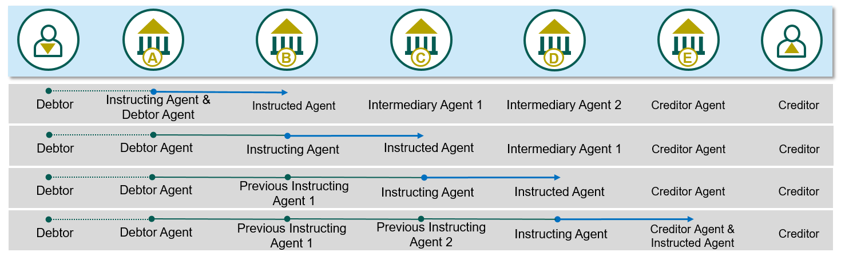

SEG/TSG recommendation:

Consider |  | X | Timing
 |  |  | - Next yearly cycle: 2020/2021  (the change will be considered for implementation in the yearly maintenance cycle which starts in 2018 and completes with the publication of new message versions in the spring of 2019) |  | X
- At the occasion of the next maintenance of the messages
(the change will be considered for implementation, but does not justify maintenance of the messages in its own right – will be pending until more critical change requests are received for the messages)
- Urgent unscheduled
(the change justifies an urgent implementation outside of the normal yearly cycle)
 |  |  | - Other timing:
Comments:

Reject
Reason for rejection:

Impact analysis and type of impact:
Following the detailed analysis of the impact of the changes to the existing messages, we identified one further impacted message.
The below list provides the full list of impacted messages per message set:
Payments Clearing and Settlement message set:
- pacs.004.001.10 PaymentReturnV10
- pacs.008.001.09 FIToFICustomerCreditTransferV09
- pacs.009.001.09 FinancialInstitutionCreditTransferV09
Exceptions and Investigations message set:
- camt.028.001.10 AdditionalPaymentInformationV10

Proposed implementation:
We support the proposed implementation as requested in this change request.
As a result the definitions for each instance of the Previous Instructing Agent 1, 2 and 3 will be extended with the proposed usage for all messages identified in the above impact analysis section, with following Usage text added to each definition, as well as the update of the definitions as proposed for all 3 agents:
- PreviousInstructingAgent1
Agent between the debtor's agent and the instructing agent.
Usage: If more than one previous instructing agent is present, then PreviousInstructingAgent1 identifies the agent between the DebtorAgent and the PreviousInstructingAgent2.
- PreviousInstructingAgent2
Agent between the debtor's agent and the instructing agent.
Usage: If more than two previous instructing agent are present, then PreviousInstructingAgent2 identifies the agent between the PreviousInstructingAgent1 and the PreviousInstructingAgent3.
- PreviousInstructingAgent3
Agent between the debtor's agent and the instructing agent.
Usage: If PreviousInstructingAgent3 is present, then PreviousInstructingAgent3 identifies the agent between the PreviousInstructingAgent2 and the InstructingAgent.

Proposed timing:
The submitting organisation confirms that it can implement the requested changes in the requested timing.

Timing | As requested

Final decision of the SEG(s):

Approve | X
Comments:

Reject
Reason for rejection:

Change request CR00858:
Add high and low limit elements on exchange rates

Origin of the request:
A.1 Submitter:
- China Foreign Exchange Trade System
A.2 Contact person:
- HuBingbing，hubingbing_zh@chinamoney.com.cn，021-38585653
A.3 Sponsors:
- China Foreign Exchange Trade System

Related messages:
- camt.017.001.04 ReturnCurrencyExchangeRate

Description of the change request:
Request to add the following new optional element to camt.017，the new elements are: Exchange Rate High Limit and Exchange Rate low Limit.
- Exchange Rate High Limit
Path:
/Document/RtrCcyXchgRate/RptOrErr/CcyXchgRpt/CcyXchgOrErr/CcyXchg/ XchgRateHiLmt
Datatype:
Percentage Rate [0..1]
Proposed definition:
“The currency authority publishes the exchange rate based on the price formed in the foreign exchange market, allowing it to float up and down within the prescribed fluctuation range. It is the highest exchange rate supported in foreign exchange market transactions.”
- Exchange Rate Low Limit
Path:
/Document/RtrCcyXchgRate/RptOrErr/CcyXchgRpt/CcyXchgOrErr/CcyXchg/ XchgRateLowLmt
Datatype:
PercentageRate [0,1]
Proposed definition:
“The currency authority publishes the exchange rate based on the price formed in the foreign exchange market, allowing it to float up and down within the prescribed fluctuation range. It is the lowest exchange rate supported in foreign exchange market transactions.”

Purpose of the change:
Currency authorities publish exchange rates based on prices formed in the foreign exchange market. It needs to limit exchange rate fluctuations in settlement,sales and foreign exchange operations. Therefore, it is necessary to add the exchange rate high limit and exchange rate low limit elements in the camt.017 message.

Urgency of the request:
Subject to normal maintenance cycle.

Business examples:
There is no exchange rate high limit and exchange rate low limit on CAMT.017 message:
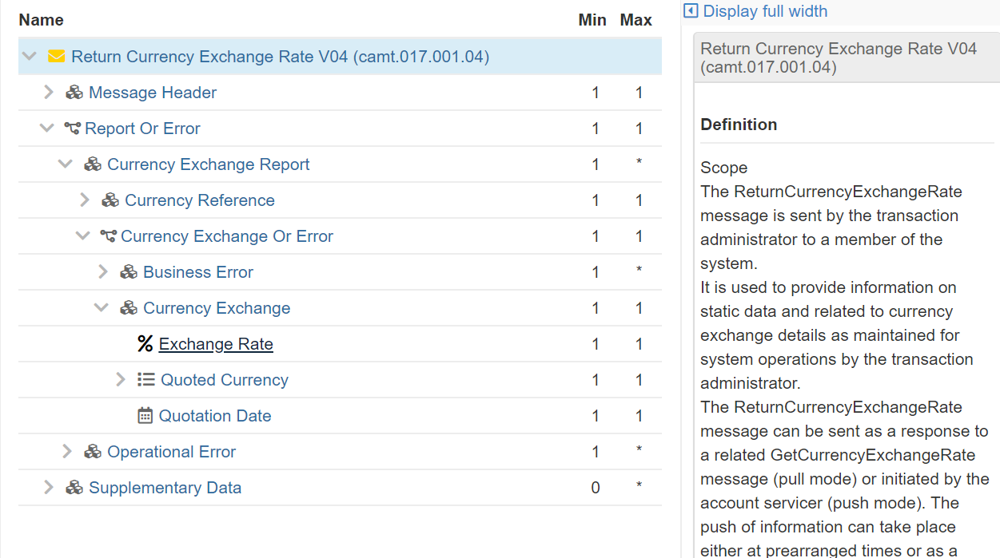

SEG/TSG recommendation:
This section is not to be taken care of by the submitter of the change request. It will be completed in due time by the SEG(s) in charge of the related ISO 20022 messages or the TSG for changes related to the BAH.

Consider |  | X | Timing
 |  |  | - Next yearly cycle: 2020/2021  (the change will be considered for implementation in the yearly maintenance cycle which starts in 2018 and completes with the publication of new message versions in the spring of 2019) |  | X
- At the occasion of the next maintenance of the messages
(the change will be considered for implementation, but does not justify maintenance of the messages in its own right – will be pending until more critical change requests are received for the messages)
- Urgent unscheduled
(the change justifies an urgent implementation outside of the normal yearly cycle)
 |  |  | - Other timing:

Comments:

Reject
Reason for rejection:

Impact analysis and type of impact:
Following the detailed analysis of the impact of the changes to the existing messages, we have not identified further impacted messages, and confirm the impact as specified by the change request submitter.
The below list provides the full list of impacted messages per message set:
Cash Management message set:
- camt.017.001.04 - ReturnCurrencyExchangeRateV04

Proposed implementation:
We support the request with a slightly modified implementation proposal to comply with the ISO 20022 modelling rules as following:
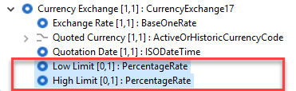
With following definitions:
- Low Limit:
Lowest limit defined for the exchange rate.
Usage: The currency authority publishes the exchange rate based on the price formed in the foreign exchange market, allowing it to float up and down within the prescribed fluctuation range. It is the lowest exchange rate supported in foreign exchange market transactions.
- High Limit:
Highest limit defined for the exchange rate.
Usage: The currency authority publishes the exchange rate based on the price formed in the foreign exchange market, allowing it to float up and down within the prescribed fluctuation range. It is the highest exchange rate supported in foreign exchange market transactions.

Question to the SEG and the submitter: the High and Low Limit for the exchange rate have been requested to be defined as a percentage rate, does this mean that:
- Option1: the limits are expressed as a percentage of the ExchangeRate (example LowLimit defined as 90% of the ExchangeRate, so when ExchangeRate is 1,40 and LowLimit equals 90%, the lowest rate allowed is 1,26),
- Option2: should the High and Low limits be defined with a BaseOneRate, expressing an absolute value of the exchange rate (in the same example LowLimit would be defined explicitly as 1,26 and NOT as a percentage of the ExchangeRate element).
We would recommend to go with the second option, or alternatively we could define the two elements as a choice between the absolute value typed by BaseOneRate or a percentage rate typed by the PercentageRate (with clear definitions clarifying the use).
The alternative solution would result in the following implementation:
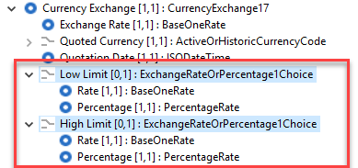

Proposed timing:
The submitting organisation confirms that it can implement the requested changes in the requested timing.

Timing | As requested

Final decision of the SEG(s):

Approve | X
Comments:

Reject
Reason for rejection:

Change request CR00906:
Add payment type in the PaymentReturn message

Origin of the request:
A.1 Submitter: Payments Canada
A.2 Contact persons:
- Malene McMahon – mmcmahon@payments.ca (+1 613 315 4991)
- Isak Penttila – ipenttila@payments.ca (+1 613 315 4075)
- Mike Hoganson – mhoganson@payments.ca (+1613 298 8087)
A.3 Sponsors: None

Related messages:
- pacs.004 Payment Return

Description of the change request:
The new high value payments system in Canada (Lynx) will implement ISO 20022 messages (including pacs.008, pacs.009 and pacs.004) in late 2022. Lynx makes use of the Local Instrument element in the Payment Type component to indicate the settlement mechanism and priority for the payment in Lynx.
Lynx makes use of a liquidity savings mechanism (LSM) and indicating the priority for the LSM is a critical aspect of the payment. The settlement mechanism itself indicates which pool of liquidity (or reserve collateral) should be used for a particular settlement. Every payment that settles in Lynx (including return payments) must indicate which settlement mechanism is to be used (and, if LSM is used, which priority should be given to the settlement).
Unfortunately, the pacs.004 does not contain this information for the payment return settlement. The information from the original pacs.008 or pacs.009 payment can be provided in the Original Transaction Reference/Payment Type/Local Instrument, but this does not allow the sender of the Payment Return to use a different liquidity pool (or priority) for the return payment.
Since Local Instrument is part of the optional Payment Type component, we are requesting that the entire optional Payment Type component be added to the pacs.004 in the Transaction Information component, just below all the ‘original’ information (see illustration in section F below).
We have come up with a work around for this functionality in the pacs.004 that we would prefer not to have to implement if we can have a new optional Payment Type/Local Instrument added that refers to the settlement of the payment return.

Purpose of the change:
While a pacs.004 is indeed the return of a specific pacs.008 or pacs.009, the use of a settlement mechanism and priority are mandatory for all Lynx settlements (payments as well as payment returns). The use of different settlement mechanisms is core to the Lynx functionality and the settlement of a payment return is the same as the settlement of a pacs.008 and pacs.009 (debits and credits are still posted to the central bank accounts of the settlement agents).
The work around we have come up with is to use the Local Instrument element in the Original Transaction Reference component in the pacs.004 as the ‘new’ Local Instrument for the payment return (instead of referring back to the original Local Instrument content). We don’t like mis-using the element like this and would prefer that the pacs.004 had its own Local Instrument element. If a mistake is made with this workaround, the wrong settlement mechanism could be used and this might result in a rejected payment in Lynx.

Urgency of the request:
Next release.

Business examples:
Examples illustrating the change request.
Current pacs.004 | Proposed pacs.004
> Group Header | > Group Header
> Original Group Information | > Original Group Information
v Transaction Information | v Transaction Information
- Return Identification | - Return Identification
- Original Group Information | - Original Group Information
- Original Instruction Identification | - Original Instruction Identification
- Original End To End Identification | - Original End To End Identification
- Original Transaction Identification | - Original Transaction Identification
- Original UETR | - Original UETR
- Original Clearing System Reference | - Original Clearing System Reference
- Original Interbank Settlement Amount | - Original Interbank Settlement Amount
- Original Interbank Settlement Date | - Original Interbank Settlement Date
- Returned Interbank Settlement Amount | v Payment Type
- Interbank Settlement Date | - Instruction Priority
- Settlement Priority | - Clearing Channel
- Settlement Time Indication | - Service Level
- Returned Instructed Amount | - Local Instrument
- …….. | - Category Purpose
 | - Returned Interbank Settlement Amount
 | - Interbank Settlement Date
 | - Settlement Priority
 | - Settlement Time Indication
 | - Returned Instructed Amount
 | - ……..

SEG/TSG recommendation:

Consider |  | X | Timing
 |  |  | - Next yearly cycle: 2020/2021  (the change will be considered for implementation in the yearly maintenance cycle which starts in 2020 and completes with the publication of new message versions in the spring of 2021) |  | X
- At the occasion of the next maintenance of the messages
(the change will be considered for implementation, but does not justify maintenance of the messages in its own right – will be pending until more critical change requests are received for the messages)
- Urgent unscheduled
(the change justifies an urgent implementation outside of the normal yearly cycle)
 |  |  | - Other timing:
Comments:

Reject
Reason for rejection:

Impact analysis and type of impact:
Following the detailed analysis of the impact of the changes to the existing messages, we identified no further impacted messages.
The below list provides the full list of impacted messages per message set:
Payments Clearing and Settlement message set:
- pacs.004.001.10 – PaymentReturnV10

Proposed implementation:
We support the proposed implementation, as specified in this change request, with an update to the definition to clarify that this is the PaymentTypeInformation that is applied on the PaymentReturn message.
Following further consultation with the submitter of the change request, we agreed to extend and align the pacs.004 with the pasc.008 logic, and include the PaymentTypeInformation at both GroupHeader and TransactionInformation levels, with the same rule PaymentTypeInformationRule applied which specifies that when PaymentTypeInformation is present, then it is not allowed at TransactionLevel.
This will result in the following structure:
- GroupHeader level updates:
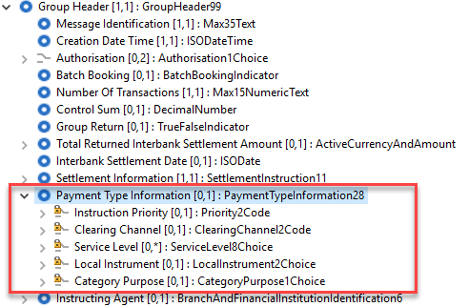

  - NB: Message component PaymentTypeInformation18 is the same component as used in the pacs.008 message.
- Transaction level updates:
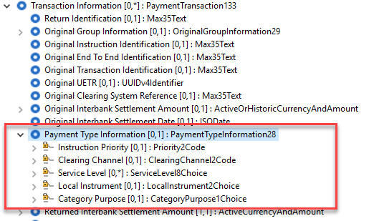
- PaymentTypeInformationRule definition:
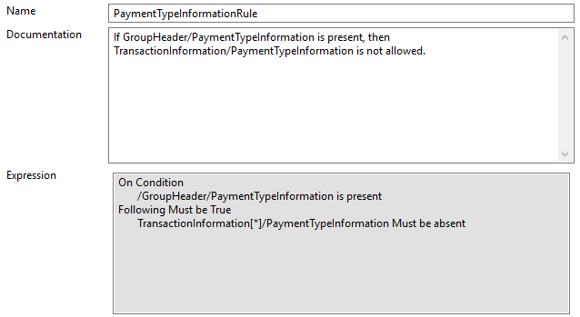

Proposed timing:
The submitting organisation confirms that it can implement the requested changes in the requested timing.

Timing | As requested

Final decision of the SEG(s):

Approve | X
Comments: Decision made at September 28th meeting.

Reject
Reason for rejection:

Change request CR00907:
Add settlement time request element in transaction information

Origin of the request:
A.1 Submitter: Payments Canada
A.2 Contact persons:
Malene McMahon – mmcmahon@payments.ca (+1 613 315 4991)
Isak Penttila – ipenttila@payments.ca (+1 613 315 4075)
Mike Hoganson – mhoganson@payments.ca (+1613 298 8087)
A.3 Sponsors:

Related messages:
- pacs.004 Return Payment

Description of the change request:
The new high value payments system in Canada (Lynx) will implement ISO 20022 messages (including pacs.008, pacs.009 and pacs.004) in late 2022. Lynx makes use of the Settlement Time Request component for new functionality that allows our members to indicate the time ‘from which’ a payment should be considered for settlement. This new functionality was supported by our community during the design phase of the new Lynx system.
Unfortunately, the pacs.004 does not contain this component (which is present in both the pacs.008 and the pacs.009). The Settlement Time Indication component is included in the pacs.004 but the Settlement Time Request component is not included. We believe it should be added since a payment return is ultimately a payment that needs to be settled and should have the same functionality available to it as the pacs.008 and pacs.009.
Given that this component is missing from the pacs.004, Lynx is unable to offer this functionality for a Payment Return. We were not able to come up with a work around for this during the development of our pacs.004 message.

Purpose of the change:
Giving our members the option of specifying the ‘From Time’ for their settlements is also something that would harmonize the functionality between the pacs.008/009 and the pacs.004.

Urgency of the request:
Next release.

Business examples:
Examples illustrating the change request.

Current pacs.004 | Proposed pacs.004
> Group Header | > Group Header
> Original Group Information | > Original Group Information
v Transaction Information | v Transaction Information
- Return Identification | - Return Identification
- Original Group Information | - Original Group Information
- Original Instruction Identification | - Original Instruction Identification
- Original End To End Identification | - Original End To End Identification
- Original Transaction Identification | - Original Transaction Identification
- Original UETR | - Original UETR
- Original Clearing System Reference | - Original Clearing System Reference
- Original Interbank Settlement Amount | - Original Interbank Settlement Amount
- Original Interbank Settlement Date | - Original Interbank Settlement Date
- Returned Interbank Settlement Amount | - Returned Interbank Settlement Amount
- Interbank Settlement Date | - Interbank Settlement Date
- Settlement Priority | - Settlement Priority
- Settlement Time Indication | - Settlement Time Indication
- Returned Instructed Amount | - Settlement Time Request
- …….. | - Returned Instructed Amount
 | - ……..

SEG/TSG recommendation:

Consider |  | X | Timing
 |  |  | - Next yearly cycle: 2020/2021  (the change will be considered for implementation in the yearly maintenance cycle which starts in 2020 and completes with the publication of new message versions in the spring of 2021) |  | X
- At the occasion of the next maintenance of the messages
(the change will be considered for implementation, but does not justify maintenance of the messages in its own right – will be pending until more critical change requests are received for the messages)
- Urgent unscheduled
(the change justifies an urgent implementation outside of the normal yearly cycle)
 |  |  | - Other timing:
Comments:

Reject
Reason for rejection:

Impact analysis and type of impact:
Following the detailed analysis of the impact of the changes to the existing messages, we identified no further impacted messages.
The below list provides the full list of impacted messages per message set:
Payments Clearing and Settlement message set:
- pacs.004.001.10 – PaymentReturnV10

Proposed implementation:
We support the proposed implementation, as requested in this change request.
This will result in the following structure:
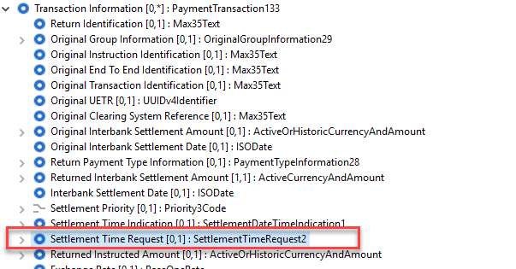
- NB: Message component SettlementTimeRequest2 is the same component as used in the pacs.008 message.

Proposed timing:
The submitting organisation confirms that it can implement the requested changes in the requested timing.

Timing | As requested

Final decision of the SEG(s):

Approve | X
Comments: Decision made at September 28th meeting.

Reject
Reason for rejection:

Change request CR00936:
Update of OriginalIdentificationRule and IdentificationRule

Origin of the request:
A.1 Submitter:
Federal Reserve Bank of New York (on behalf of the US Federal Reserve Banks)
33 Liberty Street
New York, NY 10045
U.S.A.
A.2 Contact person:
Federal Reserve Bank of New York
Mr. Frank Van Driessche (frank.vandriessche@ny.frb.org)
Ms. Hui Chang (hui.chang@ny.frb.org)
A.3 Sponsors:
Payments Canada
Mrs. Malene McMahon (mmcmahon@payments.ca)
Mr. Isak Penttila (ipenttila@payments.ca)

Related messages:
camt.026.001.07 – Unable To Apply
camt.028.001.09 – Additional Payment Information
camt.029.001.09 – Resolution Of Investigation
Note: we invite the RA to investigate application of the change request to more messages part of the Exceptions and Investigations message portfolio.

Description of the change request:
The request is to change/correct the following cross-element rules
- OriginalIdentificationRule in the Underlying component, more specifically, subcomponents Initiation and Interbank, to cater for the addition of the OriginalUETR element that was added during previous maintenance (applies to camt.026 and camt.028)
- IdentificationRule in the CorrectionTransaction component, more specifically, subcomponents Initiation and Interbank, to cater for the addition of the UETR element that was added during previous maintenance (applies to camt.029)
Initiation component
The rule “Either OriginalInstructionIdentification, OriginalEndToEndIdentification or both must be present.” should be updated to read “Either OriginalInstructionIdentification, OriginalEndToEndIdentification, or OriginalUETR must be present.” (applies to camt.026 and camt.028)
The rule “Either InstructionIdentification, EndToEndIdentification or both must be present.” should be updated to read “Either InstructionIdentification, EndToEndIdentification, or UETR must be present.” (applies to camt.029)

Interbank component
The rule “Either OriginalInstructionIdentification, OriginalEndToEndIdentification, OriginalTransactionIdentification or any combination of the three must be present.” should be updated to read “Either OriginalInstructionIdentification, OriginalEndToEndIdentification, OriginalTransactionIdentification, or OriginalUETR must be present.” (applies to camt.026 and camt.028)
The rule “Either InstructionIdentification, EndToEndIdentification, TransactionIdentification or any combination of the three must be present.” should be updated to read “Either InstructionIdentification, EndToEndIdentification, TransactionIdentification, or UETR must be present.” (applies to camt.029)

Purpose of the change:
The changes described under C are a correction/alignment of the cross-element in light of the addition of the UETR to the message standards during previous message maintenance, and also in light of the increased adoption globally by the UETR as unique message identification.

Urgency of the request:
Request to include the change in the current maintenance cycle.

Business examples:
N/A

SEG/TSG recommendation:
This section is not to be taken care of by the submitter of the change request. It will be completed in due time by the SEG(s) in charge of the related ISO 20022 messages or the TSG for changes related to the BAH.

Consider |  | X | Timing
 |  |  | - Next yearly cycle: 2020/2021  (the change will be considered for implementation in the yearly maintenance cycle which starts in 2020 and completes with the publication of new message versions in the spring of 2021) |  | X
- At the occasion of the next maintenance of the messages
(the change will be considered for implementation, but does not justify maintenance of the messages in its own right – will be pending until more critical change requests are received for the messages)
- Urgent unscheduled
(the change justifies an urgent implementation outside of the normal yearly cycle)
 |  |  | - Other timing:
Comments:

Reject
Reason for rejection:

Impact analysis and type of impact:
Following the detailed analysis of the impact of the changes to the existing messages, we identified further impacted messages, compared to the list already proposed by the change request submitter (as already indicated by the submitter).
The below list provides the full list of impacted messages per message set:

Exception and Investigation message set:
- camt.026.001.08 - UnableToApplyV08
- camt.027.001.08 - ClaimNonReceiptV08
- camt.028.001.10 - AdditionalPaymentInformationV10
- camt.029.001.10 - ResolutionOfInvestigationV11
- camt.037.001.08 - DebitAuthorisationRequestV08
- camt.087.001.07 – RequestToModifyPaymentV07

Additionally, we believe that the rule should be added in below messages (same message set), where it is currently not present in the underlying transactions:
- camt.055.001.08 - CustomerPaymentCancellationRequestV08
- camt.056.001.08 - FIToFIPaymentCancellationRequestV08

Question to the SEG: would you agree to add this rule in the two cancellation request messages, to ensure that when the underlying transaction is provided, at least one identification is present.

Proposed implementation:
We support the proposed implementation, as requested in this change request, including the removal of the unnecessary description in the documentation as identified in the footnote of the change request.
This will result in the following new rule definitions:
- OriginalIdentificationRule for underlying payment initiation transactions:
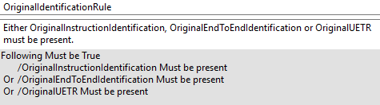
- OriginalIdentificationRule for underlying payment interbank transactions:
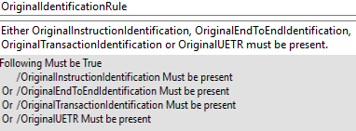
- IdentificationRule for corrective payment initiation transactions:
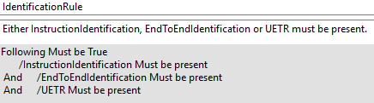
- IdentificationRule for corrective payment interbank transactions:
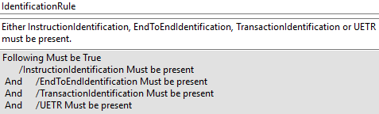

Proposed timing:
The submitting organisation confirms that it can implement the requested changes in the requested timing.

Timing | As requested

Final decision of the SEG(s):

Approve | X
Comments: Decision made at September 28th meeting.

Reject
Reason for rejection:

Change request CR00937:
Add RelatedRemittanceInformation in E&I messages

Origin of the request:
A.1 Submitter:
Federal Reserve Bank of New York (on behalf of the US Federal Reserve Banks)
33 Liberty Street
New York, NY 10045
U.S.A.
A.2 Contact person:
Federal Reserve Bank of New York
Mr. Frank Van Driessche (frank.vandriessche@ny.frb.org)
Ms. Hui Chang (hui.chang@ny.frb.org)
A.3 Sponsors:
Payments Canada
Mrs. Malene McMahon (mmcmahon@payments.ca)
Mr. Isak Penttila (ipenttila@payments.ca)

Related messages:
- camt.026.001.07 – Unable To Apply
- camt.028.001.09 – Additional Payment Information
Note: we invite the RA to investigate application of the change request to more messages part of the Exceptions and Investigations message portfolio.

Description of the change request:
The request is twofold:
C1:
- Add an additional code to investigate missing or incorrect Related Remittance Information to the following components:
  - Justification/MissingOrIncorrectInformation/MissingInformation/Code and Justification/MissingOrIncorrectInformation/IncorrectInformation/Code (applies to camt.026)
- Change the data types of the MissingInformation/Code (UnableToApplyMissingInformation3Code) and IncorrectInformation/Code (UnableToApplyIncorrectInformation4Code) components from a restricted code list explicitly embedded in the schema, to a choice component with Code vs Proprietary options (as implemented for a majority of code lists in the payment message portfolio). The Code element will be reserved for codes that have been published on an ISO 20022 externalized code lists (and should inherit in a first phase the codes currently embedded in the schema), and the Proprietary element is available for use of any community or user specific codes.
C2: Add an additional component to provide missing or corrected Related Remittance Information (aligned with pacs.008 Related Remittance Information component) to the following component:
- AdditionalPaymentInformation/Information (applies to camt.026)

Purpose of the change:
The changes described under C1 and C2 above are to align the Exception & Investigation camt.026 and camt.028 messages with the pacs.008 messages that they might investigate. Whereas today it is possible to send an Unable to Apply (camt.026) for missing or incorrect Remittance Information, it should also be possible to send that same message to enquire about missing or incorrect Related Remittance Information if that is the chosen model of exchanging remittance information between clients. Example: a link to separately posted remittance information could be broken or missing in a pacs.008, and then it should be possible to request the corrected or missing link information.

Urgency of the request:
Request to include the change in the current maintenance cycle.

Business examples:
See D.

SEG/TSG recommendation:
This section is not to be taken care of by the submitter of the change request. It will be completed in due time by the SEG(s) in charge of the related ISO 20022 messages or the TSG for changes related to the BAH.

Consider |  | X | Timing
 |  |  | - Next yearly cycle: 2020/2021  (the change will be considered for implementation in the yearly maintenance cycle which starts in 2020 and completes with the publication of new message versions in the spring of 2021) |  | X
- At the occasion of the next maintenance of the messages
(the change will be considered for implementation, but does not justify maintenance of the messages in its own right – will be pending until more critical change requests are received for the messages)
- Urgent unscheduled
(the change justifies an urgent implementation outside of the normal yearly cycle)
 |  |  | - Other timing:
Comments:

Reject
Reason for rejection:

Impact analysis and type of impact:
Following the detailed analysis of the impact of the changes to the existing messages, we believe that on top of those messages, the RelatedRemittanceInformation element should also be added to the RequestToModifyPayment (camt.087) message
The below list provides the full list of impacted messages per message set:
Exception and Investigation message set:
- camt.026.001.08 - UnableToApplyV08
- camt.028.001.10 - AdditionalPaymentInformationV10
- camt.087.001.07 – RequestToModifyPaymentV07

Proposed implementation:
As indicated during the initial assessment, and following common review with the submitter of the change request, we have agreed on the updated proposed implementation, resulting in the following structure:

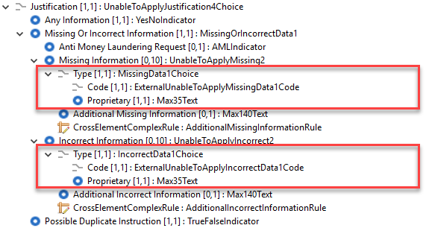
Note to the SEG: following discussion with the submitter, we finally agreed to externalise the code as requested, but we must ensure that a note is appended to the new external code set, to ensure that any new code added to the set does not violate the rules as defined in the Exception and Investigation – Message Definition Report – Part 1.

Proposed timing:
The submitting organisation confirms that it can implement the requested changes in the requested timing.

Timing | As requested

Final decision of the SEG(s):

Approve | X
Comments: Decision made at September 28th meeting.

Reject
Reason for rejection:

Change request CR00938:
Update of Period in Tax component

Origin of the request:
A.1 Submitter: Payments Canada
A.2 Contact persons:
Malene McMahon – mmcmahon@payments.ca (+1 613 315 4991)
Isak Penttila – ipenttila@payments.ca (+1 613 315 4075)
A.3 Sponsors: U.S. Federal Reserve Bank (Frank Vandriessche)

Related messages:
pacs.008, pacs.009, pacs.004 and any other message with a tax component.

Description of the change request:
This is a request to change the data type for an element in the Tax and Tax Remittance components in the pacs.008, pacs.009 (Underlying) and pacs.004 (Original Transaction Reference). For illustration, we will refer to the pacs.008 but it is the same element for the pacs.009 and the pacs.004.
Under pacs.008/CreditTransferTransactionInformation/Tax/Record/Period, there is an element called “Year” which is defined as the “Year related to the tax payment”. Unfortunately, the data type is ISODate (Date). We believe this should be changed to reflect only a ‘year’ data type where you can only put the 4-digit year as the value. With the ISODate (Date) data type you are forced to put an actual calendar date.
The same anomaly occurs under pacs.008/CreditTransferTransactionInformation/RemittanceInformation/Structured/TaxRemittance/Record/Period. We believe “Year” under this component should be typed as only a year and not a full date.

Purpose of the change:
We believe that this is simply an error in the assignment of the data type and should be corrected to reflect the appropriate data type for the definition of the element.

Urgency of the request:
This correction should be made during the next maintenance cycle.

Business examples:
Below is a snippet of the component (from RmtInf/Strd in pacs.008, highlighted in blue) that we believe should be changed to properly reflect a ‘year’ and not a ‘date’.

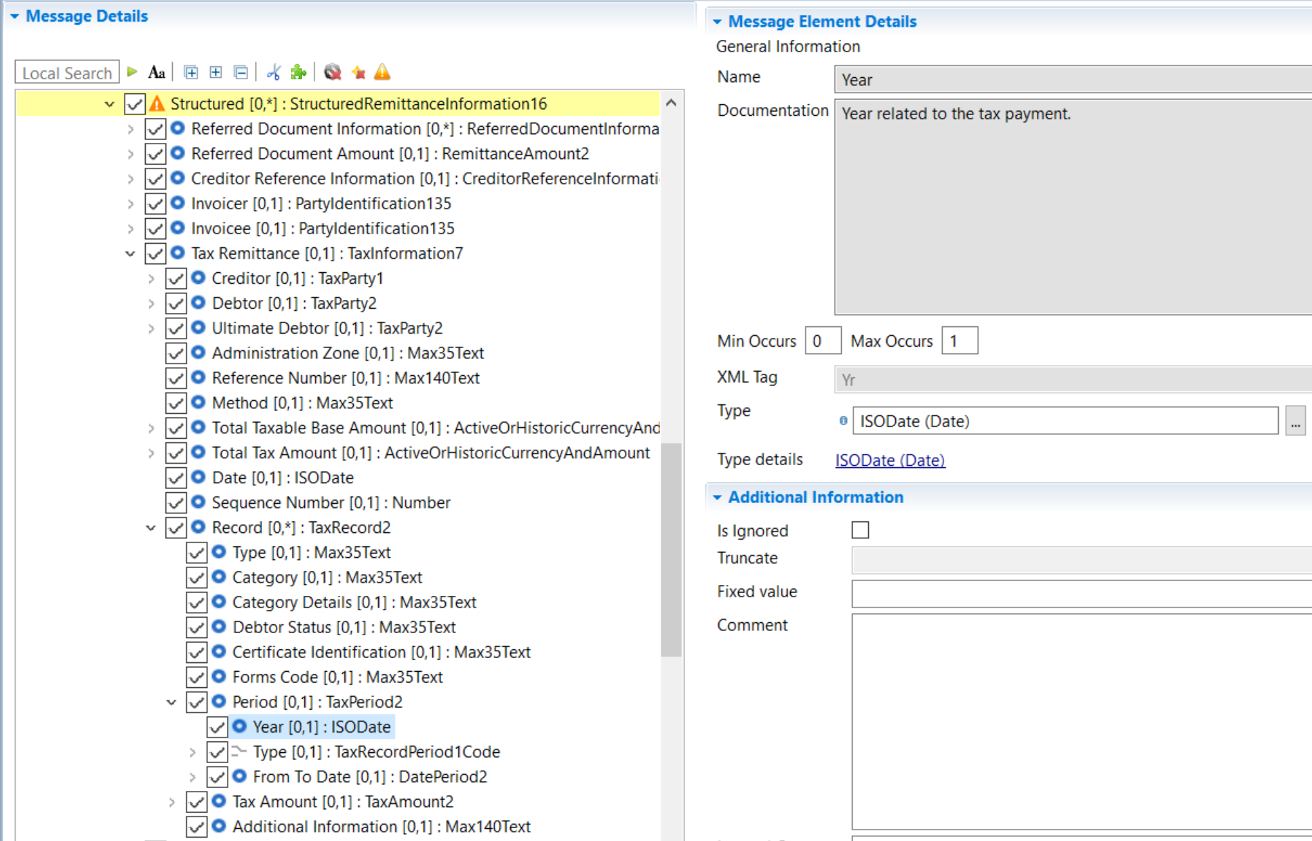

SEG/TSG recommendation:

Consider |  | X | Timing
 |  |  | - Next yearly cycle: 2020/2021  (the change will be considered for implementation in the yearly maintenance cycle which starts in 2018 and completes with the publication of new message versions in the spring of 2019) |  | X
- At the occasion of the next maintenance of the messages
(the change will be considered for implementation, but does not justify maintenance of the messages in its own right – will be pending until more critical change requests are received for the messages)
- Urgent unscheduled
(the change justifies an urgent implementation outside of the normal yearly cycle)
 |  |  | - Other timing:
Comments:

Reject
Reason for rejection:

Impact analysis and type of impact:
Following the detailed analysis of the impact of the changes to the existing messages, we identified further impacted messages, as already suggested by the change request submitter
The below list provides the full list of impacted messages per message set:
Account Switching message set:
- acmt.027.001.03 - AccountSwitchInformationRequestV03
- acmt.028.001.03 - AccountSwitchInformationResponseV03
- acmt.029.001.03 - AccountSwitchCancelExistingPaymentV03
- acmt.031.001.03 - AccountSwitchRequestBalanceTransferV03
- acmt.032.001.03 - AccountSwitchBalanceTransferAcknowledgementV03
- acmt.034.001.03 - AccountSwitchRequestPaymentV03
Bank-to-Customer Cash Management message set:
- camt.052.001.08 - BankToCustomerAccountReportV08
- camt.053.001.08 - BankToCustomerStatementV08
- camt.054.001.08 - BankToCustomerDebitCreditNotificationV08
Creditor Payment Activation Request message set:
- pain.013.001.08 - CreditorPaymentActivationRequestV08
- pain.014.001.08 - CreditorPaymentActivationRequestStatusReportV08
Exceptions and Investigations message set:
- camt.026.001.08 - UnableToApplyV08
- camt.027.001.08 - ClaimNonReceiptV08
- camt.028.001.10 - AdditionalPaymentInformationV10
- camt.029.001.10 - ResolutionOfInvestigationV10
- camt.037.001.08 - DebitAuthorisationRequestV08
- camt.055.001.09 - CustomerPaymentCancellationRequestV09
- camt.056.001.09 - FIToFIPaymentCancellationRequestV09
- camt.087.001.07 - RequestToModifyPaymentV07
Notification to Receive message set:
- camt.057.001.06 - NotificationToReceiveV06
- camt.058.001.06 - NotificationToReceiveCancellationAdviceV06
- camt.059.001.06 - NotificationToReceiveStatusReportV06

Payments Clearing and Settlement message set:
- pacs.002.001.11 - FIToFIPaymentStatusReportV11
- pacs.003.001.08 - FIToFICustomerDirectDebitV08
- pacs.004.001.10 - PaymentReturnV10
- pacs.007.001.10 - FIToFIPaymentReversalV10
- pacs.008.001.09 - FIToFICustomerCreditTransferV09
- pacs.009.001.09 - FinancialInstitutionCreditTransferV09
- pacs.028.001.04 - FIToFIPaymentStatusRequestV04
Payments Initiation message set:
- pain.001.001.10 - CustomerCreditTransferInitiationV10
- pain.002.001.11 - CustomerPaymentStatusReportV11
- pain.007.001.10 - CustomerPaymentReversalV10
- pain.008.001.09 - CustomerDirectDebitInitiationV09
Stand-Alone Remittance Advice message set:
- remt.001.001.04 - RemittanceAdviceV04

Proposed implementation:
We support the proposed implementation, as requested in this change request.
Additionnally to the requested change, we have also identified a discrepancy between the two components defined for the Tax data and we would also to propose the alignment of the components used in the CreditTransferTransactionInformation/TaxInformation element and the RemittanceInformation/Structured/TaxRemittance to use the same component:
- Delta between the current components:
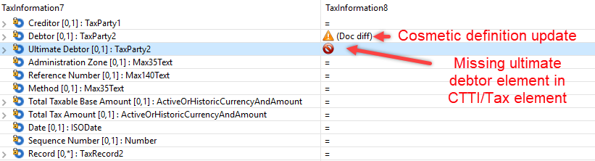
The proposed implementation of the new component to be used for both elements, including the Year update, would result in following implementation:
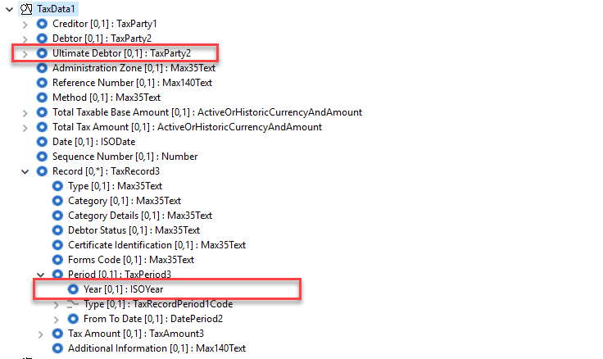

Proposed timing:
The submitting organisation confirms that it can implement the requested changes in the requested timing.

Timing | As requested

Final decision of the SEG(s):

Approve | X
Comments: Decision made at September 28th meeting.

Reject
Reason for rejection:

Additional technical adjustments in the ISO 20022 rules identified during the maintenance (standing change request)

As part of the implementation, we have identified a number of technical errors in the description of the rules defined in the messages. Below is the exhaustive list of corrections as applied to the messages:

 | Issue in rule | Description of the change required
1. | Following the externalisation of codes from the schemas to the external code sets, a number of rules were still referring to the internal codes in the formal definition of the rules, which resulted in an invalid formal definition of the rule.  The list of impacted messages has been provided in the table below | The formal description of the rules has been adjusted to reflect those changes – from an implementation point of view we have defined a number of new code sets based on a single master code set. Those new codes are only used in the formal definitions.
2.
3.

List of rules impacted by Item 1 which have been updated:

Message | Rule Name | Location of the rule in the messag
BankToCustomerAccountReportV09 | ReturnReasonRule | PaymentReturnReason5
BankToCustomerDirectDebitNotificationV09 | ReturnReasonRule | PaymentReturnReason5
BankToCustomerStatementV09 | ReturnReasonRule | PaymentReturnReason5
CreditorPaymentActivationRequestStatusReportV09 | GroupStatusAcceptedRule | Message level
CreditorPaymentActivationRequestStatusReportV09 | GroupStatusPendingRule | Message level
CreditorPaymentActivationRequestStatusReportV09 | GroupStatusReceivedRule | Message level
CreditorPaymentActivationRequestStatusReportV09 | GroupStatusRejectedRule | Message level
CreditorPaymentActivationRequestStatusReportV09 | PaymentInformationStatusAcceptedRule | OriginalPaymentInstruction42
CreditorPaymentActivationRequestStatusReportV09 | PaymentInformationStatusPendingRule | OriginalPaymentInstruction42
CreditorPaymentActivationRequestStatusReportV09 | PaymentInformationStatusReceivedRule | OriginalPaymentInstruction42
CreditorPaymentActivationRequestStatusReportV09 | PaymentInformationStatusRejectedRule | OriginalPaymentInstruction42
CreditorPaymentActivationRequestStatusReportV09 | StatusReasonInformationRule | OriginalGroupInformation30
CreditorPaymentActivationRequestStatusReportV09 | StatusReasonRule | StatusReasonInformation12
CreditorPaymentActivationRequestV09 | InstructionForCreditorAgentRule | CreditTransferTransaction55
CustomerCreditTransferInitiationV11 | InstructionForCreditorAgentRule | CreditTransferTransaction54
CustomerPaymentStatusReportV12 | GroupStatusAcceptedRule | Message level
CustomerPaymentStatusReportV12 | GroupStatusPendingRule | Message level
CustomerPaymentStatusReportV12 | GroupStatusReceivedRule | Message level
CustomerPaymentStatusReportV12 | GroupStatusRejectedRule | Message level
CustomerPaymentStatusReportV12 | PaymentInformationStatusAcceptedRule | OriginalPaymentInstruction40
CustomerPaymentStatusReportV12 | PaymentInformationStatusPendingRule | OriginalPaymentInstruction40
CustomerPaymentStatusReportV12 | PaymentInformationStatusReceivedRule | OriginalPaymentInstruction40
CustomerPaymentStatusReportV12 | PaymentInformationStatusRejectedRule | OriginalPaymentInstruction40
CustomerPaymentStatusReportV12 | StatusReasonInformationRule | OriginalGroupHeader17
CustomerPaymentStatusReportV12 | StatusReasonRule | StatusReasonInformation12
FIToFICustomerCreditTransferV10 | InstructionForCreditorAgentRule | CreditTransferTransaction50
FIToFIPaymentStatusReportV12 | GroupStatusAcceptedRule | Message level
FIToFIPaymentStatusReportV12 | GroupStatusPendingRule | Message level
FIToFIPaymentStatusReportV12 | GroupStatusReceivedRule | Message level
FIToFIPaymentStatusReportV12 | GroupStatusRejectedRule | Message level
FIToFIPaymentStatusReportV12 | StatusReasonInformationRule | OriginalGroupHeader17
FIToFIPaymentStatusReportV12 | StatusReasonRule | StatusReasonInformation12
PaymentReturnV11 | ReturnReasonRule | PaymentReturnReason6
UnableToApplyV09 | AdditionalIncorrectInformationRule | UnableToApplyIncorrect2
UnableToApplyV09 | AdditionalMissingInformationRule | UnableToApplyMissing2

We believe the ‘or both’ part of the rule is superfluous and can be deleted.
We believe the ‘or both’ part of the rule is superfluous and can be deleted.
We believe the ‘or any combination of the three’ is superfluous and can be deleted.
We believe the ‘or any combination of the three’ is superfluous and can be deleted.

