Maintenance Change Request
for fast track maintenance of existing message definitions

- Submitting organization(s):
European Securities and Markets Authority (ESMA)
103 rue de Grenelle
75007 Paris
France

- Related messages:
auth.017.001.01 FinancialInstrumentReportingReferenceDataReport
auth.036.001.01 FinancialInstrumentReportingReferenceDataDeltaReport
auth.042.001.01 FinancialInstrumentReportingInvalidReferenceDataReport
auth.033.001.01 FinancialInstrumentReportingNonEquityTransparencyDataReport
auth.044.001.01 FinancialInstrumentReportingEquityTradingActivityResult
auth.045.001.01 FinancialInstrumentReportingNonEquityTradingActivityResult
auth.049.001.01 FinancialInstrumentReportingMarketIdentificationCodeReport

- Purpose of the change:
Based on input received from National Competent Authorities and analysis of the reported data since the go live of MiFID 2 / MiFIR reporting started in July 2017 for reference data reports and October 2017 for transparency data reports, ESMA proposes the implementation of the following improvements in the messages and systems supporting the regulation:
- For the purpose of regulatory reporting of financial instrument reference data (Regulatory Technical Standard 23), ESMA compares reporting across trading venues reporting the same instrument and in case of inconsistencies, it sends a warning to the reporting entities that are required to address such inconsistency issues. To support this process in a more efficient manner and facilitate the reconciliation, information about the “relevant trading venue” (the reporting entity which reference data prevails in case of inconsistencies) should be included in the messages.
- For the purpose of regulatory reporting of financial instrument transparency data (Regulatory Technical Standard 2) related to credit default swap index, additional elements should be included in the message and element names must be improved to provide more clarity on what is to be reported;
- For market participants, ESMA also plans to distribute information about the financial instrument classification in the context of the information collected under MiFIR Regulatory Technical Standards 1 and 2;
- National Competent Authorities, have also requested to enrich the Market Identification Code Report with the categories of MIC such as Approved Publication Arrangements (APA) and Consolidated Tape Providers (CTP) in the data distributed to them;

- Urgency of the request:
As these improvements will facilitate reporting and improve data quality, ESMA aims at including changes in the next major maintenance release cycle of the systems scheduled for November / December 2018.
To accommodate for sufficient lead time for the reporting entities to adapt to the changes, the updated XML Schema will need to be published as soon as possible.

- Commitments of the submitting organization:
The ESMA MiFIR project team confirms that it plans to develop a new version of the impacted systems in accordance to the changes proposed in this document.

- Contact persons:
Cyril Minoux – cyril.minoux@esma.europa.eu
Lukasz Popko – lukasz.popko@esma.europa.eu

Change number #1
- Related messages:
auth.017.001.01 FinancialInstrumentReportingReferenceDataReport
auth.036.001.01 FinancialInstrumentReportingReferenceDataDeltaReport
auth.042.001.01 FinancialInstrumentReportingInvalidReferenceDataReport

- Description of the change and type of impact:
For the purpose of regulatory reporting of financial instrument reference data (Regulatory Technical Standard 23), ESMA compares reporting across trading venues reporting the same instrument and in case of inconsistencies, it sends a warning to the reporting entities that are required to address such inconsistency issues. To support this process in a more efficient manner and facilitate the reconciliation, information about the “relevant trading venue” (the reporting entity which reference data prevails in case of inconsistencies) should be included in the messages.
This change impact the base messages of the data reported to ESMA and distributed by ESMA. This element is optional and will be used only in the derived messages of the data distributed by ESMA.
- Proposed implementation:
Addition of the “Relevant Trading Venue” element, defined as “Trading venue of the record used by the relevant competent authority to determine the reference data for the instrument.”
Approved message | Proposed change
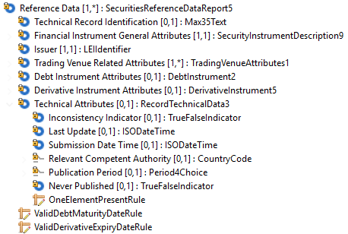 | 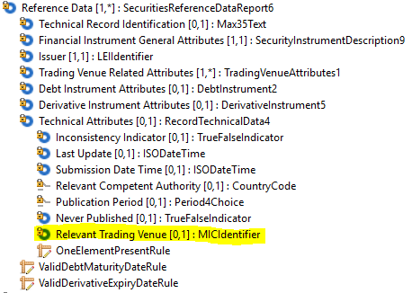
The updated SecuritiesReferenceDataReport6 is used consistently across all three base messages impacted (auth.017.001.01, auth.036.001.01, auth.042.001.01)
- Decision of the SEG(s):
This section is not to be taken care of by the submitting organization. It will be completed in due time by the SEG(s) in charge of the related ISO 20022 message definitions.

Change
 | approved | X
 | rejected
Comments:

Timing
 | - Fast track maintenance  (the change justifies an urgent implementation using the fast track maintenance process) |  | X
- At the occasion of the next maintenance of the messages
(the change will be considered for implementation, but does not justify an urgent implementation – will be pending until the next [yearly] maintenance of the messages)

Change number #2
A.Related messages:
auth.033.001.01 FinancialInstrumentReportingNonEquityTransparencyDataReport
- Description of the change and type of impact:
For the purpose of regulatory reporting of financial instrument transparency data (Regulatory Technical Standard 2) related to credit default swap index, additional elements should be included in the message to report some regulatory fields: Regulatory Technical Standard 2 fields 32 (for Credit Default Swap Index Derivative) and fields 33 and 34 (for Credit Default Swap Index).
Some element names must also be improved to provide more clarity on what is to be reported and a typographical error needs to be corrected as requested by SEG Evaluation Team.

- Proposed implementation:
Approved message | Proposed change
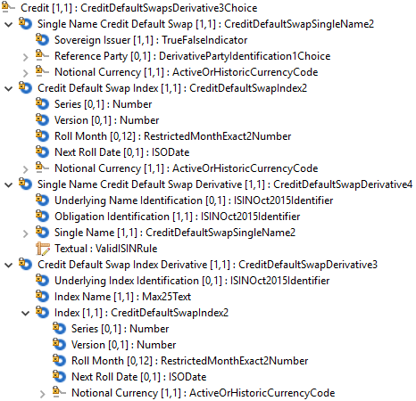 | 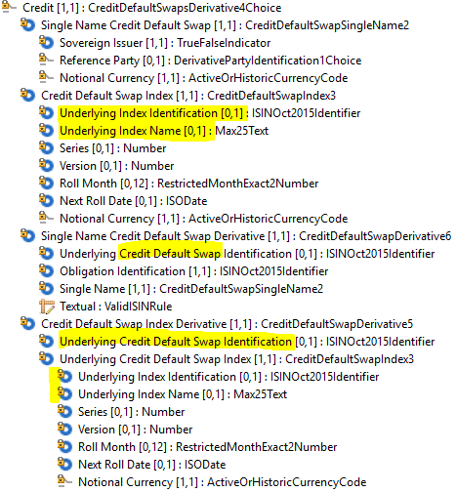
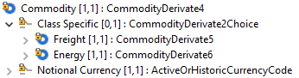 | 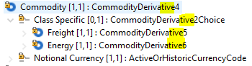
- For Credit Default Swap Index: addition of Underlying Index Identification and Underlying Index Name, in order to hold information specified in Regulatory Technical Standard 2 Fields 33 and 34.
- For Credit Default Swap Index Derivative: addition of Underlying Credit Default Swap Identification in order to hold information specified in Regulatory Technical Standard 2 Field 32. The elements “Underlying Index Identification” and “Index Name” are now covered under the “Underlying Credit Default Swap Index” element.
- For Single Name Credit Default Swap Derivative: clarification of the element name for the underlying instrument: Underlying Credit Default Swap Identification.
- For Commodity Derivatives, the message component names should use the word “derivative” instead of “derivate”. This impacts CommodityDerivative2Choice / CommodityDerivative4 / CommodityDerivative5 / CommodityDerivative6
- Decision of the SEG(s):
This section is not to be taken care of by the submitting organization. It will be completed in due time by the SEG(s) in charge of the related ISO 20022 message definitions.

Change
 | approved | X
 | rejected
Comments:

Timing
 | - Fast track maintenance  (the change justifies an urgent implementation using the fast track maintenance process) |  | X
- At the occasion of the next maintenance of the messages
(the change will be considered for implementation, but does not justify an urgent implementation – will be pending until the next [yearly] maintenance of the messages)

Change number #3
- Related messages:
auth.044.001.01 FinancialInstrumentReportingEquityTradingActivityResult

- Description of the change and type of impact:
For market participants, ESMA also plans to distribute information about the financial instrument classification in the context of the information collected under MiFIR Regulatory Technical Standards 1 and 2. This change is for Regulatory Technical Standard 1 (Equity).
.
- Proposed implementation:
Addition of the Financial Instrument Classification under the Equity Transparency Data distributed by ESMA.
Approved message | Proposed change
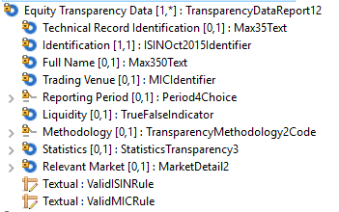 | 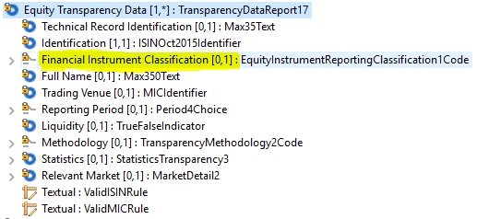

FinancialInstrumentClassification and EquityInstrumentReportingClassification1Code are reused, consistently with auth.032.001.01.

- Decision of the SEG(s):
This section is not to be taken care of by the submitting organization. It will be completed in due time by the SEG(s) in charge of the related ISO 20022 message definitions.

Change
 | approved | X
 | rejected
Comments:

Timing
 | - Fast track maintenance  (the change justifies an urgent implementation using the fast track maintenance process) |  | X
- At the occasion of the next maintenance of the messages
(the change will be considered for implementation, but does not justify an urgent implementation – will be pending until the next [yearly] maintenance of the messages)

Change number #4
- Related messages:
auth.045.001.01 FinancialInstrumentReportingNonEquityTradingActivityResult

- Description of the change and type of impact:
For market participants, ESMA also plans to distribute information about the financial instrument classification in the context of the information collected under MiFIR Regulatory Technical Standards 1 and 2. This change is for Regulatory Technical Standard 2 (Non-Equity).
- Proposed implementation:
Addition of the Financial Instrument Classification under the Non-Equity Transparency Data distributed by ESMA.
Approved message | Proposed change
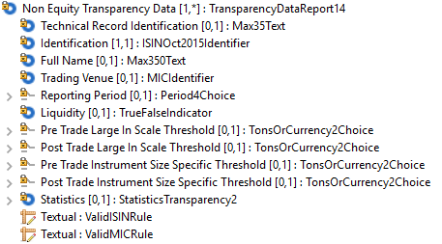 | 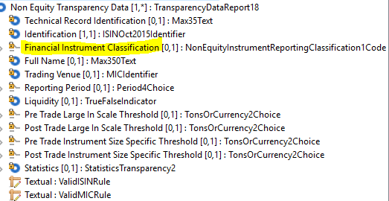

FinancialInstrumentClassification and NonEquityInstrumentReportingClassification1Code are used, consistently with auth.033.001.01.

- Decision of the SEG(s):
This section is not to be taken care of by the submitting organization. It will be completed in due time by the SEG(s) in charge of the related ISO 20022 message definitions.

Change
 | approved | X
 | rejected
Comments:

Timing
 | - Fast track maintenance  (the change justifies an urgent implementation using the fast track maintenance process) |  | X
- At the occasion of the next maintenance of the messages
(the change will be considered for implementation, but does not justify an urgent implementation – will be pending until the next [yearly] maintenance of the messages)

Change number #5

A.Related messages:
auth.049.001.01 FinancialInstrumentReportingMarketIdentificationCodeReport

- Description of the change and type of impact:

National Competent Authorities, have also requested to enrich the Market Identification Code Report with the categories of MIC such as Approved Publication Arrangements (APA) and Consolidated Tape Providers (CTP) in the data distributed to them.
- Proposed implementation:
Addition of the codes APPA and CTPS under the Category element.
Approved message | Proposed change
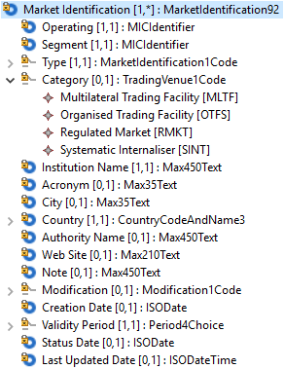 | 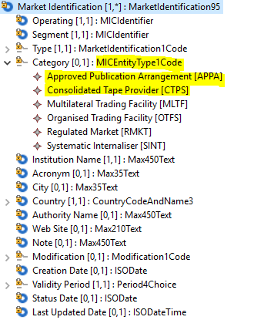
Codes are consistent with other TradingVenueCode list.

- Decision of the SEG(s):
This section is not to be taken care of by the submitting organization. It will be completed in due time by the SEG(s) in charge of the related ISO 20022 message definitions.

Change
 | approved | X
 | rejected
Comments:

Timing
 | - Fast track maintenance  (the change justifies an urgent implementation using the fast track maintenance process) |  | X
- At the occasion of the next maintenance of the messages
(the change will be considered for implementation, but does not justify an urgent implementation – will be pending until the next [yearly] maintenance of the messages)

