Maintenance Change Request
for the update of ISO 20022 financial repository items

- Name of the request:

“ISO 20022 Payments Maintenance 2015/2016”

- Submitting organisation(s):

SWIFT, on behalf of IFX Forum, SWIFT, TWIST and OAGi (ISTH), and the CBI Consortium
Standards Department,
Avenue Adele, 1
1310 La Hulpe - Belgium

- Related messages:

Under this project, below existing ISO 20022 messages will be maintained (resulting from the impact analysis performed on each CR).

- Payment Initiation messages set:
- pain.001.001.06 | CustomerCreditTransferInitiationV06
- pain.002.001.06 | CustomerPaymentStatusReportV06
- pain.007.001.05 | CustomerPaymentReversalV05
- pain.008.001.05 | CustomerDirectDebitInitiationV05

- Payment Clearing And Settlement messages set:
- pacs.002.001.06 | FIToFIPaymentStatusReportV06
- pacs.003.001.05 | FIToFICustomerDirectDebitV05
- pacs.004.001.05 | PaymentReturnV05
- pacs.007.001.05 | FIToFIPaymentReversalV05
- pacs.008.001.05 | FIToFICustomerCreditTransferV05
- pacs.009.001.05 | FinancialInstitutionCreditTransferV05

- Bank to Customer Cash Management messages set:
- camt.052.001.05 | BankToCustomerAccountReportV05
- camt.053.001.05 | BankToCustomerStatementV05
- camt.054.001.05 | BankToCustomerDebitCreditNotificationV05

- Exceptions and Investigations messages set:
- camt.028.001.05 | AdditionalPaymentInformationV05
- camt.029.001.05 | ResolutionOfInvestigationV05
- camt.055.001.04 | CustomerPaymentCancellationRequestV04
- camt.056.001.04 | FIToFIPaymentCancellationRequestV04
- camt.087.001.02 | RequestToModifyPaymentV02

- Notification To Receive messages set:
- camt.057.001.04 | NotificationToReceiveV04
- camt.058.001.04 | NotificationToReceiveCancellationAdviceV04
- camt.059.001.04 | NotificationToReceiveStatusReportV04

- Bank Services Billing message set:
- camt.086.001.01 | BankServicesBillingV01

- Customer Payment Activation Request message set:
- pain.013.001.04 | CreditorPaymentActivationRequestV04
- pain.014.001.04 | CreditorPaymentActivationRequestStatusReportV04

- Stand-Alone Remittance Advice message set:
- remt.001.001.01 | RemittanceAdviceV01

Please note that although below messages are under the responsibility of other submitting organisations, SWIFT has agreed to implement the required changes on behalf of those organisations. Therefore no separate MCR will be created for the implementation of the changes in those messages:

Messages submitted by the CBI Consortium:
- pain.013.001.04 | CreditorPaymentActivationRequestV04
- pain.014.001.04 | CreditorPaymentActivationRequestStatusReportV04

Messages submitted by the IFX Forum:
- remt.001.001.01 | RemittanceAdviceV01

- Commitments of the submitting organisation:

The submitting organisations confirm that they can and will:
- undertake the development of the new version of the candidate ISO 20022 message models that it will submit to the RA for compliance review and evaluation. New valid Message Definition models will be made available to the RA by December 1.
- provide a new version of part 1 of the related Message Definition Reports (MDR) by December 1, and new examples of valid message instances of each candidate message (only when valid samples were published for current version) by May 1 at the latest.
- address any queries related to the description of the new models and messages as published by the RA on the ISO 20022 website.

SWIFT intends to implement most of the above new versions on its SWIFTNet network once the related documentation has been published by the RA.

The submitting organisations confirm their knowledge and acceptance of the ISO 20022 Intellectual Property Rights policy for contributing organisations, as follows.
“Organisations that contribute information to be incorporated into the ISO 20022 Repository shall keep any Intellectual Property Rights (IPR) they have on this information. A contributing organisation warrants that it has sufficient rights on the contributed information to have it published in the ISO 20022 Repository through the ISO 20022 Registration Authority in accordance with the rules set in ISO 20022. To ascertain a widespread, public and uniform use of the ISO 20022 Repository information, the contributing organisation grants third parties a non-exclusive, royalty-free license to use the published information”.

- Contact persons:
Vincent Kuntz – SWIFT Standards, vincent.kuntz@swift.com
Karin de Ridder – SWIFT Standards, karin.deridder@swift.com

Table of Contents
CR0334: Remove XOR rule in camt.086 6
CR0396: Update StructuredRemittanceInformation 9
CR0475: Remove duplicate components 14
CR0517: Add BankTransactionCode in camt.086 20
CR0529: Remove XOR rule in camt.052 and camt.053 25
CR0530: Update Structured Remittance Information 30

Note from the ISO 20022 Registration Authority
ISO 20022 CR0534 - Change of pattern of datatypes ISIN and CFI in all ISO 20022 messages, issued by the ISO 20022 Registration Authority on 23 November 2015, has been implemented in three Bank to Customer Cash Management messages, as well as in 28 Securities Settlement and Reconciliation messages, 12 Corporate Actions messages and 3 Collateral Management messages, in the 2015/2016 maintenance cycle.
It was decided to already implement CR0534 in this maintenance cycle, since there was a unique opportunity to update, in one go, the 40 Securities Settlement & Reconciliation and Corporate Actions messages, which had to be maintained in this 2015/2016 maintenance cycle, as well as their 40 ISO 15022 variants.
As CR0475, described on page 14 below, impacted the exact same message components in the three Bank to Customer Cash Management messages, CR0534 was de facto implemented at the same time.
A copy of CR0534 has been added at the end of this document for reference.

CR0334: Remove XOR rule in camt.086

- Origin of the request:
A.1 Submitter: ISO 20022 Registration Authority.
A.2 Contact person: Jean-Marie Eloy (jean-marie.eloy@swift.com, +3226553854)
A.3 Sponsors: new edition of ISO 20022:2013 (v1.5)
- Related messages:
Bank Services Billing: camt.086.001.01
- Description of the change request:
Replacement of the ‘unnamed’ <<xor>> choice used in camt.086 by a ‘named’ ChoiceComponent to ensure compliance with the new edition ISO 20022:2013 (v1.5).
- Purpose of the change:
Under the new edition ISO 20022:2013, ‘unnamed’ choices (known as XOR choices) are forbidden and should be replaced by ‘named’ ChoiceComponents. Unnamed choices are difficult to implement as they require an implementer to 'invent' a name for the choice. Unnamed choices may also be confusing to a user if a choice has to be made without any context as to why the choice is there.
- Urgency of the request:
We leave it up to the SEG and the Submitting Organisation in charge of the maintenance of this message definition to decide the most appropriate maintenance cycle to implement the changes.
- Business examples:
N/A
- SEG recommendation:

Consider |  | X | Timing
 |  |  | - Next yearly cycle: 2015/2016  (the change will be considered for implementation in the yearly maintenance cycle which starts in 2015 and completes with the publication of new message versions in the spring of 2016) |  | X
- At the occasion of the next maintenance of the messages
(the change will be considered for implementation, but does not justify maintenance of the messages in its own right – will be pending until more critical change requests are received for the messages)
- Urgent unscheduled
(the change justifies an urgent implementation outside of the normal yearly cycle)
 |  |  | - Other timing:
Comments:

Reject
Reason for rejection:

- Impact analysis:
This change request impacts the Bank Services Billing message (camt.086.001.01) only.
- Proposed implementation:
Following element BillingStatementGroup / BillingStatement / CashAccountCharacteristics / CashAccount is still typed with the CashAccount16 message component, which incorrectly contains the XOR rule instead of a named choice component.
The CashAccount16 message component was updated in the remaining payments messages with the CashAccount24 component, which removes the XOR rule from the message component.
In order to perform the similar update we propose to update the AccountCharacteristics message component, so that the CashAccount element is typed by the CashAccount24 message component.
Below is a description of the detailed update resulting from this change:
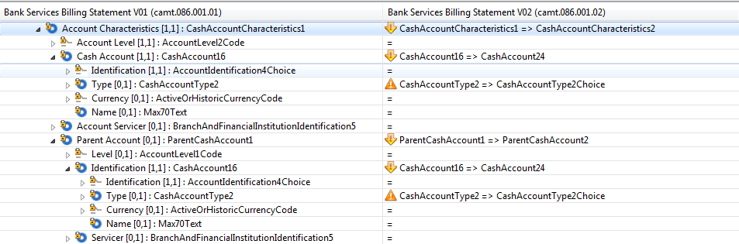

- Proposed timing:
The submitting organisation confirms that it can implement the requested changes in the requested timing.

Timing | As requested

- Final decision of the SEG:

Approve | X
Comments:

Reject
Reason for rejection:

CR0396: Update StructuredRemittanceInformation
This Change Request was only partially implemented during
Payments Maintenance 2014/2015

- Origin of the request:
A.1 Submitter:
IFX Forum, Inc. is the submitting organisation
A.2 Contact persons:
Richard Urban, ifxpresident@ifxforum.org, +01 952 270-7773
Deborah Canale, canaledl@wellsfargo.com, +01 602-579-0438

A.3 Sponsors: None at this time, but IFX Forum expects to act in cooperation with SWIFT and others who have maintenance responsibilities for pain, pacs and camt messages.
- Related messages:
This change request is to replace older versions of the Structured Remittance Information component with the new version, StructuredRemittanceInformation10. This will impact all messages that use the Remittance Information component since StructuredRemittanceInformation is a sub-component of RemittanceInformation.
The following messages were determined to be impacted by the introduction of RemittanceInformation8. The current version of each message is likely to be updated with the new StructuredRemittanceInformation10 component.

Messages using RemittanceInformation7 | Message identifier
AdditionalPaymentInformationV04 | camt.028.001.04
BankToCustomerAccountReportV04 | camt.052.001.04
BankToCustomerDebitCreditNotificationV04 | camt.054.001.04
BankToCustomerStatementV04 | camt.053.001.04
CreditorPaymentActivationRequestV03 * | pain.013.001.03
CustomerCreditTransferInitiationV05 | pain.001.001.05
CustomerDirectDebitInitiationV04 | pain.008.001.04
CustomerPaymentCancellationRequestV03 | camt.055.001.03
CustomerPaymentReversalV04 | pain.007.001.04
CustomerPaymentStatusReportV05 | pain.002.001.05
FIToFICustomerCreditTransferV04 | pacs.008.001.04
FIToFICustomerDirectDebitV04 | pacs.003.001.04
FIToFIPaymentCancellationRequestV03 | camt.056.001.03
FIToFIPaymentReversalV04 | pacs.007.001.04
FIToFIPaymentStatusReportV05 | pacs.002.001.05
FinancialInstitutionCreditTransferV04 | pacs.009.001.04
NotificationToReceiveCancellationAdviceV03 | camt.058.001.03
NotificationToReceiveStatusReportV03 | camt.059.001.03
NotificationToReceiveV03 | camt.057.001.03
PaymentReturnV04 | pacs.004.001.04
RequestToModifyPaymentV01 | camt.087.001.01
ResolutionOfInvestigationV04 | camt.029.001.04
*Note: The last version of CreditorPaymentActivationRequestV03 (pain.014) uses RemittanceInformation7. However, the related StatusReport message, CreditorPaymentActivationRequestStatusReportV03 (pain.014) uses RemittanceInformation6. We are assuming that this was an oversight and that pain.014 should also move to a version that uses the updated StructuredRemittanceInformation10.

Messages using RemittanceInformation6 | Message identifier
CreditorPaymentActivationRequestStatusReportV03 | pain.014.001.03

- Description of the change request:
Incorporate a new version of the StructuredRemittanceInformation message component in payment messages for year 2015. The new version, StructuredRemittanceInformation10, is a subcomponent of RemittanceInformation8 which was developed for the Payments Remittance Advice (remt) messages. It should be substituted for previous versions of the messages shown in Section B.
- Purpose of the change:
A new ISO 20022 Stand-alone Remittance Advice message (RemittanceAdviceV01, remt.001.001.01) was developed that includes an enhanced version of the StructuredRemittanceInformation message component, a sub-component of RemittanceInformation8. This change request is to replace older versions of the StructuredRemittanceInformation message component with the new version.
- Urgency of the request:
This change should be introduced as part of the default maintenance schedule.
- Business examples:
Examples illustrating the change request.
Messages that use StructuredRemittanceInformation9 will be changed to use the enhanced version StructuredRemittanceInformation10.

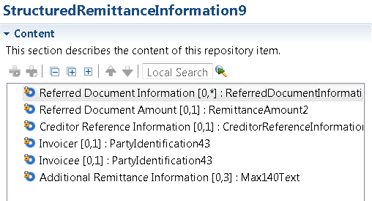

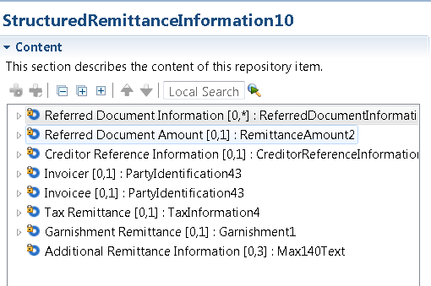

- SEG recommendation:

Consider |  | X | Timing
 |  |  | - Next yearly cycle: 2014/2015  (the change will be considered for implementation in the yearly maintenance cycle which starts in 2014 and completes with the publication of new message versions in the spring of 2015) |  | X
- At the occasion of the next maintenance of the messages
(the change will be considered for implementation, but does not justify maintenance of the messages in its own right – will be pending until more critical change requests are received for the messages)
- Urgent unscheduled
(the change justifies an urgent implementation outside of the normal yearly cycle)
 |  |  | - Other timing:
Comments:
Further correction to be implemented in 2015/2016 maintenance cycle

Reject
Reason for rejection:

- Impact analysis:
We confirm that this change request impacts the aforementioned messages, as identified in section B. No other messages have been identified.
- Proposed implementation:
Following the implementation performed for the maintenance cycle, 2014/2015, the StructureRemittanceInformation element has been incompletely implemented, as the following element has been missed in the updated component:
- StructureRemittanceInformation/ReferredDocumentInformation/LineDetails
We propose therefore to complete the implementation of the StructuredRemittanceInformation element through the following update through the replacement of current StructuredRemittanceInformation12 message component with the newly created StructuredRemittanceInformation13 component.
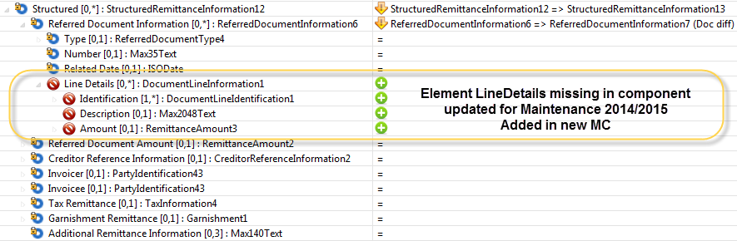
The result in the schema will be as follows:

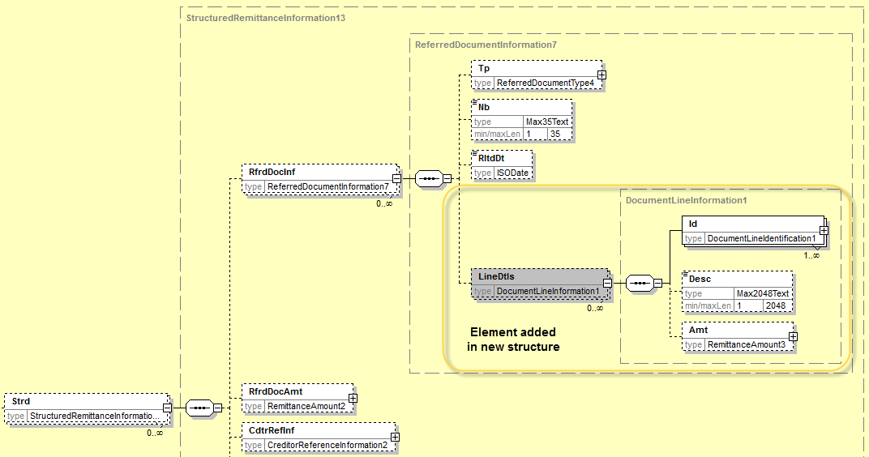

Remark: for the update of the same StructuredRemittanceInformation element in the RemittanceAdvice Message, please see CR0530: Update Structured Remittance Information
- Proposed timing:
The submitting organisation confirms that it can implement the requested changes in the requested timing.

Timing | As requested

- Final decision of the SEG:

Approve | X
Comments:

Reject
Reason for rejection:

CR0475: Remove duplicate components

- Origin of the request:
A.1 Submitter:
ISO 20022 RA
A.2 Contact persons:
Alexandre Hotat (iso20022ra@iso20022.org)
A.3 Sponsors: None

- Related messages:
The following message sets are impacted by this change request:
Cards:
- Card Payments Exchanges - Acceptor to Acquirer (Nexo)
Payments:
- Exceptions and Investigations (SWIFT)
- Payments Clearing and Settlement (SWIFT)
- Payments Initiation (SWIFT, ISTH)
Securities:
- Central Counter Party (CCP) Clearing (SWIFT, FPL)
- Collateral Management (SWIFT, FPL, ISDA/FpML and ISITC)
- Corporate Actions (SWIFT)
- Investment Funds (SWIFT)
- Issuers' Agents Communication (Euroclear)
- Post Trade Matching (SWIFT)
- Proxy Voting (SWIFT)
- Settlement and Reconciliation (SWIFT)
- Total Portfolio Valuation Report (ISITC)
- Transaction Regulatory Reporting (SWIFT)
Trade Services:
- Trade Services Management (SWIFT)

- Description of the change request:
Elimination of a series of 351 message components present in the ISO 20022 Data Dictionary that are duplicates of other existing message components. To ensure the elimination of these duplicates, the RA has registered all these components as ‘Obsolete’ in the Data Dictionary. Obsolete components cannot be re-used in new (versions of) messages. Out of these 351 message components, 80 are used in the current versions of ISO 20022 message definitions and will need to be replaced next time the messages have to be maintained for business reasons. The list of the obsolete message components and the message set(s) they are used in is in the appendix (see CR). Submitting organisations that would need more information to implement this change request are invited to contact the ISO 20022 RA.
- Purpose of the change:
As mentioned in the RA report to the RMG meeting in Toronto (see RMG document N3388), the ISO 20022 RA has identified a series of message components that are identical to each other and should be eliminated. The selection of the message components to be eliminated has been based on a careful analysis aiming at minimizing the impact of the cleaning on existing messages.
The purpose of the change is to clean the ISO 20022 Data Dictionary by eliminating message components that have been duplicated. This will bring more consistency between existing message sets and will make it easier for submitting organisations to select the appropriate message components in the Data Dictionary for future developments.
- Urgency of the request:
The obsolete message components must be replaced at the occasion of the next business maintenance of each message set. For consistency reasons, it is recommended that the SEG in charge considers replacing the obsolete message components in all the messages of a message set at the same time, even if the business change requests do not impact all these messages. In other words, as soon as a business maintenance of some messages of a message set is approved, it may make sense to remove the obsolete message components not only from these messages, but also from the other messages of the message set.
- Business examples:
N/A
- SEG recommendation:

Consider |  | X | Timing
- Next yearly cycle: 2015/2016
(the change will be considered for implementation in the yearly maintenance cycle which starts in 2015 and completes with the publication of new message versions in the spring of 2016)
 |  |  | - At the occasion of the next maintenance of the messages  (the change will be considered for implementation, but does not justify maintenance of the messages in its own right – will be pending until more critical change requests are received for the messages) |  | X
- Urgent unscheduled
(the change justifies an urgent implementation outside of the normal yearly cycle)
 |  |  | - Other timing:
Comments:
Payments SEG: Conference call 6 July: approved for consideration in the 2015/2016 maintenance cycle for all message sets to be maintained, next maintenance for other message sets.

Reject
Reason for rejection:

- Impact analysis:
Following the detailed analysis of the message components marked as obsolete in the repository by the ISO 20022 RA and used in the payments messages, two components have been identified:
- SettlementInstruction1, which is a duplicated element and must be replaced with SettlementInstruction4;
- SecuritiesAccount13, which uses an obsolete message component (GenericIdentification20) and must be replaced with SecuritiesAccount19 already existing in the repository.

Based on the above review following messages are impacted:
- SettlementInstruction1:

Component: SettlementInstruction1
Impacted Message | Message Identifier
AdditionalPaymentInformationV05 | camt.028.001.05
ResolutionOfInvestigationV05 | camt.029.001.05
CustomerPaymentCancellationRequestV04 | camt.055.001.04
FIToFIPaymentCancellationRequestV04 | camt.056.001.04
FIToFIPaymentStatusReportV06 | pacs.002.001.06
PaymentReturnV05 | pacs.004.001.05
FIToFIPaymentReversalV05 | pacs.007.001.05
FIToFICustomerCreditTransferV05 | pacs.008.001.05
FinancialInstitutionCreditTransferV05 | pacs.009.001.05
CustomerPaymentStatusReportV06 | pain.002.001.06
CustomerPaymentReversalV05 | pain.007.001.05

Component: SettlementInstruction1
Impacted Message Component | Comment
GroupHeader49 | Element SettlementInformation typed by SettlementInstruction1
GroupHeader54 | Element SettlementInformation typed by SettlementInstruction1
GroupHeader57 | Element SettlementInformation typed by SettlementInstruction1
OriginalTransactionReference20 | Element SettlementInformation typed by SettlementInstruction1
PaymentComplementaryInformation4 | Element SettlementInformation typed by SettlementInstruction1
OriginalPaymentInstruction10 | Ripple Effect - Uses PaymentTransaction55
OriginalPaymentInstruction11 | Ripple Effect - Uses PaymentTransaction56
OriginalPaymentInstruction12 | Ripple Effect - Uses PaymentTransaction57
OriginalPaymentInstruction13 | Ripple Effect - Uses PaymentTransaction58
PaymentTransaction52 | Ripple Effect - Uses OriginalTransactionReference20
PaymentTransaction54 | Ripple Effect - Uses OriginalTransactionReference20
PaymentTransaction55 | Ripple Effect - Uses OriginalTransactionReference20
PaymentTransaction56 | Ripple Effect - Uses OriginalTransactionReference20
PaymentTransaction57 | Ripple Effect - Uses OriginalTransactionReference20
PaymentTransaction58 | Ripple Effect - Uses OriginalTransactionReference20
UnderlyingTransaction9 | Ripple Effect - Uses PaymentTransaction54
UnderlyingTransaction10 | Ripple Effect - Uses PaymentTransaction55
UnderlyingTransaction11 | Ripple Effect - Uses OriginalPaymentInstruction13

- SecuritiesAccount13

Component: SecuritiesAccount13
Impacted Message | Message Identifier
BankToCustomerAccountReportV05 | camt.052.001.05
BankToCustomerDebitCreditNotificationV05 | camt.054.001.05
BankToCustomerStatementV05 | camt.053.001.05

Component: SecuritiesAccount13
Impacted Message Component | Comment
EntryTransaction7 | Element SafekeepingAccount typed by SecuritiesAccount13
EntryDetails6 | Ripple Effect - Uses EntryTransaction7
ReportEntry7 | Ripple Effect - Uses EntryDetails6
AccountNotification11 | Ripple Effect - Uses ReportEntry7
AccountReport18 | Ripple Effect - Uses ReportEntry7
AccountStatement5 | Ripple Effect - Uses ReportEntry7

- Proposed implementation:
As required through the Change Request,

- SettlementInstruction1 will be replaced by SettlementInstruction4:
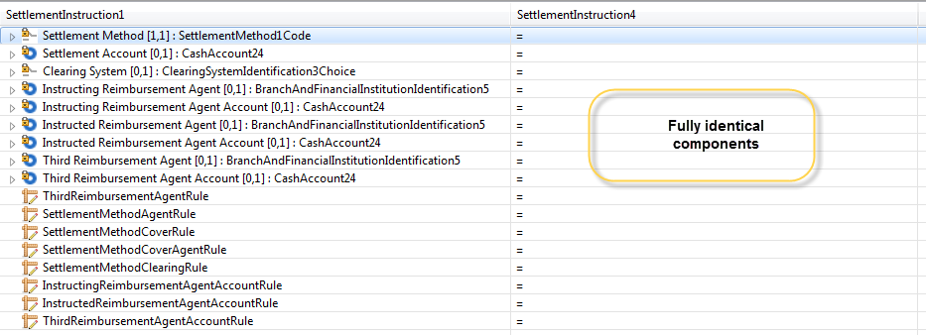

- SecuritiesAccount13 will be replaced with SecuritiesAccount19:
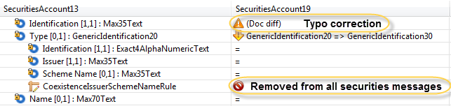
- Proposed timing:
The submitting organisation confirms that it can implement the requested changes in the requested timing.
Timing | As requested

- Final decision of the SEG:

Approve | X
Comments:

Reject
Reason for rejection:

CR0517: Add BankTransactionCode in camt.086

- Origin of the request:
A.1 Submitter:
SWIFT, 8 Marina View, Asia Square Tower 1, #28-04, Singapore 018960
A.2 Contact person:
David Dobbing,
SWIFT Standards Department,
Tel: +65 8500 8056,
Email: david.dobbing@swift.com
A.3 Sponsors:
Harri Rantanen
Global Formats and Standards Manager
SEB
Email: harri.rantanen@seb.fi

Selina Bolton
Global Transaction Banking
Deutsche Bank
Email: selina.bolton@db.com

CGI-MP - Common Global Implementation – Market Practice
WG5 Working Group 5 (Bank Services Billing)

- Related messages:
- camt.086.001.01 BankServicesBillingStatementV01

- Description of the change request:
Request to add in the BankService <BkSvc> block, a new optional component to support the specification of the Bank Transaction Code (BTC), in alignment with the same component found in the account reporting messages (camt.052, camt.053, and camt.054).
Request that it be implemented along-side the Common Code <CmonCd> in the BankService <BkSvc> block, to support the use of either, or both, the BTC and/or Common Code.
A draft of the proposed structure is depicted for reference overleaf.

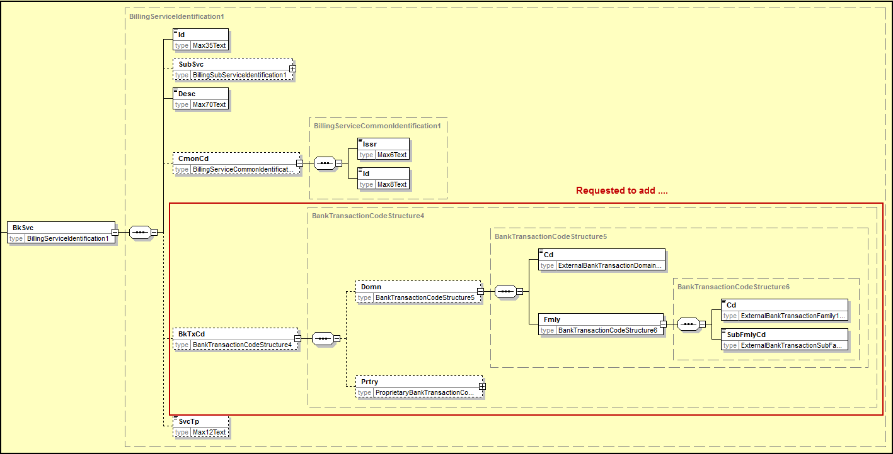
- Purpose of the change:
In terms of uniquely identifying bank services, the Bank Transaction Code (BTC) has featured in the set of existing Bank-to-Customer Cash Management ISO 20022 messages, notably the camt.052 (Bank To Customer Account Report), camt.053 (Bank To Customer Statement) and the camt.054 (Bank To Customer Debit Credit Notification). Support for the use of the same Bank Transaction Code in the camt.086 (Bank Services Billing) message is foreseen as important to ensure alignment across these message types and can be considered in addition to, or as an alternative to, the notion of the Common Code <CmonCd> found in the camt.086.

- Urgency of the request:
To be handled in accordance with the normal yearly maintenance cycle.

- Business examples:
Existing account reports have the Bank Transaction Code defined as a mandatory element and provide examples of its of usage.

- SEG recommendation:

Consider |  | X | Timing
 |  |  | - Next yearly cycle: 2015/2016  (the change will be considered for implementation in the yearly maintenance cycle which starts in 2015 and completes with the publication of new message versions in the spring of 2016) |  | X
- At the occasion of the next maintenance of the messages
(the change will be considered for implementation, but does not justify maintenance of the messages in its own right – will be pending until more critical change requests are received for the messages)
- Urgent unscheduled
(the change justifies an urgent implementation outside of the normal yearly cycle)
 |  |  | - Other timing:
Comments:

Reject
Reason for rejection:

- Impact analysis:
We confirm that this change request impacts the aforementioned message, as identified in section B:
- camt.086.001.01 BankServicesBillingStatementV01
No other messages have been identified.

In analysing the impact on the existing message, we identified that a second instance of the BankService element is used in following location:
- BillingStatement/TaxRegion/MethodC/ServiceDetail/BankService.
We confirmed with the submitter of the CR that the Bank Transaction Code should not be added to the second occurrence of the BankService element.

- Proposed implementation:

The implementation will be done exactly as proposed in section C – Description of the change.

- Proposed timing:
The submitting organisation confirms that it can implement the requested changes in the requested timing.

Timing | As requested

- Final decision of the SEG:

Approve | X
Comments:

Reject
Reason for rejection:

CR0529: Remove XOR rule in camt.052 and camt.053

- Origin of the request:
A.1 Submitter: ISO 20022 Registration Authority.
A.2 Contact person: Jean-Marie Eloy (jean-marie.eloy@swift.com, +3226553854)
A.3 Sponsors: new edition of ISO 20022:2013 (v1.5)

- Related messages:
- BankToCustomerAccountReportV05 camt.052.001.05
- BankToCustomerStatementV05 camt.053.001.05

- Description of the change request:
Replacement of the ‘unnamed’ <<xor>> rule in a message component used in camt.052 and the camt.053 by a ‘named’ ChoiceComponent to ensure compliance with the new edition ISO 20022:2013 (v1.5).
Component which contains the unnamed <<xor>> and which must be replaced is: CashBalanceAvailabilityDate1, which types the Balance/Availability/Date element.

- Purpose of the change:
Under the new edition ISO 20022:2013, ‘unnamed’ choices (known as XOR choices) are forbidden and should be replaced by ‘named’ ChoiceComponents. Unnamed choices are difficult to implement as they require an implementer to 'invent' a name for the choice. Unnamed choices may also be confusing to a user if a choice has to be made without any context as to why the choice is there.
- Urgency of the request:
We leave it up to the SEG and the Submitting Organisation in charge of the maintenance of this message definition to decide the most appropriate maintenance cycle to implement the changes.
- Business example:
N/A

- SEG recommendation:

Consider |  | x | Timing
 |  |  | - Next yearly cycle: 2015/2016  (the change will be considered for implementation in the yearly maintenance cycle which starts in 2015 and completes with the publication of new message versions in the spring of 2016) |  | x
- At the occasion of the next maintenance of the messages
(the change will be considered for implementation, but does not justify maintenance of the messages in its own right – will be pending until more critical change requests are received for the messages)
- Urgent unscheduled
(the change justifies an urgent implementation outside of the normal yearly cycle)
 |  |  | - Other timing:
Comments:

Reject
Reason for rejection:

- Impact analysis:
This change request impacts both messages, as indicated in section B.
In performing the impact analysis, we also identified that the message component is also used in the camt.054 under the Availability element (see implementation proposal below) – used in the TransactionsSummary/TotalEntriesPerBankTransactionCode/Availability element.
We therefore suggest that the new element shall not only be defined as a choice component, but also shall also be renamed into CashAvailability1Choice to reflect that the element is not only used in balance components.
Final list of impacted messages following the impact analysis results:
- BankToCustomerAccountReportV05 (camt.052.001.05)
- BankToCustomerStatementV05 (camt.053.001.05)
- BankToCustomerDebitCreditNotificationV05 (camt.054.001.05)
- Proposed implementation:
Proposal is to replace the CashBalanceAvailabilityDate1 component, which contains the XOR rule, with a new Choice component.
There is no impact on the structure of the message instances, as this XOR rule actually implements the component as a choice component.
- Current structure of the component in the schema:
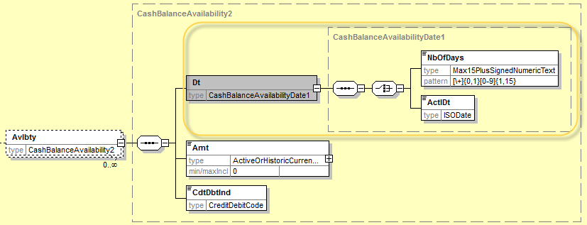

<xs:complexType name="CashBalanceAvailabilityDate1">
<xs:sequence>
<xs:choice>
<xs:element name="NbOfDays" type="Max15PlusSignedNumericText"/>
<xs:element name="ActlDt" type="ISODate"/>
</xs:choice>
</xs:sequence>
</xs:complexType>
- Resulting structure in the schema:
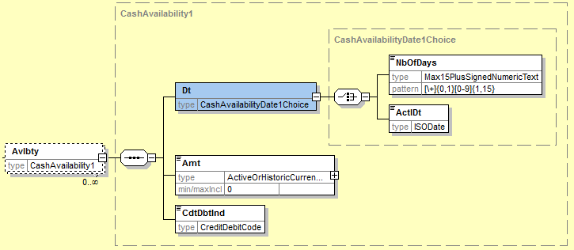

<xs:complexType name="CashAvailabilityDate1Choice">
<xs:choice>
<xs:element name="NbOfDays" type="Max15PlusSignedNumericText"/>
<xs:element name="ActlDt" type="ISODate"/>
</xs:choice>
</xs:complexType>

This change must be implemented in following elements:
- Report/Balance/Avalability/Date (only in camt.052 and camt.053)
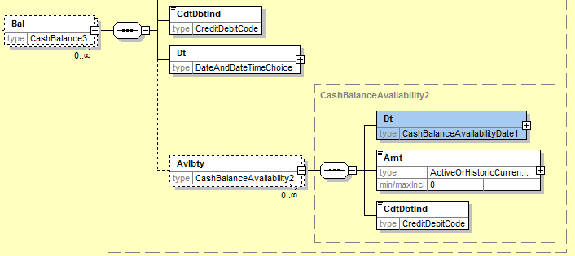

- Report/Entry/Availability/Date (in camt.052, camt.053 and camt.054)
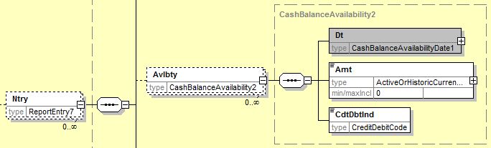

- Report/TransactionSummary/TotalPerBankTransactionCode/Availability/Date
(in camt.052, camt.053 and camt.054)
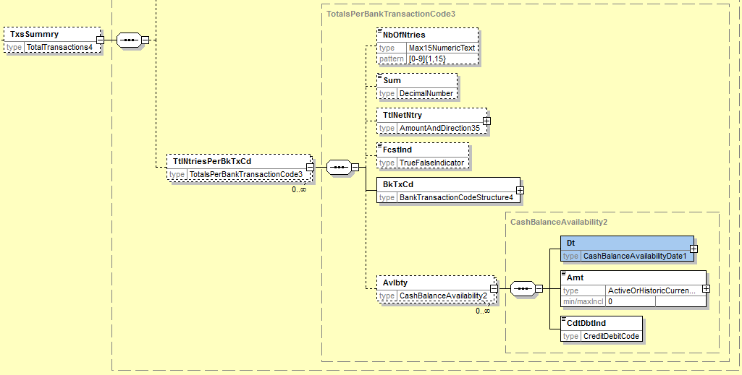
- Proposed timing:
The submitting organisation confirms that it can implement the requested changes in the requested timing

Timing | As requested

- Final decision of the SEG:

Approve | X
Comments:

Reject
Reason for rejection:

CR0530: Update Structured Remittance Information

- Origin of the request:
A.1 Submitter: SWIFT SCRL, Avenue Adèle 1, B-1310 La Hulpe, Belgium, on request of the Payments SEG.
A.2 Contact person: Vincent Kuntz, vincent.kuntz@swift.com (+32.2.655.33.53)
A.3 Sponsors: Payments SEG.

- Related messages:
- remt.001.001.01 | RemittanceAdviceV01

- Description of the change request:
Incorporate a new updated version of the StructuredRemittanceInformation message component in Stand-Alone Remittance Advice message, to align with the payment messages for year 2016. The StructuredRemittanceInformation must be aligned with the component resulting from the corrective update to be implemented for CR0396 (see MCR for detailed implementation).

- Purpose of the change:
A new ISO 20022 Stand-alone Remittance Advice message (RemittanceAdviceV01, remt.001.001.01) was developed that includes an enhanced version of the StructuredRemittanceInformation message component, a sub-component of RemittanceInformation8. This change request is to replace the version used in the Stand-alone Remittance Advice message with the one that will be created to finalise the implementation of the CR0396, to ensure full alignment between the StructuredRemittanceInformation message component with the new version.

- Urgency of the request:
This change should be introduced as part of the default maintenance schedule.
- Business examples:
See CR0396 and 2014/2015 MCR for details.
- SEG recommendation:
This section is not to be taken care of by the submitter of the change request. It will be completed in due time by the SEG(s) in charge of the related ISO 20022 messages.

Consider |  | X | Timing
 |  |  | - Next yearly cycle: 2015/2016  (the change will be considered for implementation in the yearly maintenance cycle which starts in 2015 and completes with the publication of new message versions in the spring of 2016) |  | X
- At the occasion of the next maintenance of the messages
(the change will be considered for implementation, but does not justify maintenance of the messages in its own right – will be pending until more critical change requests are received for the messages)
- Urgent unscheduled
(the change justifies an urgent implementation outside of the normal yearly cycle)
 |  |  | - Other timing:
Comments:

Reject
Reason for rejection:

- Impact analysis:
This change request impacts the RemittanceAdviceV01 (remt.001.001.01) message, as indicated in section B.

- Proposed implementation:
Implementation will be performed as described in section C – Description of the change request, as follows:
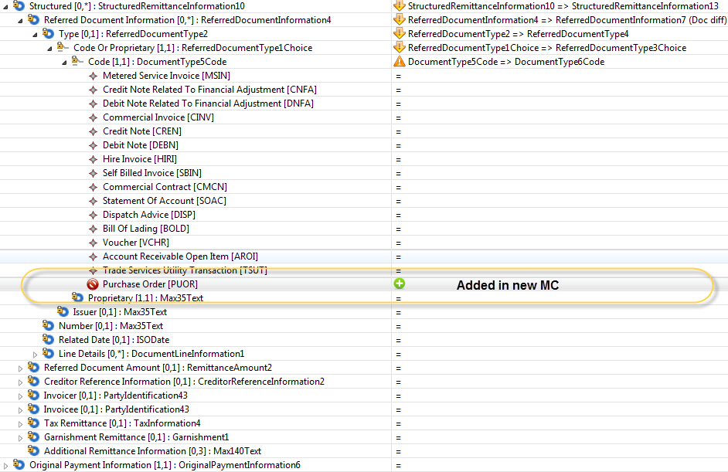
In practical, this means that the StructureRemittanceInformation10 message component will be replaced by StructuredRemittanceInformation13 (same component as defined in CR0396)
- Proposed timing:
The submitting organisation confirms that it can implement the requested changes in the requested timing.

Timing | As requested

- Final decision of the SEG:

Approve | X
Comments:

Reject
Reason for rejection:
Appendix
Change Request CR0534
Change of pattern of datatypes ISIN and CFI in all ISO 20022 messages

- Origin of the request:
A.1 Submitter: ISO 20022 Registration Authority.
A.2 Contact person: Jean-Marie Eloy (iso20022ra@iso20022.org)
A.3 Sponsors: European Securities and Markets Authority (ESMA)
- Related messages:
All message definitions that use the ISIN Identifier or the CFI Identifier.
The following message sets and messages are impacted. They all use the ISIN and those marked with a “*” also use the CFI :
- Corporate Actions
seev.031.001* | seev.031.002*
seev.033.001* | seev.033.002*
seev.034.001 | seev.034.002
seev.035.001* | seev.035.002*
seev.036.001 | seev.036.002
seev.037.001 | seev.037.002
seev.038.001 | seev.038.002
seev.039.001 | seev.039.002
seev.040.001 | seev.040.002
seev.041.001 | seev.041.002
seev.042.001 | seev.042.002
seev.044.001 | seev.044.002
- Securities Settlement and Reconciliation
semt.002.001* | semt.002.002*
semt.003.001* | semt.003.002*
semt.013.001* | semt.013.002*
semt.014.001 | semt.014.002
semt.015.001* | semt.015.002*
semt.016.001* | semt.016.002*
semt.017.001 | semt.017.002
semt.018.001 | semt.018.002
semt.019.001* | semt.019.002*
semt.021.001 | semt.021.002
sese.020.001 | sese.020.002
sese.023.001* | sese.023.002*
sese.024.001 | sese.024.002
sese.025.001* | sese.025.002*
sese.026.001* | sese.026.002*
sese.027.001 | sese.027.002
sese.028.001* | sese.028.002*
sese.029.001 | sese.029.002
sese.030.001* | sese.030.002*
sese.032.001* | sese.032.002*
sese.033.001* | sese.033.002*
sese.034.001 | sese.034.002
sese.035.001* | sese.035.002*
sese.036.001 | sese.036.002
sese.037.001* | sese.037.002*
sese.038.001* | sese.038.002*
sese.039.001 | sese.039.002
sese.040.001 | sese.040.002
- Collateral Management
colr.007.001
colr.010.001
colr.016.001
- Bank-to-Customer Cash Management
camt.052.001
camt.053.001
camt.054.001
- Total Portfolio Valuation
sese.037.001
- CCP Clearing
secl.001.001
secl.002.001
secl.003.001
secl.004.001
secl.005.001
secl.007.001
secl.008.001
secl.009.001
secl.010.001
- Post Trade Matching
setr.027.001*
setr.044.001
- Proxy Voting
seev.001.001
seev.002.001
seev.003.001
seev.004.001
seev.005.001
seev.006.001
seev.007.001
seev.008.001
- Issuers’ Agents Communication
seev.009.001
seev.010.001
seev.011.001
seev.012.001
seev.013.001
seev.014.001
seev.015.001
seev.016.001
seev.017.001
seev.018.001
seev.019.001
seev.020.001
seev.021.001
seev.022.001
seev.023.001
seev.024.001
seev.025.001
seev.026.001
seev.027.001
seev.028.001
seev.029.001
seev.030.001
- Transaction Regulatory Reporting
auth.008.001*
auth.009.001*
- Investment Funds
acmt.001.001
acmt.002.001
acmt.003.001
camt.040.001
camt.041.001
camt.042.001
camt.043.001
camt.044.001
camt.045.001
reda.001.001
reda.002.001
reda.004.001
reda.005.001
semt.002.001
semt.003.001
semt.004.001
semt.005.001
semt.006.001
semt.007.001
sese.001.001
sese.002.001
sese.003.001
sese.004.001
sese.005.001
sese.006.001
sese.007.001
sese.008.001
sese.012.001
sese.013.001
sese.014.001
sese.018.001
sese.019.001
setr.001.001
setr.002.001
setr.003.001
setr.004.001
setr.005.001
setr.006.001
setr.007.001
setr.008.001
setr.009.001
setr.010.001
setr.011.001
setr.012.001
setr.013.001
setr.014.001
setr.015.001
setr.016.001
setr.017.001
setr.018.001
setr.047.001
setr.048.001
setr.049.001
setr.050.001
setr.051.001
setr.052.001
setr.053.001
setr.054.001
setr.055.001
setr.056.001
setr.057.001
setr.058.001

- Description of the change request:
- Change the pattern of datatype ISINIdentifier from 12 uppercase alphanumeric characters, that is, [A-Z0-9]{12,12} to 2 uppercase letters + 9 uppercase alphanumeric characters + 1 digit, that is [A-Z]{2,2}[A-Z0-9]{9,9} [0-9]{1,1}
- Change the pattern of datatype CFIIdentifier from a string of up to 6 uppercase letters, that is, [A-Z]{1,6}to a string of 6 uppercase letters, that is, [A-Z]{6,6}.
For this purpose, the RA has created two new datatypes :
- ISINOct2015Identifier
- CFIOct2015Identifier
And, to avoid further re-use of the current datatypes, the RA has changed the registration status of the current ISINIdentifier and CFIIdentifier to “Obsolete”.

- Purpose of the change:
The patterns of the current datatypes ISINIdentifier and CFIIdentifer are not fully aligned with the patterns described in ISO 6166 and ISO 10962 respectively.
Within the context of the decision to use ISO 20022 for MiFIR reporting in Europe, ESMA has requested that the pattern of the two above mentioned datatypes be made more restrictive as described in the respective ISO standards.
- Urgency of the request:
Because the current datatypes have been marked as “obsolete”, all new messages will have to use the new datatypes.
All existing messages that use these datatypes will need to be updated at the occasion of their next maintenance, unless decided otherwise by the relevant SEG.
Please note however that this CR is being implemented already in the 2015/2016 maintenance cycle for the Securities Settlement & Reconciliation and Corporate Actions message sets as well as the Collateral Management and Bank to Customer Cash Management message sets which had to be maintained in this 2015/2016 cycle. This decision has been taken since there was a unique opportunity to update, in one go, all 40 S&R and Corporate Actions messages as well as their 40 ISO 15022 variants that will be published together with the new version of the global messages in February 2016.
- Business examples:
N/A
- SEG recommendation:

Consider |  | X | Timing
 |  |  | - Next yearly cycle: 2015/2016  (the change will be considered for implementation in the yearly maintenance cycle which starts in 2016 and completes with the publication of new message versions in the spring of 2017) |  | X
- At the occasion of the next maintenance of the messages
(the change will be considered for implementation, but does not justify maintenance of the messages in its own right – will be pending until more critical change requests are received for the messages)
- Urgent unscheduled
(the change justifies an urgent implementation outside of the normal yearly cycle)
 |  |  | - Other timing:
Comments:

Reject
Reason for rejection:
- Impact analysis:
This change request only impacts the 3 Bank-to-Customer Cash Management messages (camt.052, camt.053 and camt.054) in the messages sets under the responsibility of the Payments SEG, as indicated in section B.

- Proposed implementation:
Implementation will be performed through the replacement of the obsolete SecurityIdentification14 message component which types the FinancialInstrumentIdentification element in the TransactionDetails, with the new SecurityIdentification19 component created for the securities messages, as follows:
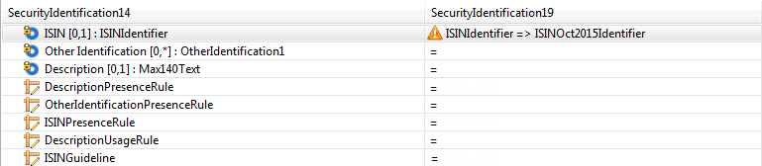
In practical, this means that the SecurityIdentification14 message component will be replaced by SecurityIdentification19.
- Proposed timing:
The submitting organisation confirms that it can implement the requested changes in the requested timing.

Timing | As requested

- Final decision of the SEG:

Approve | X
Comments:

Reject
Reason for rejection:

Note that during the Payments SEG meeting of 4 January 2016, it was agreed to revise the scope of this message to read: “The CreditorPaymentActivationRequest message is sent by the Creditor sending party to the Debtor receiving party, directly or through agents. It is used by a Creditor to request movement of funds from the debtor account to a creditor.”
Ripple effect means that the message component must be updated because it uses a message component that was updated due to the change request, but no further changes are applied.
Ripple effect means that the message component must be updated because it uses a message component that was updated due to the change request, but no further changes are applied.

