**Maintenance Change Request**

**for the update of ISO 20022 financial repository items**

1. **Name of the request:**

“ISO 20022 Payments Maintenance 2012/2013”

1. **Submitting organization(s):**

SWIFT, on behalf of IFX, SWIFT, TWIST and OAGi (ISTH).

1. **Related messages:**

Under this project, below existing ISO 20022 Payments messages would be maintained.

1. **Payments Initiation messages set:**

|  |  |
| --- | --- |
| * pain.001.001.04 | CustomerCreditTransferInitiationV04 |
| * pain.002.001.04 | CustomerPaymentStatusReportV04 |
| * pain.007.001.03 | CustomerPaymentReversalV03 |
| * pain.008.001.03 | CustomerDirectDebitInitiationV03 |

1. **Mandate messages set:**

|  |  |
| --- | --- |
| * pain.009.001.02 | MandateInitiationRequestV02 |
| * pain.010.001.02 | MandateAmendmentRequestV02 |
| * pain.011.001.02 | MandateCancellationRequestV02 |
| * pain.012.001.02 | MandateAcceptanceReportV02 |

1. **Payments Clearing and Settlement messages set:**

|  |  |
| --- | --- |
| * pacs.002.001.04 | FIToFIPaymentStatusReportV04 |
| * pacs.003.001.03 | FIToFICustomerDirectDebitV03 |
| * pacs.004.001.03 | PaymentReturnV03 |
| * pacs.007.001.03 | FIToFIPaymentReversalV03 |
| * pacs.008.001.03 | FIToFICustomerCreditTransferV03 |
| * pacs.009.001.03 | FinancialInstitutionCreditTransferV03 |

1. **B2C Cash Management messages set:**

|  |  |
| --- | --- |
| * camt.052.001.03 | BankToCustomerAccountReportV03 |
| * camt.053.001.03 | BankToCustomerStatementV03 |
| * camt.054.001.03 | BankToCustomerDebitCreditNotificationV03 |
| * camt.060.001.03 | AccountReportingRequestV03 |

1. **Exceptions & Investigations messages set:**

|  |  |
| --- | --- |
| * camt.055.001.02 | CustomerPaymentCancellationRequestV02 |
| * camt.056.001.02 | FIToFIPaymentCancellationRequestV02 |

1. **Commitments of the submitting organization:**

SWIFT, the submitting organization confirms that it can and will:

* undertake the development of the new version of the candidate ISO 20022 message models and submit to the RA for compliance review and evaluation. New valid Message Definition models will be available to the RA by December 1.
* provide compliant updated Business Process Diagram (activity diagram), Message Flow Diagram (sequence diagram) and new examples of valid and invalid XML instances of each candidate message and other descriptive material that will be used by the RA to generate the full Message Definition Report by May 1 at the latest.
* address any queries related to the description of the new models and messages as published by the RA on the ISO 20022 website.

SWIFT confirms it intends to organize the actual implementation of the new version of the messages once the related documentation has been published by the RA.

SWIFT confirms its knowledge and acceptance of the ISO 20022 Intellectual Property Rights policy for contributing organizations, as follows.

*“Organizations that contribute information to be incorporated into the ISO 20022 Repository shall keep any Intellectual Property Rights (IPR) they have on this information. A contributing organization warrants that it has sufficient rights on the contributed information to have it published in the ISO 20022 Repository through the ISO 20022 Registration Authority in accordance with the rules set in ISO 20022. To ascertain a widespread, public and uniform use of the ISO 20022 Repository information, the contributing organization grants third parties a non-exclusive, royalty-free license to use the published information”.*

1. **Contact persons:**

Vincent Kuntz – SWIFT Standards, [vincent.kuntz@swift.com](mailto:vincent.kuntz@swift.com)

Tinne Verschueren – SWIFT Standards, [tinne.verschueren@swift.com](mailto:tinne.verschueren@swift.com)

Stephen Lindsay – SWIFT Standards, [stephen.lindsay@swift.com](mailto:stephen.lindsay@swift.com)

Table of Contents

1. Global Change Requests 4

1.1. CR0235 – Define SupplementaryData at transaction level 4

1.2. CR0241 – Adapt rule to sub-elements in PaymentTypeInformation 10

2. Payment Initiation Change Requests 16

2.1 CR0174 – Allow for multiple mandate instances 16

3. Cash Mangement Change requests 22

3.1 CR0234 Restriction of TotalNetEntryAmount Data Type 22

3.2 CR0240 – Addition of RelatedPrice at Entry level 26

# Global Change Requests

## CR0235 – Define SupplementaryData at transaction level

1. **Origin of the request:**

*A.1 Submitter*: Payments SEG.

*A.2 Contact person:* Thomas Egner (Thomas.Egner@commerzbank.com)

*A.3 Sponsors*: Payments SEG, Berlin Group

1. **Related messages:**

Payments messages including a repetitive sequence of transactions: pain.001, pain.002, pain.007, pain.008, all pacs messages, camt.052, camt.053, camt.054, camt.055, camt.056.

1. **Description of the change request:**

Add a 'SupplementaryData' message component at the end of the repetitive transaction level on top of the SupplementaryData component already present at the end of the message (see appendix).

1. **Purpose of the change:**

In a mass transaction/entry scenario, the concept of having a SupplementaryData component at the end of the message only may lead to IT memory and performance problems since the repetitive sequence of SupplementaryData at the end of the message must be linked back to each iteration of transaction/entry. As recommended by the TSG and approved by the RMG (resolution 12/205), this CR aims at eliminating these problems by linking directly the extended information to the transaction/entry.

Note: a powerpoint presentation is annexed to this CR to detail transactions travelling through the payment chain.



1. **Urgency of the request:**

As several business cases has already been identified, the change should be implemented at the earliest opportunity

1. **Business example:**

Berlin Group requirements specific to the clearing of card payments (see CR0001 and CR0146).

1. **SEG recommendation:**

|  |  |  |  |
| --- | --- | --- | --- |
| **Consider** | | Y | **Timing** |
|  | | - **Next yearly cycle: 2012/2013**  (the change will be considered for implementation in the yearly maintenance cycle which starts in 2012 and completes with the publication of new message versions in the spring of 2013) | | X | **Priority**:  high  medium  low | |
|  | | - **At the occasion of the next maintenance of the messages**  (the change will be considered for implementation, but does not justify maintenance of the messages in its own right – will be pending until more critical change requests are received for the messages) | |  |
|  | | - **Urgent unscheduled**  (the change justifies an urgent implementation outside of the normal yearly cycle) | |  |  |
|  | | - **Other timing:** | | |  |

**Appendix**

**Payments Initiation messages set:**

|  |
| --- |
| * pain.001.001.04 CustomerCreditTransferInitiationV04 * GroupHeader * PaymentInformation * CreditTransferTransactionInformation * Proposal: SupplementaryData * SupplementaryData * pain.002.001.04 CustomerPaymentStatusReportV04 * GroupHeader * OriginalGroupInformationAndStatus * OriginalPaymentInformationAndStatus * TransactionInformationAndStatus * Proposal: SupplementaryData * SupplementaryData * pain.007.001.03 CustomerPaymentReversalV03 * GroupHeader * OriginalGroupInformation * OriginalPaymentInformationAndReversal * TransactionInformation * Proposal: SupplementaryData * SupplementaryData * pain.008.001.03 CustomerDirectDebitInitiationV03 * GroupHeader * PaymentInformation * DirectDebitTransactionInformation * Proposal: SupplementaryData * SupplementaryData |

**Payments Clearing and Settlement messages set:**

|  |
| --- |
| * pacs.002.001.04 FIToFIPaymentStatusReportV04 * GroupHeader * OriginalGroupInformationAndStatus * TransactionInformationAndStatus * Proposal: Supplementary Data * SupplementaryData * pacs.003.001.03 FIToFICustomerDirectDebitV03 * GroupHeader * DirectDebitTransactionInformation * Proposal: Supplementary Data * SupplementaryData * pacs.004.001.03 PaymentReturnV03 * GroupHeader * OriginalGroupInformation * TransactionInformation * Proposal: Supplementary Data * SupplementaryData * pacs.007.001.03 FIToFIPaymentReversalV03 * GroupHeader * OriginalGroupInformation * TransactionInformation * Proposal: Supplementary Data * SupplementaryData * pacs.008.001.03 FIToFICustomerCreditTransferV03 * GroupHeader * CreditTransferTransactionInformation * Proposal: Supplementary Data * SupplementaryData * pacs.009.001.03 FinancialInstitutionCreditTransferV03 * GroupHeader * CreditTransferTransactionInformation * Proposal: Supplementary Data * SupplementaryData |

**Cash Management messages set:**

|  |  |
| --- | --- |
| * camt.052.001.03 BankToCustomerAccountReportV03 * GroupHeader * Report * Entry   + EntryDetails     - TransactionDetails     - Proposal: Supplementary Data * SupplementaryData * camt.053.001.03 BankToCustomerStatementV03 * GroupHeader * Statement * Entry   + EntryDetails     - TransactionDetails     - Proposal: Supplementary Data * SupplementaryData * camt.054.001.03 BankToCustomerDebitCreditNotificationV03 * GroupHeader * Notification * Entry   + EntryDetails     - TransactionDetails     - Proposal: Supplementary Data * SupplementaryData   Note: for all camt B2C messages, Entry level and TransactionDetails level are nested and repetitive, and it is likely that each message will contain multiple entries, and each entry likely contains multiple transactions. The preference of the change request was for a supplementary data component to be added only at TransactionDetails level. In this case, entry elements could only be extended by specifying the path to the extended element in a message level supplementary data component.  An alternative, that may be considered is including a supplementary component on both levels (Entry and TransactionDetails) with a clear recommendation in the message that the supplementary data component on the level of the element to be extended should be used (and not the one higher up in the message structure). This approach would result in cleaner and more understandable messages, in cases where many entry elements need to be extended. The evaluation team should consider the likelihood of this occurring in practice. | |
| * camt.055.001.02 CustomerPaymentCancellationRequestV02 * Assignment * Case * ControlData * Underlying * OriginalPaymentInformationAndCancellation * TransactionInformation   + Proposal SupplementaryData * SupplementaryData * camt.056.001.02 FIToFIPaymentCancellationRequestV02 * Assignment * Case * ControlData * Underlying * TransactionInformation   + Proposal SupplementaryData * SupplementaryData |

1. **Impact analysis:**

This change request impacts the latest version of the messages indicated in section B and the appendix, but it can be considered to also look at a potential implementation in:

|  |  |
| --- | --- |
| * camt.060.001.03 | AccountReportingRequestV03 |
| * pain.013.001.02 | CreditorPaymentActivationRequestV02 (CBI message) |
| * pain.014.001.02 | CreditorPaymentActivationRequestStatusReportV02 (CBI message) |

**Remarks:**

1. **This is the only change request received for this maintenance cycle for the following messages:**

|  |  |
| --- | --- |
| * pain.002.001.04 | CustomerPaymentStatusReportV04 |
| * pain.007.001.03 | CustomerPaymentReversalV03 |
| * pacs.002.001.03 | FIToFIPaymentStatusReportV03 |
| * pacs.004.001.02 | PaymentReturnV02 |
| * pacs.007.001.02 | FIToFIPaymentReversalV02 |
| * camt.060.001.02 | AccountReportingRequestV02 |
| * camt.056.001.02 | FIToFIPaymentCancellationRequestV02 |

1. **Depending on the outcome of CR0174, this request should also be considered for:**

|  |  |
| --- | --- |
| * pain.009 | MandateInitiationRequest |
| * pain.010 | MandateAmendmentRequest |
| * pain.011 | MandateCancellationRequest |
| * pain.012 | MandateAcceptanceReport |

1. **Proposed implementation:**

The implementation will be similar to the supplementary data on message level, respecting the ISO 20022 modelling guidelines. The following will be added at the end of the repetitive transaction section per message as indicated in the appendix:

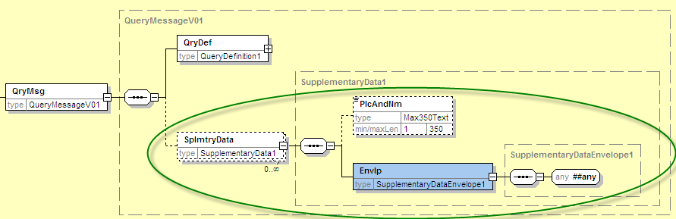

A rule will be needed to distinguish the use of supplementary data on message or transaction level. The proposed rule for SupplementaryData on **message level**:

*This block must not be used to provide additional information on transactions that cannot be captured in the structured elements and/or any other specific block. The supplementary data on transaction level should be used for that purpose.*

1. **Proposed timing:**

The submitting organization confirms that it can implement the requested changes in the requested timing.

|  |  |
| --- | --- |
| Timing | * As requested |

1. **Final decision of the SEG:**

|  |  |
| --- | --- |
| Approve | Yes |

Comments: addition of SupplementaryData component approved at transaction level.

The change should be made to the CPAR messages as well: pain.013 and pain.014 (by CBI Consortium).

|  |  |
| --- | --- |
| Reject |  |

Reason for rejection:

## CR0241 – Adapt rule to sub-elements in PaymentTypeInformation

1. **Origin of the request:**

*A.1 Submitter*:

SIX Interbank Clearing Ltd, Zurich (Switzerland)

*A.2 Contact person:*

SIX Interbank Clearing Ltd, Hardturmstrasse 201, 8021 Zurich

|  |  |  |
| --- | --- | --- |
| Istvan Teglas | istvan.teglas@six-group.com | +41 58 399 4238 |

*A.3 Sponsors*:

UBS AG, CH-8098 Zurich

Credit Suisse, CH-8070 Zurich

Postfinance, CH-3000 Bern

Zürcher Kantonalbank, CH-8001 Zurich

SIX Interbank Clearing Ltd, CH-8021 Zurich

1. **Related messages:**

pain.001.001.03

Comment: a similar rule exists also in the following messages (the change of these rules is not part of this change request):

* Pacs.003 (R7)
* Pacs.008 (R7)
* Pacs.009 (R7)
* Pain.008 (R3)

1. **Description of the change request:**

In the document “Message Definition Report”, the rule 1 limits the use of the group “Payment Type Information” in the pain.001 either to the “Payment Information” or to the “Payment Information / Credit Transfer Transaction” level:

*“R1 PaymentTypeInformationRule: If PaymentTypeInformation is present, then CreditTransferTransactionInformation/PaymentTypeInformation is not allowed.”*

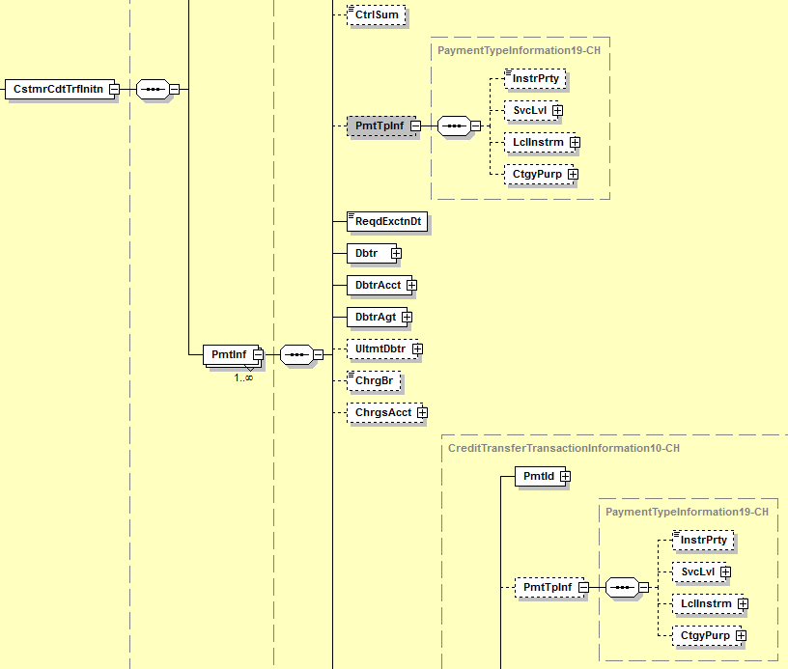

Because the group “Payment Type Information” consist of different elements/sub groups, the limitation should be applied to the sub elements/groups of “Payment Type Information”, instead of the group itself:

* Instruction Priority
* Service Level
* Local Instrument
* Category Purpose

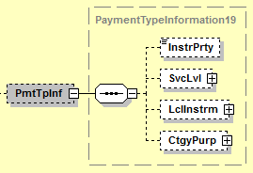

It should be possible to use some of these Elements on “Payment Information” level and some other on “Payment Information / Credit Transfer Transaction” level (but not the same Element on both level). Some transactions might have to be marked differently on the “Payment Information / Credit Transfer Transaction” level, even if some other marks are valid for all transactions and should be done on “Payment Information” level.

In particular the group “Local Instrument” is foreseen to carry “local” instructions (valid for a whole community and not just for a defined creditor agent) and information (*“This element is used to specify a local instrument, local clearing option and/or further qualify the service or service level.”)*. Thus there is the need, for example, to use Instruction Priority on the “Payment Information” level because it is valid for all transaction of this “Payment Information” level, but to use “Local Instrument” on “Credit Transfer Transaction” level with different values in some or in each transaction.

1. **Purpose of the change:**

Business Reason:

For example transactions marked as “Salary “Payment” in the element “CategoryPurpose” on the “Payment Information” level. The content is propagated to all underlying Transactions. The Transactions are used with BIC, National Identifier as well as the different values for the element “Local Instrument” as used in Switzerland for the several local Swiss payment types. This constellation is not supported by ISO Rule 1 saying, that the element “Payment Type Information” has to be either on “Payment Information” level or on “Payment Information / Credit Transfer Transaction” level.

It should also be possible to mark payments on “Payment Information” level in the Element “Payment Information/ Instruction Priority” with “HIGH”, propagated to all underlying Transactions, but to mark some of the underlying transactions in the Element “Credit Transfer Transaction Information/Payment Information/ Instruction Priority/Category Purpose” with “SALA”, and some with “PENS” and let some transactions be without any definition of “Category Purpose”.

1. **Urgency of the request:**

As soon as possible.

1. **Business examples:**

Level “Payment Information” marked in the Element Instruction Priority as “HIGH” with a transaction (level “Credit Transfer Transaction“) marked with Local Instrument “CH01” should be allowed. Some other transactions might follow in the same Payment Information without or with other marks in the Elements Service Level, Local Instrument or Category Purpose, but not with the Element Instruction Priority.

<CstmrCdtTrfInitn>

<GrpHdr>

<MsgId>1000151614</MsgId>

<CreDtTm>2012-05-07T16:42:45</CreDtTm>

<NbOfTxs>1</NbOfTxs>

<CtrlSum>4711.00</CtrlSum>

<InitgPty>

<Nm>Name of the initiating Party</Nm>

</InitgPty>

</GrpHdr>

<PmtInf>

<PmtInfId>100082146</PmtInfId>

<PmtMtd>TRF</PmtMtd>

<BtchBookg>false</BtchBookg>

<PmtTpInf>

<InstrPrty>HIGH</InstrPrty>

</PmtTpInf>

…

<CdtTrfTxInf>

<PmtId>

<InstrId>INSTRID-01-01</InstrId>

<EndToEndId>ENDTOENDID-001</EndToEndId>

</PmtId>

<PmtTpInf>

<LclInstrm>

<Prtry>CH01</Prtry>

</LclInstrm>

</PmtTpInf>

<Amt>

<InstdAmt Ccy="EUR">70000.00</InstdAmt>

</Amt>  
…

<CdtTrfTxInf>

<PmtId>

<InstrId>INSTRID-01-02</InstrId>

<EndToEndId>ENDTOENDID-002</EndToEndId>

</PmtId>

<Amt>

<InstdAmt Ccy="EUR">30000.00</InstdAmt>

</Amt>

1. **SEG recommendation:**

|  |  |  |  |
| --- | --- | --- | --- |
| **Consider** | | Y | **Timing** |
|  | | - **Next yearly cycle: 2012/2013**  (the change will be considered for implementation in the yearly maintenance cycle which starts in 2012 and completes with the publication of new message versions in the spring of 2013) | | X |
|  | | - **At the occasion of the next maintenance of the messages**  (the change will be considered for implementation, but does not justify maintenance of the messages in its own right – will be pending until more critical change requests are received for the messages) | |  |
|  | | - **Urgent unscheduled**  (the change justifies an urgent implementation outside of the normal yearly cycle) | |  |  |
|  | | - **Other timing:** | | |  |

1. **Impact analysis:**

To keep the PaymentTypeInformation rule consistent across the different ISO 20022 payments messages and if the Payments SEG approves the change, all possible impacted messages are:

|  |  |  |  |  |  |
| --- | --- | --- | --- | --- | --- |
| * pain.001.001.03 | CustomerCreditTransferInitiationV03 | | | | |
| * pain.008.001.02 | CustomerDirectDebitInitiationV02 | | | | |
| * pain.013.001.01 | CreditorPaymentActivationRequestV01 (CBI message) | | | | |
| * pacs.003.001.02 | | | FIToFICustomerDirectDebitV02 |
| * pacs.008.001.02 | | FIToFICustomerCreditTransferV02 | | |
| * pacs.009.001.02 | | FinancialInstitutionCreditTransferV02 | | |

Separating the elements on the two levels implies a risk of having (unwanted) contradictions. For example indicating everything on PaymentInformation with an InstructionPriority normal ‘NORM’, while a transaction lower down in the structure of the message has ServiceLevel code Urgent Payment ‘URGP’. Will the information on transaction level overrule the information on payment information level?

When the different elements (InstructionPriority and ServiceLevel) are in the same component, on the same level, this contradiction is more visible and less likely to occur.

1. **Proposed implementation:**

This component was heavily discussed during the creation of the first Payment Initiation and Payment Clearing And Settlement messages, and the current structure (with rule) is the result of industry consultation and not trying to overcomplicate the messages. We recommend to not change the message(s)/rule.

1. **Proposed timing:**

The submitting organization confirms that it can implement the requested changes in the requested timing.

|  |  |
| --- | --- |
| Timing | * As requested |

1. **Final decision of the SEG(s):**

*.*

|  |  |
| --- | --- |
| Approve |  |

Comments:

|  |  |
| --- | --- |
| Reject | Yes |

Reason for rejection: the submitter of the CR will work with the Common Global Implementation group (CGI) to define the changes needed for submission in the next maintenance cycle.

# Payment Initiation Change Requests

## CR0174 – Allow for multiple mandate instances

1. **Origin of the request:**

*A.1 Submitter*: SEB

*A.2 Contact person:*

|  |  |  |
| --- | --- | --- |
| Harri Rantanen | [harri.rantanen@seb.fi](mailto:harri.rantanen@seb.fi) | +358 9 616 28127 |

*A.3 Sponsors*:

SEB

1. **Related messages:**

|  |  |
| --- | --- |
| pain.009.001.02 | MandateInitiationRequestV02 |
| pain.010.001.02 | MandateAmendmentRequestV02 |
| pain.011.001.02 | MandateCancellationRequestV02 |
| pain.012.001.02 | MandateAcceptanceReportV02 |

1. **Description of the change request:**

Allow each mandate message payload part to have more than one instance per message. Now each of them are defined in the MDR as [1..1]:

* pain.009, tag index 2.0, Mandate <Mndt> [1..1]
* pain.010, tag index 2.0, UnderlyingAmendmentDetails <UndrlygAmdmntDtls> [1..1]
* pain.011, tag index 2.0, UnderlyingCancellationDetails <UndrlygCxlDtls> [1..1]
* pain.012, tag index 2.0, UnderlyingAccpetanceDetails <UndrlygAccptncDtls> [1..1].

For practical business reasons operating or reporting multiple mandates in a batch mode requires possibility to put multiple mandate instances in each mandate message. The proposed set would then be in the new ISO 20022 release:

* pain.009, tag index 2.0, Mandate **<Mndt> [1..*]**
* pain.010, tag index 2.0, UnderlyingAmendmentDetails **<UndrlygAmdmntDtls> [1..*]**
* pain.011, tag index 2.0, UnderlyingCancellationDetails **<UndrlygCxlDtls> [1..*]**
* pain.012, tag index 2.0, UnderlyingAccpetanceDetails **<UndrlygAccptncDtls> [1..*]**.

1. **Purpose of the change:**

The need for this change is obvious when banks and corporate / bank customers starts to implement the interchange for mandate management especially on SWIFTNet messaging model. In many cases when the service of electronic mandate management starts the customer want to initiate / amend all their mandates with their banking partner. If there are 100 mandates that would mean 100 messages to be sent by the end-customer to its banking partner. When bank reports to its end-customers all established and changed mandates that also would mean a multitude of messages to be sent to by the bank to its end-customers.

1. **Urgency of the request:**

For inclusion in the next ISO 20022 maintenance release.

1. **Business examples:**

SEB has already implemented the full range of pain.009 – pain.012 message support. In practice corporate and banking customers are not willing to pay SWIFTNet message costs on this basis when the standard delimits one instance of mandates per message. This has already lead to adaptation by SEB to generate an bank-specific schema message per mandate message type where one message can contain multiple mandate messages within it. This means a complex two namespace handling per one message at the both ends which is not preferred. Being pragmatic there is no other option than to open the amount of instances for multiplicity.

Each mandate message has enough information to specify mandate parties and the mandate operations (as there is separate mandate message per mandate function) so there is no risk of having multiple mandates per one message.

1. **SEG recommendation:***.*

|  |  |  |  |
| --- | --- | --- | --- |
| **Consider** | | Y | **Timing** |
|  | | - **Next yearly cycle: 2012/2013**  (the change will be considered for implementation in the yearly maintenance cycle which starts in 2012 and completes with the publication of new message versions in the spring of 2013) | | X |
|  | | - **At the occasion of the next maintenance of the messages**  (the change will be considered for implementation, but does not justify maintenance of the messages in its own right – will be pending until more critical change requests are received for the messages) | |  |
|  | | - **Urgent unscheduled**  (the change justifies an urgent implementation outside of the normal yearly cycle) | |  |  |
|  | | - **Other timing:** | | |  |

1. **Impact analysis:**

This change request impacts the latest version of the messages indicated in section B:

|  |  |
| --- | --- |
| * pain.009.001.02 | MandateInitiationRequestV02 |
| * pain.010.001.02 | MandateAmendmentRequestV02 |
| * pain.011.001.02 | MandateCancellationRequestV02 |
| * pain.012.001.02 | MandateAcceptanceReportV02 |

1. **Proposed implementation:**

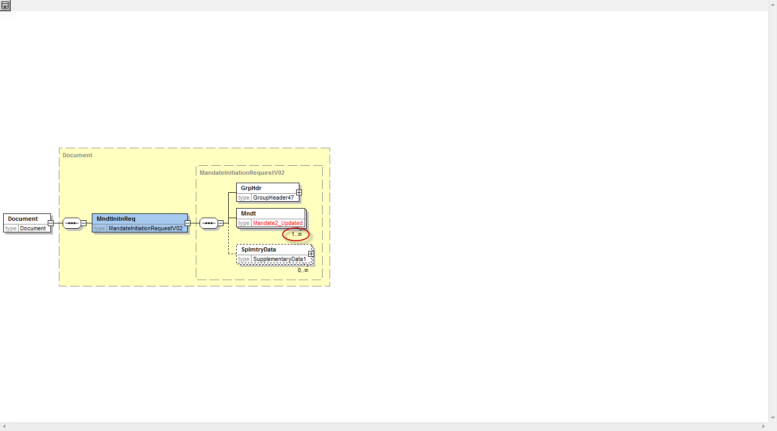

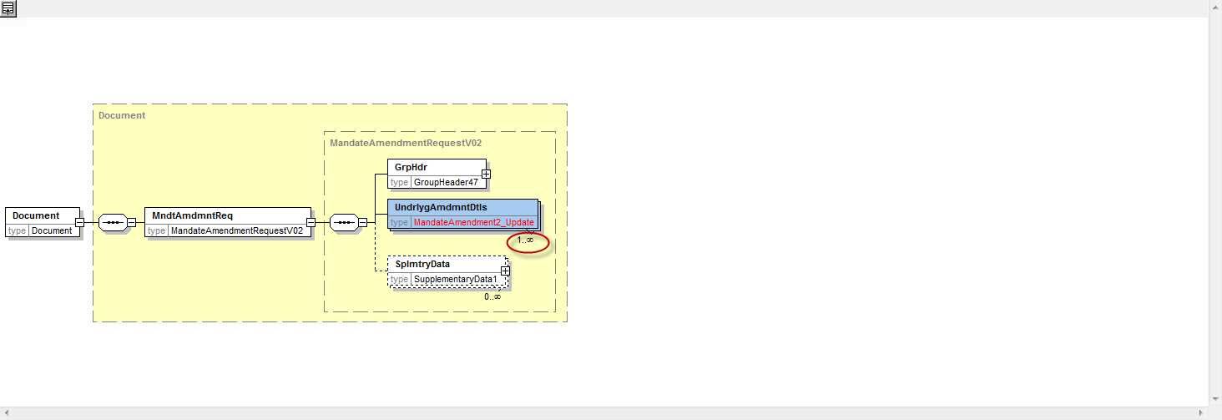

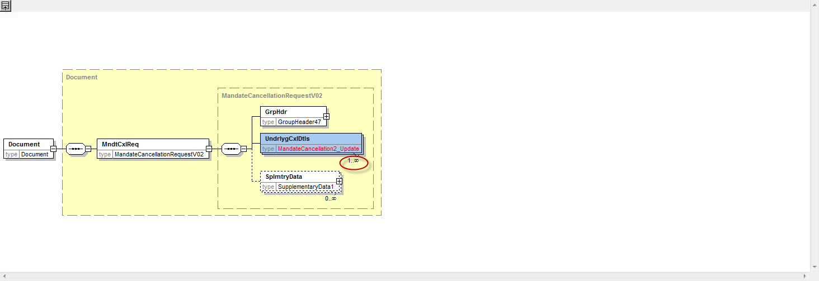

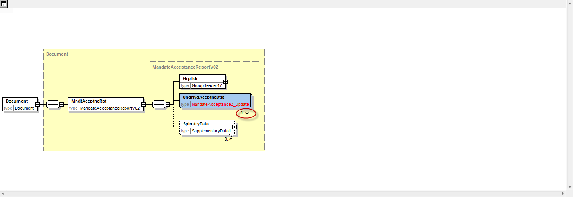

The implementation will also impact the message flows, as now one MandateInitationRequest message (pain.009) originated by the Creditor or Debtor will result in multiple MandateInitiationRequest messages (pain.009) in the interbank space. A MandateAcceptentanceReport (pain.012) will be sent per end to end flow or per mandate.

For example:

Current flow:

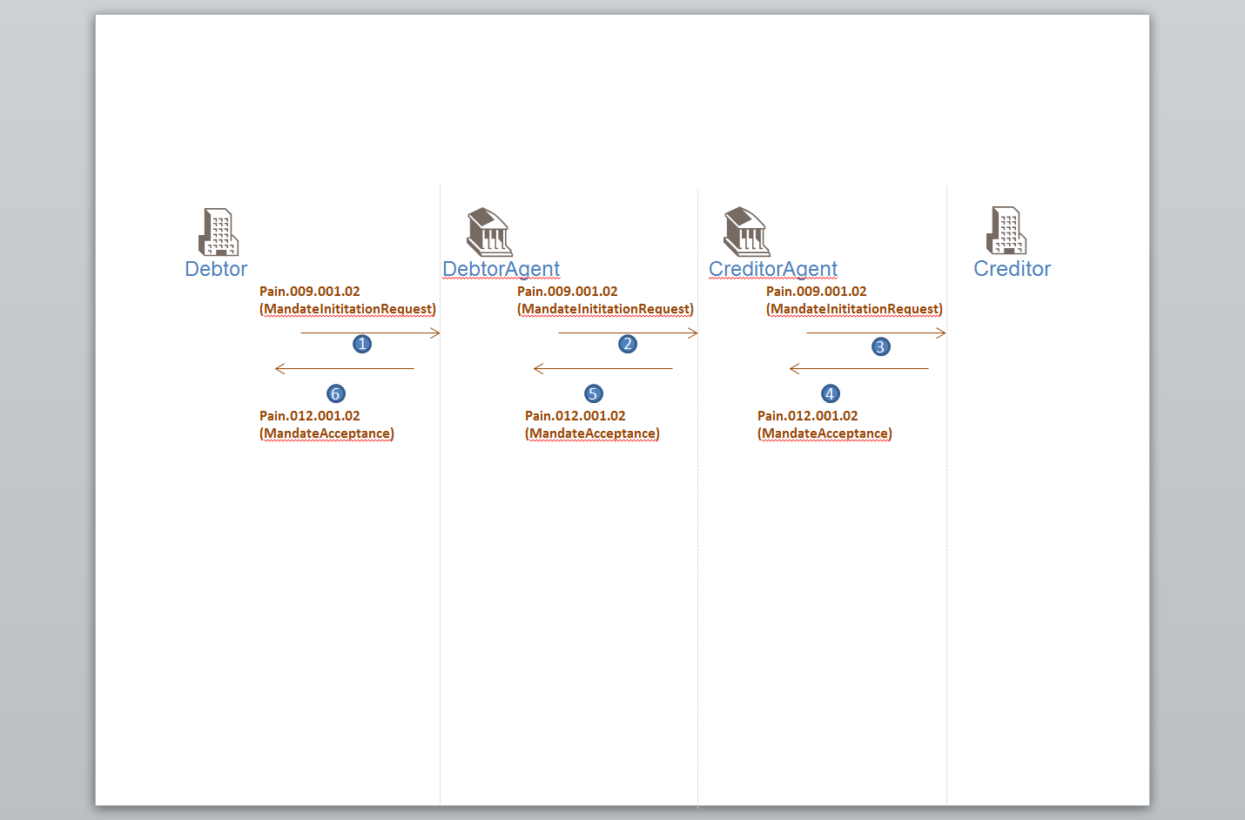

Future flow:

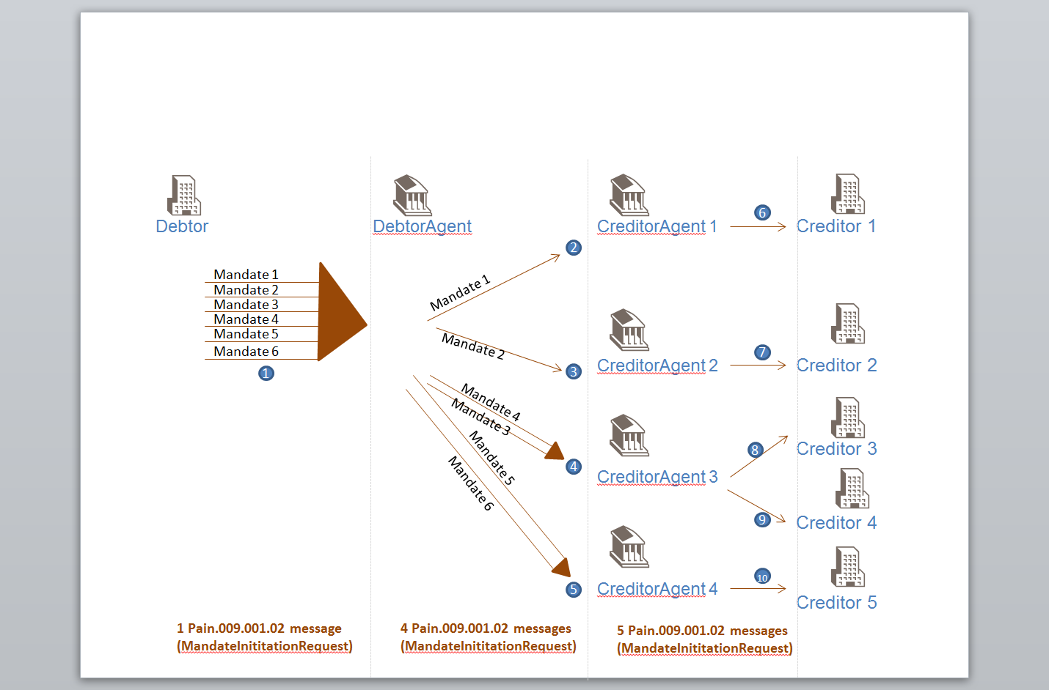

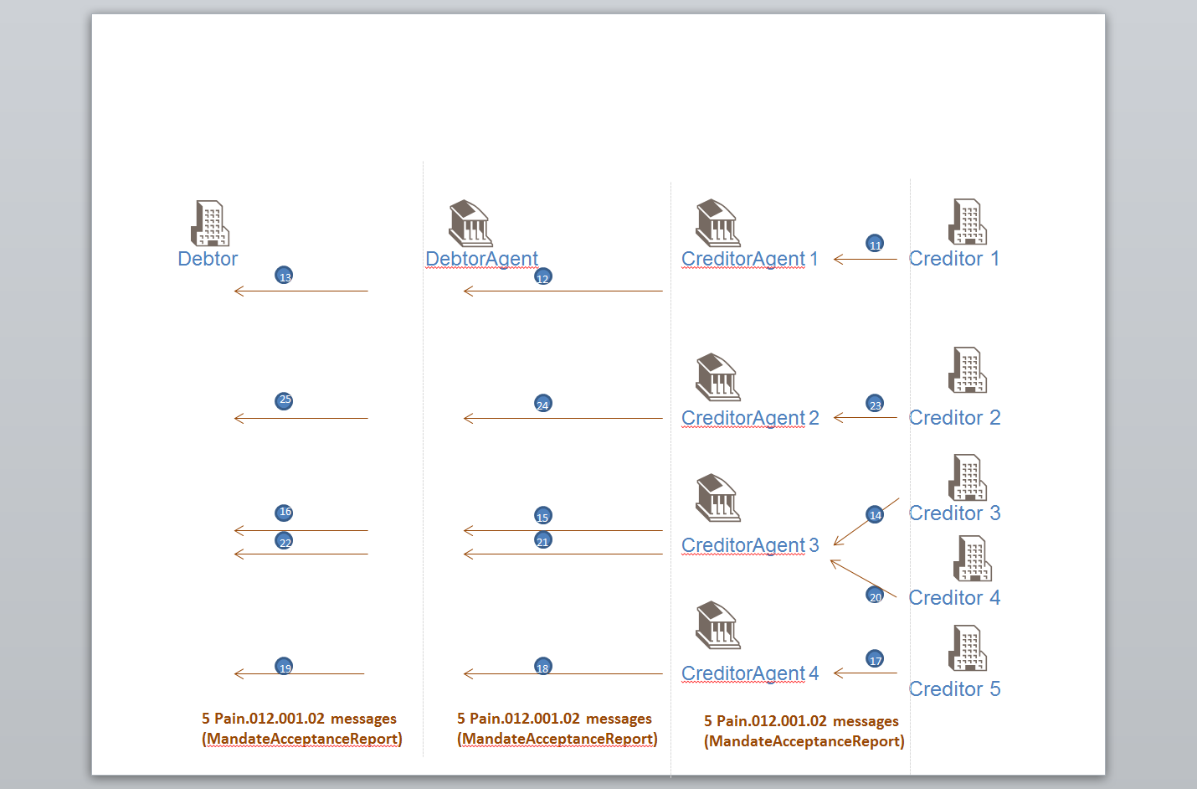

1. **Proposed timing:**

The submitting organization confirms that it can implement the requested changes in the requested timing.

|  |  |
| --- | --- |
| Timing | * As requested |

1. **Final decision of the SEG(s):**

|  |  |
| --- | --- |
| Approve | Yes |

Comments: Discussion re complexity, need by some markets (e.g. Nordics), preference for 1 for 1 correspondence by others (e.g. SEPA). Agreed to the change which will then allow the schema to accommodate both requirements.

|  |  |
| --- | --- |
| Reject |  |

Reason for rejection:

# Cash Mangement Change requests

## CR0234 Restriction of TotalNetEntryAmount Data Type

1. **Origin of the request:**

*A.1 Submitter*: CGI

*A.2 Contact person:*

|  |  |  |
| --- | --- | --- |
| Tinne Verschueren | [tinne.verschueren@swift.com](mailto:tinne.verschueren@swift.com) | +32 2 655 4606 |
| Marcel Winterhalder | [marcel.winterhalder@db.com](mailto:marcel.winterhalder@db.com) | +49(69)910-36251 |

*A.3 Sponsors*:

CGI (Common Global Implementation) Working group 2 on B2C reporting

[www.swiftcommunity.net/communities/CGI](http://www.swiftcommunity.net/communities/288/detail)

1. **Related messages:**

|  |  |
| --- | --- |
| camt.052.001.03 | BankToCustomerAccountReportV03 |
| camt.053.001.03 | BankToCustomerStatementV03 |
| camt.054.001.03 | BankToCustomerDebitCreditNotificationV03 |

1. **Description of the change request:**

Restrict the data type of TotalNetEntryAmount (exclude negative values) to remove ambiguity on current elements in TransactionsSummary.

The TotalNetEntryAmount currently is typed with DecimalNumber.

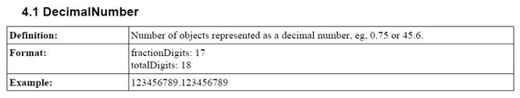

This data type does not exclude negative values.

Furthermore, the element CreditDebitIndicator is optional. If both elements (TotalNetEntryAmount and CreditDebitIndicator) are used, there can potentially be confusion or contradiction.

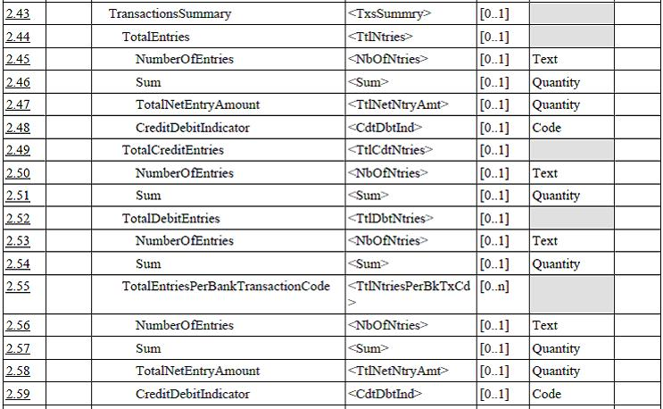

1. **Purpose of the change:**

Make the Standards Evaluation Group aware of the ambiguity in the existing schemes and open the discussion to restrict the data type and/or impose the use of the CreditDebitIndicator or keep the data type and remove the CreditDebitIndicator. CGI’s preference is to at least restrict the data type.

1. **Urgency of the request:**

For inclusion in the next ISO 20022 maintenance release.

1. **Business examples:**

Examples of ambiguity:

<TtlNtries>

<NbOfNtries>5</NbOfNtries>

<TtlNetNtryAmt>-500</TtlNetNtryAmt>

<CdtDbtInd>CRDT</CdtDbtInd>

</TtlNtries>

Or

<TtlNtries>

<NbOfNtries>5</NbOfNtries>

<TtlNetNtryAmt>-500</TtlNetNtryAmt>

</TtlNtries>

1. **SEG recommendation:**

|  |  |  |  |
| --- | --- | --- | --- |
| **Consider** | | Y | **Timing** |
|  | | - **Next yearly cycle: 2012/2013**  (the change will be considered for implementation in the yearly maintenance cycle which starts in 2012 and completes with the publication of new message versions in the spring of 2013) | | X |
|  | | - **At the occasion of the next maintenance of the messages**  (the change will be considered for implementation, but does not justify maintenance of the messages in its own right – will be pending until more critical change requests are received for the messages) | |  |
|  | | - **Urgent unscheduled**  (the change justifies an urgent implementation outside of the normal yearly cycle) | |  |  |
|  | | - **Other timing:** | | |  |

1. **Impact analysis:**

This change request impacts the messages indicated in section B. The impacted components will be NumberAndSumOfTransactions2 and TotalEntriesPerBankTransactionCode2.

1. **Proposed implementation:**
2. **Proposed implementation:**

As indicated in the change request, there are different ways to remove the current ambiguity, but as preferred by CGI, we propose the following implementation;

Create a new Datatype for TotalNetEntryAmount:

Format: fractionDigits:17

minInclusive: 0

totalDigits:18

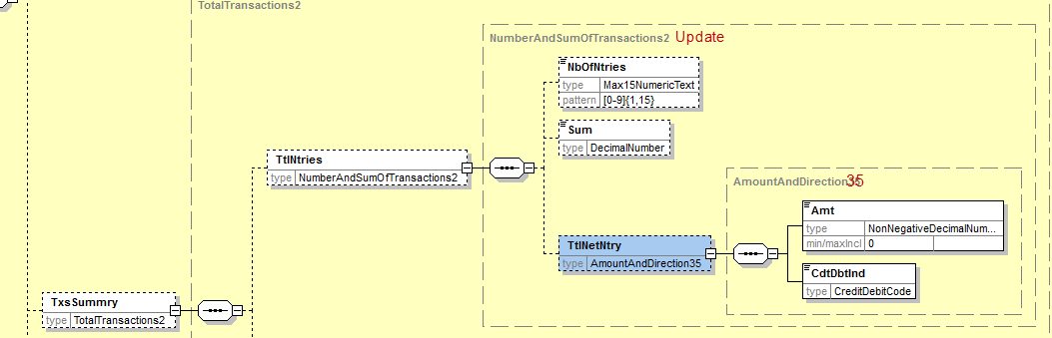

1. **Proposed timing:**

The submitting organization confirms that it can implement the requested changes in the requested timing.

|  |  |
| --- | --- |
| Timing | * As requested |

1. **Final decision of the SEG(s):**

|  |  |
| --- | --- |
| Approve | Yes |

Comments: Agreed to positive amounts only, linking of the two as recommended by the submitter

|  |  |
| --- | --- |
| Reject |  |

Reason for rejection:

## CR0240 – Addition of RelatedPrice at Entry level

1. **Origin of the request:**

*A.1 Submitter*:

SIX Interbank Clearing Ltd, Zurich (Switzerland)

*A.2 Contact person:*

SIX Interbank Clearing, Ltd Hardturmstrasse 201, 8021 Zurich

|  |  |  |
| --- | --- | --- |
| Istvan Teglas | istvan.teglas@six-group.com | +41 58 399 4238 |

*A.3 Sponsors*:

UBS AG, CH-8098 Zurich

Credit Suisse, CH-8070 Zurich

Postfinance, CH-3000 Bern

Zürcher Kantonalbank, CH-8001 Zurich

SIX Interbank Clearing Ltd, CH-8021 Zurich

1. **Related messages:**

* camt052.001.02
* camt053.001.02
* camt054.001.02

1. **Description of the change request:**

To add a similar RelatedPrice (NtryDtls/TxDtls/RltdPric) tag context to Ntry level.

As is:

Ntry-Level

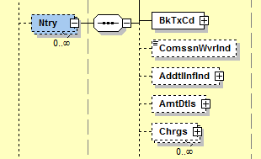

To be

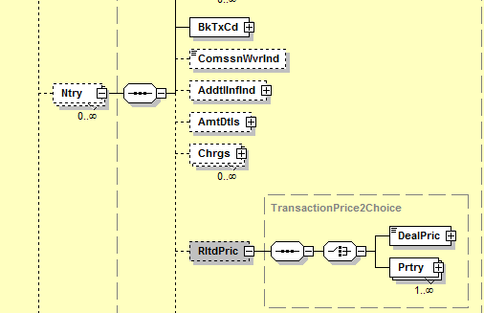

1. **Purpose of the change:**

The element “Charges” provides information to charges included in the entry amount and is available both on Ntry and NtryDtls level.

To provide information to charges/prices, which are not directly included in the entry amount (prices for example entered at the end of month) is the element “RelatedPrice “ available but only on NtryDtls level (NtryDtls/TxDtls/RltdPric).

Having this structure only on NtryDtls level cannot solve all case of charges notification. Such information must also be available as “RelatedPrice” on the Ntry Level: Ntry / RltdPric.

1. **Urgency of the request:**

As soon as possible. camt.0052.001.03, camt.0053.001.003, camt.0054.001.03

1. **Business examples:**

Customer is reported with daily camt.053. Batch or aggregate bookings are according to the use on entry level notified. The entry detail level is used to provide informations on the underlying transactions .

Some charges on batch, aggregate bookings are not entered directly but once at the end of the month and have to be in daily camt.053 on Entry level as information for the customer notified.

As example, outgoing electronic payment order:

* USD 10’000 with 2 underlying transactions (USD 8’000 and USD 2’000)
* Price for payment order treatment: USD 2.00 (will be charged at the end of the month)
* Price for underlying transaction: USD 0.20 (will be charged at the end of the month)

Entry Level

-> Information on aggregate booking with new Element <RltdPric>

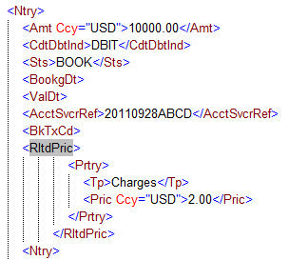

Entry Details Level

-> Information on underlying transactions with existing Element <RltdPric>

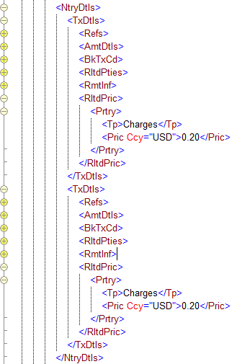

1. **SEG recommendation:**

|  |  |  |  |
| --- | --- | --- | --- |
| **Consider** | | Y | **Timing** |
|  | | - **Next yearly cycle: 2012/2013**  (the change will be considered for implementation in the yearly maintenance cycle which starts in 2012 and completes with the publication of new message versions in the spring of 2013) | | X |
|  | | - **At the occasion of the next maintenance of the messages**  (the change will be considered for implementation, but does not justify maintenance of the messages in its own right – will be pending until more critical change requests are received for the messages) | |  |
|  | | - **Urgent unscheduled**  (the change justifies an urgent implementation outside of the normal yearly cycle) | |  |  |
|  | | - **Other timing:** | | |  |

1. **Impact analysis:**

This change request impacts the latest version of the messages indicated in section B:

* camt.052.001.03 BankToCustomerAccountReportV03
* camt.053.001.03 BankToCustomerStatementV03
* camt.054.001.03 BankToCustomerDebitCreditNotificationV03

1. **Proposed implementation:**

The RelatedPrice element on TransactionDetails level was added for the reporting on transactions that relate to financial instruments trading (deal price) or proprietary transactions.

Adding the same element with the same component and definitions would not make sense on entry level as there is no direct link with securities transactions or financial instrument trading.

The proposal is to add an indicator in the ChargesRecord1 component to indicate whether a specific charge has been included in the TotalChargesAndTaxAmount or is just for information purposes/pre-advice. This may require a definition update to the charges element:

From:

*Provides information on the charges included in the entry amount.*

*Usage: This component is used on entry level in case of batch or aggregate bookings.*

To:

*Provides information on the charges, pre-advised or included in the entry amount .*

*Usage: This component is used on entry level in case of batch or aggregate bookings.*

The datatype ChargesIncludedIndicator already exists in the dictionary and should be reused if possible:

MeaningWhenTrue: Included

MeaningWhenFalse: Pre-advised

The proposed name of the element and definition can be discussed.

The resulting charges structure and definitions are:

|  |  |
| --- | --- |
| Charges | Provides information on the charges, pre-advised or included in the entry amount.  Usage: This component is used on entry level in case of batch or aggregate bookings. |
| TotalChargesAndTaxAmount | Total of all charges and taxes applied to the entry. |
| Record | Provides details of the individual charges record. |
| Amount | Transaction charges to be paid by the charge bearer. |
| CreditDebitIndicator | Indicates whether the charges amount is a credit or a debit amount.  Usage: A zero amount is considered to be a credit. |
| ChargeIncludedIndicator | Indicates whether the charge should be included or is added as pre-advice. |
| Type | Specifies the type of charge. |
| Code | Charge type, in a coded form. |
| Proprietary | Type of charge in a proprietary form, as defined by the issuer. |
| Rate | Rate used to calculate the amount of the charge or fee. |
| Bearer | Specifies which party/parties will bear the charges associated with the processing of the payment transaction. |
| Agent | Agent that takes the transaction charges or to which the transaction charges are due. |
| Tax | Provides details on the tax applied to charges. |

**Remark:**

If the creation of the indicator is not preferred, it can still be considered to add a code ‘INFO’ in the ISO 20022 external ChargeType code list with a clear definition that this is not to be included in the TotalChargesAndTaxAmount. Additional codes to the external code list don’t require a new version of the messages.

1. **Proposed timing:**

The submitting organization confirms that it can implement the requested changes in the requested timing.

|  |  |
| --- | --- |
| Timing | * As requested |

1. **Final decision of the SEG(s):**

|  |  |
| --- | --- |
| Approve | Yes |

Comments:

|  |  |
| --- | --- |
| Reject |  |

Reason for rejection: