Maintenance Change Request
for the update of UNIFI (ISO 20022) financial repository items
OUTCOME DOCUMENT
- Name of the request:

“ISO 20022 Payments Maintenance 2009”

Under this project the ISO 20022 Payment Initiation, Payment Clearing & Settlement and Bank-To-Corporate Cash Management messages will be maintained.

- Submitting organizations:
SWIFT (Payment Initiation, Payment Clearing & Settlement and Bank-To-Corporate Cash Management messages)
ISTH (Payment Initiation and Bank-To-Corporate Cash Management messages)
ISITC (Bank-To-Corporate Cash Management messages)

- Scope of the maintenance change request:
Payments Initiation
CustomerCreditTransferInitiationV02 pain.001.001.02
PaymentStatusReportV02 pain.002.001.02
PaymentCancellationRequestV01 pain.006.001.01
CustomerPaymentReversalV01 pain.007.001.01
CustomerDirectDebitInitiationV01 pain.008.001.01

Payments Clearing and Settlement
PaymentStatusReportV02 pacs.002.001.02
FIToFICustomerDirectDebitV01 pacs.003.001.01
PaymentReturnV01 pacs.004.001.01
PaymentCancellationRequestV01 pacs.006.001.01
FIToFIPaymentReversalV01 pacs.007.001.01
FIToFICustomerCreditTransferV01 pacs.008.001.01
FinancialInstitutionCreditTransferV01 pacs.009.001.01

Bank-to-Customer Cash Management
BankToCustomerAccountReportV01 camt.052.001.01
BankToCustomerStatementV01 camt.053.001.01
BankToCustomerDebitCreditNotificationV01 camt.054.001.01

- Purpose of the maintenance:
To integrate new (corporate and bank) business and regulatory requirements, submitted between September 2006 (release date of current version) and June 2008.

- Community of users:
Please refer to the individual change requests.
Various early adopters, following the implementation of the first versions of these messages, have submitted change requests as early as 2006.

- Timing and development:
The period for receiving users change requests to the messages in scope of this maintenance was closed early June 2008.
SWIFT has composed a group of 30+ Maintenance Business Validation Group (MBVG) representing the other submitting organizations, standards organizations, industry groups, corporate and financial institution user representatives, vendor representatives, service providers, regulatory bodies and market infrastructures.
Over the June-September 2008 period, ISTH, ISITC, subgroups of MBVG and Payments SEG members will discuss implementation proposals drafted by SWIFT on behalf of the submitting organizations for a list of logically grouped change requests.
A face-to-face maintenance meeting (MBVG, Payments SEG and submitting organizations) has been scheduled for 23-24 September 2008, followed by the sign-off of the change requests included in this Maintenance Change Request by the Payments SEG on 25 September 2008.
In November 2008, the reports reflecting the outcome of the face-to-face meeting will be submitted to the Payments SEG. Upon approval of the SEG recommendations by the RMG, the new version of the message models will be submitted to the RA for compliance checking and generation of the new Message Definition Report and schemas for the final SEG evaluation.
It is expected that the SEG will approve the new version of the messages by the end of the year and that the RA will publish them on the ISO 20022 website by March 2009. Respecting this timeline is crucial because introduction of some of the regulatory changes will allow financial institutions to live up to the regulators’ expectations concerning cover payments by November 2009.
- Commitments of the submitting organizations:
SWIFT, on behalf of the submitting organizations, confirms that it can and will:
- undertake the development of the new candidate UNIFI business models and message models that it will submit to the RA for compliance review and evaluation. The submission will include updated Business Process Diagram (activity diagram), Message Flow Diagram (sequence diagram) and Message Definition Diagram (class diagram), and other descriptive material that is required by the RA to generate the Message Definition Report;
- address any queries related to the description of the new models and messages as published by the RA on the UNIFI website.
SWIFT confirms it intends to organize the actual implementation of the new version of the messages once the related documentation has been published by the RA.
The submitting organizations confirm their knowledge and acceptance of the UNIFI Intellectual Property Rights policy for contributing organizations, as follows.
“Organizations that contribute information to be incorporated into the ISO 20022 Repository shall keep any Intellectual Property Rights (IPR) they have on this information. A contributing organization warrants that it has sufficient rights on the contributed information to have it published in the ISO 20022 Repository through the ISO 20022 Registration Authority in accordance with the rules set in ISO 20022. To ascertain a widespread, public and uniform use of the ISO 20022 Repository information, the contributing organization grants third parties a non-exclusive, royalty-free licence to use the published information”.

- Contact persons:
Frank Van Driessche – SWIFT Standards, frank.vandriessche@swift.com
Susan Colles – ISTH, susan.k.colles@bankofamerica.com
Leonard Schwartz – ISTH, leonard.schwartz@abnamro.com
Robert Blair – ISTH, robert.j.blair@jpmchase.com
Dannette Fleming – ISITC, DSB@ntrs.com
ISO 20022 Payments Maintenance 2009 - Change Request Overview
Payment Initiation Messages 9
CR n°U-001-PAY-2009: BatchBooking (Group Header) 9
CR n°U-002-PAY-2009: PaymentInformationIdentification (Payment Information) 12
CR n°U-003-PAY-2009: Grouping (Group Header) 14
CR n°U-004-PAY-2009: PaymentTypeInformation (Payment Information, Credit Transfer -Direct Debit Transaction Information) + PaymentMethod (Payment Information) 16
CR n°U-005-PAY-2009: AccountIdentification (CashAccount7) 22
CR n°U-006-PAY-2009: ChequeInstruction (Credit Transfer Transaction Information) 25
CR n°U-007-PAY-2009: RegulatoryDetails (Regulatory Reporting) 27
CR n°U-008-PAY-2009: RemittanceLocationElectronicAddress (Related Remittance Information) 29
CR n°U-009-PAY-2009: Structured Remittance Information (Credit Transfer - Direct Debit Transaction Information) 31
CR n°U-010-PAY-2009: UltimateDebtor (Payment Information and Credit Transfer – Direct Debit Transaction Information) 39
CR n°U-011-PAY-2009: Payment Status Report 41
CR n°U-012-PAY-2009: Reason codes (Reject/Reversal/Return) 44
CR n°U-013-PAY-2009: InitiatingParty 47
CR n°U-014-PAY-2009: StatusIdentification/ReversalIdentification/ReturnIdentification 49
Reason for rejection:CR n°U-015-PAY-2009: GroupStatus and TransactionStatus codes 51
CR n°U-016-PAY-2009: Payment Cancellation Request 53
CR n°U-017-PAY-2009: BranchAndFinancialInstitutionIdentification3 55
CR n°U-018-PAY-2009: PartyIdentification8 60
CR n°U-019-PAY-2009: Documentation requests 65
CR n°U-029-PAY-2009: Number of Transactions and Control Sum 67
CR n°U-030-PAY-2009: Requested Execution Date – Requested Interbank Settlement Date 69
CR n°U-031-PAY-2009: Digital Signature 71
CR n°U-032-PAY-2009: Additional References for Status Messages 73
CR n°U-033-PAY-2009: Instruction for Debtor Agent in Direct Debit Messages 75
CR n°U-035-PAY-2009: Character set for parties & remittance information 77
CR n°U-046-PAY-2009: Formatting Unstructured Remittance Details 80
CR n°U-051-PAY-2009: EndToEndIdentification 84
CR n°U-052-PAY-2009: MemoField (ChequeInstruction) 86
CR n°U-053-PAY-2009: RemittanceLocationMethod (Related Remittance Information) 88
CR n°U-054-PAY-2009: CreditorSchemeIdentification 90
CR n°U-056-PAY-2009: ExchangeRateInformation (Credit Transfer Transaction Information) 92
Payment Clearing & Settlement Messages 95
CR n°U-020-PAY-2009: InstructionPriority (Payment Type Information) 95
CR n°U-021-PAY-2009: Execution Time Request (SettlementTimeRequest) 100
CR n°U-022-PAY-2009: ClearingSystemIdentification (Settlement Information) 105
CR n°U-023-PAY-2009: ClearingSystemIdentification (Settlement Information) 108
CR n°U-024-PAY-2009: MessageNameIdentification (Original Group Information) 110
CR n°U-025-PAY-2009: ClearingSystemIdentification (Settlement Information) 112
CR n°U-026-PAY-2009: Transparency and Cover Payments (UnderlyingTransactionInformation) 114
CR n°U-049-PAY-2009: Local Instrument 117
CR n°U-050-PAY-2009: Purpose 119
CR n°U-055-PAY-2009: BaseDocument 122
CR n°U-057-PAY-2009: ClearingSystemReference 124
CR n°U-058-PAY-2009: EquivalentTransfers 126
CR n°U-059-PAY-2009: OUR/DEBT Charges 128
B2C Cash Management Messages 130
CR n°U-027-PAY-2009: Type codes (Charges) 130
CR n°U-028-PAY-2009: Technical Input Channel (Entry) 136
CR n°U-034-PAY-2009: Enhancement to cater for e.g. lockbox reporting 138
CR n°U-036-PAY-2009: Update Message Usage section 140
CR n°U-037-PAY-2009: References 142
CR n°U-038-PAY-2009: Opening and Interim Balance Information 144
CR n°U-039-PAY-2009: Debit/Credit indicator for Charges 146
CR n°U-040-PAY-2009: Additional Report Information 148
CR n°U-041-PAY-2009: Type of Rate 150
CR n°U-042-PAY-2009: Payment Information Id 152
CR n°U-043-PAY-2009: Forecast Balance Types 154
CR n°U-044-PAY-2009: Account Report Generator 156
CR n°U-045-PAY-2009: Contractual Settlement Date for Trade Activity 158
CR n°U-047-PAY-2009: Balance Types 160
CR n°U-048-PAY-2009: Bank Transaction Code 169
Late Change Requests 172
CR n°U-060-PAY-2009: CurrencyAmount 173
CR n°U-061-PAY-2009: BookingDate 175
CR n°U-062-PAY-2009: Authorisation 177
CR n°U-063-PAY-2009: Transaction Status 179
CR n°U-064-PAY-2009: RegulatoryReporting 181
CR n°U-065-PAY-2009: Tax 184
Technical adjustments 188
CR n°U-066-PAY-2009: XORs 188
CR n°U-067-PAY-2009: CurrencyAndAmount 190

Payment Initiation Messages

CR n°U-001-PAY-2009: BatchBooking (Group Header)
Origin of request and date | CR Status
Requestor(s):  - Member banks of CSTP  - Members of EPC SPS Task Force  - Members of SWIFT SCORE group  - GUF (Groupement des utilisateurs de SWIFT en France)  Date of the request: requests made during various implementation discussions/meetings taking place in 2007/early 2008 | New
Nature of Change | Message(s) Impacted
Addition of, or deletion of, or modification to a sequence/modification of definition | Message Identifier (message Name)  - pain.001.001.02  Customer Credit Transfer Initiation  - pain.008.001.01  Customer Direct Debit Initiation  Depending on outcome of requirement discussion and solution, may also impact:  - pacs.008.001.01  FI to FI Customer Credit Transfer  - pacs.003.001.01  FI to FI Customer Direct Debit
Context
Business reasons
Requirement description
1. Background information
The optional BatchBooking indicator is present at GroupHeader level. When the ‘Mixed’ grouping mode was introduced (during the harmonization process in 2006), the BatchBooking indicator was not revisited. This currently leads to confusion as to whether BatchBooking applies to all transactions included in the message (regardless of presence of several PaymentInformation components), or whether it applies to each occurrence of PaymentInformation component.
French SWIFT user group has provided the following information: BatchBooking is a functional (accounting) element related to an account. The presence of this element in the GroupHeader block means that it is not related to an account but to a message, and a message can be composed of different payments related to different accounts.
We consider that this element should be moved to the PaymentInformation component to fully play its role at payment level and not at a technical level (moreover, the GroupHeader component is mainly used for routing and not for business purposes).
Other parties have questioned the usage of the BatchBooking indicator and have indicated that batch booking is a result of a combination of factors: pre-agreements between a customer and his bank, payment types, organisation of information in the message, etc. In their opinion a BatchBooking indicator is not strictly necessary.
All parties have stressed that batch booking is a request, not an order.
2. Requirement
Several requirements have been expressed:
- Requirement to indicate that batch booking (if feasible) applies to transactions grouped per PaymentInformation level.
Note: several solutions have been proposed by parties submitting the change request: adapt definition and/or change indicator into an element with 3 possible codes (indicating that batch booking applies at Message/Group/Transaction level) or move the BatchBooking indicator from GroupHeader to PaymentInformation level (as suggested by the French SWIFT user group).
- Requirement to remove the BatchBooking indicator as the indicator itself should not trigger batch booking, but a combination of other factors (as expressed in background information).
- Requirement to clearly state that the BatchBooking indicator is used to request and not order possible batch booking.

Recommendation from the Payments SEG:
This section is to be completed by the (lead) SEG which had approved the existing version of the messages.
Approve | X
Comments:
The BatchBooking indicator will be moved from GroupHeader to PaymentInformation level.
The definition and usage will be updated:
- Updated definition: “Identifies whether a single entry per individual transaction or a batch entry for the sum of the amounts of all transactions within a group in the message is requested”
- Updated Usage: “The BatchBooking indicator is used to request and not order possible batch booking”
- Updated Data Type definition:
“One of the following BatchBookingIndicator values must be used:
    - MeaningWhenTrue: Identifies that a batch entry for the sum of the amounts of all transactions in the message within a group is requested.
    - MeaningWhenFalse: Identifies that a single entry for each of the transactions in the message within a group is requested.”

Reject
Reason for rejection:

RMG decision:
This section is to be completed in due time by the RMG secretariat based on RMG approval/rejection of the SEG recommendation.
Approve
Comments:

Reject
Reason for rejection:

CR n°U-002-PAY-2009: PaymentInformationIdentification (Payment Information)
Origin of request and date | CR Status
Requestor(s):  - Member banks of CSTP  - Members of EPC SPS Task Force  - Members of SWIFT SCORE group  - GUF (Groupement des utilisateurs de SWIFT en France)  - Austrian community  Date of the request: requests made during various implementation discussions/meetings taking place in 2007/early 2008 | New
Nature of Change | Message(s) Impacted
Change to a usage guideline | Message Identifier (message Name)  - pain.001.001.02  Customer Credit Transfer Initiation  - pain.008.001.01  Customer Direct Debit Initiation  No impact on ‘PACS’ messages (do not contain this element, only 2 levels available)
Context
Business reasons
Requirement description
1. Background information
Change request is linked to CR n°U-001-PAY-2009 for BatchBooking. If BatchBooking applies to the PaymentInformation level (regardless of the fact whether it has been explicitly requested through the BatchBooking indicator, or whether it is the result of a pre-agreed set of criteria), the PaymentInformation Id should be present in the initiation message, in order to be able to return an appropriate Id in the Payment Status / Account Reporting messages. Currently, this is not clearly stated in the Message Definition report (also due to the fact that the definition of BatchBooking applies to ‘all transactions’ in the message).
Note: Message Id refers to all payment info components possibly included in the message, whereas the other transactions (EndToEnd Id, Instruction Id) are on Payment Transaction level.
Some users have expressed the opinion that the PaymentInformation Id should preferably be present always in order to avoid complex rules relating to PaymentInformation Id - BatchBooking indicator - implicit batch booking.
PaymentInformationIdentification is the first and optional element of the PaymentInstructionInformation. Due to the ambiguity of PaymentInformationIdentification and MessageIdentification (of GroupHeader) triggered by content of BatchBooking and Grouping (both GroupHeader) PaymentInformationIdentification shall be altered to be mandatory. MessageIdentification shall never be seen as replacement for PaymentInformationIdentification. This will ease processing regardless of content of other elements (Austria).
The French SWIFT user group has provided the following info: when a customer asks for a bulk payment with global accounting, he needs to have one reference per payment to be able to make its reconciliation. In order to answer to this need, with the current message structure, the customer will use the reference of the Message Id if there is no PaymentInformation Id. But the Message Id is defined as a technical reference. Moreover, it is a technical reference because it is the reference used in the FileAct Header. Instead of defining a rule to choose which reference is taken, we suggest to make the PaymentInformation Id mandatory. Indeed, this reference is a bank and not a technical reference.
2. Requirement
The requirement is to have a clear definition/usage of the PaymentInformation Id. The solution may range from adding a recommended ‘usage’ description to the element, or to make it mandatory in the message itself.
Recommendation from the Payments SEG:
This section is to be completed by the (lead) SEG which had approved the existing version of the messages.
Approve | X
Comments:
The PaymentInformationIdentification element will be made mandatory.

Reject
Reason for rejection:

RMG decision:
This section is to be completed in due time by the RMG secretariat based on RMG approval/rejection of the SEG recommendation.
Approve
Comments:

Reject
Reason for rejection:

CR n°U-003-PAY-2009: Grouping (Group Header)
Origin of request and date | CR Status
Requestor(s):  - Member banks of CSTP  - Members of EPC SPS Task Force  - Members of SWIFT SCORE group  - GUF (Groupement des utilisateurs de SWIFT en France)  Date of the request: requests made during various implementation discussions/meetings taking place in 2007/early 2008 | New
Nature of Change | Message(s) Impacted
Deletion of a Message Item | Message Identifier (message Name)  - pain.001.001.02  Customer Credit Transfer Initiation  - pain.008.001.01  Customer Direct Debit Initiation  No impact on ‘PACS’ messages (do not contain ‘Grouping’ indicator)
Context
Business reasons
Requirement description
1. Background information
Since the introduction of the ‘Mixed’ grouping mode (during the Harmonization process in 2006), which caters for all possible scenarios (‘grouped’, ‘single’ and ‘mixed’), the relevance of having the indicator explicitly included in the message has been questioned.
The French SWIFT user group has provided the following information: the Grouping element only gives information about the structure of occurrences between the PaymentInformation and CreditTransferTransactionInformation level. This information is not useful out of a business point of view and moreover, it could lead to misunderstanding as it can be wrong (the bank has to control if the value is correct before processing the message). From our point of view, the bank does not need this information to process the message, so this element should be optional.
Example: a customer sends a file with the value “Single” but with one payment of 3 transactions in the message. What should the bank do? The customer wouldn’t appreciate to have this message rejected. If the bank processes the message anyway, the utility is not obvious.
Another example of the optional property of this element could be: the customer can give the value “Mixed” regardless the structure of the message. It will be always correct even if the structure is “single” or “grouped”.
2. Requirement
Several ‘solutions’ have been proposed:
- Remove the Grouping indicator
- Make Grouping indicator optional (French SWIFT user group)

Recommendation from the Payments SEG:
This section is to be completed by the (lead) SEG which had approved the existing version of the messages.
Approve | X
Comments:
The Grouping element will be removed.

Reject
Reason for rejection:

RMG decision:
This section is to be completed in due time by the RMG secretariat based on RMG approval/rejection of the SEG recommendation.
Approve
Comments:

Reject
Reason for rejection:

CR n°U-004-PAY-2009: PaymentTypeInformation (Payment Information, Credit Transfer -Direct Debit Transaction Information) + PaymentMethod (Payment Information)
Origin of request and date | CR Status
Requestor(s):  - Member banks of CSTP  - user communities implementing in the framework of SEPA  - Members of SWIFT SCORE group  - HK RTGS (for PACS)  - GUF (Groupement des utilisateurs de SWIFT en France)  - HSBC  - Austrian community  Date of the request: requests made during various implementation discussions/meetings taking place in 2007/early 2008 | New
Nature of Change | Message(s) Impacted
Modification to a Message component. | Message Identifier (message Name)  All ‘PAIN’ messages:  - pain.001.001.02  Customer Credit Transfer Initiation  - pain.008.001.01  Customer Direct Debit Initiation  - pain.007.001.01  Customer Payment Reversal  - pain.006.001.01  Payment Cancellation Request  - pain.002.001.02  Payment Status Report  Also impacts all ‘PACS’ messages:  - pacs.008.001.01  FI to FI Customer Credit Transfer  - pacs.003.001.01  FI to FI Customer Direct Debit  - pacs.007.001.01  FI to FI Payment Reversal  - pacs.009.001.01  Financial Institution Credit Transfer  - pacs.006.001.01  Payment Cancellation Request  - pacs.004.001.01  Payment Return  - pacs.002.001.02  Payment Status Report
Context
Business reasons
Requirement description
1. Background information
The payment type component is complex to interpret and does not seem to meet all existing requirements. Several requests have been received to have a simpler PaymentTypeInformation component that enables unambiguous interpretation and implementation, and evolution of payment types, whilst respecting the different existing market practices.
- not all elements always belong to the same level: for example ‘clearing channel/service level’ may belong to transaction level, whereas ‘instruction priority’ could be on ‘payment information level’. For smoother batching of payments it is necessary to modify the mutually exclusivity rule to allow the PaymentTypeInformation component on both levels, but make the elements mutually exclusive. For example, this allows to batch payments with same InstructionPriority and CategoryPurpose, but would support various ServiceLevels, ClearingChannels or LocalInstruments at transaction level.
- harmonise the current functionality provided by the Clearing Channel and Service Level. At present, customers are required to use Service Level for SEPA transactions and the Clearing Channel for ACH (Bulk Transactions). This logic adds unnecessary complexity to the message implementation, which would be simplified, if a single field supporting a consolidated list of payment methods was available (HSBC).
- confusion about relationships between various elements within the component and with other elements from the message (for example category purpose versus purpose / choice between service level and clearing channel / local instrument versus service level / instruction priority versus settlement priority expressed through service level / clearing channel / payment method (containing ‘TRA’ versus category purpose)

On this last point, the French SWIFT user group proposes to delete the value “TRA” in the list of codes which can be used in the PaymentMethod block (2.2.) and to add a specific code in the CategoryPurpose element of the Payment Type Information element (2.3.), like “Transfer to government” which justified the initial request to create a code TRA (request from Denmark). The code TRA is used to identify a Transfer Advice. A Transfer Advice is not a payment method and therefore it should not be an option for the PaymentMethod element. Nevertheless, it can be useful to specify in a Credit Transfer Initiation that the customer needs a Transfer Advice, as a special service. Therefore it is proposed to have this information by adding a new code in the Category Purpose element.
Example: Customers might need proof that a credit transfer to a government body or administration has been done at a specific date. In this case, the customer will ask for a credit transfer with Transfer Advice. The payment method is the same as for a standard transfer (TRF) and the bank knows which service to apply (an advice must be sent back) by checking the CategoryPurpose.
- at present Category Purpose Codes are defined as enumeration list. Due to business, usability and maintenance reasons CategoryPurpose shall have the same structure as LocalInstrument containing a choice of Code and Proprietary. More over the Code element shall be defined as external Code List. All existing codes of current enumeration list shall be inserted in the new External Category Purpose Code List. Following codes shall be amended to the new codelist (Austria):

ICCP General Irrevocable Credit Card Payment
Transaction is reimbursement of credit card payment.
IDCP General Irrevocable Debit Card Payment
Transaction is reimbursement of debit card payment.
CCRD General Credit Card Payment
Transaction is related to a payment of credit card.
DCRD General Debit Card Payment
Transaction is related to a payment of debit card.
- questions about the explicit code values present in for example Service Level (for example EBA Priority Service)– and when to put codes in proprietary (for example to express a payment with ‘URGENT’ settlement priority)
- need for clearer definitions (or usage) for the following elements:
  - payment method:
> TRF: Credit Transfer. Transfer of an amount in the books of the account servicer.
> TRA: Transfer advice. Transfer of an amount in the books of the account servicer. An advice should be sent back to the account owner.
Comment of the French user community: these definitions can be interpreted in two ways: either TRA = TRF + an advice, or TRF = Credit transfer and TRA = book transfer. It has been clarified that the correct interpretation is the first one, but ‘books of the account servicer’ is misleading in the definition – as it seems to point to a book transfer (where the creditor also has its account at the debtor bank). The French SWIFT user group suggests replacing the current definition of the PaymentMethod, code TRF by a more appropriate one. A credit transfer is not always a “transfer” of an amount of money in the books of the account servicer.
  - instruction priority:
‘Indicator of the urgency or order of importance that the instructing party would like the instructed party to apply to the processing of the instruction.’
In the MUG and the SCORE Rulebook, additional clarifications have been added – that this relates to ‘queue’ priority at the first bank, and is not related to a settlement priority.
- additional requirement: the HK RTGS is implementing a new way of payment settlement, named Super Linked Settlement. A code/way to identify this as a payment type (predominantly in PACS messages) should be foreseen.
- additional rule: a rule should be added to rule out the presence of the element ‘ServiceLevel’ when PaymentMethod contains ‘cheque’.
Question: should the presence of other ‘payment type’ elements also be ruled out if PaymentMethod contains ‘cheque’?
- In the payment initiation and interbank payment messages the PaymentTypeInformation component is either present at PaymentInstructionInformation or at TransactionInformation Level as it is defined as mutually exclusive. The structure contains various subelements. For smoother batching of payments it is necessary to modify the mutually exclusivity rule to allow PaymentTypeInformation on both levels, but make the subelements mutually exclusive. For example, this allows to batch payments of same Instruction Priority and Category Purpose together, but still supports various Service Levels, Clearing Channels or Local Instruments at TransactionInformation Level (Austria).
2. Requirement
Requirement is to have a simpler PaymentTypeInformation component that enables unambiguous interpretation and implementation, and evolution of payment types, whilst respecting the different existing market practices.

Recommendation from the Payments SEG:
This section is to be completed by the (lead) SEG which had approved the existing version of the messages.
Approve | b, d, e, f, g
Comments:
The PaymentTypeInformation component will be reorganised and will be different in the pain and pacs space as far as the ClearingChannel element is concerned. This element will be removed from the component in the pain space and will stay as an optional element in the pacs messages (where the choice between ServiceLevel and ClearingChannel will be removed, meaning that both elements will be optionally available).
Furthermore, for both pain and pacs spaces:
- InstructionPriority will stay as is
- ServiceLevel remains, but the code list is externalised. The definitions of Code and Proprietary will be changed to read:
Code: “Identification of a pre-agreed service or level of service between the parties as published in an external service level code list.”
Proprietary: “Identification of a pre-agreed service or level of service between the parties as a proprietary code.”

- LocalInstrument stays as is. Usage will be updated to read:

Usage Rule: “This element is used to specify a local instrument, local clearing option and/or further qualify the service or service level.”
- CategoryPurpose remains, but the element will offer a choice between a Code (externalised list) and Proprietary element
- For direct debit messages the pain PaymentTypeInformation component will contain an additional SequenceType element component as it is the case in the current version.
Additional requests for the ServiceLevel, LocalInstrument and CategoryPurpose element code lists will be considered when the external code lists are discussed.
To better distinguish CategoryPurpose from Purpose, the suggestion is to add Usage to the definition of CategoryPurpose:
  - Category Purpose: Specifies the high level purpose of the instruction based on a set of pre-defined categories.
  - Usage: CategoryPurpose is used by the initiating party, i.e. (ultimate) debtor, (ultimate) creditor to provide information concerning the processing of the payment. It is likely to trigger special processing by any of the agents involved in the payment chain.
  - Purpose: Underlying reason for the payment transaction.
  - Usage: Purpose is used by the end-customers, i.e. initiating party, (ultimate) debtor, (ultimate) creditor to provide information concerning the nature of the payment. Purpose is a content element, which is not used for processing by any of the agents involved in the payment chain.)
TRF definition: “Transfer of an amount by the account servicer to an account in his books or to an account in another account servicer’s books”
InstructionPriority: add usage to definition as per MUG:
- Definition: Indicator of the urgency or order of importance that the instructing party would like the instructed party to apply to the processing of the instruction.
- Usage: Instruction priority defines the urgency of processing at the instructed party. It does not indicate the settlement priority, for example a wire payment versus an ACH payment.

Reject | a, c, h, i
Reason for rejection:
a&i. Allowing textual rules on the individual rules in the Payment Type Information component will make the batching logic too complex.
c. TRA will be kept as Payment Method code as doubling the complete CategoryPurpose code lists to indicate that it is a transfer with advice request is more cumbersome.
h. It seems that ServiceLevel can be used with PaymentMethod being Cheque.

RMG decision:
This section is to be completed in due time by the RMG secretariat based on RMG approval/rejection of the SEG recommendation.
Approve
Comments:

Reject
Reason for rejection:

CR n°U-005-PAY-2009: AccountIdentification (CashAccount7)
Origin of request and date | CR Status
Requestor(s):  - CHIPS  - Member banks of CSTP  - Members of SWIFT SCORE group  - Banks and CSMs in framework of SEPA (IBAN update)  - HSBC  Date of the request: requests made during various implementation discussions/meetings taking place in 2007/early 2008 | New
Nature of Change | Message(s) Impacted
Modification to a Message Item | All messages defined in ‘PAIN’ and ‘PACS’.  (as described in CR 4)  Also impacts CAMT messages.
Context
Business reasons
Requirement description
1. Background information
Several requests have been received related to this component:
- add Chips UID (next to UPIC) (The Clearing House).
Note: Chips UID should be removed from Party Identification/Organisation Id.
- remove BBAN and use ProprietaryAccount instead (as the difference between a BBAN and ProprietaryAccount is not clear).
- upgrade IBAN pattern to current version of the IBAN (that is 2007 IBAN). Technically this means that the first two characters of the IBAN (which represent the country code) must always be uppercase.
- remove the current XOR constraint under CashAccount7, Identification, covering IBAN, BBAN, UPIC and Proprietary (HSBC).
In some countries, the RTGS (real time) clearing system and ACH (bulk clearing system) require a different account number. This is particularly relevant to the UK market, where the RTGS clearing system requires the IBAN and the ACH (BACS) clearing system requires the domestic account number. This situation requires a corporate to maintain 2 separate account Id’s in respect of the creditor account.
In order to simply the implementation, the corporate should not be required to determine which account Id is required in respect of the payment method, the corporate should have the flexibility to provide both account Id’s. The originating bank will then be able to determine which account Id should be used based on the payment method.
- either increase the number of occurrences of the AccountIdentification/Proprietary element to 2 or introduce a new template identification option. Some banks have the ability to store payment details or other material data in the form of a template. Access to this data is through a unique template Id that could apply at either the debtor or creditor level. The debtor agent will perform a merge process on the basis of this template Id (HSBC).
2. Requirement
Requirement is to have account Ids that can be correctly identified – according to existing and implemented categories.
Recommendation from the Payments SEG:
This section is to be completed by the (lead) SEG which had approved the existing version of the messages.
Approve | a, b, c
Reject | d, e
Comments:
The CashAccount7 component will be replaced by the CashAccount16 component as shown below:
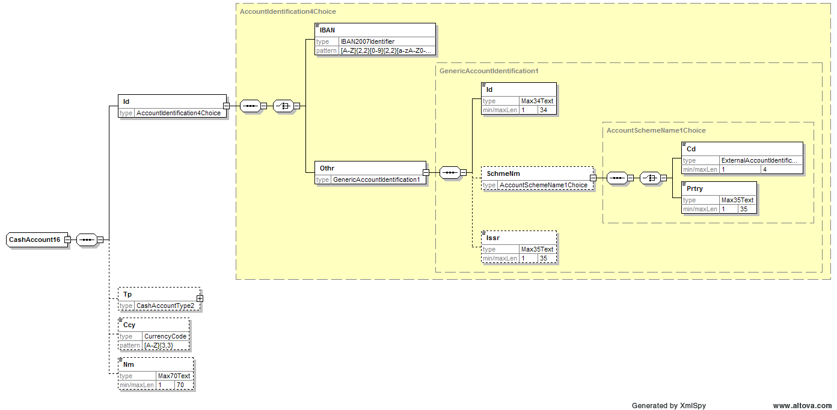
Changes are restricted to the Identification component where a choice will be available between IBAN and Other. Inside Other an optional SchemeName and Issuer element can be used to further qualify the mandatory Id. The SchemeName will be typed by a choice between a Code and Proprietary element. The Code element will be typed by an externalised code list with current values BBAN, CUID, UPIC.
For the individual change requests as described under paragraph 1, this means:
- Add Chips UID to the Identification component
à Will be covered by the new agreed component structure (CUID part of externalised code list for SchemeName)
- Remove BBAN from the Identification component
à Will be removed (BBAN part of externalised code list for SchemeName)
- Upgrade IBAN pattern to current version of the IBAN
à Pattern will be updated
- Remove the current XOR constraint from the Identification component
à Rejected, only one account identification must be provided
- Increase the number of occurrences of the Proprietary element in the Identification component or introduce a new template identification option
à Rejected, covered by new agreed party identification structure

RMG decision:
This section is to be completed in due time by the RMG secretariat based on RMG approval/rejection of the SEG recommendation.
Approve
Comments:

Reject
Reason for rejection:

CR n°U-006-PAY-2009: ChequeInstruction (Credit Transfer Transaction Information)
Origin of request and date | CR Status
Requestor: IKEA (member of ISO Payment SEG as CRG, and member of SCORE group)  Date of the request: Q4 2007 | New
Nature of Change | Message(s) Impacted
Modification to a Message Item (either through increasing message item multiplicity / or addition of new element) | Message Identifier (message Name)  - pain.001.001.02  Customer Credit Transfer Initiation  No impact on ‘PACS’ messages
Context
Business reasons
Requirement description
1. Background information
IKEA is currently outsourcing cheques.
As requested in the power of attorney the cheque has to be signed by two persons that have to be specified in the payment message. The bank will then print out the signatures of the two persons indicated in the paymul file (format used today).
Question is where to indicate the name of the two signers to be printed on the cheque.
A solution would be to use the element <FormsCode>, but this element has only one iteration possible and is already been used for indicating the cheque layout. A temporary solution could be to put both signers (name or Id) in that field with a separator in between, for example:
<MemoFld>NameSigner1, NameSigner2</MemoFld>

Would it be possible to increase the number of iterations of the tag FormsCode in the schema? Concern is how to specify that a code is linked to a logo, layout or a signer.

2. Requirement
Requirement is to have the possibility to quote two cheque signers in a consistent way.

Recommendation from the Payments SEG:
This section is to be completed by the (lead) SEG which had approved the existing version of the messages.
Approve
Comments:

Reject | X
Reason for rejection:
The change request is referred to the next maintenance cycle as more information needs to be gathered first.

RMG decision:
This section is to be completed in due time by the RMG secretariat based on RMG approval/rejection of the SEG recommendation.
Approve
Comments:

Reject
Reason for rejection:

CR n°U-007-PAY-2009: RegulatoryDetails (Regulatory Reporting)
Origin of request and date | CR Status
Requestor(s):  - Deutsche Bank (as Member bank of CSTP and SWIFT SCORE group)  - JPM Chase (as Member bank of CSTP and SWIFT SCORE group)  - HSBC  Date of the request: requests made during various implementation discussions/meetings taking place in 2007/early 2008 | New
Nature of Change | Message(s) Impacted
Modification to a Message Item Type | Message Identifier (message Name)  - pain.001.001.02  Customer Credit Transfer Initiation  - pain.008.001.01  Customer Direct Debit Initiation  Also impacts following ‘PACS’ messages:  - pacs.008.001.01  FI to FI Customer Credit Transfer  - pacs.003.001.01  FI to FI Customer Direct Debit
Context
Business /technical /regulatory reasons
Requirement description
1. Background information
The length of the code in Regulatory Details should be extended from 3 to 4 characters, as many existing codes today use 4 characters. It should be added that codes can be obtained from the central bank authorities. Currently, users are forced to use the Information text field in the Regulatory Details component to send the longer value codes. This element is not intended for that purpose (Deutsche and JPM).
Increase the length of the code under Regulatory Details to 35 characters. For some countries, in addition to providing a local code, there is also a requirement to provide the associated country Id. This is not currently possible (HSBC).
2. Requirement
The requirement is to have a code length that meets existing requirements.

Recommendation from the Payments SEG:
This section is to be completed by the (lead) SEG which had approved the existing version of the messages.
Approve | X
Comments:
The code length will be increased from Max3Text to Max10Text.
The complete update of the RegulatoryReporting component is shown with CR-n°U-064-PAY-2009.

Reject
Reason for rejection:

RMG decision:
This section is to be completed in due time by the RMG secretariat based on RMG approval/rejection of the SEG recommendation.
Approve
Comments:

Reject
Reason for rejection:

CR n°U-008-PAY-2009: RemittanceLocationElectronicAddress (Related Remittance Information)
Origin of request and date | CR Status
Requestor(s):  - Deutsche Bank (as Member bank of CSTP and SWIFT SCORE group)  Date of the request: requests made during various implementation discussions/meetings taking place in 2007/early 2008 | New
Nature of Change | Message(s) Impacted
Modification to a Message Item Type | Message Identifier (message Name)  - pain.001.001.02  Customer Credit Transfer Initiation  - pain.008.001.01  Customer Direct Debit Initiation  Also impacts following ‘PACS’ messages:  - pacs.008.001.01  FI to FI Customer Credit Transfer  - pacs.003.001.01  FI to FI Customer Direct Debit  Also impacts CAMT messages  - camt.052.001.01  B2CAccountReportV01  - camt.053.001.01  B2CStatementV01 (AdditionalStatementInformation element)  - camt.054.001.01  B2CDebitCreditNotificationV01 (AdditionalNotificationInformation element)
Context
Business/technical reasons
Requirement description
1. Background information
Request to increase length of type for electronic address from 256 to 500 characters, as 256 characters are not sufficient.
An additional guideline (through ‘usage’ as part of definition) in the Message Definition Report should stipulate that this electronic address is only to be used in case of e-mail/fax.
For the Postal address, a similar guideline should stipulate that this element is only to be used in case the method is ‘POST’ and must be sent to a postal address.
2. Requirement
Requirement is to have an element that can cope with existing lengths of urls, etc.

Recommendation from the Payments SEG:
This section is to be completed by the (lead) SEG which had approved the existing version of the messages.
Approve | X
Comments:
The length of RemittanceLocationElectronicAddress will be increased to Max2048Text (There is no defined limitation in length, but the maximum length for a URL imposed by Internet Explorer is 2048 characters).
No Usage will be added to the definitions of RemittanceLocationElectronicAddress and RemittanceLocationPostalAddress elements. The correct use of the elements in combination with the RemittanceLocationMethod will be clarified in the Message Usage Guidelines (MUG).

Reject
Reason for rejection:

RMG decision:
This section is to be completed in due time by the RMG secretariat based on RMG approval/rejection of the SEG recommendation.
Approve
Comments:

Reject
Reason for rejection:

CR n°U-009-PAY-2009: Structured Remittance Information (Credit Transfer - Direct Debit Transaction Information)
Origin of request and date | CR Status
Requestor(s):  - The Clearing House (Electronic Payments Network)  - EACT (through Robert Bol)  - Deutsche Bank (as Member bank of CSTP and SWIFT SCORE group)  - HSBC  Date of the request: requests made during various implementation discussions/meetings taking place in 2007/early 2008 | New
Nature of Change | Message(s) Impacted
Modification to a Message Item | All messages defined in ‘PAIN’ and ‘PACS’ (as described in CR 4)  (with the exception of pacs.009.001.01 Financial Institution Credit Transfer)  Also impacts CAMT messages
Context
Business reasons
Requirement description
1. Background information
Several requests have been received with regard to the Structured Remittance Information component:
- Referred Document Type / add Code to Referred Document Related Date and provide Adjustment information, including as a set of Adjustment Reason codes. These codes are needed to make the standard consistent and mappable from the STP 820 remittance data elements.
Referred Document Type: additional codes needed:
Elements | Description |  | Description
BM | Bill of Lading |  | Shipping notice
VV | Voucher |  | Electronic Payment Document
R7 | AR Open Item |  | Payment applies to a specific source document

- Referred Document Related Date: currently typed by DateTime. Need to
be able to identify
092 | Contract Effective |  | Date of the contract associated with the payment
- Adjustment taken against the item being paid – this is in addition to the discount. The ISO 20022 makes no provision for the concept of an Adjustment.
Monetary Amount | Adjustment (dollar amount) taken from the gross amount of the invoice/PO… - would be in addition to the discount taken if discount is present
Adjustment Reason Code | Associated adjustment reason code - see table of 12 codes see below
Free form descriptive information about the Adjustment taken | Separate from the descriptive information describing the item being paid.
Adjustment Reason codes

Code |  | Description
1 |  | Pricing Error
3 |  | Extension Error
4 |  | Item Not Accepted - Damaged
5 |  | Item Not Accepted - Quality
6 |  | Quantity Contested
7 |  | Incorrect Product
11 |  | Returns - Damage
12 |  | Returns - Quality
59 |  | Item not received
75 |  | Total order not received
81 |  | Credit as Agreed
CM |  | Covered by Credit Memo

- to increase the length/remove the limit of characters of the AdditionalRemittanceInformation element in the Structured Remittance Information component (currently max 140 text), to avoid having to chain up pairs of Structured and Unstructured remittance information (Deutsche Bank, as part of CSTP/SCORE).
- to increase the number of occurrences of AdditionalRemittanceInformation field from 1 to n. Under the current structured remittance information design, there is no opportunity for a customer to introduce their own free text headings. This is required where the data does not currently fit into the existing structured options (HSBC).
- to remove the limit of characters from the RemittanceInformation/Unstructured element (currently this component is repetitive and limited to max 140 text) (Deutsche Bank, as part of CSTP/SCORE)
- to remove the XOR in the ReferredDocumentAmount component and to have an optional list of possible amounts, rather than a repetitive choice (Deutsche Bank, as part of CSTP/SCORE)
- to update the definitions of ‘invoicer’ and ‘invoicee’ with terminology used in the rest of the standard. Currently, the terminology used for these terms still refers to ‘final party’ (should be changed to ‘ultimate creditor’) and ‘originator’ (should be changed to ‘ultimate debtor’)
- Proposal to optimize the structure of the Structured remittance information component (has been submitted in the framework of the Max 140 character constraint set by SEPA, by EACT):
Although the remittance information can be presented with the implemented structure, it does not provide a logical and efficient solution. Currently a repetition of basic elements (invoice documents or creditor references or AdditionalRemittanceInformation) can only be provided by multiple occurrences of the group-level “Structured”.
In SEPA only 140 characters of structured remittance details are allowed; with the XML overhead of the different levels, repeating the complete structure will almost be impossible.
The basic idea is that within “Structured” multiple occurrences of the group-levels ReferredDocumentInformation and CreditorReferenceInformation would be allowed.
Within these group-levels all related data elements would be specified at a lower level (now some are at the same level and even separated by CreditorReferenceInformation).
And it should be clear from the structure which elements are attributes to Referred Document.
Proposal for updated Remittance Info (submitted by EACT):
Note: the proposal below does not yet take into account the other change requests that were received under a/b/c. The changes compared to the current component are highlighted in yellow.
RemittanceInformation <RmtInf> [0..1]
Unstructured <Ustrd> [0..n] Text
Structured <Strd> [0..1]
ReferredDocumentInformation <RfrdDocInf> [0..n]
ReferredDocumentType <RfrdDocTp> [0..1]
{Or Code <Cd> [1..1] Code
Or} Proprietary <Prtry> [1..1] Text
Issuer <Issr> [0..1] Text
ReferredDocumentNumber <RfrdDocNb> [0..1] Text
ReferredDocumentRelatedDate <RfrdDocRltdDt> [0..1]
ReferredDocumentAmount <RfrdDocAmt> [0..n]
{Or DuePayableAmount <DuePyblAmt> [1..1] Amount
Or DiscountAppliedAmount <DscntApldAmt> [1..1] Amount
Or RemittedAmount <RmtdAmt> [1..1] Amount
Or CreditNoteAmount <CdtNoteAmt> [1..1] Amount
Or} TaxAmount <TaxAmt> [1..1] Amount
Invoicer <Invcr> [0..1] +
Invoicee <Invcee> [0..1] +
CreditorReferenceInformation <CdtrRefInf> [0..n]
CreditorReferenceType <CdtrRefTp> [0..1]
{Or Code <Cd> [1..1] Code
Or} Proprietary <Prtry> [1..1] Text
Issuer <Issr> [0..1] Text
CreditorReference <CdtrRef> [0..1] Text
AdditionalRemittanceInformation <AddtlRmtInf> [0..n] Text
2. Requirement
The requirement is to have an optimized remittance info component, which allows for efficient implementation and transport.

Recommendation from the Payments SEG:
This section is to be completed by the (lead) SEG which had approved the existing version of the messages.

Approve | a, c, e, g, h, i
Reject | b, d, f
Comments for the individual change requests as described under paragraph 1.
- Addition of codes to ReferredDocumentType
à 4 codes will be added, but the code list will not be externalised:
Elements | Description | Definition
BOLD | Bill of Lading | Document to acknowledge the shipment of goods
VCHR | Voucher | Electronic Payment Document
AROI | Accounts Receivable Open Item | Payment applies to a specific source document
TSUT | Trade Services Utility Transaction | Document is a transaction identifier as assigned by the Trade Services Utility
- Addition of an additional ReferredDocumentRelatedDate
à Rejected, the required functionality to combine a contract effective date with an invoice date will be accommodated by the fact that the new ReferredDocumentInformation component shown under bullet point i will be repetitive.
- Addition of Adjustment Amount and Reason elements
à A component will be added as shown under bullet point i.
- Increase length/remove limit of the AdditionalRemittanceInformation element
à Rejected, length kept at Max140Text.
- Increase occurrences of AdditionalRemittanceInformation element from 1 to n
à The number of occurrences will be increased from 1 to 3
- Increase length/remove limit of the Unstructured remittance information element
à Rejected, length kept at Max140Text.
- Remove XOR in ReferredDocumentAmount
à The amount elements will be in a single occurring sequence instead of a repetitive choice.
- Update definitions of Invoicer and Invoicee
àInvoicer: Identification of the organization issuing the invoice when different than the creditor or ultimate creditor.
àInvoicee: Identification of the party to whom an invoice is issued, when different than the ultimate debtor or debtor.
- Optimize the Structured remittance information component
The StructuredRemittanceInformation6 component will be replaced by the component below:
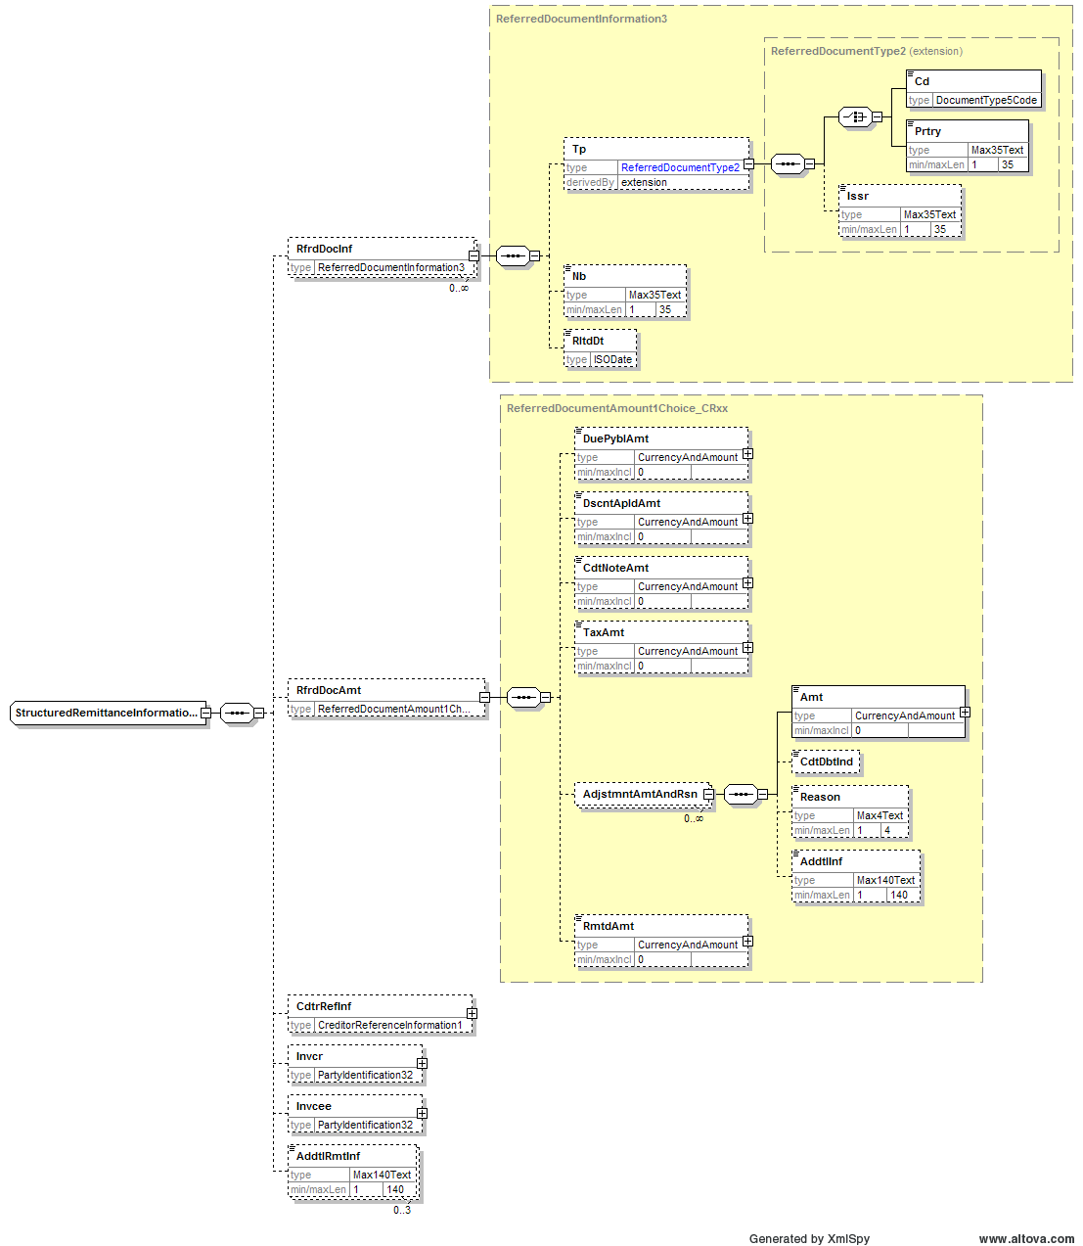
Structural changes are restricted to the ReferredDocumentInformation and ReferredDocumentAmount components.
The ReferredDocumentInformation component will be repetitive and the ReferredDocumentNumber and ReferredDocumentRelatedDate will be integrated in this component (and renamed to Number and RelatedDate). As mentioned under bullet point a above 4 codes will be added to the type code list.
The ReferredDocumentAmount component will be a single occurring component with a sequence of amount elements. An optional repetitive AdjustmentAmountAndReason component will be added as shown above.
Following the positive outcome of the vote on technical adjustments (see Technical Adjustments paragraph at the end of this document) the XOR at nesting level will be removed in the ReferredDocumentInformation that will becomed:
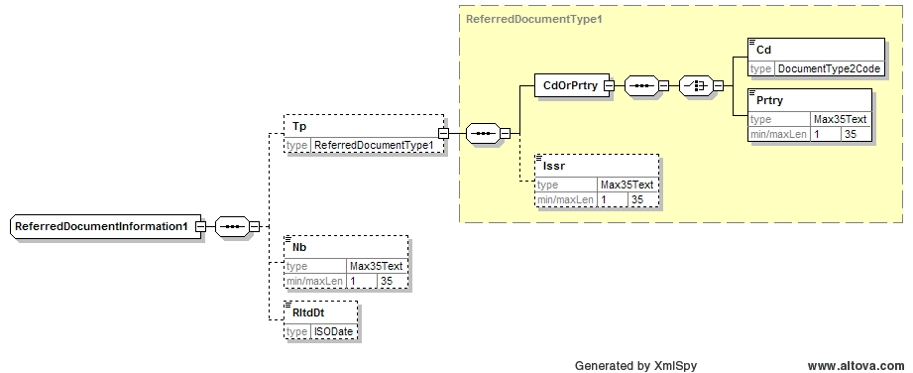

Also the CreditorReferenceInformation component will be impacted by this change and some further tag optimisation will be done as it has also been done for the ReferredDocumentInformation component: CreditorReferenceType will be renamed Type and CreditorReference will be renamed Reference. The current component shown below:
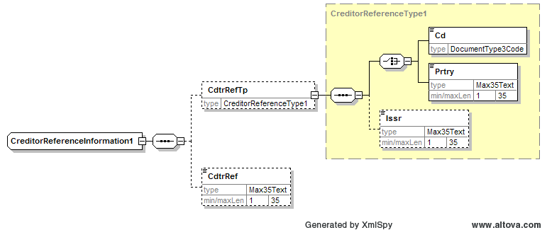

Will become:
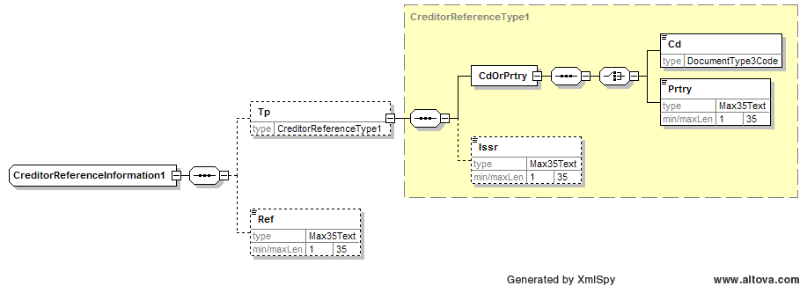
RMG decision:
This section is to be completed in due time by the RMG secretariat based on RMG approval/rejection of the SEG recommendation.
Approve
Comments:

Reject
Reason for rejection:

CR n°U-010-PAY-2009: UltimateDebtor (Payment Information and Credit Transfer – Direct Debit Transaction Information)
Origin of request and date | CR Status
Requestor(s):  - Member banks of CSTP  - SWIFT  Date of the request: requests made during various implementation discussions/meetings taking place in 2007/early 2008 | New
Nature of Change | Message(s) Impacted
Addition of a rule | Message Identifier (message Name)  - pain.001.001.02  Customer Credit Transfer Initiation  - pain.008.001.01  Customer Direct Debit Initiation
Context
Business reasons
Requirement description
1. Background information
UltimateDebtor can appear at Payment Information level and Transaction level, according to the Message Definition Report.
Just like for PaymentType and ChargeBearer, a rule should be added that this element can only be present once: either at Payment Information level or at Transaction level, but not at both levels.
This was always the intention, but a textual rule was not included in the Message Definition Report.
2. Requirement
The requirement is to have consistent implementation of this element, in line with the other optional elements, which can either be present at Payment Information level, or on Transaction level, but not both.

Recommendation from the Payments SEG:
This section is to be completed by the (lead) SEG which had approved the existing version of the messages.
Approve | X
Comments:
A textual rule will be added:
In the Customer Credit Transfer Initiation:
UltimateDebtorRule
If PaymentInformation/UltimateDebtor is present, then PaymentInformation/CreditTransferTransactionInformation/UltimateDebtor is not allowed.
If PaymentInformation/CreditTransferTransactionInformation/UltimateDebtor is present, then PaymentInformation/UltimateDebtor is not allowed.
PaymentInformation/UltimateDebtor and PaymentInformation/CreditTransferTransactionInformation/UltimateDebtor may both be absent.

In the Customer Direct Debit Initiation:
UltimateCreditorRule
If PaymentInformation/UltimateCreditor is present, then PaymentInformation/DirectDebitTransactionInformation/UltimateCreditor is not allowed.
If PaymentInformation/DirectDebitTransactionInformation/UltimateCreditor is present, then PaymentInformation/UltimateCreditor is not allowed.
PaymentInformation/UltimateCreditor and PaymentInformation/DirectDebitTransactionInformation/UltimateCreditor may both be absent.

Reject
Reason for rejection:

RMG decision:
This section is to be completed in due time by the RMG secretariat based on RMG approval/rejection of the SEG recommendation.
Approve
Comments:

Reject
Reason for rejection:

CR n°U-011-PAY-2009: Payment Status Report
Origin of request and date | CR Status
Requestor(s):  - Member banks of CSTP  - Members of SWIFT SCORE group  - GUF (Groupement des utilisateurs de SWIFT en France)  Date of the request: requests made during various implementation discussions/meetings taking place in 2007/early 2008 | New
Nature of Change | Message(s) Impacted
Addition and modification to a sequence | Message Identifier (message Name)  - pain.002.001.02  Payment Status Report  Also impacts PACS message:  - pacs.002.001.02  Payment Status Report  Note: the two messages currently share the same schema. The change request only pertains to the ‘pain’ domain, as the concept of ‘Payment Info level’ does not exist in the PACS payment messages.
Context
Business reasons
Requirement description
1. Background information
The Payment Status Report does not cater for reporting (positive and negative) on Payment Information level in the B2C space. This is a requirement in a number of user communities, but the French SWIFT user group stresses the urgency of the request and a French national member sub-group working on the user guides needs to get some quick responses for this big issue. Three options have been presented but they depend on the deadline of the correction of the message.
Option 1: The Payment Status Report message is not rapidly corrected
It is suggested to use the “OriginalMessageIdentification <OrgnMsgId>” element of the Payment Status Report message and feed it with the “PaymentInformationIdentification <PmtInfId>” data of the Customer Credit Transfer Initiation message in order to provide the instructing party with batch reference.
Disadvantages of this choice are:
- One Payment Status Report message will be generated for each “Payment Information” received in the original message
- The item “OriginalMessageIdentification will be used in order to get the item “PaymentInformationIdentification” of the Customer Credit Transfer Initiation message for each Payment Information got in the included in the remittance.
Option 2: The Payment Status Report message is not rapidly corrected
Another solution will be to map the “OriginalPaymentInformationIdentification” of the Payment Status Report message with the item “PaymentInformationIdentification” of the original message. In this case, the “Payment Information” is “rebuilt” from transactions.
Disadvantages of this solution are:
- In case of positive status:
    - Either the bank sends a global status to the customer. In that case, only the reference number of the message “OriginalMessageStatusIdentification” will be provided in order to allow the customer to make the reconciliation (the account number is provided only at Transaction level).
    - Or the bank provides all the transactions to the client. In that case, the customer needs a powerful tool in order to rebuild all the remittances (important volumes).
- In case of partial status (some of them are rejected) for a multiple remittance in acquisition, it will be necessary to provide all the transactions.
Option 3: The Payment Status Report message is rapidly corrected
Pending the arrival of the corrected Payment Status Report message, it is planned to use the current ARAs with a mapping of UNIFI items. This mapping should be planned.

To conclude, the choice of the option is much dependent on the deadline of the correction of the Payment Status Report that ISO could publish. Options 1 and 2 imply heavy IT developments for a short term. Therefore, option 3 is preferred pending the new release of the message.

2. Requirement
The Payment Status report should be structurally enhanced to enable the acceptance/rejection of Payment Information groups. This only pertains to usage of the Payment Status Report in the B2C space, not in the interbank space.

Recommendation from the Payments SEG:
This section is to be completed by the (lead) SEG which had approved the existing version of the messages.
Approve | X
Comments:
The Payment Status Report in the customer-to-bank space (pain.006.001.01) will be updated to allow status reporting at PaymentInformation level.
Furthermore, as the relevance of this (important) structural change is limited to the pain space, it has been decided to have different pain and pacs Payment Status Report schemas. This means for the current (common) schemas that elements specific to the pacs space will be eliminated in the pain schema and pain specific elements will be eliminated in the pacs schema.

Reject
Reason for rejection:

RMG decision:
This section is to be completed in due time by the RMG secretariat based on RMG approval/rejection of the SEG recommendation.
Approve
Comments:

Reject
Reason for rejection:

CR n°U-012-PAY-2009: Reason codes (Reject/Reversal/Return)
Origin of request and date | CR Status
Requestor(s):  - EPC SPS Task Force  - GUF (Groupement des utilisateurs de SWIFT en France)  Date of the request: requests made during various implementation discussions/meetings taking place in 2007/early 2008 | New
Nature of Change | Message(s) Impacted
Addition to message item type | Message Identifier (message Name)  - pain.002.001.02  Payment Status Report  - pain.007.001.01  Customer Payment Reversal  Also impacts PACS messages:  - pacs.002.001.02  Payment Status Report  - pacs.007.001.01  FItoFI Payment Reversal  - pacs.004.001.01  Payment Return
Context
Business reasons
Requirement description
1. Background information
The Status, Return and Reversal messages have been implemented in the framework of SEPA. A number of reject/return/reversal reasons included in the SEPA rulebooks currently have to be conveyed using the ‘Proprietary’ reason element, as the codes are not foreseen in the code list.
Proposal is to add the following codes to the reason code lists:
Request to add the following codes (and reasons) in
  - Return Reason (in Payment Return - FI To FI)
    - RR01 Regulatory Reason (used in Credit Transfers and Direct Debits)
    - SL01 Specific Service offered by Debtor Bank (used in Direct Debits)
  - Reject Reason (in Payment Status Report - B2C and FI To FI):
    - RR01 Regulatory Reason (used in Credit Transfers and Direct Debits)
    - SL01 Specific Service offered by Debtor Bank (used in Direct Debits)
  - Reversal Reason (in FI to FI Payment Reversal)
    - MS02 Not Specified Reason Customer Generated (used in Direct Debits)
    - MS03 Not Specified Reason Agent Generated (used in Direct Debits)
  - Reversal Reason (in Customer Payment Reversal - C2B)
    - MS02 Not Specified Reason Customer Generated (used in Direct Debits)
Today, there are already codes to identify that there are insufficient or incoherent details about the debtor or creditor, but not with respect to regulatory requirements. If the information missing or incorrect is required by the FATF SRVII, it would be more efficient to know it from the start and therefore to indicate it with a specific code.
The GUF proposes to add new repository codes specific to FATF to the following elements:
-StatusReason (pain.002.001.02 and pacs.002.001.02)
-ReturnReason (pacs.004.001.01)

2. Requirement
The requirement is to be able to express the reasons in a coded way, rather than through using the free ‘proprietary’ element.
The requirement is to have specific codes with regard to FATF SR VII regulatory requirements to be able to ask for complete information on debtor as stated in SR VII and the derived European regulation 1781/2006.

Recommendation from the Payments SEG:
This section is to be completed by the (lead) SEG which had approved the existing version of the messages.
Approve | X
Comments:
A single common code list for reject/return/reversal reason codes will be externalised with an indication where codes can be used (reject/return or reversal). Below codes will be added to the current list:
- To the reject / return reason code list
  - RR01: Specification of the debtor’s account or unique identification needed for reasons of regulatory requirements is insufficient or missing.
  - RR02: Specification of the debtor’s name and/or address needed for regulatory requirements is insufficient or missing.
  - RR03: Specification of the creditor’s name and/or address needed for regulatory requirements is insufficient or missing.
  - RR04: Regulatory Reason
  - SL01: Due to specific service offered by debtor agent
  - SL02: Due to specific service offered by creditor agent
- To the reversal reason code list
  - MS02: Not Specified Reason Customer Generated
  - MS03: Not Specified Reason Agent Generated (only FIToFI Reversal)

Reject
Reason for rejection:

RMG decision:
This section is to be completed in due time by the RMG secretariat based on RMG approval/rejection of the SEG recommendation.
Approve
Comments:

Reject
Reason for rejection:

CR n°U-013-PAY-2009: InitiatingParty
Origin of request and date | CR Status
Requestor(s):  - Member banks of CSTP  Date of the request: requests made during various implementation discussions/meetings taking place in 2007/early 2008 | New
Nature of Change | Message(s) Impacted
Modification of definition | All ‘PAIN’ and ‘PACS’ messages  Also impacts some of the CAMT messages.
Context
Business reasons
Requirement description
1. Background information
The definition of initiating party currently refers to a direct debit context and credit transfer context: ‘Party that initiates the payment. In the payment context, this can either be the debtor (in a credit transfer), the creditor (in a direct debit), or a party that initiates the payment on behalf of the debtor or creditor.’
The suggestion is to make the definition context specific: remove ‘direct debit’ context from definition in Credit Transfer related messages, and remove ‘credit transfer’ from definition in Direct Debit related messages.
2. Requirement
The requirement is to have clear definitions that can be understood in a message-driven context.

Recommendation from the Payments SEG:
This section is to be completed by the (lead) SEG which had approved the existing version of the messages.
Approve | X
Comments:
Specific definitions will be given for the InitiatingParty in direct debit and credit transfer messages instead of the current generic definition that caters for both:
- Credit Transfer messages:
Party initiating the payment. In the context of the Credit Transfer this can either be the Debtor or a party that initiates the payment on behalf of the Debtor.
- Direct Debit messages:

Party initiating the payment. In the context of the Direct Debit this can either be the Creditor or a party that initiates the payment on behalf of the Creditor.

Reject
Reason for rejection:

RMG decision:
This section is to be completed in due time by the RMG secretariat based on RMG approval/rejection of the SEG recommendation.
Approve
Comments:

Reject
Reason for rejection:

CR n°U-014-PAY-2009: StatusIdentification/ReversalIdentification/ReturnIdentification
Origin of request and date | CR Status
Requestor(s):  - User communities/banks implementing SEPA  Date of the request: requests made during various implementation discussions/meetings taking place in 2007/early 2008 | New
Nature of Change | Message(s) Impacted
Modification of definition | Message Identifier (message Name)  - pain.007.001.01  Customer Payment Reversal  - pain.002.001.02  Payment Status Report  Also impacts all ‘PACS’ ‘related’ messages:  - pacs.007.001.01  FI to FI Payment Reversal  - pacs.004.001.01  Payment Return  - pacs.002.001.02  Payment Status Report
Context
Business reasons
Requirement description
1. Background information
The current ‘Id’s used in the ‘related’ Payment Status/Reversal/Return messages, on Transaction level, refer to ‘instructing parties’ and ‘instructed parties’ – as shown below:
StatusIdentification: Unique identification as assigned by an instructing party for an instructed party to unambiguously identify
It should be clarified that this instructing party is the party sending the Status/Reversal/Return message, not the original party instructing the payment.
2. Requirement
The requirement is to have clear definitions that avoid ambiguity.

Recommendation from the Payments SEG:
This section is to be completed by the (lead) SEG which had approved the existing version of the messages.
Approve | X
Comments:
Clarifying Usage will be added to each of the definitions:
- Status Identification
“Unique identification as assigned by an instructing party for an instructed party to unambiguously identify the reported status.”
Usage: The instructing party is the party sending the status message and not the party that sent the original instruction that is being reported on.
- Return Identification
“Unique identification as assigned by an instructing party for an instructed party to unambiguously identify the returned transaction.”
Usage: The instructing party is the party sending the return message and not the party that sent the original instruction that is being returned.
- Reversal Identification
“Unique identification as assigned by an instructing party for an instructed party to unambiguously identify the reversed transaction.”
Usage: The instructing party is the party sending the reversal message and not the party that sent the original instruction that is being reversed.
- The same clarification will be added to InstructingAgent and InstructedAgent in R- messages:
Usage: The instructing / instructed agent is the party sending the status/return/reversal message and not the party that sent the original instruction that is being reported on / returned / reversed.

Reject
Reason for rejection:

RMG decision:
This section is to be completed in due time by the RMG secretariat based on RMG approval/rejection of the SEG recommendation.
Approve
Comments:

Reject

Reason for rejection:CR n°U-015-PAY-2009: GroupStatus and TransactionStatus codes
Origin of request and date | CR Status
Requestor(s):  - CSTP member banks  - SCORE member banks  - ISTH  Date of the request: requests made during various implementation discussions/meetings taking place in 2007/early 2008 | New
Nature of Change | Message(s) Impacted
Modification of definition | Message Identifier (message Name)  - pain.002.001.02  Payment Status Report  Also impacts ‘PACS’ message:  - pacs.002.001.02  Payment Status Report
Context
Business reasons
Requirement description
1. Background information
Several requests have been received:
- Clarification of definitions: current positive Status codes Accepted Customer Profile and Accepted Settlement in Process refer to positive assessment of ‘static’ and ‘dynamic’ risks. These risks should be further defined (as is the case in the ISO 20022 Message Usage Guide).
Note: any reference to assessment of ‘static risks’ including ‘embargo/black list/etc’ checking should be removed from the clarification.
- Additional status codes are necessary as specific profiles (as defined by existing status codes) may or may not be checked at the time of the generation of process platform references (ISTH)
2. Requirement
The requirement is to have clear definitions that avoid ambiguity and to have status codes reflecting actual scenarios.

Recommendation from the Payments SEG:
This section is to be completed by the (lead) SEG which had approved the existing version of the messages.
Approve
Comments:

Reject | X
Reason for rejection:
The definitions of existing codes ACCP and will be reworded to take out any reference to risk:

ACCP AcceptedCustomerProfile Preceding check of technical validation was successful.
Customer profile check was also successful. This includes the assessment of the static risks.
ACSP AcceptedSettlementInProcess All preceding checks such as technical validation and customer
profile were successful. Dynamic risk assessment
is now also successful and therefore the payment initiation has been accepted for execution.

RMG decision:
This section is to be completed in due time by the RMG secretariat based on RMG approval/rejection of the SEG recommendation.
Approve
Comments:

Reject
Reason for rejection:

CR n°U-016-PAY-2009: Payment Cancellation Request
Origin of request and date | CR Status
Requestor(s):  - SWIFT Cash Management BVG  - Subset of ISO Payment SEG (also present at Cash Management maintenance meeting September 2007)  Date of the request: request was agreed during cash management maintenance meeting September 2007 | New
Nature of Change | Message(s) Impacted
Modification of message item | - pain.006.001.01  Payment Cancellation Request  - pain.002.001.02  Payment Status Report  Also impacts ‘Pacs’ messages:  - pacs.006.001.01  Payment Cancellation Request  - pacs.002.001.02  Payment Status Report  Also impacts ‘ CAMT’ (E&I) message:  - camt.008.002.02
Context
Business/alignment reasons
Requirement description
1. Background information
During the SWIFT Cash Management maintenance meeting that took place in September 2007, it was agreed to try and merge the different cancellation request messages (and the replies to these requests) that currently exist.
Cancellation requests currently exist in ‘pain’ and ‘pacs’, as well as in ‘camt-enquiry management’ and even ‘camt-cash flow management’ (that is the message set used by MI’s, which has not been ISO stamped yet).
The reply message to answer a Payment Cancellation Request is different as well: through Payment Status Report in ‘pain’ and ‘pacs’, through Resolution of Investigation in ‘camt-E&I’, and no answer required in ‘camt-cash flow management’.
During the meeting, the overall outcome was to try and use the Resolution of Investigation message to answer to a Payment Cancellation Request (and remove the functionality from the Payment Status report message).
2. Requirement
The requirement is to have a harmonized way and solution to issue a Payment Cancellation Request and to reply to such a request.

Recommendation from the Payments SEG:
This section is to be completed by the (lead) SEG which had approved the existing version of the messages.
Approve | X
Comments:
The current pain&pacs and E&I cancellation request messages will be merged into a common schema maintaining their current functionality.
Two schemas will be created: one for a corporate-to-bank and one for an inter-bank payment cancellation request. These will belong to the E&I message family (with a camt business area):
- Customer Payment Cancellation Request (camt.055.001.01)
- FIToFI Payment Cancellation Request (camt.056.001.01)
A merged list of cancellation reason codes has been approved.
The Resolution of Investigation message will be used to answer a cancellation request. Cancellation specific reason codes will be removed from the Payment Status Report message.
More information, including a complete comparison between the old and new messages can be found in below file:


Reject
Reason for rejection:

RMG decision:
This section is to be completed in due time by the RMG secretariat based on RMG approval/rejection of the SEG recommendation.
Approve
Comments:

Reject
Reason for rejection:

CR n°U-017-PAY-2009: BranchAndFinancialInstitutionIdentification3
Origin of request and date | CR Status
Requestor(s):  - Member banks of CSTP  - SCORE member banks  - SWIFT  - ISTH  - German Community  Date of the request: requests made during various implementation discussions/meetings taking place in 2007/early 2008 | New
Nature of Change | Message(s) Impacted
Modification of message item | All ‘PAIN’, ‘PACS’ and ‘CAMT’ messages
Context
Business/alignment reasons
Requirement description
1. Background information
Several requests have been received:
- ClearingSystemMemberIdentification:
The current Clearing System Member Identification is typed by an External code (from the ISO 20022 External Code list). This external code is a combination of the type of clearing system, as well as the actual value of the clearing system member Id. This is not in line with the other identification mechanisms used in the messages.
Proposal is to separate the Clearing System from the actual value of the Id.
The clearing system should encompass the inclusion of a code to represent all countries with the two character country code appearing in the first two positions with a generic representation in the next three positions, that is CCXXX (ISTH)
- Review component structure:
It has been noted during various implementation discussions that the current component for Financial Institution (which is a choice between separate identification methods and as last choice a combination of all of these identification methods) is complex to implement. It has been suggested to use the Combined Id only (in combination with the Branch identification)
Agent party identification confusion (JPMChase): Agent party declarations within the message use both Financial Institution Identification and Combined Identification groups for all Agent Party definitions. However, only the Combined Identification supports both entry of a BIC/Clearing System Identification/Proprietary Identification, and Name and Address information. This restriction is based upon the schema’s XOR condition to all level four (4) sub-groups within the Financial Institution Identification group. This means that banks need to support potential data content in both the Financial Institution Identification and Combined Identification groups for all Agent Party definitions. This is more complex than necessary, and clients find it equally confusing. For ease of implementation and sort out ambiguity FinancialInstitutionIdentification5Choice shall be renamed to FinancialInstitutionIdentification5 with deleted element CombinedIdentification and altered choice to sequence. FinancialInstitutionIdentification3, the structure of CombinedIdentification, can then be deleted (Austria).
Recommendation:
Most likely, ERP and accounting systems will always have a Name and Address to associate to some form of party identification, such as a BIC or Clearing System Member Code. We think the ISO message would be simpler to just support the Financial Institution Identification group, and eliminate the XOR conditions for the current level four (4) sub-groups therein. This would eliminate the need for a Combined Identification section in all Agent Party definitions, and provide a single place for entry of all Agent party identification information.
- Country code (ISTH): if Proprietary Id is used to identify an agent, you may need to have the country code as additional information. It would be useful to have a dedicated element for country code (that is, not as part of postal address).
Furthermore, it should also be investigated whether country code should stay mandatory in Postal address (Note: also see request from JPMChase below)
- Postal address (JPMorgan Chase):
1. ERP and accounting systems usually only store Postal Address as either Structured or Unstructured, but not both. When legacy systems are incorporated into newer ERP systems, legacy address are usually stored as unstructured data that would be supported by Address Line in the ISO Postal Address. Newer address entries are most likely to be structured, and stored in individual elements supported within the ISO Postal Address. Supporting both variants makes presenting data to downstream systems that support only unstructured addressing very complex.
2. Customers that store their postal addresses in an unstructured format generally do not have the capability to make the country code available as an isolated field. ISO schema requires that if any part of Postal Address is provided, that the Country element is mandatory. While the segregation of the Country is certainly useful, customers that store vendor master files in an unstructured manner will have great difficulty in meeting the schema requirement to present the Country code as a unique element.
Recommendation:
  - JPM recommends that the Message User Guide advise clients to send Postal Addresses in either structured or unstructured format, but not both. In addition, we recommend the schema be enhanced to group the structured content into a new, individual group (Structured), and have ‘XOR’ conditions on the Address Line and the new Structured address group. This will simplify the potential coding required to support both structured and unstructured addresses within the same Postal Address, and present data more compatible to downstream payment processing systems.
  - JPM and the German community suggest that the schema requirement for country code be relaxed to be an optional element. This will allow client systems that store their Postal Addresses in an unstructured format, to not be required to present the country code in the Postal Address in order to maintain schema compliance. Clients that cannot meet the current schema requirement due to legacy addressing stored in an unstructured manner, would then have the option of supplying the country code element if available. While we support having this field segregated and mandatory, the reality is that not all systems have the data element isolated to support the current schema requirement.
This applies to the global Postal address component, which is also part of the Party Identification component, not just the BranchAndFinancialInstitutionIdentification3 component.
2. Requirement
The requirement is to have a consistent and easy to implement way of identifying agents.

Recommendation from the Payments SEG:
This section is to be completed by the (lead) SEG which had approved the existing version of the messages.
Approve | a, b, d
Reject | c
The BranchAndFinancialInstitutionIdentification3 component will be replaced by the BranchAndFinancialInstitutionIdentification4 component as shown below:
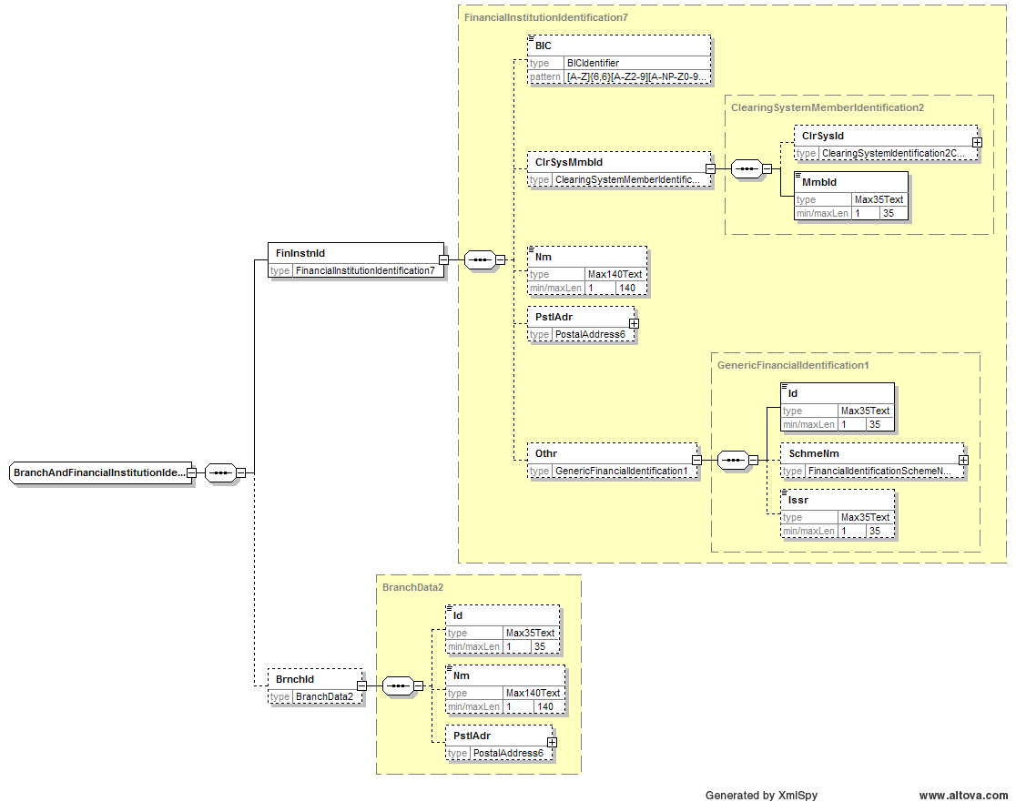
Comments for the individual change requests as described under paragraph 1.
- ClearingSystemMemberIdentification
à Agreed to separate ClearingSystemId from the actual MemberId
- Review component structure
à Agreed as per above screenshot
- Include country code to Proprietary Id
à Rejected, to be covered by Issuer element in the new structure
- Changes to PostalAddress1
à Agreed to make the country code optional
à Agreed to add a guideline to the Message Definition Report/Message User Guide to advise to use either structured or unstructured address format, but not both. No XOR will be implemented.
Some further changes were discussed / will be made to the PostalAddress1 component, more specifically coming from change requests to the PartyIdentification8 component (see change request n°U-018-PAY-2009 below):
à Agreed to add an element for department and sub-department name
à Agreed to increase the occurrences from Addressline from 5 to 7
The PostalAddress1 component will be replaced by the PostalAddress6 component as shown below:
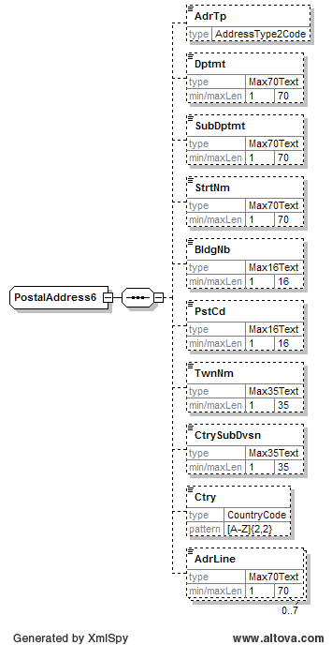

RMG decision:
This section is to be completed in due time by the RMG secretariat based on RMG approval/rejection of the SEG recommendation.

Approve
Comments:

Reject
Reason for rejection:

CR n°U-018-PAY-2009: PartyIdentification8
Origin of request and date | CR Status
Requestor(s):  - The Clearing House (Chips UID)  - Banks and CSMs implementing ISO 20022 for SEPA  - SWIFT  - GUF (Groupement des utilisateurs de SWIFT en France)  - HSBC  - Austrian community  Date of the request: requests made during various implementation discussions/meetings taking place in 2007/early 2008 | New
Nature of Change | Message(s) Impacted
Modification of message item | All ‘PAIN’, ‘PACS’ and ‘CAMT’ messages
Context
Business/alignment reasons
Requirement description
1. Background information
Several requests have been received:
- Remove IBEI and CHIPS UID from Organisation Id.
IBEI does no longer exist (SWIFT and French SWIFT User Group), and it has been requested by the Clearing House to add Chips UID as an account identifier, rather than a party identifier
- Review concept of explicit, schema-embedded code lists for Private and Organisation Identification.
It has been noted during various implementation discussions that the code lists available for Private Id and Organisation Id may cause some concern when implementing and maintaining these elements. It has been suggested to possibly review this concept, and possibly consider the use of another mechanism (such as External Code lists) for some of these codes.
- Remove XOR between Private Id and Organisation Id, so multiple Ids can be included (for different authorisation parties) (HSBC). For some countries, additional authorisation parties (that are involved in creation & authorisation of the transaction before it is sent to the bank) are required to be identified at a transaction level in certain countries (Regulatory Requirement for example in Russia). The Debtor agent needs to check this information against the customer profile held in static data. This type of information does not need to be carried through the inter-bank payment chain.
- From Organisation Id sequence to choice (Austria) OrganisationIdentification2 is part of Party2Choice and allows multiple identifications of an organisation (due to being a sequence) while PersonIdentification3, also part of Party2Choice, allows just one identification of a person (due to being a choice). For ease of implementation it should only be possible to identify any party with a single identification. Therefore OrganisationIdentification2 shall be altered from sequence to choice.
- Increase the length of the Name field from 70 to 140 characters (HSBC). In some countries (India, Thailand), the actual length of the name exceeds the current maximum field length. This has resulted in each bank implementing a tactical fix. The field should have the capacity to support the maximum required length.
- Include a department name and sub department name elements in the structured address logic and extend the number of occurrences of the unstructured address line from 5 to 7 (HSBC). Through customer implementations, we have identified real life example of where the current design does not cater for the needs of the pharmaceuticals industry. This has resulted in customers being forced to use both structured and unstructured address options. The issue is where you need to include the department name and sub name in order for the items to reach their intended recipient, in a timely manner.
- Include a contact information component and Payment Tracking Indicator (FED). In the “Message Items Types” under “PartyIdentification8”, add a new optional data element for “Contact Information”. The options for Contact Information would include:
E-Mail Address
Phone Number
Fax Number
Other
It would be particularly helpful to the beneficiary (and other parties in the payment chain) if the originator could include this information in the message. It also makes sense to allow each party in the payment chain to include contact information. This information could be used by any parties in the payment chain to either confirm processing of the payment or to collect additional information from a given party regarding the payment. For this reason an optional Payment Tracking Indicator element is requested. In this element the originator could indicate a preference for payment tracking. For example: PMTY – Payment Tracking Yes. If the originator indicates a preference for payment tracking and provides an End-to End ID and an e-mail address or other contact information, banks within the payment chain could send a confirmation to the originator once they successfully processed their leg of the payment.
2. Requirement
The requirement is to have a consistent and easy to implement way of identifying parties.

Recommendation from the Payments SEG:
This section is to be completed by the (lead) SEG which had approved the existing version of the messages.

Approve | a, b, e, f, g
Reject | c, d
The PartyIdentification8 component will be replaced by the PartyIdentification32 component as shown below:
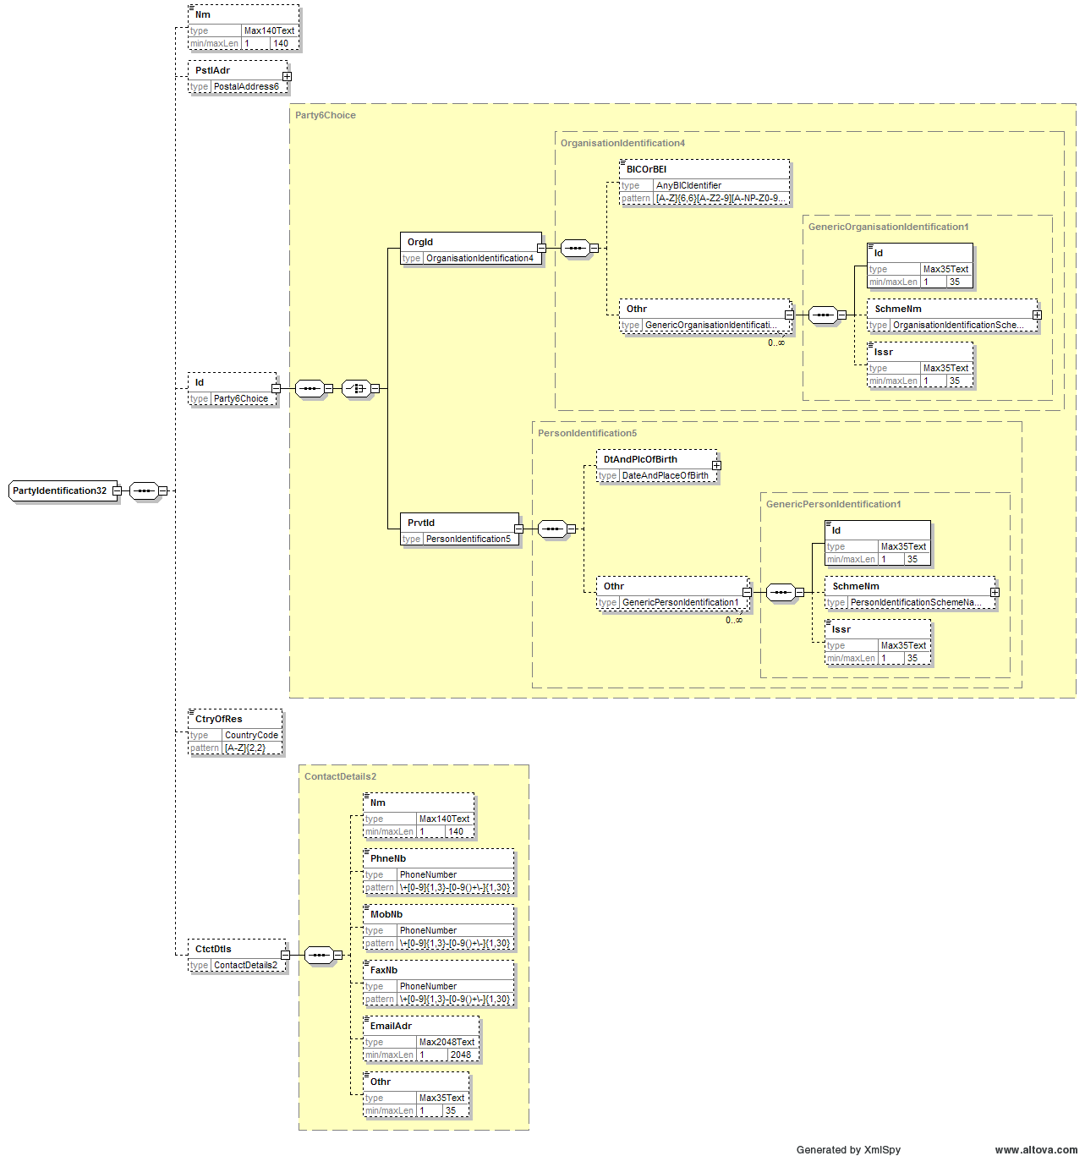
Comments for the individual change requests as described under paragraph 1.
- Remove IBEI & Chips UID from OrganisationId
à Agreed
- Review concept of explicit, schema-embedded code lists for OrganisationId and PrivateId
à Agreed, will be externalised in new component structure. Current list of SchemeName codes for
Organisation Id
CUST
DUNS
EANG
TXID
Private Id
ARNU
CCPT
CUST
EMPL
NIDN
SOSE
TXID
- Remove XOR between OrganisationId & PrivateId
à Rejected, party will either be a private party or an organisation, but not both
- Change OrganisationId from element sequence to choice
à Rejected, new component structure is sequence for both OrganisationId and PrivateId. Several organisation or private ids sometimes need to be combined
- Increase Name length from 70 to 140 characters
à Agreed to change Name to Max140Text
- Include a department and sub-department name
à Agreed, both elements will be Max70Text
Extend occurrences AddressLine from 5 to 7
à Agreed
Some further changes will be made to the PostalAddress1 component, as described under change request n°U-017-PAY-2009 above. The country code will be made optional and a guideline will be added to the Message Definition Report/Message User Guide to advise to use either structured or unstructured address format, but not both. The new PostalAddress6 component can be found there.
- Include a Contact Information component
à Agreed, see screenshot above for added details
Include a Payment Tracking indicator
à Rejected, to be agreed in service levels

RMG decision:
This section is to be completed in due time by the RMG secretariat based on RMG approval/rejection of the SEG recommendation.
Approve
Comments:

Reject
Reason for rejection:

CR n°U-019-PAY-2009: Documentation requests
Origin of request and date | CR Status
Requestor(s):  - Member banks of CSTP  Date of the request: requests made during various implementation discussions/meetings taking place in 2007/early 2008 | New
Nature of Change | Message(s) Impacted
All ‘PAIN’ and ‘PACS’ messages
(as well as CAMT messages, and messages from other domains)
Context
Business reasons
Requirement description
1. Background information
A number of issues have been pointed out:
- Rules/Guidelines/Usage: are different categories of information, relating to the presence and usage of message items. They should be used in a consistent manner. It should also be easier to find all rules and all guidelines impacting the message and all of its elements (that is, have them in one central place).
- Some message items are expanded in the Message Structure section, others are not. It has been requested not to expand Remittance Location Postal Address, and to expand Cheque Instruction in the message Structure section.
2. Requirement
The requirement is to have a consistent and clear way of providing information about the message.

Recommendation from the Payments SEG:
This section is to be completed by the (lead) SEG which had approved the existing version of the messages.
Approve | X
Comments:
The concerns will be addressed by the submitter at time of the Message Definition Report generation.

Reject
Reason for rejection:

RMG decision:
This section is to be completed in due time by the RMG secretariat based on RMG approval/rejection of the SEG recommendation.
Approve
Comments:

Reject
Reason for rejection:

CR n°U-029-PAY-2009: Number of Transactions and Control Sum
Origin of request and date | CR Status
Requestor(s) :  - GUF (Groupement des utilisateurs de SWIFT en France)  - Austrian community  Date of the request : originally submitted June 2007, resubmitted April 2008 and May 2008 | New
Nature of Change | Message(s) Impacted
Addition of 2 elements : Number of Transactions and Control Sum to the Payment Information component | - pain.001.001.02  Customer Credit Transfer Initiation  - pain.008.001.01  Customer Direct Debit Initiation  Impact on ‘related’ messages (such as Cancellation and Payment Status) must be assessed when discussing CR 16 for Cancellation Request and CR 11 for Payment Status Report
Context
Business reasons
Requirement description
1. Background information
The NumberofTransactions and ControlSum elements are used to technically control the completeness of the message. But this information is also useful at Payment Information level:
- it gives a more detailed control (you can reject at Payment Information instead of at Message level)
- this information is more commonly used between the customer and his bank in daily business to identify a payment remittance (by phone, for instance), rather than references
- the total amount (ControlSum) is a main business data corresponding to the effective amount booked for the remittance

NumberOfTransactions (mandatory) and Control Sum (optional) are located in the GroupHeader and count the transactions/transaction amounts contained in the whole message. Since Grouping (in GroupHeader) provides the possibility of indicating MIXD, several batches can be sent by an initiator. For ease of processing it is necessary to know the number of transactions and control sum per batch. Therefore these elements shall be available at PaymentInformation Level as well (Austria).

2. Requirement
When a problem occurs in a message composed of several Payment Information components, reactivity will be improved by identifying the amount or number of transactions involved, and by giving this information to the customer by phone or by a status message.
Recommendation from the Payments SEG:
This section is to be completed by the (lead) SEG which had approved the existing version of the messages.
Approve | X
Comments:
The NumberOfTransactions and ControlSum elements will be added optionally at PaymentInformation level.

Reject
Reason for rejection:

RMG decision:
This section is to be completed in due time by the RMG secretariat based on RMG approval/rejection of the SEG recommendation.
Approve
Comments:

Reject
Reason for rejection:

CR n°U-030-PAY-2009: Requested Execution Date – Requested Interbank Settlement Date
Origin of request and date | CR Status
Requestor(s) :  - GUF (Groupement des utilisateurs de SWIFT en France)  Date of the request: April 2008 | New
Nature of Change | Message(s) Impacted
Addition of an element “Requested Interbank Settlement Date” with the same properties as the existing “Requested Execution Date” element. These 2 elements must be present, at the same level, as a choice: “Requested Execution Date” OR “Requested Interbank Settlement Date”. | - pain.001.001.02  Customer Credit Transfer Initiation  Note: Related messages such as the Payment Status report, and the Cancellation request used in the C2B space may also be impacted (if this element needs to be included in ‘original transaction data set)
Context
Business reasons
Requirement description
1. Background information
In a large majority (more than 80%) of the domestic credit transfers in France, the customers indicate to his bank (the sending bank) a requested settlement date instead of an execution date. The settlement date is more important from a customer point of view as it should most of the time represent the availability of funds at beneficiary’s bank.
As the Requested Execution Date is equivalent to the debit date, this date is not adapted to a payment of a draft paid at maturity (this vocabulary is used for the trade finance industry) or “due date” (for the payments industry). For example, in accordance with the term of a documentary credit, on the account of the bank of the beneficiary whatever the payment method used the date on which the payment is made is the maturity date (correspondent banking, ACH…..).

2. Requirement
Adding this new date element in the message will:
- Allow the customer to keep the best practice from a business point of view
- Allow the customer to use the execution date if needed in particular cases
- Reduce the risk of misunderstandings in the meaning of the execution date
- Reduce the risk of calculation errors for a customer to deduce the execution date from the settlement

Recommendation from the Payments SEG:
This section is to be completed by the (lead) SEG which had approved the existing version of the messages.
Approve
Comments:

Reject | X
Reason for rejection:
The group felt that the decision of the InterbankSettlementDate must remain with the bank and it is to be bilaterally/multilaterally agreed between customers and their bank or ruled at community level how a RequestedExecutionDate will translate into an InterbankSettlementDate.
RMG decision:
This section is to be completed in due time by the RMG secretariat based on RMG approval/rejection of the SEG recommendation.
Approve
Comments:

Reject
Reason for rejection:

CR n°U-031-PAY-2009: Digital Signature
Origin of request and date | CR Status
Requestor(s) :  - ISTH  Date of the request: March 2008 | New
Nature of Change | Message(s) Impacted
Addition of an element at three levels | - pain.001.001.02  Customer Credit Transfer Initiation  - pain.008.001.02  Customer Direct Debit Initiation  Note: Related messages such as the Payment Status report, and the Cancellation request used in the C2B space may also be impacted (if this element needs to be included in ‘original transaction data set)
Context
Business reasons
Requirement description
1. Background information
Applications utilized by customers are including the ability for messages to be signed at various levels. It should be noted that this signature is different from the mandate signature already included in the Customer Direct Debit Initiation message.

2. Requirement
A digital signature component/tag is required at three levels in the messages noted above: group header, payment information and transaction levels.

Recommendation from the Payments SEG:
This section is to be completed by the (lead) SEG which had approved the existing version of the messages.
Approve
Comments:

Reject | X
Reason for rejection:
It was felt that digital signatures do not belong inside the message. New developments in the field propose solutions outside the message content and are able to refer to any part in the message, thereby allowing digital signatures at almost every level as requested in the change request. More analysis is required and the change request is referred to a next maintenance cycle.

RMG decision:
This section is to be completed in due time by the RMG secretariat based on RMG approval/rejection of the SEG recommendation.
Approve
Comments:

Reject
Reason for rejection:

CR n°U-032-PAY-2009: Additional References for Status Messages
Origin of request and date | CR Status
Requestor(s) :  - ISTH  Date of the request : March 2008 | New
Nature of Change | Message(s) Impacted
Addition of an element at three levels | - pain.002.001.02  Payment Status Report  - pacs.002.001.02  Payment Status Report
Context
Business reasons
Requirement description
1. Background information
Status messages to be provided by processing platforms may be able to advise references assigned by the platforms, i.e., platform reference (Account Service Reference), Fed Wire Reference (Clearing System Reference), FX rates, FX calculated amount (Transaction Amount/Currency Exchange), etc. These references are desired by the originators of the transactions to further update their applications.
FX information is currently provided to clients prior to the postings made to their account, and currently has to be provided as free form text. This data can be utilized by the originator to make financial accounting adjustments prior to the receipt of the statement.

2. Requirement
The requirement is to provide the original initiating party with all necessary references:
- AccountServicerReference
- ClearingSystemReference
- CurrencyExchange reference information

Recommendation from the Payments SEG:
This section is to be completed by the (lead) SEG which had approved the existing version of the messages.
Approve | a, b
Comments:
An AccountServicerReference and ClearingSystemReference will be added to the Payment Status Report messages in line with the bank-to-customer reporting messages where these references are already available.

Reject | c
Reason for rejection:
The information should be reported in the camt.054.001.01 BankToCustomerDebitCreditNotificationV01 with the CurrencyExchange component.

RMG decision:
This section is to be completed in due time by the RMG secretariat based on RMG approval/rejection of the SEG recommendation.
Approve
Comments:

Reject
Reason for rejection:

CR n°U-033-PAY-2009: Instruction for Debtor Agent in Direct Debit Messages
Origin of request and date | CR Status
Requestor(s) :  - ISTH  Date of the request: April 2008 | New
Nature of Change | Message(s) Impacted
Addition of an element | - pain.008.001.02  Customer Direct Debit Initiation  - pacs.003.001.02  FI to FI Customer Direct Debit
Context
Business reasons
Requirement description
1. Background information and requirement

The direct debit messages currently do not include ‘Instruction for Debtor Agent’ (contrary to the credit transfer messages, which do include an ‘Instruction for Creditor Agent’). The need has been expressed to have an Instruction for Debtor Agent element that can be transported up to the Debtor Agent, to give an instruction. Example: an instruction needs to be sent to have a resource at the debtor agent to phone the creditor agent.

Recommendation from the Payments SEG:
This section is to be completed by the (lead) SEG which had approved the existing version of the messages.
Approve
Comments:

Reject | X
Reason for rejection:
The change request is referred to the next maintenance cycle as it was felt more clarification on the business need is required.

RMG decision:
This section is to be completed in due time by the RMG secretariat based on RMG approval/rejection of the SEG recommendation.
Approve
Comments:

Reject
Reason for rejection:

CR n°U-035-PAY-2009: Character set for parties & remittance information
Origin of request and date | CR Status
Requestor(s):  - ISTH  Date of the request: May 2008 | New
Nature of Change | Message(s) Impacted
Modification to message items | All ‘PAIN’, ‘PACS’ and ‘CAMT’ messages
Context
Business reasons, technical reasons, implementation bottlenecks
Requirement description
1. Background information
Corporations are currently facing the burden to replace characters outside the range of basic Latin by phonetic equivalents for payment initiation messages. After the SEPA implementation banks are more and more confronted with the occurrence of characters outside the basic character set, defined as basic Latin (both upper and lower case). The implementation of SEPA for countries with many (or all, like Cyrillic or Greek) non-Latin characters in the local language urges a solution.

A sub-working group of the European Payments Council has been commissioned to come up with a structural solution. The “Character Set Work Group” has met only once, where an in-depth analysis of the conflicting ISO 8859 tables (a.o. preventing the implementation of @ and € sign), was presented by Richard Hauke.
The conclusion of the work group is that a structural new solution must be defined and verified with stakeholders to assess the implementation consequences before being defined as standard. This may take quite a while, considering issues like printers with national character sets and conversion to mainframes (EBCDIC). But as the proposed solution requires changes to the current message sets, early submission of a change request is required.

2. Requirement

The line of thought of the structural solution is as follows:

- Only fields of type TEXT may contain the extended character set, if further restrictions apply this might be expressed in rules.
- XML supports UTF-8 as multi-byte variable width format that also includes the ASCII character set using single byte encoding.
- UNICODE is the only coding table to specify the local language character representation. Each character has a unique bit value in UTF-8, pointing to a position in the UNICODE table.
- Specifically for names and addresses the following rules apply:
  - Domestic payments may contain name and address data in the language of the country or in basic Latin characters.
  - Same rule applies in a community, e.g. a region with the same language. Example: Germany and Austria.
  - Cross-border payments require name and address details in basic Latin characters for Anti Money Laundering and CFAC purposes.
In addition a version of the name and address details may be provided in local characters.

A standardized transliteration for financial transactions should be agreed with FATF.
Conversion rules to derive names in Basic Latin characters from local languages are available as Passport & Visa standard, containing the transliteration info at http://mrtd.icao.int/content/view/33/202/
In general it is not possible to translate back to local characters, for that reason the option to include 2 versions of the name and address seems inevitable.

Modern ERP systems facilitate the inclusion of name and addresses in master data in both Latin and local characters, so payment messages can be generated with both versions. The provision of the Latin character version of names and addresses for cross-border transactions in principle is the responsibility of the originator, but transliteration can be offered as a service by the first bank. FATF rules specify that the original data must be maintained.

An option to avoid conversion by the first bank would be the conversion of local language characters by every party in the chain on if-needed basis: for verification with FATF or CFAC tables, fields can be “Latinized” before matching; for printing on checks or letters fields can be translated if required.

The proposed concept (or any comparable solution) requires a second occurrence of the name and address details of parties, with rules when the Latin character version MUST be provided. In order to avoid a “language-type” field, it is proposed that the first occurrence always contains the (current) Latin version, the second the local character version.

Recommendation from the Payments SEG:
This section is to be completed by the (lead) SEG which had approved the existing version of the messages.
Approve
Comments:

Reject | X
Reason for rejection:
It was felt that there was no valid business case. Doubling all text elements would have an enormous impact with high (AML-related) risks.

RMG decision:
This section is to be completed in due time by the RMG secretariat based on RMG approval/rejection of the SEG recommendation.
Approve
Comments:

Reject
Reason for rejection:

CR n°U-046-PAY-2009: Formatting Unstructured Remittance Details
Origin of request and date | CR Status
Requestor(s):  - EACT  Date of the request : May 2008 | New
Nature of Change | Message(s) Impacted
Addition to a Guideline | Message Identifier (message Name)  - pain.001.001.02  Customer Credit Transfer Initiation  - pain.008.001.01  Customer Direct Debit Initiation
Business context
Business reasons, Technical reasons, Other reasons (processability of unstructured text)
Requirement description
1. Background information
For corporates the purchase-to-pay and order-to-cash processes represent the highest potential for improving cash management. The problem is that there is no control over the quality of data exchanged between the commercial partners.
For both payer and beneficiary the payment transaction is only complete, when both the funds are transferred and the detailed information of the transaction is processed in the Accounts Payable and Accounts Receivable system. The number of queries by the beneficiary about the details of the payment will be drastically reduced if the payer takes care of providing these details in a proper way.
By exchanging these transaction details electronically, a high level of automation can be realized. This electronic exchange of information applies to the financial aspects of the payment transaction (where the financial institutions play the dominant role by providing an information-rich electronic bank statement), but also applies to the underlying business details: invoice specification or any reference required by the beneficiary to automatically reconcile the payment with open receivable items. Specification of the remittance details can be accomplished by sending this information embedded in the payment instruction - forwarded through the financial institutions to the beneficiary- or it can be sent as a separate Remittance Advice message from the payer to the beneficiary.
The scenario where the remittance details are embedded in the Payment Order, forwarded through the banking chain and specified on the bank statement or credit advice is most convenient for the beneficiary, as this method guarantees consistency between the payment order and its specification. In addition: the majority of Payment Orders (estimate: > 90%) will contain such a limited number of details that the remittance details can be embedded in the Payment Order and forwarded through the banking chain. Payment initiators can also choose to combine fewer invoices per payment order to remain within the available space.
2. Requirement
Any information required for the automatic reconciliation process which is not delivered in the structured data elements of the Payment Initiation message or the Bank statement must be contained in the Remittance Information field, which is either structured or unstructured, depending on its content.
These contents could encompass the XML tags and formatting when the structured remittance information field is selected. But XML is not advisable because of its verbose character and the general limitation in available space.
In addition: for several years the XML message will be converted into other formats during the process (EDIFACT, MT, ANSI-X12, local standards, paper) before being reported to the beneficiary. So structuring the Remittance details in XML is not practical.
Banks only allow limited space for Remittance Information. So when providing unstructured information, it appears advisable to design a compact structure to be hosted in the “unstructured” option for the remittance information. So we must define formatting rules for the contents where possible, in order to enable automated processing.
As banks will treat the Remittance Information field as a black box, the payment initiator completely controls the content.
EACT proposal for formatting Remittance Information:
- Every element is preceded by a code (“tag”), placed between forward slashes.
- Multiple elements can be used: the code, placed between forward slashes, must be repeated between two elements of the same kind.
- Components of an element are optional and separated by a forward slash followed by a space (both for readability and to allow the use of individual slashes and spaces within elements).
- For compound elements (like invoices) a predefined sequence of components determines the meaning of the information.
Element codes:
DOC for document detail, a compound element.
CNR the customer number as issued by the beneficiary (and specified on the invoice).
RFS a 25-character reference issued by the beneficiary, including check digits according to the ISO CD 11649 standard.
RFB a reference issued by the beneficiary customer without check digits as in RFS. National standards may define fixed formats including check digits (e.g. the Norwegian KID)
PUR purpose of payment, coded
URI identification of a Remittance Advice which is sent separately.
URL location where Remittance Advice is sent.
TXT free text, to be used in combination with other structured elements.

Components of the DOC compound element:
- document number (document may be invoice, credit note or any commercial document as basis for the payment)
- document date, the date the document was issued, in the format DDMMYYYY, an optional element, needs to be specified if next component is specified
- amount paid, signed (only to be specified if deviating from invoice amount, because of discount applied or partial payment).

Notes:
In order to limit the complexity of the embedded remittance details, all kind of deviations from the invoice amount -other than for discount for early payment or partial payment- cannot be specified in the payment order: they will have to be communicated to the beneficiary separately and must be formalized in a credit note.
In a frequent customer/ supplier relationship the separate Remittance Advice message is recommended, allowing extensive specifications of adjustments.
The US is asking ISO to add a list of “adjustment reasons” that cover more than just “discount”. This would create greater alignment with the US standard STP 820.
We recommend using the separate Remittance Advice message or the structured option of remittance information in those situations.
In VAT-based countries it is not allowed to “modify the invoice-amount” in the payment order for other reasons than discount for early payment. Any other reason for adjustment must be documented by a debit- or credit note.
This Change Request proposes to expand the Message User Guide to show the formatting rules for Unstructured Remittance Information.
3. Business Example
/CNR/876543/DOC/894584334/DOC/894584335/ 27072007/ 45.56
/CNR/876543/ means customer number 876543
/DOC/894584334 means invoice number 894584334 is paid as invoiced
/DOC/894584335/ 27072007/ 45.56 means for invoice 894584335 dated 27072007 only 45.56 is paid

/CNR/876543/DOC/94584334/DOC/94584335/ 27072007/ 45.56/DOC/94584336/ 31072007/ -34.10
/CNR/876543 means customer number 876543
/DOC/94584334 means invoice number 94584334 is paid as invoiced
/DOC/94584335/ 27072007/ 45.56 means for invoice 94584335 dated 27072007 only 45.56 is paid
/DOC/94584336/ 31072007/ -34.10 means 94584336 is a credit note dated 31072007 at an amount of 34.10 deducted from the payment (if this would have been the credit note amount, it could have been omitted from the specification, as well as the date)

/RFS/RF23567483937849450550875
This means that the reference provided by the beneficiary, including check digits, is specified.

/RFB/9876096598656344
This means that a reference provided by the beneficiary according to local standard is specified. This may include check digits (like the Norwegian KID, the Dutch Acceptgiro reference)

/PUR/SAL/TXT/salary number 1234578 November 2006
This specifies that the purpose is a salary payment for the month of November 2006.

/URI/8798877/URL/mailbox@system.company.com
This refers to separate Remittance Advice number 8798877 sent to the mail address specified.
/CNR/876543/TXT/ADVANCED PAYMENT FOR PROJECT SAUDI ARABIA TELECOM
Text in combination with the customer number.

Recommendation from the Payments SEG:
This section is to be completed by the (lead) SEG which had approved the existing version of the messages.
Approve
Comments:

Reject | X
Reason for rejection:
This is not to be handled at ISO standard level, but at community level, for example a guideline issued by the EPC. The remittance information component provides the option to structure the remittance information through the Structured component.
RMG decision:
This section is to be completed in due time by the RMG secretariat based on RMG approval/rejection of the SEG recommendation.
Approve
Comments:

Reject
Reason for rejection:

CR n°U-051-PAY-2009: EndToEndIdentification
Origin of request and date | CR Status
Requestor(s):  - HSBC  Date of the request: June 2008 | New
Nature of Change | Message(s) Impacted
Modification to a message item | Message Identifier (message Name)  - pain.001.001.02  Customer Credit Transfer Initiation  Also impacts all ‘PAIN’, ‘PACS’ and B2C ‘CAMT’ messages.
Context
Business reasons
Requirement description
1. Background information
Under the current message design, customers are required to use the unstructured remittance information where they are making a SWIFT based priority payment. This combined use of 2 separate fields enables the originating customer to pass the maximum 140 characters of payment details to the beneficiary.
This approach adds complexity to the current implementation process, which should be removed
2. Requirement
Increase the number of iterations of the EndToEnd Id element from the current single instance of 35 characters to 4 occurrences of 35 characters, making a total of 140 characters.
Recommendation from the Payments SEG:
This section is to be completed by the (lead) SEG which had approved the existing version of the messages.
Approve
Comments:

Reject | X
Reason for rejection:
The EndToEndIdentification is intended as a reference and not to be used to transport remittance information.
RMG decision:
This section is to be completed in due time by the RMG secretariat based on RMG approval/rejection of the SEG recommendation.
Approve
Comments:

Reject
Reason for rejection:

CR n°U-052-PAY-2009: MemoField (ChequeInstruction)
Origin of request and date | CR Status
Requestor(s):  - HSBC  Date of the request: June 2008 | New
Nature of Change | Message(s) Impacted
Modification to a message item | Message Identifier (message Name)  - pain.001.001.02  Customer Credit Transfer Initiation
Context
Business reasons
Requirement description
1. Background information
Some customers have a requirement to provide specific information on the back of a paper instrument. This can be up to a maximum of 2 lines of material data.
2. Requirement
Increase the number of occurrences of the MemoField from a single instance to 2.

Recommendation from the Payments SEG:
This section is to be completed by the (lead) SEG which had approved the existing version of the messages.
Approve | X
Comments:
The multiplicity of the element will be increased from [0..1] to [0..2].

Reject
Reason for rejection:

RMG decision:
This section is to be completed in due time by the RMG secretariat based on RMG approval/rejection of the SEG recommendation.
Approve
Comments:
Reject
Reason for rejection:

CR n°U-053-PAY-2009: RemittanceLocationMethod (Related Remittance Information)
Origin of request and date | CR Status
Requestor(s):  - HSBC  Date of the request: June 2008 | New
Nature of Change | Message(s) Impacted
Modification to a Message Item Type | Message Identifier (message Name)  - pain.001.001.02  Customer Credit Transfer Initiation  - pain.008.001.01  Customer Direct Debit Initiation  Also impacts following ‘PACS’ messages:  - pacs.008.001.01  FI to FI Customer Credit Transfer  - pacs.003.001.01  FI to FI Customer Direct Debit  Also impacts CAMT messages  - camt.052.001.01  B2CAccountReportV01  - camt.053.001.01  B2CStatementV01 (AdditionalStatementInformation element)  - camt.054.001.01  B2CDebitCreditNotificationV01 (AdditionalNotificationInformation element)
Context
Business/technical reasons
Requirement description
1. Background information
-
2. Requirement
Introduce an SMS option as a RemittanceLocationMethod.
Recommendation from the Payments SEG:
This section is to be completed by the (lead) SEG which had approved the existing version of the messages.
Approve | X
Comments:
A code SMSM (SMS Message) will be added to the list of RemittanceLocationMethod codes.

Reject
Reason for rejection:

RMG decision:
This section is to be completed in due time by the RMG secretariat based on RMG approval/rejection of the SEG recommendation.
Approve
Comments:

Reject
Reason for rejection:

CR n°U-054-PAY-2009: CreditorSchemeIdentification
Origin of request and date | CR Status
Requestor(s):  - Austrian Community  Date of the request: May 2008 | New
Nature of Change | Message(s) Impacted
Addition of, or deletion of, or modification to a sequence/modification of definition | Message Identifier (message Name)  - pain.008.001.01
Context
Business reasons
Requirement description
1. Background information
The CreditorSchemeIdentification (CdtrSchmeId) is part of the structure below DirectDebitTransaction at DirectDebitTransactionInformation Level. This forces the creditor to send his Creditor Identification for every single debit.
2. Requirement
The CreditorSchemeIdentification shall also be present at PaymentInformation Level. A mutually exclusivity rule shall restrict the usage. This will allow the creditor to quote all himselves regarding information at a single spot and not to repeat partly information on every TransactionInformation.
Note: the original Austrian demand requested the same change to be made to pacs.003.001.01, but this request has been removed since the latter pacs direct debit message doesn't include a PaymentInformation level.
Recommendation from the Payments SEG:
This section is to be completed by the (lead) SEG which had approved the existing version of the messages.
Approve | X
Comments:
A CreditorSchemeIdentification element will be added at PaymentInformation level.

A textual rule will be added:
CreditorSchemeIdentificationRule
If PaymentInformation/CreditorSchemeIdentification is present, then PaymentInformation/DirectDebitTransactionInformation/DirectDebitTransaction/CreditorSchemeIdentification is not allowed.
If PaymentInformation/DirectDebitTransactionInformation/DirectDebitTransaction/CreditorSchemeIdentification is present, then PaymentInformation/CreditorSchemeIdentification is not allowed.

PaymentInformation/CreditorSchemeIdentification and PaymentInformation/DirectDebitTransactionInformation/DirectDebitTransaction/CreditorSchemeIdentificationmay both be absent.

Reject
Reason for rejection:

RMG decision:
This section is to be completed in due time by the RMG secretariat based on RMG approval/rejection of the SEG recommendation.
Approve
Comments:

Reject
Reason for rejection:

CR n°U-056-PAY-2009: ExchangeRateInformation (Credit Transfer Transaction Information)
Origin of request and date | CR Status
Requestor:  - IKEA (member of ISO Payment SEG as CRG, and member of SCORE group)  Date of the request: June 2008 | New
Nature of Change | Message(s) Impacted
Modification to a Message Item through addition of new element | Message Identifier (message Name)  - pain.001.001.02  Customer Credit Transfer Initiation  No impact on ‘PACS’ messages
Context
Business reasons
Requirement description
1. Background information
In order to remit payment linked to a FX contract, the credit transfer message should incorporate information linked to FX contract like
- Exchange Rate
- Rate Type
- Contract Identification
- Deal date
- Dealer name
It is today input in every corporate treasury system and confirmed through third systems to the banks.
If required by the debtor agent, debtor incorporates the FX details linked to the payment within the credit transfer, as it could be done today with the Edifact standard, in order to clearly identify the FX transaction linked to the payment.
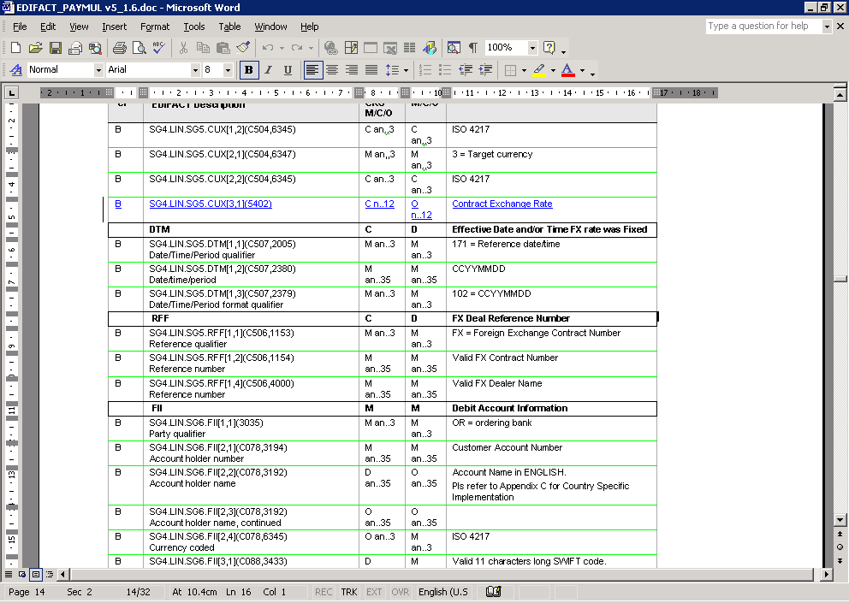
2. Requirement
To have the possibility to quote the deal date and the dealer name in credit transfer message. Each corporate input these information in treasury systems in order to identify and confirm the FX transaction either from the credit transfer between the debtor and the debtor agent or through separate confirmation process.

Recommendation from the Payments SEG:
This section is to be completed by the (lead) SEG which had approved the existing version of the messages.
Approve
Comments:

Reject | X
Reason for rejection:
The group felt there was a lack of business justification.

RMG decision:
This section is to be completed in due time by the RMG secretariat based on RMG approval/rejection of the SEG recommendation.
Approve
Comments:

Reject
Reason for rejection:

Payment Clearing & Settlement Messages

CR n°U-020-PAY-2009: InstructionPriority (Payment Type Information)
Origin of request and date | CR Status
Requestor(s):  - 3CB (TARGET 2)  Date of the request: 8 May 2007 | New
Nature of Change | Message(s) Impacted
Addition of a code to an element | Message Identifier (message Name)  - pacs.008.001.01  FI to FI Customer Credit Transfer  - pacs.009.001.01  Financial Institution Credit Transfer  Also impacts other ‘PACS’ messages:  - pacs.002.001.02  Payment Status Report  - pacs.003.001.01  FI to FI Customer Direct Debit  - pacs.004.001.01  Payment Return  - pacs.006.001.01  Payment Cancellation Request  - pacs.007.001.01  FI to FI Payment Reversal  Also impacts all ‘PAIN’ messages:  - pain.001.001.02  Customer Credit Transfer Initiation  - pain.002.001.02  Payment Status Report  - pain.006.001.01  Payment Cancellation Request  - pain.007.001.01  Customer Payment Reversal  - pain.008.001.01  Customer Direct Debit Initiation
Business context
Business reasons and MT-MX coexistence reasons
Requirement description
1. Background information
The purpose of the change request is to extend an element through maintenance with the goal to cover more “priority” options concerning the settlement of credit transfers across real time gross settlement systems (RTGS – TARGET2). As these options are already in place for FIN MT transactions, the maintenance to the PACS standards will accommodate the evolution of the business (for example when a migration from FIN to XML will take place the same options would be supported as per UNIFI Credit Transfer Messages). The request is expected to reflect a wide need and/or usage, at least at European banking industry level, enhancing the global relevance of the standard.
To better highlight the scope of the change request, a naming like “priority” could be adopted for the change request itself. In recent years, the management of liquidity and the improvement of liquidity efficiency, especially in RTGS systems, have become of outmost importance. Offering a broad set of liquidity management features helps to fulfil the objectives of TARGET2. These features may give participants the tools to achieve a flexible and need-based control of their payment flow (thereby limiting possible liquidity risks) and result in faster settlement with a reduced amount of liquidity.
The management of liquidity and the related payment processing across real time gross settlement systems (RTGS – TARGET2) is indeed influenced by the following factors:
- priority classes
- execution time
- liquidity reservation
In general, payments are settled immediately if sufficient liquidity is available on the RTGS account of the participant. Payments that are finally executed are immediately posted to the involved RTGS account. When transactions cannot be settled immediately, a different queuing is applied according to their priority class (highly urgent queue, urgent queue, normal queue). At this stage continuous attempt to settle transactions in the queues will occur and optimisation procedures for queues can run at the same time.
Of course, every payment should be marked as “normal” or “urgent” or “highly urgent” (rationale of this change request).
Allowing participants to specify priority classes will improve the liquidity management, also considering payments urgency together with liquidity reservation options:
- with the usage of the highly urgent reservation facility, liquidity can be reserved for the execution of highly urgent transactions (priority class 0);
- with the usage of the urgent reservation facility, liquidity can be reserved for the execution of urgent and highly urgent transactions (priority class 1 and 0)
MX messages for liquidity reservation options belong to the cash management business area (CAMT) and are out of scope.
Categories of parties/actors that would use/benefit from the updated message(s) are the European banking industry, all involved NCBs (National Central Banks) and the ECB (European Central Bank).
The estimated/potential number of users of each category would be:
- European banking industry (about 10,500 participants will use TARGET2 to initiate payments on their own or on their customer‘s behalf - close to 53,000 banks worldwide (and thus all the customers of these banks) could be addressed via TARGET2);
- All involved NCBs (20).
The estimated/expected number of messages would be, as per current FIN MT103 and FIN MT202 estimation, 380.000 payments per day (500.000 payments in the peak day, 105.000 payments in the peak/hour).
The timing for this maintenance is driven by the significant coexistence foreseen in the credit transfers area, where a mix of MXs and MTs is going to be used. It is suggested to drive a migration to MX and to ensure interoperability in the case of coexistence of MT and MX, by defining – where necessary – translation rules between MXs and MTs.
In any case, the proposed maintenance will become a major priority in the years to come, ensuring the mentioned interoperability through proper translation rules concerning information for “priority” options.
The submitting organization will try to involve in the development SWIFT (standards organization(s)), user representatives (WGT2), regulatory bodies (ECB) and market infrastructures (3CB).
The submitting organization is not aware of any other standards maintenance initiative in this domain concerning liquidity management features (“priority”).
Whilst the submitting organization has a certain degree of expertise in XML messages related standardisation issues, some help will be sought from the RA for the maintenance of the ISO 20022 Data Model, especially as regards the use of the RA modelling tools developed especially by the RA for this purpose.
The submitting organization is committed to initiate and/or participate in the future message maintenance.

2. Requirement
How is the communication of “priority” options happening today? With existing messages (FIN MT103 and FIN MT202) adopted within the TARGET2 RTGS system, participants have the possibility to specify priority classes (highly urgent, urgent, normal) to be applied during the settlement with the aim to properly consider payments urgency using some options available for the field FIN 113 “Banking Priority”. The following options are currently available (set by the sender):
- priority class 0 (highly urgent payments - H);
- priority class 1 (urgent payments - U);
- priority class 2 (normal payments - N).
All priority classes have specific characteristics. Some of the priority classes can only be used by certain groups of participants. Within a priority class no further prioritisation is possible (no sub-priorities).
The PACS standard already foresees the business feature of providing information about the urgency or order of importance that the instructing party would like the instructed party to apply to the processing of the instruction (please see the element “InstructionPriority” <InstrPrty>).
The proposed maintenance is expected to bring the same kind of communication into the PACS standard because the existing item (InstructionPriority) doesn’t allow specifying all the above “priority” options (“highly urgent payments” – “urgent payments”– “normal payments”).
In fact, the data type associated to the existing item (InstructionPriority) currently foresees only two priority classes:
<xs:simpleType name="Priority2Code">
<xs:restriction base="xs:string">
<xs:enumeration value="HIGH"/>
<xs:enumeration value="NORM"/>
</xs:restriction>
</xs:simpleType>

The purpose of the change request is to add at least one value to the existing above data type “Priority2Code” with the aim to make participants able to specify all “priority” options (“highly urgent payments” – “urgent payments”– “normal payments”):
<xs:simpleType name="Priority2Code">
<xs:restriction base="xs:string">
<xs:enumeration value="HIGH"/>
<xs:enumeration value="URGN"/>
<xs:enumeration value="NORM"/>
</xs:restriction>
</xs:simpleType>

Recommendation from the Payments SEG:
This section is to be completed by the (lead) SEG which had approved the existing version of the messages.
Approve
Comments:

Reject | X
Reason for rejection:
The request will be accommodated in the pacs.008.001.02 and pacs.009.001.02 by adding a SettlementPriority element with codes URGN, HIGH and NORM.
RMG decision:
This section is to be completed in due time by the RMG secretariat based on RMG approval/rejection of the SEG recommendation.
Approve
Comments:

Reject
Reason for rejection:

CR n°U-021-PAY-2009: Execution Time Request (SettlementTimeRequest)
Origin of request and date | CR Status
Requestor(s):  - 3CB (TARGET 2)  Date of the request: 8 May 2007 | New
Nature of Change | Message(s) Impacted
Addition of a code to an element | Message Identifier (message Name)  - pacs.008.001.01  FI to FI Customer Credit Transfer  - pacs.009.001.01  Financial Institution Credit Transfer
Business context
Business reasons and MT-MX coexistence reasons
Requirement description
1. Background information

The purpose of the change request is to add some elements to a component through maintenance with the goal to cover more “execution time” options concerning the settlement of credit transfers across real time gross settlement systems (RTGS – TARGET2). As these options are already in place for FIN MT transactions, the maintenance to the PACS standards will accommodate the evolution of the business (for example when a migration from FIN to XML will take place the same options would be supported as per UNIFI Credit Transfer Messages). The request is expected to reflect a wide need and/or usage, at least at European banking industry level, enhancing the global relevance of the standard.
To better highlight the scope of the change request, a naming like “execution time” could be adopted for the change request itself. In recent years, the management of liquidity and the improvement of liquidity efficiency, especially in RTGS systems, have become of outmost importance. Offering a broad set of liquidity management features helps to fulfil the objectives of TARGET2. These features may give participants the tools to achieve a flexible and need-based control of their payment flow (thereby limiting possible liquidity risks) and result in faster settlement with a reduced amount of liquidity.

The payment processing across real time gross settlement systems (RTGS – TARGET2) is indeed influenced by the execution time set by participants, including a time that indicates when payments should be settled or should have been settled (rationale of this change request).
Categories of parties/actors that would use/benefit from the updated message(s) are the European banking industry, all involved NCBs (National Central Banks) and the ECB (European Central Bank).
The estimated/potential number of users of each category would be:
- European banking industry (about 10,500 participants will use TARGET2 to initiate payments on their own or on their customer‘s behalf - close to 53,000 banks worldwide (and thus all the customers of these banks) could be addressed via TARGET2);
- All involved NCBs (20).
The estimated/expected number of messages would be, as per current FIN MT103 and FIN MT202 estimation, 380.000 payments per day (500.000 payments in the peak day, 105.000 payments in the peak/hour).
The timing for this maintenance is driven by the significant coexistence foreseen in the credit transfers area, where a mix of MXs and MTs is going to be used. It is suggested to drive a migration to MX and to ensure interoperability in the case of coexistence of MT and MX, by defining – where necessary – translation rules between MXs and MTs.
In any case, the proposed maintenance will become a major priority in the years to come, ensuring the mentioned interoperability through proper translation rules concerning information for “execution time” options.
The submitting organization will try to involve in the development SWIFT (standards organization(s)), user representatives (WGT2), regulatory bodies (ECB) and market infrastructures (3CB).
The submitting organization is not aware of any other standards maintenance initiative in this domain concerning liquidity management features (“execution time”).
Whilst the submitting organization has a certain degree of expertise in XML messages related standardisation issues, some help will be sought from the RA for the maintenance of the ISO 20022 Data Model, especially as regards the use of the RA modelling tools developed especially by the RA for this purpose.
The submitting organization is committed to initiate and/or participate in the future message maintenance.

2. Requirement
How is the communication of information for “execution time” options happening today? With existing messages (FIN MT103 and FIN MT202) adopted within the TARGET2 RTGS system, participants have also the possibility to specify the settlement time of their transactions using some options available for the field FIN 13C “Time Indication”.
The following options are currently available:
- transactions with an “Earliest Debit Time Indicator” (payments can include a time that indicates when they should be settled)
- transactions with a “Latest Debit Time Indicator” (payments can include a time that indicates when they should have been settled).
The following table describes payments with an execution time set by participants:

 | Earliest Debit Time Indicator | Latest Debit Time Indicator
Features | Transactions to be executed from a certain time (FIN codeword: /FROTIME/). | Option A: transactions to be executed up to a certain time (FIN codeword: /REJTIME/).  Option B: transactions which should be executed up to certain time (only warning indicator) (FIN codeword: /TILTIME/).
Effect | Transaction is stored until the indicated time. At the earliest debit time, the transaction runs through the entry disposition.
Management | If the transaction cannot be settled at the earliest debit time, it will be queued. | If the transaction cannot be settled until the indicated debit time:  Option A: The payment will be rejected.  Option B: The payment will remain in the queue.
It is possible to combine the “Earliest Debit Time Indicator” with the “Latest Debit Time Indicator” (Option A or Option B). In case of “Earliest Debit Time Indicator” combined with “Latest Debit Time Indicator” (Option A), the transaction is meant to be executed during the indicated period.
The PACS standard already foresee the business feature of providing information on the requested settlement time of the instruction (please see the element “SettlementTimeRequest” <SttlmTmReq>), when the CLS system is involved.
The proposed maintenance is expected to bring the same kind of communication into the PACS standard because the existing item (SettlementTimeRequest) doesn’t allow specifying the above “execution time” features (“Earliest Debit Time Indicator” and “Latest Debit Time Indicator” with both Option A and Option B).
The purpose of the change request is to add some (sub) elements to the existing element “SettlementTimeRequest” (<SttlmTmReq>) to enable participants to specify the settlement time of their transactions using one or more options at the same time (as per FIN transaction already in place):
<xs:element name="SttlmTmReq" type="SettlementTimeRequest1" minOccurs="0" maxOccurs="unbounded"/>
<xs:complexType name="SettlementTimeRequest1">
<xs:sequence>
<xs:choice>
<xs:element name="CLSTm" type="ISOTime"/>
<xs:element name="TILLTm" type="ISOTime"/>
<xs:element name="FROMTm" type="ISOTime"/>
<xs:element name="REJETm" type="ISOTime"/>
</xs:choice>
</xs:sequence>
</xs:complexType>

An equivalent data structure could be:

<xs:element name="SttlmTmReq" type="SettlementTimeRequest1" minOccurs="0" maxOccurs="1"/>
<xs:complexType name="SettlementTimeRequest1">
<xs:sequence>
<xs:element name="CLSTm" type="ISOTime" minOccurs="0" maxOccurs="1"/>
<xs:element name="TILLTm" type="ISOTime" minOccurs="0" maxOccurs="1"/>
<xs:element name="FROMTm" type="ISOTime" minOccurs="0" maxOccurs="1"/>
<xs:element name="REJETm" type="ISOTime" minOccurs="0" maxOccurs="1"/>
</xs:sequence>
</xs:complexType>

Recommendation from the Payments SEG:
This section is to be completed by the (lead) SEG which had approved the existing version of the messages.
Approve | X
Comments:
Three elements will be added to the SettlementTimeRequest element to specify
  - TILLTime (until what time the payment may be settled)
  - FROMTime (as from what time the payment may be settled)
  - REJTTime (until what time the payment must be settled to avoid rejection)

Reject
Reason for rejection:

RMG decision:
This section is to be completed in due time by the RMG secretariat based on RMG approval/rejection of the SEG recommendation.
Approve
Comments:

Reject
Reason for rejection:

CR n°U-022-PAY-2009: ClearingSystemIdentification (Settlement Information)
Origin of request and date | CR Status
Requestor(s):  - Banco de la República (Colombian Central Bank)  Date of the request: 28 February 2007 | New
Nature of Change | Message(s) Impacted
Addition of a 3 codes to an element | Message Identifier (message Name)  - pacs.008.001.01  FI to FI Customer Credit Transfer  - pacs.009.001.01  Financial Institution Credit Transfer  Also impacts other ‘PACS’ messages:  - pacs.002.001.02  Payment Status Report  - pacs.003.001.01  FI to FI Customer Direct Debit  - pacs.004.001.01  Payment Return  - pacs.006.001.01  Payment Cancellation Request  - pacs.007.001.01  FI to FI Payment Reversal  Also impacts all ‘PAIN’ messages:  - pain.002.001.02  Payment Status Report  - pain.006.001.01  Payment Cancellation Request  - pain.007.001.01  Customer Payment Reversal
Business context
Business reasons
Requirement description
1. Background information

In the <ClrSysId> table, Clearing System Identifier, used in the pacs008 and pacs009 messages, the code named COP has been assigned to the Colombia Central Bank´s ACH. However, we area adopting messages not only for the Central Bank´s ACH but also for the Electronic Cheque Clearing System and Our RTGS system, both of them run by the Central Bank. So, I would appreciate if you could take into account these three systems based on our suggestion for the following Ids for three mentioned systems:
To include:
COI – For the Colombian Central Bank´s ACH, which name is CENIT (Compensación Electrónica Nacional Interbancaria),
COE - For the Colombian Electronic Cheque System, which name is CEDEC (Compensación Electrónica De Cheques) and
COU – For the RTGS Systems, which name is CUD (Cuentas de Depósito).
(All start with CO meaning that are Colombian Payment Systems).
To remove: COP

2. Requirement
The CENIT and CEDEC systems are low value payment systems. The first one is used mainly to make treasury payments and Social Security collection for the Social Security obligations of any company or person in the country. So it is an important source of liquidity for the Colombian Financial System. This system is intensive in the use of Direct Credit for applications as government payrolls, third party payments and utilities payments, mainly to execute the national budget of national order institutions. However, the banks also use it for similar purposes. The second system electronically interchanges the 92% of the cheques that are negotiated in the country under a Debit Request operation.
Both systems enforce regulation and standards of Low Value Payment Systems having a leading role on this kind of systems in the country, so we expect that using the ISO 20022 standard, we are going to pull the banks to embrace modernization and technical compatibility to make them suitable for global operations and reaching greater interoperability alongside the variety of systems them poses.
The system CUD is our RTGS systems High Value Payment Systems which receive mainly on line Real Time transfers and Interbank operations. This system also settles batch operations from clearing process of some systems as Security Depositary institutions, Stock Exchange and Foreign Exchange Clearing Systems. This will use the pacs.009.001.01 message to settle some of the later operations.

Recommendation from the Payments SEG:
This section is to be completed by the (lead) SEG which had approved the existing version of the messages.
Approve | X
Comments:
The codes will be added to the current list and the code list will be externalised.

Reject
Reason for rejection:

RMG decision:
This section is to be completed in due time by the RMG secretariat based on RMG approval/rejection of the SEG recommendation.
Approve
Comments:

Reject
Reason for rejection:

CR n°U-023-PAY-2009: ClearingSystemIdentification (Settlement Information)
Origin of request and date | CR Status
Requestor(s):  - European Banking Association (EBA)  - VocaLink Limited, UK  Date of the request: 18 January 2007 | New
Nature of Change | Message(s) Impacted
Addition of a code to an element | Message Identifier (message Name)  - pacs.008.001.01  FI to FI Customer Credit Transfer  - pacs.009.001.01  Financial Institution Credit Transfer  Also impacts other ‘PACS’ messages:  - pacs.002.001.02  Payment Status Report  - pacs.003.001.01  FI to FI Customer Direct Debit  - pacs.004.001.01  Payment Return  - pacs.006.001.01  Payment Cancellation Request  - pacs.007.001.01  FI to FI Payment Reversal  Also impacts all ‘PAIN’ messages:  - pain.002.001.02  Payment Status Report  - pain.006.001.01  Payment Cancellation Request  - pain.007.001.01  Customer Payment Reversal
Business context
Business reasons
Requirement description
1. Background & requirement information

Please can you add an ISO Code to the list of Clearing System Codes that must be present in the ISO Element
GrpHdr
SttlmInf
ClrSys
To include:
ST2 – EBA Clearing STEP 2
VCS – VocaLink Clearing System

Recommendation from the Payments SEG:
This section is to be completed by the (lead) SEG which had approved the existing version of the messages.
Approve | X
Comments:
The codes will be added to the current list and the code list will be externalised.

Reject
Reason for rejection:

RMG decision:
This section is to be completed in due time by the RMG secretariat based on RMG approval/rejection of the SEG recommendation.
Approve
Comments:

Reject
Reason for rejection:

CR n°U-024-PAY-2009: MessageNameIdentification (Original Group Information)
Origin of request and date | CR Status
Requestor(s):  - GUF (Groupement des Utilisateurs de SWIFT en France)  - European Banking Association (EBA)  Date of the request: 6 July 2007 | New
Nature of Change | Message(s) Impacted
Changing occurrence of a message component from a mandatory single occurrence (1..1) to a mandatory possibly repetitive occurrence (1..n) | Message Identifier (message Name)  - pacs.006.001.01  Payment Cancellation Request  Also impacts the ‘PAIN’ messages:  - pain.006.001.01  Payment Cancellation Request
Business context
Business reasons
Requirement description
1. Background information
Following an analysis of the current Payments Clearing & Settlement standards, the EBA has identified a need which is common to all Market Infrastructures. Some Clearing and Settlement Mechanisms use the FIN message type as part of the key to uniquely identify a payment. Without this information it is not possible to find back the payment that needs to be cancelled.
2. Requirement
We propose to make it possible to identify the message types of the original messages which are requested to be cancelled when sending a Payment Cancellation Request message. We suggest the changes to be identified by the appropriate Business Validation Group. The request is to make a change in the Payment Cancellation Request standard in order to cover the need of identifying the message type of the original messages which are requested to be cancelled when sending a Payment Cancellation Request message. We need to have this information in a repeatable element because in some systems there is a functionality which enables to request multiple cancellations with only one Payment Cancellation Request message, and these cancellations requests may concern different payment transactions originated by different message types. In addition, we think it is important that this information is at the same level as all the payment information and close to the original information identification.
3. Example
The EBA EURO1/STEP1 offers a functionality which enables to request several cancellations by sending only one Payment Cancellation Request message. If the cancellation refers to payments originated by different message types, it is necessary to have this information.
Recommendation from the Payments SEG:
This section is to be completed by the (lead) SEG which had approved the existing version of the messages.
Approve | X
Comments:
Realisation of the change request has been incorporated in the solution described under change request n°U-016-PAY-2009 Payment Cancellation Request.

Reject
Reason for rejection:

RMG decision:
This section is to be completed in due time by the RMG secretariat based on RMG approval/rejection of the SEG recommendation.
Approve
Comments:

Reject
Reason for rejection:

CR n°U-025-PAY-2009: ClearingSystemIdentification (Settlement Information)
Origin of request and date | CR Status
Requestor(s):  - The Clearing House Association (during a coexistence meeting at SWIFT – New York)  - Equens NL & DE  Date of the request: June 2007 | New
Nature of Change | Message(s) Impacted
Change of definition | Message Identifier (message Name)  - pacs.008.001.01  FI to FI Customer Credit Transfer  - pacs.009.001.01  Financial Institution Credit Transfer  Also impacts other ‘PACS’ messages:  - pacs.002.001.02  Payment Status Report  - pacs.003.001.01  FI to FI Customer Direct Debit  - pacs.004.001.01  Payment Return  - pacs.006.001.01  Payment Cancellation Request  - pacs.007.001.01  FI to FI Payment Reversal  Also impacts all ‘PAIN’ messages:  - pain.002.001.02  Payment Status Report  - pain.006.001.01  Payment Cancellation Request  - pain.007.001.01  Customer Payment Reversal
Business context
Business reasons
Requirement description
1. Background information

-
2. Requirement

Align definitions to read:

CHI USChips Scheme code for US (United States) - CHIPS

EPN USTCHEPN Scheme code for US (United States) – The Clearing House EPN

FDA USFedACH Scheme code for US (United States) - FED-ACH

FDW USFedwire Scheme code for US (United States) – FEDWIRE
INC NLEquens Scheme code for Equens in Germany and The Netherlands
DEEquens

Recommendation from the Payments SEG:
This section is to be completed by the (lead) SEG which had approved the existing version of the messages.
Approve | X
Comments:
The code definitions will be updated as requested. “Scheme code” will be taken out of all definitions.

Reject
Reason for rejection:

RMG decision:
This section is to be completed in due time by the RMG secretariat based on RMG approval/rejection of the SEG recommendation.
Approve
Comments:

Reject
Reason for rejection:

CR n°U-026-PAY-2009: Transparency and Cover Payments (UnderlyingTransactionInformation)
Origin of request and date | CR Status
Requestor(s):  - Various SWIFT User Group communities during the extra-ordinary country vote on cover payments and transparency  Date of the request: 15 Jan 2008 | New
Nature of Change | Message(s) Impacted
Addition of a group of elements. | Message Identifier (message Name)  - pacs.009.001.01  Financial Institution Credit Transfer
Business context
Business and coexistence reasons.
Requirement description
1. Background information
Following the change request submitted by the Wolfsberg Group & The Clearing House Association to increase transparency with cover payments, SWIFT will release a variant of the MT 202 with FIN standards release 2009. Compared to the MT 202 message, this MT 202 COV variant will contain an additional repetitive sequence to carry information on (an) underlying customer credit transfer(s) message(s) for which cover is being provided with the MT 202 COV.
The European banking sector is currently implementing ISO 20022 standards for SEPA retail payments. In the upcoming years a similar migration is expected for high value payments as Target 2 and Euro1 will migrate from FIN to ISO 20022 standards to become SEPA compliant for commercial payments. Further adoption of ISO 20022 in the European securities industry will be pushed by concerns raised in the Giovannini report and by the T2 Securities project.

2. Requirement
Given this evolution, the banking industry cannot base the future financial payment world on FIN standards only. The same changes as those made in the MT 202 COV must also be made to the equivalent ISO 20022 standard (pacs.009.001.01). This will allow ordering and sending banks to freely choose which standard to use (FIN or ISO 20022).

Recommendation from the Payments SEG:
This section is to be completed by the (lead) SEG which had approved the existing version of the messages.
Approve | X
Comments:
The below optional component will be added to the pacs.009.001.01 message to enable reporting of underlying customer credit transfer transaction information when the message is used as cover payment for a customer credit transfer.
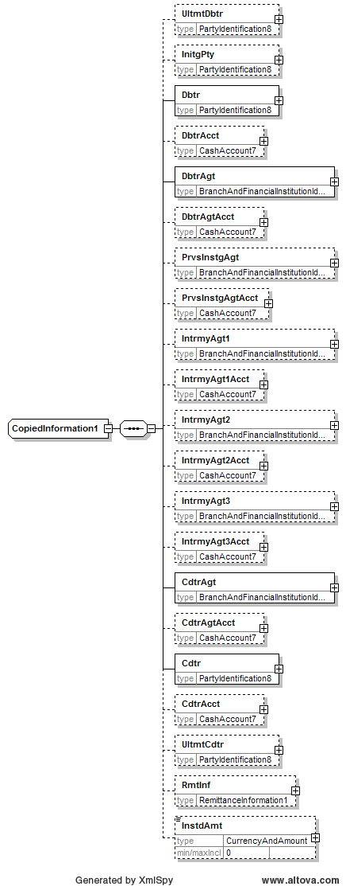

Reject
Reason for rejection:

RMG decision:
This section is to be completed in due time by the RMG secretariat based on RMG approval/rejection of the SEG recommendation.
Approve
Comments:

Reject
Reason for rejection:

CR n°U-049-PAY-2009: Local Instrument
Origin of request and date | CR Status
Requestor(s):  - The Berlin Group (through Thomas Egner, Payment SEG)  - European Payments Council  - Wholesale Product Office (WPO), Federal Reserve Bank of New York  Date of the request: May/June 2008 | New
Nature of Change | Message(s) Impacted
Addition of codes to a message item | Message Identifier (message Name)  - pacs.003.001.01  FI to FI Customer Direct Debit  Also impacts other ‘PACS’ messages:  - pacs.002.001.02  Payment Status Report  - pacs.008.001.01  FI to FI Customer Credit Transfer  - pacs.004.001.01  Payment Return  - pacs.006.001.01  Payment Cancellation Request  - pacs.007.001.01  FI to FI Payment Reversal  Also impacts all ‘PAIN’ messages:  - pain.001.001.02  Customer Payment Initiation  - pain.002.001.02  Payment Status Report  - pain.006.001.01  Payment Cancellation Request  - pain.007.001.01  Customer Payment Reversal  - pain.008.001.01  Customer Direct Debit Initiation
Business context
Business reasons
Requirement description
1. Background information
DE: For the purpose of clearing and settlement of card based transactions a code qualifying a transaction as card initiated should be added to the list of local instruments.
2. Requirement
DE: a new code “CARD” should be added to the external LocalInstrument code list. The code CARD must be present at either ‘GroupHeader’ or ‘DirectDebitTransactionInformation’ level.
EPC: 2 codes should be added to the external LocalInstrument code list: one for SEPA Direct Debit - Core (CORE), one for SEPA Business to Business Direct Debit (B2B).
Federal Reserve: the following codes should be added.
COVU – Cover Payment Unstructured
RMTS – Remittance Information Structured
categorized as follows:
Region: WHEM
ISO Country Code: US
ISO Currency Code: USD
Payment System: Fedwire Credit Transfer
Note: The Federal Reserve has withdrawn its request. A new request will be submitted after further internal analysis has taken place.
Recommendation from the Payments SEG:
This section is to be completed by the (lead) SEG which had approved the existing version of the messages.
Approve | X
Comments:
The codes will be considered for inclusion when the externalised LocalInstrument code list is discussed.

Reject
Reason for rejection:

RMG decision:
This section is to be completed in due time by the RMG secretariat based on RMG approval/rejection of the SEG recommendation.
Approve
Comments:
Reject
Reason for rejection:

CR n°U-050-PAY-2009: Purpose
Origin of request and date | CR Status
Requestor(s):  - The Berlin Group (through Thomas Egner, Payment SEG)  - Austrian community  - HSBC  Date of the request: May/June 2008 | New
Nature of Change | Message(s) Impacted
Addition of codes to a message item  Modification of a message item | Message Identifier (message Name)  - pacs.003.001.01  FI to FI Customer Direct Debit  Also impacts other ‘PACS’ messages:  - pacs.008.001.01  FI to FI Customer Credit Transfer  Also impacts all ‘PAIN’ messages:  - pain.001.001.02  Customer Payment Initiation  - pain.008.001.01  Customer Direct Debit Initiation  Also impacts all B2C ‘CAMT’ messages:  - camt.052.001.01  B2CAccountReportV01  - camt.053.001.01  B2CStatementV01 (AdditionalStatementInformation element)  - camt.054.001.01  B2CDebitCreditNotificationV01 (AdditionalNotificationInformation element)
Business context
Business reasons
Requirement description
1. Background information
For identifying various purposes the codes of an external code list are used.
2. Requirement
For further qualifying the underlying transaction the following codes should be added to the code list (Germany):
Content | Proposed Value
Purchase of goods and services | PGS
Cash disbursement | CD
Purchase of goods and services with cash back | PGSCB
Refund | REF

Various domains need more specific codes for correct identification and proper processing. Following codes shall be added to the existing list (Austria):
ICCP | General | Irrevocable Credit Card Payment | Transaction is reimbursement of credit card payment.
IDCP | General | Irrevocable Debit Card Payment | Transaction is reimbursement of debit card payment.
GVEA | Government | Government Employees Category A | Transaction is payment to category A government employees.
GVEB | Government | Government Employees Category B | Transaction is payment to category B government employees.
GVEC | Government | Government Employees Category C | Transaction is payment to category C government employees.
GVED | Government | Government Employees Category D | Transaction is payment to category D government employees.

For regulatory reporting in Thailand and Malaysia, new elements must be introduced to support (HSBC):
- Thailand Purpose of Payment codes (Comment: additional codes to the externalised list?)
- Purpose of Payment Description with multiplicity 0..2

Recommendation from the Payments SEG:
This section is to be completed by the (lead) SEG which had approved the existing version of the messages.
Approve | X
Comments:
The codes will be considered for inclusion when the externalised Purpose code list is discussed. A broader audience will be consulted for the card related code requests i.e. the Cards SEG.

The request for regulatory reporting codes for Thailand and Malaysia has been taken into the revised RegulatoryReporting component (see CR n°U-064-PAY-2009: RegulatoryReporting).

Reject
Reason for rejection:

RMG decision:
This section is to be completed in due time by the RMG secretariat based on RMG approval/rejection of the SEG recommendation.
Approve
Comments:

Reject
Reason for rejection:

CR n°U-055-PAY-2009: BaseDocument
Origin of request and date | CR Status
Requestor(s):  - Austrian Community  Date of the request: May 2008 | New
Nature of Change | Message(s) Impacted
Addition of, or deletion of, or modification to a sequence/modification of definition | Message Identifier (message Name)  - pacs.008.001.01  - pacs.003.001.01
Context
Business/alignment reasons
Requirement description
1. Background information
CreditTransfer/DirectDebit TransactionInformation2 shall contain an optional element to enable transport of images of the underlying triggering paper based document, for example check or payment slip.
2. Requirement
For ease of checking and minimisation of claim and investigation it turned out to be extremely helpful to be able to receive images of the underlying triggering paper based document together with the transaction.
The new element shall contain a sequence of some elements providing meta information about the also contained images.
The image data shall be base64 encoded. The needed meta information is Type (eg. JPEG, TIFF, aso.), Identification (Code, Proprietary and Issuer for layout identification aso.), Size (Horizontal, Vertical and Units for processing), Surface (FRNT or BACK) and Date (saving date of image).

Recommendation from the Payments SEG:
This section is to be completed by the (lead) SEG which had approved the existing version of the messages.
Approve
Comments:

Reject | X
Reason for rejection:
The change request is rejected on grounds of possible overload of payment messages across payment systems. Other ways than the payment instruction must be used to get this information across.

RMG decision:
This section is to be completed in due time by the RMG secretariat based on RMG approval/rejection of the SEG recommendation.
Approve
Comments:

Reject
Reason for rejection:

CR n°U-057-PAY-2009: ClearingSystemReference
Origin of request and date | CR Status
Requestor(s):  - Wholesale Product Office (WPO), Federal Reserve Bank of New York  Date of the request: June 2008 | New
Nature of Change | Message(s) Impacted
Addition of new message item | Message Identifier (message Name)  - pacs.008.001.01  FI to FI Customer Credit Transfer  - pacs.009.001.01  Financial Institution Credit Transfer  Also impacts other ‘PACS’ messages:  - pacs.003.001.01  FI to FI Customer Direct Debit  - pacs.004.001.01  Payment Return  - pacs.007.001.01  FI to FI Payment Reversal
Business context
Business reasons
Requirement description
1. Background information
Fedwire participants have indicated that it’s important to preserve the ability to have a place in the message for the Fedwire Funds Service Output Message Accountability Data (OMAD). This field is used by the clearing system to insert their unique reference number to indicate that they successfully processed/settled the message.
2. Requirement
Addition of a new optional element to include the reference of the clearing system (operator).

Recommendation from the Payments SEG:
This section is to be completed by the (lead) SEG which had approved the existing version of the messages.
Approve | X
Comments:
An optional ClearingSystemReference will be added to the messages in line with the decision taken for the Payment Status Report messages (see CR n°U-032-PAY-2009).

Reject
Reason for rejection:

RMG decision:
This section is to be completed in due time by the RMG secretariat based on RMG approval/rejection of the SEG recommendation.
Approve
Comments:

Reject
Reason for rejection:

CR n°U-058-PAY-2009: EquivalentTransfers
Origin of request and date | CR Status
Requestor(s):  - SWIFT  Date of the request: May 2008 | New
Nature of Change | Message(s) Impacted
Addition of new message item | Message Identifier (message Name)  - pacs.008.001.01  FI to FI Customer Credit Transfer
Business context
Business reasons
Requirement description
1. Background information
A change request to cater for equivalent transfers in the MT 103 has been submitted for the SWIFTNet FIN Standards Release 2009. Currently the functionality of equivalent transfers is only catered for in the MT 101. In a similar way, the ISO 20022 pacs.008.001.01 (FI To FI Customer Credit Transfer) message does not cater for equivalent transfers where the pain.001.001.02 (Customer Credit Transfer Initiation) message does.
For coexistence reasons, SWIFT submits the same change request to the pacs.008.001.01 message. If not withheld for the MT 103, then the change request for the ISO message could be withdrawn in agreement with the maintenance BVG.
2. Requirement
Inclusion of “Equivalent Transfers” functionality in the FIToFICustomerCreditTransfer.

Recommendation from the Payments SEG:
This section is to be completed by the (lead) SEG which had approved the existing version of the messages.
Approve
Comments:

Reject | X
Reason for rejection:
The change request was withdrawn by the requestor as it has not been withheld for the FIN SR2009 maintenance.
RMG decision:
This section is to be completed in due time by the RMG secretariat based on RMG approval/rejection of the SEG recommendation.
Approve
Comments:

Reject
Reason for rejection:

CR n°U-059-PAY-2009: OUR/DEBT Charges
Origin of request and date | CR Status
Requestor(s):  - SWIFT  Date of the request: May 2008 | New
Nature of Change | Message(s) Impacted
Addition of a new textual rule | Message Identifier (message Name)  - pacs.008.001.01  FI to FI Customer Credit Transfer
Business context
Business reasons
Requirement description
1. Background information
Various change requests in relation to OUR charges and Interbank Settlement Amount & Instructed Amount have been submitted for the SWIFTNet FIN Standards Release 2009. Currently the textual rules in the ISO 20022 Customer Credit Transfer messages for DEBT charging are aligned with the network validation in the MT customer credit transfer messages.
For coexistence reasons, SWIFT submits the change request to align the textual rules for the pacs.008.001.01 with those for the MT 103. If not withheld for FIN, then the change request for the ISO message could be withdrawn in agreement with the maintenance BVG.
2. Requirement
Alignment of textual rules related to OUR/DEBT charges between FIN and ISO 20022 customer credit transfer messages.

Recommendation from the Payments SEG:
This section is to be completed by the (lead) SEG which had approved the existing version of the messages.
Approve
Comments:

Reject | X
Reason for rejection:
The change request was withdrawn by the requestor as it has not been withheld for the FIN SR2009 maintenance.

RMG decision:
This section is to be completed in due time by the RMG secretariat based on RMG approval/rejection of the SEG recommendation.
Approve
Comments:

Reject
Reason for rejection:

B2C Cash Management Messages

CR n°U-027-PAY-2009: Type codes (Charges)
Origin of request and date | CR Status
Requestor(s):  - Belgian FEBELFIN  Date of the request: requests made by e-mail to SWIFT on 19/02/2008 | New
Nature of Change | Message(s) Impacted
Addition of new charge type codes in tag 2.128, following the Belgian CODA reporting system, currently missing in the defined charge type codes. | Message Identifier (message Name)  - camt.052.001.01  B2CAccountReportV01  - camt.053.001.01  B2CStatementV01  - camt.054.001.01  B2CDebitCreditNotificationV01
Context
Business reasons
Requirement description
1. Background information
The Belgian system has an additional level of reporting transaction type codes for charges that are currently not covered in the existing charges types.
Those charge types are used for the differentiation between specific charges reporting.
2. Requirement
At the level of commissions, fees, charges, etc… we do not find the possibility to transaction into XML charge type codes, some very important data for the FEBELFIN.
Especially VAT, withholding taxes, etc...
A solution would be to extend the 2 existing codes with the below values: (those values will need to be translated into XML values):

CODE | Original Description  (as received from FEBELFIN) | English Translation
0 | Montant net Montant tel qu'il figure sur l'extrait | Net amount: Amount as stated on the account
1 | Intérêts crédités | Interest received
2 | Intérêts débités | Interest paid
3 | Commission de crédit | Credit commission
4 | Frais de port | Postage
5 | Loyer boîte courrier | Renting of letterbox
6 | Commissions et frais divers | Various fees/commissions
7 | Droit d'accès banque de données | Access right to database
8 | Frais pour renseignements par ex. informations commerciales, attestation de conservation d'effets, | Information charges, e.g. commercial information, certificate for bills taken in safe custody, etc.
9 | Frais de déplacement | Travelling expenses
10 | Frais d'huissier | Writ service fee
11 | TVA | VAT
12 | Commission de change | Exchange commission
13 | Commission de paiement | Payment commission
14 | Commission d'encaissement | Collection commission
15 | Frais correspondant | Correspondent charges
17 | Frais d'étude | Research costs
18 | Frais pour garantie locative | Rental guarantee charges
19 | Taxe livraison matérielle Par ex. titres | Tax on physical delivery, e.g. securities
20 | Coûts livraison matérielle Par ex. titres | Costs of physical delivery, e.g. securities
21 | Frais confection chèque bancaire | Costs for drawing up a bank cheque
22 | Frais de priorité Frais pour virements urgents | Priority costs: Costs for urgent credit transfers
23 | Commission d'exercice En cas de plan d'option sur actions | Exercising fee in case of a share option plan
24 | Prime de croissance | Growth premium
25 | Comptab. indiv. de frais de change | Individual entry for exchange charges
26 | Commission de manipulation Intervention manuelle dans les paiements | Handling commission: Manual processing of payments
27 | Frais traites impayées | Charges for unpaid bills
28 | Prime de fidélité | Fidelity premium
29 | Frais de protêt frais de radiation inclus | Protest charges: Crossing off costs included
30 | Assurance compte | Account insurance
31 | Frais chèque étranger | Charges foreign cheque
32 | Confection chèque circulaire | Drawing up a circular cheque
33 | Frais effet étranger | Charges for a foreign bill
34 | Indemnité de remploi En cas de remboursement anticipé partiel d'une avance fixe | Reinvestment fee - in case of partial advanced reimbursement of a fixed advance
35 | Frais effet documentaire étranger | Charges foreign documentary bill
36 | Frais chèque refusé | Costs relating to a refused cheque
37 | Commission pour frais de dossier | Commission for handling charges
38 | Télécommunications Confirmation d'un ordre étranger au bénéficiaire ou au tiers | Telecommunications - confirmation of a foreign order to the beneficiary or to a third party
41 | Frais carte de crédit | Credit card costs
42 | Frais carte de paiement | Payment card costs
43 | Frais d'assurance | Insurance costs
45 | Frais de dossier | Handling costs
47 | Frais de prolongation d'un effet | Charges extension bill
49 | Timbres fiscaux/droit de timbre | Fiscal stamps/stamp duty
50 | Capital placement à terme | Capital term investment
51 | Précompte mobilier Montant de base | Withholding tax - basic amount
52 | Prélèvement (européen) pour l’Etat de résidence | Residence state tax - basic amount
53 | Confection de formulaires | Printing of forms
55 | Amortis. capital d'un prêt ou d'un crédit | Repayment loan or credit capital
57 | Subvention en intérêts | Interest subsidy
58 | Prime de capital | Capital premium
59 | Intérêts moratoires | Default interest
61 | Tarification d'opérations | Charging fees for transactions
63 | Différences d'arrondi | Rounding differences
65 | Avis de bonification | Interest payment advice
66 | Acompte fixe crédits – remboursement | Fixed loan advance – reimbursement
67 | Acompte fixe crédits – prolongation | Fixed loan advance - extension
68 | Contre-valeur d'une écriture | Counter value of an entry
69 | Contrats à terme arbitrage: somme à payer par le client | Forward arbitrage contracts: sum to be supplied by customer
70 | Contrats à terme arbitrage: somme à payer par la banque | Forward arbitrage contracts: sum to be supplied by bank
71 | Acompte fixe crédits – mise à disposition | Fixed loan advance - availability
72 | Contre-valeur commissions à des tiers | Counter value of commission to third party
73 | Coûts guichets automatiques étrangers | Costs of ATM abroad
74 | Coûts de courrier | Mailing costs
100 | Montant brut Montant dans décompte avant frais et commiss. | Gross amount - amount in a settlement for fees and commissions
200 | Frais de crédit documentaire global | Overall documentary credit charges
201 | Commission de préavis | Advice notice commission
202 | Commission de notification | Advising commission
202 | Commission de notification additionnelle | Additional advising commission
203 | Commission de confirmation | Confirmation fee
203 | Commission de confirmation additionnelle | Additional confirmation fee
203 | Commission d'engagement | Commitment fee
203 | Commission flat | Flat fee
203 | Commission de réservation de confirmation | Confirmation reservation commission
203 | Commission de réservation additionnelle | Additional reservation commission.
204 | Commission de modification Par ex. pour les effets | Amendment fee, e.g. for bills
205 | Commission de paiement documentaire | Documentary payment commission
205 | Commission documentaire | Document commission
205 | Commission d'utilisation | Drawdown fee
205 | Commission de négociation | Negotiation fee
206 | Commission pour garanties/paiement sous réserve | Surety fee/payment under reserve
207 | Commission pour divergences | Non-conformity fee
208 | Commission d'engagement paiement différé | Commitment fee deferred payment
209 | Commission de transfert | Transfer commission
210 | Commission de mise à disposition | Commitment fee
211 | Commission d'ouverture de crédit | Credit arrangement fee
211 | Commission d'ouverture de crédit additionnelle | Additional credit arrangement fee
212 | Commission de d’entreposage | Warehousing fee
213 | Commission de financement | Financing fee
214 | Commission d'émission (laissez-suivre) | Issue commission (delivery order)
400 | Commission d'acceptation | Acceptance fee
401 | Frais de visa | Visa charges
402 | Frais de certification | Certification costs
403 | Droit minimum d'escompte | Minimum discount rate
404 | Commission d'escompte | Discount commission
405 | Commission d'aval | Bill guarantee commission
406 | Frais de recouvrement | Collection charges
407 | Frais d'article 45 | Costs Article 45
408 | Commission de couverture | Cover commission
409 | Frais de garde Par ex. pour des effets remis à l'encaissement dont l'échéance est encore lointaine | Safe deposit charges, e.g. for bills remitted for collection whose maturity date is still a long way off
410 | Frais de retour | Reclamation charges
411 | Droit fixe d'encaissement | Fixed collection charge
412 | Frais d'avis d'expiration | Advice of expiry charges
413 | Frais d'acceptation | Acceptance charges
414 | Frais de régularisation | Regularisation charges
415 | Commission de cautionnement | Surety fee
416 | Frais de dépôt de caution Frais rétrocédés à la Caisse des dépôts et consignations | Charges for the deposit of security, Charges transferred to the Deposit and Consignment Office
418 | Commission d'endossement | Endorsement commission
419 | Commission d'intervention Par ex. pour présentation d'un effet à l'acceptation | Bank service fee, e.g. for presentation of a bill for acceptance
420 | Frais de retenue Frais retenus sur le produit d'un escompte par ex. pour garantie insuffisante | Retention charges, Charges retained on the yield of a discount when the client has given insufficient guarantees
425 | Courtage étranger taxe comprise | Foreign broker's commission, Tax included
426 | Courtage belge | Belgian broker's commission
427 | Taxe boursière belge | Belgian Stock Exchange tax
428 | Intérêts courus Uniquement en matière d'opérations sur titres | Interest accrued only for securities transactions
429 | Taxe boursière étrangère | Foreign Stock Exchange tax
430 | Récupération taxe étrangère | Recovery of foreign tax
431 | Livraison copie par ex. copie d'effets de commerce | Delivery of a copy, e.g. copy of commercial paper
Additional information on the CODA coding may be found on the www.febelfin.be website for clarification on the usage of the codes.

Recommendation from the Payments SEG:
This section is to be completed by the (lead) SEG which had approved the existing version of the messages.
Approve
Comments:

Reject | X
Reason for rejection:
The codes can be given in the Proprietary element. An Issuer element will be added to identify the issuer of used codes.

The Payment SEG will also kick-off an exercise to define a more global code list (AFP, CODA…).

RMG decision:
This section is to be completed in due time by the RMG secretariat based on RMG approval/rejection of the SEG recommendation.
Approve
Comments:

Reject
Reason for rejection:

CR n°U-028-PAY-2009: Technical Input Channel (Entry)
Origin of request and date | CR Status
Requestor(s):  - German user group  Date of the request: requests made by e-mail to SWIFT on 15/08/2008 | New
Nature of Change | Message(s) Impacted
Addition of a new element in the entry to allow for the identification of the technical input channel (paper, tape…). | Message Identifier (message Name)  - camt.052.001.01  B2CAccountReportV01  - camt.053.001.01  B2CStatementV01  - camt.054.001.01  B2CDebitCreditNotificationV01
Context
Business reasons
Requirement description
1. Background information
On the German statement, there is a requirement to provide the technical input channel. During the analysis of the Bank Transaction Code list, the German working group identified that this element should be present in the reporting messages.
2. Requirement

In the German GVC the technical input channel (paper, tape...) is expressed. This information is important to know for the customer for example to check bank fees depending on the input channel. We suggest adding a data element 'Technical Input Channel' to the camt messages.

Recommendation from the Payments SEG:
This section is to be completed by the (lead) SEG which had approved the existing version of the messages.
Approve | X
Comments:
The element will offer a choice between a Code and Proprietary element. The Code element will be typed by an external code list as the list of channels might evolve over time.

Reject
Reason for rejection:

RMG decision:
This section is to be completed in due time by the RMG secretariat based on RMG approval/rejection of the SEG recommendation.
Approve
Comments:

Reject
Reason for rejection:

CR n°U-034-PAY-2009: Enhancement to cater for e.g. lockbox reporting
Origin of request and date | CR Status
Requestor(s):  - ISTH  Date of request : April 2008 | New
Nature of Change | Message(s) Impacted
 | All B2C CAMT messages
Context
Business reasons
Requirement description
1. Background information
Lockbox processing provides for multiple batches of work to reference a specific batch identifier. When reporting to the customer all payments included in the batch need to be grouped with the specific batch identifier.
Currently there is no way to tie a batch number for a lockbox process to all of the checks processed in that batch. There can be multiple batches that are consolidated into a single posted amount. As batch can have multiple occurrences at the same level as Amount and Transaction Details, for lockbox reporting the business case is to have the following:
Amount
Batch
Tx Details
Amount
Batch
Tx Details
2. Requirement

The messages should cater for adequate lockbox reporting.
Recommendation from the Payments SEG:
This section is to be completed by the (lead) SEG which had approved the existing version of the messages.
Approve | X
Comments:
An EntryReference will be added to cater for the lockbox identifier.

The Entry component will be updated with a repetitive EntryDetails component where batch information and transaction details can be provided as shown below:
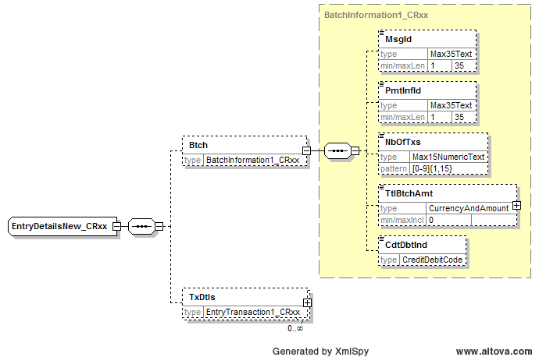

Reject
Reason for rejection:

RMG decision:
This section is to be completed in due time by the RMG secretariat based on RMG approval/rejection of the SEG recommendation.
Approve
Comments:

Reject
Reason for rejection:

CR n°U-036-PAY-2009: Update Message Usage section
Origin of request and date | CR Status
Requestor(s):  - SWIFT for the members of the SWIFT for corporates ISO 20022 workshop  Date of the request: May 2008 | New
Nature of Change | Message(s) Impacted
Modification to the message usage section | Message Identifier (message Name)  - camt.052.001.01  B2CAccountReportV01  - camt.053.001.01  B2CStatementV01
Context
Business reasons
Requirement description
1. Background information
The ‘binding’ and legal considerations articulated in the Bank-to-Customer Statement are constraints that are inhibiting the common use of this message as a statement and have given rise to a number of banks using the customer account report as a statement. Given that such ‘binding’ and legal considerations are subject to individual bank arrangement with their customers, these considerations should be outside the usage guidance provided in the message definition.
Note: this change request has no impact on the message structure.

2. Requirement
camt.052.001.01 BankToCustomerAccountReportV01
Modify the following text from the Usage section of the Message Definition.
From:
For a statement that is required due to local legal stipulations, the Bank-to-Customer Account Statement message should be used.
To:
For a statement, the Bank-to-Customer Account Statement message should be used.

camt.053.001.01 BankToCustomerStatementV01
Modify the following text from the Usage section of the Message Definition.
From:
The message is exchanged as defined between the account servicer and the account owner. It provides information on items that have been booked to the account (and therefore are ‘binding’) and also balance information. Depending on services agreed between banks and their customers, ‘binding’ statements can be generated and exchanged intraday.
Depending on legal requirements in local jurisdictions, ‘end-of-day’ statements may need to be mandatorily generated and exchanged.
To:
The message is exchanged as defined between the account servicer and the account owner. It provides information on items that have been booked to the account and also balance information. Depending on services and schedule agreed between banks and their customers, statements may be generated and exchanged accordingly, for example for intraday or prior day periods.

Recommendation from the Payments SEG:
This section is to be completed by the (lead) SEG which had approved the existing version of the messages.
Approve | X
Comments:
The reference to binding and legal will be removed as they do not belong at standard level. Two separate schemas for Account Report and Statement will be kept, but the differences between the schemas will disappear with exception of the Balance component that will be optional in the Report message and mandatory in the Statement.

Reject
Reason for rejection:

RMG decision:
This section is to be completed in due time by the RMG secretariat based on RMG approval/rejection of the SEG recommendation.
Approve
Comments:

Reject
Reason for rejection:

CR n°U-037-PAY-2009: References
Origin of request and date | CR Status
Requestor(s):  - German community (through Thomas Egner, Payment SEG)  Date of the request: May 2008 | New
Nature of Change | Message(s) Impacted
Addition of message items | Message Identifier (message Name)  - camt.052.001.01  B2CAccountReportV01  - camt.053.001.01  B2CStatementV01  - camt.054.001.01  B2CDebitCreditNotificationV01
Context
Business reasons
Requirement description
1. Background information
References are only allowed on transaction details level.
In the future the processing should also be possible by getting the information on entry level. For that reason, all important information (especially references) has to be part of the entry level.
2. Requirement
References should also be allowed on entry level.

Recommendation from the Payments SEG:
This section is to be completed by the (lead) SEG which had approved the existing version of the messages.
Approve
Comments:

Reject | X
Reason for rejection:
The references will not be duplicated at Entry level, but a unique EntryReference (Max35Text) will be added.

RMG decision:
This section is to be completed in due time by the RMG secretariat based on RMG approval/rejection of the SEG recommendation.
Approve
Comments:

Reject
Reason for rejection:

CR n°U-038-PAY-2009: Opening and Interim Balance Information
Origin of request and date | CR Status
Requestor(s):  - German community (through Thomas Egner, Payment SEG)  Date of the request: May 2008 | New
Nature of Change | Message(s) Impacted
Addition of message items | Message Identifier (message Name)  - camt.052.001.01  B2CAccountReportV01  - camt.053.001.01  B2CStatementV01
Context
Business reasons
Requirement description
1. Background information
Theoretically, a XML message can be unlimited in size. However, in the transport network (for example SWIFTNet FileAct) or in the processing certain constraints do exist. Hence, additional balancing codes are needed for interim balances due to a splitting of the message.
2. Requirement
Two additional codes should be added to the code list (Interim-Opening [tag :60M: in MT 940] and Interim-Closing [tag :62M: in MT 940]).

Recommendation from the Payments SEG:
This section is to be completed by the (lead) SEG which had approved the existing version of the messages.
Approve
Comments:

Reject | X
Reason for rejection:
The requirement should be handled at the transport layer. If really needed the Balance/Subtype Proprietary element can be used (see CR n°U-047-PAY-2009).
RMG decision:
This section is to be completed in due time by the RMG secretariat based on RMG approval/rejection of the SEG recommendation.
Approve
Comments:

Reject
Reason for rejection:

CR n°U-039-PAY-2009: Debit/Credit indicator for Charges
Origin of request and date | CR Status
Requestor(s):  - German community (through Thomas Egner, Payment SEG)  Date of the request: May 2008 | New
Nature of Change | Message(s) Impacted
Addition of message items | Message Identifier (message Name)  - camt.052.001.01  B2CAccountReportV01  - camt.053.001.01  B2CStatementV01  - camt.054.001.01  B2CDebitCreditNotificationV01
Context
Business reasons
Requirement description
1. Background information
The field “amount” within charges does not include a differentiation between credits and debits.
2. Requirement
The group charges (amount) should indicate if it is a debit or credit amount by using the tag <CdtDbtInd>.

Recommendation from the Payments SEG:
This section is to be completed by the (lead) SEG which had approved the existing version of the messages.
Approve | X
Comments:
A DebitCreditIndicator element will be added.

Reject
Reason for rejection:

RMG decision:
This section is to be completed in due time by the RMG secretariat based on RMG approval/rejection of the SEG recommendation.
Approve
Comments:

Reject
Reason for rejection:

CR n°U-040-PAY-2009: Additional Report Information
Origin of request and date | CR Status
Requestor(s):  - German community (through Thomas Egner, Payment SEG)  Date of the request: May 2008 | New
Nature of Change | Message(s) Impacted
Change to message items | Message Identifier (message Name)  - camt.052.001.01  B2CAccountReportV01  - camt.053.001.01  B2CStatementV01 (AdditionalStatementInformation element)  - camt.054.001.01  B2CDebitCreditNotificationV01 (AdditionalNotificationInformation element)
Context
Business reasons
Requirement description
1. Background information
Currently, the presence is [0..1]. Banks could use it for additional bank information. Hence, the field should be enlarged.
2. Requirement
Presence should be [0..n].

Recommendation from the Payments SEG:
This section is to be completed by the (lead) SEG which had approved the existing version of the messages.
Approve
Comments:

Reject | X
Reason for rejection:
Lack of a real business justification to allow for more free format information.

RMG decision:
This section is to be completed in due time by the RMG secretariat based on RMG approval/rejection of the SEG recommendation.
Approve
Comments:

Reject
Reason for rejection:

CR n°U-041-PAY-2009: Type of Rate
Origin of request and date | CR Status
Requestor(s):  - German community (through Thomas Egner, Payment SEG)  Date of the request: May 2008 | New
Nature of Change | Message(s) Impacted
Modification of message item | Message Identifier (message Name)  - camt.052.001.01  B2CAccountReportV01  - camt.053.001.01  B2CStatementV01 (AdditionalStatementInformation element)  - camt.054.001.01  B2CDebitCreditNotificationV01 (AdditionalNotificationInformation element)
Context
Business reasons
Requirement description
1. Background information
The description of the specification contains in 2.21 / 2.22, 2.143 / 2.144, 2.214 / 2.215 the title “Rate”.
2. Requirement
The title of the subfield (2.22, 2.144, 2.215) should be changed into “Type of Rate”.

Recommendation from the Payments SEG:
This section is to be completed by the (lead) SEG which had approved the existing version of the messages.
Approve | X
Comments:
The correction of the element naming will be done (no business impact).

Reject
Reason for rejection:

RMG decision:
This section is to be completed in due time by the RMG secretariat based on RMG approval/rejection of the SEG recommendation.
Approve
Comments:

Reject
Reason for rejection:

CR n°U-042-PAY-2009: Payment Information Id
Origin of request and date | CR Status
Requestor(s):  - German community (through Thomas Egner, Payment SEG)  Date of the request: May 2008 | New
Nature of Change | Message(s) Impacted
Addition of message item | Message Identifier (message Name)  - camt.052.001.01  B2CAccountReportV01  - camt.053.001.01  B2CStatementV01 (AdditionalStatementInformation element)  - camt.054.001.01  B2CDebitCreditNotificationV01 (AdditionalNotificationInformation element)
Context
Business reasons
Requirement description
1. Background information
The “Payment Information Id” exists in ISO pain-messages.
2. Requirement
The Id should be added to camt-messages as well to the “references” on transaction details level.

Recommendation from the Payments SEG:
This section is to be completed by the (lead) SEG which had approved the existing version of the messages.
Approve | X
Comments:
The PaymentInformationIdentification element will be added to the References component at TransactionDetails level.

Reject
Reason for rejection:

RMG decision:
This section is to be completed in due time by the RMG secretariat based on RMG approval/rejection of the SEG recommendation.
Approve
Comments:

Reject
Reason for rejection:

CR n°U-043-PAY-2009: Forecast Balance Types
Origin of request and date | CR Status
Requestor(s):  - ISITC NA  Date of the request: May 2008 | New
Nature of Change | Message(s) Impacted
Addition of message items | Message Identifier (message Name)  - camt.052.001.01  B2CAccountReportV01  - camt.053.001.01 B2CStatementV01
Context
Business reasons
Requirement description
1. Background information
The ISITC NA Market Practice Reconciliation Working Group has identified a business need for projected cash balances reporting using the B2C Cash Account Report to assist in their cash forecasting activities. A company’s ability to accurately forecast is a critical component of their business. Forecasted balances in both local and base currency will allow account owners (for example, Treasury Departments, Fund Managers) to manage their daily and future cash activity. By providing forecasted short balances to trading desks and fund managers, firms can determine their short term investment needs, manage or avoid overdrafts, and facilitate foreign currency trading. Cash projections can be a tool used to mitigate the financial risks incurred by over investing or under investing available cash. The number of days projected is necessary in order to inform the receiver of the period being reported, and therefore the timeframe of the forecast.
An automated, standard means of receiving and sending projected cash balances will allow for the replacement of ad hoc manual spreadsheets, emails and faxes currently being used in the industry. More efficient cash balances’ reporting also meets a regulatory need by giving an institution more transparent controls over their forecasting processes.

2. Requirement
Description of the proposed change or new functionality:
Addition of the following types of balances for cash projection purposes:
Projected Cash Balance – Local Currency
Projected Cash Balance – Base Currency
Number of Days Projected

Recommendation from the Payments SEG:
This section is to be completed by the (lead) SEG which had approved the existing version of the messages.
Approve | X
Comments:
No code will be added to the Balance/Type code list for projected balances. It was agreed with the submitter that the code XPCD (Expected) can be used.
Two codes will be added to the externalised Balance/Subtype code list:
- BCUR (BaseCurrency)
- LCUR (LocalCurrency)
No Number of Days Projected element will be added as this requirement can be accommodated through the Availability component.
See also CR n°U-047-PAY-2009.

Reject
Reason for rejection:

RMG decision:
This section is to be completed in due time by the RMG secretariat based on RMG approval/rejection of the SEG recommendation.
Approve
Comments:

Reject
Reason for rejection:

CR n°U-044-PAY-2009: Account Report Generator
Origin of request and date | CR Status
Requestor(s):  - ISITC NA  Date of the request: May 2008 | New
Nature of Change | Message(s) Impacted
Addition of a message item | Message Identifier (message Name)  - camt.052.001.01  B2CAccountReportV01  - camt.053.001.01  B2CStatementV01
Context
Business reasons
Requirement description
1. Background information
The purpose of this change request is to be able to identify if the report was initiated from a custody or accounting system.
2. Requirement
Description of the proposed change or new functionality:
Add a new optional simple string element within the Rpt complex element (type AccountReport9). Its name could be “AcctCustSrc”, and it would have string values ACCOUNTING or CUSTODY. Its multiplicity would be [0..1].

Recommendation from the Payments SEG:
This section is to be completed by the (lead) SEG which had approved the existing version of the messages.
Approve | X
Comments:
A ReportingSource element typed by an external code list will be added.

Reject
Reason for rejection:

RMG decision:
This section is to be completed in due time by the RMG secretariat based on RMG approval/rejection of the SEG recommendation.
Approve
Comments:

Reject
Reason for rejection:
CR n°U-045-PAY-2009: Contractual Settlement Date for Trade Activity
Origin of request and date | CR Status
Requestor(s):  - ISITC NA  Date of the request: May 2008 | New
Nature of Change | Message(s) Impacted
Addition of a message item | Message Identifier (message Name)  - camt.052.001.01  B2CAccountReportV01  - camt.053.001.01  B2CStatementV01
Context
Business reasons
Requirement description
1. Background information
The investment manager community would like to know the contractual settlement date for trade activity so they can determine when cash should have contractually credited or debited the account vs. when the cash actually settled (debited/credited) the cash account.
2. Requirement
Additional Business Element added to Transaction Detail Sequence:
Contractual Settlement Date for Trade Activity

Recommendation from the Payments SEG:
This section is to be completed by the (lead) SEG which had approved the existing version of the messages.
Approve | X
Comments:
A TradeActivityContractualSettlementDate element will be added to the RelatedDates component at TransactionDetails level.

Reject
Reason for rejection:

RMG decision:
This section is to be completed in due time by the RMG secretariat based on RMG approval/rejection of the SEG recommendation.
Approve
Comments:

Reject
Reason for rejection:

CR n°U-047-PAY-2009: Balance Types
Origin of request and date | CR Status
Requesting organisation:  - Clearstream Banking AG, Frankfurt  - SWIFT  Date of the request : May 2008 | New
Nature of Change | Message(s) Impacted
Addition of, or deletion of, or modification to a sequence  Addition of, or deletion of, or modification to a Message Item  Modification/addition/deletion of codes | Message Identifier (message Name)  - camt.052.001.01 (BankToCustomerAccountReport)  - camt.053.001.01 (BankToCustomerStatement)
Business context
Business and technical reasons
Requirement description
1. Background information
The balance type codes present in the BankToCustomerAccountReport cater for the corporate needs. As the message will be used also in SWIFTNet Cash Reporting as of June 2008, there is a need to include the balance type codes that exist for the financial institutions in the ReturnAccount message.
Some balance type codes relate to others. In order to show the hierarchy between balances and sub-balances, we request to introduce a balance type code reporting at two levels: balance and sub-balance.
2. Requirement
Two requirements:
1) To include all the balance type codes of the ReturnAccountV4 (release Nov. 2008) in the BankToCustomerAccountReportV2 message. The list of codes is enclosed below:
Code | Name | Definition | Comment | Usage Area | Transaction-Types | Forecast / final at CSD
FCOL | Firm collateralization | Balance representing the forecast of the cash-equivalent resulting from evaluation of existing holdings at CSD that are qualified to serve as collateral | Forecast of assets that could become collateral (expressed in cash) | CSD's / Custodians | collateralization | forecast
FCOU | Amounts that have been used to serve as firm collateral | Balance representing the cash equivalent resulting from evaluation of existing holdings at CSD that are qualified to serve as collateral and have been used as collateral | FCOL effectively used. | CSD's / Custodians | collateralization | final at CSD / Custodian
SCOL | Self-collateralization | Balance representing the forecast of the cash-equivalent resulting from evaluation of the net incoming balance of securities qualified to serve as collateral for which settlement instructions are held at. | Forecast of assets that could become collateral (expressed in cash) | CSD's / Custodians | collateralization | forecast
SCOU | Amounts that have been used to serve as self collateral | Balance representing the cash-equivalent resulting from evaluation of incoming securities, qualified to serve as collateral and actually used as collateral, which have been settled during the settlement process. | SCOL effectively used. | CSD's / Custodians | collateralization | final at CSD / Custodian
EAST | EligibleAssets | Balance representing the potential loan a Central Bank would make in cash if the collateral is pledged, eg, securities available and eligible as collateral with the Central Bank. |  | Custodians | collateralization | forecast
CUST | CustodyForecast | Balance representing the forecast of the total of all asset servicing transactions such as dividends, income corporate actions equivalents, tax returns, redemptions etc. | Incoming amounts from Income, Corp.Actions etc.) will influence the cash needs thus reducing funding or collateral provisioning. In some CSD’s this could be limited to income etc. on certain instruments (e.g. Government Bonds) | CSD's / Custodians | Corp.Actions/Income/redemptions | forecast
CUSA | Custody | Balance representing the actual total of all asset servicing transactions such as dividends, income corporate actions equivalents, tax returns, redemptions, etc. |  | CSD's / Custodians | Corp.Actions/Income/redemptions | final at CSD / Custodian
XCHC  (currently  CCPS) | Forecasting of CCP-guaranteed exchange trades | Balance representing the forecast of the total of all cash legs of transactions in exchanges, going through CCP functions |  | CSD's / Custodians | Exchange Trades | forecast
XCHG | Forecasting of exchange trades | Balance representing the forecast of the total of all cash legs of transactions traded in exchanges | This balance type-code is to be used where the service-provider does not distinguish between transactions going through CCP and other transactions. | CSD's / Custodians | Exchange Trades | forecast
XCHN | Forecasting of non-CCP guaranteed exchange trades | Balance representing the forecast of the total of all cash legs of transactions traded in exchanges not going through CCP functions |  | CSD's / Custodians | Exchange Trades | forecast
FORC | CashForecast | Balance representing the total of all balance types representing the forecast of transactions to settle (FSET), blocked items (BLOC), custody transactions (CUST) and Corporate Actions cash disbursements (COLC) |  | CSD's / Custodians | funding | forecast
FUND | NetFunding | Balance representing the net amount to be funded resulting from the difference between the total of all transactions with a cash impact and the existing cash coverage. | Used to show delta between required and existing coverage.  On that basis:  - Further cash can be moved in  - More eligible and available assets can be used as collateral to cover the delta  - More collateral can be moved in from other sources | CSD's / Custodians | funding | forecast
NOTE | Reserved liquidity | Balance representing the amount that a financial institution has set aside for a specific reason and which is therefore not available. In the context of CSDs, reservation of liquidity made to meet settlement obligations | The purchasing power of a treasurer, as a “paying agent” in a given settlement service. Could be the sum of NOTE, CUST, FCOL and SCOL | CSD's / Custodians | funding | final at CSD / Custodian
PIPO | PayInPayOut | Balance representing the fictive amount of automated direct debits or payment based on standing arrangements between the CSD and the user.  Usage: Pay-Ins and Pay-Outs can be different based on individual payment instructions or available funds. |  | CSD's / Custodians | funding | final at CSD / Custodian
COLC | Corporate Actions Cash Disbursements | Balance representing the projected amount of all corporate actions related payment obligations of the participant (bank), based on their role as main paying agent (e.g. collection of interests, dividends or redemptions) |  | CSD's | Paying Agency Function | forecast
BLOC | BlockedTrades | Balance representing the projected total of all cash legs for trades settling via CSD that have been matched but blocked in order to not settle. These blocked trades are included in the calculation for settlement (eg, to avoid overdrafts).  Usage rule: Blocking can be done by account owner or its counterparties. Usually this is done to avoid usage of holdings (on stock) or to prioritise other trades. Blocked trades have an indicator that prevents the transactions from settling. Once matched, they can settle whenever the freeze is lifted. In this case they will move to FSET. Lifting the freeze can happen anytime during the day or night. The transaction will be settling in the next settlement cycle which can be the same day if the (I)CSD's operates several settlements cycles per day. | Trades blocked by account owner or its counterparties | CSD's / Custodians | settlement | forecast
DSET | Definitive cash balance for settled securities transactions | Balance representing the cash equivalent of all settled securities transactions |  | CSD's / Custodians | settlement | final at CSD / Custodian
FSET | ForecastSettlement | Balance representing the forecast of total of all cash legs for trades that are ready to settle via CSD for the quoted value date. Amounts shown are still subject to processing of the securities settlement. |  | CSD's / Custodians | settlement | forecast
LACK | Cash balance of transactions with a lack of holdings | Balance representing the cash equivalent of transactions with a lack of holdings. Monte Titoli to check if LACK is not the same as FUND and if therefore could be removed | This increases the overall negative cash balance the treasurer must fund.  In the context of ISO 15022 securities messages, status reason code LACK means “lack of securities”: insufficient deliverable securities in your account | CSD's / Custodians | settlement | forecast
NSET | Definitive cash balance of non-settled securities transactions | Balance representing the cash equivalent of all non-settled securities transactions |  | CSD's / Custodians | settlement | final at CSD / Custodian
OTCC | Forecasting of CCP guaranteed OTC transactions | Balance representing the Forecast of the total of all cash-legs of transactions ‘over the counter’ (OTC), going through CCP functions |  | CSD's / Custodians | settlement | forecast
OTCG | Forecasting of OTC transactions | Balance representing the forecast of the total of all cash legs of transactions traded ‘over the counter’ (OTC) | This balance type-code is to be used where the service-provider does not distinguish between transactions going through CCP and other transactions. | CSD's / Custodians | settlement | forecast
OTCN | Forecasting of non-CCP guaranteed OTC transactions | Balance representing the forecast of the total of all cash legs of transactions traded ‘over the counter’ (OTC) not going through CCP functions. |  | CSD's / Custodians | settlement | forecast
OTHB | OtherBlockedTrades | Balance representing the projected total of all cash legs for trades settling via CSD that have been matched but blocked in order to not settle. These blocked transactions are for information only. They are not included in the calculation for settlement. | Blocking done by CSD. Once unblocked, these trades will move to FSET. | CSD's / Custodians | settlement | forecast
ADJT | Adjustment | Balance to be held in the settlement account in order to comply with the average reserve due, in the event that the bank's balance is equal to the reserve due during the remaining days of the maintenance period. |  | general
AVLB | Available | Balance of money or securities at disposal of the account owner on the date specified. |  | general
BLCK | Blocked | Balance representing the regulatory reserve that a financial institution must have with the account servicing institution, eg, the minimum credit balance a financial institution is to keep with its Central Bank for mandatory reserve purposes.  In some countries, a blocked balance is known as a 'reserve' balance. | Minimum-Reserve-Regulations | general
BOOK | Book | Balance that is registered in the books of the account servicer. |  | general
CLSG | Closing | Balance of the account at the end of the account servicer's business day. It is the sum of the opening balance at the beginning of the day and all entries booked to the account during the account servicer's business day. |  | general
COHB | CreditOnHold | Balance representing the total incoming payments that were put on hold because the credit limit has been exceeded. |  | general
CPBL | CreditProcessed | Balance representing the total incoming payments that have been processed and are waiting for settlement. |  | general
CRDT | Credit | Balance representing the sum of all credit entries booked to an account. |  | general
CRRT | Current | Balance of the account at a precise moment in time. |  | general
DBIT | Debit | Balance representing the sum of all debit entries booked to an account. |  | general
DLOD | DaylightOverdraft | Balance representing the intra day overdraft granted by the Central Bank to financial institutions participating in a RTGS system. This balance may vary over time and shall be offset at the end of the day. |  | general
DOHB | DebitOnHold | Balance representing the total outgoing payments that were put on hold because the debit limit has been exceeded. |  | general
DPBL | DebitProcessed | Balance representing the total outgoing payments that have been processed and are waiting for settlement. |  | general
FUTB | TotalFuture | Balance representing the total of the payments with a processing date in the future. |  | general
INTM | Interim | Balance calculated in the course of the account servicer's business day, at the time specified, and subject to further changes during the business day. The interim balance is calculated on the basis of booked credit and debit items during the calculation time/period specified. |  | general
LRLD | LimitRelated | Balance of a specific limit value, eg, a bilateral balance is calculated in relation to a given bilateral limit. |  | general
LTSF | LiquidityTransfer | Balance composed of the sum of all liquidity transfers made to or from an account. |  | general
MSTR | Master | Balance of the identified account plus the balance of all of its subaccounts. |  | general
OPNG | Opening | Book balance of the account at the beginning of the account servicer's business day. It always equals the closing book balance from the previous business day. Note: the available balance at the beginning of the account servicer's business day may be different from the closing book balance from the previous business day. |  | general
PDNG | Pending | Balance of securities pending delivery, eg, orders to sell securities have been executed but settlement of the open transactions has not been confirmed. |  | general
PRAV | ProgressiveAverage | Average of the daily balances on the account used to fulfil the reserve requirements calculated from the beginning of the maintenance period. |  | general
PYMT | Payment | Balance representing the sum of entries as a result of payments processing. Entries relating to fees, interest, or other movements not a result of payments sent or received by the account owner are not included. |  | general
REJB | TotalRejected | Balance representing the total of the payments that have been rejected. |  | general
SELF | Self | Balance of the account identified (as opposed to Master Balance) |  | general
THRE | Threshold | Balance representing the amount that will be destined for investment. Difference between available balance and threshold for investment limit. |  | general
TOHB | TotalOnHold | Balance representing the total of the payments that were put on hold because the limits have been exceeded. |  | general
TPBL | TotalProcessed | Balance representing the total of the payments that have been processed and are waiting for settlement during the day. |  | general
XCRD | ExpectedCredit | Balance, composed of booked entries and pending items known at the time of calculation, which projects the end of day credit balance if everything books to the account and no other credit entry is posted. |  | general
XDBT | ExpectedDebit | Balance, composed of booked entries and pending items known at the time of calculation, which projects the end of day debit balance if everything books to the account and no other debit entry is posted. |  | general
Formulas:
Code | Name | Definition | Formula | Example
FORC | CashForecast | Balance representing the total of all balance types (cash in and cash out) representing the forecast of transactions to settle (FSET), blocked items (BLOC), custody transactions (CUST) [such as dividends, income corporate actions equivalents, tax returns, redemptions etc] and of all corporate actions related payment obligations of the participant (bank), based on their role as main paying agent [e.g. collection of interests, dividends or redemptions] (COLC) | Purchasing Power = FCOL + SCOL + CUST + NOTE  FORC = FSET + BLOC + CUST + COLC.  FORC is funded with:  FCOL + SCOL + NOTE. The delta to be funded is identified in FUND.  In other words,  FUND = FORC - FCOL - SCOL - NOTE | FORC = 28  FSET + BLOC
FSET | ForecastSettlement | Balance representing the forecast of total of all cash legs for trades that are ready to settle via CSD for the quoted value date. Amounts shown are still subject to processing of the securities settlement. | FSET = XCHG (i.e XCHC + XCHN) + OTCG (i.e. OTCC + OTCN)  After settlement, FSET moves to DSET and NSET | FSET = 20  XCHG = 5  XCHC = 3  XCHN = 2  OTCG = 15  OTCC = 10  OTCN = 5
BLOC | BlockedTrades | Balance representing the projected total of all cash legs for trades settling via CSD that have been matched but blocked in order to not settle. These blocked trades are included in the calculation for settlement (eg, to avoid overdrafts). | BLOC = XCHN + OTCN | BLOC = 8  XCHG = 3  XCHN = 3  OTCG = 5  OTCN = 5
FORECAST
Trades matched: information used by the treasurer
FSET
BLOC
OTHB (not included in forecast)
Trades unmatched: information irrelevant to the treasurer
Blocked by account owner
Not blocked

FINAL AT CSD
NSET
DSET
DSET – PIPO = 0

2) To introduce a balance type code reporting at two levels in order to be able to illustrate the hierarchy between balances and sub-balances.
For the balance type codes DSET, FSET, BLOC and OTHB, the following sub-balances should be available: OTCC, OTCN, OTCG, XCHC, XCHN, XCHG.
OTCC + OTCN = OTCG
XCHC + XCHN = XCHG
Therefore, the sub-balances should be used as follows:
- Either OTCC and OTCN or OTCG but not the three codes together.
- Either use XCHC and XCHN or XCHG but not the three codes together.
The linkages/relations between balance type codes (level 1-level 2) should be established.
3. Business Example
Clearstream Banking AG, Frankfurt will use the balance codes FSET, BLOC and OTHB. For each of the balances, they will use the three sub-balance codes: XCHC, XCHN and OTCG. With the current structure of the message, nine new codes would have to be created to reflect this business reality.
By introducing a second level of information and a hierarchy between balances and sub-balances, the necessity to create these nine new codes disappears.
Level 1:
FSET, BLOC, OTHB
Level 2:
XCHC, XCHN, OTCG
9 possibilities:
FSET
XCHC
XCHN
OTCG
BLOC
XCHC
XCHN
OTCG
OTHB
XCHC
XCHN
OTCG

Recommendation from the Payments SEG:
This section is to be completed by the (lead) SEG which had approved the existing version of the messages.
Approve | X
Comments:
The balance Type element will be split into a (mandatory) Type and (optional) Subtype element.
The balance Type and Subtype code lists will be the same for the Account Report and Statement messages.
The Type code list will contain below values:
OPAV OpeningAvailable
OPBD OpeningBooked
ITAV InterimAvailable
ITBD InterimBooked
CLAV ClosingAvailable
CLBD ClosingBooked
FWAV ForwardAvailable
PRCD PreviouslyClosedBooked
XPCD Expected

INFO Information (Definition: Balance for informational purposes)
The code INFO is the only new code and will be used to indicate that a balance is "for information" only. For example, a balance that could become available if collateral were used is not actually booked or expected to be booked. But the treasurer might need the information.
The Subtype code list will be externalised and will contain below values (see also CR n°U-043-PAY-2009):
BCUR
LCUR
FCOL
FCOU
SCOL
SCOU
EAST
FUND
NOTE
PIPO
ADJT
BLCK
DLOD
LRLD
PRAV
THRE
The other requested balance codes have been identified as transaction summaries instead of balances and the will be taken as input for a revision of the Bank Transaction Type code list to cover their reporting through the TotalEntriesPerBankTransactionCode in the TransactionSummary component:
CUST
CUSA
XCHC
XCHG
XCHN
FORC
COLC
BLOC
DSET
FSET
NSET
OTCC
OTCG
OTCN
OTHB
COHB
CPBL
CRDT
LACK
DBIT
PDNG
PYMT
REJB
TOHB
TPBL
XCRD
XDBT

The codes MSTR and SELF will not be added to any list as they are account identifications and should be catered for at the account component level.

Reject
Reason for rejection:

RMG decision:
This section is to be completed in due time by the RMG secretariat based on RMG approval/rejection of the SEG recommendation.
Approve
Comments:

Reject
Reason for rejection:

CR n°U-048-PAY-2009: Bank Transaction Code
Origin of request and date | CR Status
Requestor(s):  - GUF (Groupement des utilisateurs de SWIFT en France)  Date of the request: May 2008 | New
Nature of Change | Message(s) Impacted
Modification of / Addition to message item | Message Identifier (message Name)  - camt.052.001.01  B2CAccountReportV01  - camt.053.001.01  B2CStatementV01 (AdditionalStatementInformation element)  - camt.054.001.01  B2CDebitCreditNotificationV01 (AdditionalNotificationInformation element)
Context
Business reasons, improved functionality
Requirement description
1. Background information
The request is about the Bank transaction Code and especially the flexibility of the use of the element SubFamilyCode. Indeed, we have some difficulties to specify our operations.
The French community use generic codes for credit transfer (Domain PMNT and Family RCDT) implemented with the element BankTransactionCode. And for a transaction like a SEPA cross border credit transfer for a salary payment, different SubFamilyCode can apply in the same time: ESCT and XBCT and SALA.
Without a generic code as it is currently used, SubFamilyCode cannot be filled in: the choice of a specific code is sometimes difficult.
In the BTC List of 19 March 2008 for PMNT domain and RCDT family, the SubFamilyCode “Miscellaneous” or “Other” or “Not available” does not exist.
Consequently, the element SubFamilyCode should be implemented as an optional element.
Nevertheless, if it is not possible to make the element optional, the creation of some new generic codes would facilitate the ISO 20022 migration.

2. Requirement
We propose to improve the use of the element SubFamilyCode on entry level by:

- changing the element’s status from Mandatory to Optional
OR

- creating new SubFamilyCode generic codes

3. Business example

- Example for credit transfer without SubFamilyCode
<BkTxCd>
<Domn>
<Cd>PMNT</Cd>
<Fmly>
<Cd>RCDT</Cd>
</Fmly>
</Domn>
</BkTxCd>

- Example for credit transfer with a generic code like ‘OTHER’ (or ‘NOT AVAILABLE’)
<BkTxCd>
<Domn>
<Cd>PMNT</Cd>
<Fmly>
<Cd>RCDT</Cd>
<SubFmlyCd>OTHR</SubFmlyCd>
</Fmly>
</Domn>
</BkTxCd>

Recommendation from the Payments SEG:
This section is to be completed by the (lead) SEG which had approved the existing version of the messages.
Approve
Comments:

Reject | X
Reason for rejection:
The requested change was based on outdated information and the requirement is already covered by the implemented structure.

RMG decision:
This section is to be completed in due time by the RMG secretariat based on RMG approval/rejection of the SEG recommendation.
Approve
Comments:

Reject
Reason for rejection:

Late Change Requests
Below change requests were submitted after the 1 June 2008 deadline, but during the joint Maintenance BVG and Payments SEG meeting of 23-24 September 2008 it was agreed to allow for a 30-day discussion/revision period to agree whether they could still be integrated in the 2009 ISO 20022 Payments Maintenance cycle.

CR n°U-060-PAY-2009: CurrencyAmount
Origin of request and date | CR Status
Submitting organisation name: SWIFT HK  Country: ID  Submitter name: Kineth Yuen  Submitter contact information:  E-mail address: kineth.yuen@swift.com  Telephone: +852 21078700  August 2008 | New
Nature of Change | Message(s) Impacted
Modification of a datatype | Message Identifier (message Name)  - All messages
Context
Business reasons
Requirement description
1. Background information
When Indonesia issues government bonds at central bank, quite sometimes payment transactions will fully use up to 16 digits before the 2 decimal places in the amount field. It reaches the maximum number of digits allowed in amount field in ISO 20022 messages. There are different schedules for the issuance, yearly, bi-annual, and every quarter. If the total value becomes larger, the current format in the amount field is definitely not enough.
Concerning the required length, we do not have an idea, just longer than the current 18. In the Central Bank’s system, currently 35 digits have been allocated, but this might be over the top.
The other country that wants to have more digits in amount field is Vietnam. They are looking at ISO 20022 as the standard for the central bank’s new RTGS system. This country is having hard currency starts with 200 and 500 coins. VND is still keeping the 2 decimal places. The last 4 in-significant digits are not having daily use. But in accounting practice, they are still significant. It also means that the total 18 digits can only leave 14 digits to be used for daily transactions. Although no detailed study has been done with VN players, they will soon face a similar issue as ID in the amount field.
What is understood from ID and VN is that a currency redenomination is not a topic for discussion because the impact is huge in the community. All the accounting and money related systems are to be changed. Even the currency redenomination issue draws the attention in the community, the discussion has also be brought up at national level where parliament has to be involved. It will take a long time to conclude the decision and number of years to implement.
2. Requirement
Increase of the amount length in the CurrencyAmount datatype from the current 18 characters.
Data Type: CurrencyAndAmount
This data type must be used with the following XML Attribute: Currency (Ccy) which is typed by CurrencyCode.
Format: CurrencyAndAmount
fractionDigits: 5
minInclusive: 0
totalDigits: 18
CurrencyCode
[A-Z]{3,3}

Recommendation from the Payments SEG:
This section is to be completed by the (lead) SEG which had approved the existing version of the messages.
Approve
Comments:

Reject | X
Reason for rejection:
A cross SEG discussion is needed and the change request will be referred to the next maintenance cycle.

RMG decision:
This section is to be completed in due time by the RMG secretariat based on RMG approval/rejection of the SEG recommendation.
Approve
Comments:

Reject
Reason for rejection:

CR n°U-061-PAY-2009: BookingDate
Origin of request and date | CR Status
Requestor(s):  Melanie Jones, JPMorgan  melanie.x.jones@jpmorgan.com  Date of the request: 30 July, 2008 | New
Nature of Change | Message(s) Impacted
Modification of usage/removal of rule | Message Identifier (message Name)  - camt.052.001.01  B2CAccountReportV01  - camt.053.001.01  B2CStatementV01  - camt.054.001.01  B2CDebitCreditNotificationV01
Context
Business reasons
Requirement description
1. Background information
Currently the Booking Date usage restricts it to only being present if Status is booked and a rule at the entry level states that the Booking Date is not allowed when that Status is pending.
2. Requirement
Need to specify the expected booking date on ATRs and other unconfirmed transactions.
Booking Date should be allowed regardless of Status. If the entry is booked then this indicates that the entry was posted on this date, where an entry is pending or informational then this indicates that the entry has not yet been posted and the Booking Date is the expected Booking Date.
Update Booking Date Usage to:
Booking date is the expected booking date unless the Status is booked in which case it is the actual booking date.
Remove Entry Rule : StatusAndBookingDateRule

Recommendation from the Payments SEG:
This section is to be completed by the (lead) SEG which had approved the existing version of the messages.
Approve | X
Comments:
The textual rule will be removed allowing the use of BookingDate with a Status different than ‘booked’. The BookingDate Usage will be updated to read “Booking date is the expected booking date unless the Status is booked in which case it is the actual booking date”.

Reject
Reason for rejection:

RMG decision:
This section is to be completed in due time by the RMG secretariat based on RMG approval/rejection of the SEG recommendation.
Approve
Comments:

Reject
Reason for rejection:

CR n°U-062-PAY-2009: Authorisation
Origin of request and date | CR Status
Requestor(s):  Submitting organisation name: HSBC Bank plc  Country: UK  Submitter name: Mark SUTTON  Submitter contact information:  E-mail address: marksutton@hsbc.com  Telephone: +44 (0)207 992 5303  July 2008 | New
Nature of Change | Message(s) Impacted
Modification of an element | Message Identifier (message Name)  - pain.001.001.02  Customer Credit Transfer Initiation  - pain.007.001.01 Customer Payment Reversal  - pain.008.001.01  Customer Direct Debit Initiation  - pacs.003.001.01  FI to FI Customer Direct Debit  - pacs.004.001.01  Payment Return  - pacs.007.001.01 FI to FI Payment Reversal
Context
Business reasons
Requirement description
1. Background information
Some customers that submit a file of payment instructions via an electronic method require a pause in the underlying payments process, to allow for some form of additional authorisation/approval. The level of approval may depend on a number of factors, including payment type (i.e. Salary), threshold amount or local country or operations practice.
As the originating customer may not require authorisation/approval of all files, this requirement is at a file level as opposed to a customer level.
2. Requirement
Amend the current design of the Authorisation field <Authstn> which is located in the Group Header from a Text field to a component with the following choice options.
- Code (Code)
- Proprietary (Text).

The following codes would be supported:
Code | Name | Definition
AUTH | Pre Authorised File | Indicates a file has been pre authorised or approved within the originating customer environment and no further approval is required.
FDET | File Level Authorisation (Detail) | Indicates that a file requires additional file level approval, with the ability to view both the payment information block and supporting customer credit transaction detail.
FSUM | File Level Authorisation (Summary) | Indicates that a file requires additional file level approval, with the ability to view only the payment information block level information.
ILEV | Instruction Level Authorisation | Indicates that a file requires all customer transactions to be authorised or approved.

Recommendation from the Payments SEG:
This section is to be completed by the (lead) SEG which had approved the existing version of the messages.
Approve | X
Comments:
The Authorisation field will be typed by a choice between Code and Proprietary.
The Code element will be typed by the code list as listed above.

Reject
Reason for rejection:

RMG decision:
This section is to be completed in due time by the RMG secretariat based on RMG approval/rejection of the SEG recommendation.
Approve
Comments:

Reject
Reason for rejection:

CR n°U-063-PAY-2009: Transaction Status
Origin of request and date | CR Status
Requestor(s):  Submitting organisation name: Deutsche Bank AG  Country: Germany  Submitter name: Heike Matzner  Submitter contact information:  E-mail address: heike.matzner@db.com  Telephone: +49 (0)69 910 73741  Date of the request: 28.08.2008 | New
Nature of Change | Message(s) Impacted
Enhance the supported codes in the Status field <Sts> | Message Identifier (message Name)  - camt.054.001.01  B2CDebitCreditNotificationV01
Context
Business reasons
Requirement description
1. Background information
Currently the Status is restricted to only
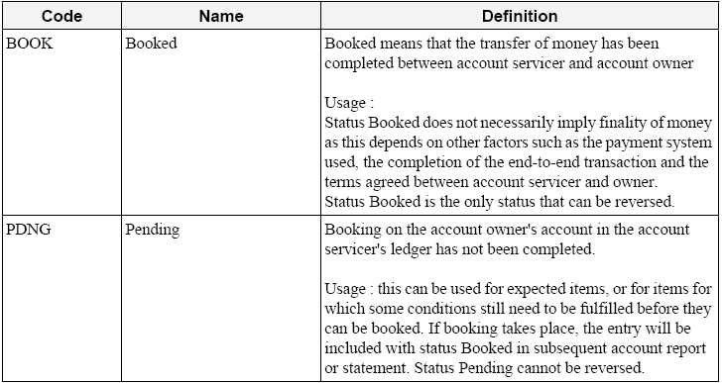
In case of a returned transaction that is reported back to the customer with camt.054.001.01 there must be the possibility to send the message with Status “INFO”, as the information if the item is in fact booked or pending booking is not always available.
2. Requirement
Also allow for the Status “INFO” in the message
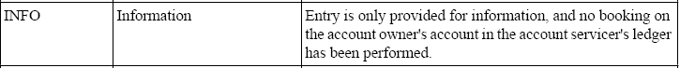

Recommendation from the Payments SEG:
This section is to be completed by the (lead) SEG which had approved the existing version of the messages.
Approve | X
Comments:
The Status code list will be aligned across the 3 Bank-To-Customer Cash Management messages camt.052.001.01, camt.053.001.01 and camt.054.001.01.

Reject
Reason for rejection:

RMG decision:
This section is to be completed in due time by the RMG secretariat based on RMG approval/rejection of the SEG recommendation.
Approve
Comments:

Reject
Reason for rejection:

CR n°U-064-PAY-2009: RegulatoryReporting
Origin of request and date | CR Status
Requestor(s):  Submitting organisation name: Deutsche Bank AG  Country: Germany  Submitter name: Heike Matzner  Submitter contact information:  E-mail address: heike.matzner@db.com  Telephone: +49 (0)69 910 73741  Date of the request: 28.08.2008 | New
Nature of Change | Message(s) Impacted
Modification of the current design of the RegulatoryReporting <RgltryRptg> component | Message Identifier (message Name)  - pain.001.001.02  - pain.008.001.01  - pacs.003.001.01  - pacs.008.001.01
Context
Business reasons
Requirement description
1. Background information
Today customers have the possibility to provide their Central Bank Reporting together with the Payment Message during a file upload. However, the current structure of XML ISO 20022 does not allow to include all information as it is required in some countries. In order to promote XML as the future format the same functionality has to be available.
2. Requirement
The current structure does not allow submitting central bank reporting for all countries, where it is required. In order to be able to include central bank reporting additional elements are required.
Attached Sheet provided a more extensive RegulatoryReporting structure. The enhancements are based on the German Central Bank Reporting but structured and naming can also be used by other countries.


Recommendation from the Payments SEG:
This section is to be completed by the (lead) SEG which had approved the existing version of the messages.
Approve | X
Comments:
To accommodate the business requirements the current RegulatoryReporting component (typed RegulatoryReporting2) will be replaced by the component below. This component also takes the requirements into account that were mentioned under CR n°U-050-PAY-2009.

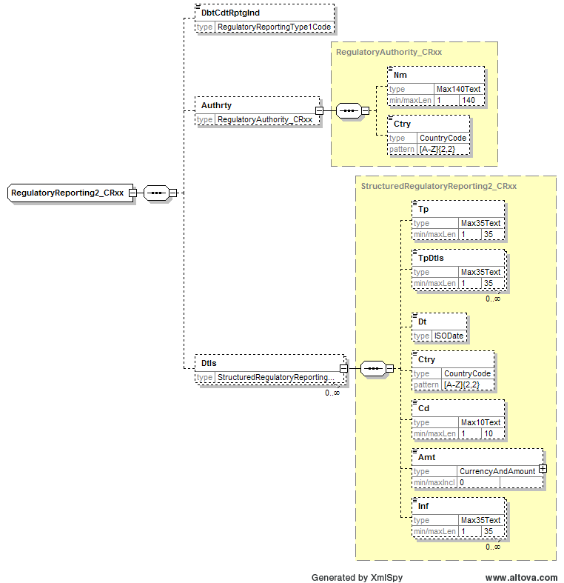

Reject
Reason for rejection:

RMG decision:
This section is to be completed in due time by the RMG secretariat based on RMG approval/rejection of the SEG recommendation.
Approve
Comments:

Reject
Reason for rejection:

CR n°U-065-PAY-2009: Tax
Origin of request and date | CR Status
Requestor(s):  Submitting organisation name: Deutsche Bank AG  Country: Germany  Submitter name: Heike Matzner  Submitter contact information:  E-mail address: heike.matzner@db.com  Telephone: +49 (0)69 910 73741  Date of the request: 29.08.08 | New
Nature of Change | Message(s) Impacted
Modification of the current design of the Tax <Tax> component. The current structure does not allow specify a period for which the Tax Payment has been done. | Message Identifier (message Name)  - pain.001.001.02  B2CCreditTransfer  - pain.008.001.01  B2CDirectDebit  - camt.052.001.01  B2CAccountReportV01  - camt.053.001.01  B2CStatementV01  - camt.054.001.01  B2CDebitCreditNotificationV01
Context
Business reasons
Requirement description
1. Background information
Today customers have the possibility to provide their Tax Details together with the Payment Message during a file upload. However, the current structure of XML ISO 20022 does not allow including all information as it is required in some countries. In order to promote XML as the future format the same functionality has to be available.
2. Requirement
Tax Amount:
The Tax component should have the possibility to specify more than one amount.
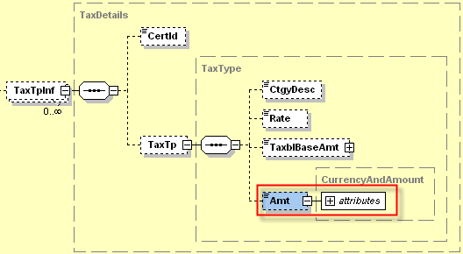
<TaxAmt>
<Amt Ccy="EUR">3.000</Amt>
<AmtInf>1st months of 1st Quarter 2008</AmtInf>
</TaxAmt>
AmountInformation: Optional Element with 70 Char
Tax Period:
The Tax component should have the possiblity to specify a tax period.
Below a proposal for a choice to define the Tax Period. The Period component should follow the TaxDate Element.
The Component has to support either from – to dates or the definition of e.g. a quarter of the year.
<TaxPrd>
<PrdDtls>
<Cd>QUAR</Cd>
<Prd>2008-03</Prd>
</PrdDtls>
</TaxPrd>
or
<TaxPrd>
<FrmToDtls>
<FrmDt>2008-01-01</FrmDt>
<ToDt>2008-03-31</ToDt>
</FrmToDtls>
</TaxPrd>

Possible Codes: QUAR – Quarter
HALF – Semester

Recommendation from the Payments SEG:
This section is to be completed by the (lead) SEG which had approved the existing version of the messages.
Approve | X
Comments:
To accommodate the business requirements the current Tax component (typed TaxInformation2) will be replaced by the component below.
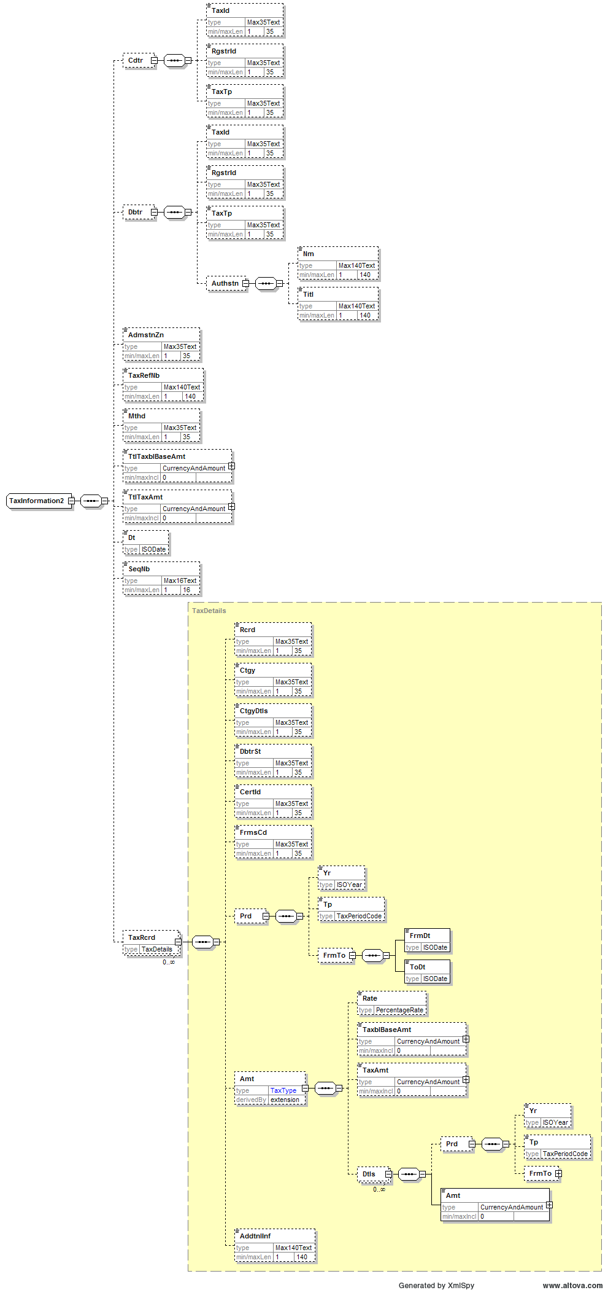

Reject
Reason for rejection:

RMG decision:
This section is to be completed in due time by the RMG secretariat based on RMG approval/rejection of the SEG recommendation.
Approve
Comments:

Reject
Reason for rejection:

Technical adjustments

CR n°U-066-PAY-2009: XORs
Origin of request and date | CR Status
Requestor(s):  SWIFT  Date of the request: October 2008 | New
Nature of Change | Message(s) Impacted
Modification of the design of XOR choices at tree nesting level. | Message Identifier (message Name)  All pain, pacs and camt messages where occurring.
Context
Technical reasons
Change to XORs at tree nesting level
In the next version of ISO 20022, an XOR choice at nesting tree level will not be allowed, XORs will only be allowed at element level.
For example: in the remittance information component, ReferredDocumentType, there is an XOR between Code and Proprietary as indicated below.
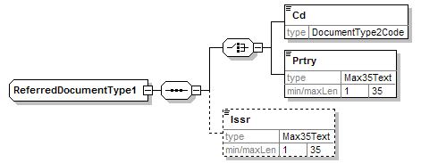

This will need to be changed into:
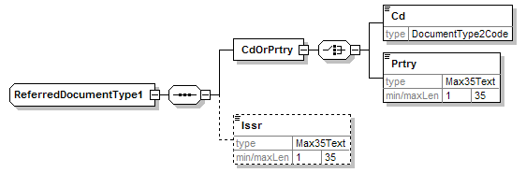

The proposal is address all occurrences of similar XORs across the messages in scope of this maintenance.
Recommendation from the Payments SEG:
This section is to be completed by the (lead) SEG which had approved the existing version of the messages.
Approve | X
Comments:

Reject
Reason for rejection:

RMG decision:
This section is to be completed in due time by the RMG secretariat based on RMG approval/rejection of the SEG recommendation.
Approve
Comments:

Reject
Reason for rejection:

CR n°U-067-PAY-2009: CurrencyAndAmount
Origin of request and date | CR Status
Requestor(s):  SWIFT  Date of the request: October 2008 | New
Nature of Change | Message(s) Impacted
Modification of the amount element data type | Message Identifier (message Name)  All pain, pacs and camt messages
Context
Technical reasons
CurrencyAndAmount
The payments messages are out of sync with some of the other areas as far as the CurrencyAndAmount element is concerned. Datatypes used in other spaces are ActiveCurrencyAndAmount and ActiveOrHistoricCurrencyAndAmount. Reason for this is that in certain message elements a currency might need to meet certain requirements. For example: as from 1 January 2009 the euro will replace the Slovak Koruna in the Republic of Slovakia. As from that moment, the use of SKK in settlement amount elements will no longer be allowed. This can be monitored when the difference is made between active and historic currencies.
Reference to ‘old’ currencies -in for example instructed amounts elements- can still be made if the element is typed ActiveOrHistoricCurrencyAndAmount.
This change is transparent at schema level, only the name of the datatype would change.
The proposal is to update all amount datatypes across the messages in scope of this maintenance.
Recommendation from the Payments SEG:
This section is to be completed by the (lead) SEG which had approved the existing version of the messages.
Approve | X
Comments:

Reject
Reason for rejection:

RMG decision:
This section is to be completed in due time by the RMG secretariat based on RMG approval/rejection of the SEG recommendation.
Approve
Comments:

Reject
Reason for rejection:

During the September ISO 20022 Payments Maintenance 2009 meeting the request was made to add a code to link a payment with a trade transaction stored in the Trade Services Utility through the transaction identifier (TID). The TID is a unique identifier assigned by the TSU to a single underlying corporate purchase agreement (where purchase orders and invoice numbers are not necessarily unique). The code will be used in combination with the TID, invoice number and amount.
TARGET2 focus session (SIBOS) Wednesday, 11 October 2006.
As per TARGET2 capacity planning.
TARGET2 focus session (SIBOS) Wednesday, 11 October 2006.
As per TARGET2 capacity planning.

