**Maintenance Change Request**

**for fast track maintenance of existing message definitions**

*Note: the purpose of this document is to give guidelines to submitting organizations that intend to use the Fast Track maintenance process to develop a new version of existing ISO 20022 messages. Such development is subject to the approval, by the related Standards Evaluation Group (SEG), of a Maintenance Change Request which must include a detailed description of the impact of each change on the related messages. The Maintenance Change Request must start with a general chapter covering topics related to the whole maintenance effort and a specific chapter for each change request, as described below. Please consult the iso20022.org website for additional details on the Fast Track maintenance process. Maintenance Change Requests must be sent to* [*iso20022ra@iso20022.org*](mailto:iso20022ra@iso20022.org)*.*

1. **Submitting organization(s):**

SMPG

1. **Related messages:**

Seev.001.001.09 (meeting notification)

1. **Purpose of the change:**

The purpose of the change is to align the element SecuritiesBlockingPeriodEndDate in the seev.001 with the corresponding field/element in the MT564 and seev.031 messages.

1. **Urgency of the request:**

This lack of alignment between the MT564/seev.031 and the seev.001 was not identified earlier*.* Unless the change request can be fast-tracked for 2023, participants to e.g. the Eurosystem Collateral Management System which is scheduled to be deployed in November 2023 will not be able to use date code in the seev.001 for a bondholder meeting but will be able to do so in an MT564 for the same event.

1. **Commitments of the submitting organization:**

The SMPG confirms that it can and will:

* address any queries related to the description of the message versions as published by the RA on the ISO 20022 website.

The SMPG confirms its knowledge and acceptance of the ISO 20022 Intellectual Property Rights policy for contributing organizations, as follows.

*“Organizations that contribute information to be incorporated into the ISO 20022 Repository shall keep any Intellectual Property Rights (IPR) they have on this information. A contributing organization warrants that it has sufficient rights on the contributed information to have it published in the ISO 20022 Repository through the ISO 20022 Registration Authority in accordance with the rules set in ISO 20022. To ascertain a widespread, public and uniform use of the ISO 20022 Repository information, the contributing organization grants third parties a non-exclusive, royalty-free license to use the published information”.*

1. **Contact persons:**

Name: Christine Strandberg

Email Address: Christine.strandberg@seb.se

Telephone number: +46 (8) 763 60 74

Name: Mariangela Fumagalli

Email Address: mariangela.fumagalli@bnpparibas.com

Telephone number: +442075954988

Name: Jacques Littré

Email Address: jacques.littre@swift.com

Telephone number: +32 2 655 4335

# Change number 1

***This section must be completed for each particular change.***

1. **Related messages:**

Seev.001.001.09 (meeting notification).

1. **Description of the change and type of impact:**

The purpose of the change is to align the element SecuritiesBlockingPeriodEndDate in the seev.001 with the corresponding field/element in the MT564 and seev.031 messages. This alignment will allow users to map/translate between ISO 15022 and ISO 20022 for both meeting and corporate action notifications. The impact to users that do not wish to use this optional element, or the optional element as a date, should be very minor.

1. **Proposed implementation:**

The data type ISODateTime of the SecuritiesBlockingPeriodEndDate should be supplemented by the similar data type existing in the seev.031 in element EndOfSecuritiesBlockingPeriod, thus amending the element from a date to a choice of date or date code. Please see the illustration below.

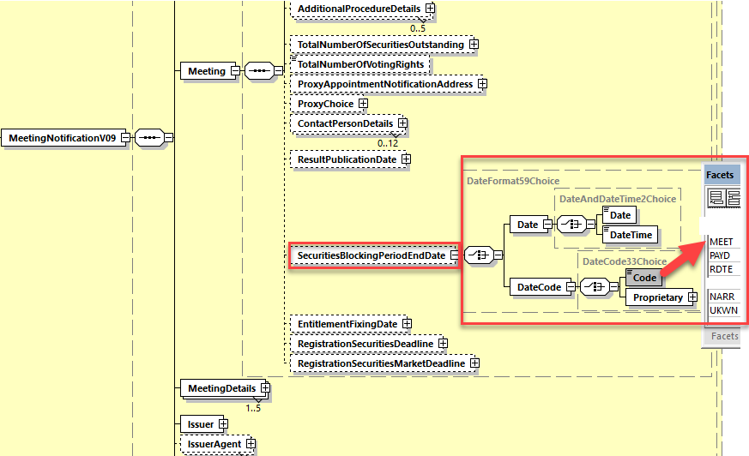

1. **Decision of the SEG(s):**

*This section is not to be taken care of by the submitting organization. It will be completed in due time by the SEG(s) in charge of the related ISO 20022 message definitions.*

|  |  |
| --- | --- |
| **Change** | |
| approved | X |  |
|  | rejected |  |  |

Comments:

**Next yearly cycle: 2022/2023**

**The change will be considered for implementation in the yearly maintenance cycle which starts in 2022 and completes with the publication of new message versions in the spring of 2023.**

|  |  |
| --- | --- |
| **Timing** | |
| **- Fast track maintenance**  (the change justifies an urgent implementation using the fast track maintenance process) | | X |
| - **At the occasion of the next maintenance of the messages**  (the change will be considered for implementation, but does not justify an urgent implementation – will be pending until the next [yearly] maintenance of the messages) | |  |