Maintenance Change Request
for fast track maintenance of existing message definitions
Note: the purpose of this document is to give guidelines to submitting organizations that intend to use the Fast Track maintenance process to develop a new version of existing ISO 20022 messages. Such development is subject to the approval, by the related Standards Evaluation Group (SEG), of a Maintenance Change Request which must include a detailed description of the impact of each change on the related messages. The Maintenance Change Request must start with a general chapter covering topics related to the whole maintenance effort and a specific chapter for each change request, as described below. Please consult the iso20022.org website for additional details on the Fast Track maintenance process. Maintenance Change Requests must be sent to iso20022ra@iso20022.org.

- Submitting organization(s):
SWIFT Standards on behalf of NMPG Funds Italy.

- Related messages:
Under this project, the following ISO 20022 funds messages will be maintained:
 | Name | Identifier
1 | Fund Reference Data Report | reda.004.001.05
There is one message in scope of this 2021 fast track maintenance.

D. Commitments of the submitting organisation
SWIFT confirms that it can and will:
- undertake the development of the new version of the candidate ISO 20022 message models that it will submit to the RA for compliance review and evaluation. The new valid Message Definition models will be available to the RA by 15 July 2021.
- provide a new version of part 1 of the Message Definition Report (MDR) by 15 July 2021
- address any queries related to the description of the new models and messages as published by the RA on the ISO 20022 website.
SWIFT confirms that it intends to organise the testing and the actual implementation of the new version of the messages once the related documentation has been published by the RA.
SWIFT confirms its knowledge and acceptance of the ISO 20022 Intellectual Property Rights policy for contributing organisations, as follows.
“Organisations that contribute information to be incorporated into the ISO 20022 Repository shall keep any Intellectual Property Rights (IPR) they have on this information. A contributing organisation warrants that it has sufficient rights on the contributed information to have it published in the ISO 20022 Repository through the ISO 20022 Registration Authority in accordance with the rules set in ISO 20022. To ascertain a widespread, public and uniform use of the ISO 20022 Repository information, the contributing organisation grants third parties a non-exclusive, royalty-free license to use the published information”.

- Purpose of the change:
Adaptation of the message to the new template EMT V3.1 within MIFID II regulation.
The changes in comparison to EMT V3.0 affect data field 56 (05105) that has been updated and data fields 95-98 (09000, 09010, 09020, 10020) that have been added.
The EMT V3.1 has been in use since 10th March 2021.

- Urgency of the request:
As soon as possible.

- Contact persons:
- Janice Chapman – SWIFT Standards, mail to: janice.chapman@swift.com
- Gregory Mestag – SWIFT Standards, mail to: gregory.mestdag@swift.com

Change number #1
- Related messages:
Under this project, the following ISO 20022 funds messages will be maintained:
 | Name | Identifier
1 | Fund Reference Data Report | reda.004.001.05
There is one message in scope of this 2021 fast track maintenance.

- Description of the change and type of impact:

[1] Amend the last paragraph of Definition/Usage:
From | To
The FundReferenceDataReport message may be used to provide data concerning product governance, such as target market data, and a breakdown of the costs and fees in the context of MiFID II, with respect to the European MiFID Template (EMT) version 3. | The FundReferenceDataReport message may be used to provide data concerning product governance, such as target market data, and a breakdown of the costs and fees in the context of MiFID II, with respect to the European MiFID Template (EMT) version 3 and version 3.1 which will coexist until version 4 is available.
[2] Add in the following section:
Report/TargetMarket/ClientObjectivesAndNeeds
a new element to be compliant with field 05105 EMT V3.1:
SustainabilityPreferences
XML Tag: SstnbltyPrefs
Definition:
Specifies whether the product is compatible with investors that have Sustainability preferences. When used in reference to MiFID, this is in the scope of the European MiFID Template (EMT V3.1) reference 05105
Multiplicity: [0..1]
Type: TargetMarket4Code:
Neutral [NEUT] (Neutral or has no impact)
Esg preference [CESG] (Preferences for products having ESG Characteristics)
Sustainable preference [OSUS] (Preferences for products having Sustainable Objectives)
[3] Add the following new section:
Report/AdditionalProductInformationsGermanMarket (place after the section CostsAndCharges)
XML Tag: AddtlPdctInfGrmnMkt
Definition:
Additional information required for distribution in German market
Multiplicity: [0..1]
Type: AdditionalProductInformations1:
[3.1] ESGCategoryForGermanFundMarket
XML Tag: ESGCtgyGrmnFndMkt
Definition:
Specifies category of funds product. When used in reference to MiFID, this is in the
scope of the European MiFID Template (EMT V3.1) reference 09000
Multiplicity: [0..1]
Type: ESGCategory1Code:
Neutral [NEUT] (Neutral or has no impact)
Basic Category [BASF] (Product with ESG opportunities/risks)
ESG Strategy [ESGF] (Product with dedicated ESG strategy)
Impact [IMPF] (Product with impact related investment)
[3.2] ESGCategoryForGermanStructuredSecuritiesMarket
XML Tag: ESGCtgyGrmnStrdSctiesMkt
Definition:
Specifies category of structured securities product. When used in reference to MiFID, this is in the scope of the European MiFID Template (EMT V3.1) reference 09000
Multiplicity: [0..1]
Type: ESGCategory2Code:
Neutral [NEUT] (Neutral or has no impact)
Basic Category SS [BASS] (Product Manufacturer follows ESG product and transparency standard)
ESG Strategy SS [ESGS] (Product Manufacturer has the status of a sustainable company)
Impact SS [IMPS] (Product Manufacturer follows ESG product and transparency standard)
[3.3] ESGFocus
XML Tag: ESGFcs
Definition:
Specifies if main focus will be Environmental or Social or Governance. When used in reference to MiFID, this is in the scope of the European MiFID Template (EMT V3.1) reference 09010
Multiplicity: [0..1]
Type: ESGFocus1Code:
Environmental [ENVR] (Main focus will be Environmental)
Social [SOCL] (Main focus will be Social)
Governance [GOVR] (Main focus will be Governance)
[3.4] ESGLabelOrStandard
XML Tag: ESGLablOrStd
Definition:
Specifies the ESG label or standard of a product. When used in reference to MiFID, this is in the scope of the European MiFID Template (EMT V3.1) reference 09020
Multiplicity: [0..*]
Type: ESGLabelsOrStandard1Code:
ICMA Green Bond [A001] (ICMA Green Bond Principles)
EU Green Bond [B002] (EU Green Bond Standard)
EU Ecolabel [C003] (EU Ecolabel for Financial Products)
FNG-Siegel [D004] (FNG-Siegel)
CBI Climate Bonds [E005] (CBI Climate Bonds Standards)
ICMA Social Bonds [F006] (ICMA Social Bonds Principles)
LuxFLAG ESG [G007] (LuxFLAG ESG)
LuxFLAG Climate Finance [H008] (LuxFLAG Climate Finance)
LuxFLAG Environment [I009] (LuxFLAG Environment)
Kein Verstoß gegen Atomwaffensperrvertrag [J010] (Kein Verstoß gegen Atomwaffensperrvertrag)
ISR [K011] (ISR)
Febelfin / Towards Sustainability [L012] (Febelfin / Towards Sustainability)
UZ49 [M013] (UZ49 - das österreichische Umweltzeichen)
Nordic Swan [N014] (Nordic Swan)
GreenFin Label [O015] (GreenFin Label)
[4] Add the following new section:
Report/AdditionalProductInformationsFrenchMarket (place after the section CostsAndCharges)
XML Tag: AddtlPdctInfFrnchMkt
Definition:
Additional information required for distribution in French market
Multiplicity: [0..1]
Type: AdditionalProductInformations2:
[4.1] AMFDoctrine
XML Tag: AMFDctrn
Definition:
Specifies the approach of the AMF position/recommendation 2020-03 complied by fund.
When used in reference to MiFID, this is in the scope of the European MiFID
Template (EMT V3.1) reference 01020
Multiplicity: [0..1]
Type: AMFDoctrine1Code:
Significantly methodology [1001] (Approach based on a significantly engaging methodology)
No significantly methodology [2002] (Non-significantly engaging methodology approach)
No communication standards [3003] (Approach not meeting central or limited communication standards)

- Proposed implementation:
  - Overview of impact:
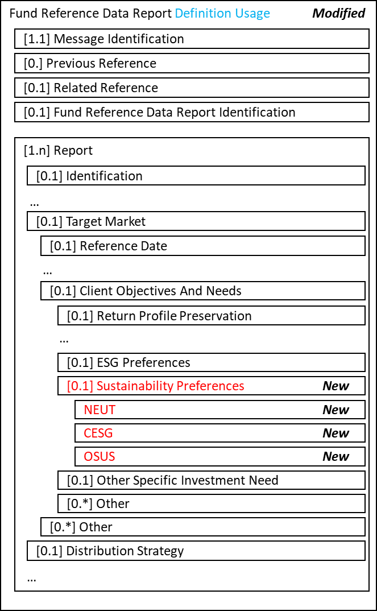
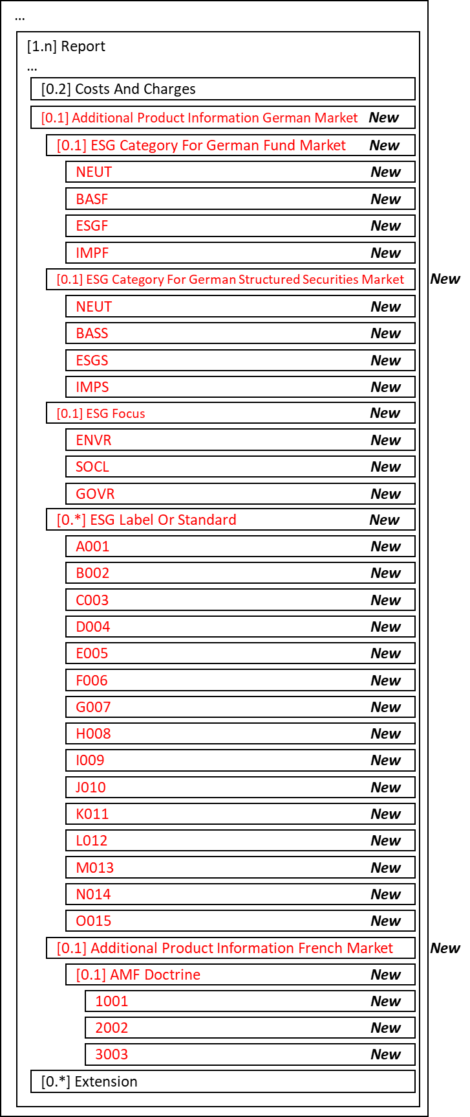
  - Item [1] Message Scope & Usage
The scope and usage documentation are to be updated:
Current Definition | Proposed Definition
Scope  The FundReferenceDataReport message is sent by a report provider, for example, a fund promoter, fund management company, transfer agent, or market data provider to the report recipient, for example, a professional investor, investment fund distributor, market data provider, regulator or other interested party, to provide the key reference data for financial instruments to facilitate trading. The message may also include reporting data concerning product governance, such as target market data, and a breakdown of the costs and fees.  Usage  A FundReferenceDataReport message should be prepared for each class of unit/share (for which an individual ISIN should have been allocated), in respect of its "home" market. Each time the fund data changes, the ‘product provider’ must provide the data to a product user, for example, the distributors, by sending a new funds reference data report. A single message may contain more than one report. When the FundReferenceDataReport message is sent to provide updated reference data, the message overwrites the previously sent data.  The FundReferenceDataReport message may be used in various models or environments:  - in a standalone environment, for example, initiated by the Report Provider (fund promoter, fund manager and / or reference data vendors) sent on a regular frequency, or when changes are needed.  - in a request / response environment, with the InvestmentFundReportRequest, for example, initiated by report users (data vendors, professional investors, regulators or investment fund distributors) in enabling the user to control the flow and updates of information.  - in a reference data vendor environment, for example, market infrastructure and reference data providers may collate and store all fund reference data information centrally for access via database or regular distribution information. A reference data vendor may assume the role of both report provider and report user.  The FundReferenceDataReport message may be used to provide data concerning product governance, such as target market data, and a breakdown of the costs and fees in the context of MiFID II, with respect to the European MiFID Template (EMT) version 3. | Scope  The FundReferenceDataReport message is sent by a report provider, for example, a fund promoter, fund management company, transfer agent, or market data provider to the report recipient, for example, a professional investor, investment fund distributor, market data provider, regulator or other interested party, to provide the key reference data for financial instruments to facilitate trading. The message may also include reporting data concerning product governance, such as target market data, and a breakdown of the costs and fees.  Usage  A FundReferenceDataReport message should be prepared for each class of unit/share (for which an individual ISIN should have been allocated), in respect of its "home" market. Each time the fund data changes, the ‘product provider’ must provide the data to a product user, for example, the distributors, by sending a new funds reference data report. A single message may contain more than one report. When the FundReferenceDataReport message is sent to provide updated reference data, the message overwrites the previously sent data.  The FundReferenceDataReport message may be used in various models or environments:  - in a standalone environment, for example, initiated by the Report Provider (fund promoter, fund manager and / or reference data vendors) sent on a regular frequency, or when changes are needed.  - in a request / response environment, with the InvestmentFundReportRequest, for example, initiated by report users (data vendors, professional investors, regulators or investment fund distributors) in enabling the user to control the flow and updates of information.  - in a reference data vendor environment, for example, market infrastructure and reference data providers may collate and store all fund reference data information centrally for access via database or regular distribution information. A reference data vendor may assume the role of both report provider and report user.  The FundReferenceDataReport message may be used to provide data concerning product governance, such as target market data, and a breakdown of the costs and fees in the context of MiFID II, with respect to the European MiFID Template (EMT) version 3 and 3.1. Versions 3 and 3.1 will coexist until version 4 is available.

  - Item [2] Sustainability Preferences
In the Report/TargetMarket/ClientObjectivesAndNeeds sequence, add optional element:
Element Name | M/0 | Definition | Data Type
SustainabilityPreferences | [0.1] | Specifies whether the product is compatible with investors that have sustainability preferences. When used in reference to MiFID, this is in the scope of the European MiFID Template (EMT V3.1) reference 05105. | New code list
New code list
Nbr | Code | Code Name | Definition
1 | NEUT | Neutral | Neutral or has no impact.
2 | CESG | ESGPreference | Preference for products having environmental, social and corporate governance (ESG) characteristics.
3 | OSUS | SustainablePreference | Preference for products having sustainable objectives.
  - Item [3] Additional Product Information German Market
In the Report sequence, add optional element:
Element Name | M/0 | Definition | Data Type
AdditionalProduct InformationGermanMarket | [0.1] | Additional information required for distribution in the German market. | AdditionalProductInformation1
See items 3.1 to 3.4 below for the elements of AdditionalProduct InformationGermanMarket (AdditionalProductInformation1)
    - Item [3.1] ESG Category for German Fund Market
In the Report/AdditionalProductInformationGermanMarket sequence, add optional element:
Element Name | M/0 | Definition | Data Type
ESGCategoryGermanFundMarket | [0.1] | Category of fund product. When used in reference to MiFID, this is in the scope of the European MiFID Template (EMT V3.1) reference 09000. | New code list
New code list
Nbr | Code | Code Name | Definition
1 | NEUT | Neutral | Neutral or has no impact.
2 | BASF | BasicCategory | Product having environmental, social and corporate governance (ESG) characteristics, opportunities or risks according to the "ESG integration enhanced" criteria.  Product integration approach is disclosed and the product manager follows recognised industry standard (UN PRI).
3 | ESGF | ESGStrategy | Product with a dedicated environmental, social and corporate governance (ESG) strategy (pursuant to Art. 8 Disclosure Regulation)
4 | IMPF | Impact | Product with impact-related investment (pursuant to Art.9 Disclosure Regulation).  - No serious breach of UNGC  - Relevant for both individual products and those in a portfolio/basket (shares/bonds)  - Product manager follows recognised industry standard (UN PRI).

    - Item [3.2] ESG Category for German Structure Securities Market
In the Report/AdditionalProductInformationGermanMarket sequence, add optional element:
Element Name | M/0 | Definition | Data Type
ESGCategoryGermanStructureSecuritiesMarket | [0.1] | Category of structured securities product. When used in reference to MiFID, this is in the scope of the European MiFID Template (EMT V3.1) reference 09000. | New code list
New code list
Nbr | Code | Code Name | Definition
1 | NEUT | Neutral | Neutral or has no impact.
2 | BASS | BasicCategorySS | Product manufacturer follows ESG product and transparency standard.
3 | ESGS | ESGStrategySS | Product manufacturer attains at least with one rating agency the status of a sustainable company.
4 | IMPS | ImpactSS | Impact-related bond according to recognised market standards (e.g., Green/Social Bond Principles, EU Green Bond Standards).
    - Item [3.3] ESG Focus
In the Report/AdditionalProductInformationGermanMarket sequence, add optional element:
Element Name | M/0 | Definition | Data Type
ESGFocus | [0.1] | Specifies if focus will be Environmental, Social or Governance. When used in reference to MiFID, this is in the scope of the European MiFID Template (EMT V3.1) reference 09010. | New code list
New code list
Nbr | Code | Code Name | Definition
1 | ENVR | Environmental | Main focus will be environmental.
2 | SOCL | Social | Main focus will be social.
3 | GOVR | Governance | Main focus will be governance.

    - Item [3.4] ESG Label Or Standard
In the Report/AdditionalProductInformationGermanMarket sequence, add optional element:
Element Name | M/0 | Definition | Data Type
ESGLabelOrStandard | [0.*] | ESG label or standard of a product. When used in reference to MiFID, this is in the scope of the European MiFID Template (EMT V3.1) reference 09020. | New code list
New code list
Nbr | Code | Code Name | Definition
1 | A001 | ICMA Green Bond | ICMA Green Bond Principles.
2 | B002 | EU Green Bond | EU Green Bond Standard.
3 | C003 | EU Ecolabel | EU Ecolabel for Financial Products.
4 | D004 | FNGSiegel | FNG-Siegel.
5 | E005 | CBIClimateBonds | CBI Climate Bonds Standards.
6 | F006 | ICMASocialBonds | ICMA Social Bonds Principles.
7 | G007 | LuxFLAGESG | LuxFLAG ESG.
8 | H008 | LuxFLAGClimate | LuxFLAG Climate Finance.
9 | I009 | LuxFLAGEnvironment | LuxFLAG Environment.
10 | J010 | KeinVerstoßGegenAtomwaffensperrvertrag | Kein Verstoß gegen Atomwaffensperrvertrag.
11 | K011 | ISR | ISR.
12 | L012 | FebelfinTowardsSustainability | Febelfin / Towards Sustainability.
13 | M013 | UZ49 | UZ49 - das österreichische Umweltzeichen.
14 | N014 | NordicSwan | Nordic Swan.
15 | O015 | GreenFinLabel | GreenFin Label.

  - Item [4] Additional Product Information French Market
In the Report sequence, add optional element:
Element Name | M/0 | Definition | Data Type
AdditionalProductInformationFrenchMarket | [0.1] | Additional information required for distribution in the French market. | AdditionalProductInformation2
See items 4.1 below for the elements of AdditionalProduct InformationFrenchMarket (AdditionalProductInformation2)
    - Item [4.1] AMF Doctrine
In the Report/AdditionalProductInformationFrenchMarket sequence, add optional element:
Element Name | M/0 | Definition | Data Type
AMFDoctrine | [0.1] | Approach of the Autorite des Marches Financiers (AMF) recommendation 2020-03 to which the fund complies.  When used in reference to MiFID, this is in the scope of the European MiFID Template (EMT V3.1) reference 01020. | New code list
New code list
Nbr | Code | Code Name | Definition
1 | 1001 | SignificantlyEngagingMethodology | Approach based on a significantly engaging methodology.
2 | 2002 | NonSignificantlyEngagingMethodology | Approach based on a non-significantly engaging methodology.
3 | 3003 | NotMeetingCentralCommunicationStandards | Approach not meeting central communication standards or based on limited communication standards.

  - Summary of Changes
New elements are shown in red. Modified elements are shown in blue.
# | Element |  |  |  |  |  |  | Type of Change | Status Draft 1
1 | FundReferenceDataReportV05 |  |  |  |  |  |  | Definition Usage
 |  | MessageIdentification
 |  | PreviousReference
 |  | RelatedReference
 |  | FundReferenceDataReportIdentification
 |  | Report
 |  |  | Identification
 |  |  | Version
 |  |  | AuthorisedProxy
 |  |  | GeneralReferenceDate
 |  |  | TargetMarketIndicator
 |  |  | ExAnteIndicator
 |  |  | ExPostIndicator
 |  |  | Security Identification
 |  |  | Fund Parties
 |  |  | MainFundOrderDesk
 |  |  | FundManagementCompany
 |  |  | FundDetails
 |  |  | ValuationDealingCharacteristics
 |  |  | InvestmentRestrictions
 |  |  | SubscriptionProcessingCharacteristics
 |  |  | RedemptionProcessingCharacteristics
 |  |  | SwitchProcessingCharacteristics
 |  |  | PlanCharacteristics
 |  |  | PaymentInstrument
 |  |  | CashSettlementDetails
 |  |  | LocalMarketAnnex
 |  |  | TargetMarket
 |  |  |  | ReferenceDate
 |  |  |  | InvestorType
 |  |  |  | KnowledgeAndOrExperience
 |  |  |  | AbilityToBearLosses
 |  |  |  | RiskTolerance
 |  |  |  | ClientObjectivesAndNeeds
 |  |  |  |  |  | ReturnProfilePreservation
 |  |  |  |  |  | ReturnProfileGrowth
 |  |  |  |  |  | ReturnProfileIncome
 |  |  |  |  |  | ReturnProfileHedging
 |  |  |  |  |  | OptionOrLeveragedReturnProfile
 |  |  |  |  |  | ReturnProfilePensionSchemeGermany
 |  |  |  |  |  | MinimumHoldingPeriod
 |  |  |  |  |  | ESGPreferences
2 |  |  |  |  |  | SustainabilityPreferences |  | New
3 |  |  |  |  |  |  | NEUT
4 |  |  |  |  |  |  | CESG
5 |  |  |  |  |  |  | OSUS
 |  |  |  |  |  | OtherSpecificInvestmentNeed
 |  |  |  |  |  | Other
 |  |  |  | DistributionStrategy
 |  |  |  | CostsAndCharges
6 |  |  |  | AdditionalProductInformationGermanMarket |  |  |  | New
7 |  |  |  |  | ESGCategoryForGermanFundMarket
8 |  |  |  |  |  |  | NEUT
9 |  |  |  |  |  |  | BASF
10 |  |  |  |  |  |  | ESGF
11 |  |  |  |  |  |  | IMPF
12 |  |  |  |  | ESGCategoryForGermanStructureSecuritiesMarket
13 |  |  |  |  |  |  | NEUT
14 |  |  |  |  |  |  | BASS
15 |  |  |  |  |  |  | ESGS
16 |  |  |  |  |  |  | IMPS
17 |  |  |  |  | ESGFocus
18 |  |  |  |  |  |  | ENVR
19 |  |  |  |  |  |  | SOCL
20 |  |  |  |  |  |  | GOVR
21 |  |  |  |  | ESGLabelOrStandard
22 |  |  |  |  |  |  | A001
23 |  |  |  |  |  |  | B002
24 |  |  |  |  |  |  | C003
25 |  |  |  |  |  |  | D004
26 |  |  |  |  |  |  | E005
27 |  |  |  |  |  |  | F006
28 |  |  |  |  |  |  | G007
29 |  |  |  |  |  |  | H008
30 |  |  |  |  |  |  | I009
31 |  |  |  |  |  |  | J010
32 |  |  |  |  |  |  | K011
33 |  |  |  |  |  |  | L012
34 |  |  |  |  |  |  | M013
35 |  |  |  |  |  |  | N014
36 |  |  |  |  |  |  | O015
37 |  |  |  | AdditionalProductInformationFrenchMarket
38 |  |  |  |  | AMFDoctrine
39 |  |  |  |  |  |  | 1001
40 |  |  |  |  |  |  | 2002
41 |  |  |  |  |  |  | 3003
 |  |  |  | Extension

- Decision of the SEG(s):
This section is not to be taken care of by the submitting organization. It will be completed in due time by the SEG(s) in charge of the related ISO 20022 message definitions.

Change
 | approved | X
 | rejected
Comments:

Timing
 | - Fast track maintenance  (the change justifies an urgent implementation using the fast track maintenance process) |  | X
- At the occasion of the next maintenance of the messages
(the change will be considered for implementation, but does not justify an urgent implementation – will be pending until the next [yearly] maintenance of the messages)

