Maintenance Change Request
for fast track maintenance of existing message definitions

Submitting organization(s):
- European Securities and Markets Authority (ESMA)
201-203 rue de Bercy
75012 Paris
France
- Regulatory Oversight Committee (ROC)
Represented here by the ESMA, the Ontario Securities Commission (OSC) and the Commodities Futures Trading Commission (CFTC).

Related messages:
auth.030.001.01 - DerivativesTradeReportV01

Purpose of the change:
In 2009, the G20 Leaders agreed that all over-the-counter (OTC) derivatives transactions should be reported to trade repositories (TRs) to further the goals of improving transparency, mitigating systemic risk and preventing market abuse.
Aggregation of the data reported to TRs will help authorities to obtain a comprehensive view of the OTC derivatives market and its activity. Standardisation and harmonisation of key OTC data elements is the enabler of such aggregation.
Since November 2014, the CPMI and IOSCO Harmonisation Group has worked to develop guidance regarding the definition, format and usage of key OTC derivatives data elements reported to TRs, including the Unique Transaction Identifier (UTI), the Unique Product Identifier (UPI) and other Critical Data Elements (CDE). Technical Guidance on the Unique Transaction Identifier (UTI) was published in February 2017 and Technical Guidance on the Unique Product Identifier (UPI) was published in September 2017.
The CPMI and IOSCO published consultative reports on three batches of CDE (other than UTI and UPI) in 2015, 2016 and 2018. Then, in April 2018, CPMI and IOSCO published Technical Guidance on the CDE other than UTI and UPI (hereinafter: CDE Technical Guidance).
As stated in the CDE Technical Guidance, the responsibility for issuing requirements on the reporting of OTC derivatives transactions to TRs falls within the remit of the relevant authorities in their own jurisdiction.
The CDE Technical Guidance develops guidance for authorities on the definition, format and allowable values of CDE to be reported to TRs.
As stated in the Report on the Governance Arrangements for critical OTC derivatives data elements (other than UTI and UPI), the inclusion of the CDE in the ISO 20022 Repository would make the CDE generally available for purposes other than reporting of OTC derivatives to TRs and enhance its acceptance and use by industry, an important goal in ensuring reliable and widespread use of CDE as a global standard. Furthermore, the creation of an ISO 20022 message for CDE would provide the authorities with adequate control over how the ISO 20022 elements are utilised in OTC derivatives transaction reporting.
Consequently, the CDE have been mapped to the ISO 20022 Business Model and the existing auth.030.001.01 message already used for reporting of derivatives transactions per the European Market Infrastructures Regulation (EMIR).

Urgency of the request:
Introducing the changes before the yearly maintenance cycle will enable the authorities to include the CDE requirements in their own jurisdictional regulations and guidelines without further delay. Therefore, it is proposed to follow the fast track process for this change request.

Commitments of the submitting organization:
ESMA and the ROC confirm that it can and will:
- undertake the development of the new version of the candidate ISO 20022 message model that it will submit to the Registration Authority (RA) for compliance review. It is expected that the submission of the modified message to the RA will take place in Q4 2020.
- address any queries related to the description of the message versions as published by the RA on the ISO 20022 website.
ESMA acknowledges that the changes proposed in this MCR will also impact the other message types in the Financial Instruments and Transactions Regulatory Reporting message set, which should be also updated for consistency and alignment. However, it is worth noting that these other messages are currently used only for EU specific purposes under EMIR under control of ESMA, therefore there is no immediate need to change them.
ESMA commits to update all related messages in the above-mentioned set accordingly in 2021 during its scheduled work related to the EMIR Refit changes and to dedicate relevant resources for the work. The following reasons explain the postponement of this task:
  - The entire structure of the auth.091 and auth.092 messages requires rework because under the new technical standards they will be carrying additional information and should be better aligned with the corresponding SFTR messages.
  - Since most of the changes are dependent on the revised technical standards on EMIR (which are not yet finalised) and the subsequent approval by the European Commission (EC), ESMA plans to start the work once the CDE works are completed and the technical standards are endorsed by the EC.
  - The EMIR Refit rework of the messages will not only be limited to the review of the existing fields (which are the representation of the business objectives), but there will be new fields added too for which new information is planned to be gathered from the market participants. And these new fields also have to be included additionally in the other messages – consolidation, aggregation, statistics on the new information will be required, in the same or similar structure. Furthermore, the reconciliation and rejection messages should also provide a trade level information (similarly to the SFTR messages), so they are expected to undergo substantial changes as well.
  - As all the connecting messages (rejections, reconciliations, position) have to be reviewed in details after all relevant updates under the EMIR Refit scope, ESMA would like to avoid additional (and duplicate) effort for the market participants and for the SEG who will be tasked with the review and approval of the proposed changes.
  - Finally, the auth.030 update should ideally be performed swiftly in order to allow other regulators to use the new version of the message in the context of the CDE implementation. Including other messages in this review by SEG may unnecessarily extend the approval process, with no clear benefit.

ESMA and the ROC confirm their knowledge and acceptance of the ISO 20022 Intellectual Property Rights policy for contributing organizations, as follows.
“Organizations that contribute information to be incorporated into the ISO 20022 Repository shall keep any Intellectual Property Rights (IPR) they have on this information. A contributing organization warrants that it has sufficient rights on the contributed information to have it published in the ISO 20022 Repository through the ISO 20022 Registration Authority in accordance with the rules set in ISO 20022. To ascertain a widespread, public and uniform use of the ISO 20022 Repository information, the contributing organization grants third parties a non-exclusive, royalty-free license to use the published information”.

Contact persons:
The following persons can be contacted to get additional information on this Maintenance Change Request:
ESMA:
- Joanna Lednicka - joanna.lednicka@esma.europa.eu
- Krisztina Miklossy - krisztina.miklossy@esma.europa.eu
- Michal Zubrycki - michal.zubrycki-ext@esma.europa.eu
ROC:
- OSC – Shaun Olson - SOLSON@osc.gov.on.ca
- CFTC – Kate Mitchel - KMitchel@CFTC.gov
- ROC secretariat - ROCSecretariat@fsb.org

Change number # 1

Description of the change and type of impact:
The overall structure and modelling logic of the message has been adapted to enable authorities in different jurisdictions to adopt the message for their respective reporting requirements and to better align with the auth.052 message that is used for reporting of securities financing transactions to TRs. Also message components have been modified as well as the cardinality of message elements and some code sets to align with the requirements established in the CDE Technical Guidance.

To reduce the size and complexity of the message, the Position reporting component has been replaced by a reporting level code [ModificationLevel1Code].

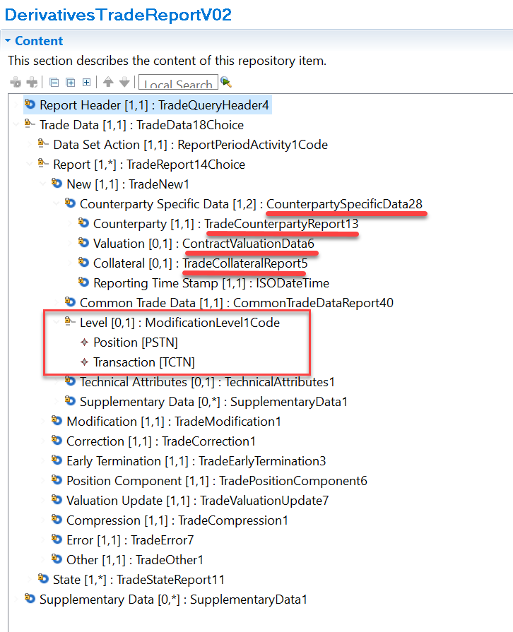

The currently approved version of the message is illustrated below
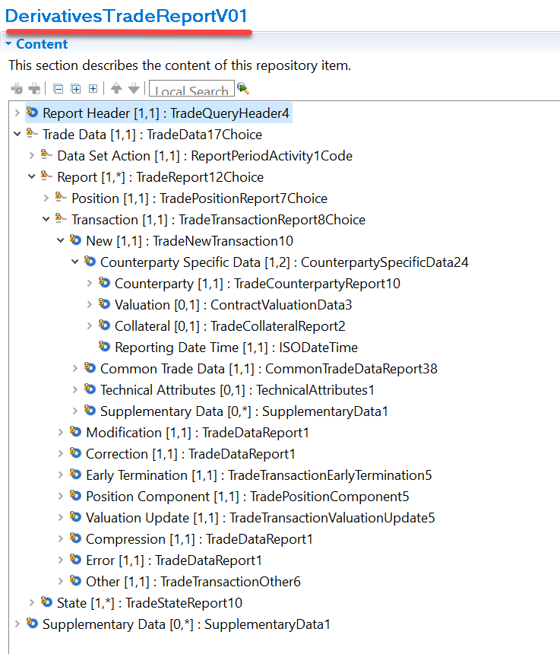

The message components inside each action type (new, modification, ….) have been harmonised to enable a standardised implementation.

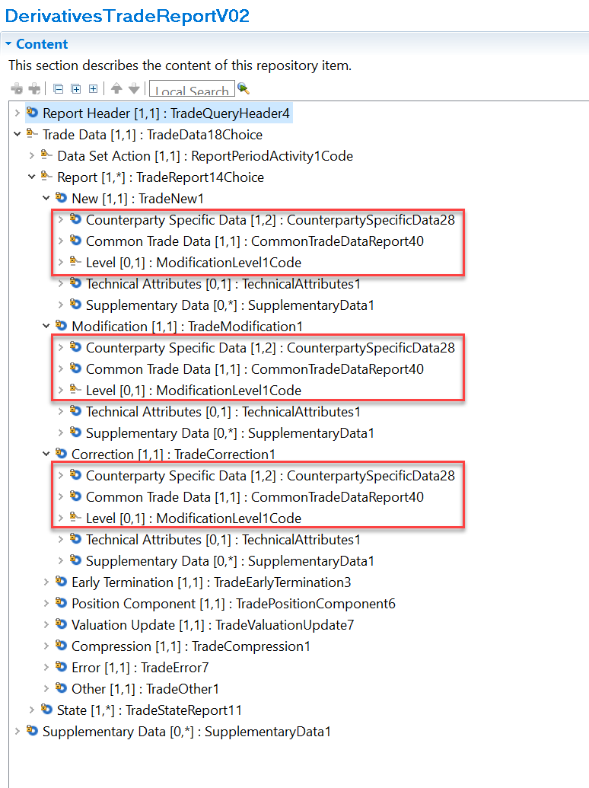

Proposed implementation:
A detailed view of the proposed changes is shown in the updated version of the XML schema appended to the MCR.
To better describe and understand the changes to the message, an excel file with a comparison between the currently approved version of the message and the proposed new version is also appended to this MCR.

Decision of the SEG(s):

Change
 | approved | X
 | rejected

Comments:

Timing
 | - Fast track maintenance  (the change justifies an urgent implementation using the fast track maintenance process) |  | X
- At the occasion of the next maintenance of the messages
(the change will be considered for implementation, but does not justify an urgent implementation – will be pending until the next [yearly] maintenance of the messages)

