Standards
Standards MT Release 2020 – Fast Track
ISO 20022 maintenance cycle 2019/2020
Maintenance Change Request – Maintenance Working Group DRAFT Minutes
Corporate Action

Distribution: Corporate Actions Maintenance Working Group
Author: Jacques Littré

Date Issued: January 14, 2020
Meeting Date: January 14, 2020

Table of Contents
1 Introduction 3
ISO 15022 – 20022 Maintenance Process 3
Standards Illustrations in this document 3
SR 2020 change requests 3
CR Title Colour notation (for minutes only) 3
Contact persons regarding this document 3
CA MWG Members for SR2020 3
2 Overview of User Change requests 5
2.1 CR 001616: Add Indicator for announcement made Under SRDII obligations (ISO 20022 ID: CR 0828) 5

Introduction

ISO 15022 – 20022 Maintenance Process
As from the year 2012, a joint maintenance process has been put in place for ISO 20022 and 15022 and Corporate Action messages with the support of the ISO 20022 RMG and of the SWIFT Board.
This joint maintenance will ensure interoperability between the two standards and a more efficient maintenance process.

Standards Illustrations in this document
Standards illustrations are provided by SWIFT Standards. They are not part of the original request.
Any standard illustrations (rules, codes, qualifiers, wordings) are only for illustration purposes. It does not mean SWIFT Standards is in agreement with the maintenance request or that the final standards solutions (for accepted maintenance requests) will be as shown in this document.
The MT Standards Release Guide (+ potential erratum) and the ISO 20022 message definition reports are the ONLY source of reliable information based on which implementation of changes should be made. Any other documentation (including this one) is subject to change.

SR 2020 change requests
This document contains all CA MT/MX CRs for MT category 5 and equivalent MX messages investigated this year for implementation in SR 2020.
The requests originator is indicated as follows:
  - Requesting Country; Country code of requesting NMPG or UG; eg. BE
  - Requesting Group: a SWIFT User Group or a National (Securities) Market Practice Group with the acknowledgement of the UGC or Recognized industry group eg. SMPG (the global Securities Market Practice Group)

CR Title Colour notation (for minutes only)
In GREEN are items that are approved or approved with comments or approved with alternative solution.
In RED are items that are rejected, postponed, withdrawn or linked to agreed items

Contact persons regarding this document
Jacques Littré – SWIFT Standards; jacques.littre@swift.com

CA MWG Members for SR2020
The following people are part of the CA MWG for SR2020.
- Narelle Rutter – AU (Excused for the Jan. 14 call)
- Véronique Peeters - BE
- Michael Blumer - CH
- Daniel Schäfer / Hendrik Melchior - DE
- Jean-Pierre Klak – FR
- James Mullens – HK (Excused for the Jan. 14 call)
- )
- Catarina Marques - LU
- Jyi-Chen Chueh - SG
- Mariangela Fumagalli – UK
- Paul Fullam - US/ISITC
- Jean-Paul Lambotte – XS
- Jacques Littré – SWIFT, MWG Chair

Note also that the following people attend usually the CA MWG meeting as the representatives from the ISO 20022 Securities SEG:
- Christine Strandberg – ISO 20022 Securities SEG (SE) (Excused for the Jan. 14 call)
- Steven Sloan – ISO 20022 Securities SEG (US)
- Quinnie Luong – ISO 20022 Securities SEG (US)

Overview of User Change requests

CR 001616: Add Indicator for announcement made Under SRDII obligations (ISO 20022 ID: CR 0828)
Origin of request
Requesting Group: | SMPG
Sponsors
SMPG CA WG members
Message type(s) impacted
MT 564, seev.031
Complies with regulation
SRDII and SRDII implementing regulation
Business impact of this request
MEDIUM - To facilitate implementation of SRDII obligations for intermediaries, we believe an indicator is required to inform any intermediary along the chain that a corporate event (including meetings) announcement or shareholder identification request has been initiated by the first intermediary following the announcement/request from the issuer or third party.
Commitment to implement the change
Percentage of messages impacted: 50%
Commits to implement and when: SMPG in 2020
Business context
According to SRDII, all corporate event (including meetings) announcements should be communicated by the issuer to the first intermediary and along the chain of intermediaries to the shareholder. However, as the corporate events are often announced via other sources (e.g. stock exchange) prior to the first intermediary's announcement, after the implementation of SRDII we need to ensure intermediaries are able to easily identify when an announcement comes from the first intermediary compared to other sources so to know when their SRDII compliance obligations kick-in.
Nature of change
Add an indicator to the MT564 and seev.031 to confirm the announcement is made under SRDII obligations.
Workaround
SMPG Proposed Workaround
In case the proposed MT/MX implementation solution illustrated in the following section would not be approved or would be postponed to a next release (for instance SR2021), the following workaround solution would be adopted as a temporary SMPG CA WG market practice as of the SRDII IR deadline of September 3, 2020.
In the MT 564, in sequence D, in field :22F::ADDB, use the following proprietary codes with the data source scheme “SMPG”:

SRDC | Shareholder Rights Directive II Compliant | This announcement was initiated by the first intermediary in the custody chain upon request from, and using information provided by, the issuer, and accordingly SRD II compliance obligations for intermediaries become applicable.
SRDN | Shareholder Rights Directive II Non-Compliant | This announcement was not initiated by the first intermediary in the custody chain upon request from, and using information provided by, the issuer, and accordingly SRD II compliance obligations for intermediaries are not applicable.
Example of the use in the MT 564 message when the announcement is subject to SRDII compliance:
…
:16R:CADETL
:98A::XDTE//20200925
:98A::RDTE//20201002
:22F::ADDB/SMPG/SRDC
:16S:CADETL
…

Example of the use in the MT 564 message when the announcement is not subject to SRDII compliance:
…
:16R:CADETL
:98A::XDTE//20200925
:98A::RDTE//20201002
:22F::ADDB/SMPG/SRDN
:16S:CADETL
…
Examples
NA

Standards Illustration

1. ISO 15022 Illustration
1. In the MT 564 message, in sequence D, in field :17B: Flag, add a new optional and non-repeatable qualifier SRDC as illustrated here below:

MT 564 Field Specifications

50. Field 17B: Flag

FORMAT
Option B | :4!c//1!a | (Qualifier)(Flag)

PRESENCE
Optional in optional sequence D

QUALIFIER
(Error code(s): T89)
Order | M/O | Qualifier | R/N | CR | Options | Qualifier Description
1 | O | CERT | N |  | B | Certification/Breakdown Flag
2 | O | RCHG | N |  | B | Charges Flag
3 | O | COMP | N |  | B | Information to be Complied With
4 | O | ACIN | N |  | B | Accrued Interest Indicator
5 | O | LEOG | N |  | B | Letter of Guaranteed Delivery Flag
6 | O | SRDC | N |  | B | Shareholder Rights Directive Indicator

DEFINITION
This qualified generic field specifies:
ACIN | Accrued Interest Indicator | Indicates whether the holder is entitled to accrued interest.
CERT | Certification/Breakdown Flag | Indicates whether certification/breakdown is required.
COMP | Information to be Complied With | Indicates whether restrictions apply to the event.
LEOG | Letter of Guaranteed Delivery Flag | Indicates whether a letter of guaranteed delivery can be submitted in order to participate in the offer on full eligible position. It is not intended for use in situations arising from failed or late trades.
RCHG | Charges Flag | Indicates whether charges apply to the holder, for instance redemption charges.
SRDC | Shareholder Rights Directive Indicator | Indicates whether the announcement was initiated by the first intermediary in the custody chain in accordance with SRD II.

CODES
Flag must contain one of the following codes (Error code(s): K17):
N | No | No.
Y | Yes | Yes.

2. ISO 20022 Illustration
In the seev.031 (CorporateActionNotification) message, in the CorporateActionDetails sequence, add the new optional and non-repeatable ShareholderRightsDirectiveIndicator element as defined in ISO 15022 above and as illustrated here below:
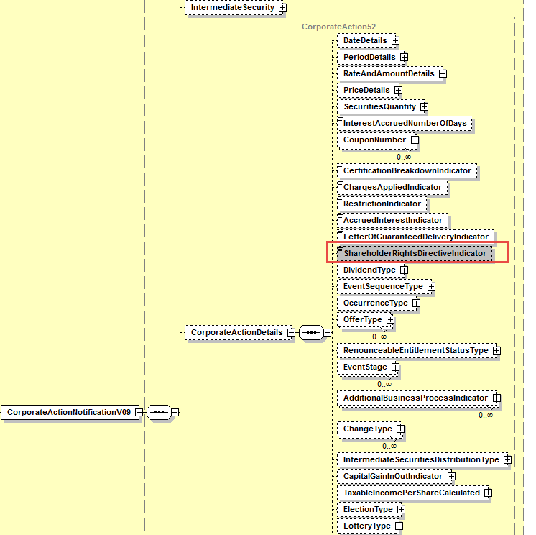

SWIFT Comment

Working Group Meeting

Discussion
Although LU is not fully convinced by the business case at this stage, all other MWG members fully support it and the MWG could reach consensus to support it.
DE does not see an absolute urgency for implementing the proposed solution for SR2020. For Germany, the implementation could well be done in 2021.
All other countries present were however fully supportive of the proposed solution to be implemented in SR2020.
Nevertheless, in addition to adding the flag, CH would like that the first intermediary party identification be also added in the MT564/seev.031 message. Not all countries agree however on the need to have the first intermediary identification in the message but all agree that this further change could still be discussed for SR 2021 in due time.
The MWG agrees that a market practice should accompany the change request to explain the usage of the new flag, its default value and the usage conditions i.e. the presence of the flag with value “Yes” means that the security is in the scope of SRDII and the announcement was sent by the first intermediary (i.e. issuer CSD). This should be reflected in an SMPG MP.
All representatives of the ISO 20022 CA ET agreed with the business case and with the proposed solution for CA in MX.
Decision
CR Approved with proposed solution.

MWG maintenance meeting minutes are distributed around first week of September.

