Maintenance Change Request
for the update of ISO 20022 financial repository items
Note: the purpose of this document is to give guidelines to submitting organisations that will develop a new version of existing ISO 20022 messages based on change requests screened by the Standards Evaluation Group(s). Such development is subject to the approval of a Maintenance Change Request which must include a detailed description of the impact of each change on the related messages. The Maintenance Change Request must start with a general chapter covering topics related to the whole maintenance effort and a specific chapter for each change request, as described below. Please consult the iso20022.org website for additional details on the maintenance process.
The Maintenance Change Requests for this ISO 20022 maintenance will follow the fast track process and will be sent to iso20022ra@iso20022.org by end of August 2019.

- Name of the request:
General Meeting and Shareholders Identification Disclosure Maintenance for year 2019/2020
- Submitting organization(s):SMPG
- Related messages:
Under this project, all the following ISO 20022 General Meeting and ShareholderIdentification Disclosure messages would be maintained:
 | Message Name | Identifier
1 | MeetingNotificationV06 | seev.001.001.06
2 | ShareholderIdentificationDisclosureRequestV01 | seev.045.001.01
- Commitments of the submitting organization:
SWIFT and SMPG confirm that it can and will:
- undertake the development of the new version of the candidate ISO 20022 message models that it will submit to the RA for compliance review and evaluation by January 2020.
- provide a new version of part 1 of the Message Definition Report (MDR) and new examples of valid message instances of each message by January 2020 at the latest.
- address any queries related to the description of the new models and messages as published by the RA on the ISO 20022 website.
SWIFT confirms that it intends to organize the actual implementation of the new version of the messages on its SWIFTNet network once the related documentation has been published by the RA.

The submitting organisations confirm their knowledge and acceptance of the ISO 20022 Intellectual Property Rights policy for contributing organisations, as follows.
“Organisations that contribute information to be incorporated into the ISO 20022 Repository shall keep any Intellectual Property Rights (IPR) they have on this information. A contributing organisation warrants that it has sufficient rights on the contributed information to have it published in the ISO 20022 Repository through the ISO 20022 Registration Authority in accordance with the rules set in ISO 20022. To ascertain a widespread, public and uniform use of the ISO 20022 Repository information, the contributing organisation grants third parties a non-exclusive, royalty-free license to use the published information”.

- Contact persons:
Christine Strandberg – christine.strandberg@seb.se – phone: +46 8 763 6074
Mari Fumagalli – mariangela.fumagalli@bnpparibas.com – phone: +44 207 595 4988
Jacques Littré – jacques.littre@swift.com – phone: +32 2 655 43 35
ISO 20022 General Meeting and Shareholder Identification Disclosure Messages Maintenance 2019/2020

Table of Contents

1 CR 0828: Add Indicator for announcement made Under SRDII obligations 4

CR 0828: Add Indicator for announcement made Under SRDII obligations
- Origin of the request:
A.1 Submitter: SMPG
A.2 Contact person:
Christine Strandberg – christine.strandberg@seb.se – phone: +46 8 763 6074
Mari Fumagalli – mariangela.fumagalli@bnpparibas.com – phone: +44 207 595 4988
Jacques Littré – jacques.littre@swift.com – phone: +32 2 655 43 35
A.3 Sponsors: N/A

- Related messages:
List of ISO 20022 Proxy Voting messages which would be impacted by the change:
seev.001.001.06 MeetingNotificationV06
seev.045.001.001 ShareholdersIdentificationDisclosureRequestV01

- Description of the change request:
Add an indicator to the seev.001 and seev.045 messages to confirm the announcement of a meeting or of a shareholder identification disclosure request is made under SRDII obligations.
- Purpose of the change:
According to SRDII, all corporate events, meetings and shareholder identification disclosure requests announcements should be communicated by the issuer to the first intermediary and along the chain of intermediaries to the shareholder. However, as these events are sometime announced via other sources (e.g. stock exchange) prior to the first intermediary's announcement, after the implementation of SRDII we need to ensure intermediaries are able to easily identify when an announcement comes from the first intermediary compared to other sources so to know when their SRDII compliance obligations kick-in.
- Urgency of the request:
This maintenance change request follows the ISO 20022 fast track maintenance process so as to publish a new version of those messages around end of Q3 2019.
- Business examples:
NA
- SEG recommendation:
This section is not to be taken care of by the submitter of the change request. It will be completed in due time by the SEG(s) in charge of the related ISO 20022 messages.

Consider |  |  | Timing
 |  |  | - Next yearly cycle: 2019/2020  (the change will be considered for implementation in the yearly maintenance cycle which starts in 2019 and completes with the publication of new message versions in the spring of 2020) |  |  | Priority:  high  medium  low
- At the occasion of the next maintenance of the messages
(the change will be considered for implementation, but does not justify maintenance of the messages in its own right – will be pending until more critical change requests are received for the messages)
 |  |  | - Urgent unscheduled  (the change justifies an urgent implementation outside of the normal yearly cycle) |  | X
 |  |  | - Other timing:
Comments:

Reject
Reason for rejection:

- Impact analysis:
This change request impacts the following messages:
seev.001.001.06 MeetingNotificationV05
seev.045.001.001 ShareholdersIdentificationDisclosureRequestV01

- Proposed implementation:
In the seev.001 (MENO – MeetingNotification) message, in the NotificationGeneralInformation sequence, add a new optional and non-repeatable indicator element ShareholderRightsDirectiveIndicator typed by YesNoIndicator and defined as:
“Indicates whether the announcement was initiated by the first intermediary in the custody chain in accordance with SRD II.”
and illustrated below as follows:

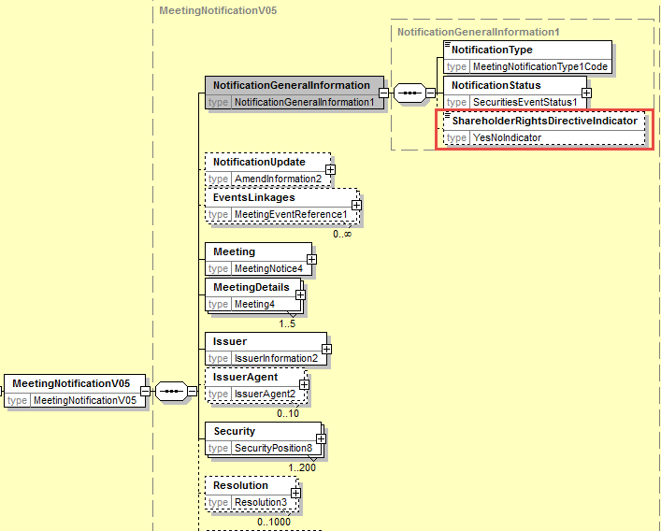

In the seev.045 ( SIDR – ShareholderIdentificationDisclosureRequest) message, add a new optional and non-repeatable indicator element ShareholderRightsDirectiveIndicator typed by YesNoIndicator at the root of the message and defined as:
“Indicates whether the request was initiated by the first intermediary in the custody chain in accordance with SRD II.”
and illustrated below as follows:
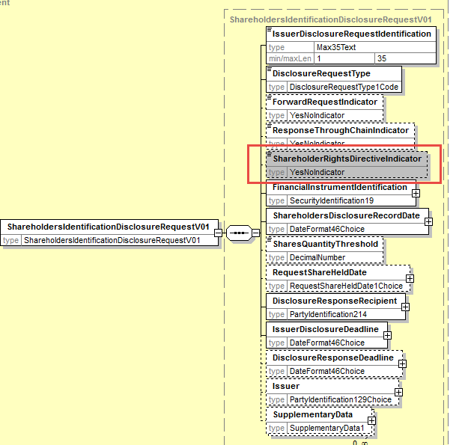

- Proposed timing:
The submitting organization confirms that it can implement the requested changes in the requested timing

Timing | - As requested

- Final decision of the SEG(s):

Approve
Comments:

Reject
Reason for rejection:

