Change Request
for the update of ISO 20022 financial repository items
- Origin of the request:
A.1 Submitter: SWIFT Standards, on behalf of the SMPG IF WG.
A.2 Contact person: Janice Chapman, SWIFT
Janice.Chapman@swift.com
+ 32 2 655 3390
A.3 Sponsors: None
- Related messages:
 | Account Opening Instruction V05 | acmt.001.001.05
 | Account Details Confirmation V05 | acmt.002.001.05
 | Account Modification Instruction V05 | acmt.003.001.05
 | Transfer Out Instruction V06 | sese.001.001.06
 | Transfer Out Instruction Cancellation Request V06 | sese.002.001.06
 | Transfer Out Confirmation V06 | sese.003.001.06
 | Reversal of Transfer Out Confirmation V06 | sese.004.001.06
 | Transfer In Instruction V06 | sese.005.001.06
 | Transfer In Instruction Cancellation Request V06 | sese.006.001.06
 | Transfer In Confirmation V06 | sese.007.001.06
 | Reversal In Transfer Out Confirmation V06 | sese.008.001.06
 | Request for Transfer Status Report | sese.009.001.04
There is also an impact on the order and confirmation messages, which is submitted as a separate change request because of the order maintenance freeze, with the hope that the change to the acmt and sese messages can be made before there are more users and thus reduce the impact overall. Note that the change is on an optional element so there is only an impact of those using the optional element.

- Description of the change request:
Account management Messages
In the Investment Account sequence, element Income Preference, change the code word list so that DRIP is replaced by SECU
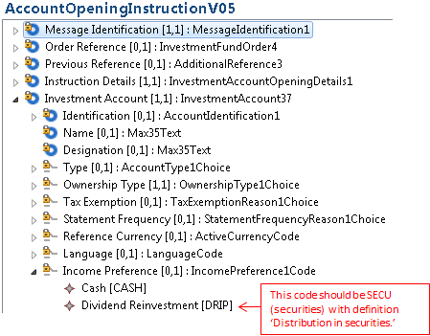

Transfer Messages
In the Account Details sequence, element Income Preference, change the code word list so that DRIP is replaced by SECU
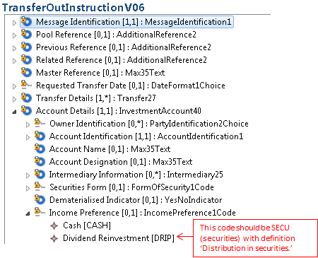
- Purpose of the change:
To have better clarity on the income preference. Income is either ‘cash’ or ‘securities’.

- Urgency of the request:
Next yearly maintenance cycle (2015/2016).

- Business examples:

- SEG recommendation:
This section is not to be taken care of by the submitter of the change request. It will be completed in due time by the SEG(s) in charge of the related ISO 20022 messages.

Consider |  |  | Timing
- Next yearly cycle: 2015/2016
(the change will be considered for implementation in the yearly maintenance cycle which starts in 2015 and completes with the publication of new message versions in the spring of 2016)
- At the occasion of the next maintenance of the messages
(the change will be considered for implementation, but does not justify maintenance of the messages in its own right – will be pending until more critical change requests are received for the messages)
- Urgent unscheduled
(the change justifies an urgent implementation outside of the normal yearly cycle)
 |  |  | - Other timing:
Comments:

Reject
Reason for rejection:

