Change Request
for the update of ISO 20022 financial repository items
Note: the purpose of this document is to give guidelines to parties who want to introduce a request to change an existing ISO 20022 message(s), or update other items of the ISO 20022 financial repository. Such change requests are subject to the approval of the ISO 20022 Standards Evaluation Group(s) in charge of the related message/item or to the approval of the Technical Support Group (TSG), if the requested change relates to the Business Application Header (BAH). Please consult the iso20022.org website for additional details on the maintenance process. Change requests are to be sent to iso20022ra@iso20022.org. All change requests conforming to this template received by June 1st will be considered for development in the following yearly ISO 20022 maintenance cycle which completes with publication of new message versions in April/May of the following year.
- Origin of the request:
A.1 Submitter:
SIX Interbank Clearing Ltd.
A.2 Contact person:
Martin Walder
martin.walder@six-group.com
T +41 58 399 53 79
A.3 Sponsors: SIX Interbank Clearing is involved in several committees focused on questions of standardization concerning the national and international payment traffic. In this role SIX Interbank Clearing acts as a representative of the Swiss financial industry.
This change was discussed with the WG responsible for the bank-to-client interfaces.
- Related messages:
camt.053
camt.052
camt.054
There might be other message, for which the change is useful as well.

- Description of the change request:
Add an optional element “Running Total” for an entry, which indicates the running total resulted by this specific entry.
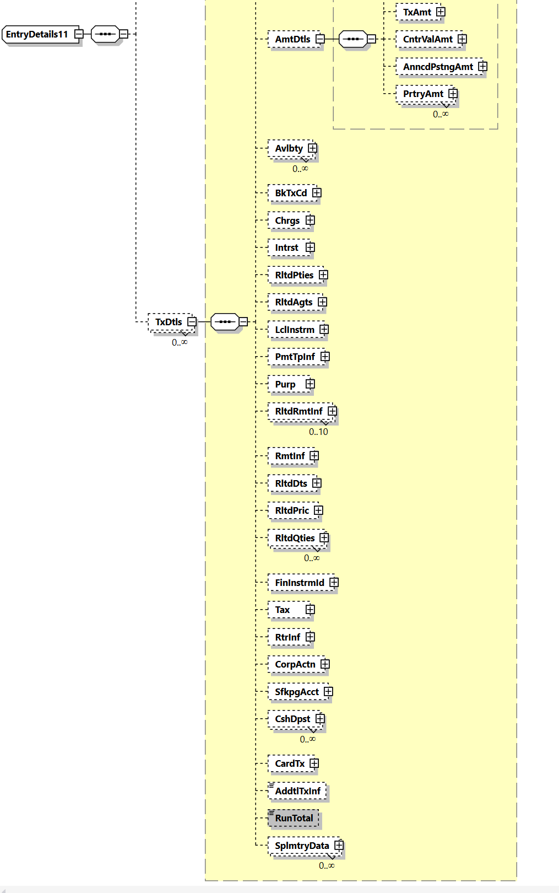
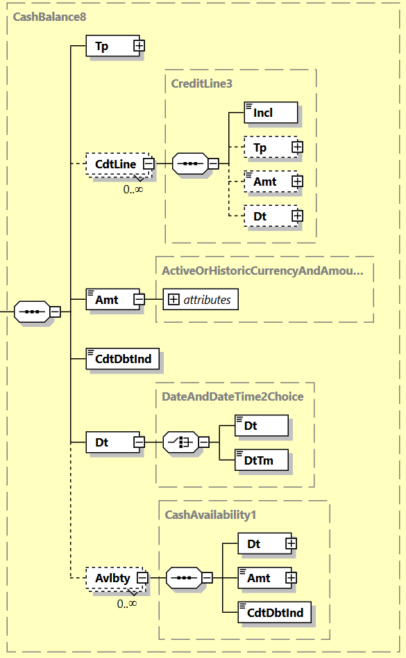
The component could be consist of the same elements as CashBalance8, but might be limited to less elementsas well.
Purpose of the change:
With the increasing implementation of instant payment schemes and systems, the need for comprehensive information is growing. One example is the reporting of respective transactions which can be used as a base for various services by clients, e.g e-commerce provider.
One new feature is the RunningTotal indicating the immediate result of transaction on the bank account of the client.
This allow banks and provider to offer similar services with instant payments, as already know by card transaction (e.g. 100 USD debited, you available amount its USD 4383).
In addition, this information can be used to oversee the liquidity and for statistical purposes.
- Urgency of the request:
There is no specific timeline for this change request. I can be assumed, that before 2025 our market is not changing the message version. Nevertheless, it may be helpful for other markets, if this option is available within the next cycle.

Business examples:
camt.054 offered as single debit or credit notification. In this case informing the client of a credit of an incoming payment of SEK 105’678.50 resulting in a running total of SEK 507’328.25
Element | <XMLTag> | Content
Group Header | <GrpHdr>
MessageIdentification | <MsgId> | AAAASESS-FP-00001
CreationDateTime | <CreDtTm> | 2015-10-18T13:20:00+01:00
Notification | <Ntfctn>
Identification | <Id> | AAAASESS-FP-CN-98765
CreationDateTime | <CreDtTm> | 2015-10-18T13:20:00+01:00
Account | <Acct>
Identification | <Id>
Other | <Othr>
Identification | <Id> | 50000000054910000003
Owner | <Ownr>
Name | <Nm> | FINPETROL
Servicer | <Svcr>
FinancialInstitutionIdentification | <FinInstnId>
Name | <Nm> | AAAA BANKEN
PostalAddress | <PstlAdr>
Country | <Ctry> | SE
Entry | <Ntry>
Amount | <Amt> | SEK 105678.50
CreditDebitIndicator | <CdtDbtInd> | CRDT
Status | <Sts> | BOOK
BookingDate | <BookgDt>
DateTime | <DtTm> | 2015-10-18T13:15:00+01:00
ValueDate | <ValDt>
Date | <Dt> | 2015-10-18
AccountServicerReference | <AcctSvcrRef> | AAAASESS-FP-CN-98765/01
BankTransactionCode | <BkTxCd>
Domain | <Domn>
Code | <Cd> | PAYM
Family | <Fmly>
Code | <Cd> | 0001
SubFamilyCode | <SbFmlyCd> | 0005
EntryDetails | <NtryDtls>
TransactionDetails | <TxDtls>
References | <Refs>
EndToEndIdentification | <EndToEndId> | MUELL/FINP/RA12345
……
RunningTotal | <RunTotal>
Type | <Tp>
Code | <Cd> | ITBD
Amount | <Amt> | SEK 507328.25
CreditDebitIndicator | <CdtDbtInd> | CRDT
Date | <Dt> | 2015-10-18T13:15:00+01:00

- SEG/TSG recommendation:
This section is not to be taken care of by the submitter of the change request. It will be completed in due time by the SEG(s) in charge of the related ISO 20022 messages or the TSG for changes related to the BAH.

Consider |  | X | Timing
- Next yearly cycle: 2022/2023
(the change will be considered for implementation in the yearly maintenance cycle which starts in 2022 and completes with the publication of new message versions in the spring of 2023)
- At the occasion of the next maintenance of the messages
(the change will be considered for implementation, but does not justify maintenance of the messages in its own right – will be pending until more critical change requests are received for the messages)
- Urgent unscheduled
(the change justifies an urgent implementation outside of the normal yearly cycle)
 |  |  | - Other timing: TBD in MCR review
Comments:

Reject
Reason for rejection:

