Change Request
for the update of ISO 20022 financial repository items
- Origin of the request:
A.1 Submitter: Swiss Commission for Financial Standardisation (SCFS)
A.2 Contact person: Rainer Vogelgesang, rainer.vogelgesang@six-group.com, +41 58 399 3808
A.3 Sponsors:
The ISO 20022 Technical Support Group (TSG) supports the approach to request amendments of the BAH through the CR mechanism. Furthermore, the TSG documented its opinion that the BAH is the most convenient mechanism to implement/fulfil the requirements specified in this document.
As per the meeting minutes of 04 March 2015, it was recorded that the TSG concluded that the BAH would be the most convenient solution to implement the requirements of this CR. The TSG encouraged Rainer Vogelgesang to send a CR related to the BAH to the ISO 20022 Registration Authority.
- Related messages:
- BusinessApplicationHeaderV01 (head.001.001.01)
- Description of the change request:
This CR proposes to add a content indicator (block) to the BAH. The content indicator is to provide information about the content of the document part of the message to which the BAH is linked. This information could be used for various purposes.
This content indicator is to provide the following functions:
- Specification of a global market practice (0 .. n)
For this purpose, a global market practice is intended to be a recommendation (by a global market practice group) how messages are recommended to be implemented. The global MP can be used by local market practice organisations to develop their local market practices based on or derived from the global market practices.
This specification (of a global MP) within the BAH identifies that a message instance has been created to be compliant to the identified global market practice.
Examples:
- SMPG IF (Securities Market Practice Group - Investment Funds)
- EPC SEPA (European Payments Council – SEPA)

- Specification of the global market practice version (0 .. n)
The specification identifies the applicable version of the global market practice.
Example:
- ‘2.1’
- ‘A.c’

- Specification of a local market practice (0 .. n)
A local market practice is intended to be a recommendation (of a local market practice group) how messages are recommended to be implemented. The local MPs can be developed independently of any other MP efforts or, alternatively, can be developed based on or derived from a global market practice.
This specification within the BAH identifies that a message instance has been created to be compliant to the identified local market practice.
Examples:
- ALMUS IF (Luxembourg local Market Practice Group - Investment Funds)
- SCFS IF (Swiss Commission for Financial Standards – Investment Funds)
- Findel SLT (Luxembourg Transfer Agent Group (‘Findel’), Single Leg Transfer market practice)
- Specification of the local market practice version (0 .. n)
The specification identifies the applicable version of the local market practice.
Example:
- ‘2.1’
- ‘A.c’
- Specification of a Service Specification (0 .. n)
This specification identifies that a message instance has been created to be compliant to the service specification of a service provider.
Examples:
- SWIFTNet Funds (SWIFTNet Funds Solution)
- T2S (Target2-Securities settlement messages)
- Specification of the Service Specification version (0 .. n)
The specification identifies the applicable version of the service.

Example:
- ‘2.1’
- ‘A.c’

Note: As a reference point regarding global and local market practices and ISO 20022-based solution specifications, the reader of this CR be referred to the work of the adhoc RMG documentation clarity sub-group. At the time of writing, this work is still a work-in-progress.
It is understood that a global market practice specification may be a sub-set of a global message and optionally contain additional elements not present in the pertinent global message. Similar considerations apply to local or regional market practice specifications.
Furthermore, it is understood that a local (or regional) market practice specification may be a sub-set of a global market practice specification and optionally contain additional elements not present in the global market practice specification.
Moreover, it is understood that an ISO 20022-based solution specification can be a sub-set of a global message, a global market practice specification and/or a local market practice specification and optionally contain additional element not present in any or all of the aforementioned specifications.
- Purpose of the change:
What follows are some use cases for which the content indicator information could be exploited:
- Routing of incoming messages based on their content indicator(s), i.e. which destination
- Validation of incoming messages based on their content indicator(s), e.g. schema compliance, business rules compliance, etc.
- Validation of outgoing messages based on their content indicator(s), e.g. schema compliance, business rules compliance, etc.
- Determining quality of service for message delivery depending on content indicators (e.g. priority, first class delivery, etc)
- Determining transport service depending on content indicator (cf. airmail, surface mail, by sea, etc) (e.g. SWIFTNet InterAct, SWIFTNet FileAct, etc.)
- Using the content indicator for statistical analyses in order to determine removal of legacy information from messages (through maintenance process)
In absence of such information on the content of the document part of a message, it is only possible to make inferences about the content of the document part of a message by analysing the message content. This approach may lead to ambiguous conclusions.
The availability of such information in the BAH about the document part of a message would provide the pre-requisite information to fulfil the requirements stated above.
The availability of such information in the BAH will be very useful for larger organisations that are confronted with a multitude of global or local market practices as well as solution providers.
- Urgency of the request:
It is proposed to include this CR in the next regular maintenance cycle.
- Business examples:
Examples illustrating the change request.
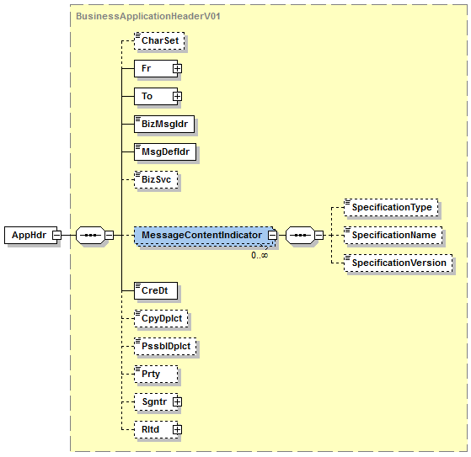
The element SpecificationType is to indicate whether the instance of the message content indicator block refers to a global market practice, regional market practice, local market practice, solution specification and so on. It is suggested to envision that an enumeration list of possible values is provided.
The element SpecificationName is to specify the name of the specification referred to by this instance of the message content indicator block, e.g. SMPG_IF_ordersMP. It is suggested to envision this element to be of type ‘text’ of sufficient length.
The element SpecificationVersion is to specify the version of the specification referred to by the instance of the message content indicator block, e.g. ‘2.1’. It is suggested to envision this element to be of type ‘text’ of sufficient length.
There may be additional optional elements that specify owner of the specification, URL and so on. This should be reviewed and decided accordingly by the TSG.
MessageContentIndicator is an optional and repeatable element. Thus, it is possible to refer to multiple specifications to which a particular message instance is compliant.

As a separate concern, it could be considered by the TSG to model the element SpecificationName for use with external code lists.
The external code lists could be employed to arrive at a standardised set of abbreviations for the various market practice groups and pertinent specifications.
It is expected that such standardisation could not be achieved over the short term. Therefore, it might be conducive to model such external code lists on an optional basis.
- TSG recommendation:
This section is not to be taken care of by the submitter of the change request. It will be completed in due time by the TSG in consultation with the CSH.

Consider |  |  | Timing
- Next yearly cycle: 2016/2017
(the change will be considered for implementation in the yearly maintenance cycle which starts in 2016 and completes with the publication of new message versions in the spring of 2017)
- At the occasion of the next maintenance of the messages
(the change will be considered for implementation, but does not justify maintenance of the messages in its own right – will be pending until more critical change requests are received for the messages)
- Urgent unscheduled
(the change justifies an urgent implementation outside of the normal yearly cycle)
 |  |  | - Other timing:
Comments:

Reject
Reason for rejection:

