Change Request
for the update of ISO 20022 financial repository items
- Origin of the request:
A.1 Submitter: Janice Chapman, on behalf of Funds UK NMPG - UK Electronic Transfer and Re-Registrations Group (UKETRG)
A.2 Contact person: Janice.chapman@swift.com, Gregory.Mestdag@swift.com, matt.smith@altus.co.uk
A.3 Sponsors:
- Related messages
# | Name | Message Identifier
1 | Account Holding Information | Sese.018.001.08
2 | Portfolio Transfer Confirmation | sese.013.001.10
- Description of the change request
In ProductTransfer/Portfolio/Pension, add optional element to state the number of drawdown tranches that has taken place.
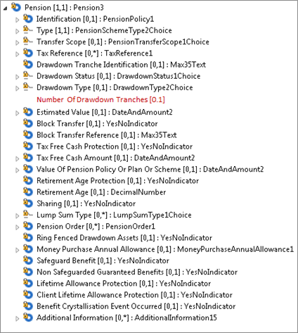

Element | M/O | Definition | Datatype
NumberOfDrawdownTranches | 0.1 | Number of drawdown tranches. | Number
- Purpose of the request
The additional element is needed to support the UK transfers market.
The number of drawdown tranches in the account being transferred in the information response and subsequent messages will provide the Acquiring Party with early sight of the shape of the portfolio.
- Urgency of the request
The UKETRG will add this to their market practice in May 2022 and so needs to be added to the ISO 20022 standard in the next maintenance cycle, 2021-2022.
- Business examples

- SEG/TSG Recommendations

This section is not to be taken care of by the submitter of the change request. It will be completed in due time by the SEG(s) in charge of the related ISO 20022 messages or the TSG for changes related to the BAH.

Consider |  |  | Timing
 |  |  | - Next yearly cycle: 2021/2022  (the change will be considered for implementation in the yearly maintenance cycle which starts in 2021 and completes with the publication of new message versions in the spring of 2022) |  | X
- At the occasion of the next maintenance of the messages
(the change will be considered for implementation, but does not justify maintenance of the messages in its own right – will be pending until more critical change requests are received for the messages)
- Urgent unscheduled
(the change justifies an urgent implementation outside of the normal yearly cycle)
 |  |  | - Other timing:
Comments:

Reject
Reason for rejection:

