Change Request
for the update of ISO 20022 financial repository items
- Origin of the request:
A.1 Submitter: Janice Chapman, SWIFT Standards on behalf of UK fund transfers group UKETRG
A.2 Contact person: Janice.chapman@swift.com, Gregory.Mestdag@swift.com; matt.smith@altus.co.uk
- Related messages
# | Name | Message Identifier
1 | Request For Transfer Status Report | Sese.009.001.07
2 | Transfer Instruction Status Report | Sese.011.001.09
- Description of the change request
In previous maintenance cycles, the Transfer Instruction Status Report sese.011 message was enhanced so that information that is not known at the time of the sending the PortfolioTransferConfirmation sese.013 message, the confirmation of intent, could be provided to the acquiring party (transferee). This change request is, in part, a continuation of this enhancement.
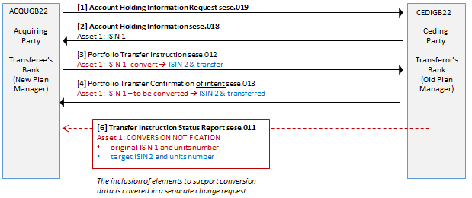
The Transfer Instruction Status Report sese.011 already has the functionality to provide tax information on the units transferred, such as that required in the Swedish market.
In addition, there are some situations in which the ceding party may need to request correct information because of some failure in the process down-stream at the asset level. Or the acquiring manager may need to request some follow-up on the status.
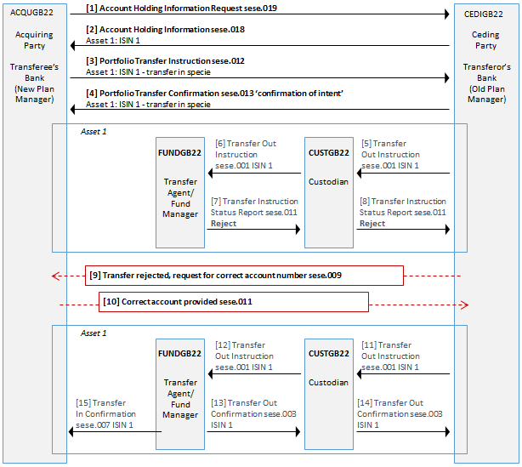
The Request For Transfer Status Report sese.009 message was designed to be used in this request scenario and the UK transfers market will probably be the first market to incorporate it into its processes. This message has, up until now, rarely been used and some functional enhancements are required. It has been noticed that there are some ‘mismatches’ between the Request For Transfer Status Report sese.009 and the Transfer Instruction Status Report sese.011 that also need to be fixed.
SWIFT Standards has worked closely with the UKETRG to make the Request For Transfer Status Report sese.009 and the Transfer Instruction Status Report sese.011 fit for purpose. However, the updates to this message will try to take the long view, not just something that will work for the UK.
Request For Transfer Status Report sese.009
In the Request Details sequence:
[1] Add optional element ‘Type Of Request’ (as the first element in Request Details). This will be a choice of a Code and Proprietary. Codes:
Element/sub-element |  | M/O | Definition | Data type
Type Of Request |  | [0.1] | Type of request required. | Choice
 | Code |  | Type of request expressed as a code. | Code list – see below
 | Proprietary |  | Type of request expressed as a proprietary code | Generic Identification36
Code list
Code | Code Name | Definition
STAT | Status | Request for a status
INFO | Information | Request for information.
[2] Add optional sequence ‘Instrument’ (this is the same sequence in the Portfolio Transfer Instruction sese.012 and Portfolio Transfer Confirmation sese.013 messages). To be positioned just after the Cancellation Reference element.
Element/sub-element | M/O | Definition | Data type
Instrument | [0.1] | Identification of the asset. | FinancialInstrument63Choice
[3] Align the party elements of existing Investment Account Details sequence with the party elements of the other funds transfer messages (this will also be added to the Transfer Instruction Status Report, sese.011 message, to correct an inconsistency in the messages). This will involve the addition of some elements and the removal of unnecessary elements:
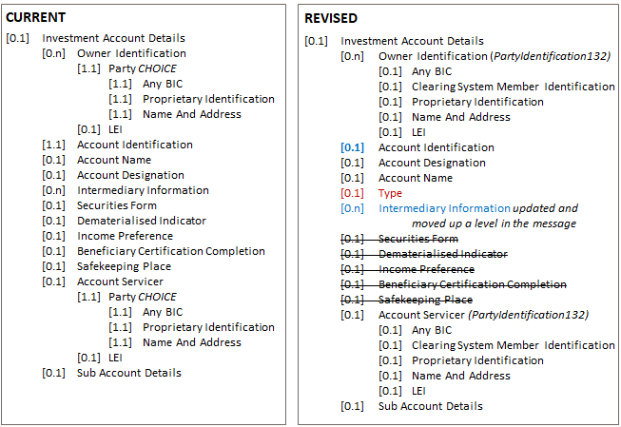
Element/sub-element | M/O | Definition | Data type
Investment Account Details | [0.1] | Investment account information of the transfer for which the status or information is requested. | Updated MC
[4] The IntermediaryInformation sequence is moved out of the Investment Account Details sequence, up a level into RequestDetails. To be positioned just after the InvestmentAccountDetails sequence and updated:
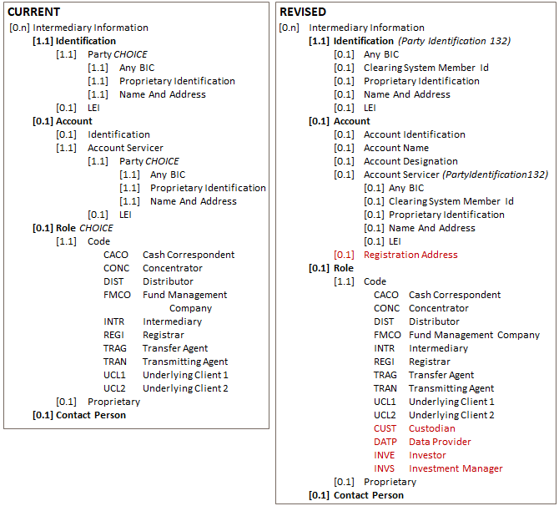
Element/sub-element | M/O | Definition | Data type
Intermediary Information | [0.n] | Identification of a related party or intermediary. | Updated MC
[5] Add an optional sequence ‘Query Information’ To be positioned just after the IntermediaryInformation sequence):
Element/sub-element |  | M/O | Definition | Data type
Query Information |  | [0.1] | Information about the query. | New MC
 | Query Type | [0.1] | Type of query | GenericIdentification36
 | Query | [1.1] | Description of the query. | Max350Text
 | Query Reason | [0.1] | Reason for the query. | Max350Text
 | Rejection Reason | [0.1] | Reason the instruction was rejected. | RejectedReason33Choice
[6] Add optional elements. To be positioned just after the new Query Information sequence. (Alignment with current Transfer Instruction Status Report sese.011 message.)
Element/sub-element | M/O | Definition | Data type
RequestIssuer |  | Party that issues the request message. | PartyIdentification139
RequestRecipient |  | Party that receives the request message. | PartyIdentification139
[7] Update the scope:
Current | Proposed
Scope  The Request For Transfer Status Report is sent by an instructing party, for example, an investment manager or its authorised representative, to the executing party, for example, a transfer agent to request the status of a previously instructed transfer.  Usage  The Request For Transfer Status Report is used to request either:  - the status of one or several transfer instructions or,  - the status of one or several transfer cancellation instructions. | Scope  The Request For Transfer Status Report is sent by an instructing party, for example, an investment manager or its authorised representative, to the executing party, for example, a transfer agent to request the status of a previously instructed transfer.  The Request For Transfer Status Report may also be sent by any party in the transfer transaction to another party in the transfer transaction chain to request information relevant for the settlement of a transfer transaction  Usage  The Request For Transfer Status Report is used to request either:  - the status of one or several information requests or transfer instructions or,  - the status of one or several transfer cancellation instructions, or  - information relevant to one or more transfer instructions.
Transfer Instruction Status Report sese.011
In the StatusReport sequence:
[1] Add new codes to TransferEventType:
 | Code | Code Name | Definition
 | S019 | AccountHoldingInformationRequest | Status report is sent in response to an account holding information request.
 | BCEV | BenefitCrystallisationEvent | Status report advises one or more Benefit Crystallisation Events (BCE) have occurred.
 | SETT | CSDorICSDSettlementInformation | Status report is sent to provide information required for a CSD or ICSD settlement leg.
 | DRAW | Drawdown | Status report advises one or more drawdowns.
 | PAYA | PaymentAdvice | Status report advises cash is or has been instructed.
 | S012 | PortfolioTransferInstruction | Status report is sent in response to a portfolio transfer instruction.
NEW | INFO | Information | Status report is sent to provide information pertinent to the transfer. May be sent in response to a request for transfer status.
NEW | STAT | Status | Status report is sent to provide the status of a transfer. May be sent in response to a request for transfer status.
 | S005 | TransferInInstruction | Status report is sent in response to a transfer-in instruction.
 | S001 | TransferOutInstruction | Status report is sent in response to a transfer-out instruction.
NEW | CONV | ConversionStatus | Status report is sent to provide the number of units following a conversion.
[2] Change the multiplicity of Transfer Status to optional. Add rules:
Rule Name | Formal description | Informal description
TransferStatusEventType1Rule | On Condition  /TransferEventType[*] is absent  Following Must be True  /TransferStatus Must be present | Either TransferStatus or TransferEventType must be present. Both may be present.
TransferStatusEventType2Rule | On Condition  /TransferStatus is absent  Following Must be True  /TransferEventType[*] Must be present | Either TransferStatus or TransferEventType must be present. Both may be present.
TransferStatusEventType3Rule | On Condition  /TransferEventType[*]/Code is equal to value 'ResponseStatus'  Following Must be True  /TransferStatus Must be present | If TransferEventType is ResponseStatus (STAT) then TransferStatus must be present.
ConversionRule | On Condition  /TransferEventType[*]/Code is equal to value 'ConversionStatus'  Following Must be True  /Conversion Must be present | If TransferEventType is ConversionStatus (CONV) then Conversion must be present.
[3] Add optional sequence ‘Instrument’ (same as above in sese.009). To be positioned just after the Transfer Status sequence.
Element/sub-element | M/O | Definition | Data type
Instrument | [0.1] | Identification of the asset. | FinancialInstrument63Choice
[4] Add optional sequence ‘InvestmentAccountDetails’ (same as above in sese.011). To be positioned just after the ‘Instrument’ sequence.
Element/sub-element | M/O | Definition | Data type
InvestmentAccountDetails | [0.1] | Investment account information of the transfer for which the status or information is provided. | Updated MC
[5] Add optional and repetitive sequence ‘IntermediaryInformation’ (same as above in sese.009). To be positioned just after the InvestmentAccountDetails sequence.
Element/sub-element | M/O | Definition | Data type
IntermediaryInformation | [0.n] | Identification of a related party or intermediary. | Updated MC
[6] Add optional element ‘CashSettlementDate’. To be positioned just after the SendOutDate element.
Element/sub-element | M/O | Definition | Data type
CashSettlementDate | [0.1] | Date on which cash is available. | ISODate
[7] Add optional sequence ‘Conversion’. To be positioned just after the UnitsDetails sequence.
Element/sub-element | M/O | Definition | Data type
Conversion | [0.1] | Information about the source security following a conversion. | New MC
This item is the subject of a separate change request.
[8] Add optional sequence ‘OtherDrawdownInformation’. To be positioned just after the Drawdown Tranche sequence.
Element/sub-element | M/O | Definition | Data type
OtherDrawdownInformation | [0.1] | Information about the source security following a conversion. | New MC
This item is the subject of a separate change request.
[9] Add optional element ‘QueryResponse’. To be positioned just after the new OtherDrawdownInformation sequence.
Element/sub-element | M/O | Definition | Data type
OtherDrawdownInformation | [0.1] | Response information. | Max350Text
[10] Add optional element ‘Additional Information’. To be positioned just after the new Status Recipient element.
Element/sub-element | M/O | Definition | Data type
OtherDrawdownInformation | [0.1] | Response information. | Max350Text
[7] Update the scope:
Current | Proposed
Scope  The TransferInstructionStatusReport message is sent by an executing party, for example, a transfer agent, to the instructing party, for example, an investment manager or one of its authorised representatives to provide the status of a previously received request for holdings information, portfolio transfer or transfer instruction.  It may also be used to report the status of an event related to the asset being transferred or provide additional information.  Usage  The TransferInstructionStatusReport message is sent by an executing party, for example, a transfer agent, to the instructing party, for example, an investment manager or one of its authorised representatives to provide the status of a previously received request for holdings information, portfolio transfer or transfer instruction. It may also be used to report the status of an event related to the asset being transferred or provide additional information.  The message identification of the transfer instruction message in which the transfer instruction was conveyed may also be quoted in RelatedReference.  One of the following statuses can be reported:  - an accepted status, or,  - an already executed status, or,  - a sent to next party status, or,  - a matched status, or,  - a settled status, or,  - a delayed status, or,  - a pending settlement status and the reason for the status, or,  - an unmatched status and the reason for the status, or,  - an in-repair status and the reason for the status, or,  - a rejected status and the reason for the status, or,  - a failed settlement status and the reason for the status, or,  - a cancelled status and the reason for the status, or,  - a cancelled status and the reason for the status, or,  - a cancellation pending status and the reason for the statu | Scope  The TransferInstructionStatusReport message is sent by an executing party, for example, a transfer agent, to the instructing party, for example, an investment manager or one of its authorised representatives to provide the status of a previously received request for holdings information, portfolio transfer or transfer instruction.  It may also be used to report the status of an event related to the asset being transferred or provide additional information.  The TransferInstructionStatusReport message may also be sent by any party in the transfer transaction to another party in the transfer transaction chain to provide information relevant for the settlement of a transfer transaction.  Usage  The TransferInstructionStatusReport message is used to provide the status of a previously received request for holdings information, portfolio transfer or transfer instruction, or in response to a RequestForTransferStatus message. It may also be used to report the status of an event related to the asset being transferred or provide additional information.
Summary Overview of Updates to Request For Transfer Status Report sese.009
 | Message Identification |  |  | [0.1]
 | Request Details |  |  | [1.n]
New |  | Type Of Request |  | [0.1]
 |  | Reference |  | [0.1]
 |  | Master Reference |  | [0.1]
 |  | Transfer Reference |  | [1.1]
 |  | Client Reference |  | [0.1]
 |  | Cancellation Reference |  | [0.1]
New |  | Instrument |  | [0.1]
Updated |  | Investment Account Details |  | [0.1]
Moved |  | Intermediary Information |  | [0.n] | Also updated
New |  | Query Information |  | [0.n]
New |  |  | Query Type | [0.1]
 |  |  | Query | [1.1]
 |  |  | Query Reason | [0.1]
 |  |  | Rejection Reason | [0.1]
New |  | Status Request Issuer |  | [0.1]
New |  | Status Request Recipient |  | [0.1]
 | MarketPracticeVersion |  |  | [0.1]
 | Extension |  |  | [0.n]
Summary Overview of Updates to Transfer Instruction Status Report sese.011
 | Message Identification |  |  |  | [1.1]
 | Counterparty Reference |  |  |  | [0.1]
 | Reference |  |  |  | [0.1]
 | Status Report |  |  |  | [1.1]
 |  | Master Reference |  |  | [0.1]
 |  | Transfer Reference |  |  | [1.1]
 |  | Client Reference |  |  | [0.1]
 |  | Cancellation Reference |  |  | [0.1]
Modified |  | Transfer Event Type |  |  | [0.n]
Modified |  | Transfer Status |  |  | [0.1]
New |  | Instrument |  |  | [0.1]
Alignment |  | Investment Account Details |  |  | [0.1]
Alignment |  | Intermediary Information |  |  | [0.n]
 |  | Trade Date |  |  | [0.1]
 |  | Settlement Date |  |  | [0.1]
 |  | Send Out Date |  |  | [0.1]
New |  | Cash Settlement Date |  |  | [0.1]
 |  | Total Units Number |  |  | [0.1]
 |  | Average Price |  |  | [0.1]
 |  | Units Details |  |  | [0.n]
New |  | Conversion |  |  | [0.1] | See separate CR
 |  |  | Source Security |  | [1.1]
 |  |  | Total Units Number |  | [0.1]
 |  |  | Units Details |  | [0.n]
 |  |  |  | Units Number | [1.1]
 |  |  |  | Order Date | [0.1]
 |  |  |  | Acquisition Date | [0.1]
 |  |  |  | CertificateNumber | [0.1]
 |  |  |  | Group 1 Or 2 Units | [0.1]
 |  |  |  | Reference | [0.1]
 |  | Total Transfer Value |  |  | [0.1]
 |  | Payment Details |  |  | [0.1]
 |  | Benefit Crystallisation Event |  |  | [0.1]
 |  | Drawdown Tranche |  |  | [0.n]
New |  | Other Drawdown Information |  |  | [0.1] | See separate CR
 |  |  | EmploymentDetails |  | [0.1]
 |  |  | Additional Information |  | [0.n]
 |  | Query Response |  |  | [0.n]
 |  | Status Initiator |  |  | [0.1]
 |  | Status Issuer |  |  | [0.1] | (Fine-tune definition)
 |  | Status Recipient |  |  | [0.1] | (Fine-tune definition)
New |  | Additional Information |  |  | [0.n]
 | Market Practice Version |  |  |  | [0.1]
 | Extension |  |  |  | [0.n]
- Purpose of the request
The UK transfers market need to be able to request information about the portfolio/individual asset transfer in process in a more specific way, such as identifying the asset for which they are requesting the status or other information. The UK transfers market intend to incorporate the request and response messages into their automation offering and start reducing the need for telephone calls and e-mails during the transfer process, as well as complete the enhancement for the provision of transfer data both inside and outside of the ‘main transfer flow’.
- Urgency of the request
The next ISO 20022 maintenance cycle, 2021-2022.
- Business examples

- SEG/TSG Recommendations

This section is not to be taken care of by the submitter of the change request. It will be completed in due time by the SEG(s) in charge of the related ISO 20022 messages or the TSG for changes related to the BAH.

Consider |  |  | Timing
 |  |  | - Next yearly cycle: 2021/2022  (the change will be considered for implementation in the yearly maintenance cycle which starts in 2021 and completes with the publication of new message versions in the spring of 2022) |  | X
- At the occasion of the next maintenance of the messages
(the change will be considered for implementation, but does not justify maintenance of the messages in its own right – will be pending until more critical change requests are received for the messages)
- Urgent unscheduled
(the change justifies an urgent implementation outside of the normal yearly cycle)
 |  |  | - Other timing:
Comments:

Reject
Reason for rejection:

