Change Request
for the update of ISO 20022 financial repository items

- Origin of the request:
A.1 Submitter: nexo A.I.S.B.L.
A.2 Contact person: Philippe CECE (Philippe.cece@ingenico.com) / Laure BELTRI (laure.beltri@frenchsys.com) / Evelyne de JONGHE (evelyne.de-jonghe@frenchsys.com) / Philippe MERMOUD (philippe.mermoud@bpce.fr) / Robert FARGIER (robert.fargier@istium.pro)
A.3 Sponsors: nexo A.I.S.B.L.

- Related messages:

- AcceptorAuthorisationRequest V11 caaa.001.001.11,
- AcceptorAuthorisationResponse V11 caaa.002.001.11,
- AcceptorCompletionAdvice V11 caaa.003.001.11,
- AcceptorCancellationResponse V10 caaa.006.001.10,
- AcceptorBatchTransfer V11 caaa.011.001.11,
- AcceptorCurrencyConversionRequest V09 caaa.016.001.09,
- AcceptorCurrencyConversionResponse V09 caaa.017.001.09,
- AcceptorCurrencyConversionAdvice V06 caaa.018.001.06,
- TransactionAdvice V03 caaa.020.001.03,
- AcceptorNonFinancialRequest V02 caaa.022.001.02,
- AcceptorNonFinancialResponse V02 caaa.023.001.02,
- AcceptorTransactionLogReportResponse V02 caaa.025.001.02,

- SaleToPOIServiceRequest V04 casp.001.001.04,
- SaleToPOIserviceResponse V04 casp.002.001.04,
- SaleToPOISessionManagementRequest V04 casp.005.001.04,
- SaleToPOISessionManagementResponse V04 casp.006.001.04,
- SaleToPOIReportResponse V04 casp.010.001.04,
- SaleToPOIAbort V04 casp.011.001.04,
- SaleToPOIEventNotification V04 casp.012.001.04,
- SaleToPOIMessageStatusResponse V04 casp.015.001.04,
- SaleToPOIDeviceRequest V04 casp.016.001.04,

- ManagementPlanReplacement V10 catm.002.001.10,
- MaintenanceDelegationRequest V08 catm.005.001.08

- Description of the change request:

We would like to correct an error in the barcode management. The current OutputBarcode1 message component mandates the message element QRCodeEncoding, which is only relevant for barcode of type COQR.

- Purpose of the change:

The aim of the modification is to set QRCodeEncoding as an optional message element.
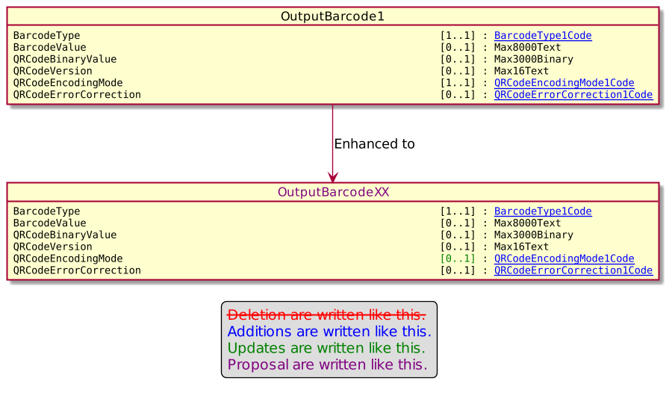

- Urgency of the request:

Urgent.

- Business examples:
Examples illustrating the change request.

- SEG/TSG recommendation:
This section is not to be taken care of by the submitter of the change request. It will be completed in due time by the SEG(s) in charge of the related ISO 20022 messages or the TSG for changes related to the BAH.

Consider |  |  | Timing
 |  |  | - Next yearly cycle: 2022/2023  (the change will be considered for implementation in the yearly maintenance cycle which starts in 2022 and completes with the publication of new message versions in the spring of 2023) |  | X
- At the occasion of the next maintenance of the messages
(the change will be considered for implementation, but does not justify maintenance of the messages in its own right – will be pending until more critical change requests are received for the messages)
- Urgent unscheduled
(the change justifies an urgent implementation outside of the normal yearly cycle)
 |  |  | - Other timing:
Comments:

Reject
Reason for rejection:

