Change Request
for the update of ISO 20022 financial repository items

- Origin of the request:
A.1 Submitter: nexo A.I.S.B.L
A.2 Contact person: Philippe CECE (Philippe.cece@ingenico.com) / Evelyne de JONGHE (evelyne.de-jonghe@frenchsys.com)

A.3 Sponsors: nexo A.I.S.B.L.

- Related messages:

- AcceptorAuthorisationRequest V11 caaa.001.001.11,
- AcceptorAuthorisationResponse V11 caaa.002.001.11,
- AcceptorCompletionAdvice V11 caaa.003.001.11,
- AcceptorCompletionAdviceResponse V10 caaa.004.001.10,
- AcceptorCancellationRequest V11 caaa.005.001.11,
- AcceptorCancellationResponse V10 caaa.006.001.10,
- AcceptorCancellationAdvice V11 caaa.007.001.11,
- AcceptorCancellationAdviceResponse V10 caaa.008.001.10,
- AcceptorReconciliationRequest V10 caaa.009.001.10,
- AcceptorReconciliationResponse V09 caaa.010.001.09,
- AcceptorDiagnosticRequest V10 caaa.013.001.10,
- AcceptorDiagnosticResponse V09 caaa.014.001.09,
- AcceptorCurrencyConversionRequest V09 caaa.016.001.09,
- AcceptorCurrencyConversionResponse V09 caaa.017.001.09,
- AcceptorCurrencyConversionAdvice V06 caaa.018.001.06,
- AcceptorCurrencyConversionAdviceResponse V05 caaa.019.001.05,
- TransactionAdvice V03 caaa.020.001.03,
- TransactionAdviceResponse V03 caaa.021.001.03,
- AcceptorNonFinancialRequest V02 caaa.022.001.02,
- AcceptorNonFinancialResponse V02 caaa.023.001.02,
- AcceptorTransactionLogReportRequest V02 caaa.024.001.02,
- AcceptorTransactionLogReportResponse V02 caaa.025.001.02

- Description of the change request:

The AcceptorCurrencyConversionRequest message could be used outside of a transaction in order to receive all conversion details in the AcceptorCurrencyConversionResponse. This behaviour allows a shorter transaction processing time. In that case, it is essential for the receiver to know if the request is made in or outside a transaction, and to not mandate a transaction in the request. Additionally, if the message response provides currency conversion details, like rate, it is important also to provide the eligible card range for this service and, if necessary, a start date for the conversion. Obviously, result of conversion and converted amount must not be mandated any more in the message response.

The aim of this Change Request is to provide all the previously identified modifications.

- Purpose of the change:

The messageFunction42Code which is used in any header of Acquirer message will be updated to identify request or response related to currency conversion rate.
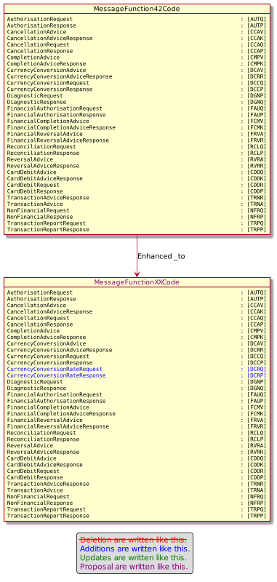

Then the AcceptorCurrencyConversionRequest must be updated to not mandate a transaction in the message.

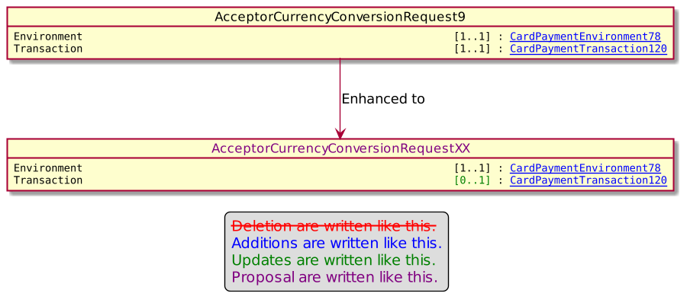

The identification of the eligible card range for the service will be provided as a suit of a BinRange identified by a lower range and a upper range.

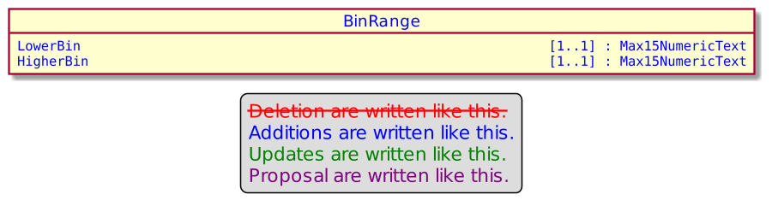

Finally the CurrencyConversion23 message component which hold the result of the currency conversion will be updated to not mandate currency conversion result or final amount, but also to provide the start date of the service and the eligible card range.
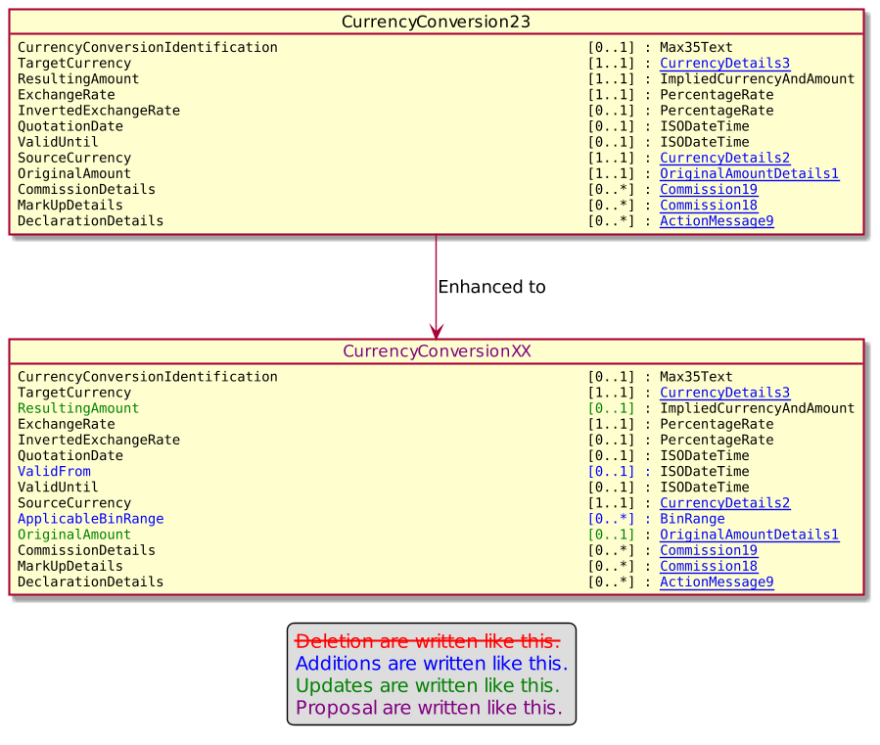

This modification will be propagated to the currency conversion response as illustrated by these diagrams.

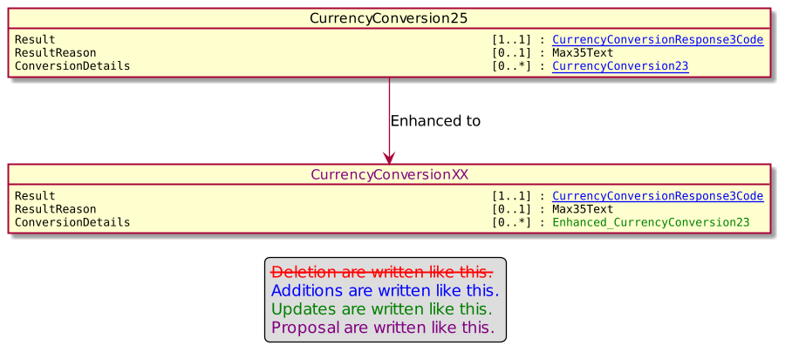

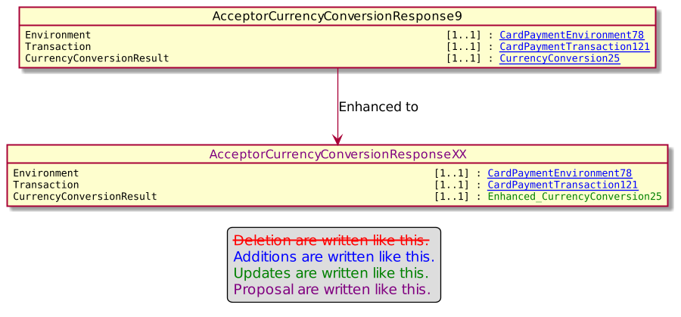
- Urgency of the request:

Urgent

- Business examples:
Examples illustrating the change request.
- SEG/TSG recommendation:
This section is not to be taken care of by the submitter of the change request. It will be completed in due time by the SEG(s) in charge of the related ISO 20022 messages or the TSG for changes related to the BAH.

Consider |  |  | Timing
 |  |  | - Next yearly cycle: 2022/2023  (the change will be considered for implementation in the yearly maintenance cycle which starts in 2022 and completes with the publication of new message versions in the spring of 2023) |  | X
- At the occasion of the next maintenance of the messages
(the change will be considered for implementation, but does not justify maintenance of the messages in its own right – will be pending until more critical change requests are received for the messages)
- Urgent unscheduled
(the change justifies an urgent implementation outside of the normal yearly cycle)
 |  |  | - Other timing:
Comments:

Reject
Reason for rejection:

