Change Request
for the update of ISO 20022 financial repository items

- Origin of the request:
A.1 Submitter: nexo A.I.S.B.L
A.2 Contact person: Philippe CECE (Philippe.cece@ingenico.com) / Evelyne de JONGHE (evelyne.de-jonghe@frenchsys.com)
A.3 Sponsors: nexo A.I.S.B.L.

- Related messages:

- AcceptorAuthorisationResponse V11 caaa.002.001.11,
- AcceptorCancellationResponse V10 caaa.006.001.10,
- AcceptorBatchTransfer V11 caaa.011.001.11,
- AcceptorNonFinancialResponse V02 caaa.023.001.02,
- AcceptorTransactionLogReportResponse V02 caaa.025.001.02,

- SaleToPOIServieResponse V04 casp.002.001.04,
- SaleToPOIReportResponse V04 casp.010.001.04,
- SaleToPOIMessageStatusResponse V04 casp.015.001.04

- Description of the change request:

Since new ISO8583 codes could be received by an Acquirer, we need to update the protocol in order to reflect the relevant action that the accepting device should trig.

These 2 new codes imply the creation of 2 new codes in the ActionType12Code codeset.
- Purpose of the change:

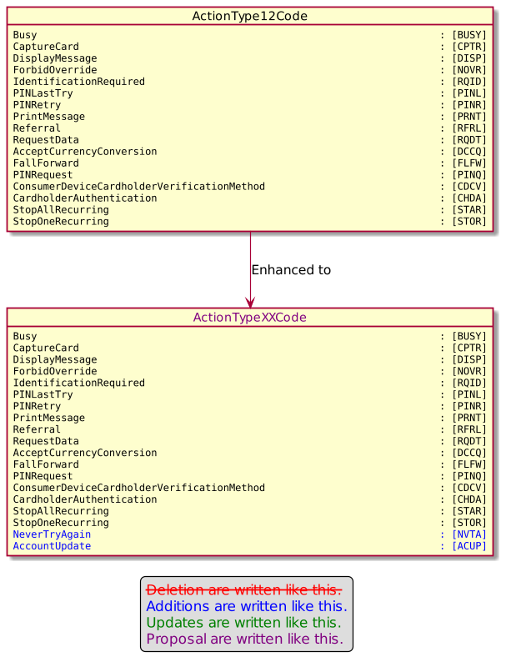

- Urgency of the request:

Urgent

- Business examples:
Examples illustrating the change request.
- SEG/TSG recommendation:
This section is not to be taken care of by the submitter of the change request. It will be completed in due time by the SEG(s) in charge of the related ISO 20022 messages or the TSG for changes related to the BAH.

Consider |  |  | Timing
 |  |  | - Next yearly cycle: 2022/2023  (the change will be considered for implementation in the yearly maintenance cycle which starts in 2022 and completes with the publication of new message versions in the spring of 2023) |  | X
- At the occasion of the next maintenance of the messages
(the change will be considered for implementation, but does not justify maintenance of the messages in its own right – will be pending until more critical change requests are received for the messages)
- Urgent unscheduled
(the change justifies an urgent implementation outside of the normal yearly cycle)
 |  |  | - Other timing:
Comments:

Reject
Reason for rejection:

