Change Request
for the update of ISO 20022 financial repository items

- Origin of the request:
A.1 Submitter: nexo A.I.S.B.L
A.2 Contact person: Philippe CECE (Philippe.cece@ingenico.com) / Evelyne de JONGHE (evelyne.de-jonghe@frenchsys.com)
A.3 Sponsors: nexo A.I.S.B.L.

- Related messages:

- AcceptorAuthorisationRequest V11 caaa.001.001.11,
- AcceptorAuthorisationResponse V11 caaa.002.001.11,
- AcceptorCompletionAdvice V11 caaa.003.001.11,
- AcceptorBatchTransfer V11 caaa.011.001.11,
- AcceptorCurrencyConversionRequest V09 caaa.016.001.09,
- AcceptorCurrencyConversionResponse V09 caaa.017.001.09,
- AcceptorCurrencyConversionAdvice V06 caaa.018.001.06,
- AcceptorCurrencyConversionAdviceResponse V03 caaa.020.001.03,
- AcceptorNonFinancialRequest V02 caaa.022.001.02,
- AcceptorNonFinancialResponse V02 caaa.023.001.02,
- AcceptorTransactionLogReportResponse V02 caaa.025.001.02,

- SaleToPOIServiceRequest V04 casp.001.001.04,
- SaleToPOIServiceResponse V04 casp.002.001.04,
- SaleToPOIReportResponse V04 casp.010.001.04,
- SaleToPOIMessageStatusResponse V04 casp.015.001.04,

- AcceptorConfigurationUpdate V11 catm.003.001.11,
- MaintenanceDelegationResponse V08 catm.005.001.08

- Description of the change request:

The aim of this Change Request is first to allow the exchange of Instalment Plans outside of a transaction. Then this behaviour will allow shorter transaction processing time and an improved integration in the sale step.
Additionally since the NonFinancialRequest message is exchanged outside of a transaction and to a service provider, it might also be an opportunity to exchange information through an AdditionalRequest which could be defined by another standards.
Then this new usage means that the NonFinancialResponse is able to convey multiple Instalment Plans and also a AdditionalResponse defined by another standards.

Secondly, since an Instalment is a loan, in some context a dedicated legal notice may be provided. Then we must update the RecurringTransaction4 message component to be sure to convey the relevant notice with the relevant Instalment Plan.

- Purpose of the change:

The NonFinancialRequestType1Code is updated with the 2 new options.
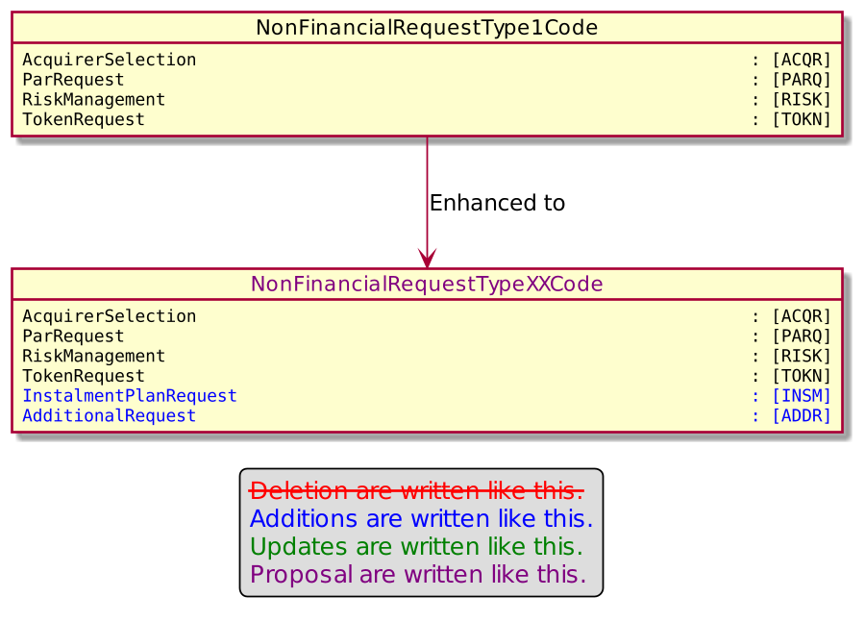
The core of the request is updated to support the exchange of an additional element defined by another standards.

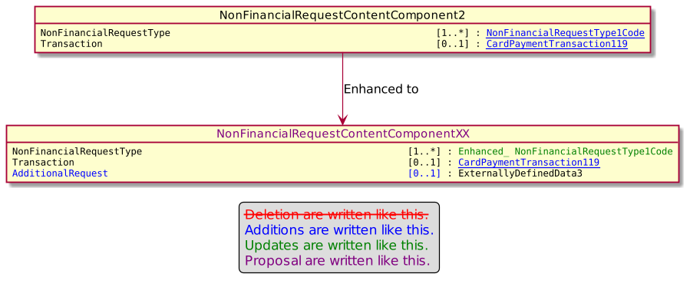

The content of the NonFinancialResponse message is updated to support a list of instalments that the POI may have to offer to the cardholder.

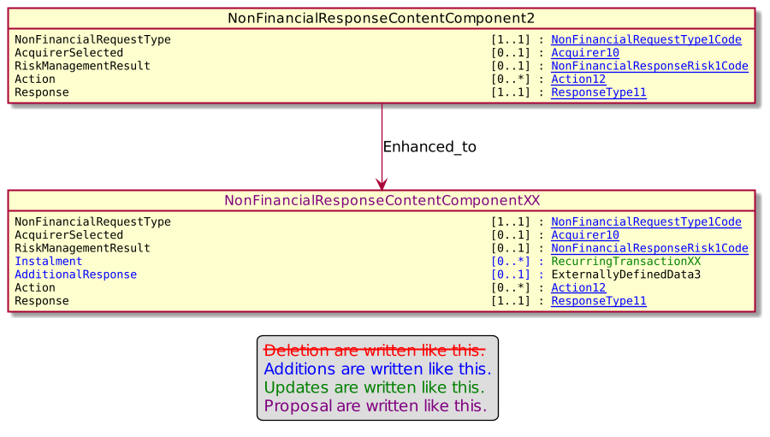

Finally, information related to a recurring transaction, like instalment, are updated to convey an optional notice.

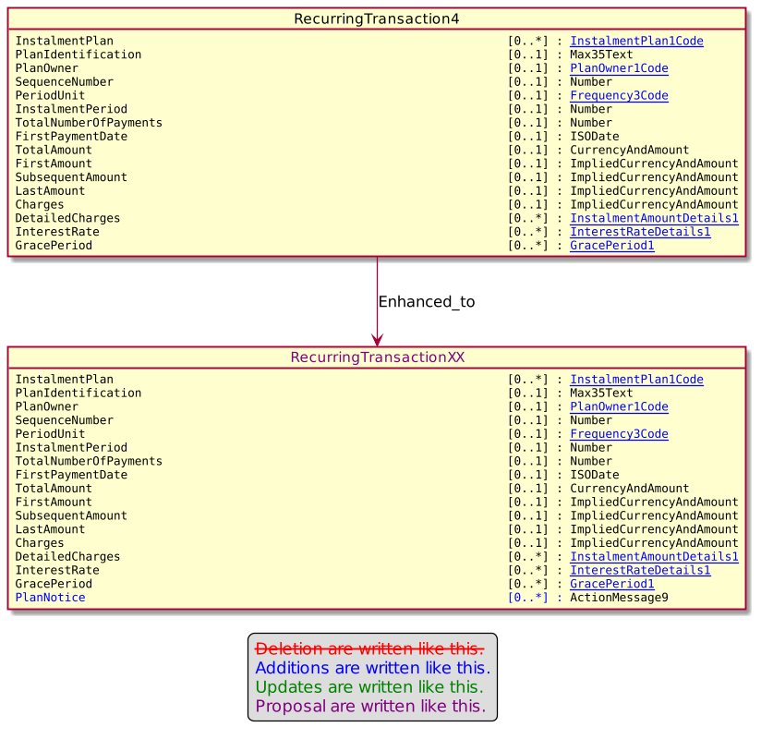

- Urgency of the request:

Urgent.

- Business examples:
Examples illustrating the change request.
- SEG/TSG recommendation:
This section is not to be taken care of by the submitter of the change request. It will be completed in due time by the SEG(s) in charge of the related ISO 20022 messages or the TSG for changes related to the BAH.

Consider |  |  | Timing
 |  |  | - Next yearly cycle: 2022/2023  (the change will be considered for implementation in the yearly maintenance cycle which starts in 2022 and completes with the publication of new message versions in the spring of 2023) |  | X
- At the occasion of the next maintenance of the messages
(the change will be considered for implementation, but does not justify maintenance of the messages in its own right – will be pending until more critical change requests are received for the messages)
- Urgent unscheduled
(the change justifies an urgent implementation outside of the normal yearly cycle)
 |  |  | - Other timing:
Comments:

Reject
Reason for rejection:

