Change Request
for the update of ISO 20022 financial repository items
Note: the purpose of this document is to give guidelines to parties who want to introduce a request to change an existing ISO 20022 message(s), or update other items of the ISO 20022 financial repository. Such change requests are subject to the approval of the ISO 20022 Standards Evaluation Group(s) in charge of the related message/item or to the approval of the Technical Support Group (TSG), if the requested change relates to the Business Application Header (BAH). Please consult the iso20022.org website for additional details on the maintenance process. Change requests are to be sent to iso20022ra@iso20022.org. All change requests conforming to this template received by June 1st will be considered for development in the following yearly ISO 20022 maintenance cycle which completes with publication of new message versions in April/May of the following year.
- Origin of the request:
A.1 Submitter:
SIX Interbank Clearing Ltd
A.2 Contact person:
Roman Locher
roman.locher@six-group.com
T +41 58 399 4125
A.3 Sponsors:
SIX Interbank Clearing is involved in several committees focused on questions of standardization concerning the national and international payment traffic. In this role SIX Interbank Clearing acts as a representative of the Swiss financial industry. SIX Interbank Clearing also operates the Swiss RTGS systems SIC for Swiss Francs (monitored and steered by the Swiss National Bank) and euroSIC in Euro.
This Change Request is supported by the national committee “Taskforce ISO V2019 Interbank”, representing Swiss National Bank, UBS, Credit Suisse, PostFinance, Raiffeisen, Zürcher Kantonalbank, Entris Banking.
- Related messages:
pacs.002 (latest version: pacs.002.001.12)
- Description of the change request:
In this change request, the Swiss community requests the extension of the block "Transaction Information And Status" (<TxInfAndSts>, Type PaymentTransaction130) by an additional optional element "Processing Date".

In its current design, the pacs.002 block <TxInfAndSts> message supports only 2 elements for specifying a timestamp related to the underlying transaction/payment:
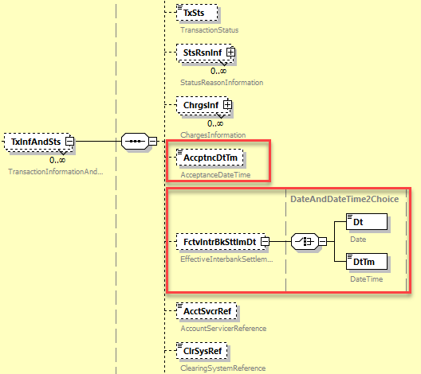
For the planned future Swiss instant payment service, the infrastructure will use the pacs.002 message to confirm final transaction status of an instant payment to the participants. This can be either the confirmation of the final settlement or the cancellation of an instant payment. For this purpose, a timestamp in the sense of a processing date time is required, which can be used in relation to the transaction status provided in the <TxSts> element. This need actually cannot be satisfied within pacs.002 <TxInfAndSts> block for the following reasons, neither in the element <AccptnDtTm>, nor <FctvIntrbkSttlmDt>:
- For SEPA Instant Credit Transfer Scheme compatibility, the <AccptncDtTm> element will contain the start of maximum execution time and therefore cannot be used to specify another processing timestamp.
- Only one of the two sub-elements <Dt> or <DtTm> can be used in the <FctvIntrBkSttlmDt> element due to the choice specification. For the Swiss instant payment service, the <Dt> element is needed for settled instant payments to confirm final interbank value date of the settlement.
SIX Interbank Clearing Ltd therefore requests addition of a new optional element called "Processing Date" in the <TxInfAndSts> block of the pacs.002 message.
In order to grant some flexibility in the use of the element, SIX Interbank Clearing Ltd proposes to
- keep the definition of this new element generic (incl. possible addition that the concrete use is to be determined by market practices / bilateral agreements) and
- design the element with type <DateAndDateTime2Choice>, i.e. consisting of a choice for sub-elements <Dt> or <DtTm>.

- Purpose of the change:
The above mentioned additional element would provide more flexibility in the usage of the pacs.002 message. With the current message design, the Swiss community is forced to use proprietary text elements (as for ex. <AddtlInf> within <StsRsnInf>) to provide timestamp information.
- Urgency of the request:
The change should be implemented in the regular yearly maintenance cycle with publication per next ISO 20022 version in spring 2023.
- Business examples:
n/a
- SEG/TSG recommendation:
This section is not to be taken care of by the submitter of the change request. It will be completed in due time by the SEG(s) in charge of the related ISO 20022 messages or the TSG for changes related to the BAH.

Consider |  | X | Timing
 |  |  | - Next yearly cycle: 2022/2023  (the change will be considered for implementation in the yearly maintenance cycle which starts in 2022 and completes with the publication of new message versions in the spring of 2023) |  | X
- At the occasion of the next maintenance of the messages
(the change will be considered for implementation, but does not justify maintenance of the messages in its own right – will be pending until more critical change requests are received for the messages)
- Urgent unscheduled
(the change justifies an urgent implementation outside of the normal yearly cycle)
 |  |  | - Other timing:
Comments:

Reject
Reason for rejection:

