Change Request
for the update of ISO 20022 financial repository items

- Origin of the request:
A.1 Submitter:
Federal Reserve Bank of New York (on behalf of the US Federal Reserve Banks)
33 Liberty Street
New York, NY 10045
U.S.A.
A.2 Contact person:
Federal Reserve Bank of New York
Mr. Frank Van Driessche (frank.vandriessche@ny.frb.org)
A.3 Sponsors:
-
- Related messages:
pain.013 – Creditor Payment Activation Request (aka Request for Payment)
pain.014 – Creditor Payment Activation Request Status Report (aka Request for Payment Response)

- Description of the change request:
- Add a Forwarding Agent to the Group Header of both pain.013 and pain.014 messages to align with other payment initiation message like the customer credit transfer initiation (pain.001) and customer direct debit initiation (pain.008) messages where a Forwarding Agent is available.
The requested change is reflected in the below diagrams.

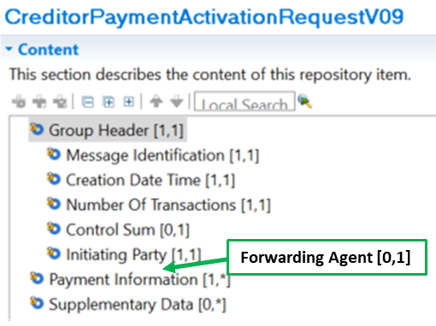

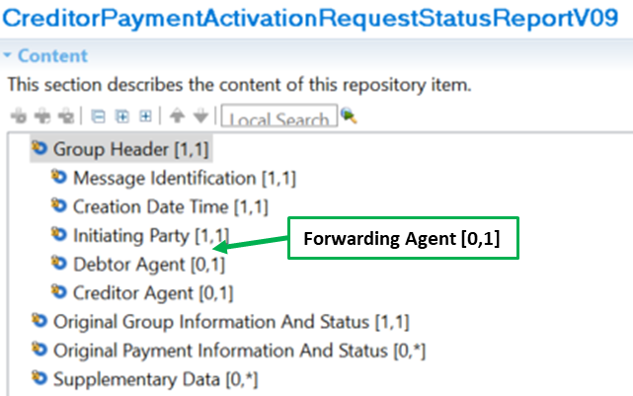

- Purpose of the change:
The change will enable use of the request for payment messages in a relay scenario where the messages are exchanged by a financial institution other than the account servicing institution of the initiating party / creditor (i.e., Creditor Agent).

- Urgency of the request:
Request to include the change in the current maintenance cycle.

- Business examples:
See above.

- SEG/TSG recommendation:
This section is not to be taken care of by the submitter of the change request. It will be completed in due time by the SEG(s) in charge of the related ISO 20022 messages or the TSG for changes related to the BAH.

Consider |  | X | Timing
 |  |  | - Next yearly cycle: 2022/2023  (the change will be considered for implementation in the yearly maintenance cycle which starts in 2021 and completes with the publication of new message versions in the spring of 2022) |  | X
- At the occasion of the next maintenance of the messages
(the change will be considered for implementation, but does not justify maintenance of the messages in its own right – will be pending until more critical change requests are received for the messages)
- Urgent unscheduled
(the change justifies an urgent implementation outside of the normal yearly cycle)
 |  |  | - Other timing:
Comments:

Reject
Reason for rejection:

