**Change Request**

**for the update of ISO 20022 financial repository items**

1. **Origin of the request:**

*A.1 Submitter*:

|  |  |
| --- | --- |
| Name of the company, organization, group, initiative or community that submits the change request. | Partior Pte. Ltd. |

*A.2 Contact person:*

Person that can be contacted for additional information on the request

Rakhi Shrivastava: [Rakhi.shrivastava@partior.com](mailto:Rakhi.shrivastava@partior.com)

Petrina Chong: [Petrina.chong@partior.com](mailto:Petrina.chong@partior.com)

Dmitry Avramenko: [dmitry.avramenko@partior.com](mailto:dmitry.avramenko@partior.com)

*A.3 Sponsors*:

If the submitter acts on behalf of or has gained support from other organizations, groups, initiatives, or communities, these should be listed as sponsors.

N.A

1. **Related messages:**

camt.046.001.06 GetReservationV06

1. **Description of the change request:**

This change request seeks to include the date-time range in the camt.046.001.06 GetReservationV06 to request the details of one or more reservations on the account.

This allows the users to select a particular time span specified between a start date time and an end date time in the camt.046.001.07 request message as one of the options in the search criteria to get the reservation details.

1. **Purpose of the change:**

Addition of date time range attributes is to allow for the ability to search the reservations in the specified time range.

This will prevent the time unbounded list of reservations to be returned with camt.047.001 which may result in huge data to handle.

1. **Urgency of the request:**

It is proposed to include this change request in the next regular maintenance cycle.

1. **Business examples:**

Requested date time fields are to be included in the message element ‘SearchCriteria’ which is used to defines the criteria to extract the reservation information.

For Example:

|  |  |
| --- | --- |
| **Field** | **Type** |
| SearchCriteria *<SchCrit>* |  |
| DateTime <DtTm> |  |
| FromDateTime *<FrDtTm>* | DateTime |
| ToDateTime *<ToDtTm>* | DateTime |

1. **High Level design Flow**

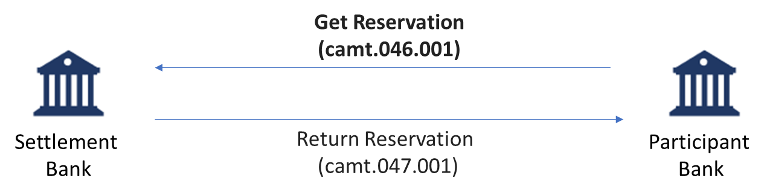**SEG/TSG recommendation:**

*This section is not to be taken care of by the submitter of the change request. It will be completed in due time by the SEG(s) in charge of the related ISO 20022 messages or the TSG for changes related to the BAH.*

|  |  |  |  |
| --- | --- | --- | --- |
| **Consider** | | X | **Timing** |
|  | | - **Next yearly cycle: 2022/2023**  (the change will be considered for implementation in the yearly maintenance cycle which starts in 2022 and completes with the publication of new message versions in the spring of 2023) | | X |
|  | | - **At the occasion of the next maintenance of the messages**  (the change will be considered for implementation, but does not justify maintenance of the messages in its own right – will be pending until more critical change requests are received for the messages) | |  |
|  | | - **Urgent unscheduled**  (the change justifies an urgent implementation outside of the normal yearly cycle) | |  |  |
|  | | - **Other timing:** | | |  |

Comments:

|  |  |
| --- | --- |
| **Reject** |  |

Reason for rejection: