Change Request
for the update of ISO 20022 financial repository items
Note: the purpose of this document is to give guidelines to parties who want to introduce a request to change an existing ISO 20022 message(s), or update other items of the ISO 20022 financial repository. Such change requests are subject to the approval of the ISO 20022 Standards Evaluation Group(s) in charge of the related message/item or to the approval of the Technical Support Group (TSG), if the requested change relates to the Business Application Header (BAH). Please consult the iso20022.org website for additional details on the maintenance process. Change requests are to be sent to iso20022ra@iso20022.org. All change requests conforming to this template received by June 1st will be considered for development in the following yearly ISO 20022 maintenance cycle which completes with publication of new message versions in April/May of the following year.
- Origin of the request:
A.1 Submitter: identity of the company, organization, group, initiative or community that submits the change request.
Russian National Member and User Group (ROSSWIFT)
A.2 Contact person: person(s) who can be contacted to get additional information on the request (name, e-mail, telephone)
Timothy Romaslovsky, Consultant, ROSSWIFT, Timothy.Romaslovsky@swift-russia.ru, +7 910 458 8897
A.3 Sponsors: it is highly recommended that a submitter of a Change Request gain the agreement and support from as many additional organisations, groups, initiatives or communities of users as possible, thus demonstrating as wide as possible a consultation of the relevant stakeholders. All organisations, groups, initiatives or communities supporting the change request should be identified as sponsors along with a contact person, if possible. This community involvement is intended to help avoid delays and/or subsequent amendments to the change request.
Russian National Member and User Group (ROSSWIFT).
- Related messages:
The list of ISO 20022 messages which would be impacted by the change, including the Message IDs as shown in the Catalogue of ISO 20022 messages. Only the latest version of a message definition can be maintained.
The submitter is invited to carefully examine whether the change may have an impact on other messages that come into play earlier or later in the transaction chain or on other messages that also use message components that this change request may impact.
pain.013.001.09 - CreditorPaymentActivationRequestV09.
- Description of the change request:
A specific change request form must be completed for each particular change requested (for example, adding, deleting, modifying, renaming, changing the cardinality, moving an element/component, or changing the type of an element, changing a code set).
If the change request consists, for example, of adding new functionality which requires several changes which would not make sense if not performed all together, then all these related changes should be described on the same form.
Change requests may not lead to creation of new messages. In such cases, a 'business justification' for development of new candidate ISO 20022 messages must be introduced by a submitting organization that is ready to develop the new messages.
The values of Creditor Agent Account and Debtor Agent Account are required in pain.013. We propose to use the standard block CashAccount40 currently available in pacs messages. These elements are to be optional and non-repetitive. They are necessary for legislation reasons in accordance with the the Central Bank of the Russian Federation regulations:
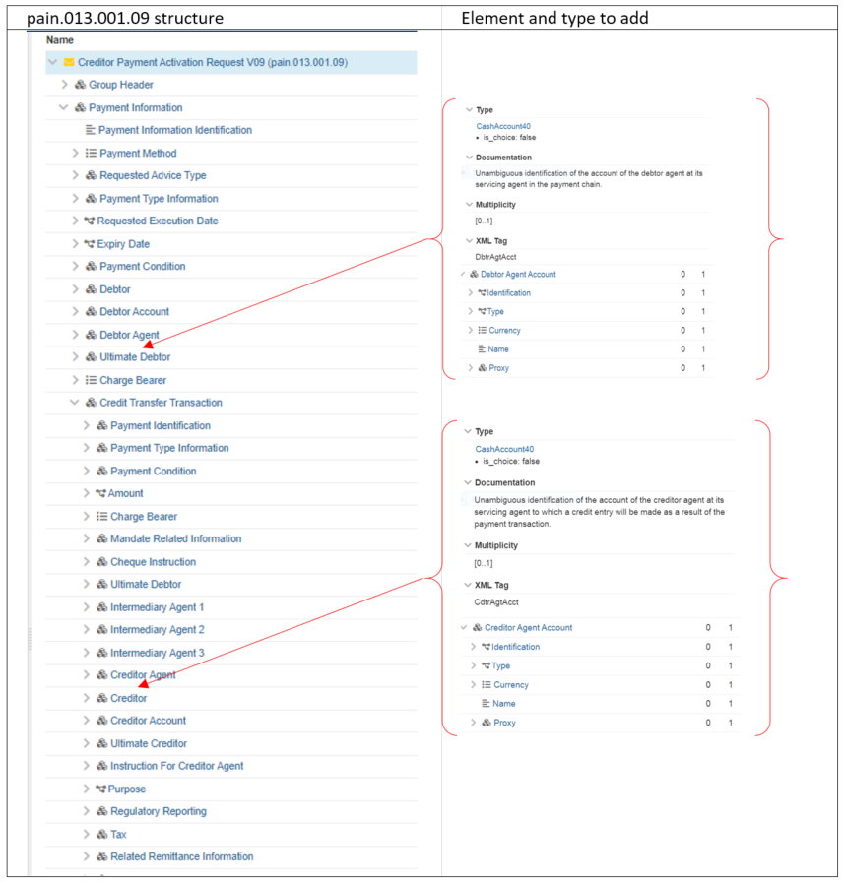
Debtor Agent Account [0..1]
Creditor Agent Account [0..1]

- Purpose of the change:
Background, business context, community of users interested by the change and expected benefits/savings.
This section must explain why the existing ISO 20022 messages need to be changed. The reason for the update may be a business reason (e.g., evolution of market practice, or creation of new financial instruments), a technical reason (e.g., automation of the business process, or switch from a batch to a real time process), a regulatory reason (introduction, generally mandatory, of new rule/law) or the extension of the user community (newly identified business requirements).
The regulatory reason - in accordance with Russian regulation Creditor Payment Activation Requests must include the value of correspondent account number of Agent in Bank of Russia.
- Urgency of the request:
By default, valid change requests introduced by June 1 and subsequently approved by the SEG/TSG will be included in the following yearly maintenance cycle which completes with the publication of new message versions by April/May of the following year, unless decided otherwise by the SEG/TSG.
If there is a need to have the new version of the related messages published earlier, the reason for the urgency of the maintenance and the expected consequences of a delay should be described here. Acceptance of such an unscheduled maintenance for the BAH is subject to approval by TSG. Acceptance of an unscheduled maintenance for messages other than the BAH is subject to the approval of the SEG and availability of a submitting organization to develop the new version of the messages.
Note: the ISO 20022 maintenance results in the publication of a new version of an ISO 20022 message. The actual implementation of such new version on networks and in user installations is not within the purview of ISO.
Migration to ISO 20022 in Russia are planning now on 2022-2024.
- Business examples:
Examples illustrating the change request.

The Debtor performs the Role of the Ultimate Debtor. The Creditor performs the Role of the Initiating Party and the Ultimate Creditor. Agents are not correspondents. Agents have opened accounts in Intermediary Agent. There is no Prior Acceptance. There is no request for notification of account transactions.
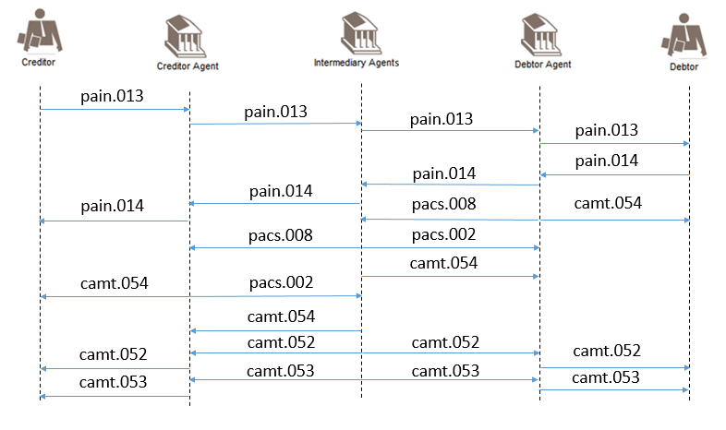
- SEG/TSG recommendation:
This section is not to be taken care of by the submitter of the change request. It will be completed in due time by the SEG(s) in charge of the related ISO 20022 messages or the TSG for changes related to the BAH.

Consider |  | X | Timing
 |  |  | - Next yearly cycle: 2022/2023  (the change will be considered for implementation in the yearly maintenance cycle which starts in 2022 and completes with the publication of new message versions in the spring of 2023) |  | X
- At the occasion of the next maintenance of the messages
(the change will be considered for implementation, but does not justify maintenance of the messages in its own right – will be pending until more critical change requests are received for the messages)
- Urgent unscheduled
(the change justifies an urgent implementation outside of the normal yearly cycle)
 |  |  | - Other timing:
Comments:

Reject
Reason for rejection:

The Bank of Russia Regulation dated 29.06.2021 # 762-P “On Funds Transfer Rules”

