Change Request
for the update of ISO 20022 financial repository items
- Origin of the request:
A.1 Submitter:
DESSUG CA – PSG (Deutsche SWIFT Securities Market User Group - Corporate Actions - Proxy Subgroup Germany)
This group represents more than 20 different institutions including domestic and global proxy providers and registrars with a key role in the German General Meeting process.

A.2 Contact person:
PSG Chair - Hendrik Melchior (employer change to Clearstream Banking Frankfurt in July)
PSG Deputy Chair - Daniel Schäfer, Daniel.Schaefer@hsbc.de, Phone +49 211 910-2362
Sabine Wolff, Sabine.Wolff@clearstream.com, Phone +352-243-3 66 40
SEG GM-ET Member (Germany) - Sven Gunkel, sven-a.gunkel@db.com, Phone +49 69910-60715
SEG GM-ET Member (Germany) - Rainer Prior, Rainer.Prior@linkmarketservices.de, Phone +49 6196 8870 514

A.3 Sponsors:
German Market - including domestic and global proxy providers with a key role in the German General Meeting process.
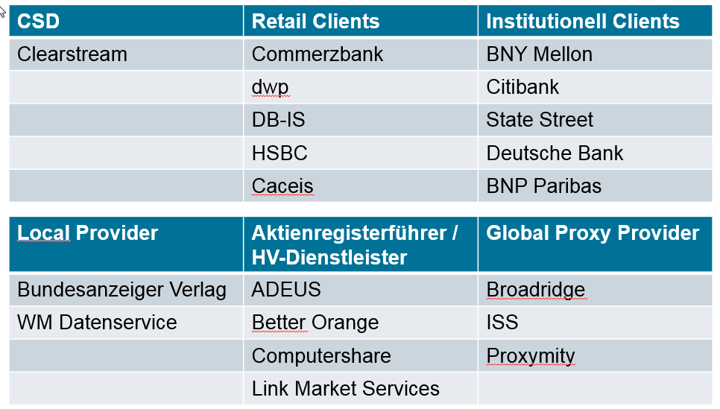

- Related messages:
Seev.003.xxx.xxx
Seev.004.xxx.xxx
Seev.005.xxx.xxx
Seev.006.xxx.xxx
Seev.007.xxx.xxx

- Description of the change request:
Two types of share classes are represented on the German market. Bearer Shares and Registered Shares. The market working group has identified a limitation of the current messages to support Proxy services for Registered Shares.

An additional Rights Holder information field should be created to provide the Company Share Registration ID to the investor and vice versa allow this ID to be reported in the instruction from the investor to the issuer.
This identification should be optional and be provided in addition to the name/address of the rights holder.
Company Register Shareholder ID <ComRegShID> [0..1] text{1,35}
Note; The Company Register Shareholder ID in Germany can be up to 12 digits, but the most ISO20022 text fields have a length of 35 characters.

For message Seev.005.xxx.xxx this information is not required, but for consistency purposes of the ISO20022 standard, we think it could be beneficial to add this data as well.

- Purpose of the change:
Each shareholder entry in a German company share register has a unique reference. This ID is mandatory to place valid voting instructions. Without the Company Register Shareholder ID it is not possible submit instructions.

If this CR will not be granted, a Proprietary Identification <PrtryId> must be used, but may not be accepted by the company if it doesn’t specify exactly what ID has been reported.

- Urgency of the request:

N/A

- Business examples:
German custodian A holds 10,000 shares of company XYZ AG for 3 different clients
Client 1 = 500 shares, natural person Mr. Max Mustermann
Registration in the company share register in the name of the beneficial owner with ID 111222333000
Client 2 = 6,000 shares, investment fund ABC
Registration in the company share register in the name of the beneficial owner with ID 444555666000
Client 3 = 3,500 shares, Omnibus account of a non-German bank B
Registration in the company share register in the name of the German custodian as Nominee with ID 777888999000

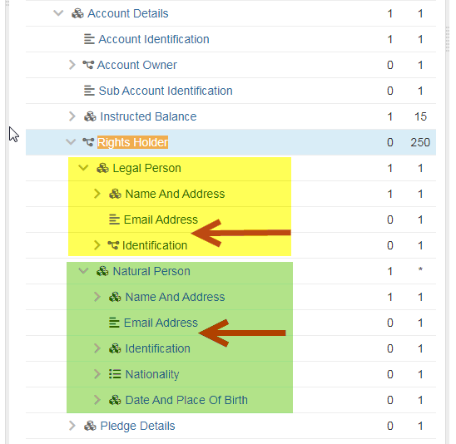

…
Legal Person <LglPrsn> [1..1]
Name And Address <NmAndAdr> [1..1]
Name <Nm> [1..1] text{1,350}
Address <Adr> [0..1]
Email Address <EmailAdr> [0..1] text{1,256}
Company Register Shareholder ID < ComShRegID > [0..1] text{1,35}
…
…
Natural Person <NtrlPrsn> [1..1]
Name And Address <NmAndAdr> [1..1]
Name Prefix <NmPrfx> [0..1] text
First Name <FrstNm> [1..1] text{1,350}
Surname <Srnm> [1..1] text{1,350}
Address <Adr> [0..1]
Email Address <EmailAdr> [0..1] text{1,256}
Company Register Shareholder ID <ComRegShID> [0..1] text{1,35}
…

- SEG/TSG recommendation:
This section is not to be taken care of by the submitter of the change request. It will be completed in due time by the SEG(s) in charge of the related ISO 20022 messages or the TSG for changes related to the BAH.

Consider |  |  | Timing
 |  |  | - Next yearly cycle: 2021/2022  (the change will be considered for implementation in the yearly maintenance cycle which starts in 2021 and completes with the publication of new message versions in the spring of 2022) |  | X
- At the occasion of the next maintenance of the messages
(the change will be considered for implementation, but does not justify maintenance of the messages in its own right – will be pending until more critical change requests are received for the messages)
- Urgent unscheduled
(the change justifies an urgent implementation outside of the normal yearly cycle)
 |  |  | - Other timing:
Comments:

Reject
Reason for rejection:

