Change Request
for the update of ISO 20022 financial repository items
- Origin of the request:
A.1 Submitter: Proxymity Limited
A.2 Contact person: Nigel Little
A.3 Sponsors:
Related messages:

seev.006

- Description of the change request:
Title: Include Position Block <Pos> in meetings instruction status message (seev.006)
Currently balances cannot be provided in the seev.006 meeting instruction status. An optional position block (as found in the meeting announcement seev.001) should be added so the account owner can advise the vote provider of the balances on the account.

- Purpose of the change:
When a vote service provider, or account owner votes on an omnibus account, multiple underlying safekeeping accounts and underlying rightsholder (BO level) may exist.
The operator of the omnibus account does not have the view on the underlying holders and if an overvote is received, they pend or reject lack all the votes received on that account back to the sender as they do not have the breakdown to apply the votes which are correct, versus those which are over.
The sender of the votes, may have the breakdown of the positions, but not the amount at the omnibus level (they can sum up all the account positions). By including the amount in the omnibus in the seev.006 meeting instruction status, the vote service provider/account owner can reconcile and identify the discrepancy between the omnibus and the account owner.
This is also like what is normally seen in an MT567 where 93B: Balance can be populated.
- Urgency of the request:
For SR2023.
- Business examples:
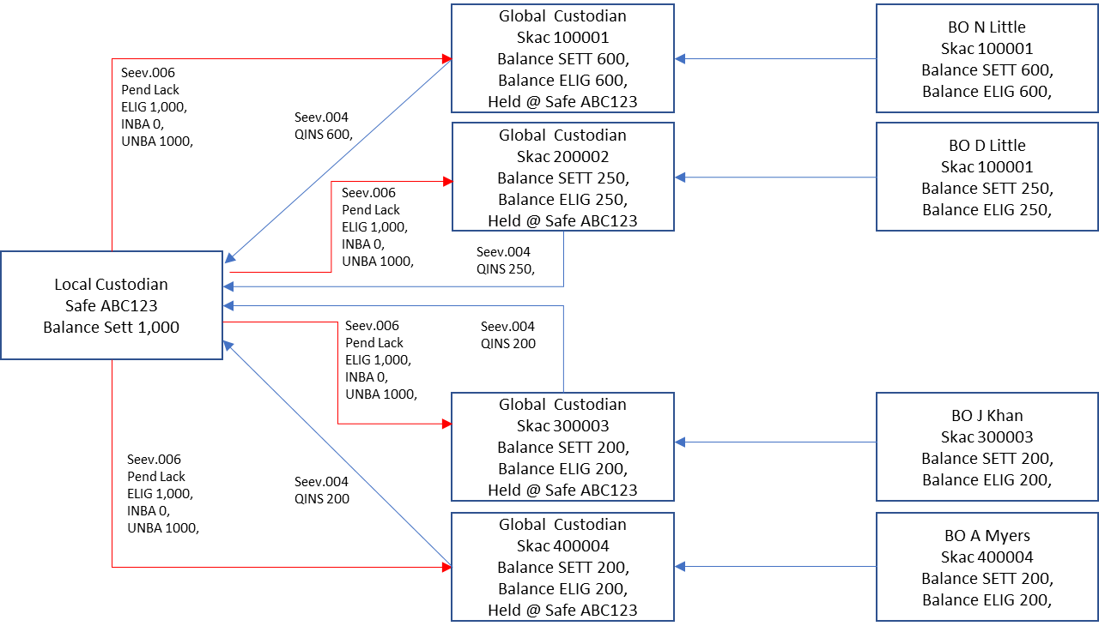
SEG/TSG recommendation:
This section is not to be taken care of by the submitter of the change request. It will be completed in due time by the SEG(s) in charge of the related ISO 20022 messages or the TSG for changes related to the BAH.

Consider |  |  | Timing
 |  |  | - Next yearly cycle: 2022/2023  (the change will be considered for implementation in the yearly maintenance cycle which starts in 2022 and completes with the publication of new message versions in the spring of 2023) |  | X
- At the occasion of the next maintenance of the messages
(the change will be considered for implementation, but does not justify maintenance of the messages in its own right – will be pending until more critical change requests are received for the messages)
- Urgent unscheduled
(the change justifies an urgent implementation outside of the normal yearly cycle)
 |  |  | - Other timing:
Comments:

Reject
Reason for rejection:

