Change Request
for the update of ISO 20022 financial repository items

- Origin of the request:
A.1 Submitter: nexo A.I.S.B.L.
A.2 Contact person: Philippe CECE (Philippe.cece@ingenico.com) / Pierre MOURA (pierre.moura@frenchsys.com)
A.3 Sponsors: nexo A.I.S.B.L.

- Related messages:

- AcceptorConfigurationUpdate V10 catm.003.001.10
- MaintenanceDelegationRequest V07 catm.005.001.07

- Description of the change request:

In some nexo messages, we use message elements defined as ExternallyDefinedData2 like AuthenticationAdditionalInformation to exchange data defined by 3DS specifications. Even if this way of processing ensure interoperability if the receiver doesn’t know how to decode the data, some nexo members would like to avoid sending the data in this case. Consequently we would like to be able to list the type of externally defined data supported by a host. Then the requester knows if it could add or not the elements defined by this ExternallyDefinedData2.

- Purpose of the change:

In order to manage exchange with hosts with Acquirer protocol, we would like to update the AcquirerHostConfiguration8 in order to record the list of ExternallyDefinedData2 type supported by the Host.

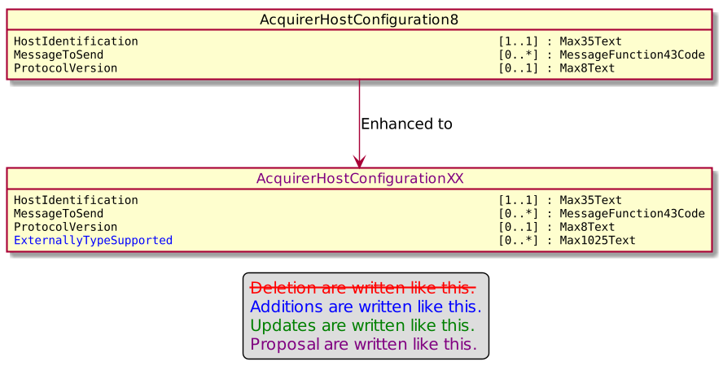
To set up the TMS protocol, we would like to change the TMSProtocolParameters5.

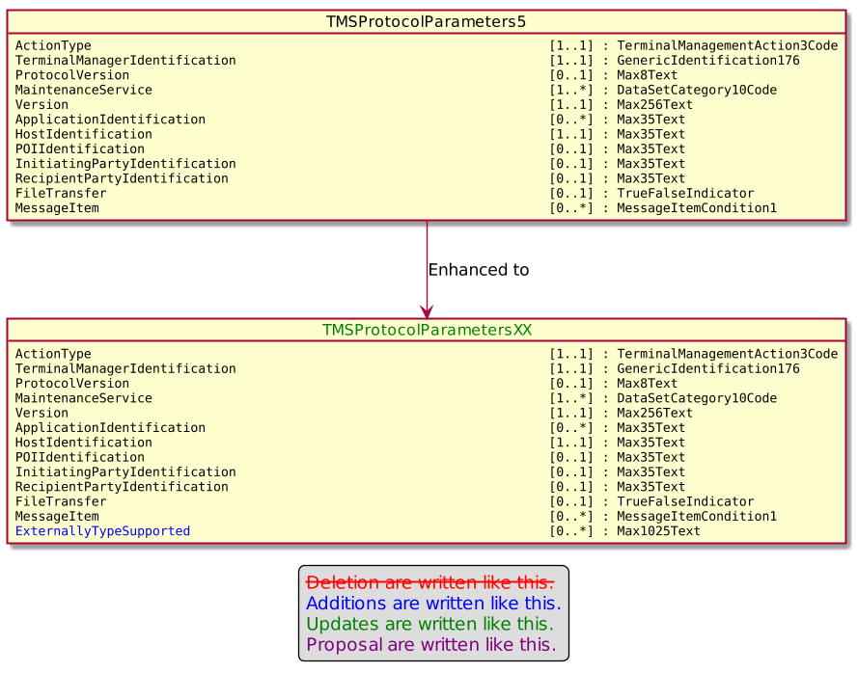

In order to manage the SaleToPOIProtocol, we would like to change the SaleToPOIProtocolParameter1.

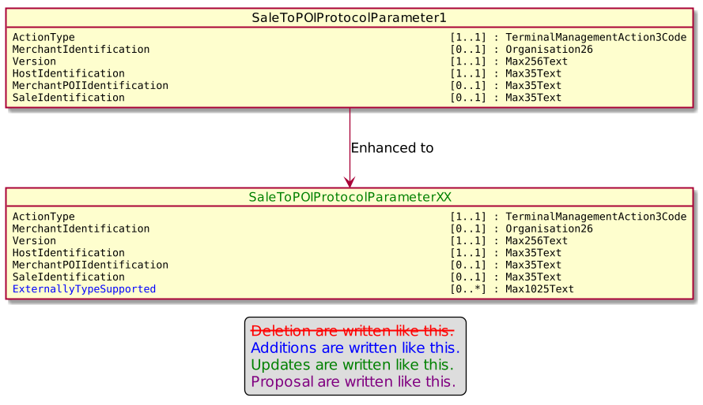
If a POI receives an unknown ExternallyTypeSupported, we would like to record an Event with a Result of type TerminalManagementActionResult4Code set to a new value SuccessWithWarning as highlighted in the following diagram.
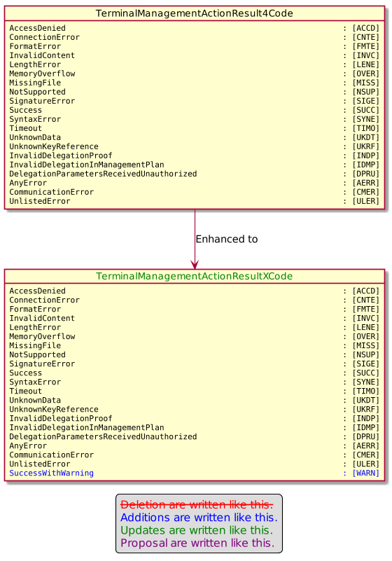

- Urgency of the request:

Urgent

- Business examples:
Examples illustrating the change request.

- SEG/TSG recommendation:
This section is not to be taken care of by the submitter of the change request. It will be completed in due time by the SEG(s) in charge of the related ISO 20022 messages or the TSG for changes related to the BAH.

Consider |  |  | Timing
 |  |  | - Next yearly cycle: 2021/2022  (the change will be considered for implementation in the yearly maintenance cycle which starts in 2018 and completes with the publication of new message versions in the spring of 2019) |  | X
- At the occasion of the next maintenance of the messages
(the change will be considered for implementation, but does not justify maintenance of the messages in its own right – will be pending until more critical change requests are received for the messages)
- Urgent unscheduled
(the change justifies an urgent implementation outside of the normal yearly cycle)
 |  |  | - Other timing:
Comments:

Reject
Reason for rejection:

