Change Request
for the update of ISO 20022 financial repository items

- Origin of the request:
A.1 Submitter: nexo A.I.S.B.L.
A.2 Contact person: Philippe CECE (Philippe.cece@ingenico.com) / Theophane LUMINEAU (theophane.lumineau@ca-ps.com)
A.3 Sponsors: nexo A.I.S.B.L.

- Related messages:

- AcceptorAuthorisationRequest V10 caaa.001.001.10
- AcceptorAuthorisationResponse V10 caaa.002.001.10
- AcceptorBatchTransferResponse V09 caaa.012.001.09
- AcceptorBatchTransfer V10 caaa.011.001.10
- AcceptorCancellationAdviceResponse V09 caaa.008.001.09
- AcceptorCancellationAdvice V10 caaa.007.001.10
- AcceptorCancellationRequest V10 caaa.005.001.10
- AcceptorCancellationResponse V19 caaa.006.001.09
- AcceptorCompletionAdviceResponse V09 caaa.004.001.09
- AcceptorCompletionAdvice V10 caaa.003.001.10
- AcceptorConfigurationUpdate V10 catm.003.001.10
- AcceptorCurrencyConversionAdviceResponse V04 caaa.019.001.04
- AcceptorCurrencyConversionAdvice V05 caaa.018.001.05
- AcceptorCurrencyConversionRequest V08 caaa.016.001.08
- AcceptorCurrencyConversionResponse V08 caaa.017.001.08
- AcceptorDiagnosticRequest V09 caaa.013.001.09
- AcceptorDiagnosticResponse V08 caaa.014.001.08
- AcceptorNonFinancialRequest V01 caaa.022.001.01
- AcceptorNonFinancialResponse V01 caaa.023.001.01
- AcceptorReconciliationRequest V09 caaa.009.001.09
- AcceptorReconciliationResponse V08 caaa.010.001.08
- AcceptorTransactionLogReportRequest V01 caaa.024.001.01
- AcceptorTransactionLogReportResponse V01 caaa.025.001.01
- MaintenanceDelegationRequest V07 catm.005.001.07
- MaintenanceDelegationResponse V05 catm.006.001.05
- ManagementPlanReplacement V09 catm 002.001.09
- SalerToPOIAbort V03 casp.011.001.03
- SaleToPOIAdministrativeRequest V03 casp.007.001.03
- SaleToPOIAdministrativeResponse V03 casp.008.001.03
- SaleToPOIDeviceRequest V03 casp.016.001.03
- SaleToPOIDeviceResponse V03 casp.017.001.03
- SaleToPOIEventNotification V03 casp.012.001.03
- SaleToPOIMesageStatusRequest V03 casp.014.001.03
- SaleToPOIMessageStatusResponse V03 casp.015.001.03
- SaleToPOIReconciliationRequest V03 cap.003.001.03
- SaleToPOIReconciliationResponse V03 casp.004.001.03
- SaleToPOIReportRequest V03 casp.009.001.03
- SaleToPOIReportResponse V03 casp.010.001.03
- SaleToPOIServiceRequest V03 casp.001.001.03
- SaleToPOIServiceResponse V03 casp.002.001.03
- SaleToPOISessionManagementRequest V03 casp.005.001.03
- SaleToPOISessioonManagementResponse V03 casp.006.001.03
- StatusReport V10 catm.001.001.10
- TransactionAdviceResponse V02 caaa.021.001.02
- TransactionAdvice V02 caaa.020.001.02

- Description of the change request:

Some nexo members would like to review and simplify how X9.24 usage is specified in the Cryptographic Message Syntax of the EnvelopedData8 and specifically the KEK7 component.
- Purpose of the change:

Currently, the message element DerivationIdentification is not large enough to store a Key Serial Number, so this value is split between DerivationIdentification and EncryptedKey.
Some members believe that this usage must be simplify.
A possible solution might be to change the type of the message element DerivationIdentification and to change the cardinality of the message element EncryptedKey.

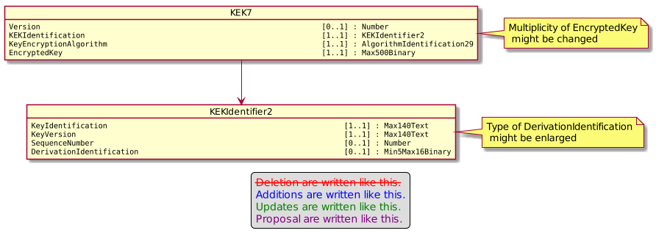

- Urgency of the request:

Not urgent

- Business examples:
Examples illustrating the change request.
- SEG/TSG recommendation:
This section is not to be taken care of by the submitter of the change request. It will be completed in due time by the SEG(s) in charge of the related ISO 20022 messages or the TSG for changes related to the BAH.

Consider |  | X | Timing
 |  |  | - Next yearly cycle: 2021/2022  (the change will be considered for implementation in the yearly maintenance cycle which starts in 2018 and completes with the publication of new message versions in the spring of 2019) |  | X
- At the occasion of the next maintenance of the messages
(the change will be considered for implementation, but does not justify maintenance of the messages in its own right – will be pending until more critical change requests are received for the messages)
- Urgent unscheduled
(the change justifies an urgent implementation outside of the normal yearly cycle)
 |  |  | - Other timing:
Comments:

Reject
Reason for rejection:

