Change Request
for the update of ISO 20022 financial repository items

- Origin of the request:
A.1 Submitter: nexo A.I.S.B.L.
A.2 Contact person: Philippe CECE (Philippe.cece@ingenico.com) / Philippe MERMOUD (philippe.mermoud@natixis.com) / Romain LOREAL (romain.loreal@fime.com)
A.3 Sponsors: nexo A.I.S.B.L.

- Related messages:

- SaleToPOIMessageStatusResponse V03 casp.015.001.03
- SaleToPOIServiceRequest V03 casp.001.001.03
- SaleToPOIServiceResponse V03 casp.002.001.03

- Description of the change request:

In current version of Sale to POI protocol, we are only able to set a SaleTransactionIdentifier with a PaymentRequest. This function must be available for every kind of payment.

- Purpose of the change:

In order to ease operation management and specifically field analysis, we suggest adding an optional identifier coming from Sale in every request, and receive it in response too. For BatchResponse, an additional and optional POI identifier is also welcomed.

Payment and Reversal requests already own a SaleTransactionIdentifier, so the update will aim BalanceInquiryRequest, LoyaltyRequest, StoredValueRequest, BatchRequest and CardAcquisitionRequest.
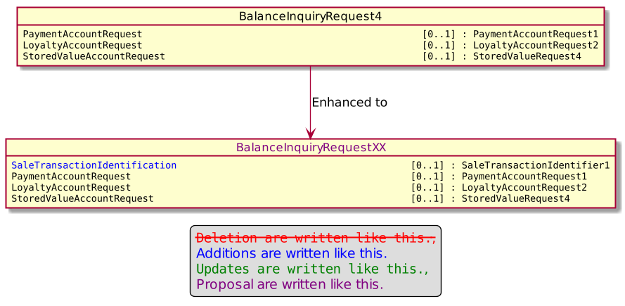
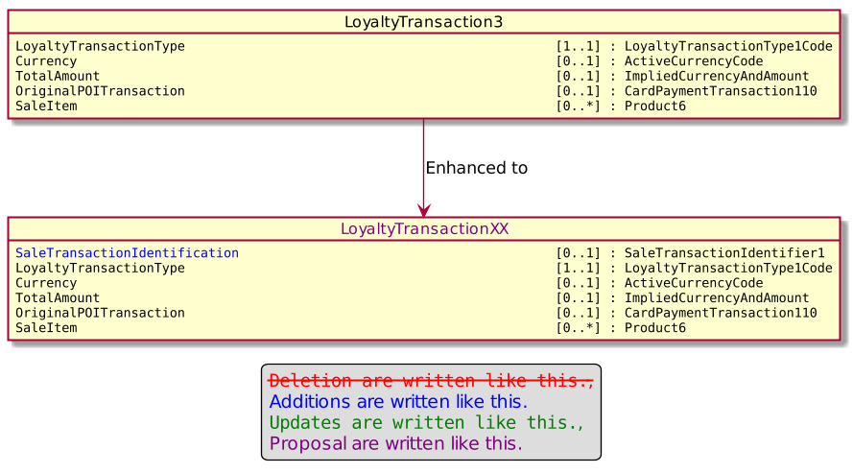
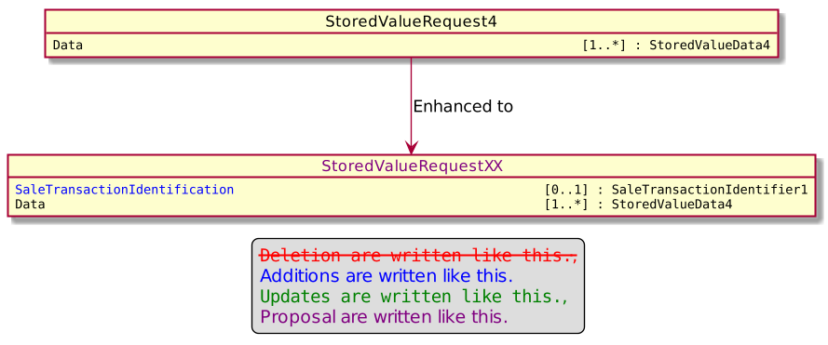
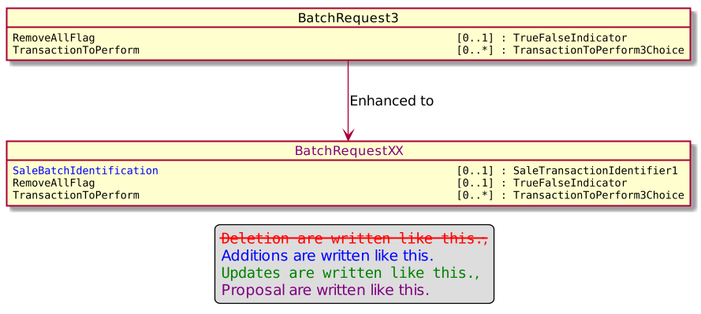
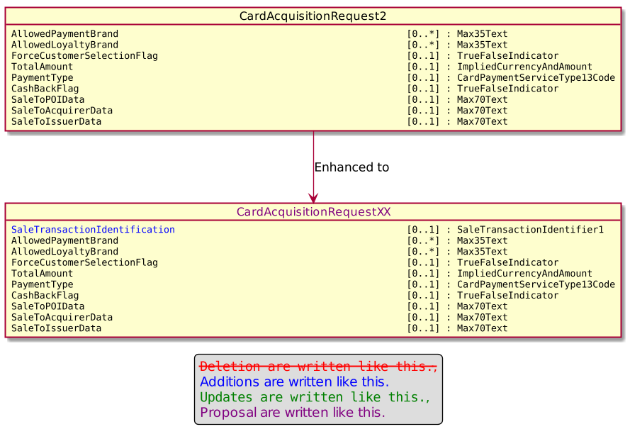
And the relevant response need to be updated by the copy of the SaleTransactionIdentifier; coupled with a new POI identifier for BatchResponse. There is no need to update LoyaltyResponse since these 2 identifiers are already present.
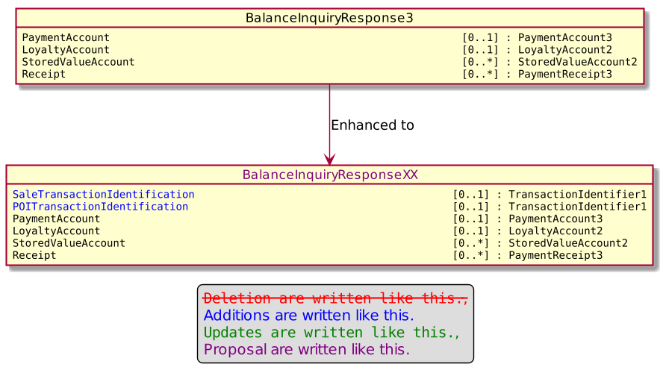
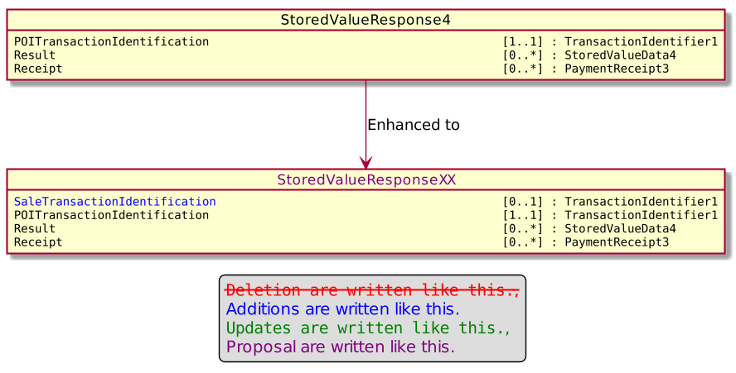
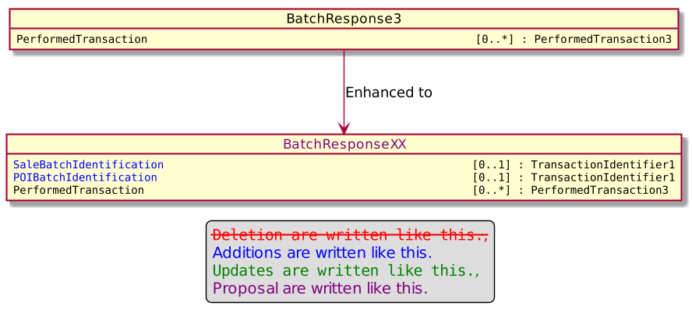
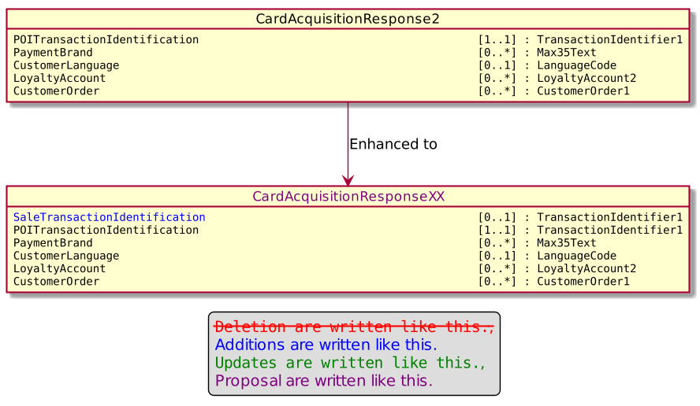

- Urgency of the request:

Urgent

- Business examples:
Examples illustrating the change request.

- SEG/TSG recommendation:
This section is not to be taken care of by the submitter of the change request. It will be completed in due time by the SEG(s) in charge of the related ISO 20022 messages or the TSG for changes related to the BAH.

Consider |  | X | Timing
 |  |  | - Next yearly cycle: 2021/2022  (the change will be considered for implementation in the yearly maintenance cycle which starts in 2018 and completes with the publication of new message versions in the spring of 2019) |  | X
- At the occasion of the next maintenance of the messages
(the change will be considered for implementation, but does not justify maintenance of the messages in its own right – will be pending until more critical change requests are received for the messages)
- Urgent unscheduled
(the change justifies an urgent implementation outside of the normal yearly cycle)
 |  |  | - Other timing:
Comments:

Reject
Reason for rejection:

