Change Request
for the update of ISO 20022 financial repository items

- Origin of the request:
A.1 Submitter: nexo A.I.S.B.L.
A.2 Contact person: Philippe CECE (Philippe.cece@ingenico.com) / Philippe MERMOUD (philippe.mermoud@natixis.com) / Romain LOREAL (romain.loreal@fime.com)
A.3 Sponsors: nexo A.I.S.B.L.

- Related messages:

- AcceptorAuthorisationRequest V10 caaa.001.001.10
- AcceptorAuthorisationResponse V10 caaa.002.001.10
- AcceptorBatchTransfer V10 caaa.011.001.10
- AcceptorBatchTransferResponse V09 caaa.012.001.09
- AcceptorCancellationAdvice V10 caaa.007.001.10
- AcceptorCancellationAdviceResponse V09 caaa.008.001.09
- AcceptorCancellationRequest V10 caaa.005.001.10
- AcceptorCancellationResponse V09 caaa.006.001.09
- AcceptorCompletionAdvice V10 caaa.003.001.10
- AcceptorCompletionAdviceResponse V09 caaa.004.001.09
- AcceptorCurrencyConversionAdviceResponse V04 caaa.019.001.04
- AcceptorCurrencyConversionAdvice V05 caaa.018.001.05
- AcceptorCurrencyConversionRequest V08 caaa.016.001.08
- AcceptorCurrencyConversionResponse V08 caaa.017.001.08
- AcceptorDiagnosticRequest V09 caaa.013.001.09
- AcceptorDiagnosticResponse V08 caaa.014.001.08
- AcceptorNonFinancialRequest V01 caaa.022.001.01
- AcceptorNonFinancialResponse V01 caaa.023.001.01
- AcceptorReconciliationRequest V09 caaa.009.001.09
- AcceptorReconciliationResponse V08 caaa.010.001.08
- AcceptorTransactionLogReportRequest V01 caaa.024.001.01
- AcceptorTransactionLogReportResponse V01 caaa.025.001.01
- MaintenanceDelegationRequest V07 catm.005.001.07
- ManagementPlanReplacement V09 catm 002.001.09
- SalerToPOIAbort V03 casp.011.001.03
- SaleToPOIAdministrativeRequest V03 casp.007.001.03
- SaleToPOIAdministrativeResponse V03 casp.008.001.03
- SaleToPOIDeviceRequest V03 casp.016.001.03
- SaleToPOIDeviceResponse V03 casp.017.001.03
- SaleToPOIEventNotification V03 casp.012.001.03
- SaleToPOIMesageStatusRequest V03 casp.014.001.03
- SaleToPOIMessageStatusResponse V03 casp.015.001.03
- SaleToPOIReconciliationRequest V03 cap.003.001.03
- SaleToPOIReconciliationResponse V03 casp.004.001.03
- SaleToPOIReportRequest V03 casp.009.001.03
- SaleToPOIReportResponse V03 casp.010.001.03
- SaleToPOIServiceRequest V03 casp.001.001.03
- SaleToPOIServiceResponse V03 casp.002.001.03
- SaleToPOISessionManagementRequest V03 casp.005.001.03
- SaleToPOISessioonManagementResponse V03 casp.006.001.03
- StatusReport V10 catm.001.001.10
- TransactionAdvice V02 caaa.020.001.02
- TransactionAdviceResponse V02 caaa.021.001.02

- Description of the change request:

In case of loyalty payment, we would like to ensure that the identification of the loyalty program is enforced in any exchange.
- Purpose of the change:

In order to enforce the presence of loyalty identification, we will mandate the LoyaltyIdentification in LoyaltyAccount2.

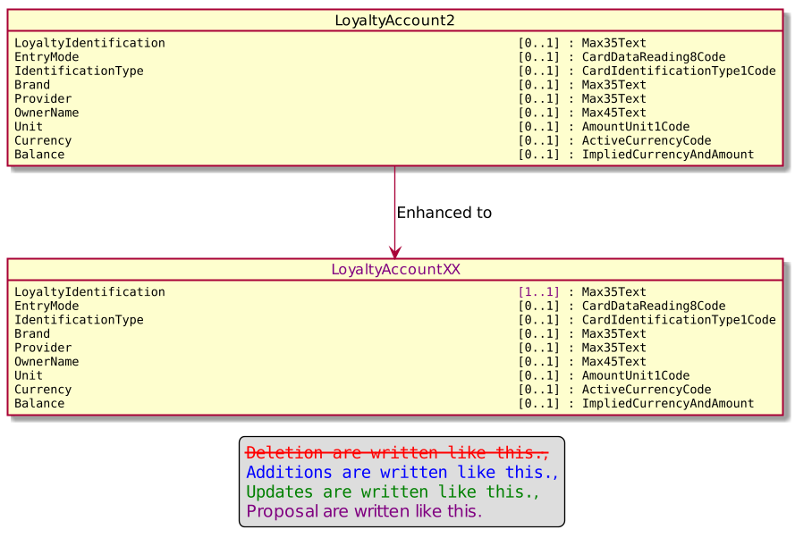

- Urgency of the request:

Urgent

- Business examples:
Examples illustrating the change request.

- SEG/TSG recommendation:
This section is not to be taken care of by the submitter of the change request. It will be completed in due time by the SEG(s) in charge of the related ISO 20022 messages or the TSG for changes related to the BAH.

Consider |  | X | Timing
 |  |  | - Next yearly cycle: 2021/2022  (the change will be considered for implementation in the yearly maintenance cycle which starts in 2018 and completes with the publication of new message versions in the spring of 2019) |  | X
- At the occasion of the next maintenance of the messages
(the change will be considered for implementation, but does not justify maintenance of the messages in its own right – will be pending until more critical change requests are received for the messages)
- Urgent unscheduled
(the change justifies an urgent implementation outside of the normal yearly cycle)
 |  |  | - Other timing:
Comments:

Reject
Reason for rejection:

