Change Request
for the update of ISO 20022 financial repository items

- Origin of the request:
A.1 Submitter: nexo A.I.S.B.L.
A.2 Contact person: Philippe CECE (Philippe.cece@ingenico.com) / Philippe MERMOUD (philippe.mermoud@natixis.com) / Romain LOREAL (romain.loreal@fime.com)
A.3 Sponsors: nexo A.I.S.B.L.

- Related messages:

- AcceptorAuthorisationResponse V10 caaa.002.001.10
- AcceptorBatchTransfer V10 caaa.011.001.10
- AcceptorCancellationAdvice V10 caaa.007.001.10
- AcceptorCancellationResponse V09 caaa.006.001.09
- AcceptorCompletionAdvice V10 caaa.003.001.10
- AcceptorCurrencyConversionRequest V08 caaa.016.001.08
- AcceptorTransactionLogReportResponse V01 caaa.025.001.01
- SaleToPOIMessageStatusResponse V03 casp.015.001.03
- SaleToPOIReportResponse V03 casp.010.001.03
- SaleToPOIServiceRequest V03 casp.001.001.03
- SaleToPOIServiceResponse V03 casp.002.001.03
- TransactionAdvice V02 caaa.020.001.02

- Description of the change request:

It should be possible to process a payment with voice authorisation through retailer protocol. So it is necessary to add an authorisation result in the payment request. Additionally, the length of an authorisation code must be corrected since a code with a length shorter than 6 could exist.
- Purpose of the change:

In order to allow authorisation code with a shorter length, we will change the type of AuthorisationCode from Min6Max8Text to Max8Text.
This modification must be applied in every component dealing with authorisation.

In AuthorisationResult14
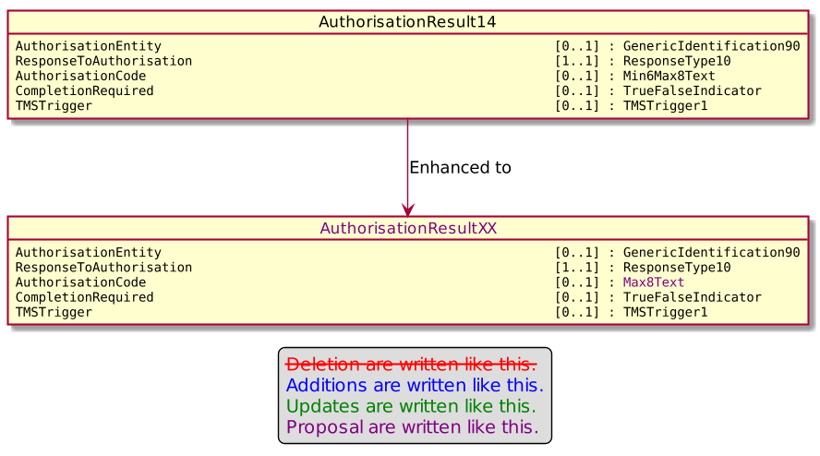

In AuthorisationResult15
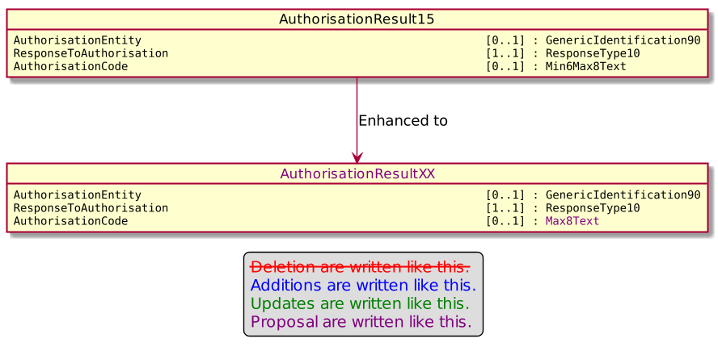

In AuthorisationResult16
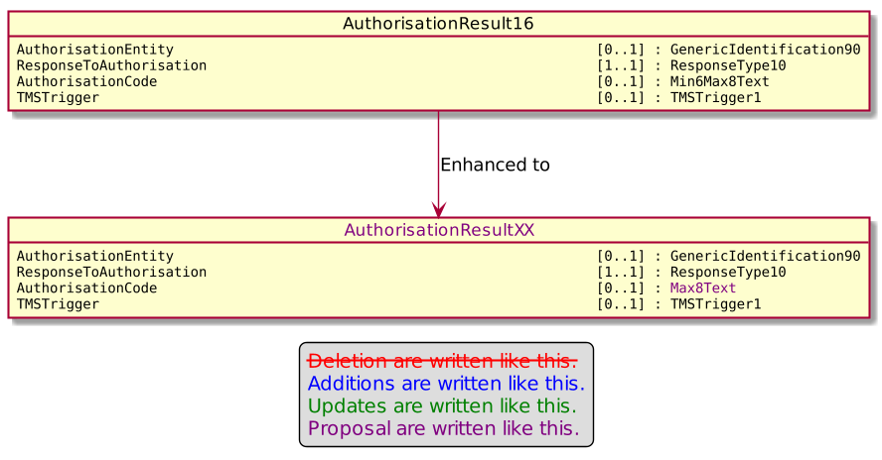Then we will have to update the CardPaymentTransaction110 in order to add an update of the AuthorisationResult15
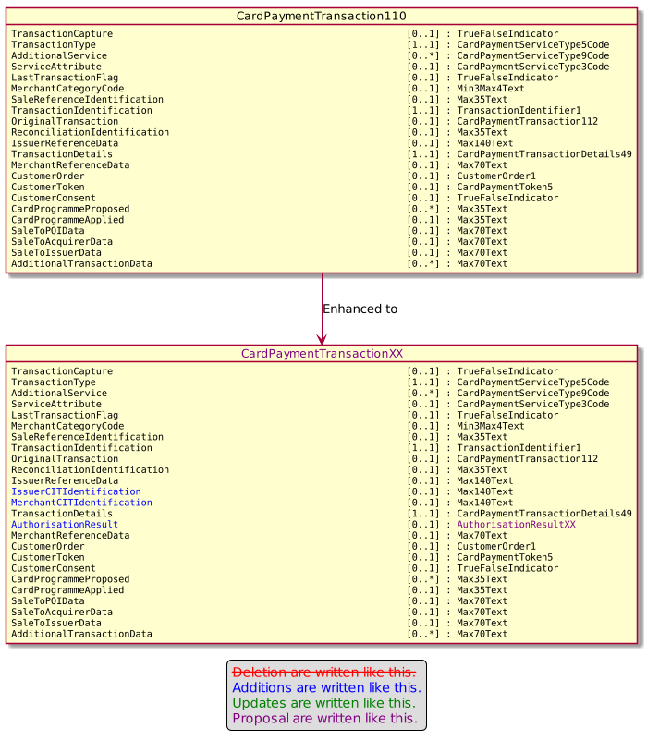
The MerchantCITdentification and IssuerCITIdentification come from an other Change Requestt.

- Urgency of the request:

Urgent

- Business examples:
Examples illustrating the change request.

- SEG/TSG recommendation:
This section is not to be taken care of by the submitter of the change request. It will be completed in due time by the SEG(s) in charge of the related ISO 20022 messages or the TSG for changes related to the BAH.

Consider |  | X | Timing
 |  |  | - Next yearly cycle: 2021/2022  (the change will be considered for implementation in the yearly maintenance cycle which starts in 2018 and completes with the publication of new message versions in the spring of 2019) |  | X
- At the occasion of the next maintenance of the messages
(the change will be considered for implementation, but does not justify maintenance of the messages in its own right – will be pending until more critical change requests are received for the messages)
- Urgent unscheduled
(the change justifies an urgent implementation outside of the normal yearly cycle)
 |  |  | - Other timing:
Comments:

Reject
Reason for rejection:

