Change Request
for the update of ISO 20022 financial repository items

- Origin of the request:
A.1 Submitter: nexo A.I.S.B.L.
A.2 Contact person: Philippe CECE (Philippe.cece@ingenico.com) / Pierre MOURA (pierre.moura@frenchsys.com)
A.3 Sponsors: nexo A.I.S.B.L.

- Related messages:

- AcceptorAuthorisationRequest V10 caaa.001.001.10
- AcceptorBatchTransfer V10 caaa.011.001.10
- AcceptorCancellationAdvice V10 caaa.007.001.10
- AcceptorCancellationRequest V10 caaa.005.001.10
- AcceptorCompletionAdvice V10 caaa.003.001.10
- AcceptorNonFinancialRequest V01 caaa.022.001.01
- AcceptorTransactionLogReportRequest V01 caaa.024.001.01
- AcceptorTransactionLogReportResponse V01 caaa.025.001.01
- MaintenanceDelegationRequest V07 catm.005.001.07
- ManagementPlanReplacement V09 catm 002.001.09
- SalerToPOIAbort V03 casp.011.001.03
- SaleToPOIAdministrativeRequest V03 casp.007.001.03
- SaleToPOIdministrativeResponse V03 casp.008.001.03
- SaleToPOIDeviceRequest V03 casp.016.001.03
- SaleToPOIDeviceResponse V03 casp.017.001.03
- SaleToPOIEventNotification V03 casp.012.001.03
- SaleToPOIMesageStatusRequest V03 casp.014.001.03
- SaleToPOIMessageStatusResponse V03 casp.015.001.03
- SaleToPOIReconciliationRequest V03 cap.003.001.03
- SaleToPOIReconciliationResponse V03 casp.004.001.03
- SaleToPOIReportRequest V03 casp.009.001.03
- SaleToPOIReportResponse V03 casp.010.001.03
- SaleToPOIServiceRequest V03 casp.001.001.03
- SaleToPOIServiceResponse V03 casp.002.001.03
- SaleToPOISessionManagementRequest V03 casp.005.001.03
- SaleToPOISessioonManagementResponse V03 casp.006.001.03
- StatusReport V10 catm.001.001.10
- TransactionAdvice V02 caaa.020.001.02

- Description of the change request:

For markets for which infrastructure supports PIN Online, the schemes want to improve the "cardholder experience" by activating strong authentication and in the continuity of the initial contactless transaction: the cardholder enters the code without inserting the card or representing the contactless device.
Then, the Acquirer needs to be aware of all options supported by a POI as above to be able to request a PIN or to offer IssuerInstalment. Currently, these functions couldn’t be identified in the SupportedOption. The aim of this Change Request is to correct this.

- Purpose of the change:

The codeset SupportedPaymentOption1Code will be updated with 2 new values.
The first one will be IssuerInstalment with the code set value INSI which already exists and is used to tag transaction done as IssuerInstalment.
The second one will be PinRequest with the code set value PINQ which is used by the Acquirer to request the action PIN request.
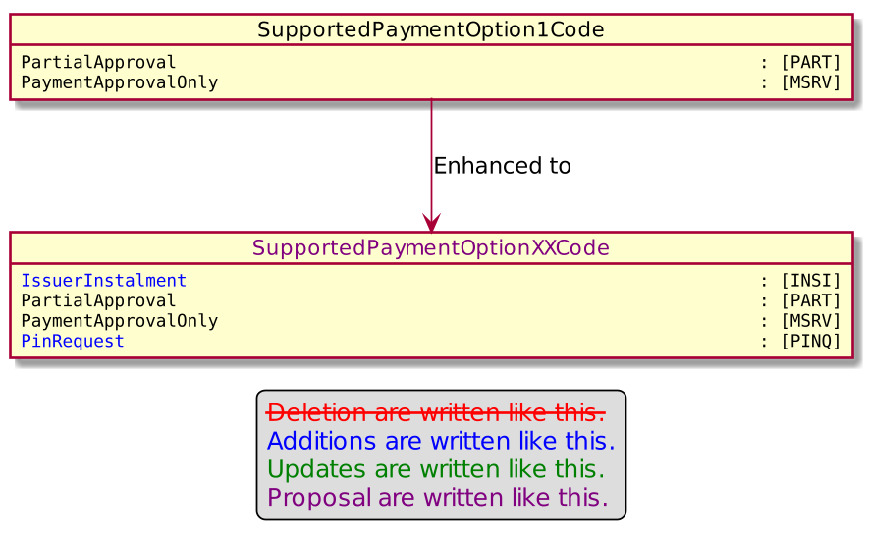

- Urgency of the request:

Urgent

- Business examples:
Examples illustrating the change request.

- SEG/TSG recommendation:
This section is not to be taken care of by the submitter of the change request. It will be completed in due time by the SEG(s) in charge of the related ISO 20022 messages or the TSG for changes related to the BAH.

Consider |  | X | Timing
 |  |  | - Next yearly cycle: 2021/2022  (the change will be considered for implementation in the yearly maintenance cycle which starts in 2018 and completes with the publication of new message versions in the spring of 2019) |  | X
- At the occasion of the next maintenance of the messages
(the change will be considered for implementation, but does not justify maintenance of the messages in its own right – will be pending until more critical change requests are received for the messages)
- Urgent unscheduled
(the change justifies an urgent implementation outside of the normal yearly cycle)
 |  |  | - Other timing:
Comments:

Reject
Reason for rejection:

