Change Request
for the update of ISO 20022 financial repository items

- Origin of the request:
A.1 Submitter: nexo A.I.S.B.L.
A.2 Contact person: Philippe CECE (Philippe.cece@ingenico.com) / Pierre MOURA (pierre.moura@frenchsys.com)
A.3 Sponsors: nexo A.I.S.B.L.

- Related messages:

- AcceptorAuthorisationRequest V10 caaa.001.001.10
- AcceptorAuthorisationResponse V10 caaa,002.001.10
- AcceptorBatchTransfer V10 caaa.011.001.10
- AcceptorCancellationAdvice V10 caaa.007.001.10
- AcceptorCancellationRequest V10 caaa.005.001.10
- AcceptorCompletionAdvice V10 caaa.003.001.10
- AcceptorCurrencyConversionAdvice V05 caaa.018.001.05
- AcceptorCurrencyConversionRequest V08 caaa.016.001.08
- AcceptorCurrencyConversionResponse V08 caaa.017.001.08
- AcceptorNonFinancialRequest V01 caaa.022.001.01
- AcceptorTransactionLogReportResponse V01 caaa.025.001.01
- SaleToPOIMessageStatusResponse V03 casp.015.001.03
- SaleToPOIReportResponse V03 casp.010.001.03
- SaleToPOIServiceRequest V03 casp.001.001.03
- SaleToPOIServiceResponse V03 casp.002.001.03
- TransactionAdvice V02 caaa.020.001.02

- Description of the change request:

During the processing of a contactless transaction, an Acquirer may request a Cardholder verification. This request is sent to the POI in the authorisation response. Consequently, a second authorisation will be sent to the Acquirer in order to send the result. In order to help the processing, it might be helpful to add in the second authorisation request that this has been triggered by a PIN request.

The aim of this Change Request is to add this information.

- Purpose of the change:

The codeset OnLineReason1Code will be updated with a new value.
This value will be PINRequest with the code set value PINQ which already exists and is used by the Acquirer to request a Cardholder Verification.

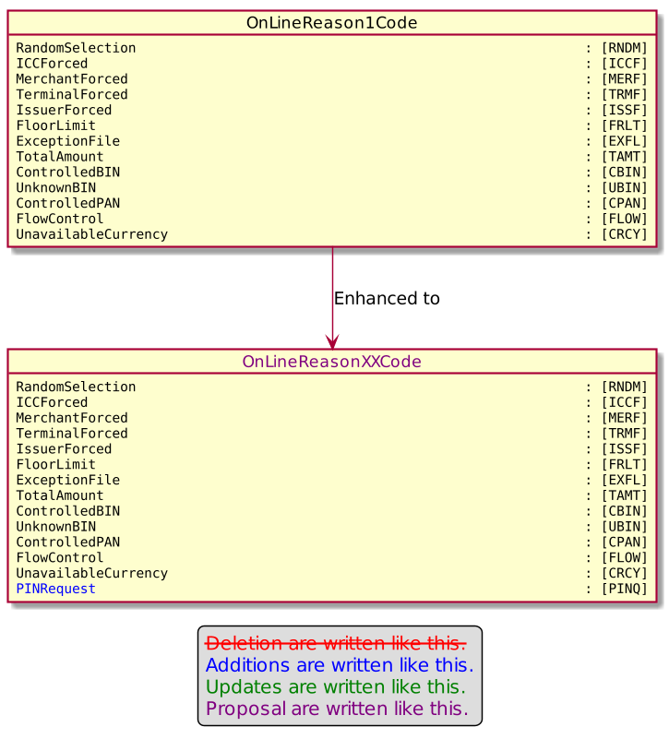

- Urgency of the request:

Urgent

- Business examples:
Examples illustrating the change request.

- SEG/TSG recommendation:
This section is not to be taken care of by the submitter of the change request. It will be completed in due time by the SEG(s) in charge of the related ISO 20022 messages or the TSG for changes related to the BAH.

Consider |  | X | Timing
 |  |  | - Next yearly cycle: 2021/2022  (the change will be considered for implementation in the yearly maintenance cycle which starts in 2018 and completes with the publication of new message versions in the spring of 2019) |  | X
- At the occasion of the next maintenance of the messages
(the change will be considered for implementation, but does not justify maintenance of the messages in its own right – will be pending until more critical change requests are received for the messages)
- Urgent unscheduled
(the change justifies an urgent implementation outside of the normal yearly cycle)
 |  |  | - Other timing:
Comments:

Reject
Reason for rejection:

