Change Request
for the update of ISO 20022 financial repository items

- Origin of the request:
A.1 Submitter: nexo A.I.S.B.L.
A.2 Contact person: Philippe CECE (Philippe.cece@ingenico.com) / Pierre MOURA (pierre.moura@frenchsys.com)
A.3 Sponsors: nexo A.I.S.B.L..

- Related messages:

- AcceptorAuthorisationRequest V10 caaa.001.001.10
- AcceptorBatchTransfer V10 caaa.011.001.10
- AcceptorCompletionAdvice V10 caaa.003.001.10
- AcceptorCurrencyConversionRequest V08 caaa.016.001.08
- AcceptorNonFinancialRequest V01 caaa.022.001.01
- AcceptorTransactionLogReportResponse V01 caaa.025.001.01
- SaleToPOIMessageStatusResponse V03 casp.015.001.03
- SaleToPOIReportResponse V03 casp.010.001.03
- SaleToPOIServiceRequest V03 casp.001.001.03
- SaleToPOIServiceResponse V03 casp.002.001.03
- TransactionAdvice V02 caaa.020.001.02

- Description of the change request:

According to some scheme regulations, it might be expected, in case of Merchant Initiated Transaction, to provide the identification, coming from the Issuer or the Network, of the initial Cardholder Initiated Transaction. In order to ease dispute management, we believe that it could be useful to provide the Merchant identification of this transaction too.

The aim of this Change Request is to allow the exchange of these 2 identifiers (MerchantCITIdentification and IssuerCITIdentification) in acquirer messages.
- Purpose of the change:

First of all, we want to be able to send the the IssuerCITIdentification coupled with the MerchantCITIdentification in the authorisation request. This will update the CardPaymentTransaction107.

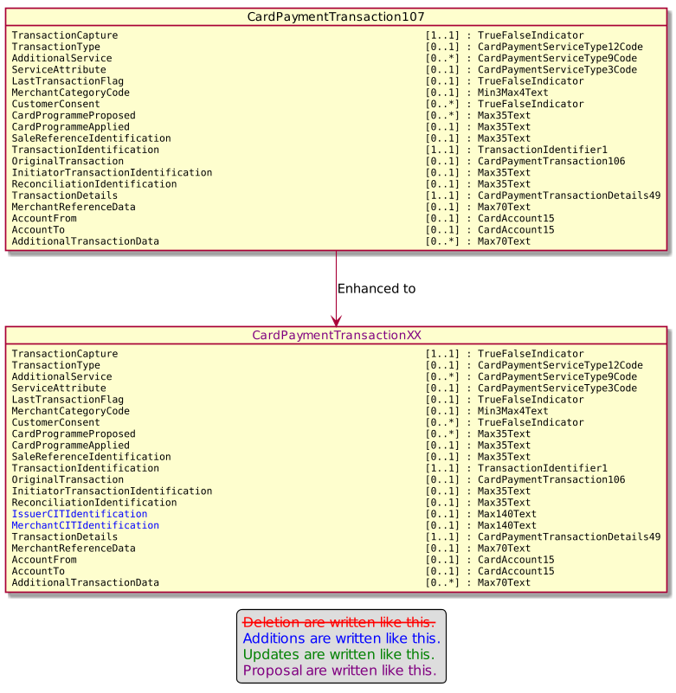

These 2 identifiers need to be in the AcceptorCompletionAdvice message too. This will update the CardPaymentTransaction103.

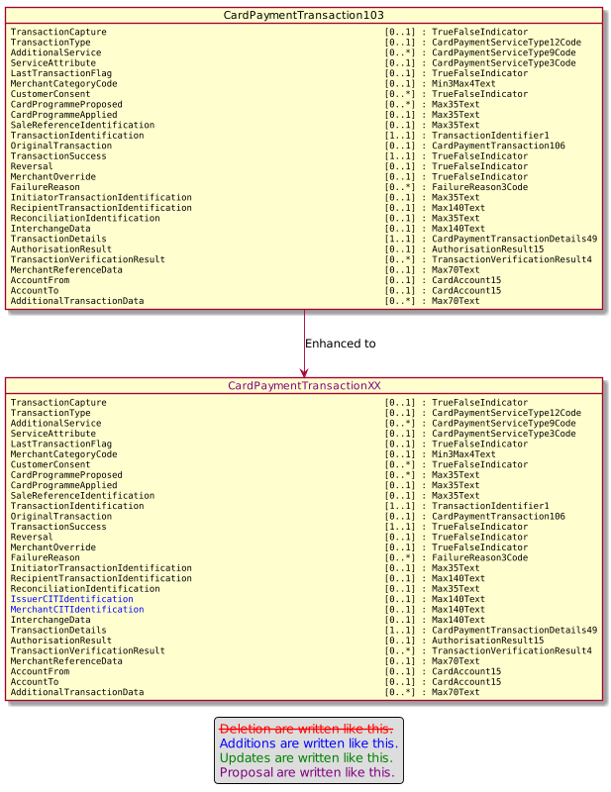

The IssuerCITIdentification in message request will be set by the InterchangeData value received in the AcceptorAuthorisationResponse.

In order to be able to manage these elements through the retailer protocol, we have to update the CardPaymentTransaction110 too.

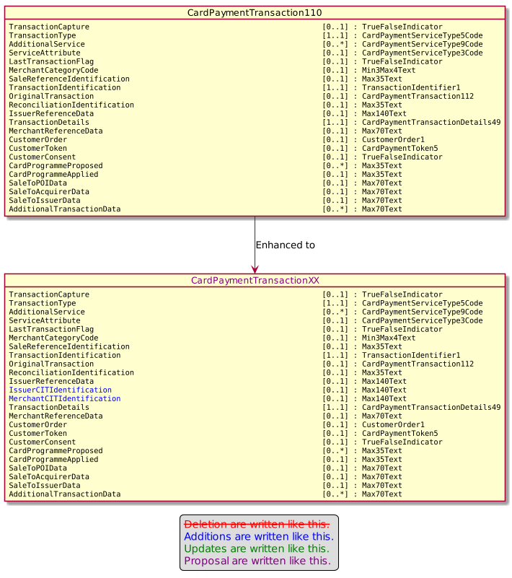

- Urgency of the request:

Urgent

- Business examples:
Examples illustrating the change request.

- SEG/TSG recommendation:
This section is not to be taken care of by the submitter of the change request. It will be completed in due time by the SEG(s) in charge of the related ISO 20022 messages or the TSG for changes related to the BAH.

Consider |  | X | Timing
 |  |  | - Next yearly cycle: 2021/2022  (the change will be considered for implementation in the yearly maintenance cycle which starts in 2018 and completes with the publication of new message versions in the spring of 2019) |  | X
- At the occasion of the next maintenance of the messages
(the change will be considered for implementation, but does not justify maintenance of the messages in its own right – will be pending until more critical change requests are received for the messages)
- Urgent unscheduled
(the change justifies an urgent implementation outside of the normal yearly cycle)
 |  |  | - Other timing:
Comments:

Reject
Reason for rejection:

