Change Request
for the update of ISO 20022 financial repository items

- Origin of the request:
A.1 Submitter: nexo A.I.S.B.L.
A.2 Contact person: Philippe CECE (Philippe.cece@ingenico.com) / Pierre MOURA (pierre.moura@frenchsys.com)
A.3 Sponsors: nexo A.I.S.B.L.

- Related messages:

- AcceptorAuthorisationResponse V10 caaa.002.001.10
- AcceptorBatchTransfer V10 caaa.011.001.10
- AcceptorCancellationRequest V10 caaa.005.001.10
- AcceptorCancellationResponse V19 caaa.006.001.09
- AcceptorNonFinancialResponse V01 caaa.023.001.01
- AcceptorTransactionLogReportResponse V01 caaa.025.001.01
- SaleToPOIMessageStatusResponse V03 casp.015.001.03
- SaleToPOIReportResponse V03 casp.010.001.03
- SaleToPOIServiceResponse V03 casp.002.001.03

- Description of the change request:

In some e-commerce use case, the Acquirer may want to stop one recurring transaction or stop all recurring transactions. Additionally in some circumstances, e.g perishable goods, an acceptor may want to cancel a capture if the clearing hasn’t been done but keep the authorisation open in order to provide a later capture.
- Purpose of the change:

The first change aims to create 2 new codesets in ActionType9Code with the value StopOneRecurring with the code STOR and a value StopAllRecurring with the code STAR.

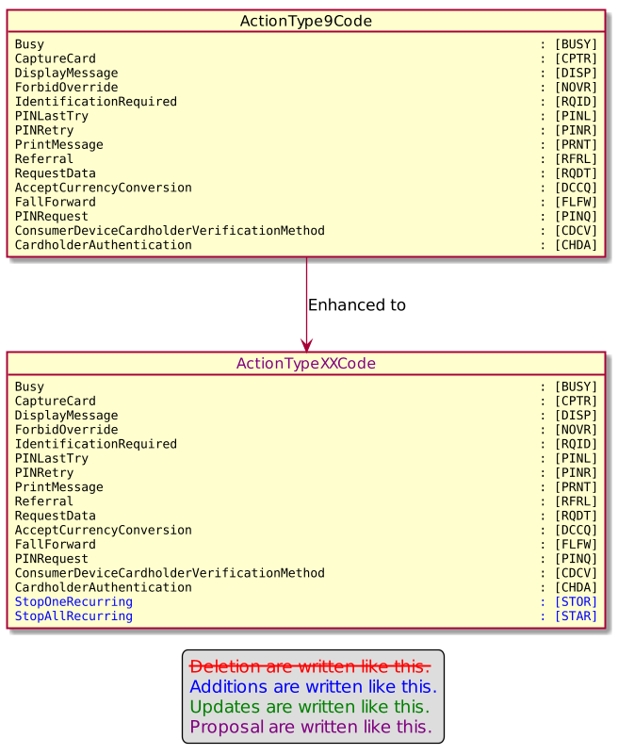

The second modification adds a TrueFalseIndicator named KeepAuthorisationOpen with multiplicity [0,1] in the CardPaymentTransaction108 which is the message element used only for AcceptorCancellationRequest.

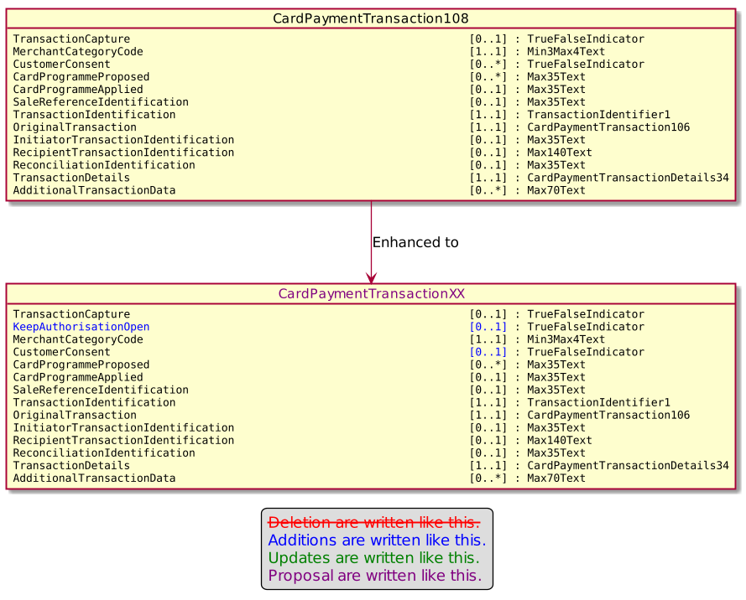

The modification aiming multiplicity of CustomerConsent comes from an other Change Request.

- Urgency of the request:

Urgent

- Business examples:
Examples illustrating the change request.
- SEG/TSG recommendation:
This section is not to be taken care of by the submitter of the change request. It will be completed in due time by the SEG(s) in charge of the related ISO 20022 messages or the TSG for changes related to the BAH.

Consider |  | X | Timing
 |  |  | - Next yearly cycle: 2021/2022  (the change will be considered for implementation in the yearly maintenance cycle which starts in 2018 and completes with the publication of new message versions in the spring of 2019) |  | X
- At the occasion of the next maintenance of the messages
(the change will be considered for implementation, but does not justify maintenance of the messages in its own right – will be pending until more critical change requests are received for the messages)
- Urgent unscheduled
(the change justifies an urgent implementation outside of the normal yearly cycle)
 |  |  | - Other timing:
Comments:

Reject
Reason for rejection:

